**5. Connect to the University Hadoop System and paste the outputs in the following:**

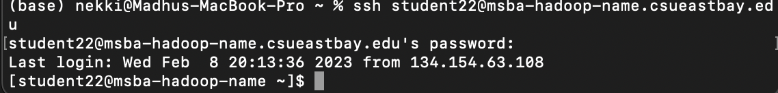

**6. Create a jar file after running the following command in the University Hadoop System, and paste the outputs indicating the jar file below:**

(1).jar -cvf max-temperature.jar ./MaxTemperature*.class

*(-c – create new archive; -v – generate verbose output on standard output; -f – specify archive file name)*



