**AWS CLOUD COMPUTING - DEVOPS**

***A Summer Internship Report submitted in partial fulfillment of the***

***requirements for the award of degree of***

**BACHELOR OF TECHNOLOGY**

**In**

**CSE-Data Science**

## Submitted by

R.MADHAVI

23MH1A4453



**ADITYA COLLEGE OF ENGINEERING & TECHNOLOGY (A)**

Approved by AICTE, Permanently affiliated to JNTUK & Accredited by NAAC with ‘A+’ Grade

**Recognized by UGC under the sections 2(f) and 12(B) of the UGC Act 1956**

**Aditya Nagar, ADB Road –Surampalem 533437, East Godavari Dist., A.P.**

**2025-26**

**ADITYA COLLEGE OF ENGINEERING & TECHNOLOGY (A)**

Approved by AICTE, Permanently affiliated to JNTUK & Accredited by NAAC with ‘A+’ Grade **Recognized by UGC under the sections 2(f) and 12(B ) of the UGC Act 1956**

**Aditya Nagar, ADB Road –Surampalem 533437, East Godavari Dist.,A.P.**

**CSE-Data Science**



**CERTIFICATE**

This is to certify that the Internship report entitled***“*Deploy a Web Application to Amazon ECS”**is being submitted by

**R. MADHAVI (23MH1A4453)**

In partial fulfillment of the requirements for the award of the B.Tech degree in

Data sciencefor the academic year 2025-2026.

**Internship Coordinator Head of the Department**

Guide Name: K. Roja Rani HOD Name: B. Manikyalarao

Designation: Assistant professor Designation: Associate professor

& HoD

Department: CSE-Data Science Department: CSE-Data Science

**DECLARATION**

I hereby declare that the Internship entitled **AWS CLOUD COMPUTING-DEVOPS** is a genuine report. This work has been submitted to the **ADITYA COLLEGE OF ENGINEERING & TECHNOLOGY (A),** Surampalem, permanently affiliated to **JNTUK, KAKINADA** in partial fulfillment of the **B.Tech** degree**.**

I also hereby declare that this internship report not submitted in full or partial any other university for any degree.

**NAME OF THE STUDENT**

**R.MADHAVI**

**23MH1A4453**

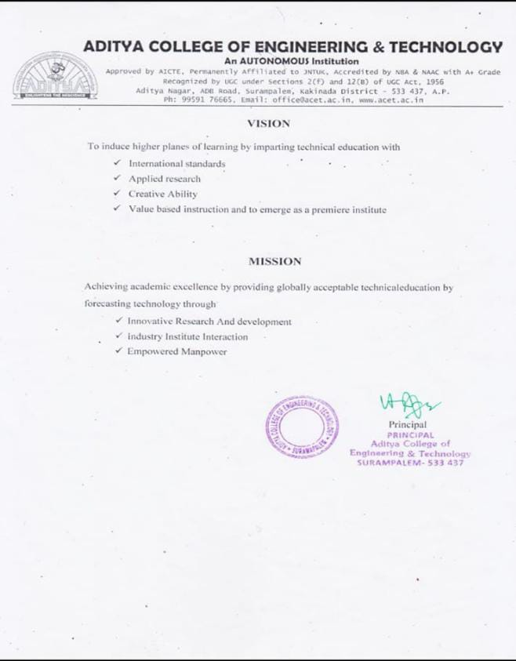**INSTITUTE VISION & MISSION**

**INTERNSHIP COMPLETION CERTIFICATE**

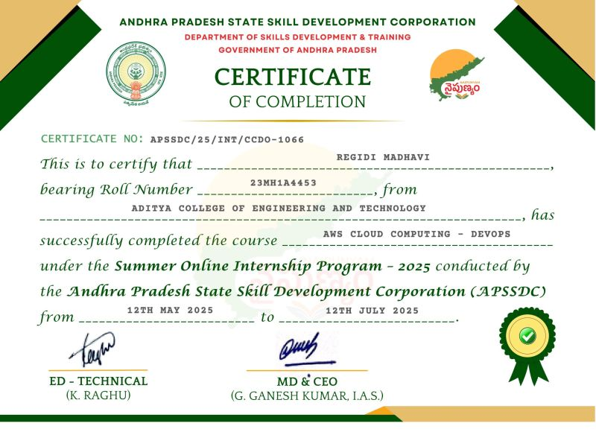

**ACKNOWLEDGEMENT**

I offer my sincere thanks to dynamic and beloved Principal, **Dr. A. Ramesh**, **Aditya College of Engineering & Technology(A)** for his co-operation.

My sincere thanks to B. Manikyalarao M.Tech., Ph.D, Head of the department of Data Science for his valuable support.

I express my sincere gratitude to my internship guide, Mrs. K. Roja Rani Assistant Professor, Department of CSE-Data Science, for her valuable guidance and encouragement which has been helpful in successful completion of this internship.

With immense pleasure I would like to express my deep sense and heart full thanks to the management of Aditya College of Engineering & Technology (A).

**Learning Objectives/Internship Objectives**

1. To understand core AWS services such as EC2, S3, IAM, and VPC.

2. To gain hands-on experience in DevOps practices including CI/CD pipelines.

3. To learn containerization using Docker and orchestration using Kubernetes on AWS.

4. To implement monitoring and logging using CloudWatch and other DevOps tools.

5. To deploy scalable and secure applications on AWS Cloud with automation.

And soon

**INDEX**

|  |  |  |  |  |  |
| --- | --- | --- | --- | --- | --- |
| **Sl.No** | | | **CONTENT** | | **PAGE No.** |
| 1 | | | CHAPTER 1: EXECUTIVE SUMMARY | | 9 |
| 2 | | CHAPTER 2: OVERVIEW OF THE ORGANIZATION | | | 10 |
| 3 | | CHAPTER 3: INTERNSHIP PART | | 11 | |
| 4 | | WEEKLY OVERVIEW INTERNSHIPACTIVITIES | | 12-27 | |
| 5 | CHAPTER 5: OUTCOMES DESCRIPTION | | | 28 | |
| 6 | Student Self Evaluation of the Short-Term Internship | | | 29 | |
| 7 | Evaluation by the Supervisor of the Intern Organization | | | 30 | |
| 8 | PHOTOS & DRIVE LINK | | | 31 | |

# CHAPTER 1: EXECUTIVE SUMMARY

# The internship report shall have only a one-page executive summary. It shall include five or more Learning Objectives and Outcomes achieved, a brief description of the sector of business and intern organization and summary of all the activities done by the intern during the period.

# The integration of AWS Cloud Computing with DevOps practices has transformed the way organizations design, deploy, and manage applications in the digital era. Cloud computing provides scalable, cost-effective, and flexible infrastructure, while DevOps focuses on collaboration, automation, and continuous delivery. Together, AWS and DevOps create a powerful ecosystem that enables enterprises to achieve faster innovation, improved reliability, and enhanced customer satisfaction.

# AWS Cloud Computing offers a wide range of services including compute (EC2, Lambda), storage (S3, EBS), networking (VPC, Route 53), and databases (RDS, DynamoDB), which allow businesses to run applications without the need for heavy upfront investments in physical infrastructure. This “pay-as-you-go” model ensures cost optimization and global reach.

# DevOps, on the other hand, bridges the gap between development and operations by automating processes like building, testing, deployment, and monitoring. Tools such as AWS CodePipeline, CodeDeploy, and CloudFormation enable Continuous Integration (CI) and Continuous Delivery (CD), ensuring rapid software releases with minimal errors. By adopting Infrastructure as Code (IaC) and containerization (Docker, Kubernetes on AWS EKS), teams can maintain consistency, scalability, and agility across environments.

# CHAPTER 2: OVERVIEW OF THE ORGANIZATION

**A. Introduction of the Organization**

The Andhra Pradesh State Skill Development Corporation (APSSDC) is a state-level initiative by the Government of Andhra Pradesh to provide industry-aligned skill development training to students and young professionals. APSSDC partners with leading technology providers and organizations to deliver high-quality programs in emerging technologies like AWS Cloud Computing, DevOps, Artificial Intelligence, Data Science, and IoT.

**B. Vision, Mission, and Values of the Organization**

Vision: To empower youth with advanced skills and create a workforce that meets global industry standards.

Mission: To provide practical, hands-on training in emerging technologies and ensure employability through industry collaborations and certifications.

Values: Excellence, Innovation, Collaboration, Integrity, and Social Responsibility.

**C. Policy of the Organization (in relation to the intern role)**

APSSDC emphasizes learning-by-doing, encouraging interns to gain hands-on experience with real-world projects. The policies include:

Providing access to AWS cloud platforms and DevOps tools for practical learning.

Ensuring mentorship and guidance from industry experts.

**D. Organizational Structure**

Board of Directors / Governing Body: Oversees strategic decisions and partnerships.

Training & Skill Development Team: Plans and executes training programs.

Technical Mentors and Trainers: Provide practical guidance on technologies such as AWS Cloud and DevOps.

**E. Roles and Responsibilities of Employees (Intern Placement)**

Technical Trainers: Conducted workshops on AWS services, DevOps tools, CI/CD, and Infrastructure as Code (IaC).

Project Mentors: Guided interns through hands-on projects involving cloud deployments, automation scripts, and containerization.

Interns: Assisted in building pipelines, deploying cloud infrastructure, and monitoring applications using AWS services and DevOps practices.

**F. Performance of the Organization**

Market Reach: Trained thousands of students across Andhra Pradesh in emerging technologies.

Impact: High placement rates for certified trainees in IT and cloud computing roles.

Market Value: Recognized nationally for bridging the gap between academic learning and industry requirements.

**G. Future Plans of the Organization**

Expand training programs in advanced cloud computing, AI, and DevOps domains.

Establish more industry partnerships to provide live project exposure to interns.

Launch certification-oriented programs to enhance employability in the global IT market.

# CHAPTER 3: INTERNSHIP PART

During my internship on AWS Cloud Computing – DevOps, I was involved in various activities and responsibilities designed to provide practical exposure to cloud infrastructure, DevOps practices, and automation tools. The internship was structured to simulate a real-world professional environment, allowing me to gain hands-on experience while working under the guidance of experienced mentors.

Working Conditions and Environment:

The internship environment was highly professional and collaborative. Workstations were equipped with high-performance computers, dual monitors, stable internet, and access to AWS cloud accounts. Adequate ventilation, lighting, and comfortable seating contributed to a conducive learning atmosphere. Regular interactions with mentors and peers encouraged knowledge sharing, teamwork, and problem-solving.

**Equipment and Tools Used:**

The internship provided access to the latest AWS management console, cloud-based virtual servers (EC2), object storage (S3), relational and NoSQL databases (RDS, DynamoDB), and networking services (VPC, Route 53). Additionally, DevOps tools like Git, Jenkins, Docker, Kubernetes, and CloudFormation were extensively used to automate and manage software deployment processes.

**Tasks Performed:**

During the internship, I performed tasks including:

Creating and managing EC2 instances and S3 buckets for cloud applications.

Setting up CI/CD pipelines using AWS CodePipeline and Jenkins.

Automating infrastructure deployment using CloudFormation templates.

Containerizing applications with Docker and orchestrating them using Kubernetes.

Monitoring and maintaining application health using AWS CloudWatch and CloudTrail.

Collaborating with team members on real-time projects to deploy scalable, fault-tolerant applications.

**Skills Acquired:**

Through these activities, I gained a strong understanding of cloud computing fundamentals, DevOps methodologies, automation, and cloud security best practices. I also developed soft skills such as time management, teamwork, problem-solving, and professional communication, which are essential in a corporate environment. This hands-on experience has prepared me for roles like Cloud Engineer, DevOps Engineer, and Site Reliability Engineer, bridging the gap between academic learning and industry requirements.

# WEEKLY OVERVIEW OF INTERNSHIP ACTIVITIES

**ACTIVITY LOG FOR THE FIRST WEEK**

|  |  |  |  |  |
| --- | --- | --- | --- | --- |
| **1stWEEK** | **Date** | **Day** | **Brief Description of Daily Activity** | **Learning Outcomes** |
| 12-05-2025 | Monday | Brief Introduction on AWS Cloud Computing | Understanding the Cloud Fundamentals |
| 13-05-2025 | Tuesday | Devops Demo | Learning About the Cloud Computing - Devops |
| 14-05-2025 | Wednesday | AWS Demo | Learnig About AWS |
| 15-05-2025 | Thursday | AWS Account creation | Learning about how to create AWS account |
| 16-05-2025 | Friday | Week-1 Assessment | Test |
| 17-05-2025 | Saturday | Holiday | - |

**WEEKLY REPORT**

WEEK – 1 (From Dt: 12-05-2025 to Dt: 17-05-2025)

## Objective of the Activity Done:

1. To understand the fundamental concepts of Cloud Computing and its relevance in modern IT infrastructure.

2. To gain a clear understanding of AWS services and their core functionalities.

3. To get an overview of DevOps practices, including continuous integration and continuous deployment (CI/CD).

4. To explore the AWS Management Console and perform basic demonstrations.

5. To familiarize with hands-on activities on cloud resources and understand how AWS supports DevOps workflows.

## Detailed Report:

**A. AWS Cloud Computing Overview**

Learned the definition and benefits of cloud computing (scalability, flexibility, cost-efficiency).

Studied different cloud deployment models: Public, Private, and Hybrid Cloud.

Explored AWS global infrastructure, including regions and availability zones.

**B. DevOps Demo**

Understood DevOps principles: collaboration, automation, continuous integration, continuous delivery, and monitoring.

Observed a demo workflow showing code changes, build process, testing, and deployment.

Learned the role of tools like Git, Jenkins, and AWS CodePipeline in automating software delivery.

**C. AWS Demo**

Logged into AWS Management Console.

Explored core services like:

EC2 (launching virtual servers)

S3 (storing and managing data)

IAM (managing user roles and permissions)

Practiced creating a simple S3 bucket and launching a basic EC2 instance.Understood how AWS services integrate to support DevOps pipelines.

**ACTIVITY LOG FOR THE SECOND WEEK**

|  |  |  |  |  |
| --- | --- | --- | --- | --- |
| **2nd WEEK** | **Date** | **Day** | **Brief Description of Daily Activity** | **Learning Outcomes** |
| 19-05-2025 | Monday | Brief Explanation on AWS Global Infrastructure | Understanding of AWS Global Infrastructure |
| 20-05-2025 | Tuesday | Learning about Launching of EC2 Server | Practical skills in launching and configuring EC2 instances |
| 21-05-2025 | Wednesday | Learning about Launching of S3 Server | Learned how to create and manage S3 bucket for storage |
| 22-05-2025 | Thursday | Learning about Launching of EFS Server | Understood the working of EFS |
| 23-05-2025 | Friday | Week-2 Assessment | Test |
| 24-05-2025 | Saturday | Holiday | - |

**WEEKLY REPORT**

WEEK – 2 (From Dt: 19-05-2025 to Dt: 24-05-2025)

## Objective of the Activity Done:

1. To understand the AWS Global Infrastructure including regions, availability zones, and edge locations.

2. To gain practical knowledge of launching and managing EC2 instances for computing needs.

3. To learn how to create and configure S3 buckets for scalable storage.

4. To explore Elastic File System (EFS) and understand its benefits for scalable, shared file storage.

## Detailed Report:

**A. AWS Global Infrastructure**

Learned that AWS operates on a global network of regions and availability zones (AZs).

Understood the significance of edge locations in delivering content through AWS CloudFront.

**B. Launching EC2 Instances**

Logged into the AWS Management Console and launched an EC2 instance.

Selected Amazon Machine Image (AMI), instance type, and configured security groups.

Connected to the instance via SSH (Linux) and RDP (Windows).

Explored scaling and instance management features.

**C. Amazon S3 (Simple Storage Service)**

Created an S3 bucket to store and retrieve objects.

Learned how to upload, download, and manage files.

Configured bucket permissions and policies for access control.

Understood versioning and lifecycle policies for data management.

**D. Amazon EFS (Elastic File System)**

Created an EFS file system and mounted it to an EC2 instance.

Understood how EFS provides shared, scalable file storage accessible by multiple instances simultaneously.

Explored differences between EFS and S3 in terms of storage type (file storage vs. object storage).

**ACTIVITY LOG FOR THE THIRD WEEK**

|  |  |  |  |  |
| --- | --- | --- | --- | --- |
| **3rdWEEK** | **Date** | **Day** | **Brief Description of Daily Activity** | **Learning Outcomes** |
| 26-05-2025 | Monday | Learning about Launching of EFS Server | Practical experience with EFS |
| 27-05-2025 | Tuesday | Brief understanding on Website Hosting | Learned the complete process of Hosting a website |
| 28-05-2025 | Wednesday | Learning about VPC | Understood VPC design, subnets, internet gateways, and routing tables |
| 29-05-2025 | Thursday | NatGateways | Configured and validated the use of NAT Gateways |
| 30-05-2025 | Friday | Week-3 assessment | Test |
| 31-05-2025 | Saturday | Holiday | - |

**WEEKLY REPORT**

WEEK – 3 (From Dt: 26-05-2025 to Dt: 31-05-2025)

## Objective of the Activity Done:

1. To gain hands-on experience in creating and managing Amazon EFS for shared file storage.

2. To understand and practice website hosting on AWS using S3 and/or EC2.

3. To learn about Amazon VPC (Virtual Private Cloud) and its components for secure networking.

4. To configure and understand the role of NAT Gateways for enabling private subnet instances to access the internet.

## Detailed Report:

**A. Launching of EFS Server**

Created a new Elastic File System (EFS) in a selected region.

Attached the EFS to multiple EC2 instances across different Availability Zones.

Learned how EFS automatically scales storage and supports concurrent access.

Tested file sharing between EC2 instances using mounted EFS.

**B. Website Hosting**

Learned two hosting approaches:

1. Static Website Hosting using S3 – Uploaded HTML/CSS files to an S3 bucket, enabled static website hosting, and set bucket policies for public access.

2. Dynamic Website Hosting using EC2 – Installed a web server (Apache/NGINX) on EC2 and hosted a sample website.

Explored Route 53 (DNS) for domain mapping and website access.

**C. Amazon VPC (Virtual Private Cloud)**

Understood the concept of a VPC as an isolated virtual network within AWS.

Created a custom VPC with subnets (public and private).

Configured Internet Gateway for internet access to the public subnet.

**D. NAT Gateways**

Learned the role of NAT (Network Address Translation) Gateway in allowing private subnet instances to access the internet without exposing them publicly.

Deployed a NAT Gateway in the public subnet.

Configured routing tables to enable outbound internet access for private subnet EC2 instances.

Tested internet connectivity from private instances via NAT Gateway.

**ACTIVITY LOG FOR THE FORTH WEEK**

|  |  |  |  |  |
| --- | --- | --- | --- | --- |
| **4thWEEK** | **Date** | **Day** | **Brief Description of Daily Activity** | **Learning Outcomes** |
| 02-06-2025 | Monday | NatGateways | Configured and validated the use of NAT Gateways |
| 03-06-2025 | Tuesday | Learning about EBS Volumes | Creating, attaching, and managing EBS volumes |
| 04-06-2025 | Wednesday | Introduction to Linux and shell scripting | Developed foundational Linux skills |
| 05-06-2025 | Thursday | Shell Scripting | Learned how to write and execute basic shell scripting |
| 06-06-2025 | Friday | Week-4 assessment | Test |
| 07-06-2025 | Saturday | Holiday | - |

**WEEKLY REPORT**

WEEK – 4 (From Dt: 02-06-2025 to Dt: 07-06-2025)

## Objective of the Activity Done:

1. To learn about Amazon EBS (Elastic Block Store) volumes, their creation, attachment, and use with EC2 instances.

2. To get introduced to Linux basics and perform fundamental operations on EC2 Linux instances.

3. To gain hands-on experience with shell scripting for task automation in cloud environments.

## Detailed Report:

**A. Amazon EBS (Elastic Block Store) Volumes**

Created a new EBS volume and attached it to an EC2 instance.

Mounted the volume on the Linux system and formatted it with a file system (ext4).

Practiced storing and retrieving files on the EBS volume.

Learned about volume persistence, snapshots, and backups for disaster recovery.

**B. Introduction to Linux**

Explored basic Linux commands:

File navigation: ls, cd, pwd

File operations: touch, nano, cat, cp, mv, rm

User and permissions management: chmod, chown

Process management: ps, top, kill

Learned the importance of Linux in cloud computing and DevOps environments.

**C. Shell Scripting Basics**

Created simple shell scripts (.sh files) to automate repetitive tasks.

Example scripts:

A script to display system information (CPU, memory, disk usage).

A script to back up files into a specific directory.

A script to update and upgrade software packages automatically.

Executed scripts using bash scriptname.sh and learned about permissions (chmod +x).

**ACTIVITY LOG FOR THE FIFTH WEEK**

|  |  |  |  |  |
| --- | --- | --- | --- | --- |
| **5thWEEK** | **Date** | **Day** | **Brief Description of Daily Activity** | **Learning Outcomes** |
| 09-06-2025 | Monday | Brief explanation on RDS | Understood hoe RDS simplifies database management |
| 10-06-2025 | Tuesday | Brief explanation on RDS | Gained knowledge in launching and configuring an RDS instances |
| 11-06-2025 | Wednesday | Brief explanation on Cloud Architecting | Learned about AWS Cloud Architecting |
| 12-06-2025 | Thursday | Brief explanation on Cloud Architecting | Learned about AWS Cloud Architecting |
| 13-06-2025 | Friday | Week-4 assessment | Test |
| 14-06-2025 | Saturday | Holiday | - |

**WEEKLY REPORT**

WEEK – 5 (From Dt: 09-06-2025 to Dt: 14-06-2025)

## Objective of the Activity Done:

1. To understand Amazon RDS (Relational Database Service), its features, and practical use cases.

2. To learn how to create, configure, and manage RDS instances for database applications.

3. To gain insights into cloud architecting principles for designing secure, scalable, and cost-effective solutions.

4. To understand best practices in high availability, fault tolerance, and disaster recovery using AWS services.

5. To integrate database management and cloud design principles into a real-world cloud solution approach.

## Detailed Report:

**A. Amazon RDS (Relational Database Service)**

Explored the concept of managed relational databases on AWS.

Learned supported database engines: MySQL, PostgreSQL, MariaDB, Oracle, and SQL Server.

Created an RDS instance with MySQL engine.

Configured database settings such as allocated storage, security groups, and backups.

Connected RDS to an EC2 instance and ran sample SQL queries.

Understood automated backups, Multi-AZ deployment, and read replicas for performance and high availability.

**B. Cloud Architecting**

Studied the concept of AWS Well-Architected Framework, which includes:

1. Operational Excellence – monitoring, automation, and improvement.

2. Security – IAM, encryption, and least privilege.

3. Reliability – high availability, fault tolerance, disaster recovery.

4. Performance Efficiency – selecting the right compute, storage, and database services.

5. Cost Optimization – using auto scaling, reserved instances, and resource monitoring.

Understood how to design applications that are scalable, resilient, and cost-effective.

**ACTIVITY LOG FOR THE SIXTH WEEK**

|  |  |  |  |  |
| --- | --- | --- | --- | --- |
| **6thWEEK** | **Date** | **Day** | **Brief Description of Daily Activity** | **Learning Outcomes** |
| 16-06-2025 | Monday | Brief explanation on shell scripting | Developed skills in shell scripting for automation |
| 17-06-2025 | Tuesday | Brief explanation on shell scripting | Developed skills in shell scripting for automation |
| 18-06-2025 | Wednesday | Git Introduction | Learned to use Git for version control |
| 19-06-2025 | Thursday | Markdown | Understood how to document projects with Markdown |
| 20-06-2025 | Friday | Week-6 Assessment | Test |
| 21-06-2025 | Saturday | Holiday | - |

**WEEKLY REPORT**

WEEK – 6 (From Dt: 16-06-2025 to Dt: 21-06-2025)

## Objective of the Activity Done:

1. To deepen the understanding of shell scripting for automating routine tasks in Linux.

2. To learn the fundamentals of Git version control, including repository creation, commits, and branching.

3. To gain knowledge of Markdown language for creating simple, readable documentation.

4. To practice integrating scripting, version control, and documentation as part of a DevOps workflow.

## Detailed Report:

**A. Shell Scripting (Advanced Practice)**

Revised basics of writing .sh files and setting execute permissions (chmod +x).

Wrote scripts for: Automating system updates (apt update && apt upgrade).

Creating backups of files into a directory with timestamps.

Displaying system logs and health checks (CPU, memory, and disk usage).

Learned about variables, conditionals (if-else), and loops (for, while) in shell scripts.

Understood how shell scripting integrates with cron jobs for scheduling tasks.

**B. Git Introduction**

Installed Git and configured username and email (git config).

Created a local Git repository (git init).

Practiced basic commands:

git add, git commit, git status, git log

git branch, git checkout, git merge

Connected a local repository to GitHub and pushed code using git remote add origin and git push.

**C. Markdown**

Learned Markdown syntax for creating structured text files.

Practiced: Headings (#, ##, ###), Bold, italic, lists, and tables, Links and images. Created a sample README.md file documenting shell scripts and Git usage.Understood the importance of Markdown in GitHub repositories, documentation, and project reports.

**ACTIVITY LOG FOR THE SEVENTH WEEK**

|  |  |  |  |  |
| --- | --- | --- | --- | --- |
| **7thWEEK** | **Date** | **Day** | **Brief Description of Daily Activity** | **Learning Outcomes** |
| 23-06-2025 | Monday | Brief explanation on Git Branching | Gained knowledge of Git branching strategies |
| 24-06-2025 | Tuesday | Brief explanation on Git Portfolio | Created a Git portfolio |
| 25-06-2025 | Wednesday | Brief explanation on Docker | Understood Docker basics |
| 26-06-2025 | Thursday | Terraform Introduction | Learned the fundamentals of Terraform |
| 27-06-2025 | Friday | Week-7 Assessment | Test |
| 28-06-2025 | Saturday | Holiday | - |

**WEEKLY REPORT**

WEEK – 7 (From Dt: 23-06-2025 to Dt: 28-06-2025)

## Objective of the Activity Done:

1. To understand and practice Git branching strategies for collaborative software development.

2. To create and maintain a Git portfolio showcasing scripts, projects, and documentation.

3. To gain an introduction to Docker and learn the basics of containerization.

4. To understand the fundamentals of Terraform for Infrastructure as Code (IaC).

## Detailed Report:

**A. Git Branching**

Learned about the importance of branches in managing multiple development streams.

Creating a branch: git branch feature-branch

Switching branches: git checkout feature-branch

Merging branches: git merge feature-branch

**B. Git Portfolio**

Created a GitHub portfolio to showcase internship work.

Uploaded shell scripts, AWS notes, Markdown documentation, and sample projects.

Structured repositories with README.md files for clarity.

Understood the value of a portfolio in demonstrating practical skills to employers.

**C. Docker (Introduction)**

Learned the concept of containers vs. virtual machines.

Installed Docker and pulled a sample image (docker pull nginx).

Learned to build custom Docker images using a Dockerfile.

Understood how Docker ensures consistency across environments.

**D. Terraform (Introduction)**

Studied the concept of Infrastructure as Code (IaC).

Installed Terraform and explored its workflow:

Write configuration in .tf files.Initialize with terraform init.Created a sample Terraform configuration to provision an EC2 instance.

Understood how Terraform manages resources across multiple providers (AWS, Azure, GCP).

**ACTIVITY LOG FOR THE EIGHTH WEEK**

|  |  |  |  |  |
| --- | --- | --- | --- | --- |
| **8thWEEK** | **Date** | **Day** | **Brief Description of Daily Activity** | **Learning Outcomes** |
| 30-06-2025 | Monday | Terraform | Understand the implementation of Infrastructure as Code(IaC) |
| 01-07-2025 | Tuesday | CodePipeline | Learn about AWS CodePipeline |
| 02-07-2025 | Wednesday | Management Tools | Explore management Tools |
| 03-07-2025 | Thursday | Assigning Projects | - |
| 04-07-2025 | Friday | Implementation of Project | - |
| 05-07-2025 | Saturday | Holiday | - |

**WEEKLY REPORT**

WEEK – 8 (From Dt: 30-06-2025 to Dt: 05-07-2025)

## Objective of the Activity Done:

The main objective of Week 8 is to understand the practical implementation of Infrastructure as Code (IaC) using Terraform, learn about AWS CodePipeline for automating CI/CD workflows, and explore AWS Management Tools that assist in monitoring, governance, and cost optimization. This week focuses on enabling learners to manage infrastructure efficiently, automate software delivery pipelines, and optimize operations in cloud environments.

## Detailed Report:

**1. Terraform**

Terraform is an open-source Infrastructure as Code (IaC) tool that allows developers to define and provision cloud infrastructure using a declarative configuration language (HCL - HashiCorp Configuration Language).

Instead of manually creating AWS resources, Terraform automates the process with code, ensuring reproducibility and scalability.

Installed Terraform and configured it with AWS credentials.

Created basic scripts to provision AWS resources like VPC, EC2 instances, and S3 buckets.

Understood the workflow: Write → Plan → Apply → Destroy.

**2. AWS CodePipeline**

AWS CodePipeline is a CI/CD service that automates the build, test, and deploy phases of applications.

It integrates with services like CodeCommit, CodeBuild, CodeDeploy, and GitHub.

**3. AWS Management Tools**

AWS provides several tools to manage, monitor, and optimize resources:

CloudWatch: For monitoring metrics, logs, and alarms.

CloudTrail: For tracking API calls and user activity.

AWS Config: For auditing and compliance tracking.

Cost Explorer: For analyzing and optimizing costs.

**CHAPTER 5: OUTCOMES DESCRIPTION**

During the internship on AWS Cloud Computing – DevOps, I had the opportunity to experience a professional and highly structured work environment that promoted both learning and practical application of skills. The environment was collaborative, with emphasis on teamwork and mutual support. Experienced mentors and trainers were always approachable, providing guidance and clarification whenever required, which helped in understanding complex concepts related to cloud architecture, DevOps pipelines, and automation tools.

The organisation ensured that all facilities required for learning and project execution were available and well-maintained. The training labs were equipped with high-performance systems, stable internet connectivity, and access to AWS cloud environments, enabling smooth execution of hands-on tasks. The workstations were arranged to allow adequate space, ventilation, and comfort, fostering concentration and productivity.

Job roles and responsibilities were clearly defined, and all participants were guided on protocols, procedures, and best practices in cloud and DevOps workflows. Processes for code deployment, version control, continuous integration, and monitoring were explained in detail, which helped in understanding real-world industry scenarios. Strict adherence to discipline and time management was encouraged, ensuring that tasks were completed within set deadlines.

Interactions among participants were highly positive, promoting socialization, knowledge sharing, and harmonious relationships. Team activities, collaborative problem-solving sessions, and group discussions enhanced learning and built a sense of community. Motivation was maintained through continuous feedback, recognition of achievements, and exposure to live AWS projects.

Overall, the work environment was supportive, well-organized, and motivating, allowing me to gain practical insights into AWS Cloud Computing and DevOps practices. The combination of structured guidance, collaborative culture, and excellent facilities created a professional atmosphere conducive to both personal and technical growth, preparing me for real-world challenges in cloud and DevOps roles.

**Student Self Evaluation of the Short-Term Internship**

**Student Name:** R. Madhavi

**Registration No:** 23MH1A4453

**Duration of Internship:** 8 Weeks

**From:** 12-05-2025  **To:** 12-07-2025

**Date of Evaluation:**

**Organization Name & Address**:

Please rate your performance in the following areas:

**Rating Scale: Letter grade of CGPA calculation to be provided**

|  |  |  |  |  |  |  |
| --- | --- | --- | --- | --- | --- | --- |
| 1 | Oral communication | 1 | 2 | 3 | 4 | 5 |
| 2 | Written communication | 1 | 2 | 3 | 4 | 5 |
| 3 | Interaction ability with community | 1 | 2 | 3 | 4 | 5 |
| 4 | Positive Attitude | 1 | 2 | 3 | 4 | 5 |
| 5 | Self-confidence | 1 | 2 | 3 | 4 | 5 |
| 6 | Ability to learn | 1 | 2 | 3 | 4 | 5 |
| 7 | Work Plan and organization | 1 | 2 | 3 | 4 | 5 |
| 8 | Quality of work done | 1 | 2 | 3 | 4 | 5 |
| 9 | Time Management | 1 | 2 | 3 | 4 | 5 |
| 10 | Achievement of Desired Outcomes | 1 | 2 | 3 | 4 | 5 |
| **OVERALL PERFORMANCE** | |  |  |  |  |  |

Student Signature

R.Madhavi

**Evaluation by the Supervisor of the Intern Organization**

**Student Name:** R. Madhavi

**Registration No:** 23MH1A4453

**Duration of Internship:** 8 Weeks

**From:** 12-05-2025  **To:** 12-07-2025

**Date of Evaluation:**

**Organization Name & Address**:

**Name & Address of the Supervisor with Mobile Number**

Please rate the student’s performance in the following areas:

Please note that your evaluation shall be done independent of the Student’s selfevaluation

**Rating Scale: 1 is lowest and 5 is highest rank**

|  |  |  |  |  |  |  |
| --- | --- | --- | --- | --- | --- | --- |
| 1 | Oral communication | 1 | 2 | 3 | 4 | 5 |
| 2 | Written communication | 1 | 2 | 3 | 4 | 5 |
| 3 | Interaction ability with community | 1 | 2 | 3 | 4 | 5 |
| 4 | Positive Attitude | 1 | 2 | 3 | 4 | 5 |
| 5 | Self-confidence | 1 | 2 | 3 | 4 | 5 |
| 6 | Ability to learn | 1 | 2 | 3 | 4 | 5 |
| 7 | Work Plan and organization | 1 | 2 | 3 | 4 | 5 |
| 8 | Quality of work done | 1 | 2 | 3 | 4 | 5 |
| 9 | Time Management | 1 | 2 | 3 | 4 | 5 |
| 10 | Achievement of Desired Outcomes | 1 | 2 | 3 | 4 | 5 |
| **OVERALL PERFORMANCE** | |  |  |  |  |  |

**Signature of the Supervisor**

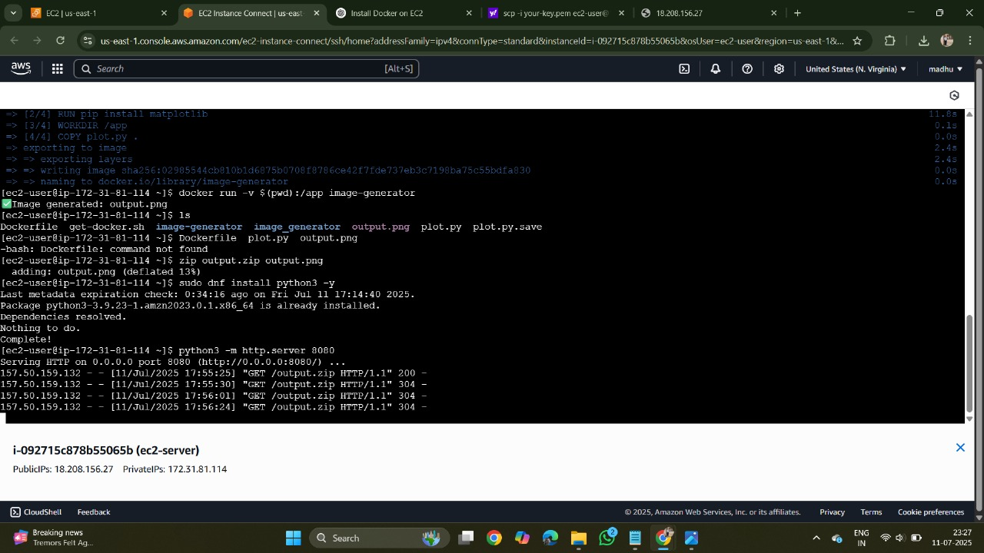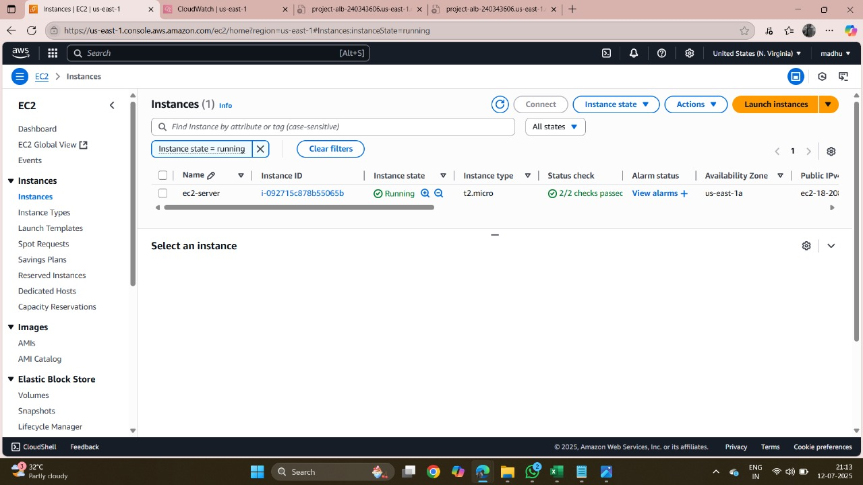 **PHOTOS & DRIVE LINK**

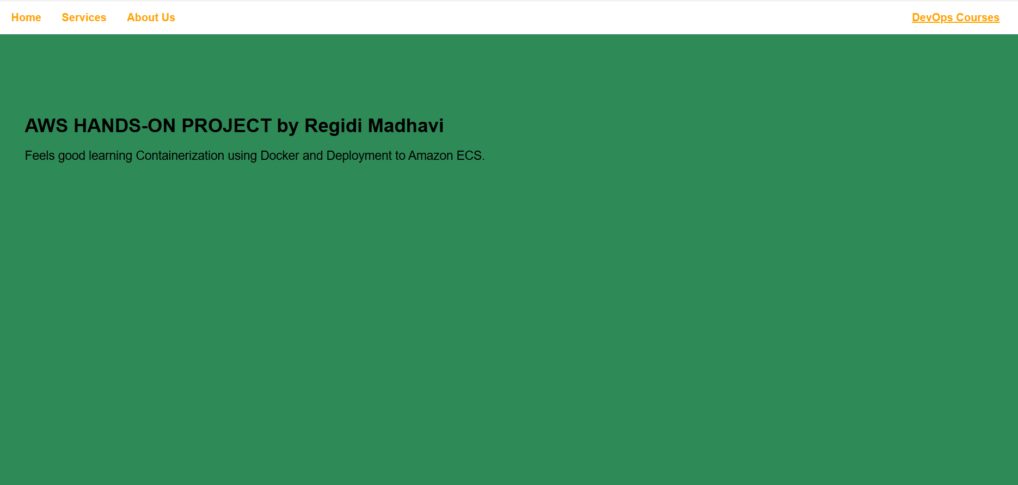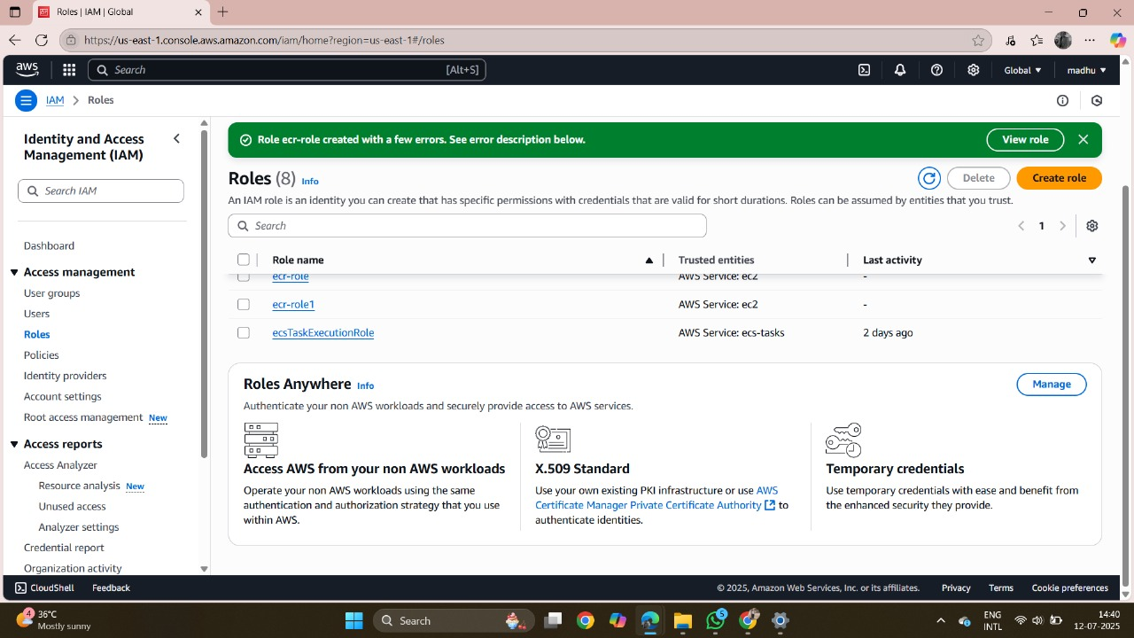

**Drive Link:**