FINSIGHT – LOAN & CREDIT RISK ANALYTICS
A PROJECT REPORT
Submitted in partial fulfillment of the requirements for the award of the degree of
BACHELOR OF TECHNOLOGY
in
DEPARTMENT OF COMPUTER SCIENCE AND ENGINEERING
By
University ID | Student Name
2420030699 | Hema
2420030321 | Madhu
2420030572 | Parnavi

Under the Esteemed Guidance of
Dr. Prathusha
Department of Computer Science and Engineering
KLH CSE, Bowrampet Campus
Academic Year: 2026–2027
Semester: Project Review – 1
K L (Deemed to be) University
Hyderabad, Telangana

DECLARATION
We hereby declare that the project report entitled “FinSight – Loan & Credit Risk Analytics” is a record of the project work carried out by Hema (2420030699), Madhu (2420030321) and Parnavi (2420030572), in partial fulfillment of the requirements for the award of the Bachelor of Technology degree in the Department of Computer Science and Engineering at K L (Deemed to be) University.
This report is based on the project documentation prepared by the team. Implementation details, experimental results or deployment evidence not available in the supplied material are identified as pending or proposed rather than represented as completed.
Hema – 2420030699
Madhu – 2420030321
Parnavi – 2420030572

CERTIFICATE
This is to certify that the project report entitled “FinSight – Loan & Credit Risk Analytics” is submitted by Hema (2420030699), Madhu (2420030321) and Parnavi (2420030572), in partial fulfillment of the requirements for the award of the degree of Bachelor of Technology in the Department of Computer Science and Engineering, K L (Deemed to be) University, during the academic year 2026–2027.
Signature of the Guide: ______________________________
Signature of the Course Coordinator: ______________________________
Signature of the HOD: ______________________________

ACKNOWLEDGEMENT
We express our sincere gratitude to our project guide, Dr. Prathusha, for her guidance and support throughout the planning and development of FinSight – Loan & Credit Risk Analytics.
We thank the Department of Computer Science and Engineering and K L (Deemed to be) University for providing the academic environment and resources required to undertake this project. We also acknowledge the support of our course coordinator, faculty members, classmates and families.
The project is a team effort by Hema, Madhu and Parnavi. We are grateful to everyone who contributed advice, feedback and encouragement.

ABSTRACT
FinSight is an end-to-end Loan and Credit Risk Analytics system designed to help financial institutions assess the creditworthiness of loan applicants and identify customers who may be at higher risk of default. The system is intended to process demographic, financial, employment, credit-history and loan-related data through a data analytics and machine-learning pipeline.
The proposed workflow collects, cleans, integrates and explores applicant data to identify patterns and relationships associated with loan outcomes. Relevant features are selected and transformed before training and comparing classification models, including Logistic Regression, Decision Tree and Random Forest. The selected model predicts whether an applicant belongs to a lower-risk or higher-risk category.
Model evaluation is planned using accuracy, precision, recall, F1-score, confusion matrix and ROC-AUC. An interactive dashboard is intended to present credit-risk indicators, applicant profiles, default trends, model performance and risk predictions. FinSight aims to support faster, data-driven lending decisions and improve credit-risk management.
Keywords: Credit risk, loan default, machine learning, classification, Logistic Regression, Decision Tree, Random Forest, risk analytics.

TABLE OF CONTENTS
Chapter | Title | Sections
 | Acknowledgement
 | Abstract
1 | Introduction | 1.1–1.6
2 | System Requirements | 2.1–2.3
3 | Technology Stack | 3.1–3.5
4 | System Architecture | 4.1–4.3
5 | Design | 5.1–5.3
6 | Implementation Methodology | 6.1–6.6
7 | Features | 7.1–7.5
8 | Testing and Evaluation | 8.1–8.4
9 | Deployment | 9.1–9.3
10 | Challenges and Limitations | 10.1–10.3
11 | Future Enhancements | 11.1–11.2
12 | Conclusion | 12.1–12.3
13 | References
14 | Appendices

CHAPTER 1 – INTRODUCTION

1.1 Background of the Project
A loan decision involves uncertainty because an applicant’s future repayment behaviour cannot be known with certainty at the time of application. Lenders therefore examine several indicators together rather than relying on one item of information. Income and employment can describe repayment capacity, while credit history can provide evidence of previous borrowing and repayment behaviour. Loan amount and other loan characteristics add context to the obligation being considered. FinSight brings these categories into one analytical workflow so that patterns can be examined systematically.
Financial institutions evaluate loan applicants using information such as income, employment, financial obligations, credit history and loan characteristics. As applicant datasets grow in size and complexity, manually reviewing every factor can become difficult and time-consuming. Credit-risk analytics applies statistical analysis and machine learning to identify patterns associated with repayment outcomes. FinSight proposes an integrated workflow that turns applicant data into risk categories and visual insights for lending support.

1.2 Problem Statement
The problem is not simply to label an application as safe or risky. A useful system must also prepare inconsistent raw records, examine the relationship between input attributes and historical outcomes, select informative features, compare different modelling approaches and communicate the prediction in a way that supports review. If the data is incomplete or the classes are imbalanced, a model may appear accurate while failing to identify many higher-risk cases. For this reason, FinSight includes data preparation and multiple evaluation measures as core parts of the proposed solution.
Financial institutions need to assess the creditworthiness of loan applicants before approving loans. Traditional assessment can become difficult when large amounts of demographic, financial, employment and credit-history data are involved. The key challenge is to identify applicants with higher default risk, analyze factors affecting loan outcomes, compare reliable classification models and present risk information in an understandable manner.

1.3 Scope of the Project
The scope covers the analytical path from applicant data to risk-oriented information. It includes data inspection, cleaning, integration, exploratory analysis, feature processing, supervised classification and model evaluation. It also includes the design of a dashboard that can bring applicant-level information and model-level performance together. The report does not assume a live connection to a bank, a production credit bureau, automated loan approval or a deployed service because those integrations are not confirmed in the supplied project material.
- Analyze demographic, financial, employment, credit-history and loan-related applicant information.
- Perform data cleaning, integration, exploratory data analysis and feature selection.
- Develop and compare Logistic Regression, Decision Tree and Random Forest classification models.
- Classify applicants into lower-risk and higher-risk categories.
- Evaluate models using multiple classification metrics.
- Present risk indicators, applicant profiles, default trends, model performance and predictions through an interactive dashboard.
The project is intended as analytical decision support. Model output does not replace a financial institution’s complete lending policy, human review or regulatory obligations.

1.4 Objectives
These objectives are connected in sequence. Data collection provides the information required for analysis; preprocessing improves its consistency; exploratory analysis helps reveal patterns; and feature selection prepares the input for model development. The three classifiers provide alternative ways to learn relationships in the data. Their comparison is intended to identify a model that performs suitably across more than one metric. Finally, dashboard visualizations are intended to make the results easier to inspect and explain.
- Collect and analyze applicant demographic, financial, employment, credit-history and loan data.
- Clean, integrate and preprocess the data for effective analysis.
- Perform exploratory data analysis to identify patterns affecting loan outcomes.
- Identify and select relevant features for credit-risk prediction.
- Develop Logistic Regression, Decision Tree and Random Forest classifiers.
- Compare models using accuracy, precision, recall, F1-score, confusion matrix and ROC-AUC.
- Predict lower-risk or higher-risk applicant categories.
- Develop an interactive dashboard for credit-risk indicators, applicant profiles, default trends and model performance.

1.5 Importance of the Application
Credit-risk analysis is important because lending decisions affect both the financial institution and the applicant. Inconsistent or incomplete assessment can increase the possibility of approving loans that are difficult to repay, or rejecting applicants who may be creditworthy. An analytical tool can support consistency by applying the same data preparation and prediction process to each record. It should be used as decision support, with human oversight and fairness checks, rather than as an unquestionable automatic decision-maker.
A structured analytics workflow can help lenders screen applications more consistently, understand patterns in historical loan data and prioritize cases for further review. Using several evaluation metrics is important because accuracy alone may hide poor detection of a smaller default-risk class.

1.6 Target Users / Audience
- Banks and other financial institutions
- Loan officers and credit analysts
- Risk-management teams
- Data analysts and decision-support teams

CHAPTER 2 – SYSTEM REQUIREMENTS

2.1 Hardware Requirements
For a small or medium-sized educational dataset, a conventional laptop or desktop is generally sufficient for notebook-based experimentation. More memory may be needed when the dataset contains many rows, high-cardinality fields or large intermediate objects. A dedicated GPU is not identified as a requirement because the proposed classifiers are conventional tabular machine-learning algorithms. Hardware capacity should be selected after confirming the actual dataset size and the environment in which the team will execute the notebooks.
The supplied project documentation does not specify exact hardware configurations. Development can be performed on a standard computer capable of running Python-based data analysis tools. Final processor, memory and storage requirements depend on dataset size and execution environment.
- Computer or laptop with a supported operating system
- Sufficient RAM to load and process the selected dataset
- Storage for datasets, notebooks, model files and outputs
- Internet connectivity when using cloud notebooks or downloading datasets

2.2 Software Requirements
A consistent Python environment is useful so that every team member can reproduce the same analysis. The notebook should record the package versions, dataset path, preprocessing sequence, random seed and model settings. Jupyter Notebook supports local execution, while Google Colab provides a browser-based notebook environment. The project should retain a clear folder structure for raw data, processed data, notebooks, model artifacts, visualizations and report material.
- Python programming environment
- Jupyter Notebook or Google Colab
- Git / GitHub for version control (recommended)
- A dashboard framework; the exact framework is not specified in the submitted documentation

2.3 Development Tools and Frameworks
The listed libraries serve different stages of the pipeline. Pandas supports structured data operations; NumPy provides numerical arrays and calculations; Matplotlib and Seaborn support charts for exploratory analysis; and Scikit-learn provides preprocessing utilities, classifiers and evaluation functions. Jupyter Notebook or Google Colab allows the team to document code, outputs and observations in one place. A dashboard framework is part of the project scope, but its final selection should be recorded only after it is actually implemented.
Tool / Library | Purpose in FinSight
Python | Primary programming language for data analysis and machine learning.
Pandas | Tabular data loading, cleaning, integration and manipulation.
NumPy | Numerical operations and array-based processing.
Matplotlib / Seaborn | Exploratory data analysis and visualizations.
Scikit-learn | Classification models, preprocessing utilities and evaluation metrics.
Jupyter Notebook / Google Colab | Interactive development and experimentation.
Dashboard framework | Present applicant risk indicators and model results; framework not identified in source.

CHAPTER 3 – TECHNOLOGY STACK

3.1 Programming Language
Python is suitable for this project because its data-science ecosystem supports the complete workflow without requiring separate languages for data preparation, model training and evaluation. Code can be organized into reusable functions for loading data, checking quality, preparing features, training models and calculating metrics. Keeping these steps separate makes the workflow easier to test, update and explain during project review.
Python is identified as the core language for the analytics and machine-learning workflow. It supports data manipulation, numerical computation, model training and evaluation through the listed libraries.

3.2 Data Processing Libraries
Pandas can be used to inspect the dataset shape, column names, data types, summary statistics and missing-value counts. It also supports filtering, grouping, joining and transforming tabular records. NumPy is useful for numerical operations and handling arrays passed between data-processing and machine-learning components. Together, these tools provide the foundation for preparing consistent model inputs.
Pandas and NumPy are planned for data preparation. Pandas supports tabular operations such as loading, filtering, cleaning and combining records. NumPy supports numerical calculations and array operations.

3.3 Visualization Libraries
Exploratory visualizations can reveal skewed distributions, unusual values, relationships between numerical variables and differences between applicant groups. Matplotlib provides control over chart layout and labelling, while Seaborn offers concise statistical visualizations. Visualizations should include titles, axis labels, legends and notes where necessary so that readers can interpret the finding without relying only on the code.
Matplotlib and Seaborn are identified for exploratory data analysis. They can visualize feature distributions, compare groups, inspect correlations and communicate patterns in applicant data.

3.4 Machine-Learning Framework
Scikit-learn supports the three classification approaches named in the project. Logistic Regression provides a linear classification baseline; Decision Tree learns a sequence of feature-based splits; and Random Forest combines predictions from multiple decision trees. Scikit-learn also provides utilities for splitting data, constructing preprocessing pipelines, calculating evaluation metrics and comparing model outputs.
Scikit-learn is identified for implementing Logistic Regression, Decision Tree and Random Forest classifiers, as well as preprocessing and evaluation workflows.

3.5 Development and Version Control
The notebooks should be saved with descriptive names and a clear execution order. A version-control repository can preserve code changes and help team members collaborate, while large or sensitive applicant datasets should not be committed to a public repository. The final report should record the actual repository location and environment versions if these are established by the team.
Jupyter Notebook and Google Colab are identified as development environments. GitHub is a suitable version-control platform; repository details were not included in the submitted documentation.
Layer | Technology / Selection | Role
Programming | Python | Data analysis and model workflow
Data handling | Pandas, NumPy | Cleaning and transformation
Visualization | Matplotlib, Seaborn | EDA and reporting
Machine learning | Scikit-learn | Classification and evaluation
Development | Jupyter Notebook / Google Colab | Interactive experimentation
Dashboard | Framework not specified | Display risk insights

CHAPTER 4 – SYSTEM ARCHITECTURE

4.1 High-Level Architecture
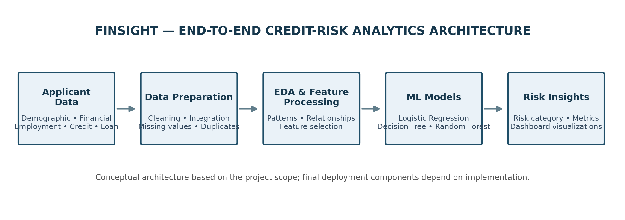
Figure 4.1: Conceptual end-to-end architecture of FinSight.
The architecture separates the project into understandable stages. Raw applicant records first enter the data-input stage. Data preparation then checks quality and creates a consistent representation. Exploratory analysis and feature processing help determine which information should be supplied to the classifiers. The machine-learning stage trains and compares the selected algorithms. The final stage presents predicted categories and evaluation information to users. This separation makes it easier to identify where an error occurs and to update one stage without redesigning the entire workflow.
FinSight is organized as a data-to-insight pipeline. Applicant information is collected as input, prepared for analysis, transformed into model-ready features and passed to classification algorithms. Predictions and evaluation outputs are then presented through a dashboard.
Stage 1 | Stage 2 | Stage 3 | Stage 4 | Stage 5
Applicant data  Demographic, financial, employment, credit and loan attributes | Data preparation  Cleaning, integration and EDA | Feature processing  Selection and transformation | Classification  Logistic Regression, Decision Tree, Random Forest | Outputs  Risk category, metrics and dashboard

4.2 Description of Each Layer
Each layer has a defined responsibility and passes its output to the next layer. Data input provides the records; preparation improves data quality; feature processing produces model-ready variables; the model layer generates predictions; and the presentation layer communicates results. In a complete implementation, the same preprocessing transformations used during training must also be applied to new applicant records to avoid inconsistent inputs.

4.2.1 Data Input Layer
This layer receives applicant-related information covering demographic, financial, employment, credit-history and loan characteristics. The exact dataset source, record count and column count are not stated in the project abstract.

4.2.2 Data Preparation and Analysis Layer
The input data is cleaned, integrated and explored. This stage examines data quality, feature distributions and relationships between applicant characteristics and loan outcomes.

4.2.3 Feature Processing Layer
Relevant features are selected and transformed before model training. Encoding, scaling or normalization may be applied where required by the data and chosen algorithm; exact preprocessing settings are not provided.

4.2.4 Machine-Learning Layer
Three classification techniques are included: Logistic Regression, Decision Tree and Random Forest. Their performance is compared to identify a suitable model for lower-risk and higher-risk classification.

4.2.5 Output and Dashboard Layer
The planned dashboard presents credit-risk indicators, applicant profiles, default trends, model performance and risk predictions. The specific dashboard framework and deployed interface are not identified.

4.3 Deployment Architecture
A notebook-based prototype and a hosted dashboard are different deployment stages. During development, the team can execute the analysis locally or in Google Colab. A dashboard deployment would additionally require a selected framework, dependency configuration, a defined method for loading the trained model and suitable access controls. Those details should be documented after the actual deployment route is chosen and tested.
Jupyter Notebook and Google Colab are identified as development environments. A production hosting platform, frontend/backend separation and CI/CD pipeline have not yet been specified.

CHAPTER 5 – DESIGN

5.1 Workflow Design
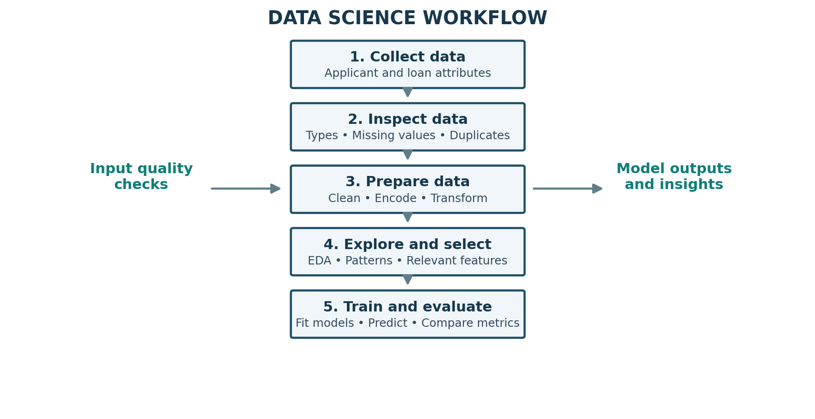
Figure 5.1: Proposed data preparation and model workflow.
The workflow should be executed in a repeatable order. First, the team defines the target variable and confirms what each class means. Next, the data is inspected and split into development and evaluation portions. Preprocessing operations are fitted using training data only where appropriate, then applied consistently to validation or test data. Models are trained on the prepared training set and evaluated on data not used to fit them. This separation helps reduce data leakage and gives a more realistic estimate of performance.
- Define the credit-risk prediction problem and target categories.
- Collect and inspect applicant data.
- Clean, integrate and explore the dataset.
- Select and transform relevant features.
- Train Logistic Regression, Decision Tree and Random Forest classifiers.
- Evaluate and compare the trained models.
- Present risk predictions and performance through a dashboard.

5.2 Input and Output Design
The input is a structured applicant record containing the available demographic, financial, employment, credit-history and loan-related fields. The target is the historical risk or loan-outcome label used during supervised training. The model output is a predicted category, and where supported, a probability or confidence score. The dashboard can summarize individual predictions alongside overall patterns and model evaluation. The exact field names and output format must match the dataset and implementation.
Category | Description
Input features | Demographic, financial, employment, credit-history and loan-related attributes.
Target variable | Applicant risk category: lower-risk or higher-risk.
Model outputs | Predicted risk category and model evaluation results.
Dashboard outputs | Risk indicators, applicant profiles, default trends, model performance and predictions.

5.3 Data Model / Dataset Schema
Before training, the team should create a data dictionary that records each field name, meaning, data type, permitted values, missing-value representation and whether it is available at the time a real lending decision is made. This is particularly important for avoiding target leakage: a field that becomes known only after repayment behaviour occurs must not be used as an input for predicting risk at application time. The available project materials describe feature groups but do not provide the actual column-level schema.
The source documentation describes categories of applicant information but does not provide a dataset file, field-level schema or entity-relationship diagram. The following is a conceptual grouping, not a verified database schema.
Conceptual feature group | Information described
Demographic | Applicant demographic attributes; exact fields not supplied.
Financial | Financial information; exact fields not supplied.
Employment | Employment-related information; exact fields not supplied.
Credit history | Credit-history information; exact fields not supplied.
Loan | Loan-related information; exact fields not supplied.
Target | Lower-risk / Higher-risk category.

CHAPTER 6 – IMPLEMENTATION METHODOLOGY

6.1 Data Collection and Integration
Data collection should preserve the original source and any applicable usage restrictions. When multiple files or tables are combined, the team should identify the join key and check whether the join creates duplicate applicant records or missing matches. A record count before and after integration is useful evidence that the process has not unintentionally removed or multiplied observations. The report should include the actual dataset source and version once confirmed.
The system uses applicant demographic, financial, employment, credit-history and loan-related data. The project abstract states that data is collected and integrated before analysis. Dataset source, licensing, record count and exact feature list are not present in the submitted files.

6.2 Data Preprocessing
Data preprocessing begins with a quality review. Missing values should be quantified by column and handled using a method appropriate to the field and model. Duplicate records should be investigated before removal, because repeated rows may represent either accidental duplication or valid repeated observations. Categorical fields may require encoding, while numerical fields may require scaling depending on the algorithm. Any fitted transformation should be learned from the training partition and then reused on the test partition.
Preprocessing prepares the dataset for analysis and model training. The planned workflow includes inspecting missing values, duplicates and outliers, then applying suitable cleaning and transformation steps. Exact handling methods and resulting data counts are not reported.

6.3 Exploratory Data Analysis and Feature Selection
EDA should be used to understand the distribution of applicant attributes and the balance of the target classes. Numerical summaries and visualizations can help identify skewness, extreme values and possible relationships with loan outcomes. Categorical summaries can show how outcome rates vary across groups. Feature selection should be justified by relevance, data availability and the risk of leakage, rather than by selecting variables solely because they correlate strongly with the target.
Exploratory data analysis identifies patterns and relationships between applicant characteristics and loan outcomes. Feature selection narrows input variables to those considered relevant for credit-risk prediction. Final selected feature names and feature count are not provided.

6.4 Model Building
The three selected algorithms provide complementary modelling approaches. Logistic Regression is a useful baseline and can offer relatively interpretable coefficient directions after suitable preprocessing. A Decision Tree represents decisions through hierarchical feature splits and can capture non-linear patterns, although a deep tree may overfit. Random Forest aggregates many trees and can improve stability, but its overall reasoning may be less straightforward to explain. A fair comparison requires the same train/test split and consistent preprocessing.
Algorithm | Purpose | Reason for inclusion
Logistic Regression | Classify applicants into risk categories. | Baseline classification approach.
Decision Tree | Classify using feature-based decision rules. | Tree-based model with inspectable decision paths.
Random Forest | Classify using an ensemble of decision trees. | Ensemble approach for model comparison.

The project documentation names these three models but does not report hyperparameter values, train/test split ratio, cross-validation strategy or class-balancing configuration.

6.5 Conceptual Model Workflow
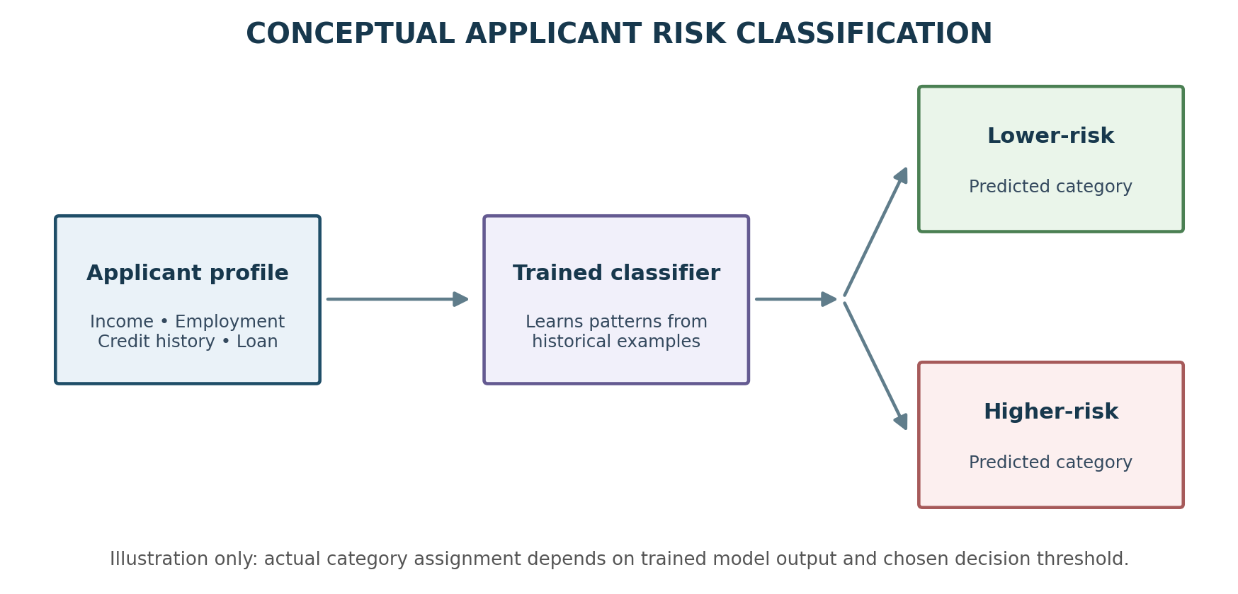
Figure 6.1: Conceptual applicant risk-classification flow (illustrative).
A complete experiment should record the target encoding, train/test split, random state, preprocessing steps, model hyperparameters and evaluation results. The code shown here is pseudocode to explain the intended sequence; it is not a claim that the supplied report contains a completed executable training script. In implementation, use a Scikit-learn Pipeline or equivalent structure so preprocessing and model fitting remain connected and reproducible.
X = applicant_features
y = risk_category # lower-risk / higher-risk
models = [LogisticRegression(),
DecisionTreeClassifier(),
RandomForestClassifier()]
for model in models:
model.fit(X_train, y_train)
predictions = model.predict(X_test)
evaluate(y_test, predictions)
# Compare accuracy, precision, recall,
# F1-score, confusion matrix and ROC-AUC

6.6 Dashboard Development
The dashboard is intended to turn analytical outputs into information that can be reviewed without reading notebook code. Useful views include an applicant summary, risk-category indicators, distributions or trends in historical outcomes, and a comparison of model metrics. Filters may allow users to inspect selected applicant groups. The dashboard should clearly distinguish historical observations from model predictions and should display a warning that a prediction is advisory rather than a guaranteed lending outcome.
The planned dashboard consolidates applicant profiles, credit-risk indicators, default trends, model performance and risk predictions. The exact framework, page layout, user roles and implementation status are not specified.

CHAPTER 7 – FEATURES

7.1 Applicant Data Analysis
Applicant data analysis establishes the profile of the dataset before any model is trained. It can summarize the number of records, available fields, data types, missing values and class distribution. Grouped summaries and charts can help the team understand whether applicant characteristics differ across historical outcome categories. The analysis should be descriptive and should avoid making causal claims from simple associations.
Processes demographic, financial, employment, credit-history and loan-related data to support risk analysis.

7.2 Data Preprocessing and Feature Selection
Preprocessing converts the raw dataset into a consistent form that algorithms can use. Feature selection focuses the model on relevant and available information. The team should document why a feature is included or excluded and verify that no variable contains information that would only be known after the loan outcome. These checks improve reproducibility and reduce the risk of misleading model performance.
Cleans and prepares data, explores patterns and selects relevant features for classification.

7.3 Comparative Risk Classification
Comparative classification allows the team to assess whether a simpler baseline or a more complex tree-based method is more suitable for the data. Each model should be trained using the same data partitions and evaluated with the same metrics. The best model should not be chosen using accuracy alone; the cost of missing a higher-risk applicant and the reliability of positive predictions should also be considered.
Uses Logistic Regression, Decision Tree and Random Forest to classify applicants into lower-risk and higher-risk categories.

7.4 Model Evaluation
Evaluation is central to determining whether a classifier is useful. Accuracy describes overall correctness, while precision and recall focus on the quality and completeness of identifying a selected class. F1-score combines precision and recall. A confusion matrix shows the types of errors, and ROC-AUC summarizes class separation across decision thresholds. The class considered positive must be stated clearly when reporting precision, recall and F1-score.
Compares classifiers using accuracy, precision, recall, F1-score, confusion matrix and ROC-AUC.

7.5 Interactive Risk Dashboard
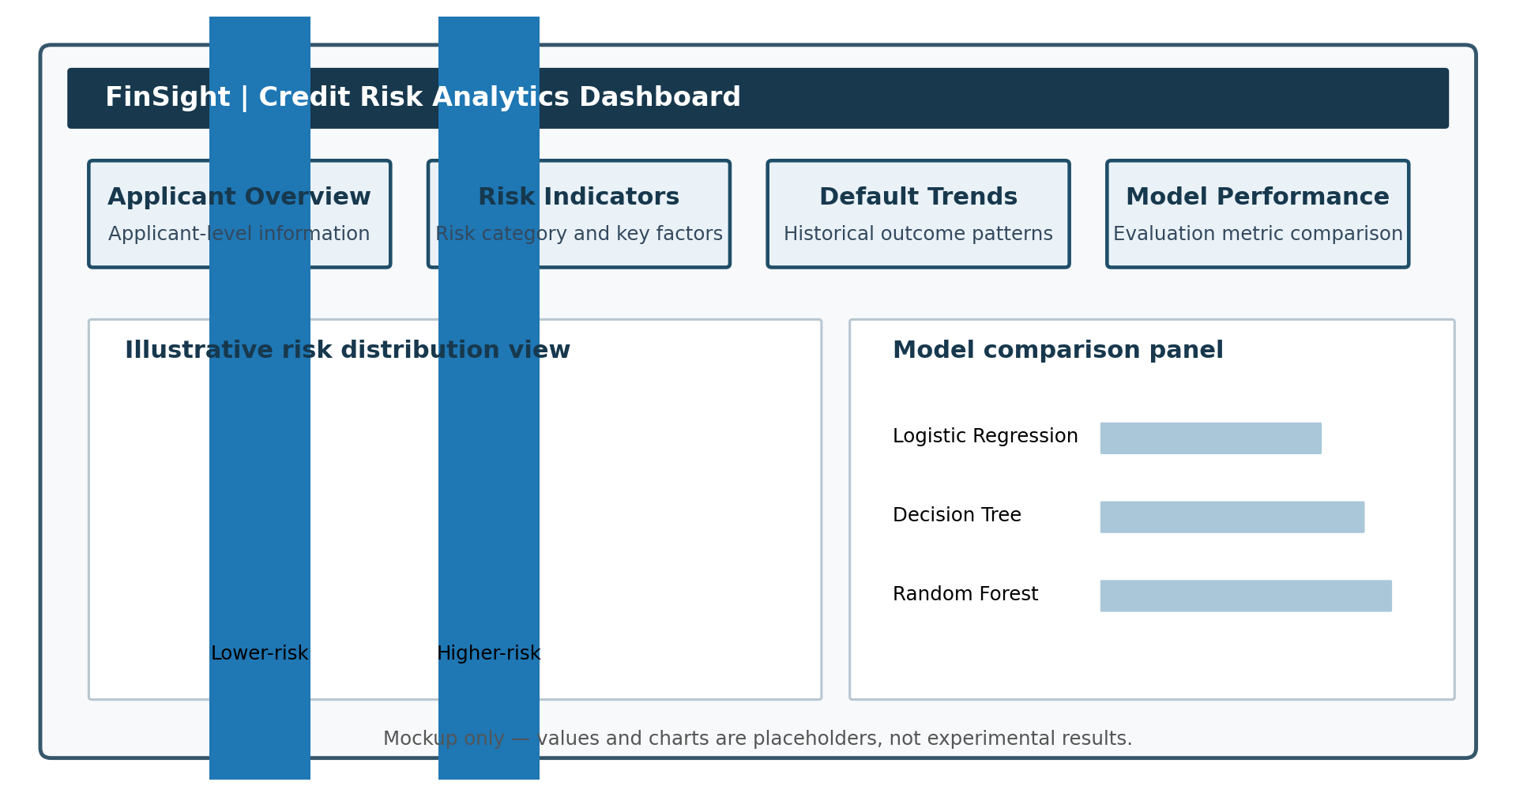
Figure 7.1: Dashboard wireframe mockup; chart values are illustrative placeholders.
The dashboard should use consistent labels and visual conventions throughout. It can provide an overview of the dataset, allow inspection of applicant profiles, show the distribution of predicted risk categories and compare model metrics. Where a prediction is displayed for an individual, the interface should identify the model used and communicate that the output is an estimate based on available data.
Planned dashboard view of risk indicators, applicant profiles, default trends, model performance and risk predictions.

CHAPTER 8 – TESTING AND EVALUATION

8.1 Testing Approach
Testing should cover data, model and presentation stages. Data checks verify expected columns, data types and missing-value handling. Pipeline checks verify that transformations run on unseen records without errors. Model checks verify that training and prediction return valid outputs. Metric checks can compare metric calculations against known small examples. Dashboard checks verify that displayed labels and values correspond to the underlying analysis outputs.
Testing should verify that applicant data can be processed, preprocessing produces model-ready features, classifiers generate risk predictions and evaluation metrics are calculated correctly. The supplied documentation lists evaluation measures but does not include executed test reports or results.

8.2 Model Evaluation Metrics
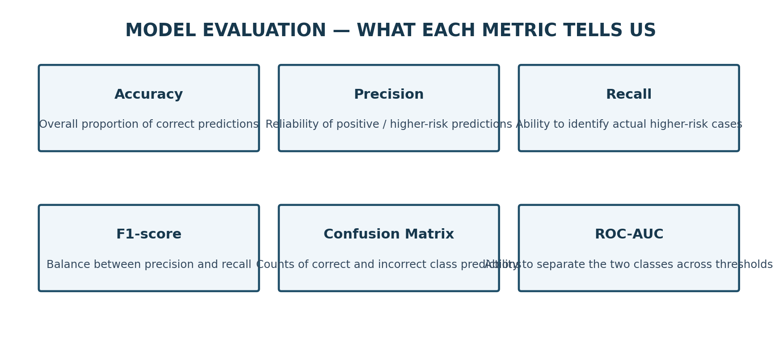
Figure 8.1: Purpose of the evaluation measures listed for FinSight.
No single metric captures every aspect of credit-risk performance. If higher-risk applicants are designated as the positive class, recall measures the proportion of actual higher-risk applicants identified, while precision measures the proportion of applicants predicted as higher-risk who truly belong to that class. A confusion matrix helps explain false negatives and false positives. ROC-AUC is threshold-independent, while the final operating threshold should be selected with the intended use and error costs in mind.
Metric | Purpose
Accuracy | Proportion of all predictions that are correct.
Precision | How many applicants predicted as a class actually belong to that class.
Recall | How many actual members of a class are correctly identified.
F1-score | Combines precision and recall into one measure.
Confusion Matrix | Shows correct and incorrect predictions for each class.
ROC-AUC | Measures how well the model distinguishes the two risk classes across thresholds.

8.3 Proposed Functional Test Cases
Each test case should be executed and recorded with its input, expected output, actual output, status and evidence. Screenshots or notebook output can be attached for successful tests, while failures should include the error and corrective action. The cases listed in this report are a test plan, not evidence of completed execution. The team should update the evidence column only after running the corresponding test.
Test ID | Test case | Expected outcome | Evidence available
TC-01 | Load applicant dataset | Dataset loads in analysis environment. | Execution result not supplied.
TC-02 | Run preprocessing | Cleaned / transformed features are produced. | Execution result not supplied.
TC-03 | Train each classifier | Three classifiers complete training. | Execution result not supplied.
TC-04 | Generate predictions | Applicants receive a lower-risk / higher-risk prediction. | Execution result not supplied.
TC-05 | Calculate metrics | Metrics generated for each model. | Numerical results not supplied.
TC-06 | Display dashboard | Dashboard shows planned risk information. | Screenshot not supplied.

8.4 Results Status
The project review material describes the models and metrics but does not provide verified numerical results. Therefore, no accuracy values, model ranking or performance chart is presented as an experimental finding. After execution, insert a table containing the measured metrics for each classifier, the confusion matrix, the selected positive class and the test-set size. Any illustrative dashboard or workflow figure in this report is labelled as a design illustration.
The project abstract specifies the evaluation metrics and candidate models, but the submitted documents do not contain numerical accuracy, precision, recall, F1-score or ROC-AUC values. No model is identified as the best-performing model. These results must be inserted after experiments are executed; no values have been invented in this report.

CHAPTER 9 – DEPLOYMENT

9.1 Development Environment
For reproducibility, record whether each experiment was executed locally or in Google Colab, the Python version, package versions and notebook filename. The dataset should be loaded from a stable path, and the notebook should execute from the first cell to the final evaluation cell without relying on undocumented manual steps.
Jupyter Notebook and Google Colab are identified as environments for developing and running the data-science workflow.

9.2 Environment Configuration
A requirements file or environment specification can be used to capture library versions. Random seeds should be set where supported so that data splits and model results can be reproduced. If the project uses cloud notebooks, access permissions and data privacy should be checked before uploading applicant information.
The project requires Python and the listed data-science libraries: Pandas, NumPy, Matplotlib, Seaborn and Scikit-learn. Exact package versions, environment files and installation commands are not specified.

9.3 Hosting and Deployment
Before public deployment, the team should verify that the dashboard does not expose personal or confidential applicant data. Model files and datasets should be stored securely, and the application should handle invalid inputs and missing fields gracefully. The final report should include the deployment platform, access method, version and a screenshot only after a working deployment has been completed.
The project abstract describes an interactive dashboard as part of the proposed system. However, the dashboard framework, hosting provider, public URL and deployment procedure have not been supplied. This section should be updated with actual deployment steps once hosting is completed.

CHAPTER 10 – CHALLENGES AND LIMITATIONS

10.1 Identified Challenges
The most important technical challenges include variation in data quality, missing or inconsistent values, class imbalance and the trade-off between predictive performance and interpretability. A model can also learn patterns that do not generalize to new applicants if the training data is unrepresentative. In a credit-related setting, fairness, privacy and explainability are important considerations because model outputs may affect access to financial services.
- Applicant datasets may contain different combinations of demographic and financial features.
- Credit-risk datasets may have imbalanced classes, particularly when default cases are fewer.
- Complex models can provide strong predictive performance but may be harder to interpret.
- No single classification algorithm is guaranteed to perform best on every dataset.
- Prediction outputs must be presented in a form that users can understand.

10.2 Approach to Address the Challenges
A disciplined workflow can reduce these risks. Data validation and preprocessing address quality issues; class-distribution analysis and class-sensitive metrics make imbalance visible; comparison of multiple algorithms reduces dependence on one modelling choice; and clear dashboard explanations help users understand outputs. Further fairness and privacy assessments should be conducted before any real-world use.
FinSight addresses these concerns through data cleaning and feature analysis, comparison of multiple classification algorithms, evaluation using several complementary metrics and a planned dashboard for communicating results.

10.3 Current Limitations
The present report is based on the supplied abstract and project-review presentation. The actual dataset, code, completed notebook outputs, model scores, dashboard screenshots and deployment URL were not included in those materials. Consequently, this document explains the planned system and its technical design but does not claim that every component has been implemented or validated.
- Dataset source, record count, feature count and quality statistics are not stated in the available documentation.
- Final preprocessing choices, feature list and model hyperparameters are not reported.
- Numerical model evaluation results and test evidence are not included.
- Dashboard framework, screenshots and deployment details are not specified.
- The supplied documentation does not include a field-level data schema or completed user interface.

CHAPTER 11 – FUTURE ENHANCEMENTS

11.1 Planned Enhancements
The next development stage should prioritize a reproducible end-to-end experiment: confirm the dataset and target definition, complete preprocessing, train all three models, calculate metrics and document the results. After this, the dashboard can be connected to the selected model and tested with representative inputs. Model explainability, fairness checks and monitoring can then be considered as extensions.
- Complete model training and tune hyperparameters using a documented validation strategy.
- Evaluate class-imbalance handling techniques where required by the dataset.
- Add feature-importance and model-explanation views to improve interpretability.
- Complete and deploy the interactive dashboard.
- Validate the workflow on larger and more diverse applicant datasets.

11.2 Possible Integrations and Optimizations
Further work may include a model explanation view that highlights influential input features, monitoring for changes in applicant data patterns and periodic evaluation on newly available outcomes. Secure access control, audit records and privacy-preserving data handling would be important if the system were integrated with institutional workflows. These enhancements require additional design, validation and approval before deployment.
Future versions may integrate secure data ingestion, role-based access, audit logging and monitoring, subject to institutional and regulatory requirements. Model monitoring can identify changes in data patterns and predictive performance over time. These are proposed extensions and are not claimed as implemented features.

CHAPTER 12 – CONCLUSION

12.1 Summary of the Project
FinSight brings together data preparation, exploratory analysis, feature selection, machine-learning classification, model evaluation and dashboard-oriented visualization. Its central idea is to provide a structured way to examine loan applicant information and identify patterns associated with lower or higher credit risk.
FinSight proposes an integrated loan and credit-risk analytics workflow that processes applicant information, performs data preparation and exploratory analysis, selects relevant features and compares three machine-learning classification techniques.

12.2 What the Project Aims to Achieve
The intended outcome is a decision-support system that helps analysts understand applicant profiles and compare risk predictions generated by different classifiers. A useful implementation should be transparent about the evidence behind its outputs, show the limitations of the model and keep human review in the decision process.
The system aims to classify applicants into lower-risk and higher-risk categories and communicate credit-risk indicators, applicant profiles, default trends, model performance and predictions through an interactive dashboard. Its intended contribution is to support faster and more informed lending decisions.

12.3 Skills and Concepts Applied
The project applies concepts from data science, supervised learning, classification, feature engineering, data visualization and model evaluation. It also requires practical skills in Python programming, notebook-based experimentation, data documentation, testing and communication of analytical results. Team collaboration and reproducibility are important parts of delivering a reliable project.
The project brings together data collection, data cleaning, exploratory data analysis, feature selection, classification, model evaluation and visualization. The selected technical stack includes Python, Pandas, NumPy, Matplotlib, Seaborn, Scikit-learn and Jupyter Notebook / Google Colab.
The submitted materials describe the proposed system and its objectives. Final implementation evidence, numerical evaluation results and deployment details should be added when available.

CHAPTER 13 – REFERENCES
- Kruppa et al. (2013). “Consumer Credit Risk: Individual Probability Estimates Using Machine Learning.” Full publication details were not included in the supplied project review.
- Brown and Mues (2012). “An Experimental Comparison of Classification Algorithms for Imbalanced Credit Scoring Data Sets.” Full publication details were not included in the supplied project review.
- “A Comparative Assessment of Credit Risk Model Based on Machine Learning” (2020). Author and publication details were not stated in the supplied project review.
- Project Abstract Submission: FinSight – Loan & Credit Risk Analytics, Department of CSE, Academic Year 2026–2027.
- Project Review-1: FinSight – Loan & Credit Risk Analytics, Data Science (24AD3107).
Note: Bibliographic details for the first three literature entries should be completed from the original papers before final submission.

CHAPTER 14 – APPENDICES

Appendix A – Project Team
University ID | Name | Guide
2420030699 | Hema | Dr. Prathusha
2420030321 | Madhu | Dr. Prathusha
2420030572 | Parnavi | Dr. Prathusha

Appendix B – Core Workflow Pseudocode
X = applicant_features
y = risk_category # lower-risk / higher-risk
models = [LogisticRegression(),
DecisionTreeClassifier(),
RandomForestClassifier()]
for model in models:
model.fit(X_train, y_train)
predictions = model.predict(X_test)
evaluate(y_test, predictions)
# Compare accuracy, precision, recall,
# F1-score, confusion matrix and ROC-AUC

Appendix C – Items to Attach Before Final Submission
- Dataset source citation and a sample of the dataset (head / info).
- Data-cleaning and exploratory-analysis screenshots or plots.
- Model training code, train/test split details and hyperparameter settings.
- Actual metric values and confusion matrices for all three classifiers.
- Dashboard screenshots and a working demo link, if available.
- Deployment steps, environment/package versions and repository link, if available.
- Complete bibliographic details for the literature survey.

