PocketSmart AI - AI Powered Budget Recommendation System
Done by:

Team Leader:
M.Madhu Sree
Reg.no. :25081371802112125

Team Members:
G.Gopika
Reg.no.:25081371802112113
R.Keerthika
Reg.no.:25081371802112124
S.Jeyasabariveni
Reg.no.:25081371802112117

ABSTRACT
- PocketSmart AI is an AI-powered budget recommendation system designed to help users make informed decisions while planning home interiors, events, and jewelry purchases. The system utilizes Google's Gemini AI model to analyze user preferences, budgets, and contextual information to generate personalized recommendations. By integrating multiple domains into a single platform, PocketSmart AI simplifies budgeting and planning activities. The application provides intelligent suggestions from popular platforms and helps users optimize their spending without compromising quality. The system is developed using FastAPI, HTML, CSS, JavaScript, SQLite, and Gemini AI technologies, ensuring scalability, responsiveness, and user-friendly interaction.

INTRODUCTION
- Budget planning is an important aspect of everyday decision-making. Individuals often struggle to find suitable products and services that match their budget and preferences. The availability of numerous online platforms further complicates the decision-making process.
- PocketSmart AI addresses this challenge by providing a unified AI-powered recommendation platform. The system allows users to plan home interiors, organize events, and select jewelry based on their budget and personal preferences. Using Gemini AI, the platform analyzes user inputs and generates meaningful recommendations that help users make smarter financial decisions.

PROBLEM STATEMENT
- Users frequently spend considerable time searching across multiple platforms to identify products and services that fit their budget requirements. Existing solutions often focus on a single category and lack personalization.
- The primary challenge is to develop an intelligent recommendation system capable of understanding user requirements and generating personalized suggestions across multiple domains while maintaining budget constraints.

OBJECTIVES
- To develop an AI-powered budget recommendation platform.
- To provide personalized recommendations for home interiors, party planning, and jewelry selection.
- To integrate AI-driven decision-making using Gemini AI.
- To simplify budget management through intelligent planning.
- To provide a responsive and user-friendly web application.
- To maintain recommendation accuracy while respecting budget limitations.

SYSTEM ARCHITECTURE
- PocketSmart AI follows a modular architecture consisting of the User Interface Layer, FastAPI Backend Layer, Database Layer, and AI Recommendation Layer.
- The user interacts with the web interface and provides budget details and preferences. The FastAPI backend processes the request and communicates with the Gemini AI engine. The AI engine analyzes the input and generates recommendations. User information and recommendation history are stored in the SQLite database. The generated recommendations are displayed through the frontend interface.

+-----------------------+
| USER |
+-----------------------+
|
v
+-----------------------+
| WEB INTERFACE |
| (HTML, CSS, JS, |
| Jinja2 Templates) |
+-----------------------+
|
v
+-----------------------+
| FASTAPI BACKEND |
| (main.py) |
+-----------------------+
| |
| |
v v
+-------------+ +------------------+
| AUTH & | | RECOMMENDATION |
| SESSION | | ENGINE |
| MANAGEMENT | | (Gemini AI) |
+-------------+ +------------------+
| |
| |
v v
+----------------+ +------------------+
| SQLite | | Product Sources |
| Database | | Amazon |
| pocketsmart.db | | Flipkart |
+----------------+ | IKEA |
| Swiggy |
| OYO |
+------------------+
|
v
+------------------+
| AI-Generated |
| Recommendations |
+------------------+
|
v
+------------------+
| User Dashboard |
| & History |
+------------------+

PROJECT STRUCTURE
- PocketSmart AI follows a modular project structure that improves maintainability, scalability, and code organization. The application is divided into multiple components, each responsible for a specific functionality. The backend is developed using FastAPI and handles user authentication, session management, recommendation generation, and database operations. HTML templates and static resources are used to build the user interface, while SQLite stores user information and recommendation history.
- The project contains configuration files for environment management, authentication modules for secure access, database modules for data storage, and planner modules that generate personalized recommendations. Templates are used for rendering web pages such as login, registration, dashboard, and recommendation pages. Static resources such as CSS and images are used to enhance the user interface and user experience.
- This modular architecture ensures that each component performs a dedicated task, making the system easier to develop, test, and maintain.
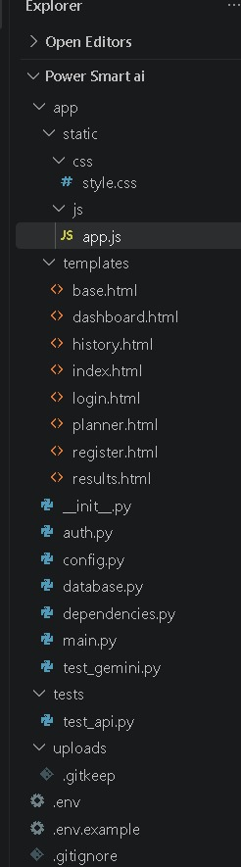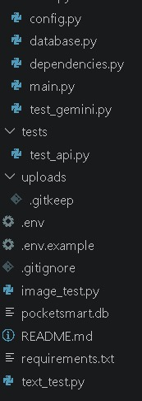
Figure 1: Project Folder Organization
- The project folder contains backend source files, configuration files, database resources, HTML templates, static assets, and supporting modules required for the implementation of PocketSmart AI. The organized structure improves code readability and simplifies future enhancements.
- You can place your folder screenshot directly below this paragraph and use the caption above. This is acceptable even if you don't have a formal project structure diagram.

TECHNOLOGIES USED

Technology | Purpose
Fast API | Backend Framework
Gemini AI | Recommendation Engine
SQLite | Database Management
HTML | User Interface Structure
CSS | Styling and Layout
JavaScript | Dynamic Functionality
Jinja2 | Templates Rendering
Python | Application Development

MODULE DESCRIPTION

User Authentication Module
- This module allows users to register, log in, and securely access the application. It manages user credentials and session handling.

Register Page
- The Register Page allows new users to create an account and gain access to the features provided by PocketSmart AI. Users are required to enter basic information such as their name, email address, and password. The system validates the entered information and securely stores the user details in the database. Upon successful registration, users can log in to the platform and access personalized budget planning and recommendation services.

Key Features:
- New user account creation
- Secure storage of user credentials
- Input validation and error handling
- Database integration for user management
- Access to personalized recommendations after registration

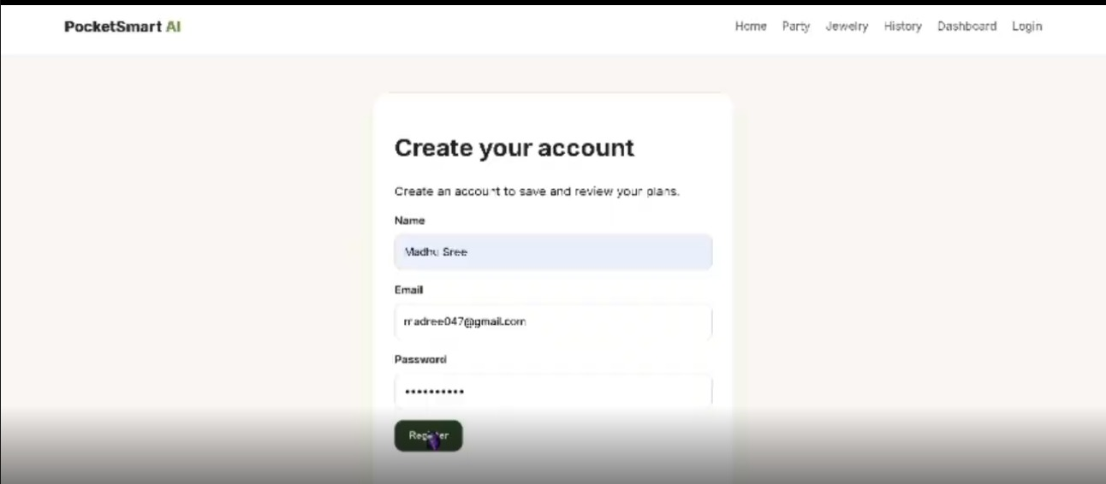
Figure 2: Register Page

User Dashboard Page
- The User Dashboard serves as the central workspace of PocketSmart AI after successful login. It provides users with quick access to all available planning modules, including Home Interior Planner, Party Planner, and Jewelry Planner. The dashboard displays user-specific information, recent activities, and recommendation history. It acts as a navigation hub that enables users to manage their planning tasks efficiently and access AI-generated recommendations in a structured manner.

Key Features:
- Personalized user interface
- Access to all planner modules
- Display of recent recommendations
- Navigation to recommendation history
- User session management and account access
- Improved user experience through centralized controls

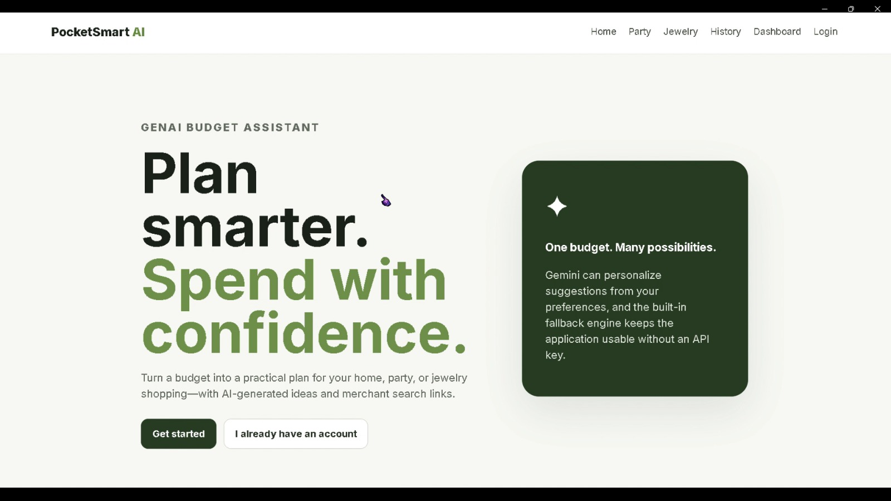
Figure 3: Dashboard Page

Home Interior Planner Module
- This module assists users in planning interior designs based on room type, budget, style, and required furniture items. Recommendations are generated within the specified budget.

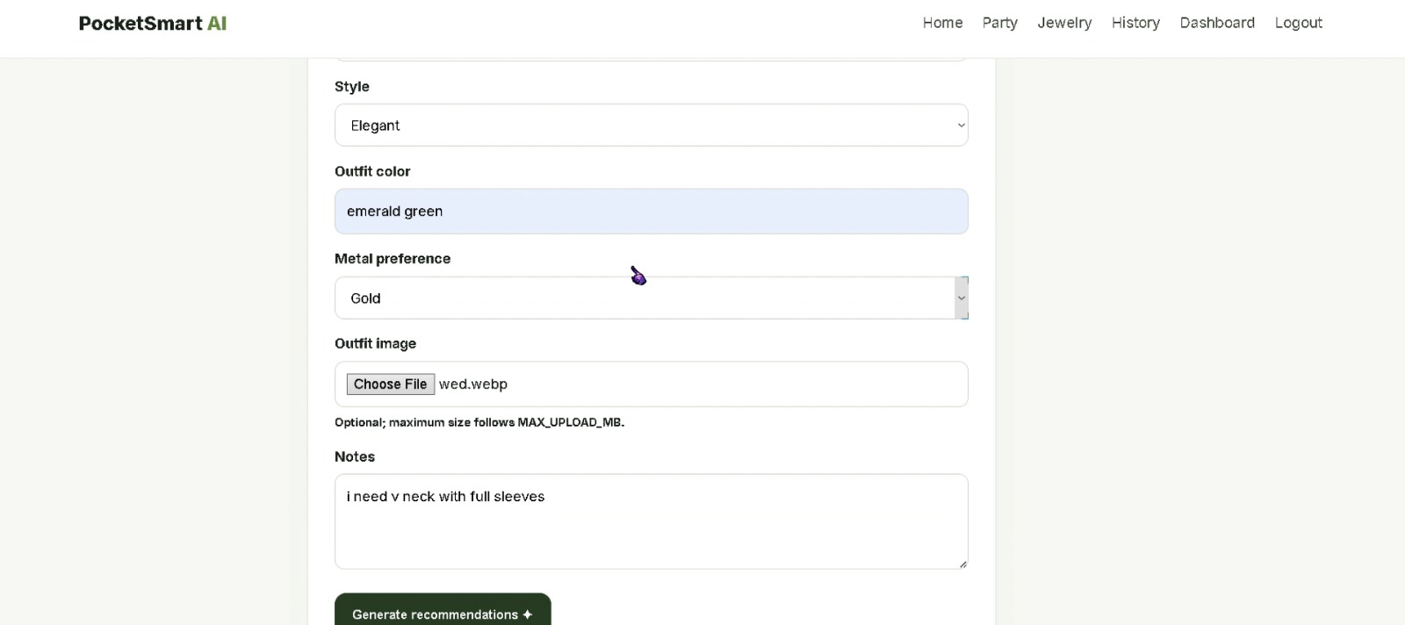
Figure 4: Home Planner

- The Home Interior Planner helps users design and furnish their living spaces while staying within a predefined budget. Users can specify room types, furniture requirements, and style preferences. Based on these inputs, PocketSmart AI generates suitable recommendations from multiple platforms, ensuring both affordability and quality.

Party Planner Module
- The Party Planner helps users organize events by considering factors such as budget, guest count, venue, and event type. The system generates suggestions for catering, decoration, and venue arrangements.

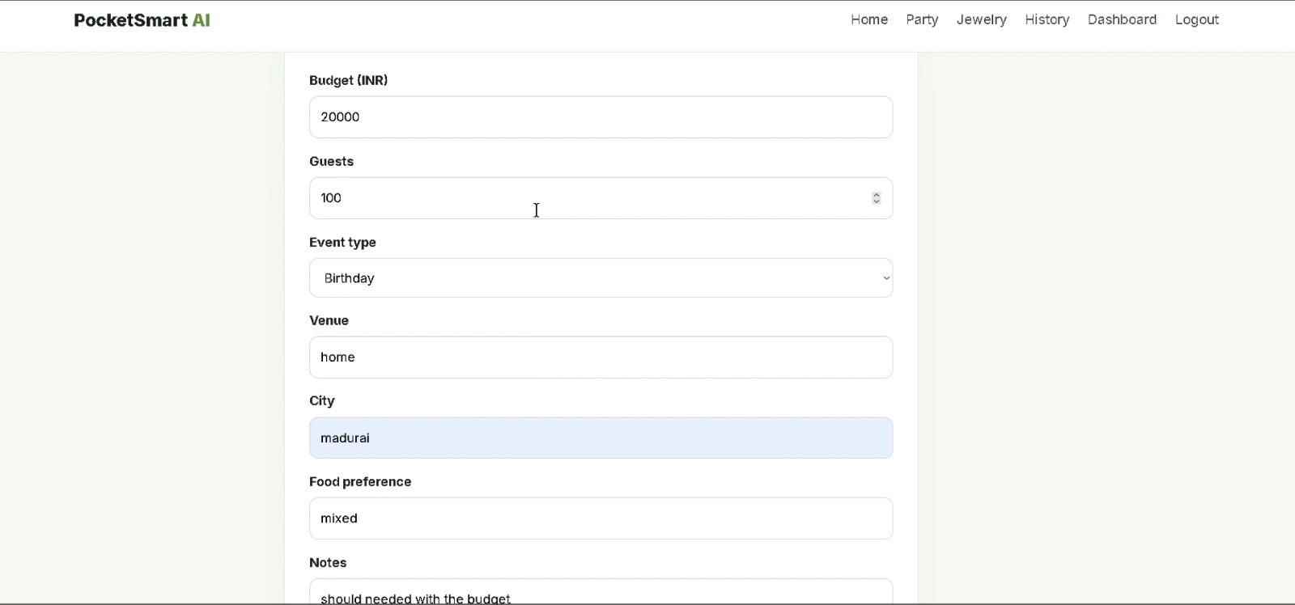
Figure 5: Party Planner

- The Party Planner assists users in organizing events by allocating budgets efficiently across food, decoration, venue, and entertainment. The AI analyzes user requirements and generates recommendations that match the event type and financial constraints.

Jewelry Planner Module
- The Jewelry Planner recommends jewelry items based on occasion, style preferences, budget, and optional outfit images. Gemini AI analyzes user inputs to provide personalized suggestions.

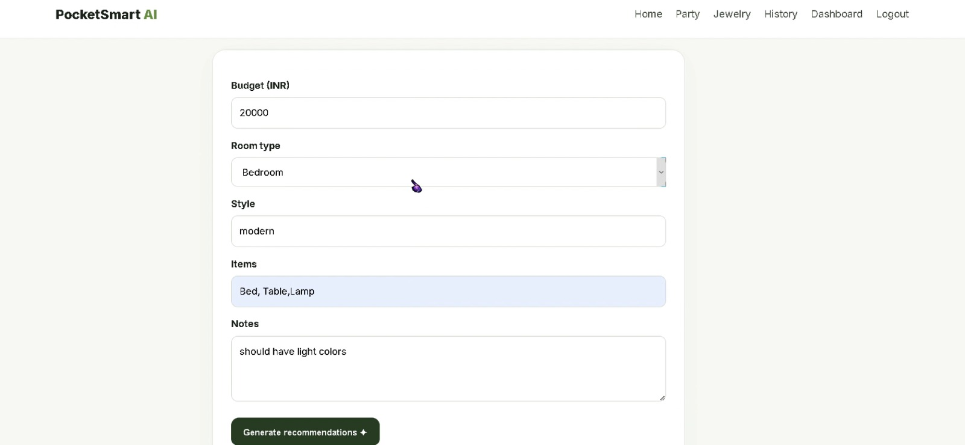
Figure 6: Jewelry Planner

- The Jewelry Planner provides personalized jewelry recommendations based on budget, occasion, and style preferences. Users can also upload outfit images to receive recommendations that complement their attire and enhance overall appearance.

Recommendation History Module
- This module stores and displays previous recommendation results, allowing users to revisit earlier plans and suggestions.

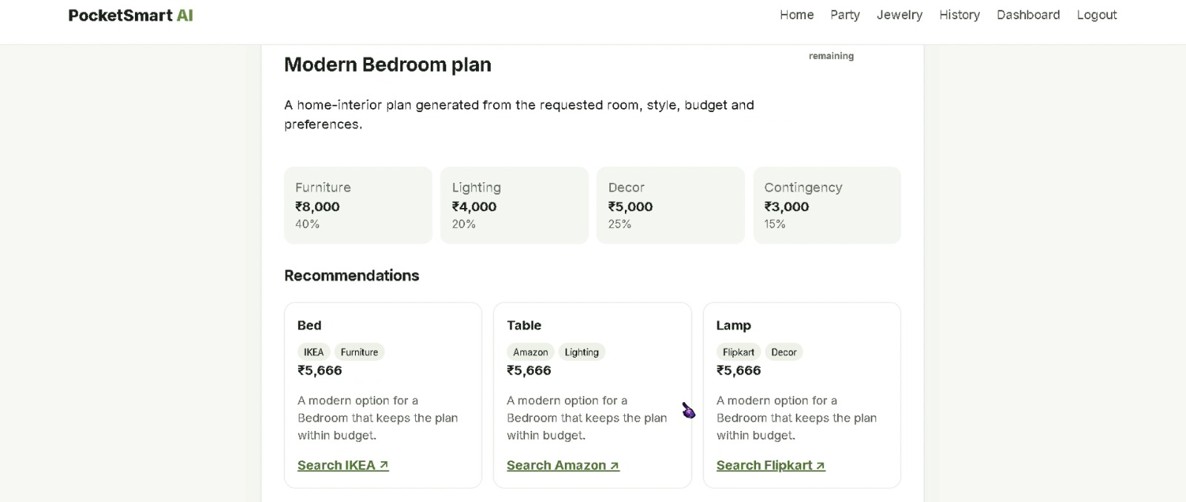
Figure 7: Modern Bedroom Recommendation

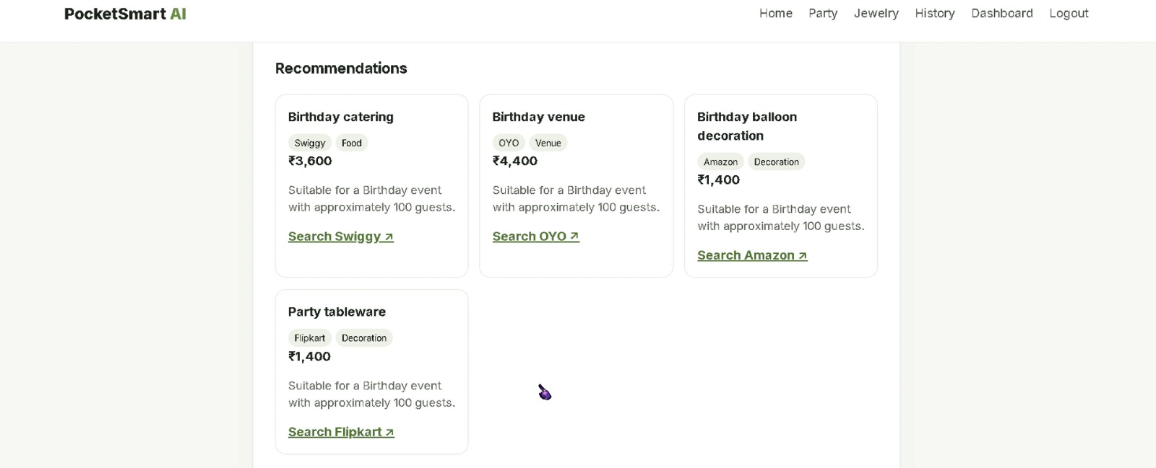
Figure 8: Birthday Party Recommendation

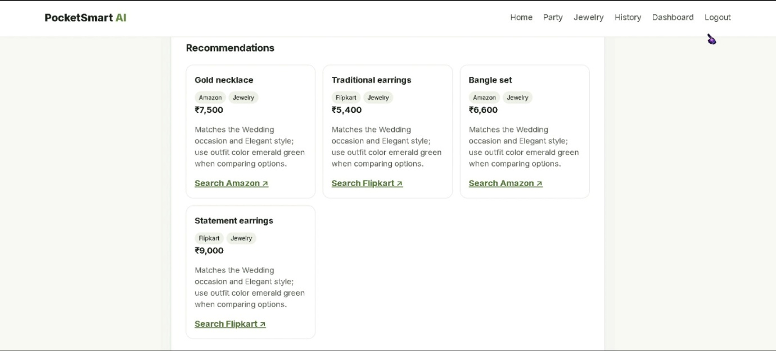
Figure 9: Elegant Jewelry Recommendation

IMPLEMENTATION
- The system is developed using FastAPI as the backend framework. HTML, CSS, and JavaScript are used for frontend development. Gemini AI processes user requirements and generates personalized recommendations.
- The backend handles routing, session management, authentication, recommendation generation, and database operations. SQLite stores user information and recommendation history.

TESTING
- Testing was conducted using various budget ranges and user preferences.

Home Planner Testing
- Different room types, budgets, and furniture requirements were tested to verify recommendation quality.

Party Planner Testing
- Various event types and guest counts were used to validate budget allocation and recommendation generation.

Jewelry Planner Testing
- Different occasions, styles, and outfit preferences were tested to ensure recommendation relevance.

RESULTS
- The application successfully generated personalized recommendations across all planning modules. The AI recommendation engine effectively interpreted user requirements and produced budget-friendly suggestions. User authentication, session management, and recommendation history features functioned as expected.

ADVANTAGES
- Intelligent budget planning
- Personalized recommendations
- User-friendly interface
- Multi-domain support
- Fast response generation
- Secure user authentication
- AI-assisted decision making

FUTURE ENHANCEMENTS
- Mobile application development.
- Real-time product API integration.
- Voice-based recommendation support.
- Advanced analytics dashboard.
- Additional planning categories.
- Improved personalization using user behavior analysis.

CONCLUSION
- PocketSmart AI successfully demonstrates the integration of Artificial Intelligence into budget planning and recommendation systems. By combining FastAPI, Gemini AI, and modern web technologies, the platform provides personalized recommendations for home interiors, party planning, and jewelry selection. The system improves decision-making, saves time, and helps users utilize their budgets efficiently. PocketSmart AI represents a practical application of AI-powered recommendation systems and can be further expanded with additional features and integrations in future versions.

