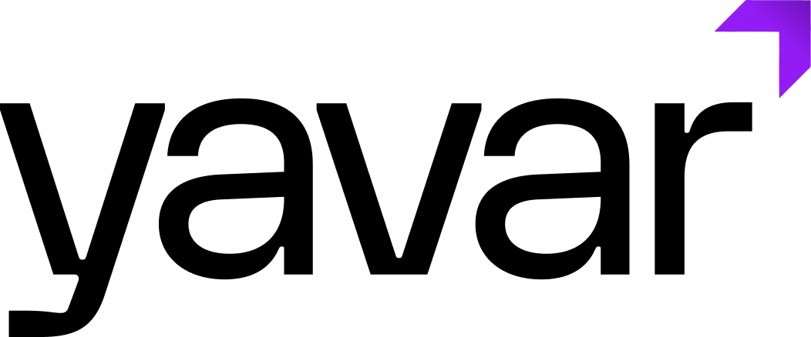

Job Title: Mobile Application Developer

Job Type: Full-Time
Location: Bangalore
Experience Level: 2-3 Years
Reports To: Engineering Lead

About Yavar

Yavar is a Enterprise Data and AI company that runs enterprise workflows at scale with its agentic platform. Yavar offers industry built autonomous agents that execute real work end-to-end governed by architecture. We sell work. We sell outcomes.

The Opportunity

Enterprise AI doesn't stay on a desktop — the agents we build need to show up wherever work happens, and increasingly that's on a phone in someone's hand. As a Mobile Application Developer at Yavar, you'll build the apps that put agentic AI directly into the hands of enterprise users, turning complex backend intelligence into fast, native, everyday experiences.

You'll work across our mobile stack — shipping features, fixing what's broken, and helping shape how we build for iOS and Android going forward.

What You'll Own

Development
- Build and maintain cross-platform mobile applications using Flutter
- Develop native features and components in Kotlin (Android) and Swift (iOS) where needed
- Translate designs and product requirements into performant, polished mobile experiences
- Write clean, tested, maintainable code and participate in code reviews
Quality & Performance
- Debug and resolve issues across platforms, devices, and OS versions
- Optimize app performance, responsiveness, and battery/resource usage
- Ensure smooth integration with backend APIs and enterprise systems
Collaboration
- Work closely with product, design, and backend engineering to ship features end-to-end
- Participate in sprint planning, estimation, and technical discussions
- Contribute to evolving our mobile architecture and best practices

What You Bring

Experience
- 2-3 years of experience building and shipping mobile applications
- Prior experience at a product company (not services/outsourcing) is required
- Experience with Flutter for cross-platform development
- Working knowledge of Kotlin for Android and/or Swift for iOS
Skills
- Solid understanding of mobile app architecture, state management, and lifecycle
- Familiarity with REST APIs, third-party SDKs, and mobile CI/CD pipelines
- Experience publishing apps to the Play Store and/or App Store
- Good grasp of mobile UI/UX principles and platform design guidelines
- Comfortable working with Git and modern development workflows
Mindset
- Product-minded — you care about the end-user experience, not just the code
- Curious and quick to pick up new tools, including AI-assisted development workflows
- Comfortable owning features end-to-end in a fast-paced environment
- Collaborative, detail-oriented, and quality-driven

Why Join Yavar?

- Build AI that people carry in their pocket — ship the mobile face of enterprise agentic AI
- Work across the full stack — Flutter, Kotlin, and Swift, not just one narrow lane
- Join at a high-growth moment — shape mobile architecture and practices as we scale
- Grow fast — a clear path into senior mobile engineering as the team expands

