SECURE FILE SHARING SYSTEM WITH
ENCRYPTION USING JAVA
A. Safrin Banu (24UAD069), R. Madhumitha (24UAD101)
Department of Artificial Intelligence and Data Science
Kamaraj College of Engineering and Technology, Virudhunagar

1. Introduction
Secure File Sharing System with Encryption using Java is a network-based cybersecurity project developed to protect the confidentiality of files while they are transferred between two computers. The application consists of two Java Swing GUI programs, a Sender and a Receiver, which communicate over a TCP socket connection.
At the sender side, the user selects a file and enters a 16-character secret key. The file is read as bytes and encrypted with the AES algorithm from the Java Cryptography Extension (javax.crypto) before it leaves the sender. Only the encrypted bytes are sent through the network, so the original content is never exposed during transmission.
At the receiver side, the user starts a server on a chosen port and enters the decryption key. The encrypted data is received, stored as received_file.enc and then decrypted with the same key to recover the original file, which is saved as received_file.txt. If the key is wrong, decryption fails and an error message is shown. The project demonstrates important concepts of network security such as symmetric-key encryption, confidentiality, socket programming and secure data transfer.

2. Objectives
The main objectives of the project are:
- To develop a simple Java-based file-sharing system that protects files during network transmission.
- To encrypt the selected file with the AES algorithm using a 16-character key before sending.
- To transfer the encrypted file from sender to receiver using TCP socket communication.
- To decrypt the received file with the correct key and recover the original file.
- To provide an easy-to-use Java Swing GUI for file selection, key entry, sending and receiving.
- To show that only a receiver holding the correct key can access the original file.

3. Proposed System
The proposed system is made up of two Java programs, SenderGUI and ReceiverGUI. It uses only built-in Java packages (javax.swing, java.awt, java.io, java.net and javax.crypto), so no external library is required.
In SenderGUI, the user browses for a file with JFileChooser and types a 16-character key in a password field. On clicking ENCRYPT & SEND, the file is read into a byte array and encrypted with Cipher in AES mode using a SecretKeySpec built from the key. A Socket then connects to the receiver on port 5000 and the encrypted bytes are written to the output stream.
In ReceiverGUI, the user enters the port number (default 5000) and the decryption key and clicks START RECEIVER. A ServerSocket waits for the sender in a background thread, so the GUI stays responsive. The incoming bytes are read in 4096-byte blocks, saved as received_file.enc, decrypted with the same AES key and saved as received_file.txt. Status messages and pop-up dialogs keep the user informed at each step.
Key Parameters
Parameter | Value
Language / Interface | Java / Swing GUI (SenderGUI and ReceiverGUI)
Encryption algorithm | AES (symmetric key) using javax.crypto.Cipher
Key length | 16 characters (16 bytes = 128 bits), validated before use
Network protocol | TCP socket communication (Socket and ServerSocket)
Default port | 5000 (editable at the receiver)
Receiver address used by sender | localhost (same machine)
Receive buffer size | 4096 bytes
Output files at receiver | received_file.enc (encrypted), received_file.txt (decrypted)
Key entry | JPasswordField, so the key is masked on screen

4. System Workflow
The workflow below shows the sender-side steps (file selection, key input, encryption), the TCP network transfer, and the receiver-side steps (file reception, key input, decryption and output generation).
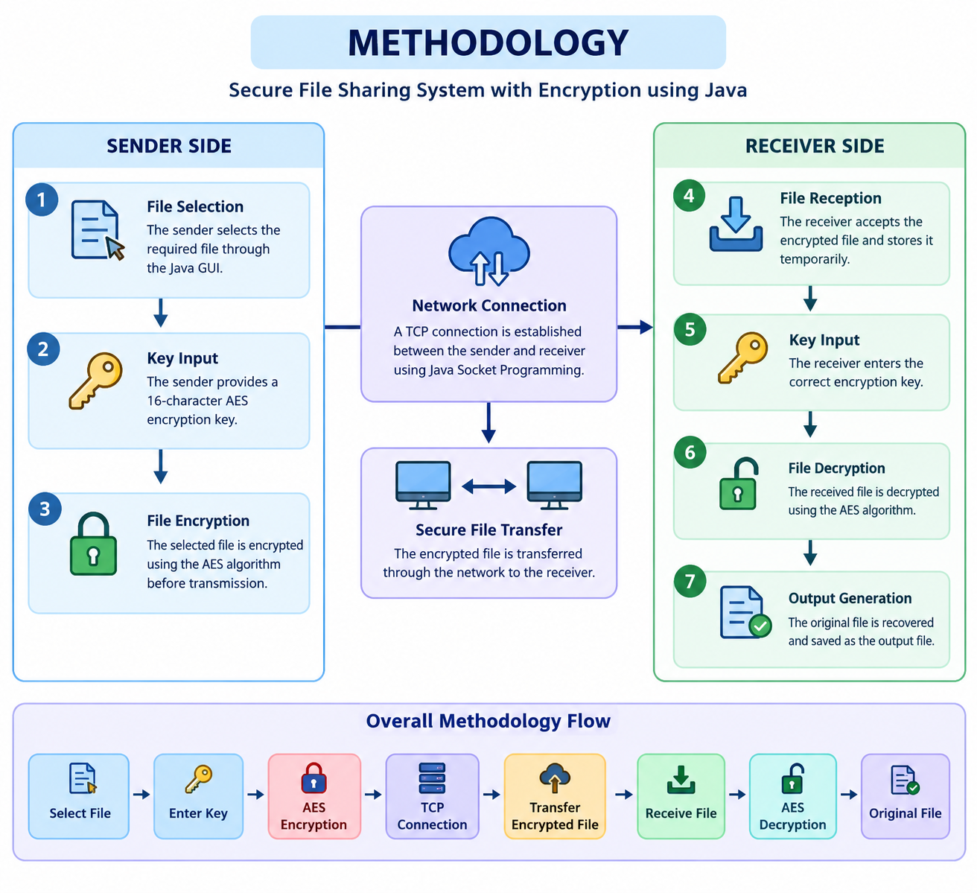
System workflow
Flow: Select File → Enter Key → AES Encryption → TCP Connection → Transfer Encrypted File → Receive File → AES Decryption → Original File.

5. Implementation and Modules
Module | Description
File Selection Module | Uses JFileChooser through the Browse button to select the file and shows its full path in the text field.
Key Validation Module | Reads the key from a JPasswordField and checks that it has exactly 16 characters before encryption (sender) or decryption (receiver). A port-number check is also done at the receiver.
Encryption Module | Reads the file into a byte array and encrypts it with Cipher (AES, ENCRYPT_MODE) using a SecretKeySpec created from the key.
Network Transfer Module | The sender opens a Socket to the receiver on port 5000 and writes the encrypted bytes. The receiver listens with a ServerSocket and reads the data in 4096-byte blocks.
Decryption Module | Saves the received data as received_file.enc, then decrypts it with Cipher (AES, DECRYPT_MODE) using the same key and writes the result to received_file.txt.
GUI and Status Module | Swing windows with labels, text fields, buttons, a status label and JOptionPane dialogs. The receiver runs in a separate Thread so the window does not freeze while waiting.

6. System Requirements
Hardware requirements
- Computer or laptop with a minimum of 4 GB RAM
- Keyboard and mouse
- Network connection (or the same machine using localhost)
Software requirements
- Windows or Linux operating system
- Java Development Kit (JDK) with Swing, java.net and javax.crypto packages
- Visual Studio Code (editor) and Command Prompt (cmd) to compile and run
Functional requirements
- Select and send a file.
- Encrypt the file before sending.
- Receive the encrypted file.
- Decrypt the file using the correct key.
- Generate the original file as output.
How to run
- Compile both programs: javac SenderGUI.java and javac ReceiverGUI.java
- Start the receiver first: java ReceiverGUI, enter the port and the 16-character key, then click START RECEIVER.
- Start the sender: java SenderGUI, browse for a file, enter the same 16-character key and click ENCRYPT & SEND.

7. Source Code
7.1 Sender Program (SenderGUI.java)
This program provides the sender window, validates the file and the 16-character key, encrypts the file with AES and sends the encrypted bytes to the receiver through a TCP socket.
import javax.swing.*;
import java.awt.*;
import java.io.*;
import java.net.*;
import javax.crypto.Cipher;
import javax.crypto.spec.SecretKeySpec;
public class SenderGUI extends JFrame {
private JTextField fileField;
private JPasswordField keyField;
private JLabel statusLabel;
public SenderGUI() {
setTitle("Secure File Sender");
setSize(500, 350);
setDefaultCloseOperation(JFrame.EXIT_ON_CLOSE);
setLocationRelativeTo(null);
// Main panel
JPanel panel = new JPanel();
panel.setLayout(null);
JLabel title = new JLabel("SECURE FILE SENDER");
title.setFont(new Font("Arial", Font.BOLD, 22));
title.setBounds(130, 25, 300, 30);
panel.add(title);
// File label
JLabel fileLabel = new JLabel("Select File:");
fileLabel.setBounds(40, 90, 100, 25);
panel.add(fileLabel);
fileField = new JTextField();
fileField.setBounds(130, 90, 230, 25);
panel.add(fileField);
JButton browseButton = new JButton("Browse");
browseButton.setBounds(370, 90, 90, 25);
panel.add(browseButton);
// Key label
JLabel keyLabel = new JLabel("Encryption Key:");
keyLabel.setBounds(40, 140, 100, 25);
panel.add(keyLabel);
keyField = new JPasswordField();
keyField.setBounds(150, 140, 210, 25);
panel.add(keyField);
// Send button
JButton sendButton = new JButton("ENCRYPT & SEND");
sendButton.setBounds(150, 190, 200, 40);
panel.add(sendButton);
// Status
statusLabel = new JLabel("Status: Waiting...");
statusLabel.setBounds(40, 255, 400, 30);
panel.add(statusLabel);
// Browse action
browseButton.addActionListener(e -> {
JFileChooser chooser = new JFileChooser();
int result = chooser.showOpenDialog(this);
if (result == JFileChooser.APPROVE_OPTION) {
fileField.setText(
chooser.getSelectedFile().getAbsolutePath()
);
}
});
// Send action
sendButton.addActionListener(e -> sendFile());
add(panel);
setVisible(true);
}
private void sendFile() {
String filePath = fileField.getText();
String key = new String(keyField.getPassword());
if (filePath.isEmpty()) {
JOptionPane.showMessageDialog(
this,
"Please select a file!"
);
return;
}
if (key.length() != 16) {
JOptionPane.showMessageDialog(
this,
"Key must contain exactly 16 characters!"
);
return;
}
try {
statusLabel.setText("Status: Encrypting...");
File file = new File(filePath);
FileInputStream input =
new FileInputStream(file);
byte[] fileData = input.readAllBytes();
input.close();
// AES encryption
SecretKeySpec secretKey =
new SecretKeySpec(
key.getBytes(),
"AES"
);
Cipher cipher =
Cipher.getInstance("AES");
cipher.init(
Cipher.ENCRYPT_MODE,
secretKey
);
byte[] encryptedData =
cipher.doFinal(fileData);
// Connect to receiver
statusLabel.setText("Status: Connecting...");
Socket socket =
new Socket("localhost", 5000);
OutputStream output =
socket.getOutputStream();
output.write(encryptedData);
output.flush();
output.close();
socket.close();
statusLabel.setText(
"Status: File sent successfully!"
);
JOptionPane.showMessageDialog(
this,
"File encrypted and sent successfully!"
);
} catch (Exception ex) {
statusLabel.setText(
"Status: Error!"
);
JOptionPane.showMessageDialog(
this,
"Error: " + ex.getMessage()
);
}
}
public static void main(String[] args) {
new SenderGUI();
}
}

7.2 Receiver Program (ReceiverGUI.java)

This program provides the receiver window, listens on the chosen port, receives the encrypted bytes, saves them as received_file.enc, decrypts them with AES and saves the original data as received_file.txt.
import javax.swing.*;
import java.awt.*;
import java.io.*;
import java.net.*;
import javax.crypto.Cipher;
import javax.crypto.spec.SecretKeySpec;
public class ReceiverGUI extends JFrame {
private JTextField portField;
private JPasswordField keyField;
private JLabel statusLabel;
public ReceiverGUI() {
setTitle("Secure File Receiver");
setSize(500, 350);
setDefaultCloseOperation(JFrame.EXIT_ON_CLOSE);
setLocationRelativeTo(null);
JPanel panel = new JPanel();
panel.setLayout(null);
JLabel title = new JLabel("SECURE FILE RECEIVER");
title.setFont(new Font("Arial", Font.BOLD, 22));
title.setBounds(120, 25, 300, 30);
panel.add(title);
JLabel portLabel = new JLabel("Port:");
portLabel.setBounds(70, 90, 100, 25);
panel.add(portLabel);
portField = new JTextField("5000");
portField.setBounds(150, 90, 220, 25);
panel.add(portField);
JLabel keyLabel = new JLabel("Decryption Key:");
keyLabel.setBounds(50, 135, 100, 25);
panel.add(keyLabel);
keyField = new JPasswordField();
keyField.setBounds(150, 135, 220, 25);
panel.add(keyField);
JButton startButton = new JButton("START RECEIVER");
startButton.setBounds(150, 185, 200, 40);
panel.add(startButton);
statusLabel = new JLabel("Status: Ready");
statusLabel.setBounds(50, 250, 400, 30);
panel.add(statusLabel);
startButton.addActionListener(e -> startReceiver());
add(panel);
setVisible(true);
}
private void startReceiver() {
String key = new String(keyField.getPassword());
if (key.length() != 16) {
JOptionPane.showMessageDialog(
this,
"Key must contain exactly 16 characters!"
);
return;
}
int port;
try {
port = Integer.parseInt(portField.getText());
} catch (NumberFormatException e) {
JOptionPane.showMessageDialog(
this,
"Enter a valid port number!"
);
return;
}
final int finalPort = port;
final String finalKey = key;
statusLabel.setText("Status: Waiting for sender...");
// Run receiver in background
new Thread(() -> {
try {
ServerSocket serverSocket =
new ServerSocket(finalPort);
Socket socket = serverSocket.accept();
statusLabel.setText("Status: Receiving file...");
InputStream inputStream =
socket.getInputStream();
ByteArrayOutputStream buffer =
new ByteArrayOutputStream();
byte[] data = new byte[4096];
int bytesRead;
while ((bytesRead = inputStream.read(data)) != -1) {
buffer.write(data, 0, bytesRead);
}
byte[] encryptedData =
buffer.toByteArray();
// Save encrypted file
FileOutputStream encryptedOutput =
new FileOutputStream("received_file.enc");
encryptedOutput.write(encryptedData);
encryptedOutput.close();
// AES Decryption
SecretKeySpec secretKey =
new SecretKeySpec(
finalKey.getBytes(),
"AES"
);
Cipher cipher =
Cipher.getInstance("AES");
cipher.init(
Cipher.DECRYPT_MODE,
secretKey
);
byte[] decryptedData =
cipher.doFinal(encryptedData);
// Save original file
FileOutputStream decryptedOutput =
new FileOutputStream(
"received_file.txt"
);
decryptedOutput.write(decryptedData);
decryptedOutput.close();
inputStream.close();
socket.close();
serverSocket.close();
statusLabel.setText(
"Status: File received & decrypted!"
);
JOptionPane.showMessageDialog(
this,
"File received successfully!\n\n" +
"Saved as: received_file.txt"
);
} catch (Exception ex) {
statusLabel.setText(
"Status: Error!"
);
JOptionPane.showMessageDialog(
this,
"Error: " + ex.getMessage()
);
}
}).start();
}
public static void main(String[] args) {
new ReceiverGUI();
}
}

8. Output Screenshots
Compiling and running the programs
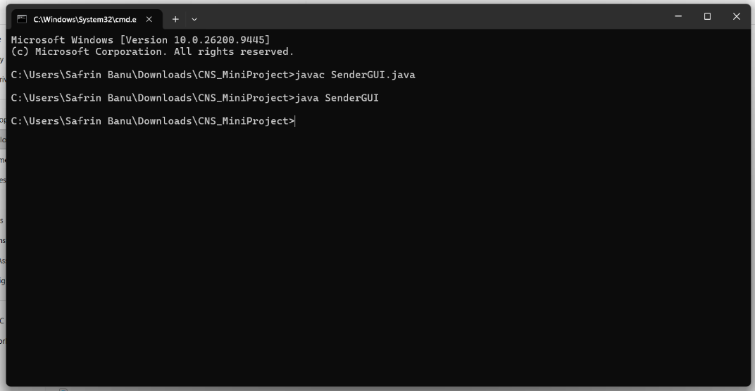
Compiling and running SenderGUI
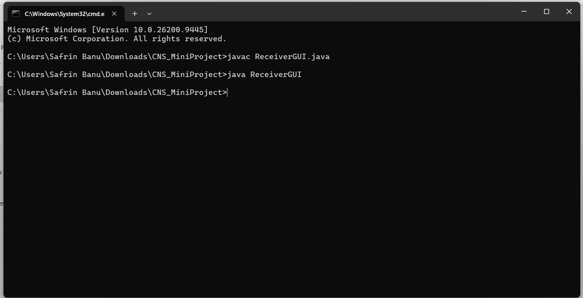
Compiling and running ReceiverGUI
Application windows
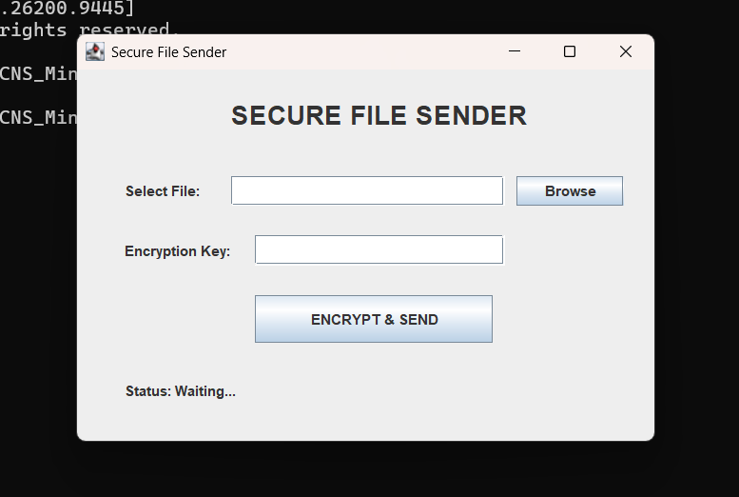
Sender window (initial state)
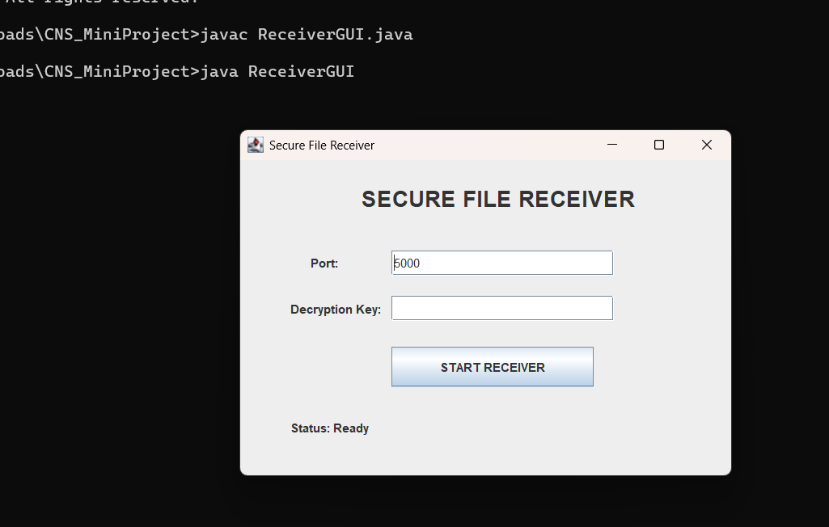
Receiver window (initial state)
Entering the file and key
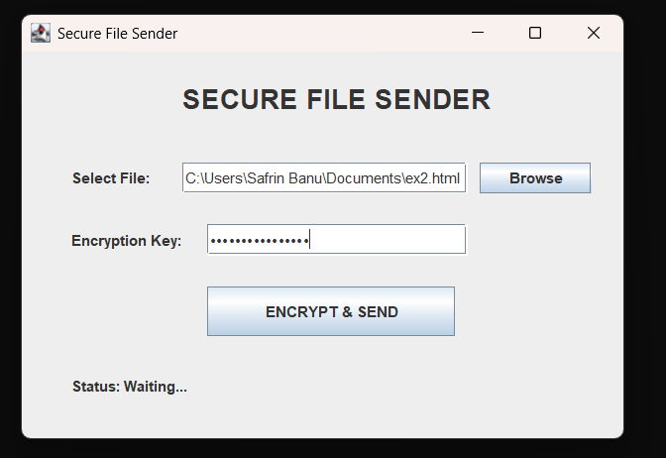
Sender with file selected and key entered
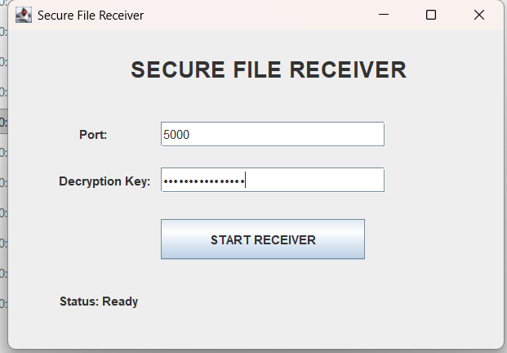
Receiver with port and decryption key entered
Successful transfer
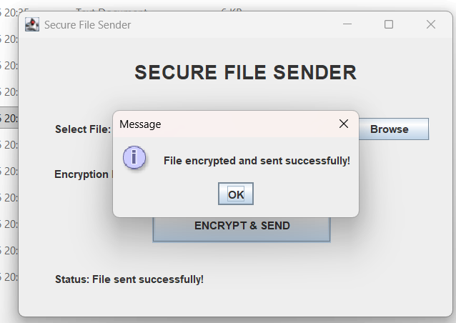
File encrypted and sent successfully
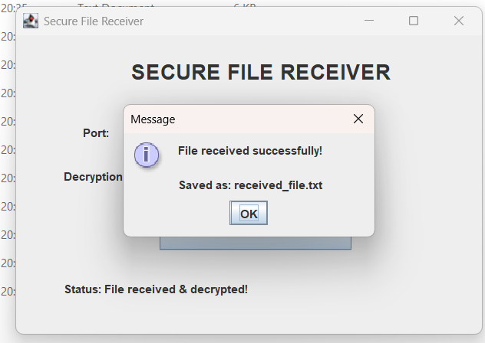
File received and decrypted successfully

9. Results
The developed system successfully encrypts a file at the sender, transfers it over a TCP connection and decrypts it at the receiver.
- The sender accepts the file only when a file is selected and the key has exactly 16 characters.
- The sender status changes from Waiting to Encrypting, Connecting and then "File sent successfully!".
- The receiver status changes from Ready to "Waiting for sender...", "Receiving file..." and then "File received & decrypted!".
- The encrypted data is stored as received_file.enc and the recovered original content as received_file.txt.
- Decryption with the correct key recovers the original file; with an incorrect key, decryption fails and an error dialog is shown.
This shows that the file content stays protected during network transmission and can be read only by a receiver who has the correct key.

10. Application Areas
- Secure sharing of confidential documents.
- File transfer in colleges and offices.
- Basic network security applications.
- Educational labs for teaching encryption and socket programming.

11. Challenges and Future Enhancements
Challenges
- The same key must be shared with the receiver safely and remembered correctly; a wrong key makes decryption fail.
- Network connection problems, such as the receiver not running or a wrong port, stop the transfer.
- Whole files are loaded into memory, so very large files are difficult to handle.
- The sender is currently set to connect to localhost, and the receiver saves the output with a fixed name (received_file.txt).
- The Cipher uses the default AES setting, which does not use an initialization vector, and there is no integrity check on the received data.
Future Enhancements
- Add user login and authentication.
- Support multiple and larger file transfers with a progress bar.
- Allow the receiver IP address to be entered, and save the file with its original name and extension.
- Use a stronger mode such as AES/CBC or AES/GCM with a random IV, and derive the key from a password.
- Add better key management, for example sharing the AES key using RSA.

12. Conclusion
The Secure File Sharing System with Encryption using Java provides a simple and secure way to transfer files between a sender and a receiver. The file is encrypted with AES before it is sent through a TCP socket and is decrypted only at the receiver side with the correct 16-character key. The project clearly demonstrates the practical use of encryption, decryption and TCP networking concepts, and the GUI makes secure file transfer easy without using complex commands.

