Section-0 Use GIT as local VCS

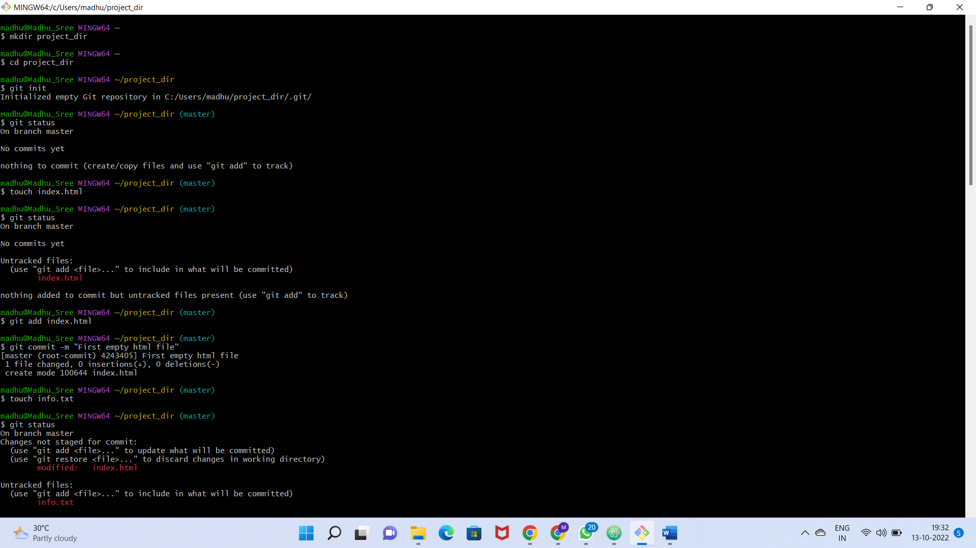

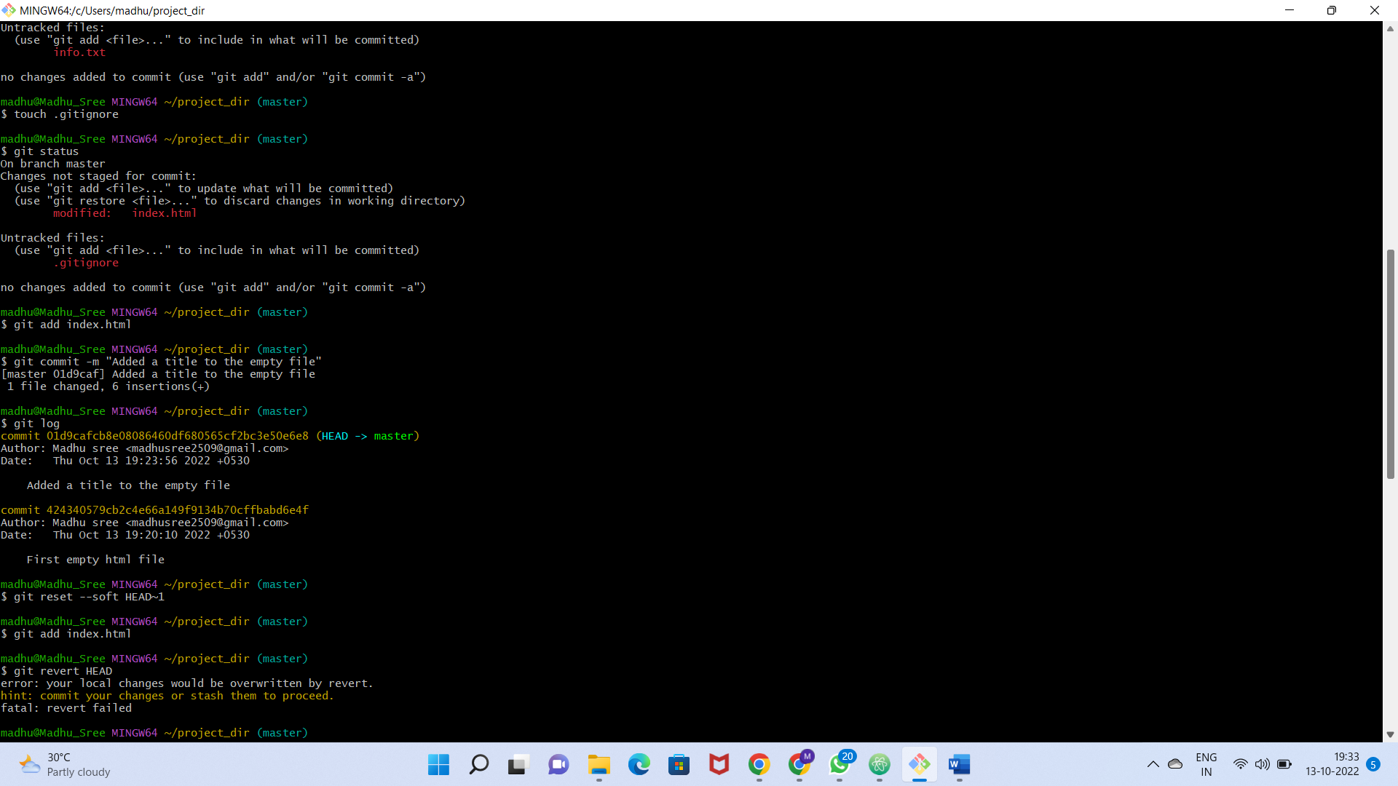

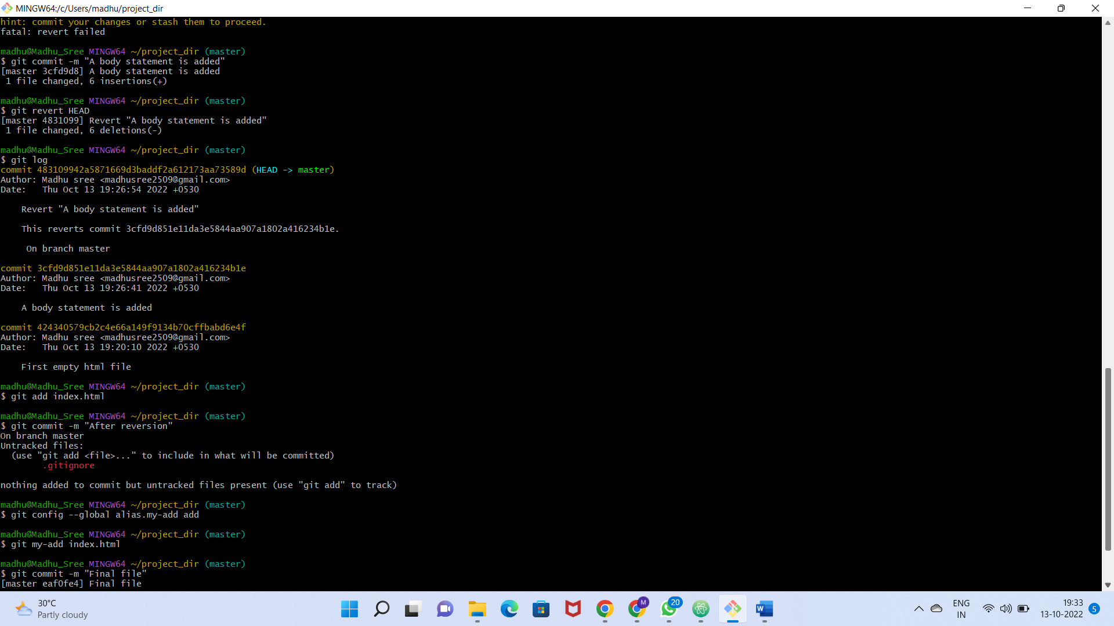

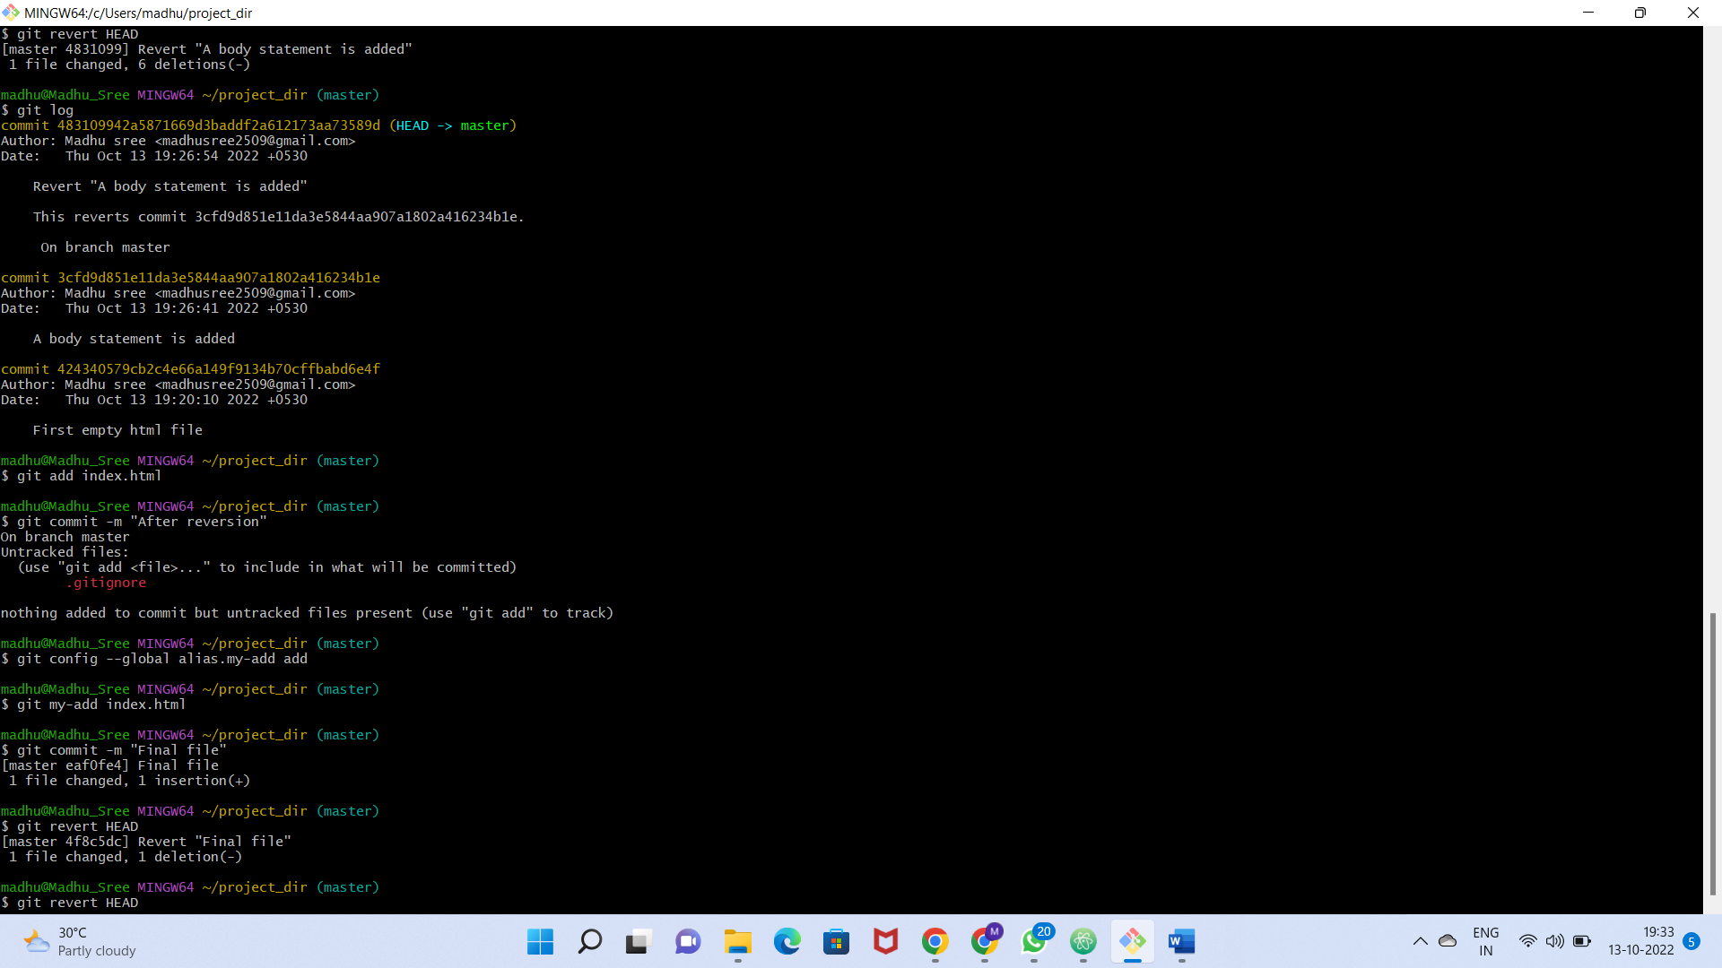

Commads:

madhu@Madhu_Sree MINGW64 ~

$ cd project_dir

madhu@Madhu_Sree MINGW64 ~/project_dir

$ git init

Initialized empty Git repository in C:/Users/madhu/project_dir/.git/

madhu@Madhu_Sree MINGW64 ~/project_dir (master)

$ git status

On branch master

No commits yet

nothing to commit (create/copy files and use "git add" to track)

madhu@Madhu_Sree MINGW64 ~/project_dir (master)

$ touch index.html

madhu@Madhu_Sree MINGW64 ~/project_dir (master)

$ git status

On branch master

No commits yet

Untracked files:

(use "git add <file>..." to include in what will be committed)

index.html

nothing added to commit but untracked files present (use "git add" to track)

madhu@Madhu_Sree MINGW64 ~/project_dir (master)

$ git add index.html

madhu@Madhu_Sree MINGW64 ~/project_dir (master)

$ git commit -m "First empty html file"

[master (root-commit) 4243405] First empty html file

1 file changed, 0 insertions(+), 0 deletions(-)

create mode 100644 index.html

madhu@Madhu_Sree MINGW64 ~/project_dir (master)

$ touch info.txt

madhu@Madhu_Sree MINGW64 ~/project_dir (master)

$ git status

On branch master

Changes not staged for commit:

(use "git add <file>..." to update what will be committed)

(use "git restore <file>..." to discard changes in working directory)

modified: index.html

Untracked files:

(use "git add <file>..." to include in what will be committed)

info.txt

no changes added to commit (use "git add" and/or "git commit -a")

madhu@Madhu_Sree MINGW64 ~/project_dir (master)

$ touch .gitignore

madhu@Madhu_Sree MINGW64 ~/project_dir (master)

$ git status

On branch master

Changes not staged for commit:

(use "git add <file>..." to update what will be committed)

(use "git restore <file>..." to discard changes in working directory)

modified: index.html

Untracked files:

(use "git add <file>..." to include in what will be committed)

.gitignore

no changes added to commit (use "git add" and/or "git commit -a")

madhu@Madhu_Sree MINGW64 ~/project_dir (master)

$ git add index.html

madhu@Madhu_Sree MINGW64 ~/project_dir (master)

$ git commit -m "Added a title to the empty file"

[master 01d9caf] Added a title to the empty file

1 file changed, 6 insertions(+)

madhu@Madhu_Sree MINGW64 ~/project_dir (master)

$ git log

commit 01d9cafcb8e08086460df680565cf2bc3e50e6e8 (HEAD -> master)

Author: Madhu sree <madhusree2509@gmail.com>

Date: Thu Oct 13 19:23:56 2022 +0530

Added a title to the empty file

commit 424340579cb2c4e66a149f9134b70cffbabd6e4f

Author: Madhu sree <madhusree2509@gmail.com>

Date: Thu Oct 13 19:20:10 2022 +0530

First empty html file

madhu@Madhu_Sree MINGW64 ~/project_dir (master)

$ git reset --soft HEAD~1

madhu@Madhu_Sree MINGW64 ~/project_dir (master)

$ git add index.html

madhu@Madhu_Sree MINGW64 ~/project_dir (master)

$ git revert HEAD

error: your local changes would be overwritten by revert.

hint: commit your changes or stash them to proceed.

fatal: revert failed

madhu@Madhu_Sree MINGW64 ~/project_dir (master)

$ git commit -m "A body statement is added"

[master 3cfd9d8] A body statement is added

1 file changed, 6 insertions(+)

madhu@Madhu_Sree MINGW64 ~/project_dir (master)

$ git revert HEAD

[master 4831099] Revert "A body statement is added"

1 file changed, 6 deletions(-)

madhu@Madhu_Sree MINGW64 ~/project_dir (master)

$ git log

commit 483109942a5871669d3baddf2a612173aa73589d (HEAD -> master)

Author: Madhu sree <madhusree2509@gmail.com>

Date: Thu Oct 13 19:26:54 2022 +0530

Revert "A body statement is added"

This reverts commit 3cfd9d851e11da3e5844aa907a1802a416234b1e.

On branch master

commit 3cfd9d851e11da3e5844aa907a1802a416234b1e

Author: Madhu sree <madhusree2509@gmail.com>

Date: Thu Oct 13 19:26:41 2022 +0530

A body statement is added

commit 424340579cb2c4e66a149f9134b70cffbabd6e4f

Author: Madhu sree <madhusree2509@gmail.com>

Date: Thu Oct 13 19:20:10 2022 +0530

First empty html file

madhu@Madhu_Sree MINGW64 ~/project_dir (master)

$ git add index.html

madhu@Madhu_Sree MINGW64 ~/project_dir (master)

$ git commit -m "After reversion"

On branch master

Untracked files:

(use "git add <file>..." to include in what will be committed)

.gitignore

nothing added to commit but untracked files present (use "git add" to track)

madhu@Madhu_Sree MINGW64 ~/project_dir (master)

$ git config --global alias.my-add add

madhu@Madhu_Sree MINGW64 ~/project_dir (master)

$ git my-add index.html

madhu@Madhu_Sree MINGW64 ~/project_dir (master)

$ git commit -m "Final file"

[master eaf0fe4] Final file

1 file changed, 1 insertion(+)

madhu@Madhu_Sree MINGW64 ~/project_dir (master)

$ git revert HEAD

[master 4f8c5dc] Revert "Final file"

1 file changed, 1 deletion(-)

madhu@Madhu_Sree MINGW64 ~/project_dir (master)

$ git revert HEAD