Section-1 Git Branching

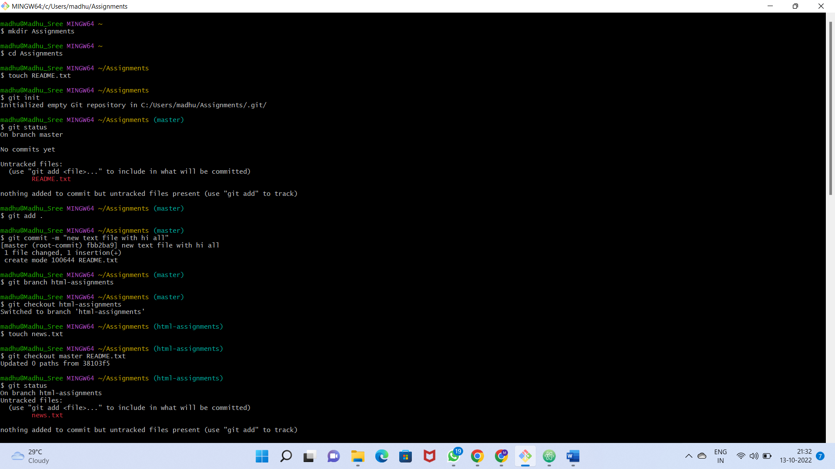

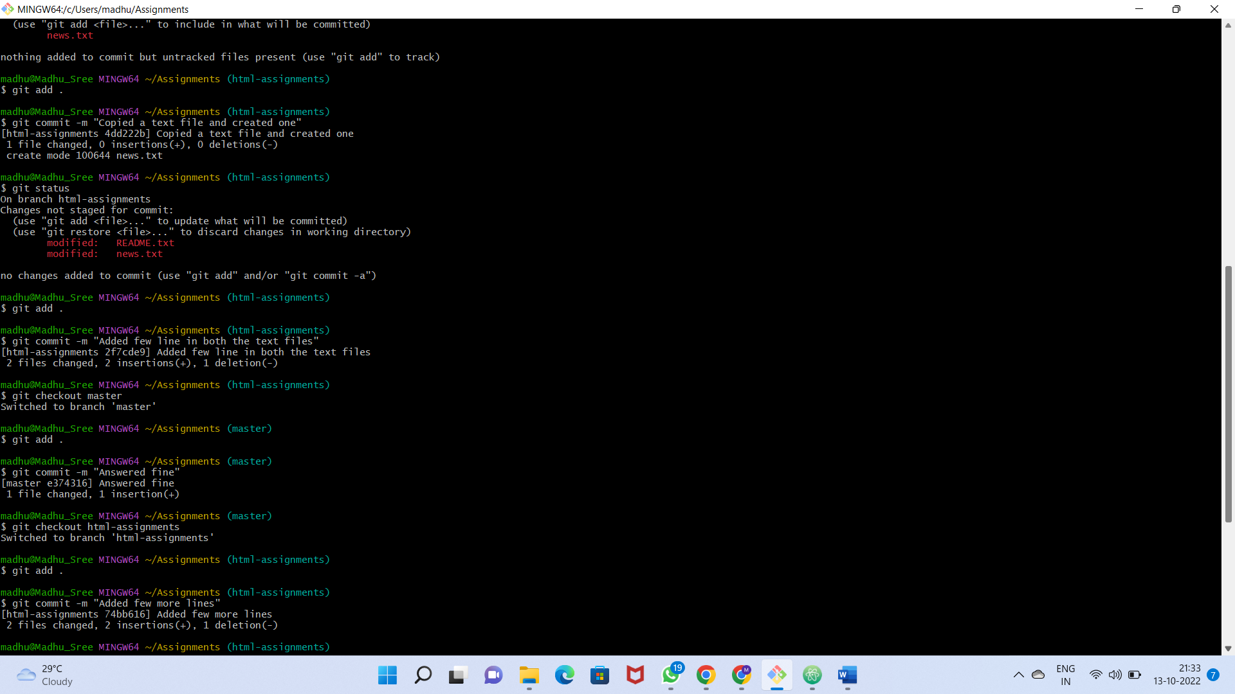

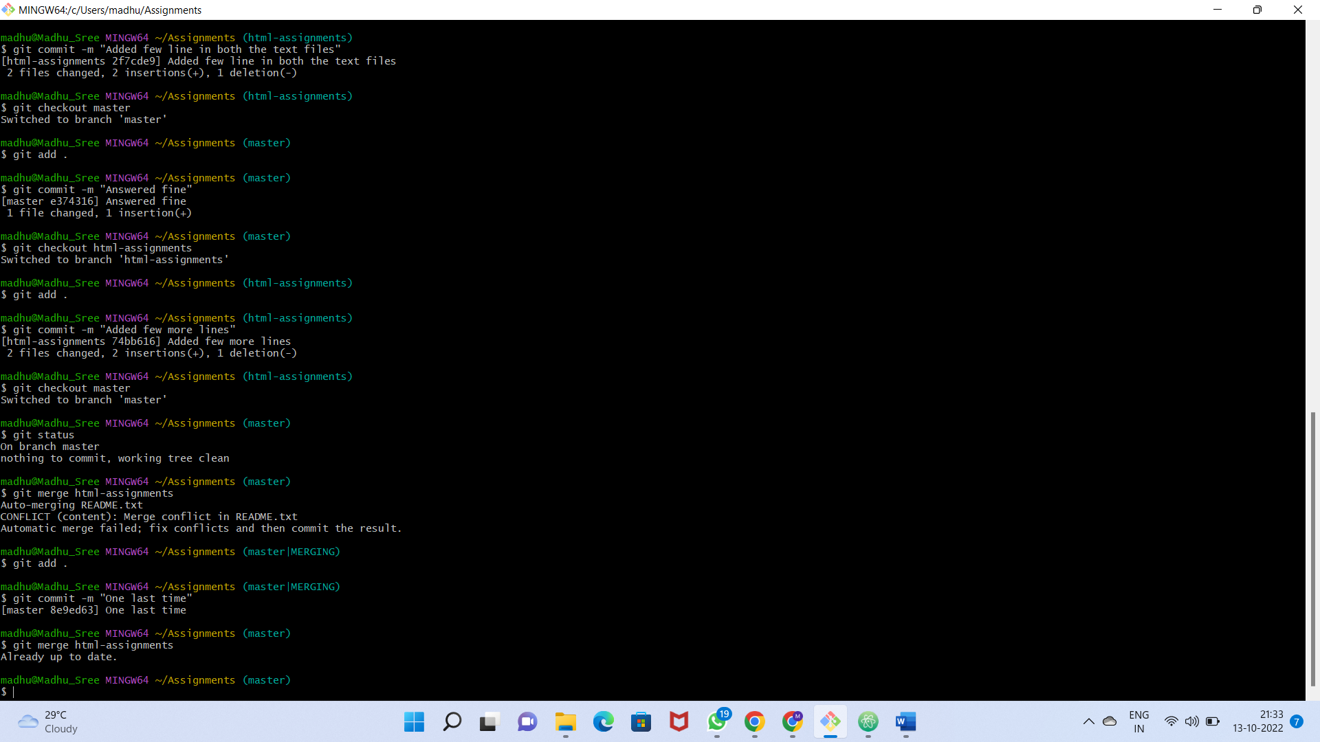

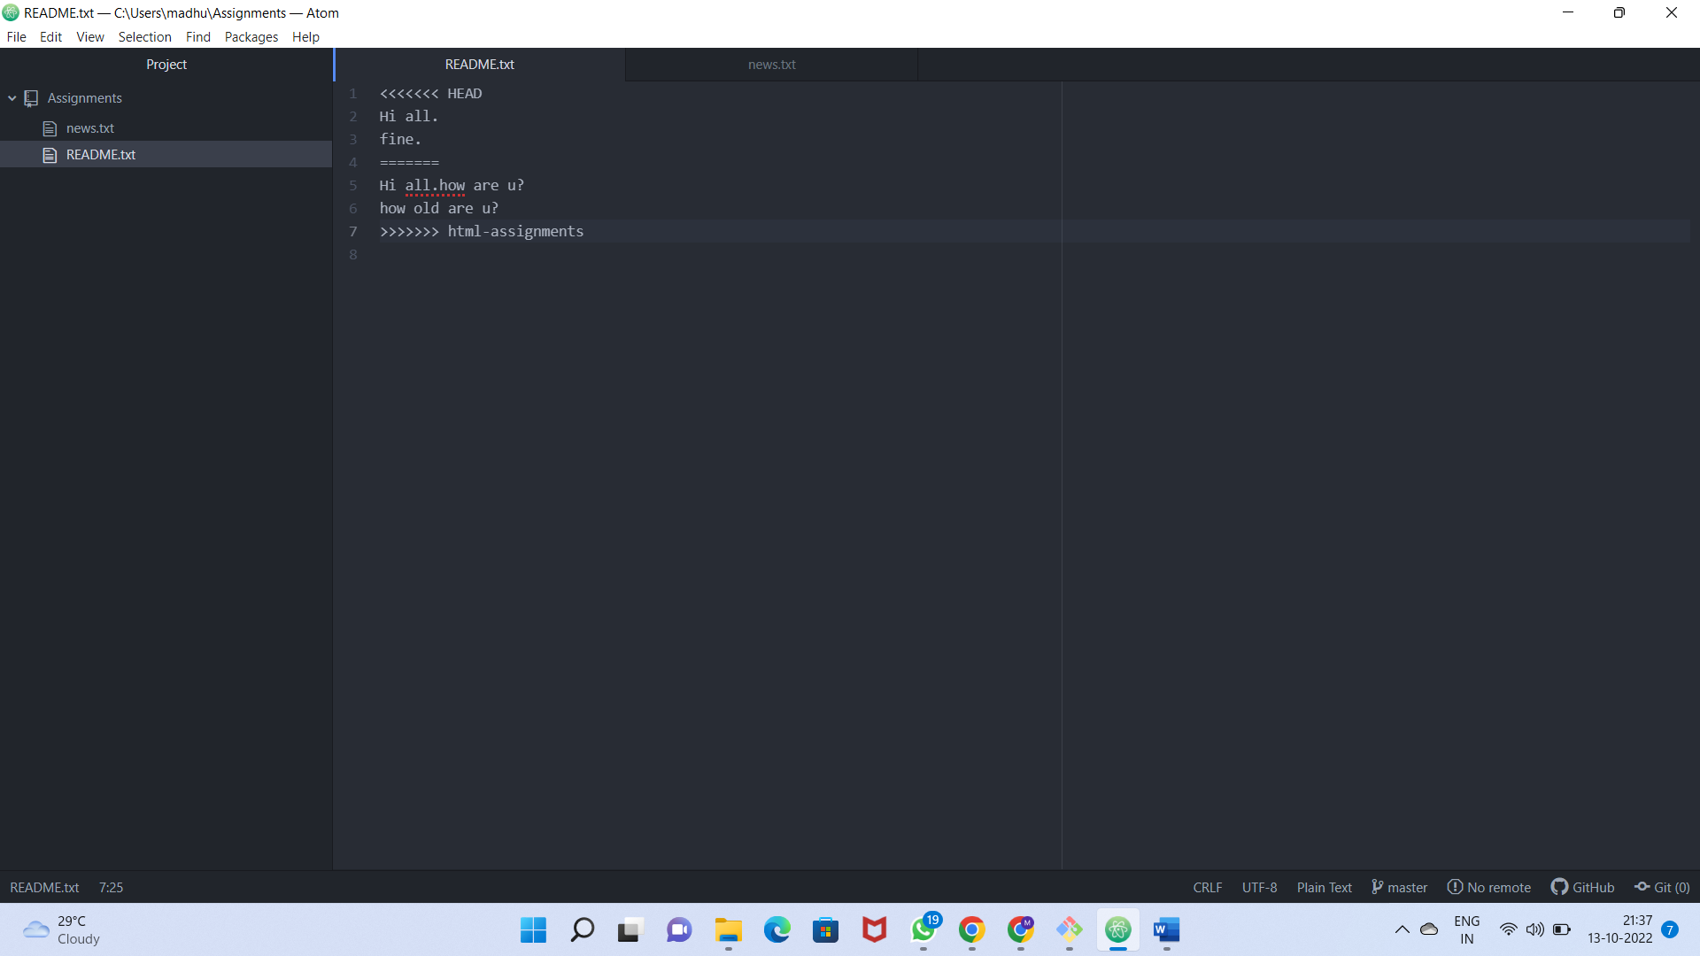

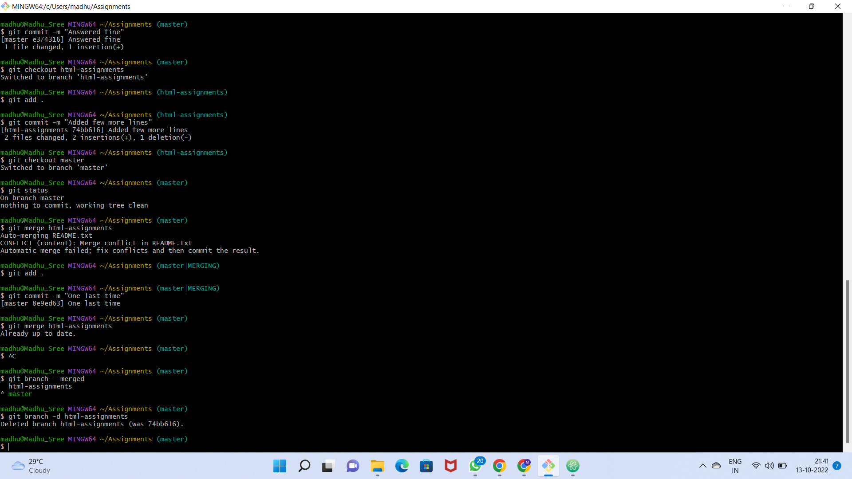

Commands:

madhu@Madhu_Sree MINGW64 ~

$ mkdir Assignments

madhu@Madhu_Sree MINGW64 ~

$ cd Assignments

madhu@Madhu_Sree MINGW64 ~/Assignments

$ touch README.txt

madhu@Madhu_Sree MINGW64 ~/Assignments

$ git init

Initialized empty Git repository in C:/Users/madhu/Assignments/.git/

madhu@Madhu_Sree MINGW64 ~/Assignments (master)

$ git status

On branch master

No commits yet

Untracked files:

(use "git add <file>..." to include in what will be committed)

README.txt

nothing added to commit but untracked files present (use "git add" to track)

madhu@Madhu_Sree MINGW64 ~/Assignments (master)

$ git add .

madhu@Madhu_Sree MINGW64 ~/Assignments (master)

$ git commit -m "new text file with hi all"

[master (root-commit) fbb2ba9] new text file with hi all

1 file changed, 1 insertion(+)

create mode 100644 README.txt

madhu@Madhu_Sree MINGW64 ~/Assignments (master)

$ git branch html-assignments

madhu@Madhu_Sree MINGW64 ~/Assignments (master)

$ git checkout html-assignments

Switched to branch 'html-assignments'

madhu@Madhu_Sree MINGW64 ~/Assignments (html-assignments)

$ touch news.txt

madhu@Madhu_Sree MINGW64 ~/Assignments (html-assignments)

$ git checkout master README.txt

Updated 0 paths from 38103f5

madhu@Madhu_Sree MINGW64 ~/Assignments (html-assignments)

$ git status

On branch html-assignments

Untracked files:

(use "git add <file>..." to include in what will be committed)

news.txt

nothing added to commit but untracked files present (use "git add" to track)

madhu@Madhu_Sree MINGW64 ~/Assignments (html-assignments)

$ git add .

madhu@Madhu_Sree MINGW64 ~/Assignments (html-assignments)

$ git commit -m "Copied a text file and created one"

[html-assignments 4dd222b] Copied a text file and created one

1 file changed, 0 insertions(+), 0 deletions(-)

create mode 100644 news.txt

madhu@Madhu_Sree MINGW64 ~/Assignments (html-assignments)

$ git status

On branch html-assignments

Changes not staged for commit:

(use "git add <file>..." to update what will be committed)

(use "git restore <file>..." to discard changes in working directory)

modified: README.txt

modified: news.txt

no changes added to commit (use "git add" and/or "git commit -a")

madhu@Madhu_Sree MINGW64 ~/Assignments (html-assignments)

$ git add .

madhu@Madhu_Sree MINGW64 ~/Assignments (html-assignments)

$ git commit -m "Added few line in both the text files"

[html-assignments 2f7cde9] Added few line in both the text files

2 files changed, 2 insertions(+), 1 deletion(-)

madhu@Madhu_Sree MINGW64 ~/Assignments (html-assignments)

$ git checkout master

Switched to branch 'master'

madhu@Madhu_Sree MINGW64 ~/Assignments (master)

$ git add .

madhu@Madhu_Sree MINGW64 ~/Assignments (master)

$ git commit -m "Answered fine"

[master e374316] Answered fine

1 file changed, 1 insertion(+)

madhu@Madhu_Sree MINGW64 ~/Assignments (master)

$ git checkout html-assignments

Switched to branch 'html-assignments'

madhu@Madhu_Sree MINGW64 ~/Assignments (html-assignments)

$ git add .

madhu@Madhu_Sree MINGW64 ~/Assignments (html-assignments)

$ git commit -m "Added few more lines"

[html-assignments 74bb616] Added few more lines

2 files changed, 2 insertions(+), 1 deletion(-)

madhu@Madhu_Sree MINGW64 ~/Assignments (html-assignments)

$ git checkout master

Switched to branch 'master'

madhu@Madhu_Sree MINGW64 ~/Assignments (master)

$ git status

On branch master

nothing to commit, working tree clean

madhu@Madhu_Sree MINGW64 ~/Assignments (master)

$ git merge html-assignments

Auto-merging README.txt

CONFLICT (content): Merge conflict in README.txt

Automatic merge failed; fix conflicts and then commit the result.

madhu@Madhu_Sree MINGW64 ~/Assignments (master|MERGING)

$ git add .

madhu@Madhu_Sree MINGW64 ~/Assignments (master|MERGING)

$ git commit -m "One last time"

[master 8e9ed63] One last time

madhu@Madhu_Sree MINGW64 ~/Assignments (master)

$ git merge html-assignments

Already up to date.

madhu@Madhu_Sree MINGW64 ~/Assignments (master)

$