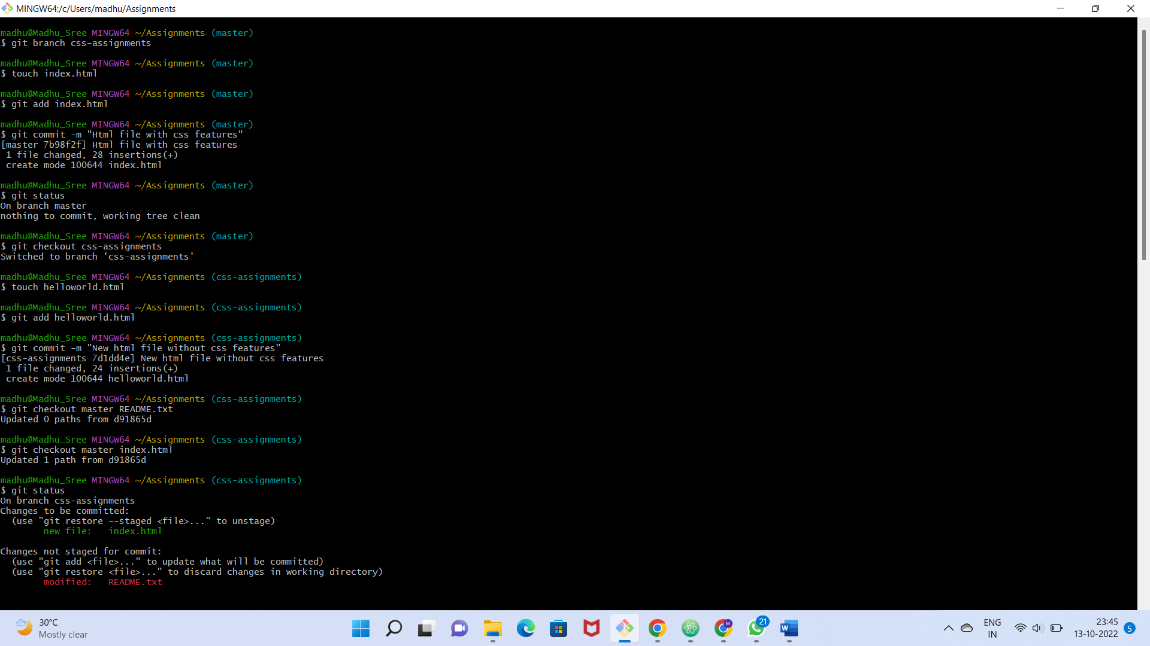

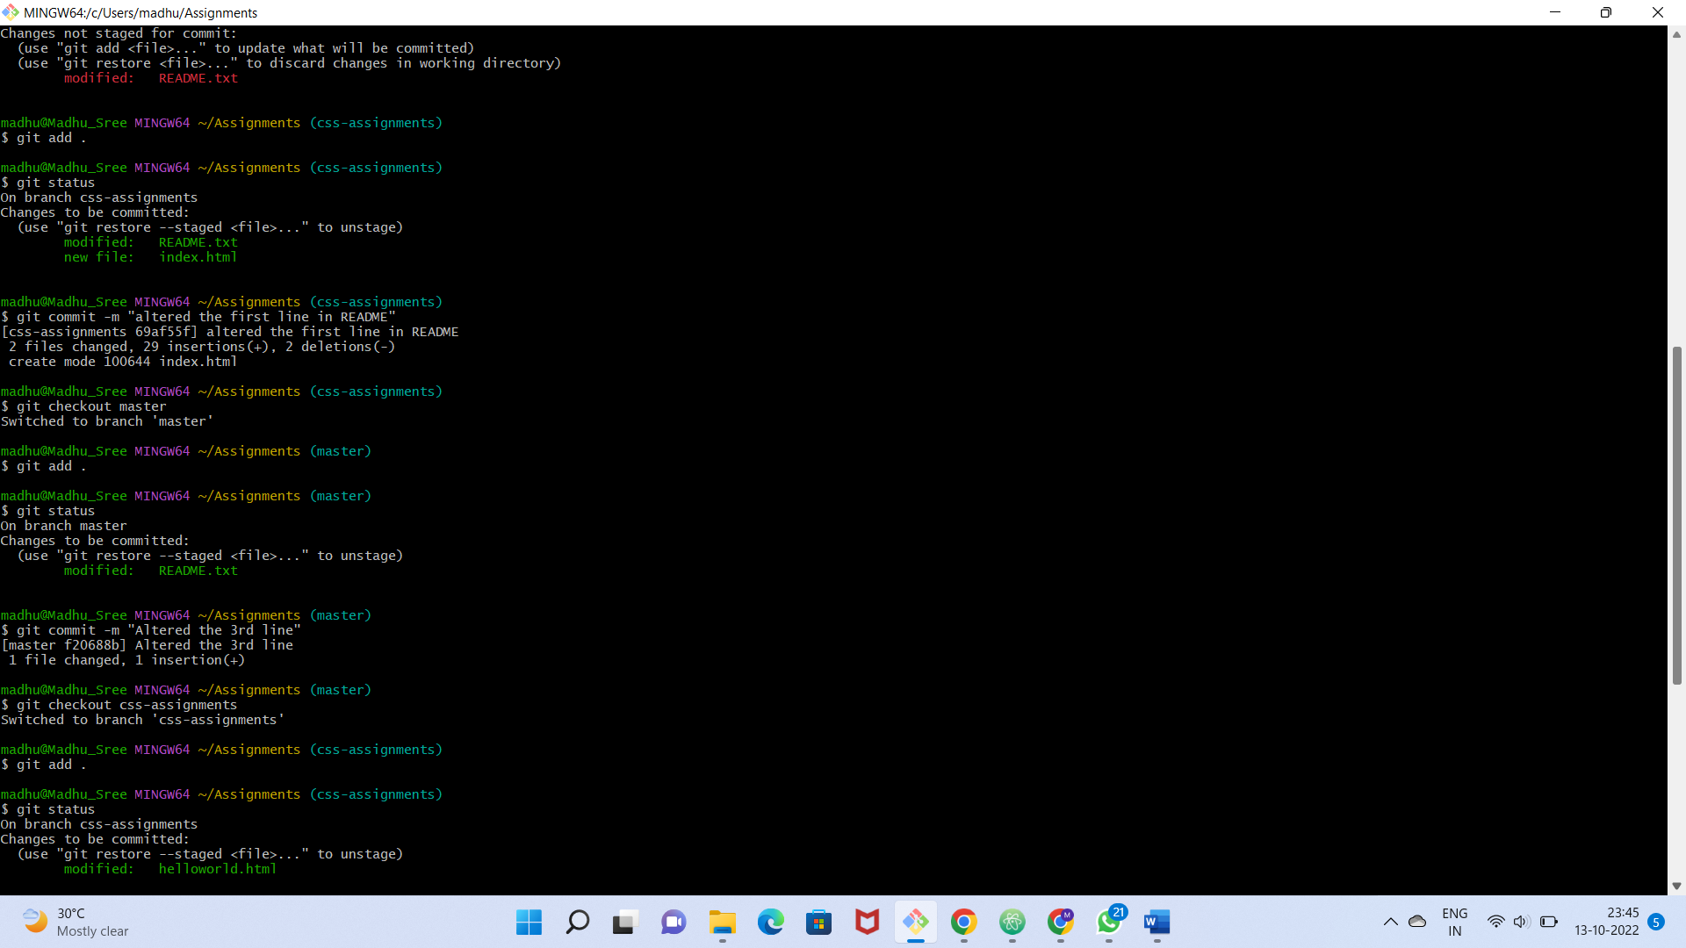

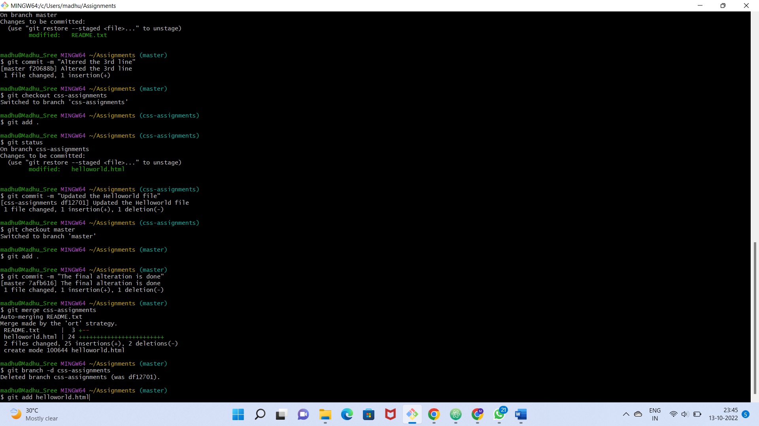

Commands:

madhu@Madhu_Sree MINGW64 ~/Assignments (master)

$ git branch css-assignments

madhu@Madhu_Sree MINGW64 ~/Assignments (master)

$ touch index.html

madhu@Madhu_Sree MINGW64 ~/Assignments (master)

$ git add index.html

madhu@Madhu_Sree MINGW64 ~/Assignments (master)

$ git commit -m "Html file with css features"

[master 7b98f2f] Html file with css features

1 file changed, 28 insertions(+)

create mode 100644 index.html

madhu@Madhu_Sree MINGW64 ~/Assignments (master)

$ git status

On branch master

nothing to commit, working tree clean

madhu@Madhu_Sree MINGW64 ~/Assignments (master)

$ git checkout css-assignments

Switched to branch 'css-assignments'

madhu@Madhu_Sree MINGW64 ~/Assignments (css-assignments)

$ touch helloworld.html

madhu@Madhu_Sree MINGW64 ~/Assignments (css-assignments)

$ git add helloworld.html

madhu@Madhu_Sree MINGW64 ~/Assignments (css-assignments)

$ git commit -m "New html file without css features"

[css-assignments 7d1dd4e] New html file without css features

1 file changed, 24 insertions(+)

create mode 100644 helloworld.html

madhu@Madhu_Sree MINGW64 ~/Assignments (css-assignments)

$ git checkout master README.txt

Updated 0 paths from d91865d

madhu@Madhu_Sree MINGW64 ~/Assignments (css-assignments)

$ git checkout master index.html

Updated 1 path from d91865d

madhu@Madhu_Sree MINGW64 ~/Assignments (css-assignments)

$ git status

On branch css-assignments

Changes to be committed:

(use "git restore --staged <file>..." to unstage)

new file: index.html

Changes not staged for commit:

(use "git add <file>..." to update what will be committed)

(use "git restore <file>..." to discard changes in working directory)

modified: README.txt

madhu@Madhu_Sree MINGW64 ~/Assignments (css-assignments)

$ git add .

madhu@Madhu_Sree MINGW64 ~/Assignments (css-assignments)

$ git status

On branch css-assignments

Changes to be committed:

(use "git restore --staged <file>..." to unstage)

modified: README.txt

new file: index.html

madhu@Madhu_Sree MINGW64 ~/Assignments (css-assignments)

$ git commit -m "altered the first line in README"

[css-assignments 69af55f] altered the first line in README

2 files changed, 29 insertions(+), 2 deletions(-)

create mode 100644 index.html

madhu@Madhu_Sree MINGW64 ~/Assignments (css-assignments)

$ git checkout master

Switched to branch 'master'

madhu@Madhu_Sree MINGW64 ~/Assignments (master)

$ git add .

madhu@Madhu_Sree MINGW64 ~/Assignments (master)

$ git status

On branch master

Changes to be committed:

(use "git restore --staged <file>..." to unstage)

modified: README.txt

madhu@Madhu_Sree MINGW64 ~/Assignments (master)

$ git commit -m "Altered the 3rd line"

[master f20688b] Altered the 3rd line

1 file changed, 1 insertion(+)

madhu@Madhu_Sree MINGW64 ~/Assignments (master)

$ git checkout css-assignments

Switched to branch 'css-assignments'

madhu@Madhu_Sree MINGW64 ~/Assignments (css-assignments)

$ git add .

madhu@Madhu_Sree MINGW64 ~/Assignments (css-assignments)

$ git status

On branch css-assignments

Changes to be committed:

(use "git restore --staged <file>..." to unstage)

modified: helloworld.html

madhu@Madhu_Sree MINGW64 ~/Assignments (css-assignments)

$ git commit -m "Updated the Helloworld file"

[css-assignments df12701] Updated the Helloworld file

1 file changed, 1 insertion(+), 1 deletion(-)

madhu@Madhu_Sree MINGW64 ~/Assignments (css-assignments)

$ git checkout master

Switched to branch 'master'

madhu@Madhu_Sree MINGW64 ~/Assignments (master)

$ git add .

madhu@Madhu_Sree MINGW64 ~/Assignments (master)

$ git commit -m "The final alteration is done"

[master 7afb616] The final alteration is done

1 file changed, 1 insertion(+), 1 deletion(-)

madhu@Madhu_Sree MINGW64 ~/Assignments (master)

$ git merge css-assignments

Auto-merging README.txt

Merge made by the 'ort' strategy.

README.txt | 3 +--

helloworld.html | 24 ++++++++++++++++++++++++

2 files changed, 25 insertions(+), 2 deletions(-)

create mode 100644 helloworld.html

madhu@Madhu_Sree MINGW64 ~/Assignments (master)

$ git branch -d css-assignments

Deleted branch css-assignments (was df12701).

madhu@Madhu_Sree MINGW64 ~/Assignments (master)

$