Section-3 JS assignments

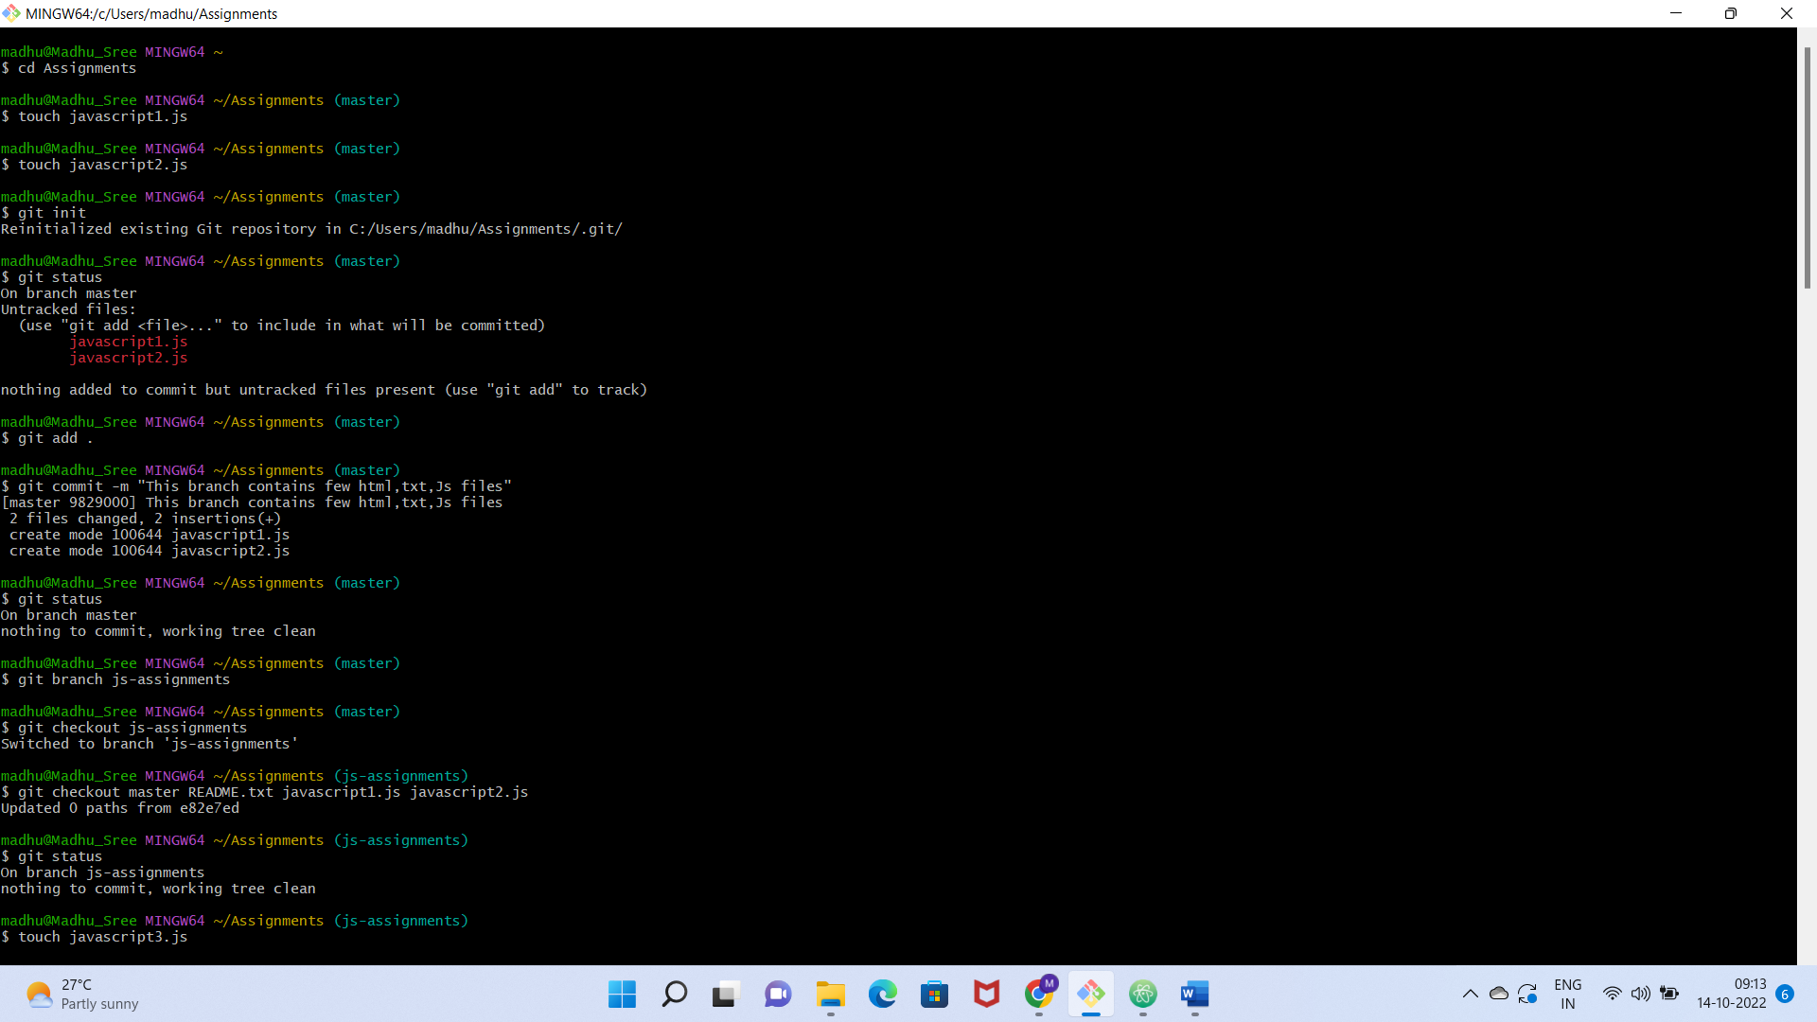

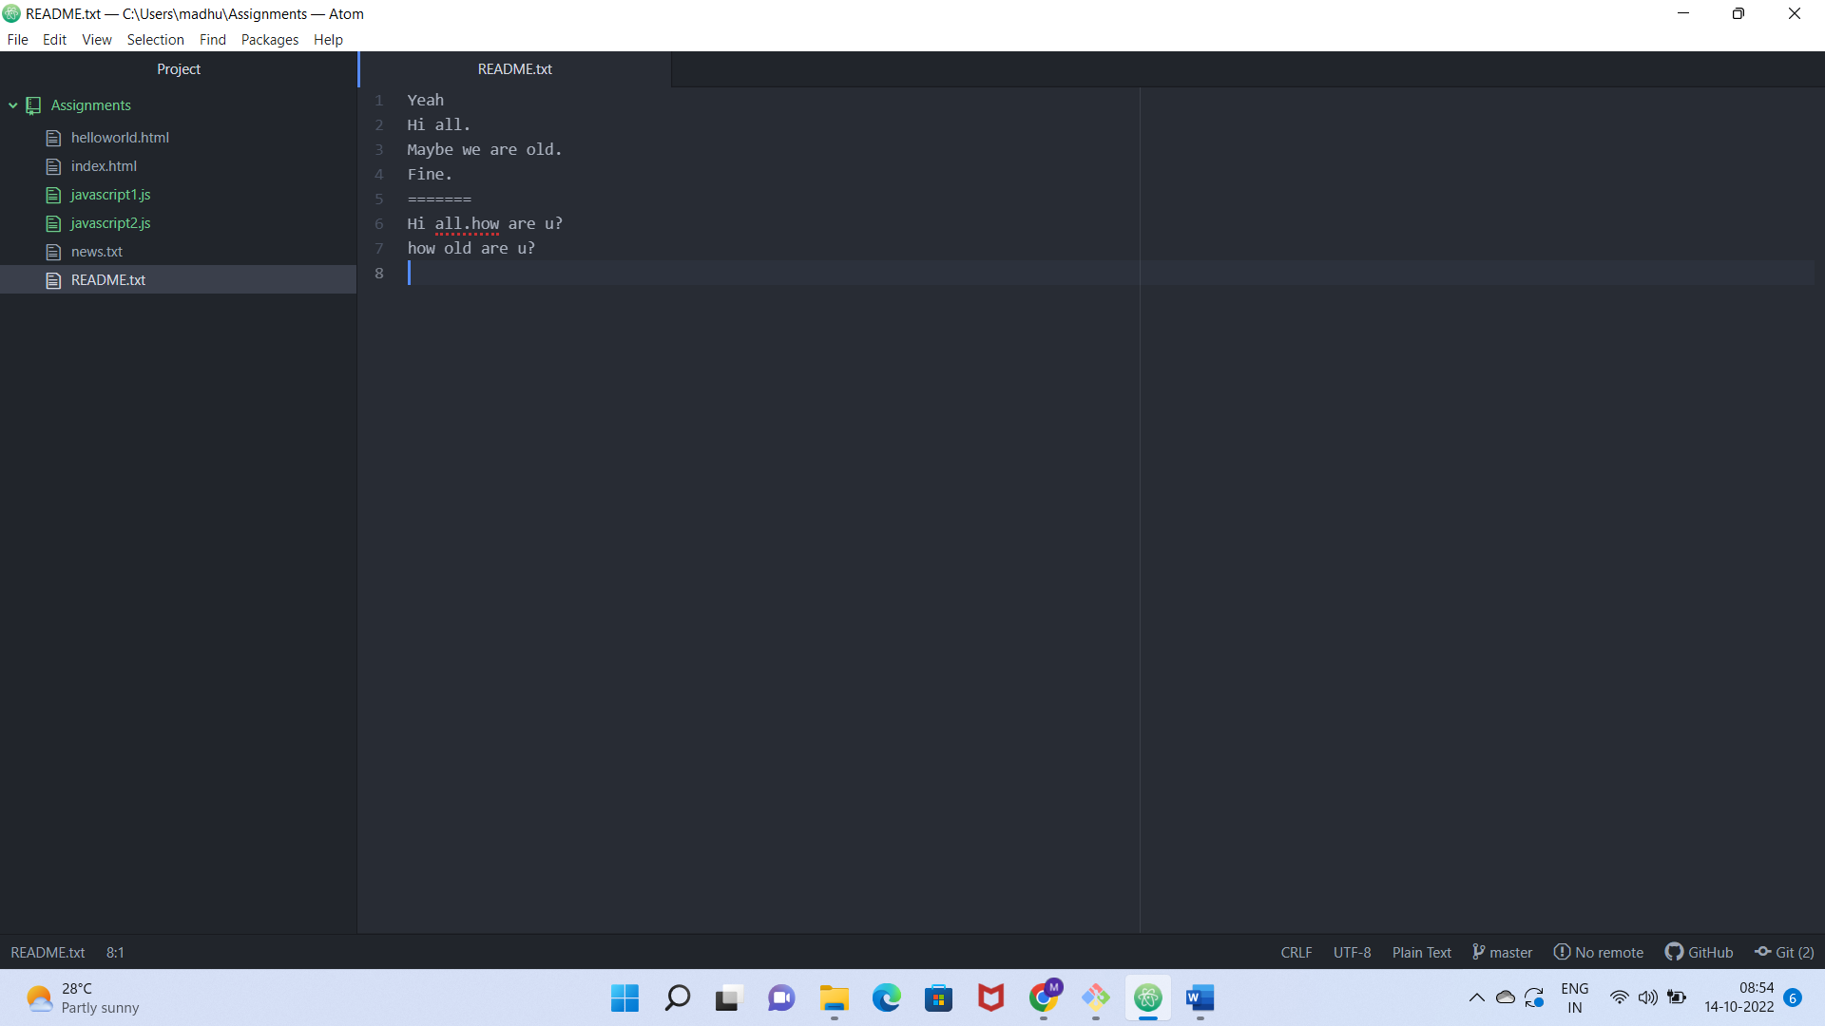

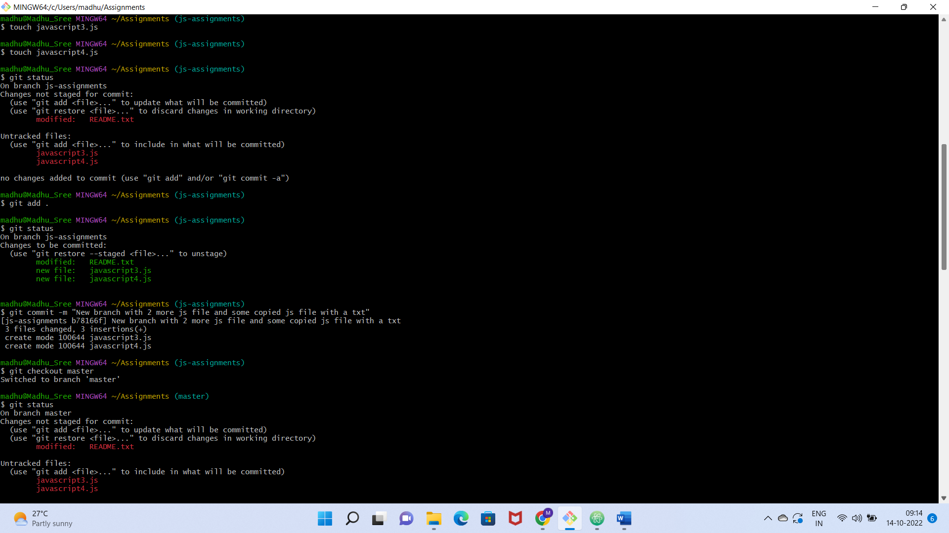

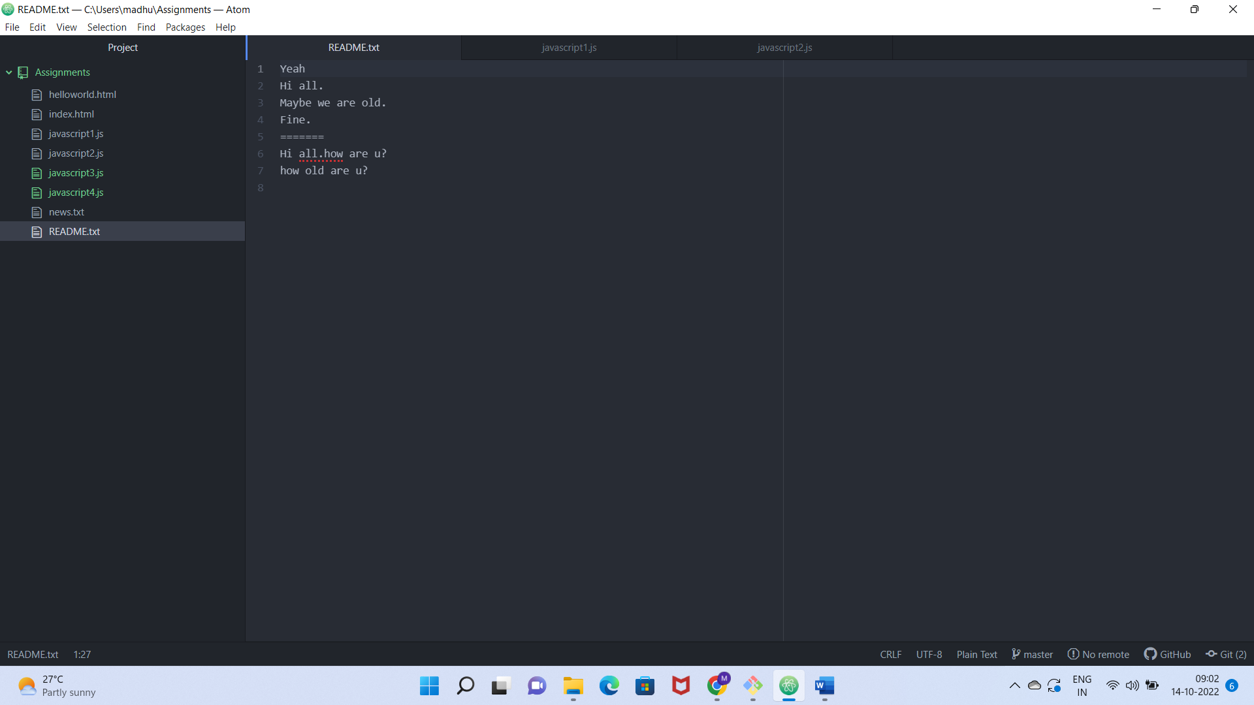

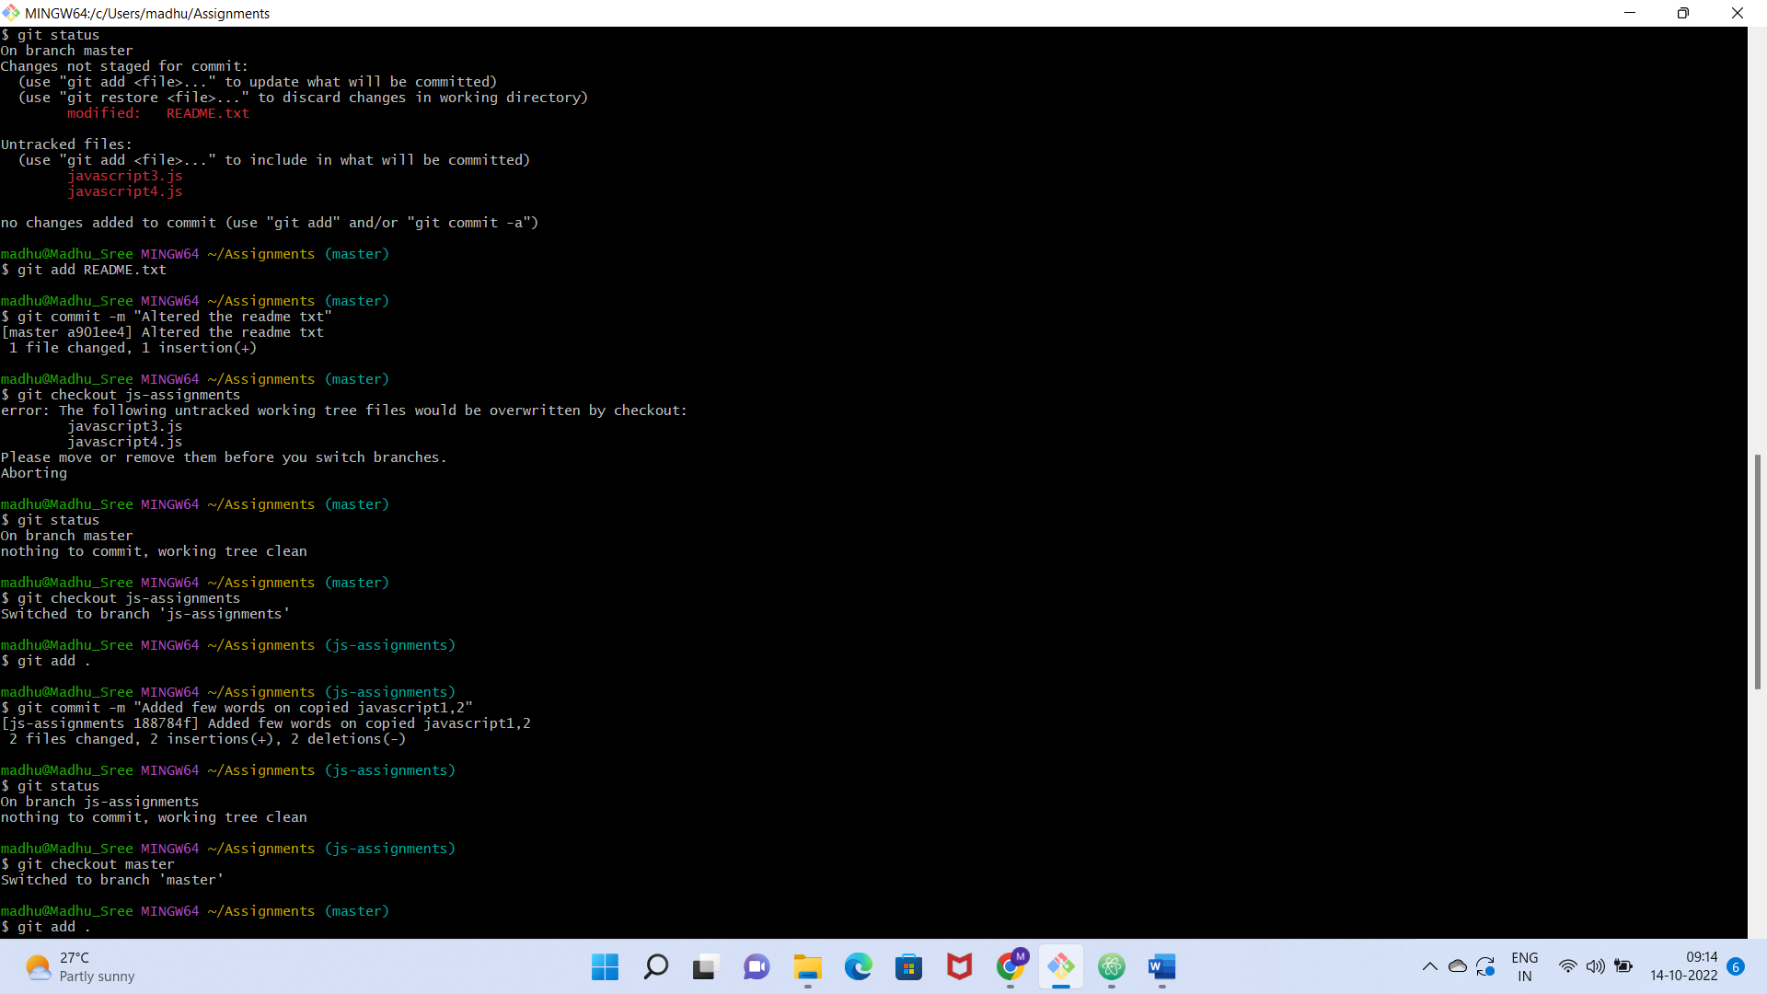

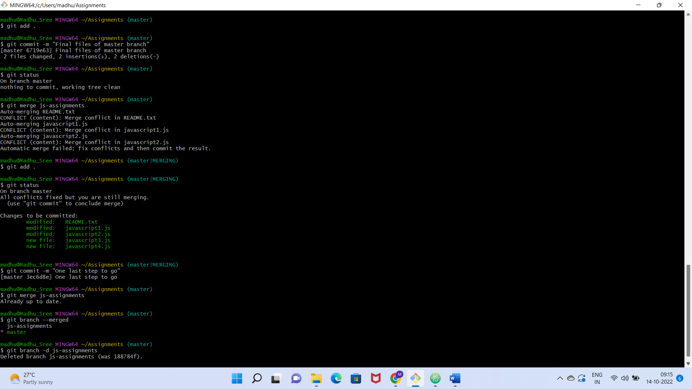

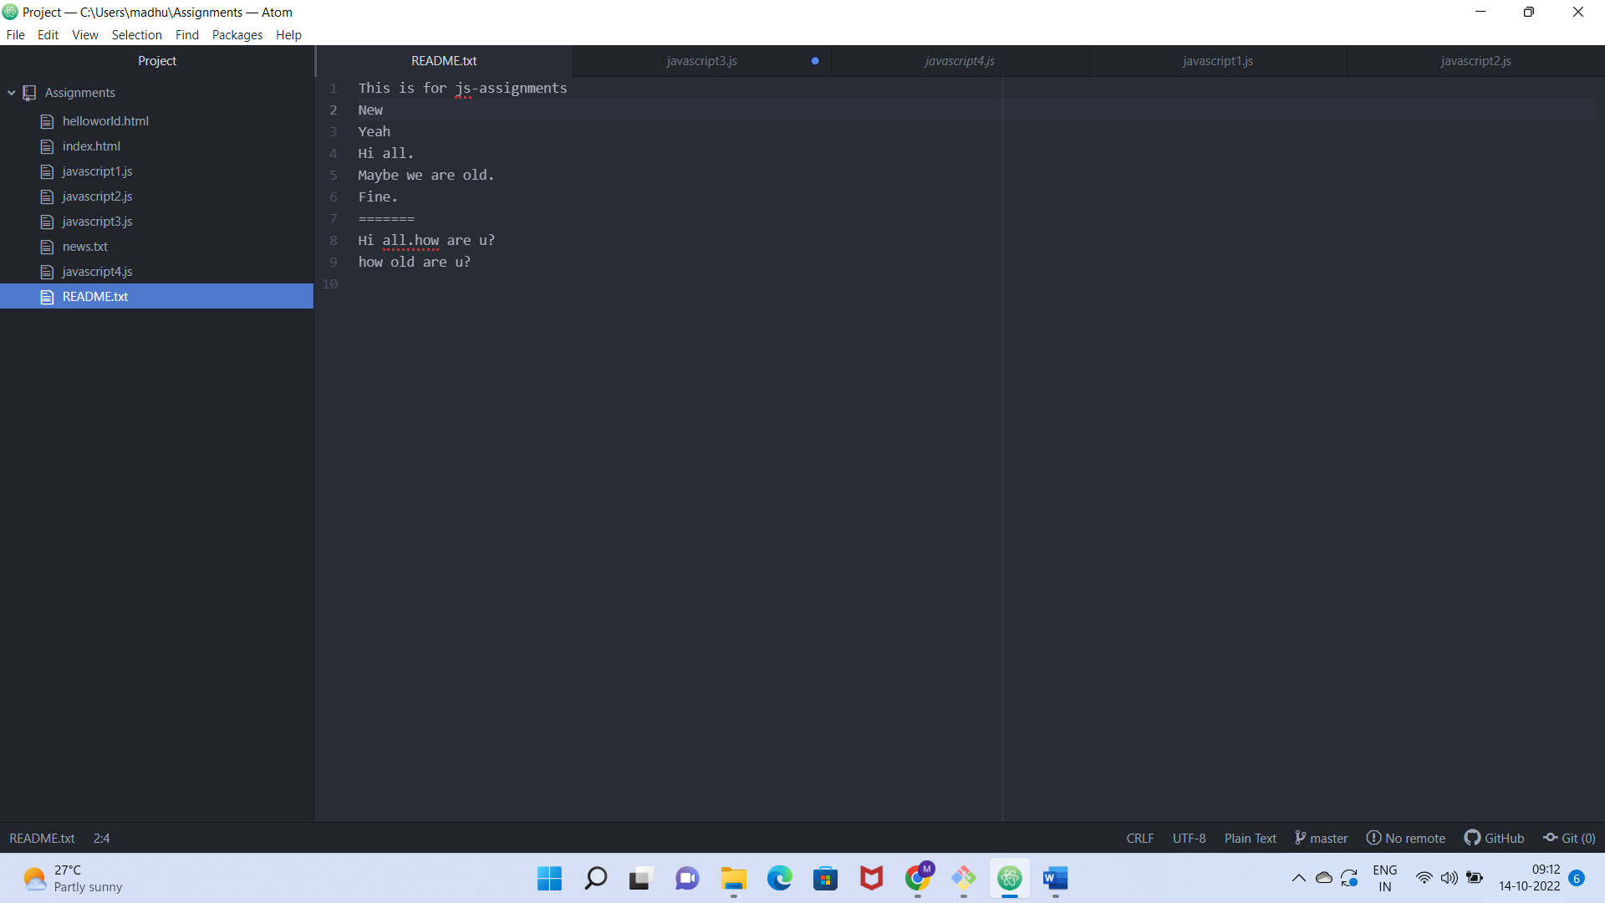

Commands:

madhu@Madhu_Sree MINGW64 ~

$ cd Assignments

madhu@Madhu_Sree MINGW64 ~/Assignments (master)

$ touch javascript1.js

madhu@Madhu_Sree MINGW64 ~/Assignments (master)

$ touch javascript2.js

madhu@Madhu_Sree MINGW64 ~/Assignments (master)

$ git init

Reinitialized existing Git repository in C:/Users/madhu/Assignments/.git/

madhu@Madhu_Sree MINGW64 ~/Assignments (master)

$ git status

On branch master

Untracked files:

(use "git add <file>..." to include in what will be committed)

javascript1.js

javascript2.js

nothing added to commit but untracked files present (use "git add" to track)

madhu@Madhu_Sree MINGW64 ~/Assignments (master)

$ git add .

madhu@Madhu_Sree MINGW64 ~/Assignments (master)

$ git commit -m "This branch contains few html,txt,Js files"

[master 9829000] This branch contains few html,txt,Js files

2 files changed, 2 insertions(+)

create mode 100644 javascript1.js

create mode 100644 javascript2.js

madhu@Madhu_Sree MINGW64 ~/Assignments (master)

$ git status

On branch master

nothing to commit, working tree clean

madhu@Madhu_Sree MINGW64 ~/Assignments (master)

$ git branch js-assignments

madhu@Madhu_Sree MINGW64 ~/Assignments (master)

$ git checkout js-assignments

Switched to branch 'js-assignments'

madhu@Madhu_Sree MINGW64 ~/Assignments (js-assignments)

$ git checkout master README.txt javascript1.js javascript2.js

Updated 0 paths from e82e7ed

madhu@Madhu_Sree MINGW64 ~/Assignments (js-assignments)

$ git status

On branch js-assignments

nothing to commit, working tree clean

madhu@Madhu_Sree MINGW64 ~/Assignments (js-assignments)

$ touch javascript3.js

madhu@Madhu_Sree MINGW64 ~/Assignments (js-assignments)

$ touch javascript4.js

madhu@Madhu_Sree MINGW64 ~/Assignments (js-assignments)

$ git status

On branch js-assignments

Changes not staged for commit:

(use "git add <file>..." to update what will be committed)

(use "git restore <file>..." to discard changes in working directory)

modified: README.txt

Untracked files:

(use "git add <file>..." to include in what will be committed)

javascript3.js

javascript4.js

no changes added to commit (use "git add" and/or "git commit -a")

madhu@Madhu_Sree MINGW64 ~/Assignments (js-assignments)

$ git add .

madhu@Madhu_Sree MINGW64 ~/Assignments (js-assignments)

$ git status

On branch js-assignments

Changes to be committed:

(use "git restore --staged <file>..." to unstage)

modified: README.txt

new file: javascript3.js

new file: javascript4.js

madhu@Madhu_Sree MINGW64 ~/Assignments (js-assignments)

$ git commit -m "New branch with 2 more js file and some copied js file with a txt"

[js-assignments b78166f] New branch with 2 more js file and some copied js file with a txt

3 files changed, 3 insertions(+)

create mode 100644 javascript3.js

create mode 100644 javascript4.js

madhu@Madhu_Sree MINGW64 ~/Assignments (js-assignments)

$ git checkout master

Switched to branch 'master'

madhu@Madhu_Sree MINGW64 ~/Assignments (master)

$ git status

On branch master

Changes not staged for commit:

(use "git add <file>..." to update what will be committed)

(use "git restore <file>..." to discard changes in working directory)

modified: README.txt

Untracked files:

(use "git add <file>..." to include in what will be committed)

javascript3.js

javascript4.js

no changes added to commit (use "git add" and/or "git commit -a")

madhu@Madhu_Sree MINGW64 ~/Assignments (master)

$ git add README.txt

madhu@Madhu_Sree MINGW64 ~/Assignments (master)

$ git commit -m "Altered the readme txt"

[master a901ee4] Altered the readme txt

1 file changed, 1 insertion(+)

madhu@Madhu_Sree MINGW64 ~/Assignments (master)

$ git checkout js-assignments

error: The following untracked working tree files would be overwritten by checkout:

javascript3.js

javascript4.js

Please move or remove them before you switch branches.

Aborting

madhu@Madhu_Sree MINGW64 ~/Assignments (master)

$ git status

On branch master

nothing to commit, working tree clean

madhu@Madhu_Sree MINGW64 ~/Assignments (master)

$ git checkout js-assignments

Switched to branch 'js-assignments'

madhu@Madhu_Sree MINGW64 ~/Assignments (js-assignments)

$ git add .

madhu@Madhu_Sree MINGW64 ~/Assignments (js-assignments)

$ git commit -m "Added few words on copied javascript1,2"

[js-assignments 188784f] Added few words on copied javascript1,2

2 files changed, 2 insertions(+), 2 deletions(-)

madhu@Madhu_Sree MINGW64 ~/Assignments (js-assignments)

$ git status

On branch js-assignments

nothing to commit, working tree clean

madhu@Madhu_Sree MINGW64 ~/Assignments (js-assignments)

$ git checkout master

Switched to branch 'master'

madhu@Madhu_Sree MINGW64 ~/Assignments (master)

$ git add .

madhu@Madhu_Sree MINGW64 ~/Assignments (master)

$ git commit -m "Final files of master branch"

[master 6719e63] Final files of master branch

2 files changed, 2 insertions(+), 2 deletions(-)

madhu@Madhu_Sree MINGW64 ~/Assignments (master)

$ git status

On branch master

nothing to commit, working tree clean

madhu@Madhu_Sree MINGW64 ~/Assignments (master)

$ git merge js-assignments

Auto-merging README.txt

CONFLICT (content): Merge conflict in README.txt

Auto-merging javascript1.js

CONFLICT (content): Merge conflict in javascript1.js

Auto-merging javascript2.js

CONFLICT (content): Merge conflict in javascript2.js

Automatic merge failed; fix conflicts and then commit the result.

madhu@Madhu_Sree MINGW64 ~/Assignments (master|MERGING)

$ git add .

madhu@Madhu_Sree MINGW64 ~/Assignments (master|MERGING)

$ git status

On branch master

All conflicts fixed but you are still merging.

(use "git commit" to conclude merge)

Changes to be committed:

modified: README.txt

modified: javascript1.js

modified: javascript2.js

new file: javascript3.js

new file: javascript4.js

madhu@Madhu_Sree MINGW64 ~/Assignments (master|MERGING)

$ git commit -m "One last step to go"

[master 3ec6d8e] One last step to go

madhu@Madhu_Sree MINGW64 ~/Assignments (master)

$ git merge js-assignments

Already up to date.

madhu@Madhu_Sree MINGW64 ~/Assignments (master)

$ git branch --merged

js-assignments

* master

madhu@Madhu_Sree MINGW64 ~/Assignments (master)

$ git branch -d js-assignments

Deleted branch js-assignments (was 188784f).

madhu@Madhu_Sree MINGW64 ~/Assignments (master)

$