azure-core-kubernetes
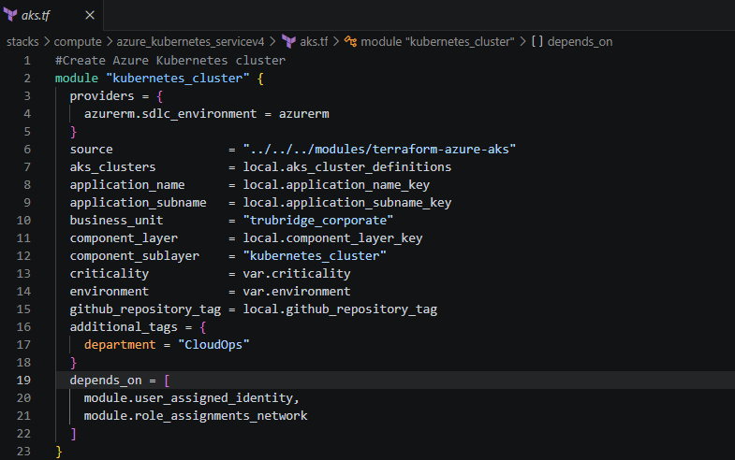
This is from AKS.tf
https://developer.hashicorp.com/terraform/language/modules
Root Module
- The root module is always the configuration in your workspace’s root directory (where you run terraform apply)
- In our case, the file aks.tf (with the module "kubernetes_cluster" block) is part of the root module.
It orchestrates everything: declares providers, variables, and calls child modules.
This is the root module calling a child module.
Child Module
- The folder ../../../modules/terraform-azure-aks is a child module.
It contains the logic for deploying AKS clusters.
Nested Child Modules
- If the terraform-azure-aks module itself calls other modules (for example, terraform-azure-aks-node-pool for node pools, or terraform-azure-aks-monitoring for monitoring), those become nested child modules.
providers = {
azurerm.sdlc_environment = azurerm
}
It tells Terraform:
“Inside this module, when the module asks for provider alias azurerm.sdlc_environment, use the root provider azurerm.”
This is called provider alias passing.
In Terraform, you pass provider aliases to child modules using the providers map within a module block. This allows a module to manage resources across different regions or accounts using specific configurations.
when we have multiple environments to deploy this code we are using the aliases (PD,QA,STG,DEV)
This prevents accidental deployment into the wrong subscription.
Ex:
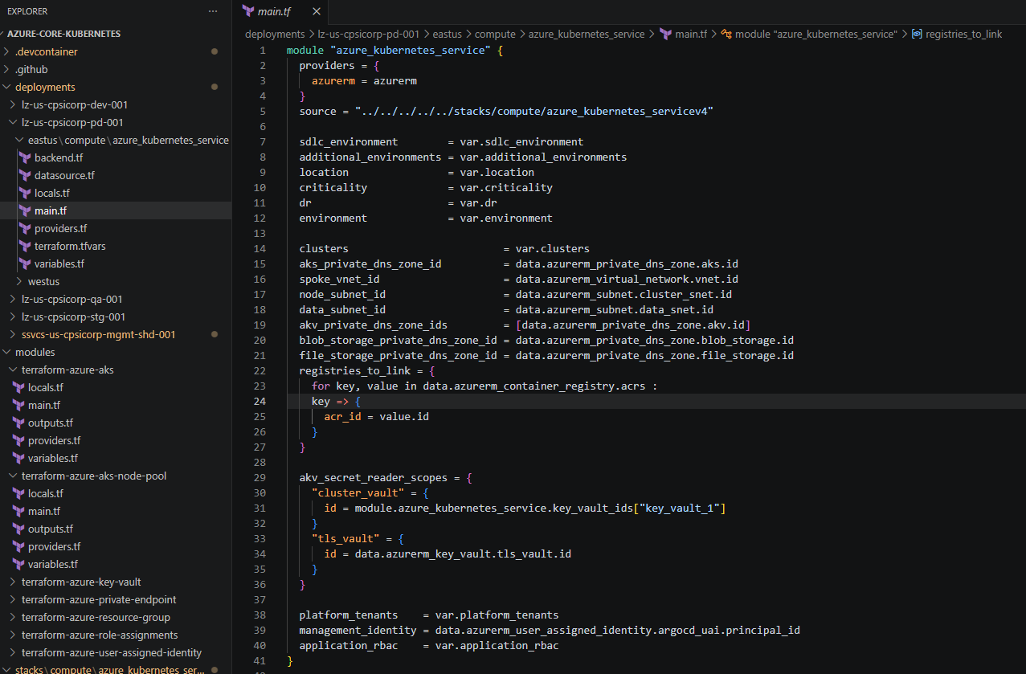
This is the lz-us-cpsicorp-pd-001 -EASTUS main.tf code .
in where they mentioned sdlc_enviroemnt = var.sdlc.envirorment
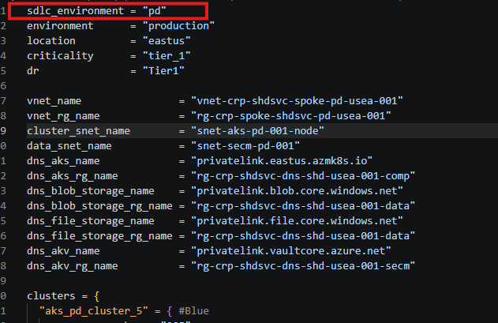
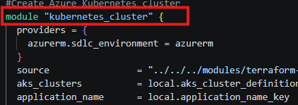
Why module "kubernetes_cluster" when we already have an AKS module?
- The root module (aks.tf) is instantiating the child module (terraform-azure-aks).
- The name kubernetes_cluster is just the label you give to that module instance. You could call it aks or cluster — it’s arbitrary.
- The important part is the source = "../../../modules/terraform-azure-aks", which points to the actual AKS module code.
Think of it like a function call: the function is terraform-azure-aks, and you’re naming this call kubernetes_cluster.
Why source = "../../../modules/terraform-azure-aks" instead of a folder/file?
- source must point to a module directory, not a single file.
- A module is always a folder containing multiple .tf files (main.tf, variables.tf, outputs.tf).
aks_clusters = local.aks_cluster_definitions
To define an Azure Kubernetes Service (AKS) cluster using Terraform locals, you typically structure your cluster configurations in a locals block to centralize and reuse settings. This approach is highly effective when managing multiple environments (e.g., dev, staging, prod) within a single configuration.
1. Define Local Variables
Start by defining a locals block where you store the specific configurations for your cluster. This keeps your main resource code clean and easily adjustable.

