Find out the no of users above the age of 25

select count(*) from facebook where age > 25;

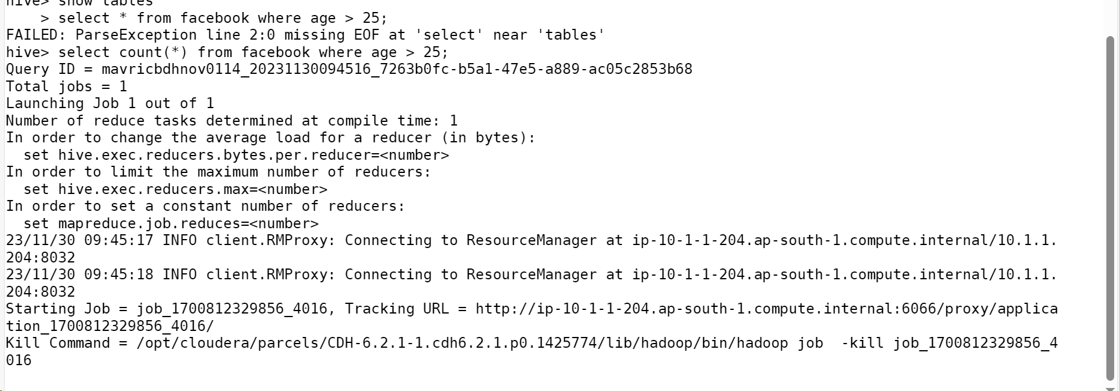

Find out the total no of users in the dataset

1. select count(userid) from facebook ;

Do male face book users tend to have more friends or female users

select gender,avg(friends) from facebook group by gender;

select gender, AVG(friend_count) from facebook where gender IN ('male', 'female') group by gender;

How many likes do young people receive on facebook as opposed to old people

select avg (likes_recd) from facebook where age >= 13 and <= 25;

5. Find out the count of facebook users for each birthday month

select month,count(*) from facebook group by month;

select avg(m_likes), avg(wlikes) from facebook where age >= 35;

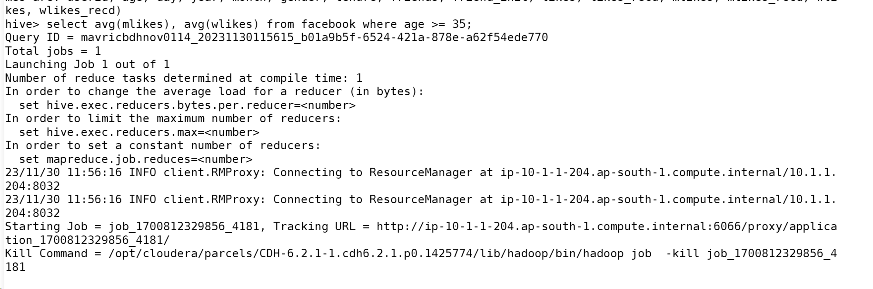

Do adult members use mobile phones or computers for facebook browsin