1. When u create a repository in github and upload all the files, create the repository with

username.github.io. eg. gadeutham2000.github.io

1. Place index.html in the root itself.
2. In github pages (which is in pages section), select your branch and folder from which the website should be deployed.
3. Ur website now will be deployed at

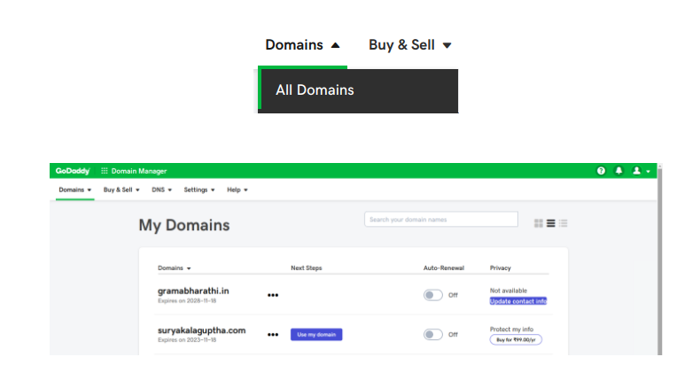

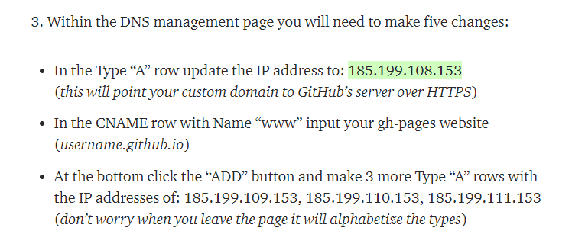

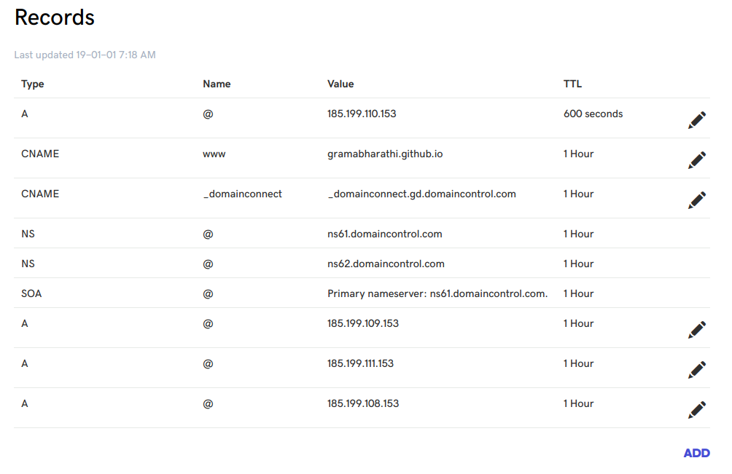

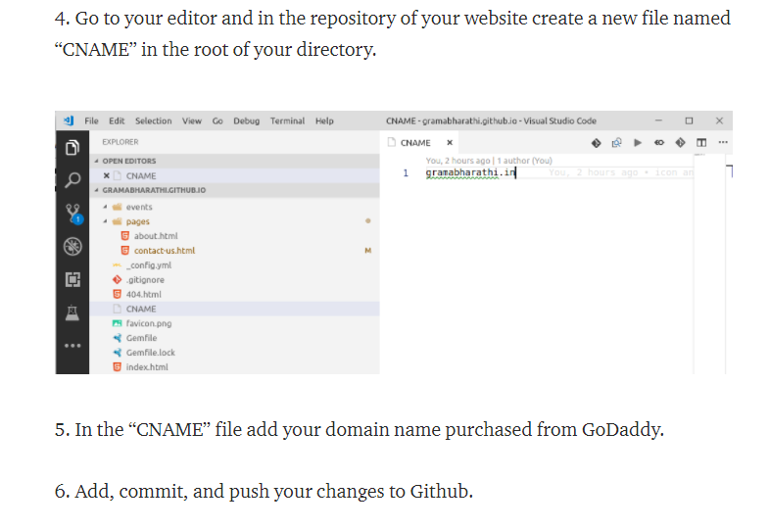

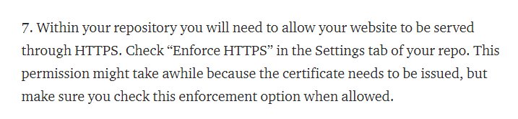

You should you custom domain in custom domain section. It will check whether the DNS settings that u did above are proper and if yes it will accept that domain. Now u can enforce https and other things etc.

