Instructions_SmallestWithMethods

Question: Java Method Exercises: Find the smallest number among three numbers

<https://www.w3resource.com/java-exercises/method/java-method-exercise-1.php>

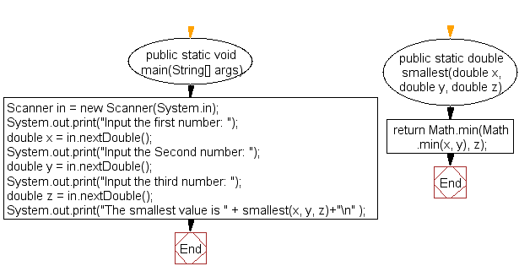

My code:

**package** Methods_Practice;

**import** java.util.Scanner;

**public** **class** SmallestWithMethods {

**public** **static** **void** main(String[] args) {

Scanner in = **new** Scanner(System.***in***);

System.***out***.print ("input the first number : ");

**double** x = in.nextDouble();

System.***out***.print ("input the second number : ");

**double** y = in.nextDouble();

System.***out***.print ("input the third number : ");

**double** z = in.nextDouble();

System.***out***.print("The smallest value is "+*smallest*(x,y,z)+"\n" );

}

**public** **static** **double** smallest(**double** x, **double** y, **double** z) {

**if** (x<y && x<z) {

**return** x;

} **else** **if** (y<z) {

**return** y;

} **else** {

**return** z;

}

}

}