**Problem Statement :**

Breast Cancer Detection Using AdaBoost Classifier .This documentation outlines a project focused on detecting breast cancer using the AdaBoost classifier. The project is designed to help students learn about machine learning for medical diagnosis by implementing and training the AdaBoost model on breast cancer data.

**Module 1: Introduction to Breast Cancer and Medical Diagnosis**  
**What is Breast Cancer?**  
At breast cancer, the uncontrolled growth of the cells in the breast into a lump or mass, most commonly known as a tumour. If the tumour is malignant, that is, cancerous, it is capable of invading the surrounding tissues or spreading to other parts of the body. so, it is essential to find this disease early on for effective treatment.  
  
**Types of Breast Cancer:**  
**Malignant (cancerous):** This type contains tumour cells that effect the surrounding tissue and grow rapidly, which allows them to easily spread to other organs without treatment.  
**Benign (non-cancerous):** For the most part, these lumps are considered harmless. They do not spread but will require monitoring or, at least, removal if they become large enough.

**Early Detection is Important:**  
If breast cancer is diagnosed early, it will drastically influence treatment results. Some early-stage cancers are easier to treat and offer a more favourable prognosis. Early detection methods include imaging tests (mammograms and ultrasounds), biopsies (where a small sample of tissue is removed), and laboratory tests. Regular self-examinations and checkups are also very important.  
  
**Machine Learning in Medical Diagnosis**  
**How Does Machine Learning Help?**  
Machine learning usage is growing healthcare through the application of algorithms to medical data that identify patterns. The technology helps in diagnosing breast cancer by finding subtle indicators in the data, such as on mammogram images and patient histories.  
  
**Machine Learning In Breast Cancer Detection Examples:**  
Classification Model: These models treat the distinction between malignant (cancerous) and benign (non-cancerous) tumours.  
Predictive Model: These models assess the chance of cancer recurring or predicting the alternative chance of survival of a patient based on some other aspects.

**Module 2: Data Collection and Preprocessing**

**Importing Required Libraries**

**pandas:** For handling data in DataFrame format.

**numpy:** For numerical operations.

**sklearn.preprocessing.StandardScaler:** For scaling features.

**sklearn.ensemble.AdaBoostClassifier:** For using the AdaBoost algorithm for classification.

**sklearn.tree.DecisionTreeClassifier:** For building a decision tree model.

**sklearn.model_selection.train_test_split**: For splitting the data into training and testing sets.

**sklearn.metrics:** For evaluating the model's performance

**Loading the Dataset**

The code defines the column names for the dataset, which includes an 'ID', 'Diagnosis' and 30 features

It reads the data from a CSV file called wdbc.data and stores it in a DataFrame named data

**Inspecting the Dataset**

**Data.head(10)** displays first 10 rows

**data.tail(10)** will displays last 10 rows of the dataset

**data.shape** shows the number of rows and columns

**data.info()** gives a summary of the dataset, including column names, data types

**data.describe().T** gives statistical summaries of numerical columns, such as count, mean, and standard deviation. T is used to display as transpose

**Outlier Detection: Using IQR (Interquartile Range)**

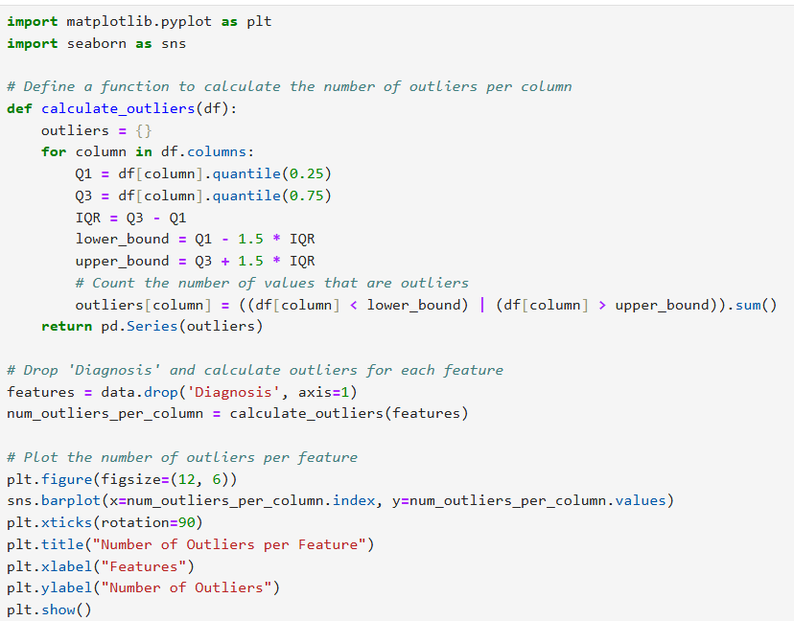

**Imports:** The code brings in tools for making graphs (matplotlib and seaborn).

**Outlier Function:**The calculate_outliers function checks each column in a table (DataFrame) for outliers.It finds the low and high limits for normal values using the first and third quartiles (Q1 and Q3).It counts how many values are outside these limits.

**Prepare Data:**The code removes the 'Diagnosis' column from the dataset, focusing only on the features for outlier analysis.

**Count Outliers:**[¶](http://localhost:8888/notebooks/OneDrive/ML/Breast_Cancer_Detection.ipynb#Count-Outliers:)It uses the function to count how many outliers are in each feature.

**Make a Bar Graph**:The code creates a bar graph showing the number of outliers for each feature, making it easy to see which features have more outliers.

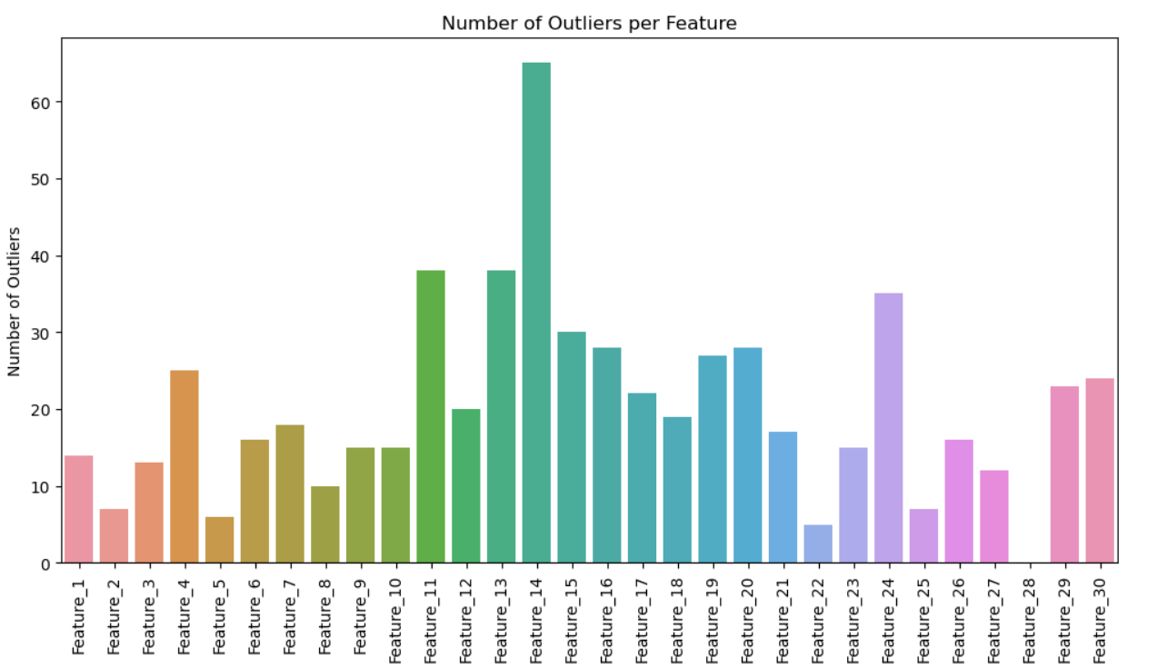

**Checking for Missing Values**

As we can see , there are no missing values , so no need for data cleaning

**Data Analysis**

**Check for Duplicates: Identify the number and percentage of duplicate rows.**

**Count Total Rows**: The code calculates the total number of rows in the Data Frame and stores it in num_total_rows.

**Count Duplicate Rows**: It checks for duplicate rows in the Data Frame and counts how many there are, storing the result in num_duplicate_rows.

**Calculate Percentage of Duplicates:** The code computes the percentage of duplicate rows by dividing the number of duplicates by the total rows and multiplying by 100.

**Print Results:** Finally, it prints the number and percentage of duplicate rows to the console.

**Data Preprocessing :**

**Note**:There are no missing values and no changes in datatypes

**Remove the 'ID' Column**

Remove the 'ID' Column: It deletes the column named 'ID' from the DataFrame data. The 'ID' column is typically used to uniquely identify each row and does not provide useful information for analysis or model training

**axis=1**: This specifies that you're dropping a column

**inplace=True**: This means that the changes will be applied directly to the data

**Scalling features**

**Define Features and Target Variable**: Separate the features (X) from the target variable (y)

The code defines X as the Data Frame containing all features except the 'Diagnosis' column

y as the Series containing the 'Diagnosis' column, which is the target variable for prediction

**Data Splitting**

**Dataset Splitting**: The code divides the dataset into a training set and a testing set.

**Training and Testing Proportions**: It uses 70% of the data for training the model and 30% for testing its performance.

**Reproducibility**: The random_state=42 ensures that the split is consistent each time the code is run, allowing for reproducible results.

**Output Dimensions**: The code prints the number of samples in both the training and testing sets, providing insight into their sizes