**Jenkins Installation:**

1. Launch EC2 Instance.
2. Check if java installed and Install java if not available.
   1. java -version
   2. yum install java-1.8*
   3. confirm java version and set java path

java -version

find /usr/lib/jvm/java-1.8* | head -n 3

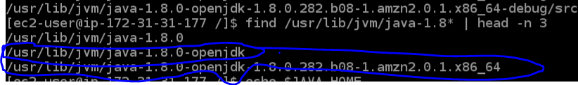

JAVA_HOME=/usr/lib/jvm/java-1.8.0-openjdk*version of amazon

export $JAVA_HOME

set the above in vi ~/.bash_profile

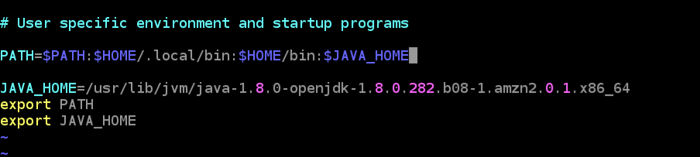

1. Now inistall the wget to fetch the Jenkins from url
   1. Yum install -y wget
2. sudo wget -O /etc/yum.repos.d/jenkins.repo https://pkg.jenkins.io/redhat-stable/jenkins.repo
3. sudo rpm --import <https://pkg.jenkins.io/redhat-stable/jenkins.io.key>
4. yum -y install jenkins
5. sudo systemctl status Jenkins
   1. if this shows as inactive start the Jenkins
6. sudo systemctl start Jenkins
7. access the Jenkins using ec2 instance ip:8080
8. on the first time get the password from sudo cat /usr/lib/Jenkins/secrets/initialAdminPassword