Update products storage ate 0 and 1 as 16 and 32:

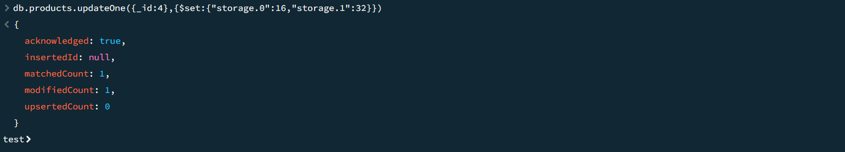

Practice updateMany:

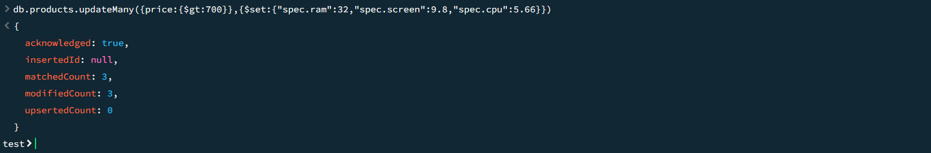

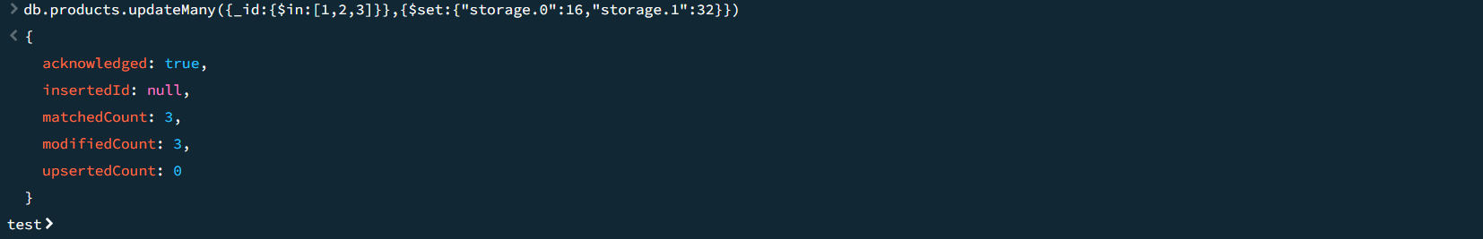

Increment operator:

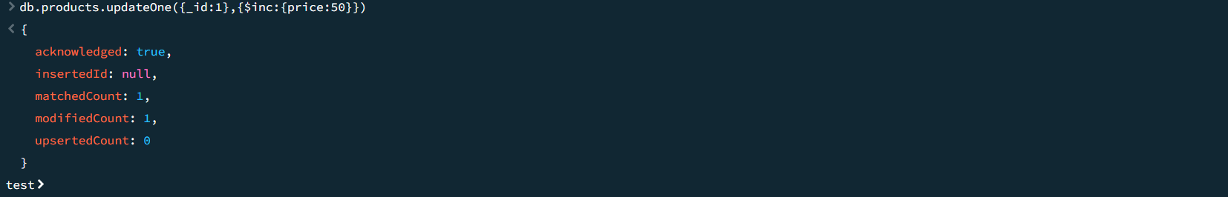

For decrement:

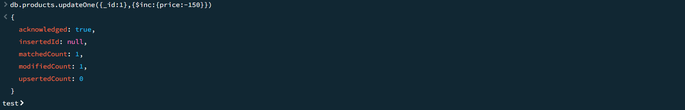

For nested:

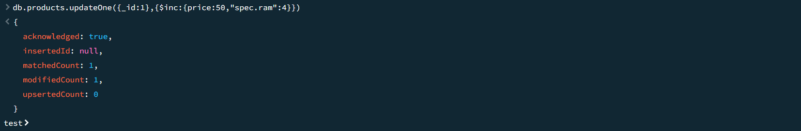

Using minimum:

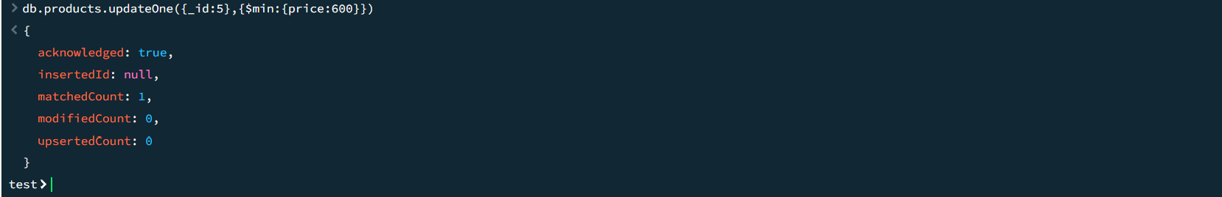

For maximum:

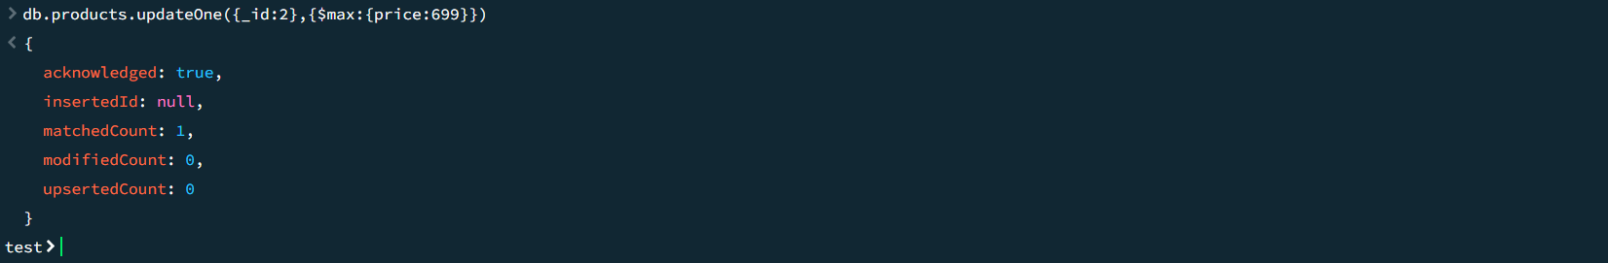

Multiple:

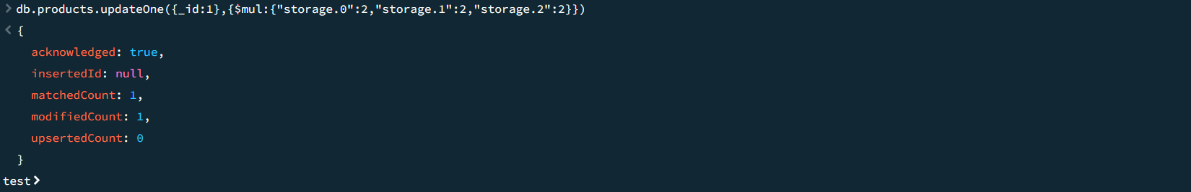

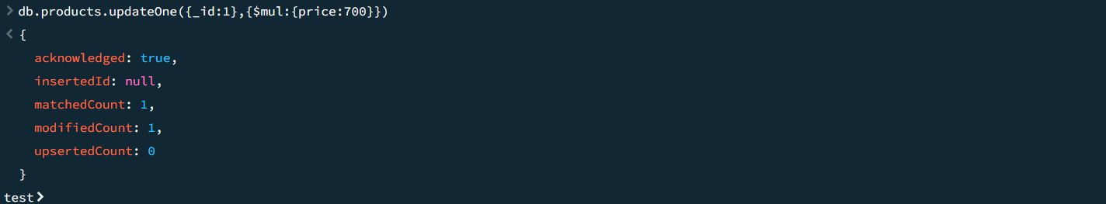

To remove price field:

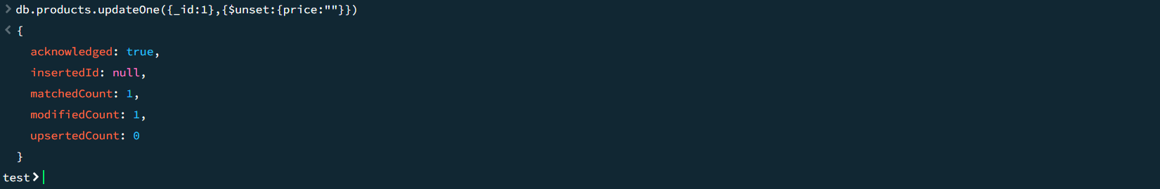

To delete spec.ram everywhere:

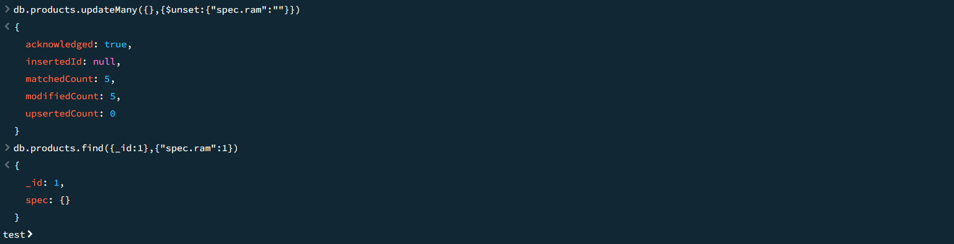

Update nmae column as name:

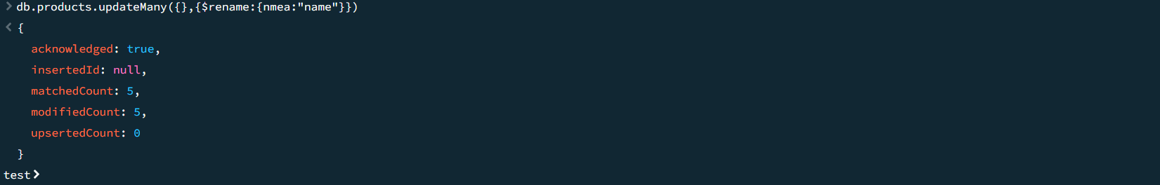

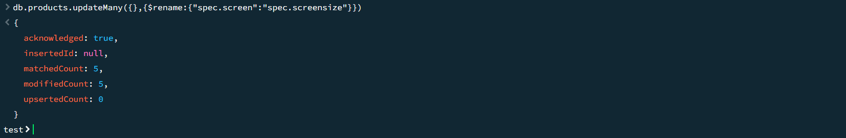

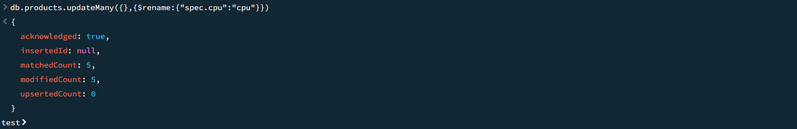

For upsert: