find out maximum quantity of the data:



Multiply each product quantity wise and get the item based on maxvalue:

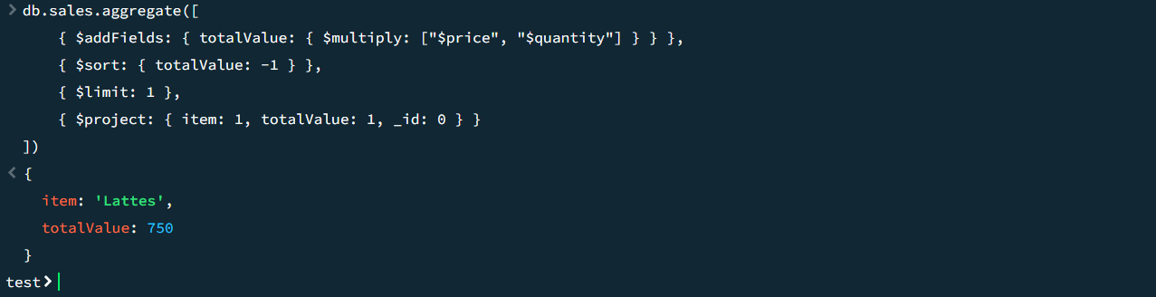

From each item having multiple products find the second maximum from the item:

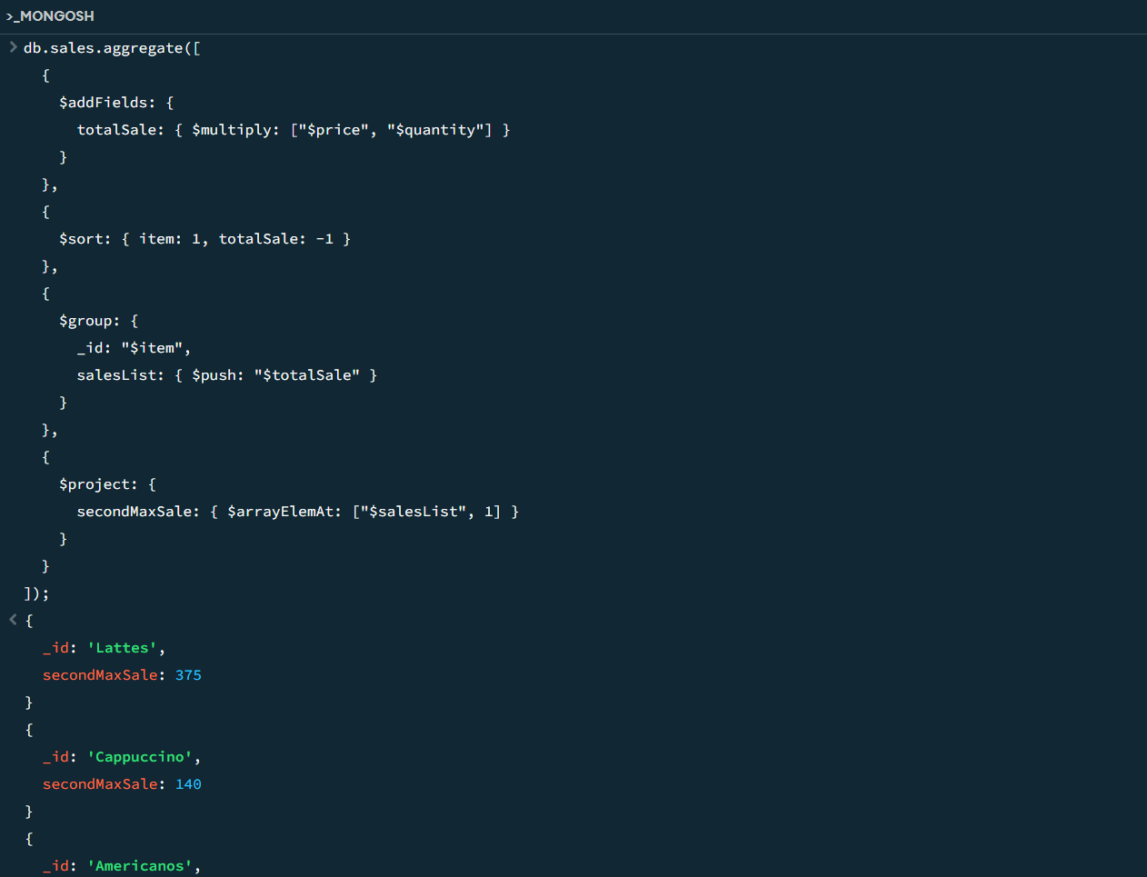



Get indexes:

