Using element match function find the products having less than 128gb:

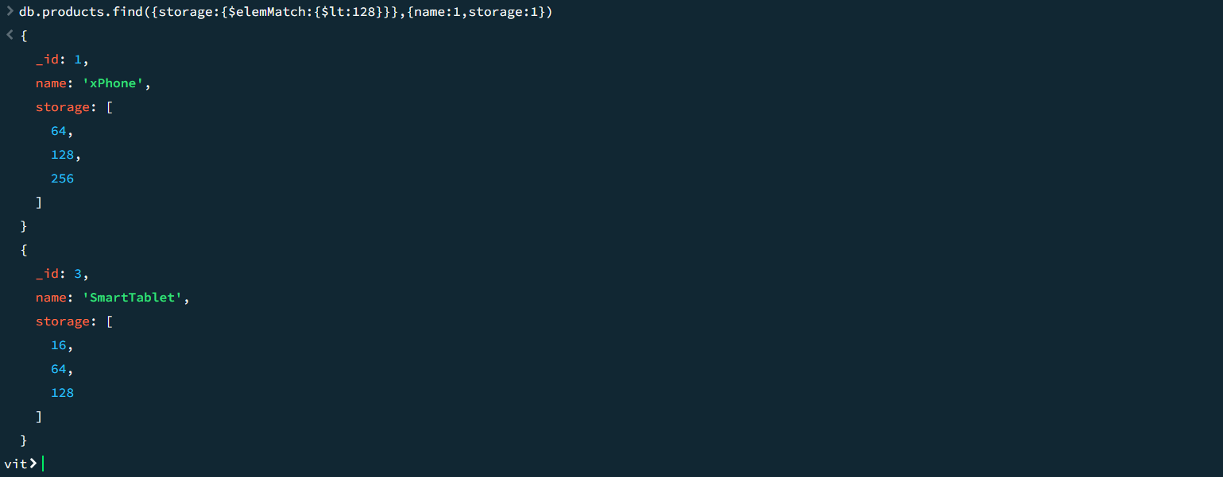

Get the same output without using element match:

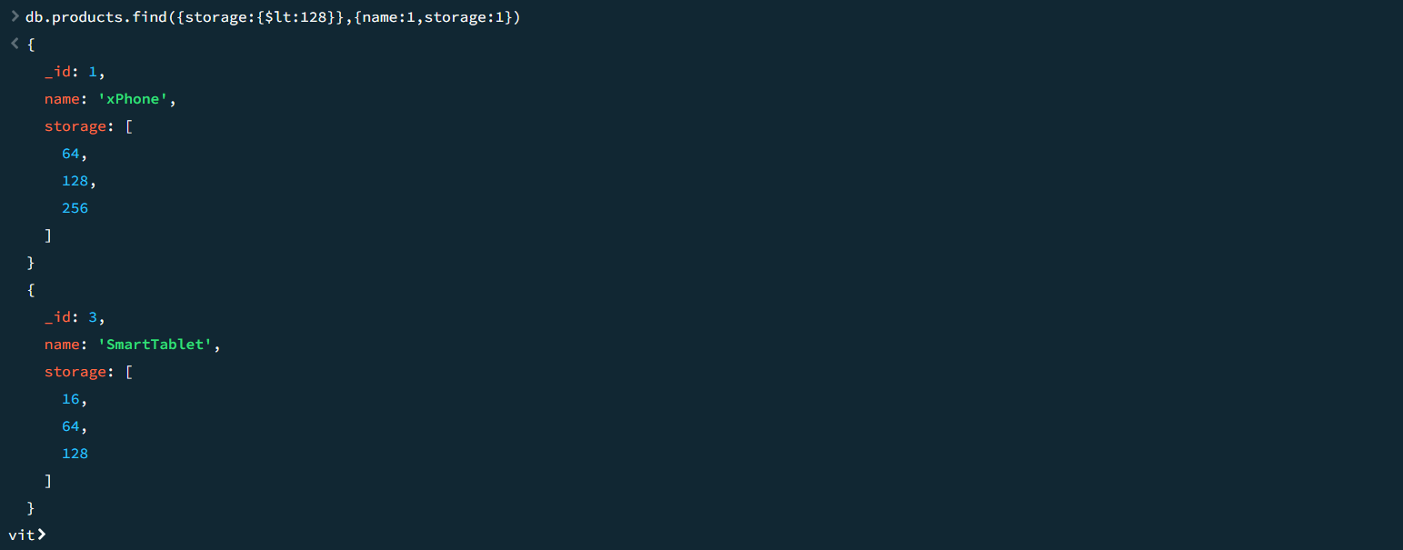

Sort products by using sorting method using price:

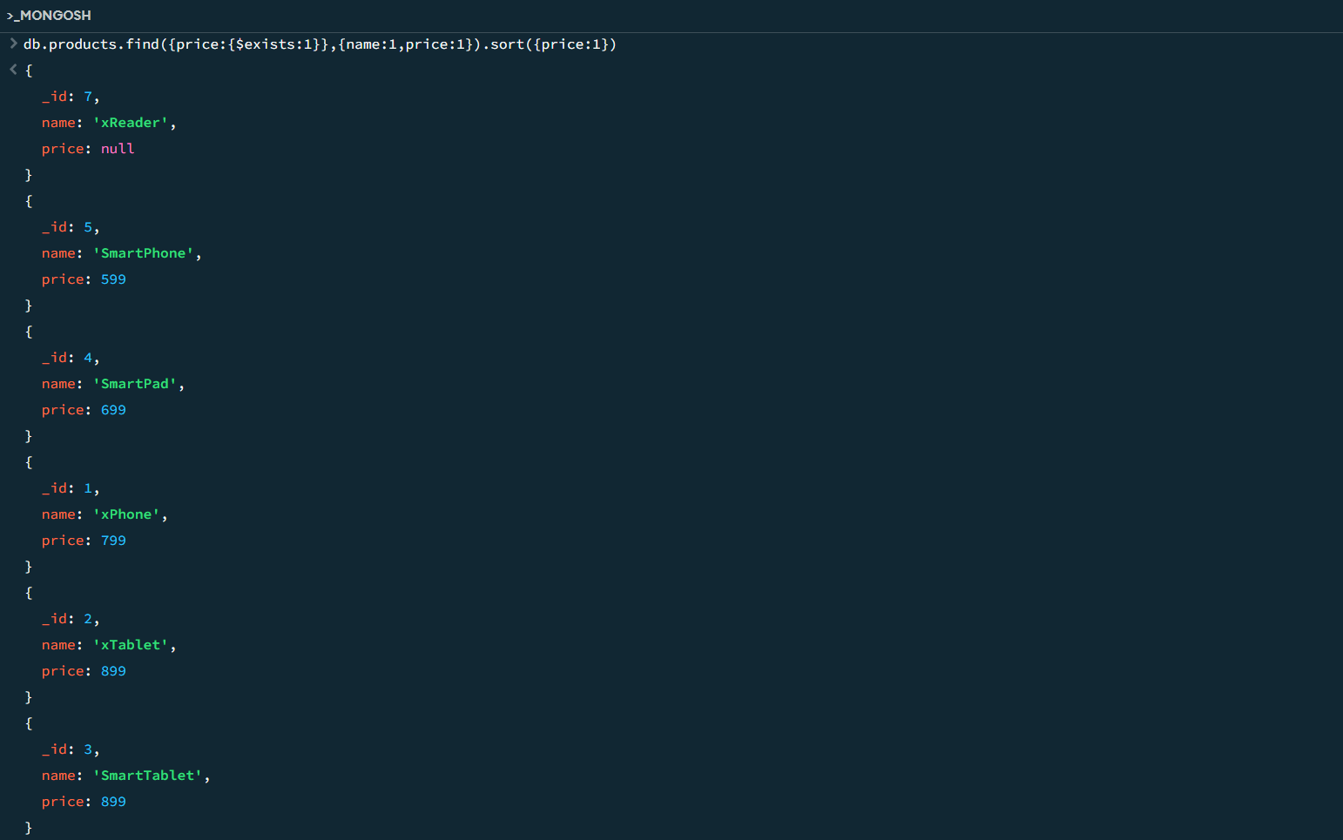

Sort the data using sorting method with the help of release date:

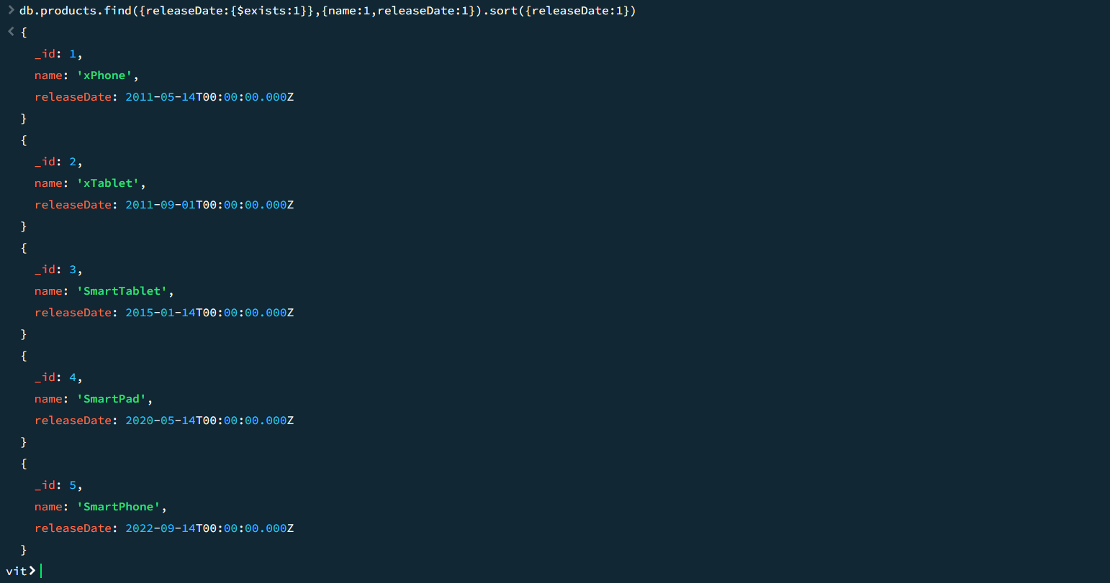

Sort products by using sorting method using price(in descending order):

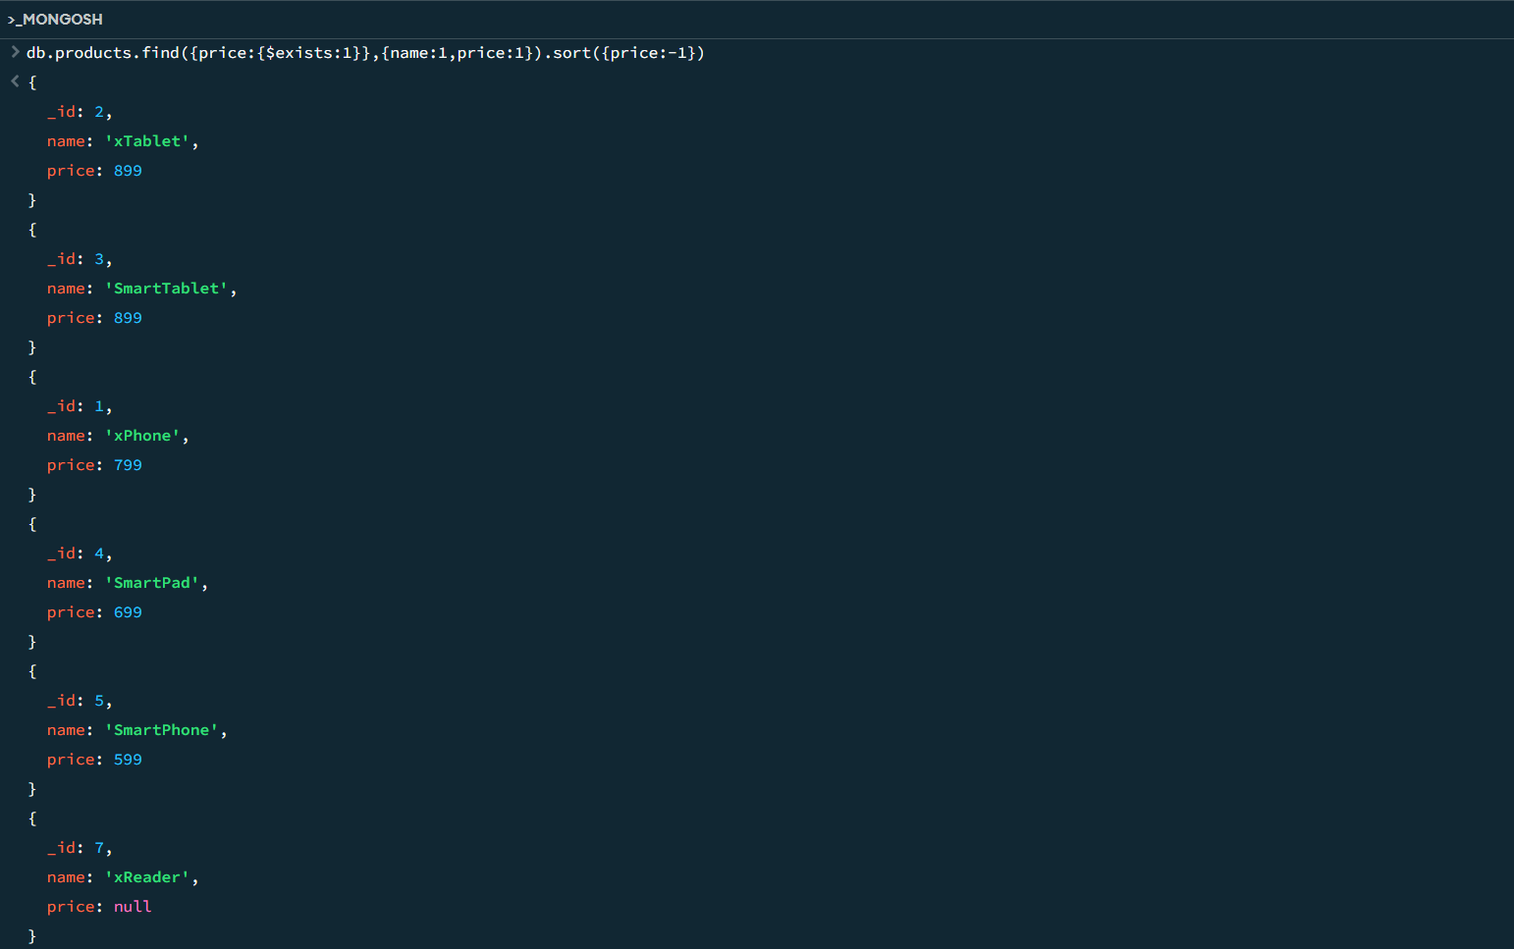

Sort using the sorting method with both price and name:

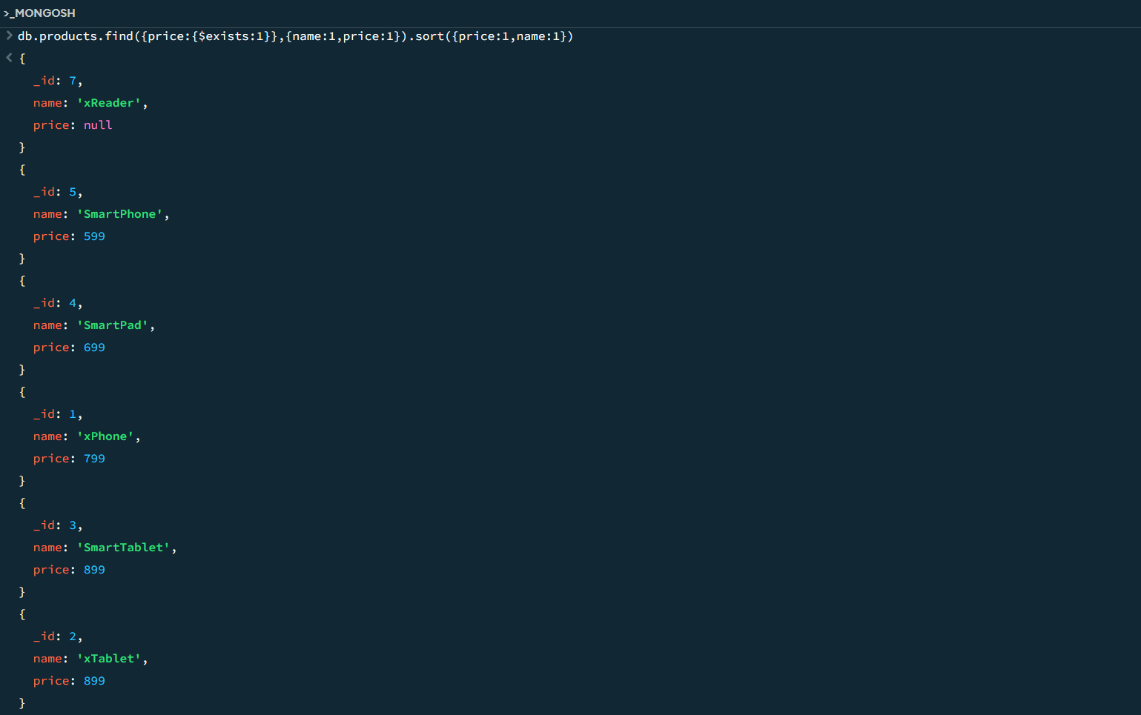

Sort using the sorting method with both price and name(price: descending order and name: ascending order) :

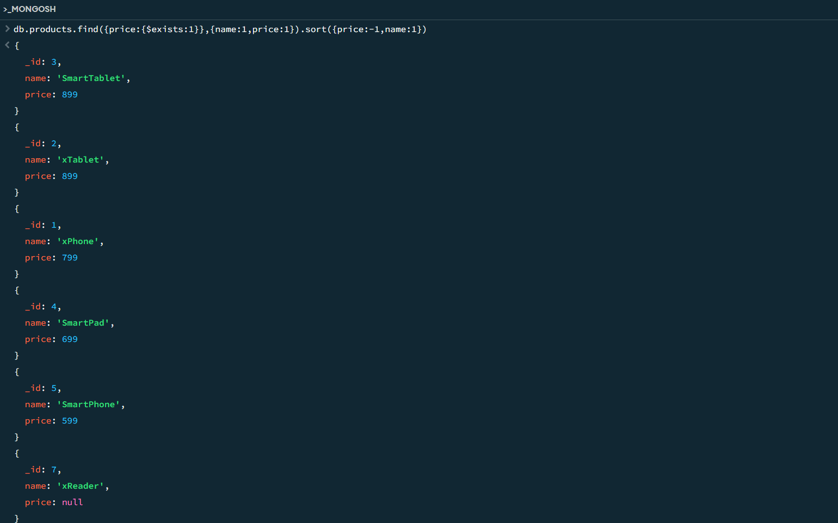

Sort the elements using sort of price and limit it to the one output:

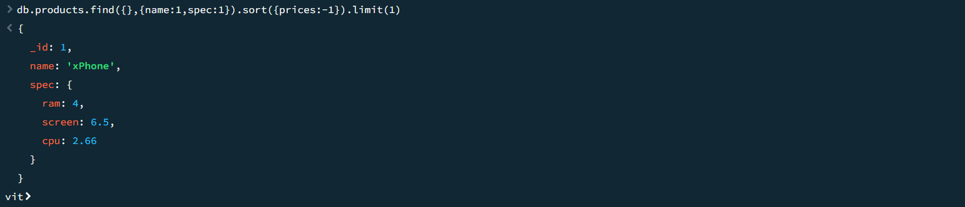

Using skip and limit print 3 to 5 elements:

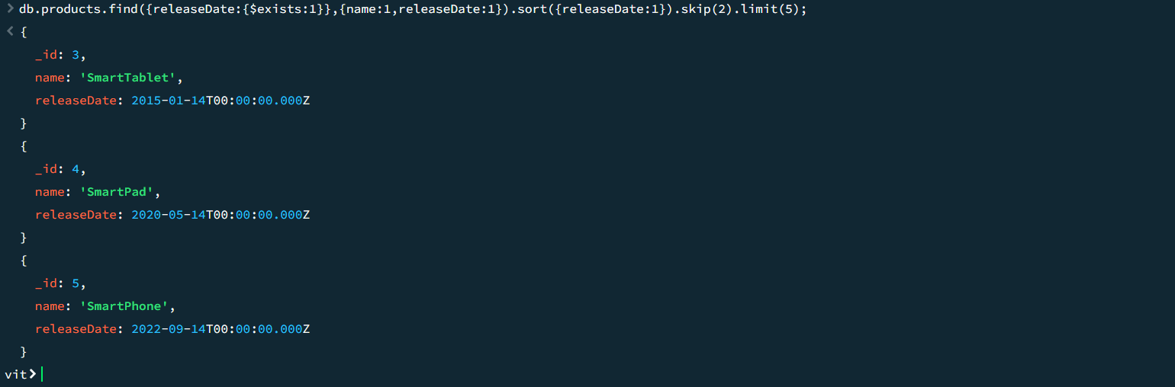

Update operation:

