Initialize the data into operators database

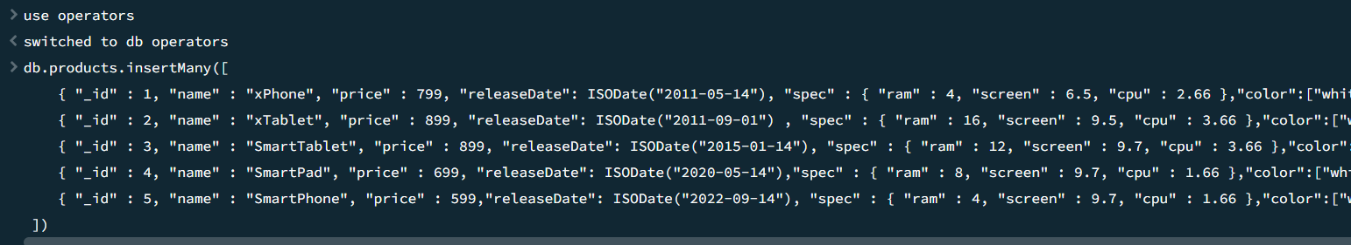

Find products having ram = 4gb

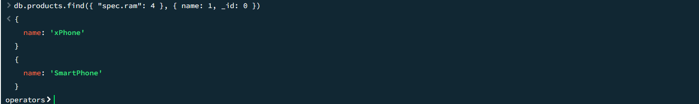

Find the products having colour = black

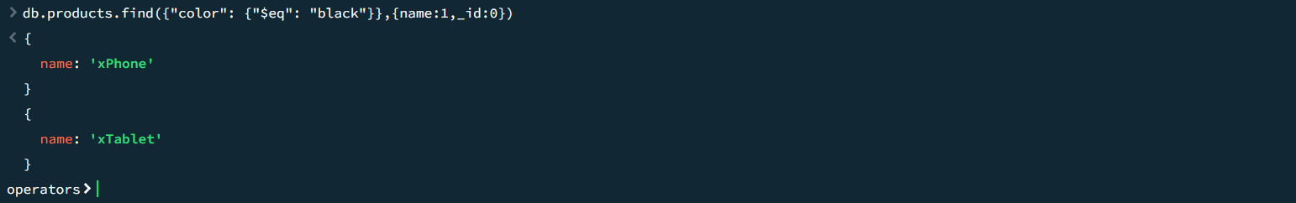

Find the product with reference to release date:

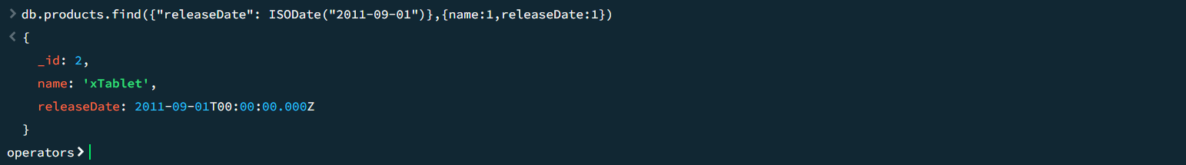

Find the product having screen size less than 7 :



Find the products having storage less than 128:

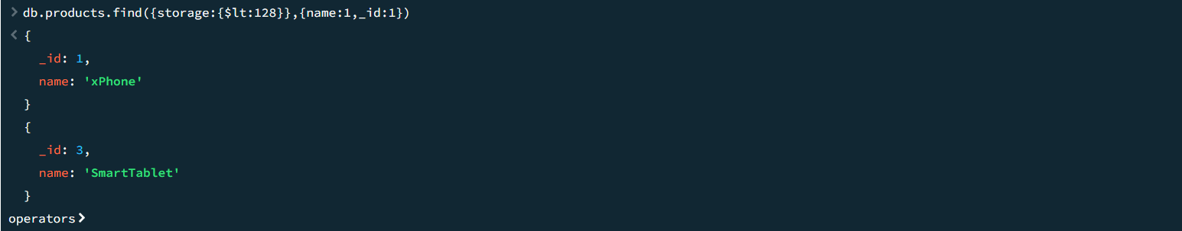

Find the products having cpu less than or equal to 3.66:

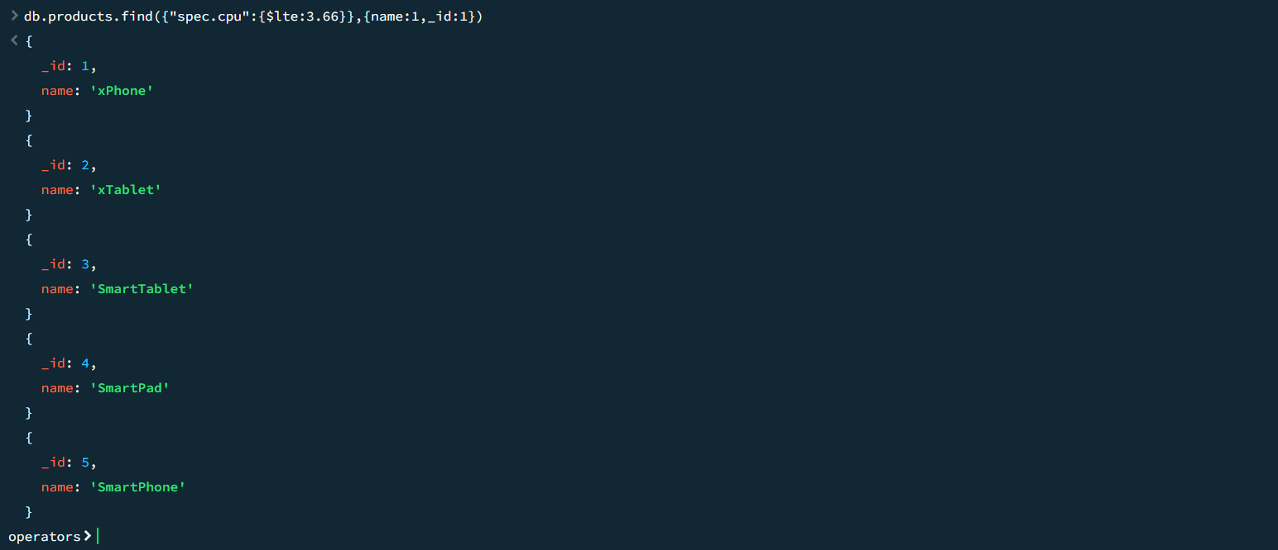

Find the products whose price is not equal to 899:

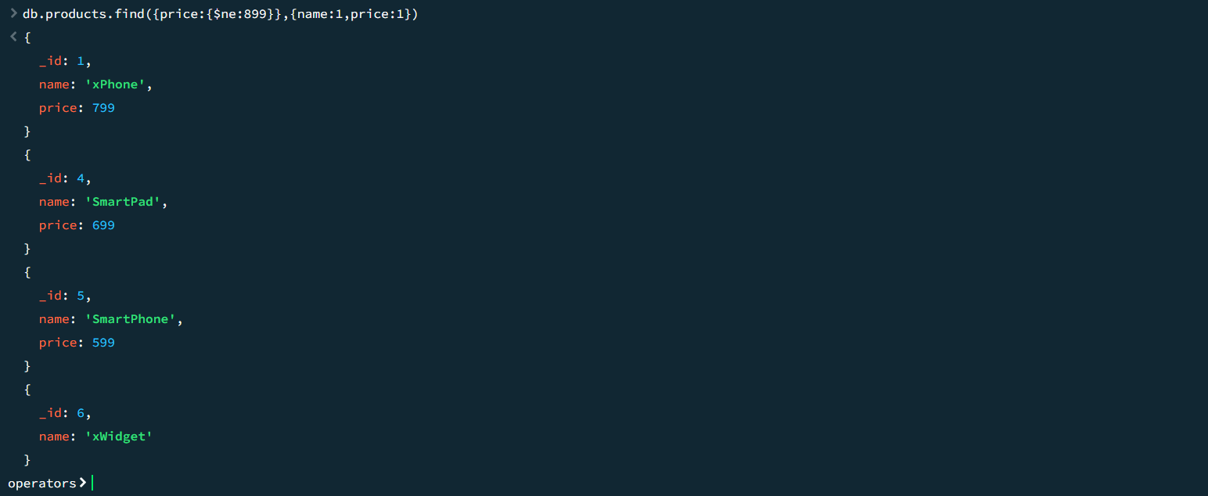

Find the products whose ram is not equal to 8;

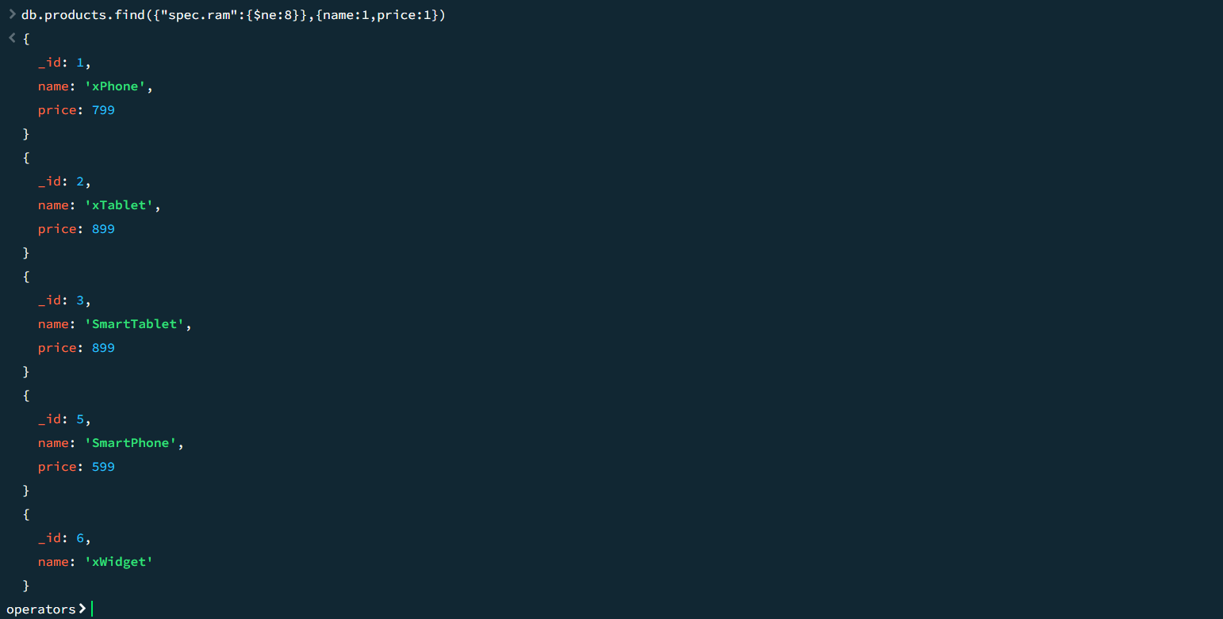

Find the products of price 699 and 799 :

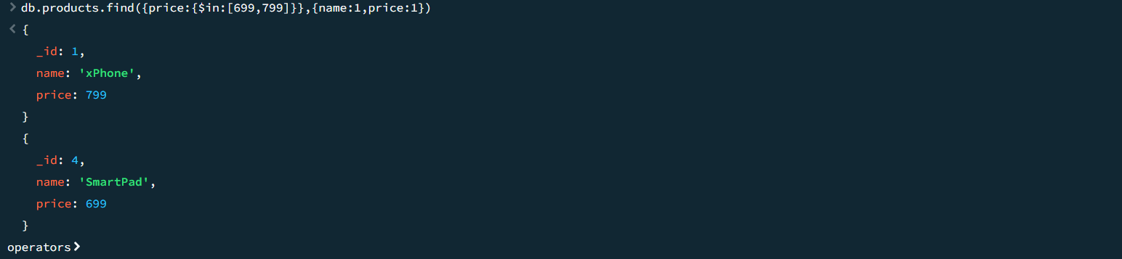

Find the products released in dates 2011-05-14 and 2015-01-14:

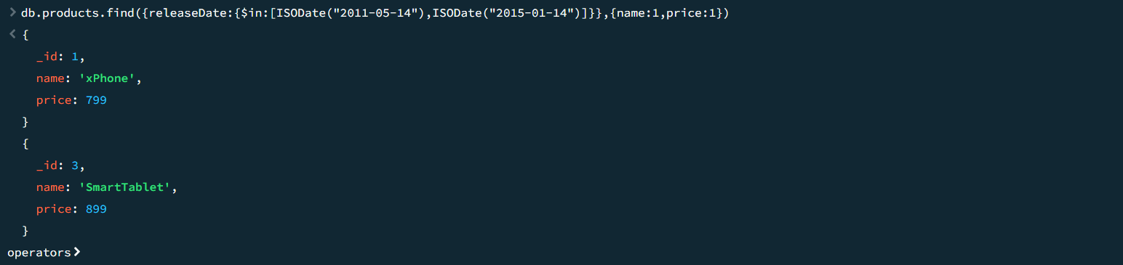

Find the products where pattern starts with g and w:

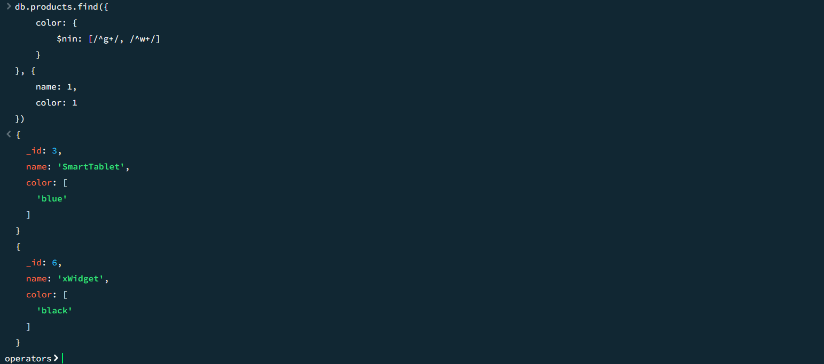

Find products where it starts with smart:

