Customer Banking and Financial Analytics

Project Overview
This project analyzes customer banking and financial activity across customer demographics, accounts, transactions, loans, credit cards, customer feedback, and transaction anomalies. Python is used for data loading, cleaning, preprocessing, exploratory data analysis, statistical analysis, and visualizations. The processed data is then presented through an interactive three-page Power BI dashboard to convert analytical findings into business-focused insights.

Business Problem
The business has a large volume of customer and financial data but needs a clear view of customer profiles, account balances, transaction behavior, loan exposure, credit-card activity, feedback, and unusual transactions. Without structured analysis, it is difficult to identify important patterns and areas requiring management attention.

Project Objectives
  - Analyze customer demographics, account information, transaction behavior, loans, and credit-card activity.
  - Examine customer feedback and resolution status to understand service experience.
  - Clean, transform, and prepare the data for reliable analysis and visualization.
  - Perform descriptive, diagnostic, and multivariate analysis using Python.
  - Build an interactive Power BI dashboard and communicate actionable business findings.

Dataset Description

Attribute | Details
Domain | Banking and Financial Services
Original dataset | 5,000 rows × 40 columns
Working dataset | 5,000 rows × 20 selected analytical columns
Format | CSV
Coverage | 2000–2023; transaction analysis is primarily focused on 2023
Tools | Python, Pandas, NumPy, Matplotlib, Seaborn, Microsoft Power BI

Key dataset areas
Customer: Customer ID, Age, Gender, City | Account: Account Type, Account Balance, Account Opening Date | Transaction: Transaction Date, Transaction Type, Transaction Amount, Balance After Transaction | Loan: Loan Type, Loan Amount, Interest Rate, Loan Status | Credit Card: Card Type, Credit Card Balance | Service: Feedback Type, Resolution Status | Risk: Anomaly.
Derived fields: Transaction Year, Transaction Month, Transaction Month Name, Account Opening Year, Customer Tenure Years, and Age Group.
Dataset source recorded in the notebook: GitHub – Comprehensive Banking Database.

Stage 1 – Problem Definition and Dataset Selection
Stage 1 established the business problem, expected outcome, project scope, and dataset selection. The selected banking dataset contains 5,000 customer records and 40 original features. Twenty relevant features were selected for the analytical workflow so that the project remained focused on customer, account, transaction, loan, credit-card, feedback, and anomaly analysis.

Expected Outcome
The expected outcome was a reliable analytical dataset, meaningful Python-based EDA, and an interactive Power BI dashboard capable of communicating customer and financial patterns to stakeholders.

Stage 2 – Data Cleaning and Pre-processing
Stage 2 prepared the selected data for analysis. The workflow checked data quality, missing values, duplicates, column naming and data types, numerical distributions, outliers, and date-related fields. Date fields were converted into useful analytical attributes, and customer tenure and age-group fields were created for segmentation.
Cleaning / Preparation Area | Work performed
Missing values | Checked missing-value counts and percentages to assess data completeness.
Duplicates | Checked duplicate records before analysis.
Data types | Validated numerical, categorical, and date columns.
Outliers | Applied the IQR method to Age, Account Balance, Transaction Amount, Balance After Transaction, Loan  Amount, Interest Rate and Credit Card Balance.
Skewness | Calculated skewness; numerical variables were approximately symmetric with values close to zero.
Feature engineering | Created year/month fields, account opening year, customer tenure, and age groups.
Statistical summary | Reviewed count, mean, standard deviation, minimum, quartiles, median, and maximum.

Data Quality Results and Treatment:
Missing values and duplicate records were checked using Pandas. The cleaned dataset contained zero missing values and zero duplicate rows; therefore, no missing-value imputation or duplicate removal was required. The IQR method was applied to seven numerical columns: Age, Account Balance, Transaction Amount, Balance After Transaction, Loan Amount, Interest Rate, and Credit Card Balance. No IQR-based outliers were identified in these columns, so no outlier removal was performed based on this test. These results do not rule out unusual transactions that may require further investigation.

Stage 2 Outcome
The result was a cleaned and analysis-ready dataset used consistently across Python EDA and Power BI. The preprocessing stage also ensured that the dashboard could use meaningful dimensions such as Age Group, Transaction Year, Transaction Month, and Customer Tenure.
- Analytical Approach
  - Descriptive analysis: customer distributions, account profiles, transaction activity, and financial summaries.
  - Diagnostic analysis: comparisons and relationships such as account balance by account type, feedback versus resolution, and loan patterns.
  - Multivariate analysis: account type + transaction type, loan type + status, and account type + gender combinations.
  - Business interpretation: each visualization was followed by insights, interpretation, and business meaning.
This structured workflow demonstrates that the project is not only a dashboard exercise: the analytical reasoning and calculations were performed in Python before the final Power BI presentation.

Stage 3 – Exploratory Data Analysis and Visualization
Stage 3 explored the cleaned dataset through univariate, bivariate, and multivariate visualizations. The notebook contains more than the minimum number of Python visualizations and includes chart-specific business questions, features used, calculations, interpretations, and business meanings.

Key Python Analysis and Findings
Analysis | Main finding / business interpretation
Gender distribution | 5,000 customers are relatively balanced across Female (1,727), Other (1,639), and Male (1,634).
Age profile | Customers span approximately 18–70 years, providing a broad base for age-segment analysis.
Age groups | 56–65 is the largest group (978); 65+ is the smallest (397).
City distribution | San Jose has the highest city count among the analyzed cities (about 163); city concentrations are  relatively close.
Account type | Savings (2,507) and Current (2,493) accounts are almost equally represented.
Account balance | Balances are spread across a broad range, supporting customer balance segmentation.
Transaction type | Deposits are the most frequent; Transfers are the least frequent, with relatively small differences.
Transaction amount | Values span roughly 0–5,000, with visible concentration in mid-to-high transaction ranges.
Anomaly distribution | 4,700 normal records (94%) and 300 anomalous records (6%).
Avg. account balance | Savings average ≈ 5,117.26 versus Current ≈ 5,003.56; the difference is small.
Avg. transaction amount | Transfer ≈ 2,521.35 is highest; Withdrawal ≈ 2,497.18 is lowest; the difference is small.
Transaction vs credit-card balance | Correlation ≈ -0.003219, indicating an almost negligible linear relationship.
Feedback vs resolution | Suggestion has the highest pending count (872); Praise has the highest resolved count (845).
Loan analysis | Auto + Rejected has the highest observed average loan amount (≈ 26,558.02); Mortgage + Approved had the lowest observed average loan amount: 24,303.98.
Correlation heatmap | Account Balance and Balance After Transaction have the strongest relationship at about 0.70; Most other numerical relationships were relatively weak.
Transaction by account + gender | Median transaction values are broadly similar; No very large difference appears between groups.

(

Stage 3 Outcome
The EDA established the evidence base for the Power BI dashboard. It identified balanced customer and account segments, transaction patterns, loan exposure, customer-service opportunities, and a measurable anomaly subset requiring monitoring.
A key analytical strength is that the notebook distinguishes insight from interpretation: the insight states the observed result, while the interpretation explains what the chart shows and why it matters.

Stage 4 – Power BI Dashboard, Insights and Presentation
The cleaned dataset was exported and connected to Power BI to create a three-page interactive dashboard. The report uses consistent navigation, KPI cards, slicers, charts, and reset-filter functionality.
Presentation note: The three dashboard pages are separate report pages. Drill-down should be described as the ability to move from a higher-level summary to a more detailed level within a visual hierarchy; the three pages themselves are not drill-down pages.

Page 1 – Customer & Account Overview

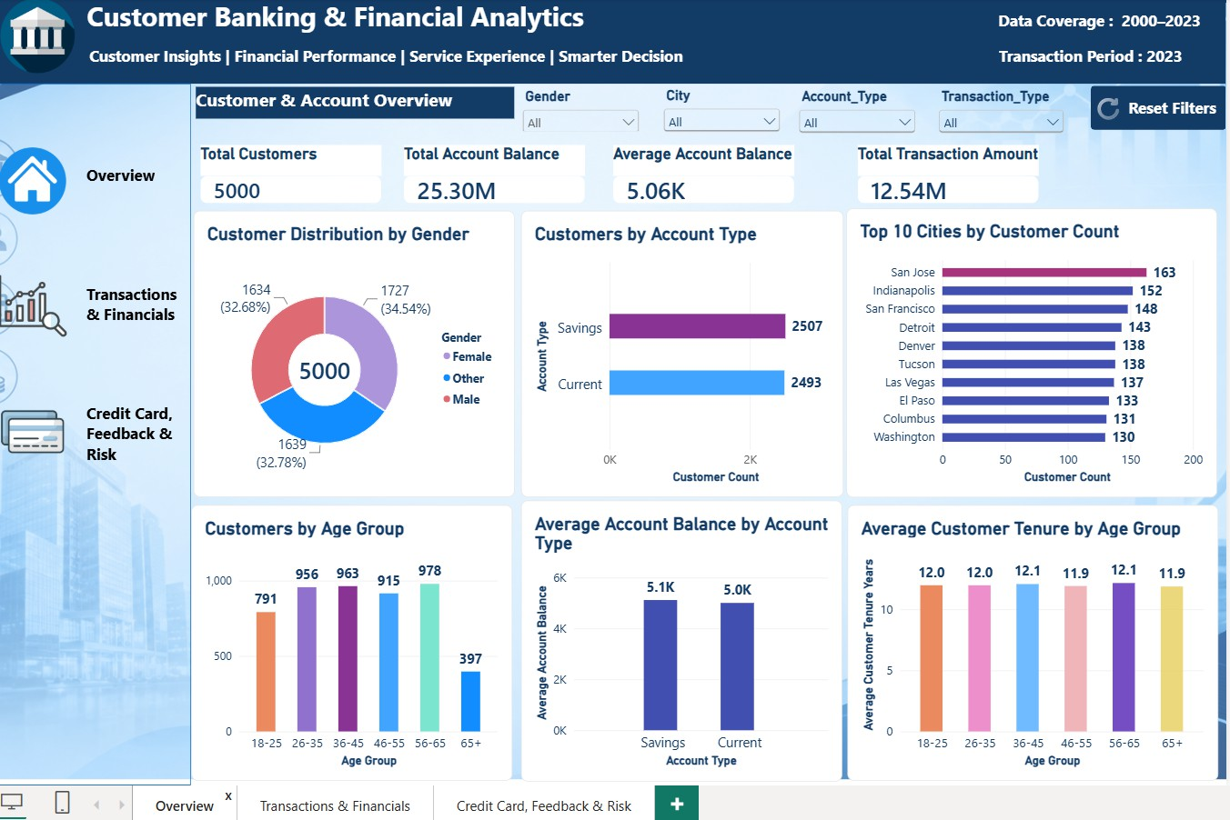
Chart explanation: The page begins with KPI cards for Total Customers, Total Account Balance, Average Account Balance, and Total Transaction Amount. The gender donut shows the composition of the 5,000 customers. The account-type bar compares Savings and Current customers. The Top 10 Cities chart highlights locations with higher customer concentration. Age-group bars show customer segmentation, Average Account Balance by Account Type compares financial balances, and Average Customer Tenure by Age Group compares relationship duration. Slicers for Gender, City, Account Type, and Transaction Type allow interactive filtering.

Page 2 – Transactions & Financial Analysis

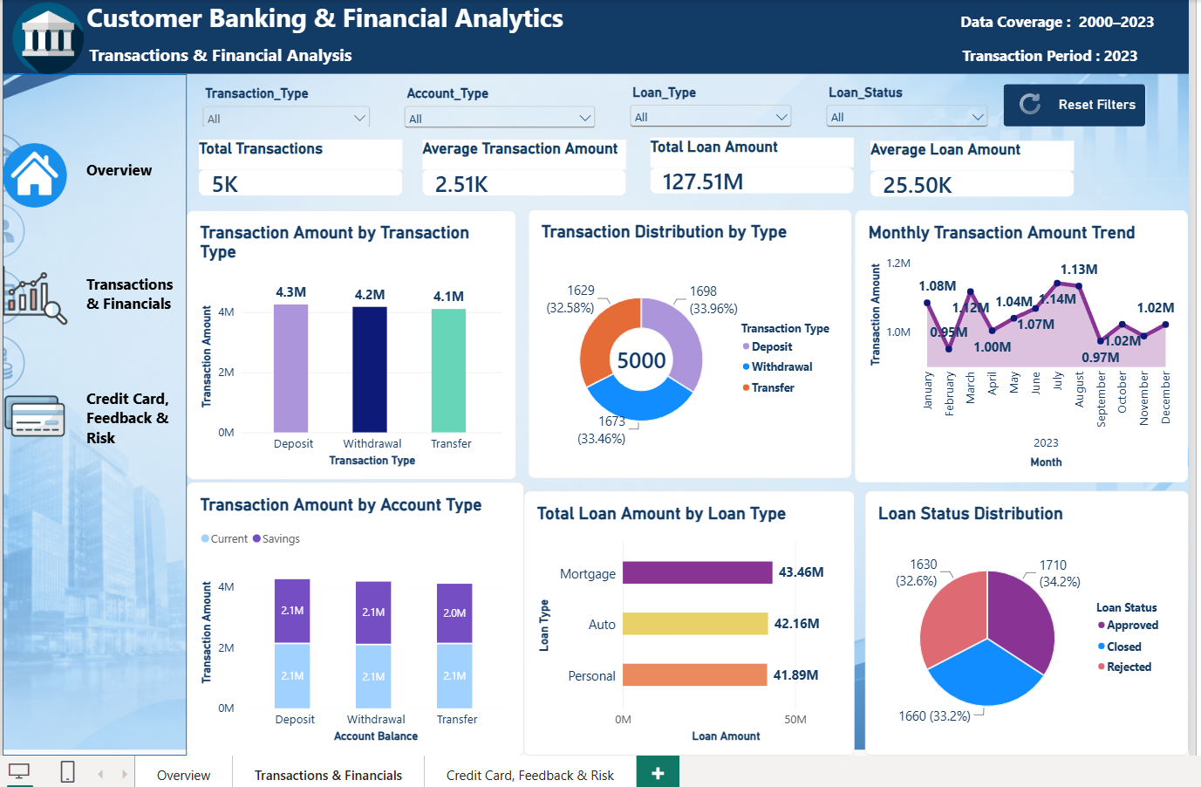

Chart explanation: KPI cards summarize total transactions, average transaction amount, total loan amount, and average loan amount. Transaction Amount by Transaction Type compares deposit, withdrawal, and transfer values. Transaction Distribution by Type shows transaction composition. The monthly trend chart tracks transaction amounts through 2023. The column chart compares Transaction Amount with Account Balance by account type. Loan Type bars show the largest loan exposure, while Loan Status distribution summarizes approved, closed, and rejected records. Slicers enable analysis by transaction type, account type, loan type, and loan status.

Page 3 – Credit Card, Feedback & Risk
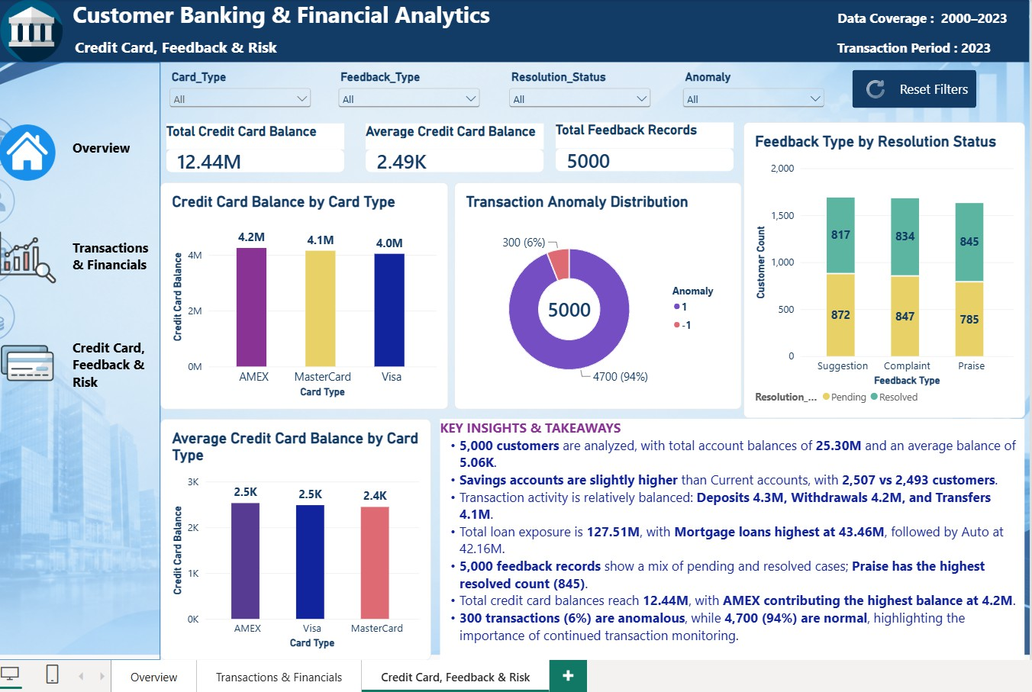
Chart explanation: KPI cards show Total Credit Card Balance, Average Credit Card Balance, and Total Feedback Records. Credit Card Balance by Card Type compares AMEX, MasterCard, and Visa. The anomaly donut clearly separates normal records from anomalous records. Feedback Type by Resolution Status compares Pending and Resolved cases for Suggestions, Complaints, and Praise. Average Credit Card Balance by Card Type compares typical balance levels across card categories. The Anomaly, Feedback Type, Resolution Status, and Card Type slicers support focused investigation.

Overall Business Findings
  - Strong customer and account base: 5,000 customers, total account balance ≈ 25.30M, and average account balance ≈ 5.06K.
  - Balanced account profile: Savings 2,507 versus Current 2,493 customers.
  - Balanced transaction activity: Deposits ≈ 4.3M, Withdrawals ≈ 4.2M, Transfers ≈ 4.1M.
  - Significant lending exposure: Total loan amount ≈ 127.51M, with Mortgage highest at ≈ 43.46M.
  - Customer-service opportunity: Feedback contains both pending and resolved cases; pending suggestions are particularly high.
  - Risk monitoring: 300 anomalous transactions (6%) versus 4,700 normal records (94%).

Business Recommendations

Customer Service: Aim to reduce pending complaints by 20% within three months and review resolution rates monthly.

Transaction Risk: Review 100% of flagged transactions within 24 hours and track confirmed issues and false positives.

Loan Portfolio: Review loan exposure and repayment performance monthly, with particular attention to the mortgage portfolio.

Transaction Trends: Monitor monthly transaction values and investigate significant deviations to support operational planning.

Data Quality: Target at least 99% completeness in critical reporting fields and conduct monthly quality checks.

These are proposed targets for future monitoring, not results achieved during this project. Targets should be assessed against operational baselines and available resources.

Conclusion
The project demonstrates an end-to-end data analytics workflow: problem definition and dataset selection, data cleaning and preprocessing, Python-based EDA, and interactive Power BI reporting. The final dashboard converts raw banking data into a structured business story covering customers, accounts, transactions, loans, credit cards, feedback, and risk. The findings can support customer-experience improvement, financial monitoring, lending analysis, and risk-focused decision-making.

