Assignment On

"Modern Operating System and Computer Networks"

(Assignment-3)
Submitted by: Madhu boini
2503B09904(MCA)

Submitted to: Dr. Mathivanan D
Date: 04 /11/2025

Task:1

Problem -01:
A bit stream 1101011011 is transmitted using the standard CRC method. The generator polynomial is X4+X+1. What is the actual bit string transmitted?
CODE:
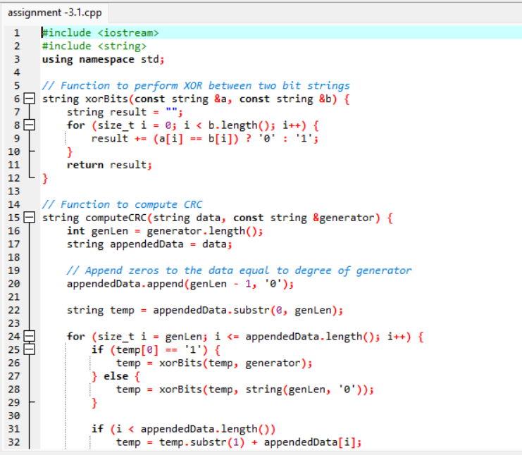
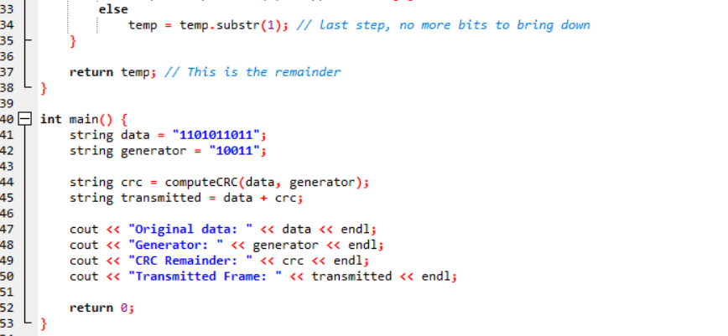
OUT PUT:
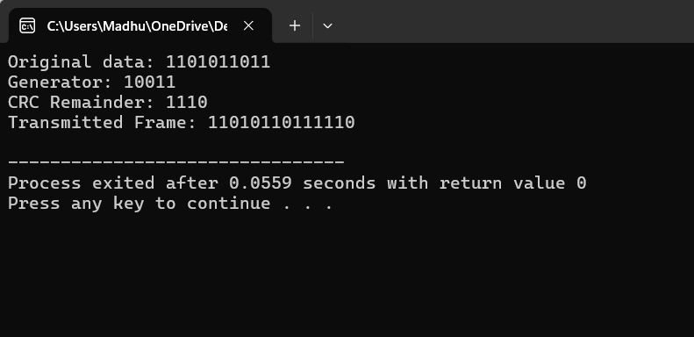

Task:2

Problem -02:
A bit stream 10011101 is transmitted using the standard CRC method. The generator polynomial is x³+1.
1.What is the actual bit string transmitted?
- Suppose the third bit from the left is inverted during transmission. How will receiver detect this error?

Code:
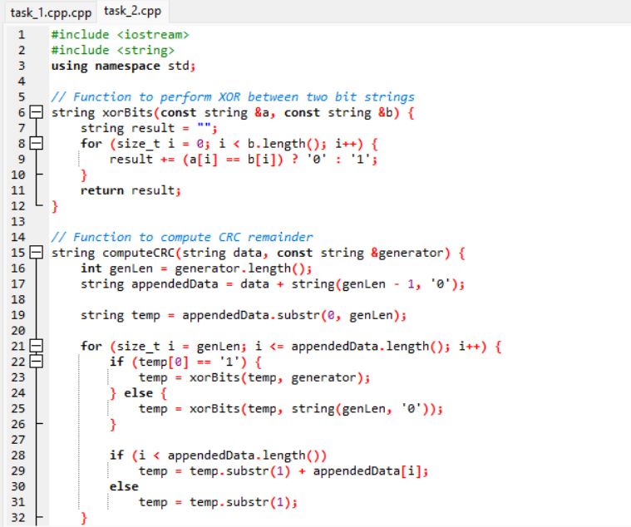
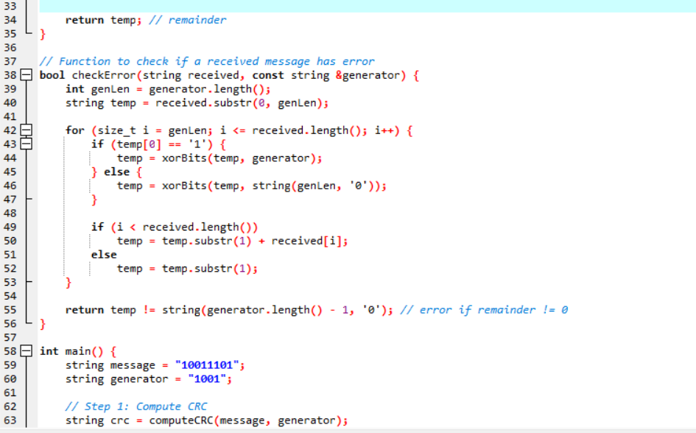
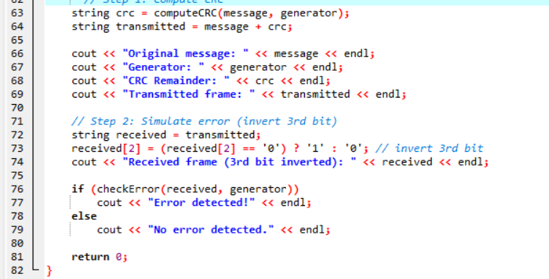

Output : 