**DS-670-Capstone: Big Data & Business Analytics**

**Assignment 10: Results**

**April 1st 2017, Madhumita D**

**Results**

We analysed the data after the neural network model for each quarter was established. The expected returns were calculated based on these models for the test data. The neural network model for every quarter had 4 layers – input layer consisting of the technical, fundamental and macro-economic factors, two hidden layers with eight and seven hidden units respectively, and an output layer which results in the expected returns.

Initially, the selected indicator data is normalized this allows the algorithm to reach a global minimum faster. Before fitting the neural network model, we have prepared the formula (i.e. y ~ x1 + x2+...) as the function neural net in R does not accept strings. Later, the neural network architecture was employed with ‘formula’ and 2 hidden layers for the two thirds of the available dates (which form the training data). Using these models the future quarter’s returns have been predicted.

After the stock returns for test data has been computed, the stocks for every quarter are ranked based on these returns. These ranked stocks are divided into five quantiles – highest to lowest. The average of each quantile defines the average returns of stocks in that bucket. In the similar way, returns, ranking and quantiles have been computed for all the future five quarters. Based on every quarter’s average returns of each quantile we will be able to identify the trends in each quantile over a period. This will help us in identifying whether there was a positive trend or negative trend followed in a particular quarter. The difference between top quantile and the bottom quantile helps us in identifying the dispersion in returns in a quarter. Also, we can identify the expected returns of top quantiles or bottom quantile in each quarter which helps us in making investment decisions (buy or sell). To demonstrate the above theory in a particular sector we have used the proposed model in Transport sector for quarters – Q4 2014, Q1 2015, Q2 2015, Q3 2015 and Q4 2015.

The results from the quarterly stock analysis have been explained in detail.

**Averages – Expected Returns**

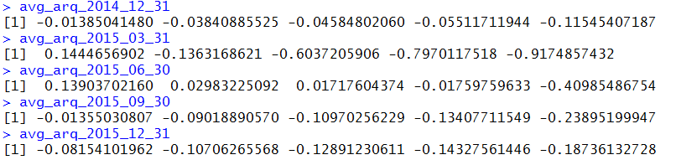

**Date: 31-12-2014 and 31-03-2015**

Observing the average expected returns for each group in these two quarters, we can say that we have a negative expected return value in each of the groups and a negative trend is followed through out.

**For 31-12-2014:** The percentage of difference in returns is very high between group1 (highest returns) and group5 (lowest returns) i.e. 10.16%. Looking at each of the groups we see that the difference in returns has gradually decreased from group1 to group4, but for group4 to group5 the drop is very high i.e. approximately 6.3%.

**For 31-03-2015:** The high cap stocks in group1 for this quarter seemed to perform well compared to the other groups with a positive average returns. Here a decreasing trend can be seen throughout the groups where the first group has had positive average returns of 14.44% and the last group has had negative average returns of about 91.7%.

Comparing the average returns for group1 in first quarter of 2015 with last quarter of 2014, there is change from negative to positive expected returns.

**Date: 30-06-2015**

Looking at the average returns for second quarter of 2015 (June – 2015), we can say that the stocks have performed with positive returns for three groups and negative for the last two groups. But there is a steep drop from group1 to group2 with a difference of about 10.92% and a gradual decrease from groups2 to group4 with a low difference in averages. The small cap stocks in this quarter have negative averages and comparing with the previous group (group4) there is huge decrease in averages i.e. approximately 39.23%.

**Date: 30-09-2015 and 31-12-2015**

When compared to the previous quarters, we observe that stocks in both third and fourth group follow a negative trend with their average expected returns decreasing for each group (group1 to group5). The difference in averages is high (from group1 to group2 is high) in September quarter. The expected return value of the last group (group5) has shown a great variance from last quarter in 2014 (Dec 2014) to first quarter in 2015 (March 2015) i.e. if we observe for 31-12-2014 and 31-03-2015 we have the average as -0.115 and -0.917 respectively. Later in the next quarters the average returns have recovered from -91.7% to -18.7%.

**Averages – Actual Returns (return_log)**

The actual returns are also ranked, grouped and the averages for each group are shown below.

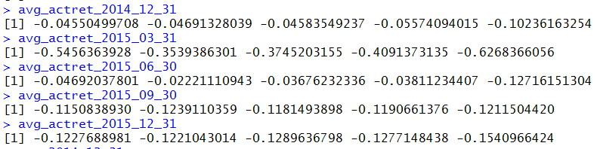

Based on the overall forecasted values we can say that the expected return of stocks in last quarter of 2014 has a negative trend while they show a positive trend in the first two quarters of 2015. However, later in third and fourth quarters in 2015 we see a similar negative trend as shown in last quarter of 2014. On the whole the averages depict a huge volatility in stock price movements.

The results from the transport sector have been explained in detail.

**Transport sector: Average – Expected Returns**

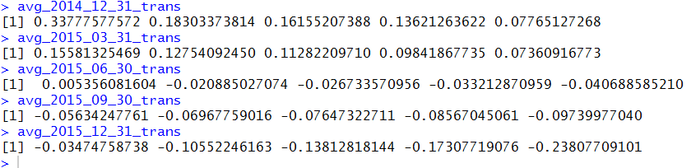

Looking at the average returns for each group in all 4 quarters of 2015, we see that the expected value of both high and low ranked stocks in Transportation sector has followed a decreasing trend. In the first quarter of 2015 the transportation stocks have a positive average returns but the average of expected returns gradually decreases from group1 to group5. Observing the values of last quarter in 2014 and 2015, the expected returns changed from a positive trend to a negative trend for these stocks.

**Transport sector: Averages – Actual Returns (return_log)**

The actual returns for stocks in transportation sector are also ranked, grouped and the averages for each group are shown below.

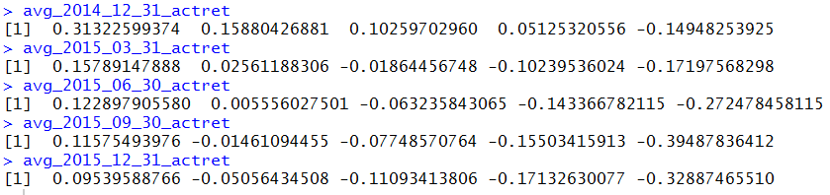

Based on the overall forecasted values from the neural networks architecture, we can say that the expected return of stocks in this sector yield a negative return value and shows a high volatility in this sector. This kind of volatility in the market gives an opportunity to the investor to gain returns. Transportation sector seems to be under-performing with a consistent drop in expected returns for all the quarters (these results are based on neural network modelling).