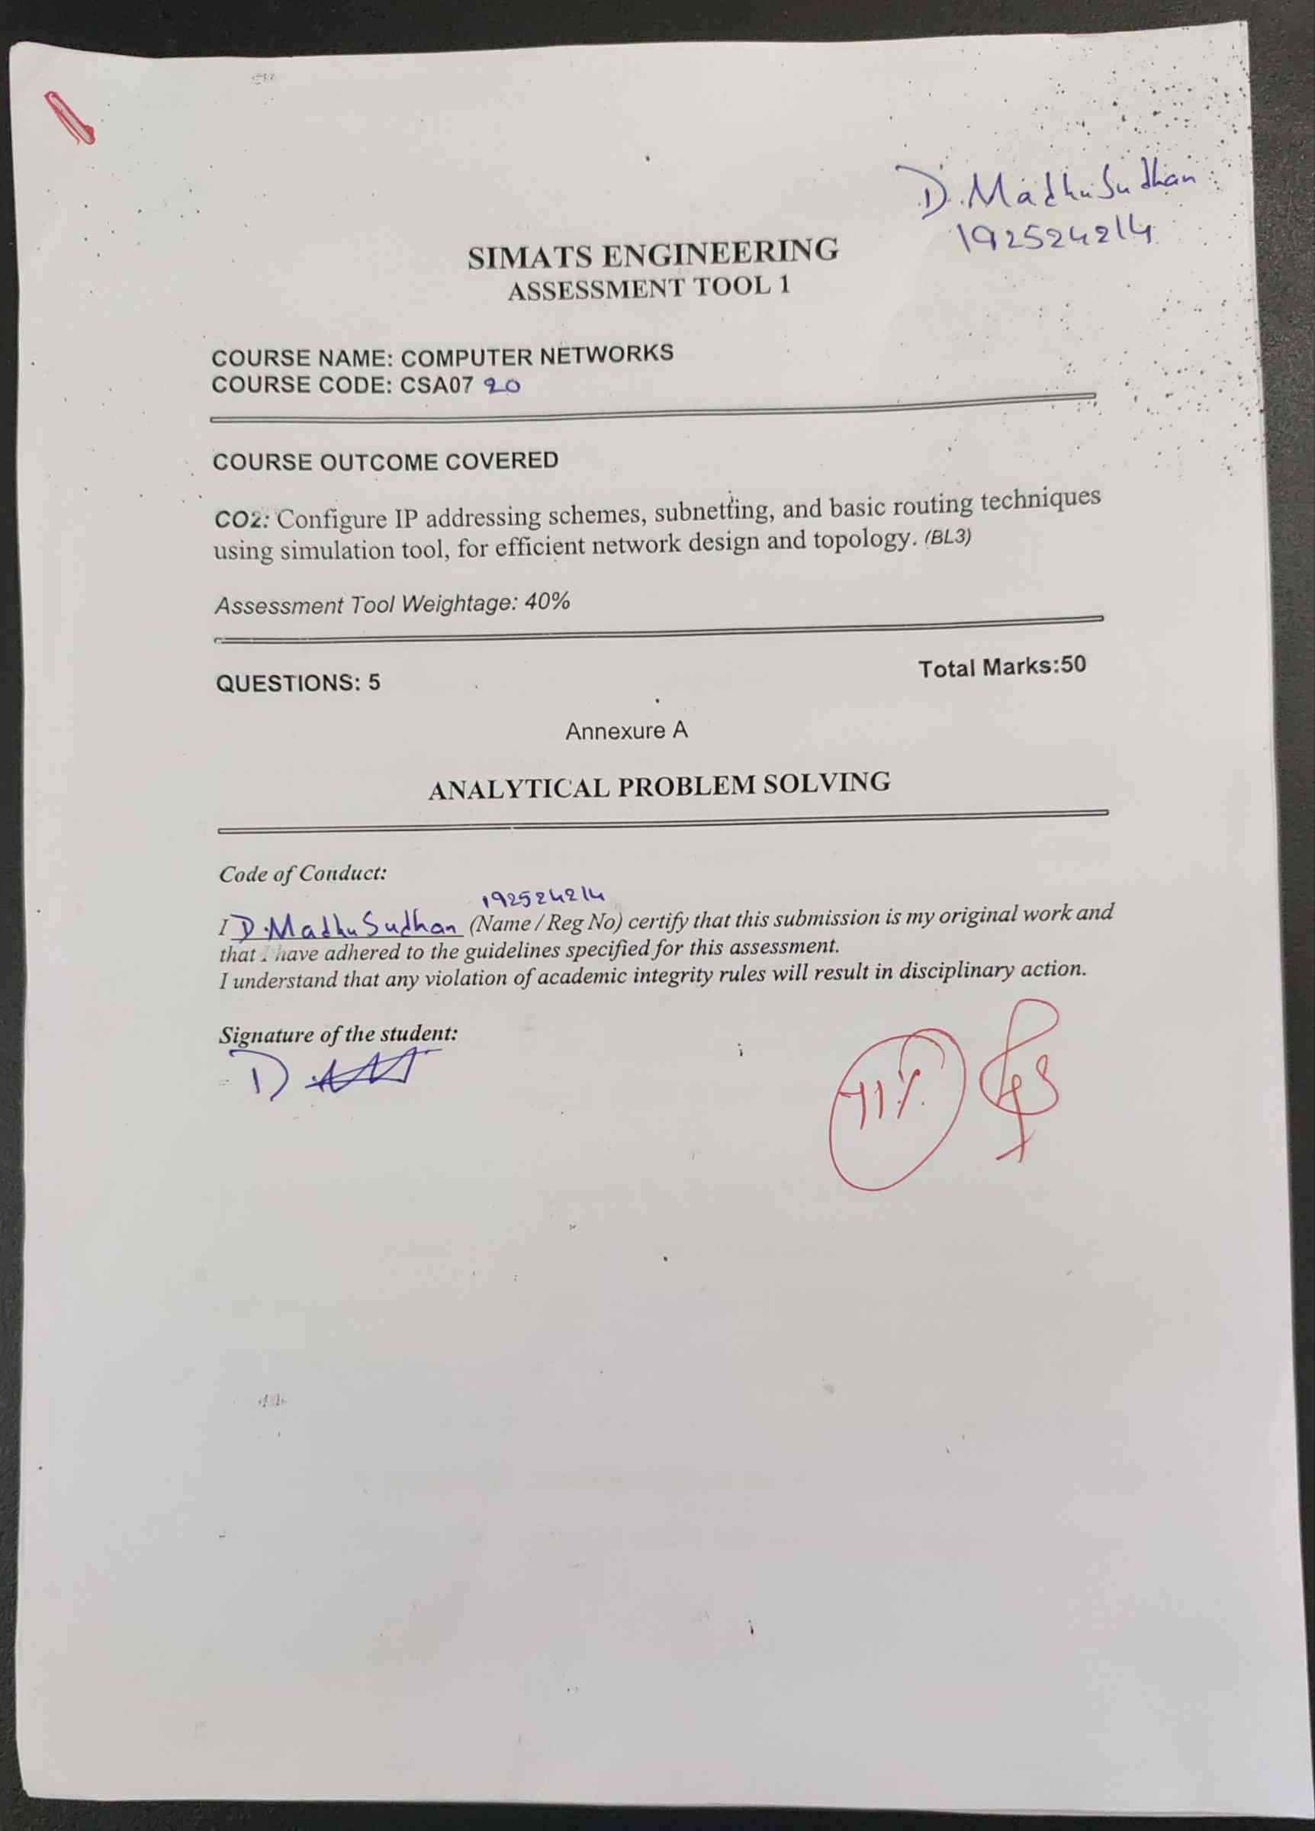
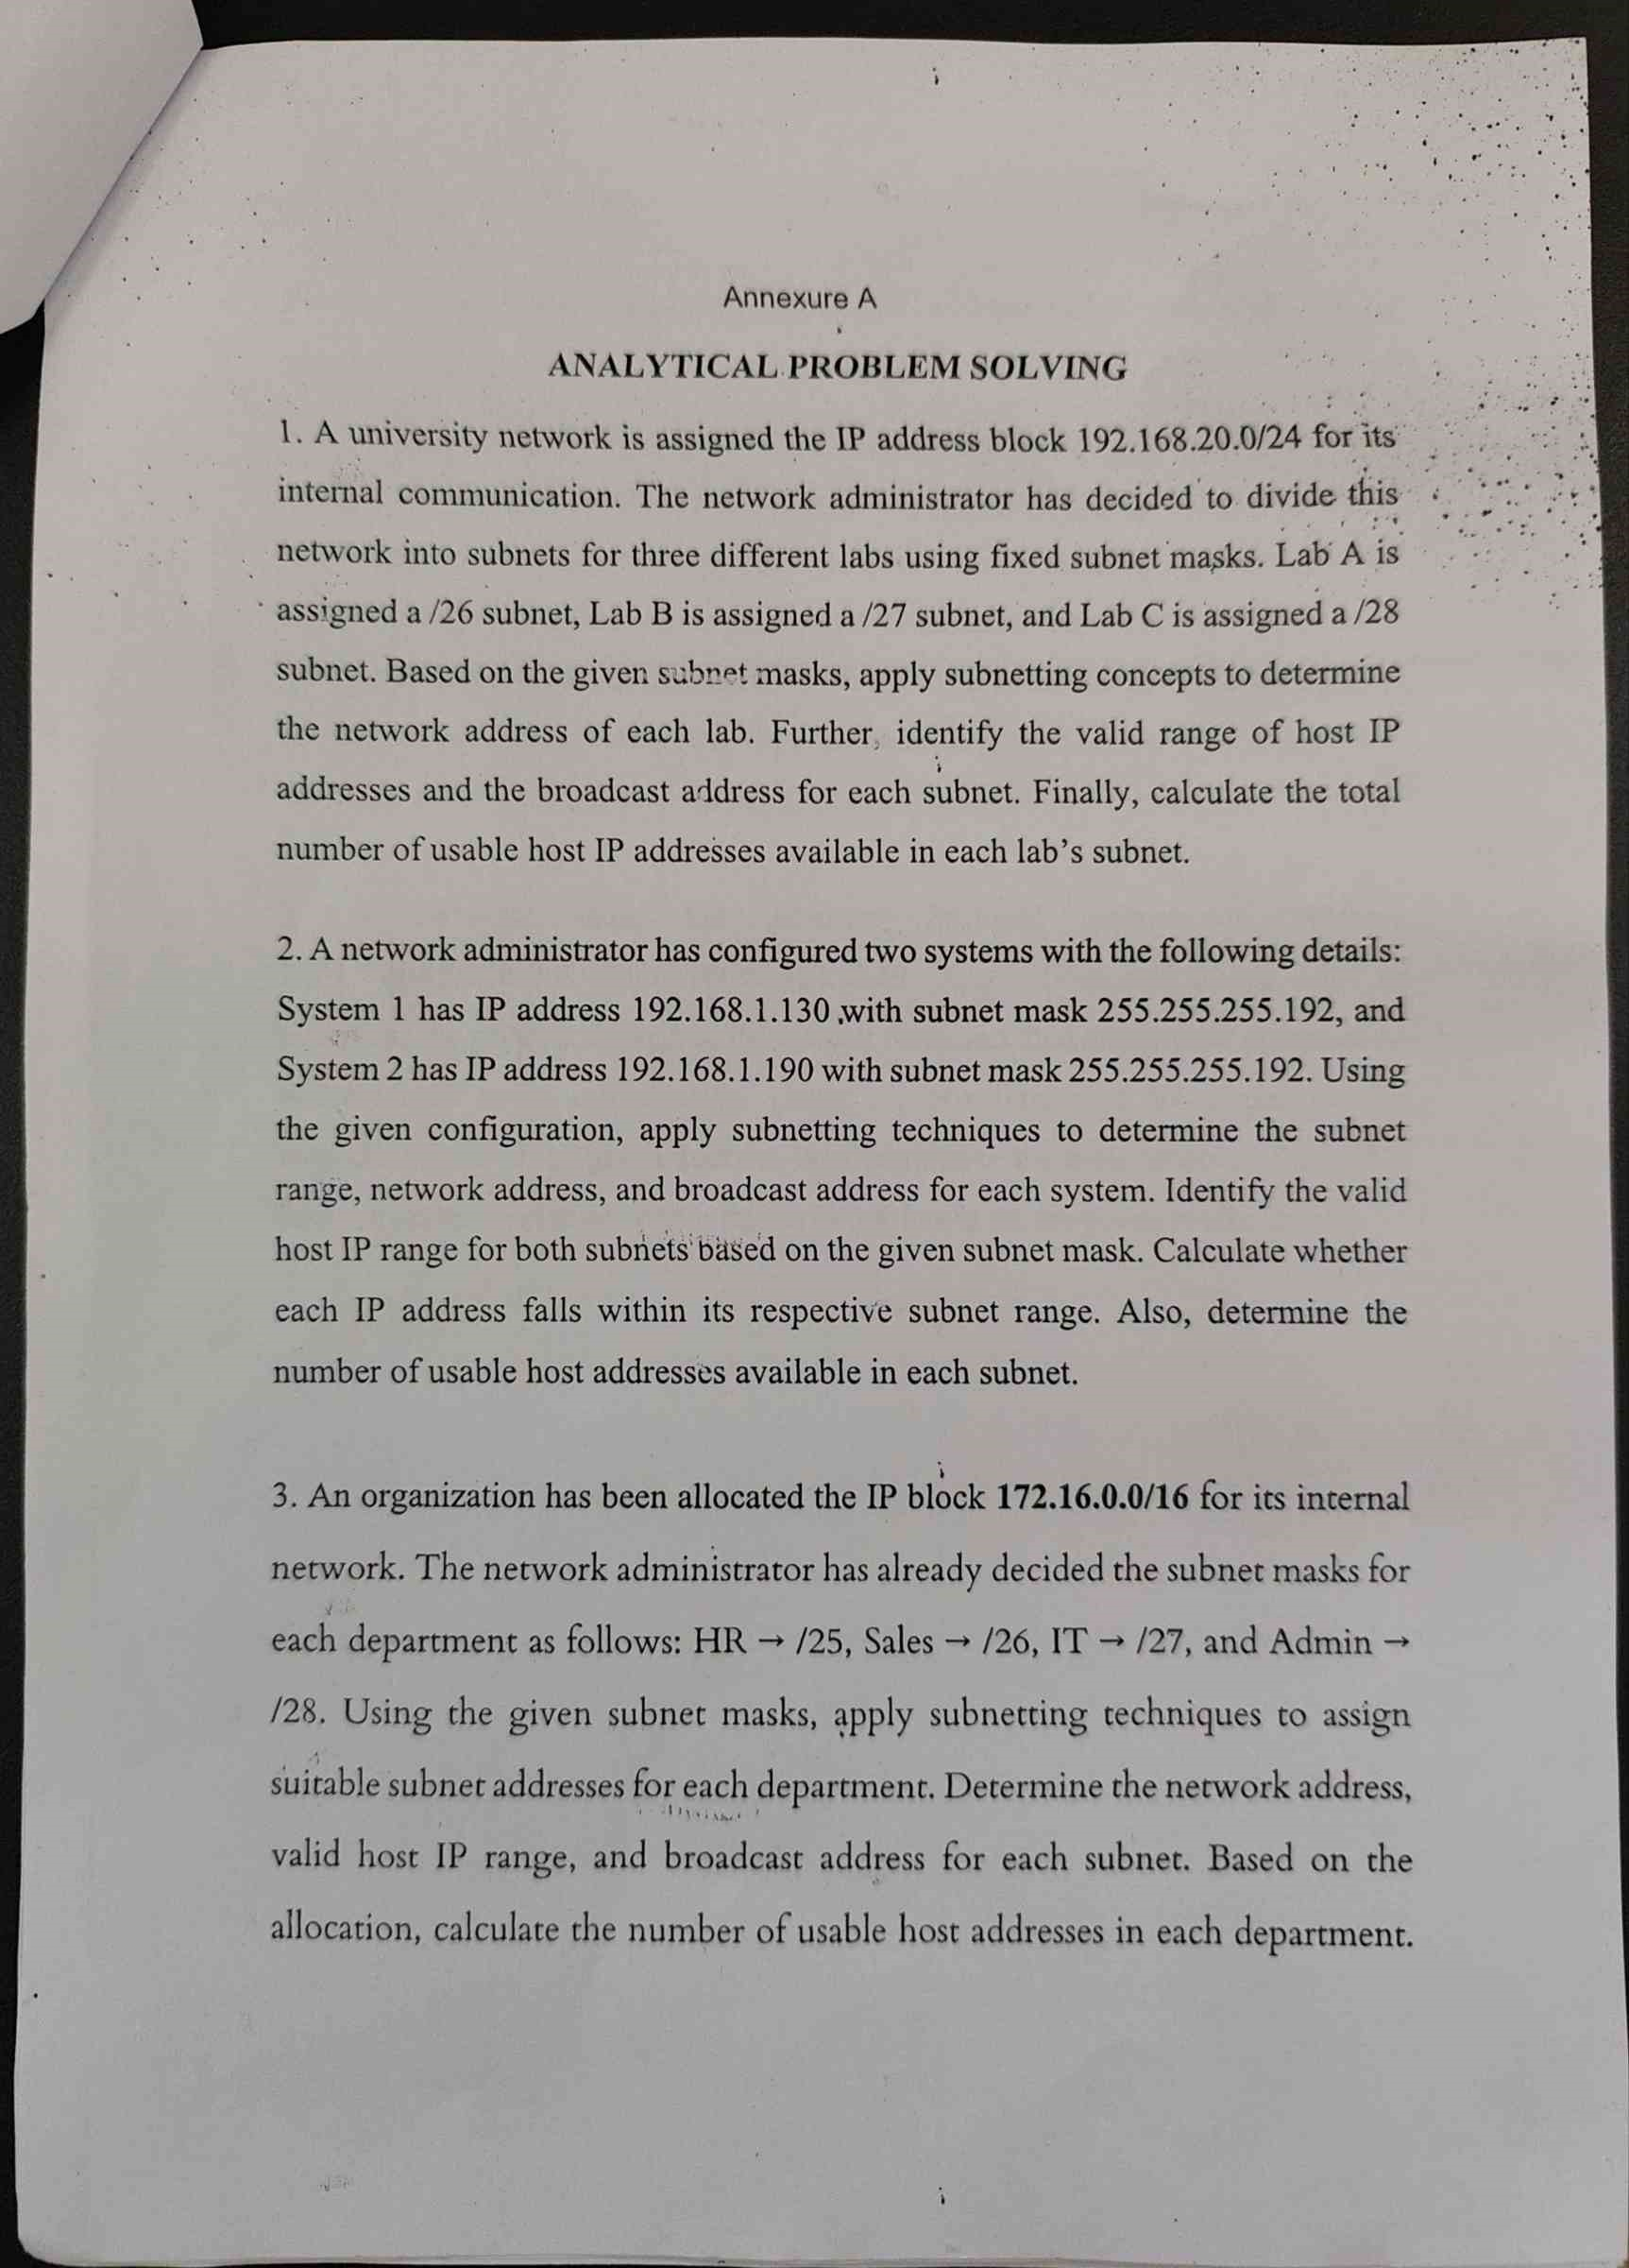
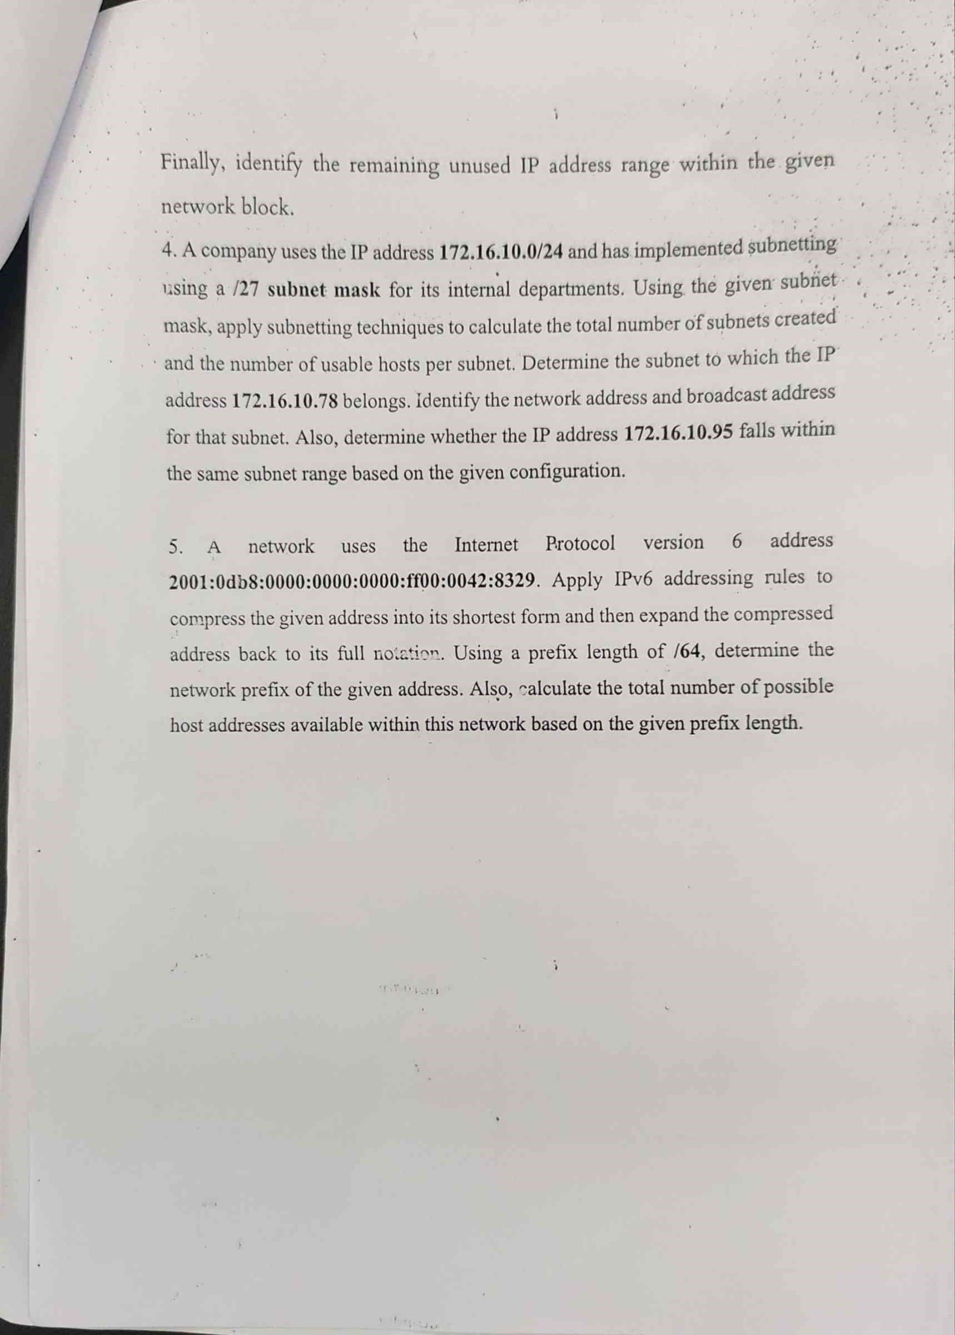
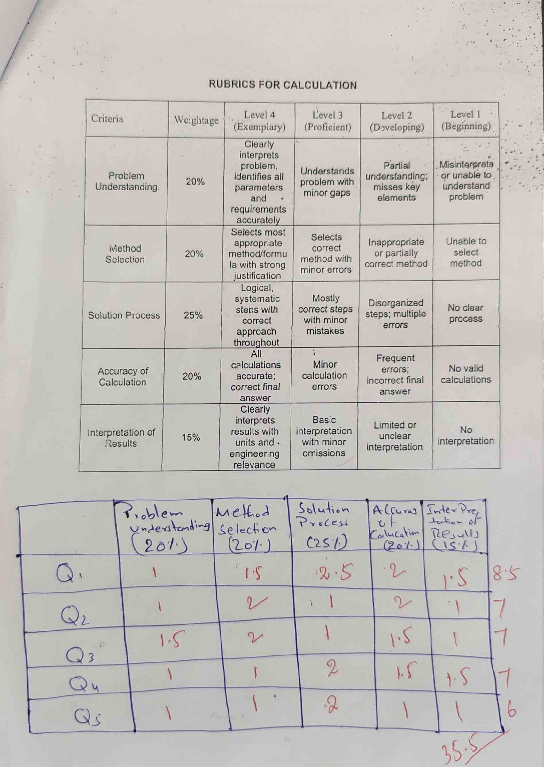

SIMATS ENGINEERING

ASSESSMENT TOOL 1

COURSE NAME: COMPUTER NETWORKS COURSE CODE: CSA0720

COURSE OUTCOME COVERED
CO2: Configure IP addressing schemes, subnetting, and basic routing techniques using simulation tool, for efficient network design and topology. (BL3)
Assessment Tool Weightage: 40%

QUESTIONS: 5 Total Marks:50

Annexure A

ANALYTICAL PROBLEM SOLVING

Code of Conduct:
I D.MADHUSUDHAN (192524214) certify that this submission is my original work and that I have adhered to the guidelines specified for this assessment.
I understand that any violation of academic integrity rules will result in disciplinary action.

Signature of the student:
Annexure A

ANALYTICAL PROBLEM SOLVING
- A university network is assigned the IP address block 192.168.20.0/24 for its internal communication. The network administrator has decided to divide this network into subnets for three different labs using fixed subnet masks. Lab A is assigned a /26 subnet, Lab B is assigned a /27 subnet, and Lab C is assigned a /28 subnet. Based on the given subnet masks, apply subnetting concepts to determine the network address of each lab. Further, identify the valid range of host IP addresses and the broadcast address for each subnet. Finally, calculate the total number of usable host IP addresses available in each lab’s subnet.

- A network administrator has configured two systems with the following details:
System 1 has IP address 192.168.1.130 with subnet mask 255.255.255.192, and System 2 has IP address 192.168.1.190 with subnet mask 255.255.255.192. Using the given configuration, apply subnetting techniques to determine the subnet range, network address, and broadcast address for each system. Identify the valid host IP range for both subnets based on the given subnet mask. Calculate whether each IP address falls within its respective subnet range. Also, determine the number of usable host addresses available in each subnet.

- An organization has been allocated the IP block 172.16.0.0/16 for its internal network. The network administrator has already decided the subnet masks for each department as follows: HR → /25, Sales → /26, IT → /27, and Admin → /28. Using the given subnet masks, apply subnetting techniques to assign suitable subnet addresses for each department. Determine the network address, valid host IP range, and broadcast address for each subnet. Based on the allocation, calculate the number of usable host addresses in each department.
Finally, identify the remaining unused IP address range within the given network block.
- A company uses the IP address 172.16.10.0/24 and has implemented subnetting using a /27 subnet mask for its internal departments. Using the given subnet mask, apply subnetting techniques to calculate the total number of subnets created and the number of usable hosts per subnet. Determine the subnet to which the IP address 172.16.10.78 belongs. Identify the network address and broadcast address for that subnet. Also, determine whether the IP address 172.16.10.95 falls within the same subnet range based on the given configuration.

- A network uses the Internet Protocol version 6 address 2001:0db8:0000:0000:0000:ff00:0042:8329. Apply IPv6 addressing rules to compress the given address into its shortest form and then expand the compressed address back to its full notation. Using a prefix length of /64, determine the network prefix of the given address. Also, calculate the total number of possible host addresses available within this network based on the given prefix length.
RUBRICS FOR CALCULATION

Criteria | Weightage | Level 4 (Exemplary) | Level 3 (Proficient) | Level 2 (Developing) | Level 1 (Beginning)
Problem  Understanding | 20% | Clearly interprets problem,  identifies all parameters and  requirements accurately | Understands problem with minor gaps | Partial understanding;  misses key elements | Misinterprets or unable to  understand problem
Method  Selection | 20% | Selects most appropriate  method/formu la with strong justification | Selects correct  method with minor errors | Inappropriate or partially correct method | Unable to select method
Solution Process | 25% | Logical, systematic  steps with correct  approach throughout | Mostly correct steps  with minor mistakes | Disorganized steps; multiple errors | No clear process
Accuracy of  Calculation | 20% | All calculations accurate;  correct final answer | Minor calculation errors | Frequent errors;  incorrect final answer | No valid calculations
Interpretation of Results | 15% | Clearly interprets  results with units and  engineering relevance | Basic interpretation with minor omissions | Limited or unclear interpretation | No  interpretation

Q1. A university network is assigned the IP address block 192.168.20.0/24 for its internal communication. The network administrator has decided to divide this network into subnets for three different labs using fixed subnet masks. Lab A is assigned a /26 subnet, Lab B is assigned a /27 subnet, and Lab C is assigned a /28 subnet. Based on the given subnet masks, apply subnetting concepts to determine the network address of each lab. Further, identify the valid range of host IP addresses and the broadcast address for each subnet. Finally, calculate the total number of usable host IP addresses available in each lab’s subnet.

Given network: 192.168.20.0/24
  - Lab A → /26
  - Lab B → /27
  - Lab C → /28

Lab A – /26

Number of host bits: 32 − 26 = 6

Total addresses: 2⁶ = 64

Usable addresses: 64 − 2 = 62

Therefore:
  - Network address: 192.168.20.0
  - Host range: 192.168.20.1 – 192.168.20.62
  - Broadcast address: 192.168.20.63
  - Usable hosts: 62

Lab B – /27
The next available subnet starts at 192.168.20.64.

Host bits: 32 − 27 = 5

Total addresses: 2⁵ = 32

Usable addresses:
32 − 2 = 30

Therefore:
- Network address: 192.168.20.64
- Host range: 192.168.20.65 – 192.168.20.94
- Broadcast address: 192.168.20.95
- Usable hosts: 30

Lab C – /28
The next available subnet starts at 192.168.20.96.

Host bits: 32 − 28 = 4 Total addresses: 2⁴ = 16

Usable addresses:
16 − 2 = 14

Therefore:
- Network address: 192.168.20.96
- Host range: 192.168.20.97 – 192.168.20.110
- Broadcast address: 192.168.20.111
- Usable hosts: 14

Final Table
Lab  A  B  C | Subnet  /26  /27  /28 | Network Address  192.168.20.0  192.168.20.64  192.168.20.96 | Host Range  .1 – .62  .65 – .94  .97 – .110 | Broadcast  .63  .95  .111 | Usable Hosts  62  30  14

Q2. A network administrator has configured two systems with the following details: System 1 has IP address 192.168.1.130 with subnet mask 255.255.255.192, and System 2 has IP address 192.168.1.190 with subnet mask 255.255.255.192. Using the given configuration, apply subnetting techniques to determine the subnet range, network address, and broadcast address for each system. Identify the valid host IP range for both subnets based on the given subnet mask. Calculate whether each IP address falls within its respective subnet range.
Also, determine the number of usable host addresses available in each subnet.

Given:

System 1: 192.168.1.130

System 2: 192.168.1.190

Subnet mask: 255.255.255.192 = /26

For /26:

32 − 26 = 6 host bits

Total addresses:

2⁶ = 64

Usable hosts:

64 − 2 = 62

The subnet ranges are:

  - 192.168.1.0 – 192.168.1.63
  - 192.168.1.64 – 192.168.1.127
  - 192.168.1.128 – 192.168.1.191
  - 192.168.1.192 – 192.168.1.255

Both 192.168.1.130 and 192.168.1.190 fall in the third subnet.

System 1

IP: 192.168.1.130
  - Network address: 192.168.1.128
  - Host range: 192.168.1.129 – 192.168.1.190
  - Broadcast: 192.168.1.191
  - Usable hosts: 62
192.168.1.130 is a valid host address.

System 2

IP: 192.168.1.190
  - Network address: 192.168.1.128
  - Host range: 192.168.1.129 – 192.168.1.190
  - Broadcast: 192.168.1.191
  - Usable hosts: 62
192.168.1.190 is also a valid host address.

Conclusion:
Both systems belong to the same subnet:
192.168.1.128/26

Q3. Subnet Allocation for Departments An organization has been allocated the IP block 172.16.0.0/16 for its internal network. The network administrator has already decided the subnet masks for each department as follows: HR → /25, Sales → /26, IT → /27, and Admin →28. Using the given subnet masks, apply subnetting techniques to assign suitable subnet addresses for each department. Determine the network address, valid host IP range, and broadcast address for each subnet. Based on the allocation, calculate the number of usable host addresses in each department Finally, identify the remaining unused IP address range within the given network block
Given:

Network: 172.16.0.0/16
  - HR → /25
  - Sales → /26
  - IT → /27 • Admin → /28

We assign the subnets sequentially.
HR – /25
Host bits: 32 − 25 = 7 Total addresses: 2⁷ = 128 Usable hosts: 128 − 2 = 126
  - Network: 172.16.0.0
  - Host range: 172.16.0.1 – 172.16.0.126
  - Broadcast: 172.16.0.127
  - Usable hosts: 126
Sales – /26
Next available address: 172.16.0.128 Total addresses: 2⁶ = 64 Usable hosts:
64 − 2 = 62
- Network: 172.16.0.128
- Host range: 172.16.0.129 – 172.16.0.190
- Broadcast: 172.16.0.191
- Usable hosts: 62
IT – /27
Next available address: 172.16.0.192 Total addresses:
2⁵ = 32 Usable hosts: 32 − 2 = 30
- Network: 172.16.0.192
- Host range: 172.16.0.193 – 172.16.0.222
- Broadcast: 172.16.0.223
- Usable hosts: 30
Admin – /28
Next available address: 172.16.0.224 Total addresses:
2⁴ = 16 Usable hosts:
16 − 2 = 14
- Network: 172.16.0.224
- Host range: 172.16.0.225 – 172.16.0.238
- Broadcast: 172.16.0.239
- Usable hosts: 14
Final Table
Department | Subnet | Network | Host Range | Broadcast | Usable
HR | /25 | 172.16.0.0 | .1 – .126 | .127 | 126
Sales | /26 | 172.16.0.128 | .129 – .190 | .191 | 62
IT | /27 | 172.16.0.192 | .193 – .222 | .223 | 30
Admin | /28 | 172.16.0.224 | .225 – .238 | .239 | 14

Remaining Unused Range
The assigned addresses end at 172.16.0.239.
So the remaining unused range is:
172.16.0.240 – 172.16.255.255

Q4. A company uses the IP address 172.16.10.0/24 and has implemented subnetting using a /27 subnet mask for its internal departments. Using the given subnet mask, apply subnetting techniques to calculate the total number of subnets created and the number of usable hosts per subnet. Determine the subnet to which the IP address 172.16.10.78 belongs. Identify the network address and broadcast address for that subnet. Also, determine whether the IP address 172.16.10.95 falls within the same subnet range based on the given configuration.

Given network:
172.16.10.0/24

New subnet mask:
/27

Number of Subnets

Bits borrowed: 27 − 24 = 3

Number of subnets:
2³ = 8

Therefore:
8 subnets are created.

Usable Hosts per Subnet Host bits: 32 − 27 = 5

Total addresses: 2⁵ = 32

Usable hosts:
32 − 2 = 30

Therefore:
30 usable hosts per subnet.

Find the Subnet of 172.16.10.78 The subnet block size is: 256 − 224 = 32

The ranges are:
  - 0 – 31
  - 32 – 63
  - 64 – 95
  - 96 – 127
  - 128 – 159
  - 160 – 191
  - 192 – 223
  - 224 – 255

Therefore, 172.16.10.78 belongs to:
172.16.10.64/27

Its details are:
      - Network address: 172.16.10.64
      - Host range: 172.16.10.65 – 172.16.10.94
      - Broadcast address: 172.16.10.95

Since .78 is between .65 and .94, it is a valid host address.
What about 172.16.10.95?

172.16.10.95 belongs to the same subnet, but it is the broadcast address. Therefore, it cannot be assigned to a normal host.

Final Answer:
Number of subnets = 8
Usable hosts/subnet = 30
Subnet of .78 = 172.16.10.64/27
Network = 172.16.10.64
Broadcast = 172.16.10.95

- Q5. A network uses the Internet Protocol version 6 address 2001:0db8:0000:0000:0000:ff00:0042:8329. Apply IPv6 addressing rules to compress the given address into its shortest form and then expand the compressed address back to its full notation. Using a prefix length of /64, determine the network prefix of the given address. Also, calculate the total number of possible host addresses available within this network based on the given prefix length.

Given IPv6 address:

2001:0db8:0000:0000:0000:ff00:0042:8329
The question asks for compression, expansion, the /64 network prefix, and the number of possible addresses.

1. Compressed Form
First remove leading zeros from each group:
2001:db8:0:0:0:ff00:42:8329
The consecutive zero groups can be replaced by ::.

Therefore:
2001:db8::ff00:42:8329
This is the shortest form.

- Expanded Form
The expanded form is:
2001:0db8:0000:0000:0000:ff00:0042:8329

- Network Prefix with /64
A /64 prefix means the first 64 bits, or first four groups, are the network portion:
2001:0db8:0000:0000

Therefore, the network prefix is:
2001:db8::/64

4. Number of Possible Host Addresses IPv6 has 128 bits.

Network bits:
64

Host bits: 128 − 64 = 64

Number of possible addresses:
2⁶⁴
= 18,446,744,073,709,551,616

Therefore:
Total possible addresses = 18,446,744,073,709,551,616

