**Why we need cloud based monitoring:**

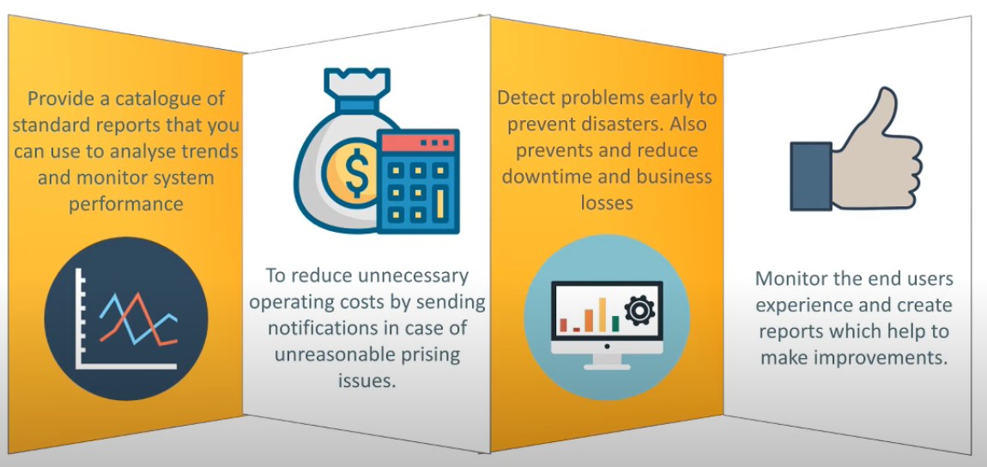

**Cloud watch ::** It’s an amazon web service that provides real time monitoring of resources and applications running on AWS infrastructure.

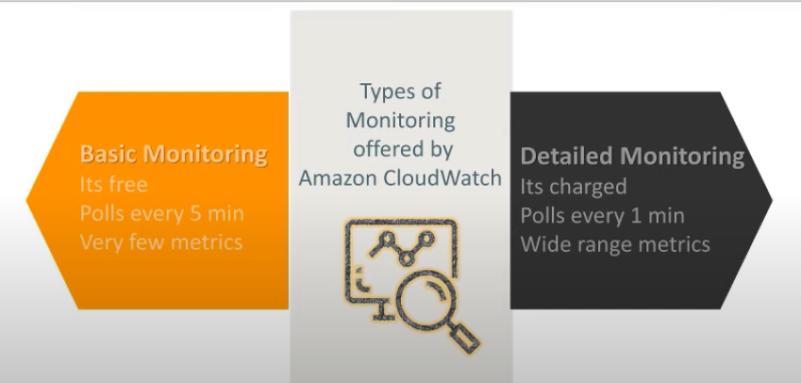

1)It collects metrics 2) collects,monitores and stores logfiles 3) Create alarms and sends notification 4) Sends events to lambda

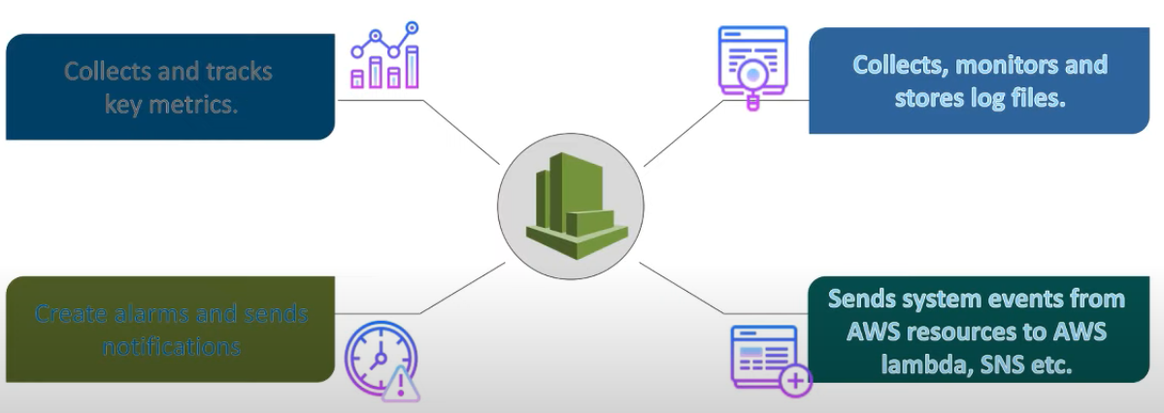

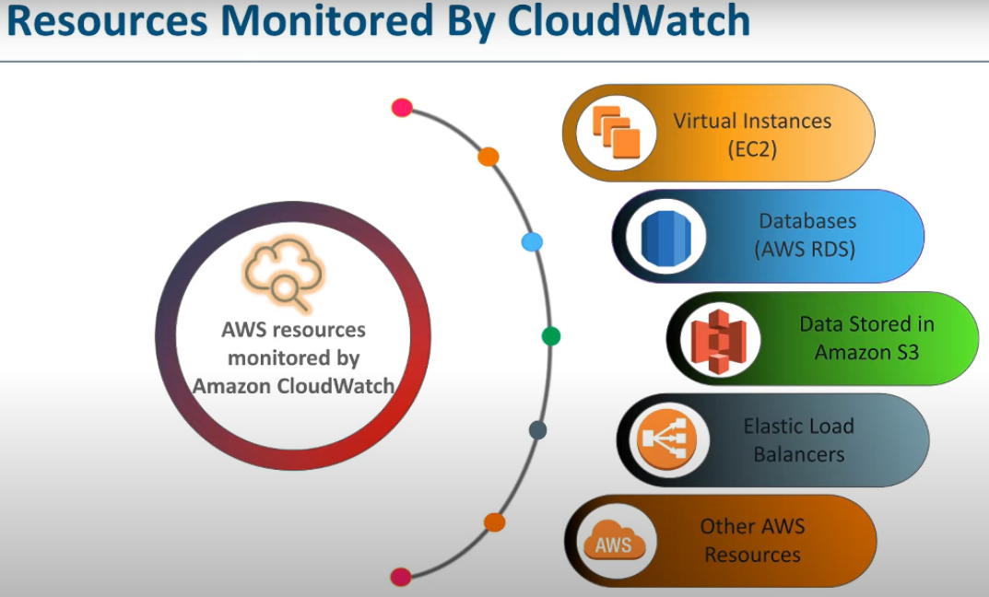

**Metrics**: A variable to monitor

**Dimension**: a value used to identify metric

**Statistics**: metrics data aggregation

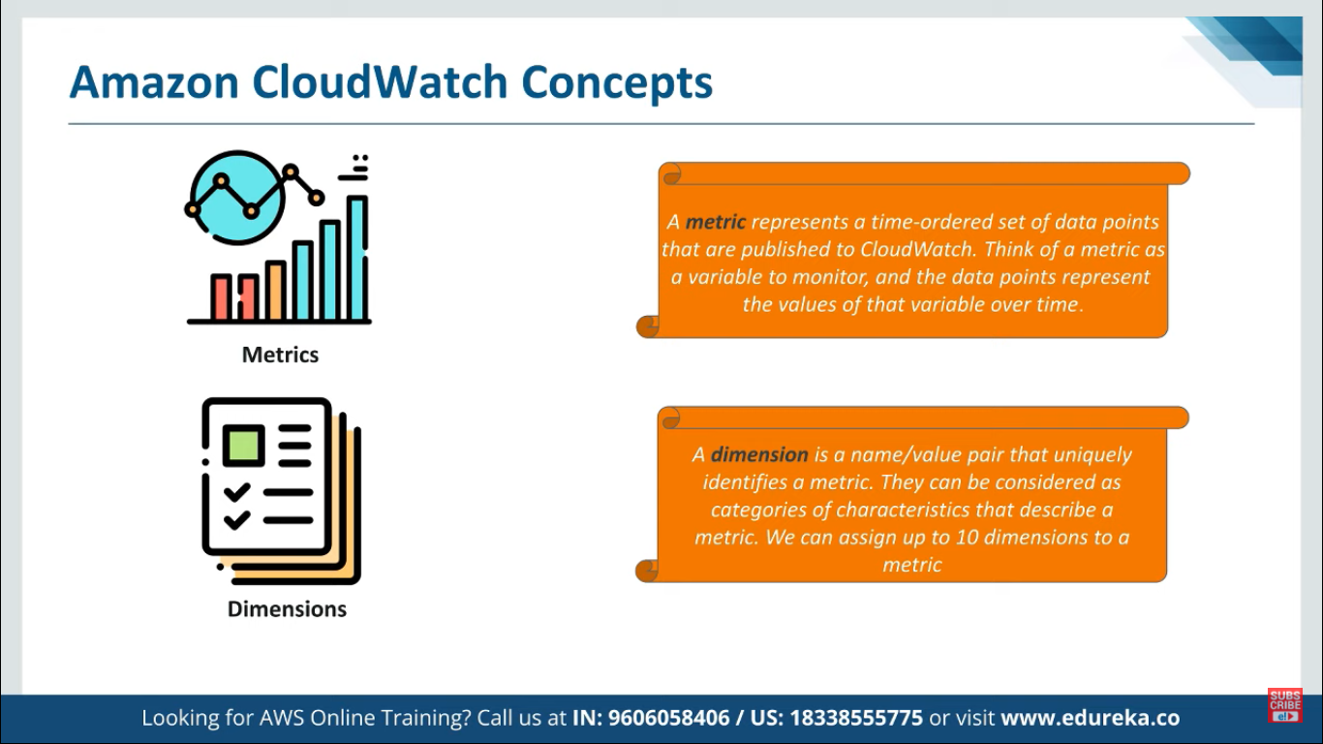

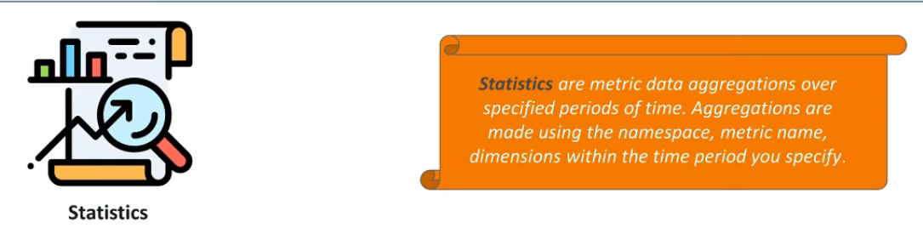

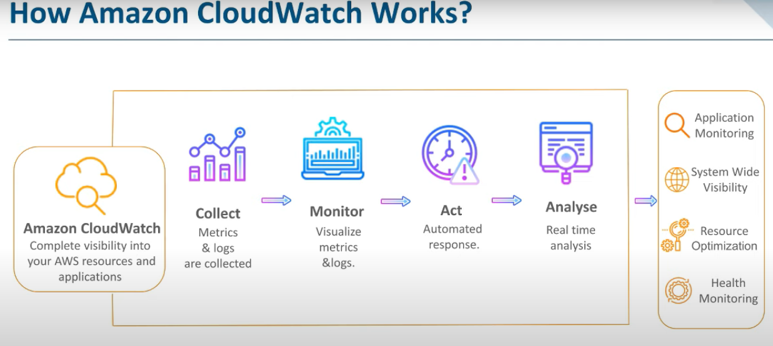

It collects metrics and logs ,visualize it and it act and analyse

**Events**:: It indicates change in your environment(Ex :: state of Ec2 instance from start to stop)

**Rules** :: it evaluates the events with the standard threshold

**Target:** A rule may invoke multiple targets.

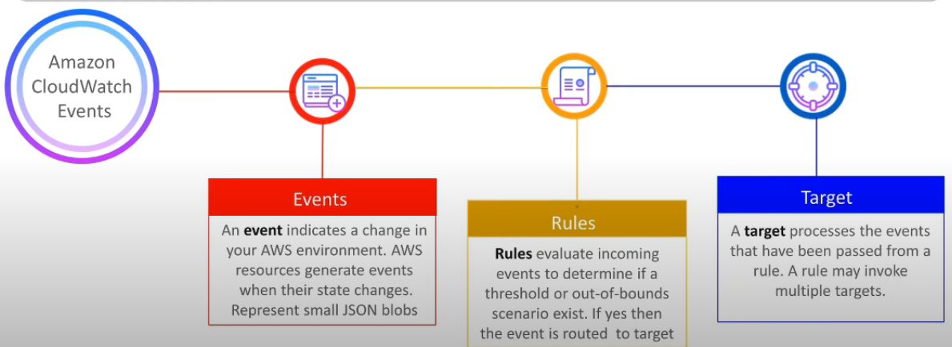

**Logs:** Used to monitor ,store and access log files from resources.

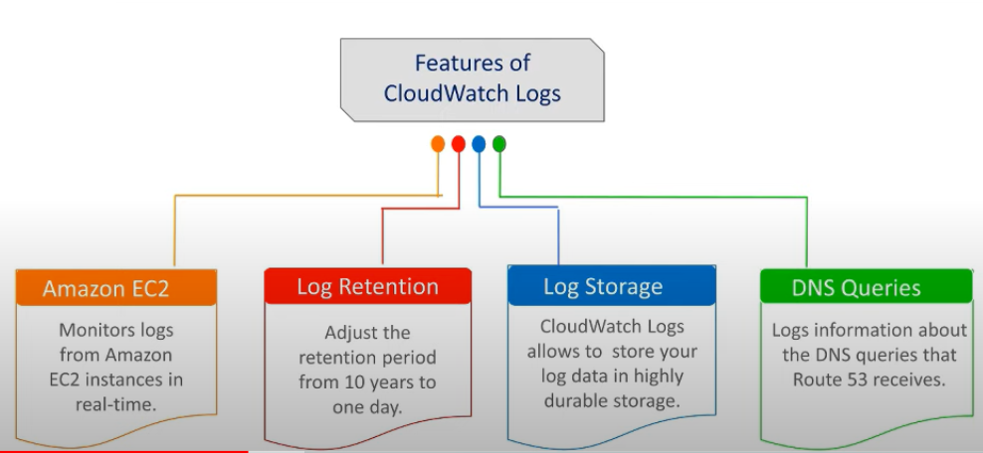

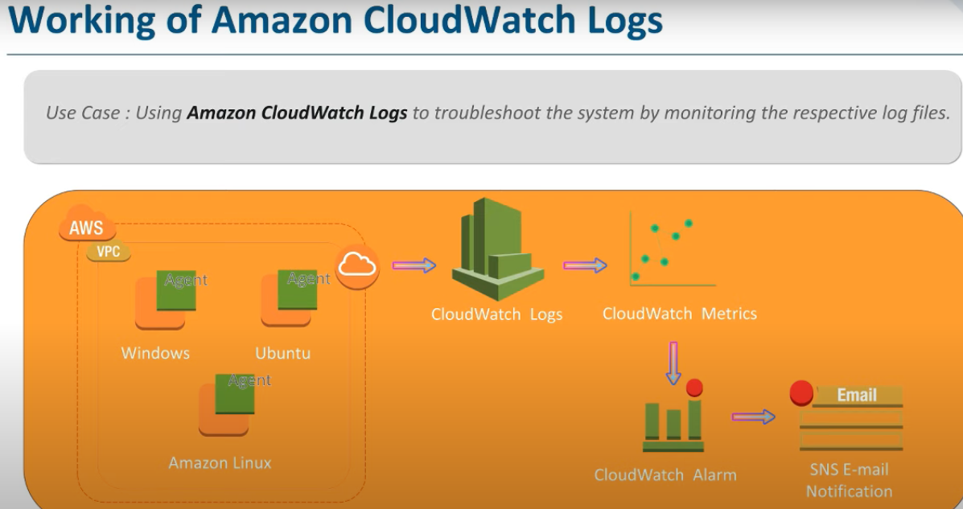

**SNS :: Simple notification service**

1. **Create a topic:**

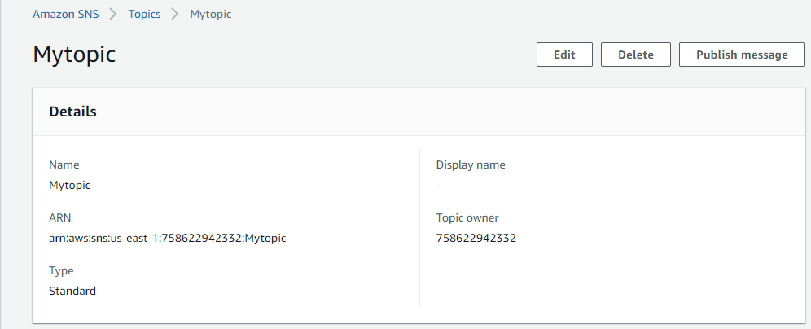

1. **Add subscription**

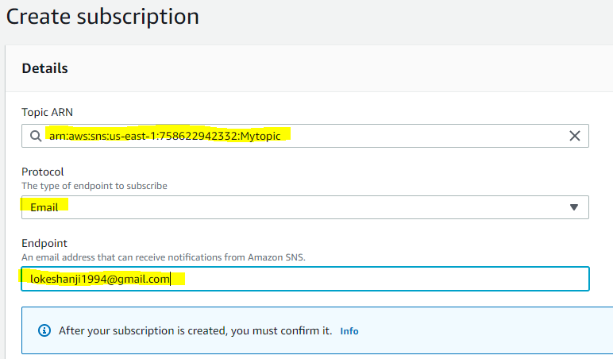

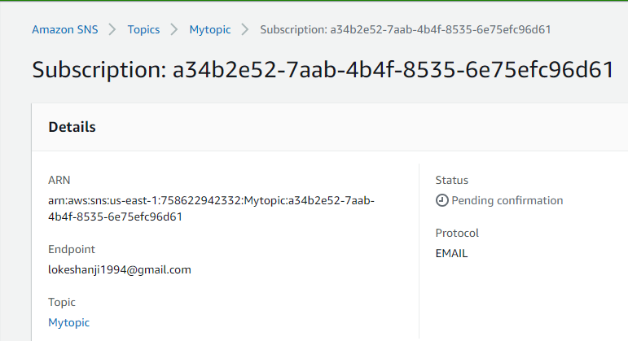

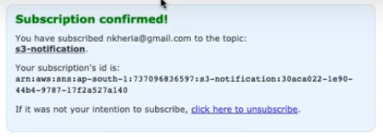

**Cloudwatch Events:**

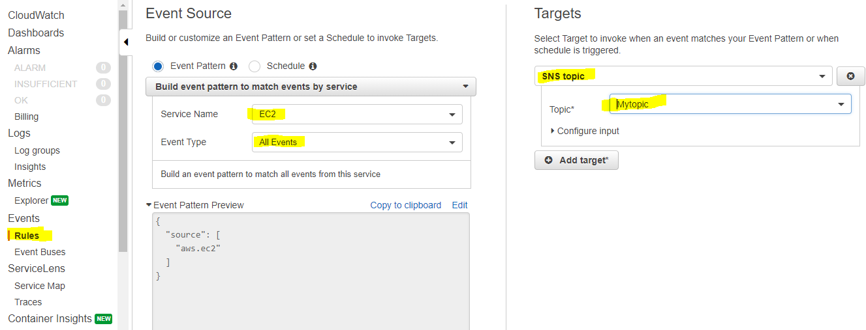

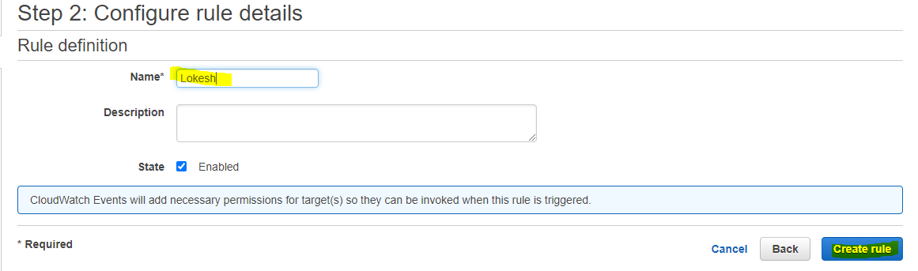

**Dashboard:**

