**“ec2-metadata”**

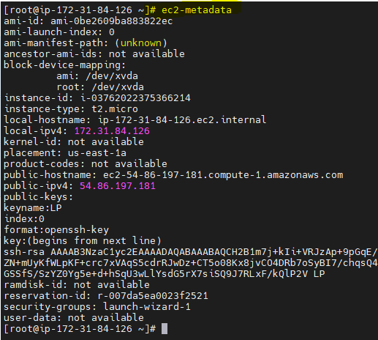

**Types of AMI?** Community AMI’s and Custom AMI’s

**Note ::** 1) AMI Id’s will differ from region to region

2) We can copy AMI from one region to other

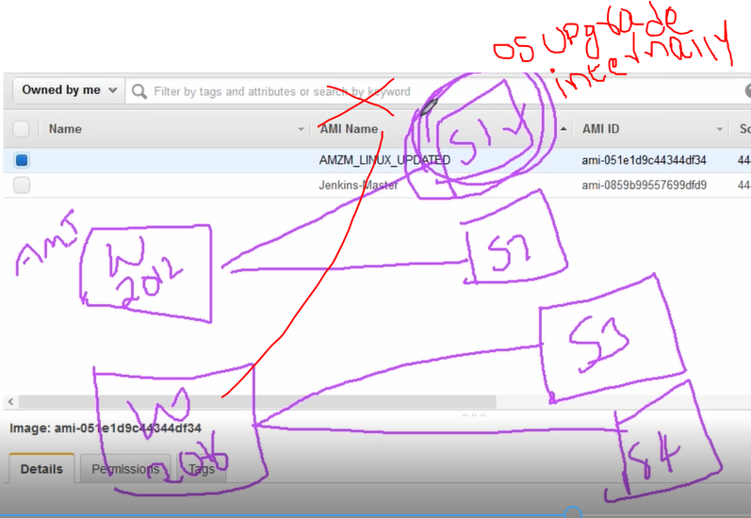

**What are all the checks happens while the instance is coming up?**

(System level checks—hyp V)

Instance level checks(OS )

**Can we increase or add ebs volume ,while EC2 is running?--yes**

**How to recover PEM file?**

**HVM v/s PV ?**

**AMI market place:**

Here you will get application as an images,,you can launch it directly

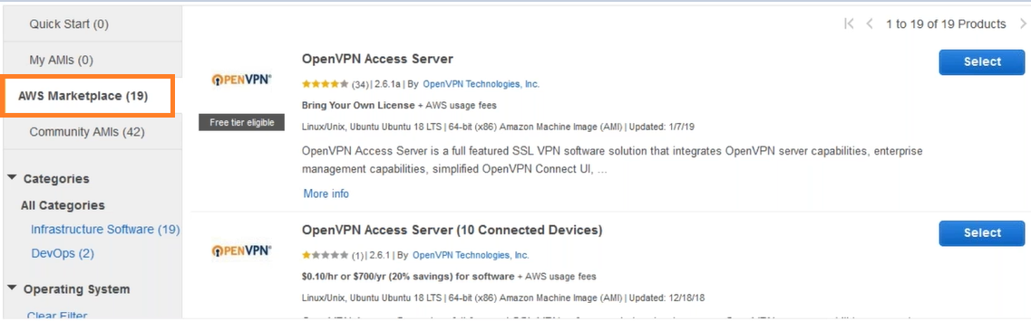

**What is an EC2 ?**

EC2 is a web service that provides instances in the cloud which are customized as per the need.

**Enable termination protection:** To protect against accidental deletion

**Monitoring** :: Enable detailed monitoring(Min by min)

**Tenancy** :: We can choose to run instances on physical servers

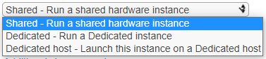

**File system :** We can specify EFS to mount on instances



**Purchase options::**

1. **Spot instances:** Spot Instances are available for less than the On-Demand prices. But we can’t use spot instance whenever we need data(when on demand instances increases AWS will terminate these spot instances by sending notice before 2min)

Used for web servers, batch servers

1. **Reserved instances** : (1-12month),(12-36months)

Amazon EC2 Reserved Instances (RI) provide a significant discount (up to 72%) compared to On-Demand pricing and provide a capacity reservation when used in a specific Availability Zone.

1. **Scheduled instances**: Scheduled Instances allow you to reserve Amazon EC2 instances on a recurring schedule. You can purchase daily, weekly, or monthly reservations to ensure your applications have the compute capacity you need, when you need it.

**Note** :: Both reserved and scheduled are same but the duration differs

1. **Capacity reservation:** Capacity Reservation requests are granted or denied based on your EC2 instance limits and our available capacity. When you create a Capacity Reservation, we reserve the specified capacity for your use. The reserved capacity is charged at the selected instance type’s On-Demand rate whether an instance is running in it or not. You can also use your regional reserved instances with your Capacity Reservations to benefit from billing discounts.
2. **Dedicated Host :**: Dedicated Hosts allow you to provision EC2 instances on physical servers fully dedicated for your use.

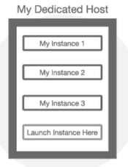

**Types of Volumes:**

1. **EBS( Elastic block store) :Block by block**
2. **Instance strore: Same has EBS but it is not persistent**
3. **File storage ---EFS ,,FSX**
4. **Object storage**

