**Identity and access management :IAM**

Why we need access management: each user depending on its work or a role the access will be given (Admin,UI developer,Business analyst,DB admin)

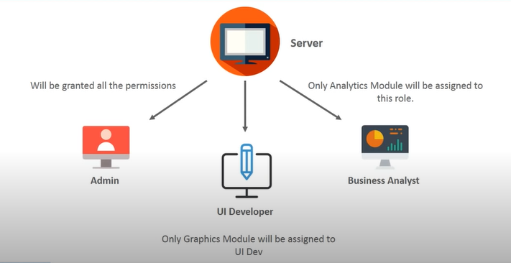

AWS access management is a web service that helps you securely control access to aws resources for your users. We can use IAM to control who can use what resources.

**Components:**

1. **Users**:: (Users are for people) Users are entities in aws to which we can give some set of permissions to access different resources.
2. **Groups** :: We can create group of users to give identical access by attaching policies.
3. **Roles** : (Roles are for resources) Roles are similar to users but these are assigned to applications ,roles can be assigned to any of the aws services
4. **Policies** :: Policies are nothing but set of permissions ,given to the users ,groups or Roles.

**MFA (Multi factor authentication)** ::Using which you can configure your aws account in such a way whenever you enter username and password ,and when u click on login it’ll ask you for a code (Google authenticator)

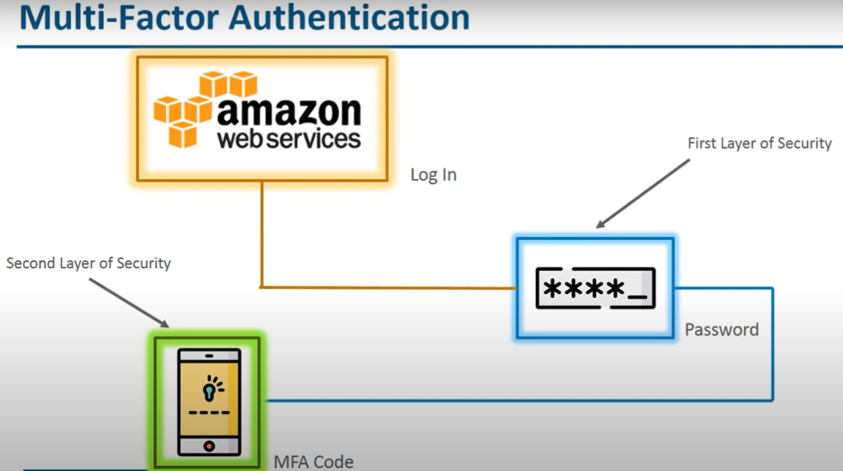

**Note** :: Will get access & secret key only when you give programmatic access to the users,

How to create users::

1. Click on add users---Provide the name and select access type (programmatic or AWS management console access) and give the password accordingly

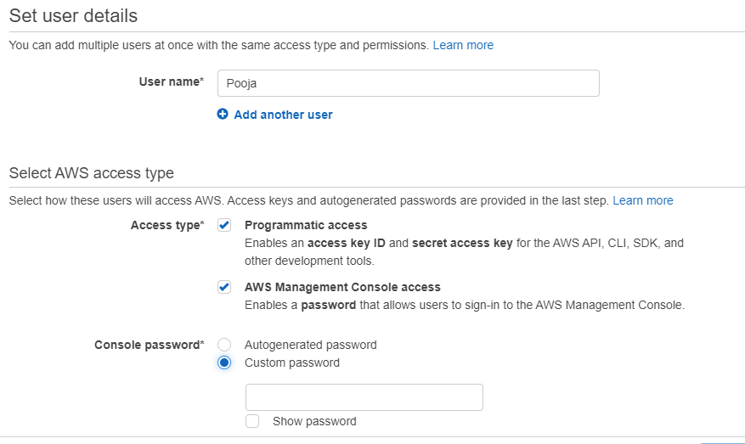

1. Need to set the permissions. (We can add user to the group ,,Copy permissions from existing user,,attach existing policy)

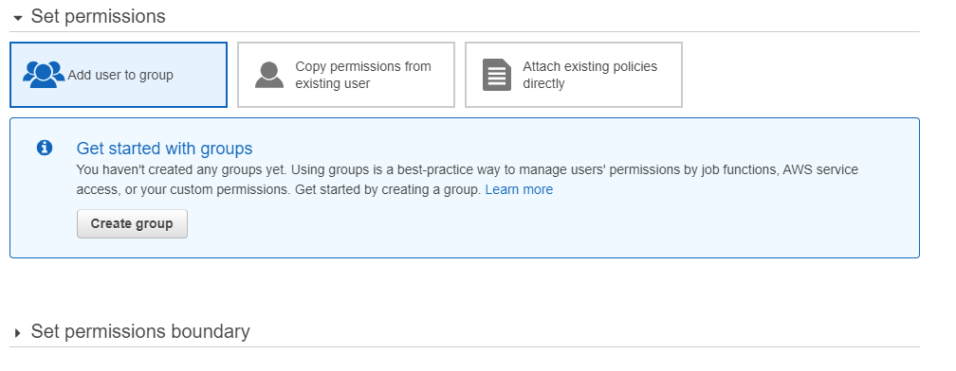

1. Create a user

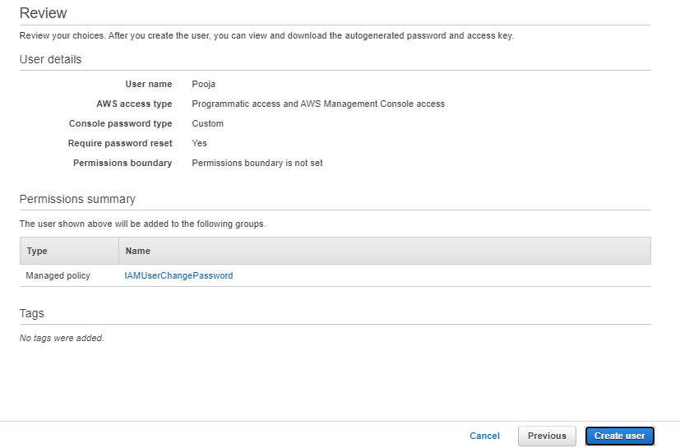

1. Download access & secret key.(if you have chosen programmatic access)

**To create a Group::**

1. **Click on create group and give the name,**
2. **Attach policies (Max –10)**

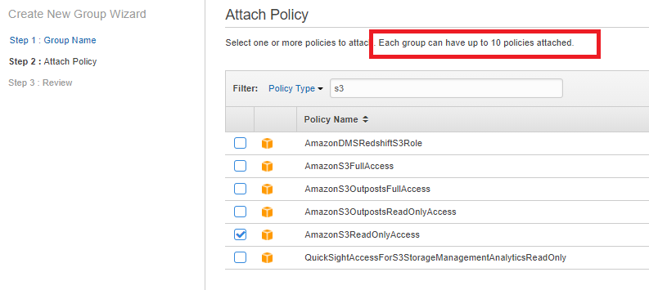

**To create roles::**

1. **Click on create roles**
2. **Select an entity/service on which you want attach a role.(Ec2)**

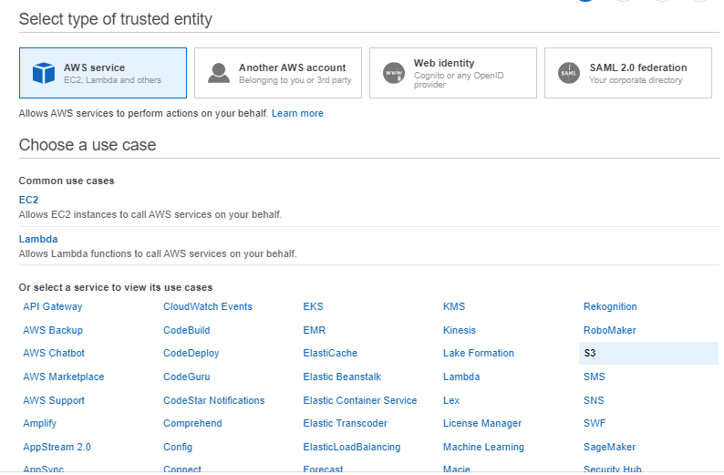

1. **Attach permissions policies**

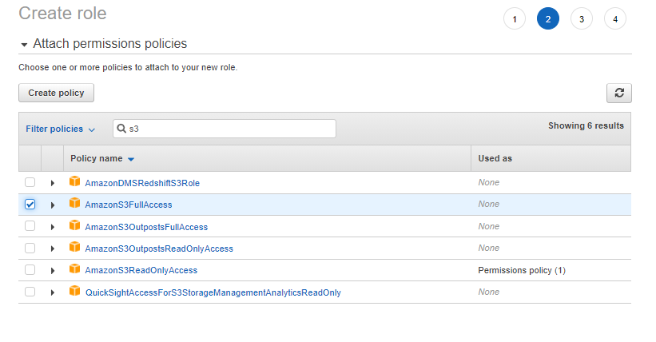

1. **Give the name**

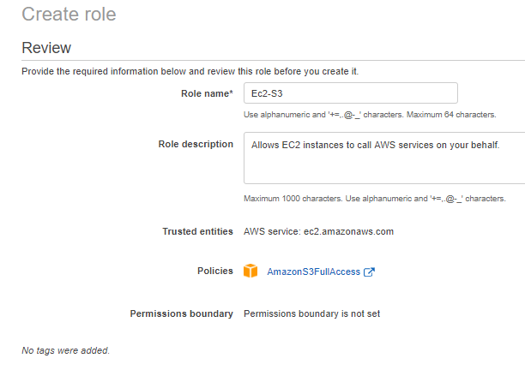

1. **Attach the role on to the Ec2.**

**To create custom Polices ::**

1. **Click on create policy (Select services)**

