Nexus is a repository to store the binaries/artifacts/packages.

*We can use Nexus as a proxy for .M2 for maven(local repo)

*We can store artifacts/binaries/packages

*We can also store Docker images

**By default, the repository manager listens on port 8081**

Requirements:

1) Java must be installed

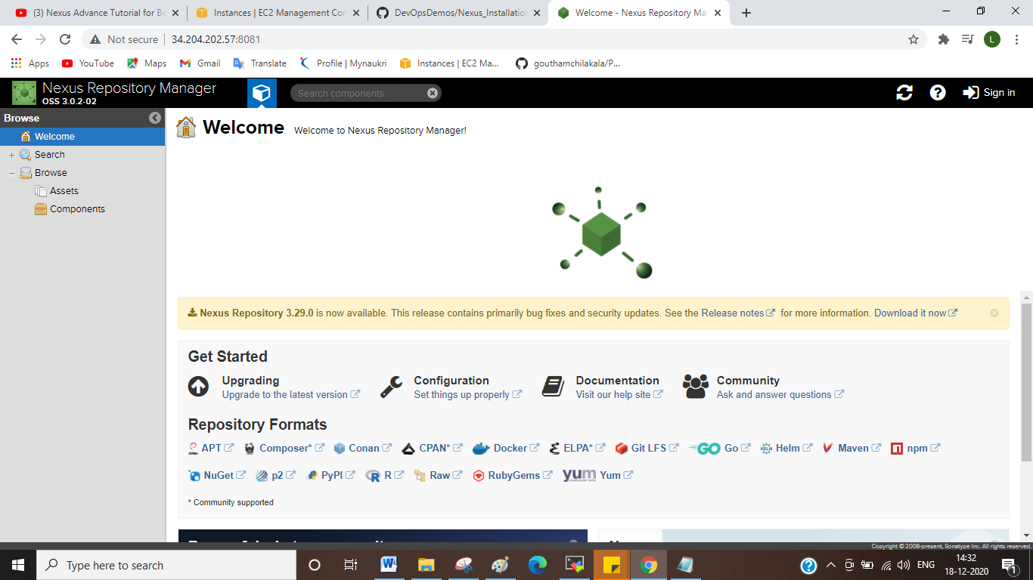

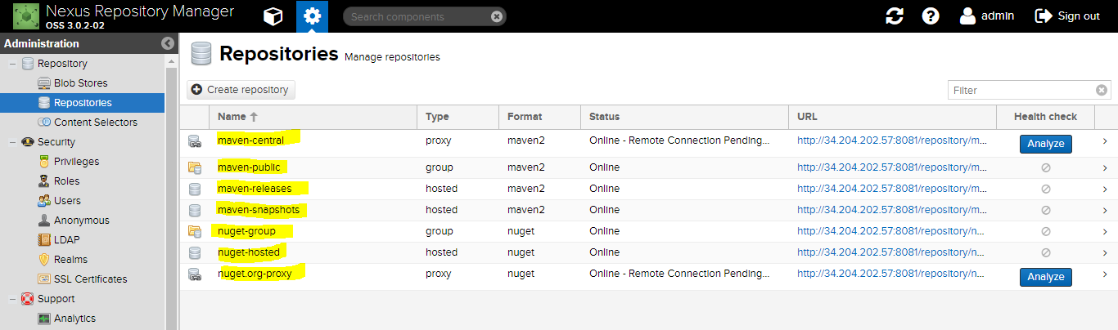

In POM.XML need to provide url in distribution management section

In settings.XML under server section need to provide creds.

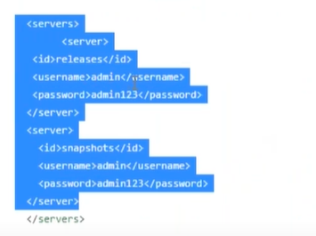

**Default repository policy:**

**SNAPSHOT**----Usually there will be a 3 week sprint in agile,so developers will write the code and checking the code and goes for a pull request ones it is approved he merges that to Dev branch

Sprint is nothing but in specified amount of time(Usually 3 weeks) we need to develop software,need to test it and need to deliver it to the customer ,,if in case it is internal we need to give demo to the product owner. ----This is generally referred to as SNAPSHOT”

**RELEASE**---At the end of the project ,lets say we worked for 3,6 months deliverables we’ve now its time to release final version that is called release.



**Types of repo:**

