**How to set criteria in SonarQube?**

**Reasons to use static code analysis:**

1. **Finds errors**
2. **Detects over complexity in code**
3. **Finds security errors**
4. **Enforces best coding practices**
5. **To find duplicates**

Sonarqube is an open source static code analysis tool it basically goes through developers code and identifies errors by doing code quality checks.

It does following code quality checks:

1. Potential bugs
2. Code defects
3. Code duplication
4. Lack of test coverage
5. Excess complexity

**Features of SonarQube:**

1. **Detects bugs:** SonarQube can detect bugs on piece of code that think it faulty
2. **Code smells:** If developers have not use the best practices while writing the code
3. **Security Vulnerability**: SonarQube can detect security issues eg :username and password written in code
4. **Automated code analysis:** Keeps working in the background
5. **Enforces a quality gate:** You can tell sonarqube what code is wrong and what is correct based on your requirement and practices.( **A quality gate--** is the best way to enforce a quality policy in the organization)
6. **finds duplicates :** It also finds duplicates in the code.

By default SonarQube uses **port 9000**

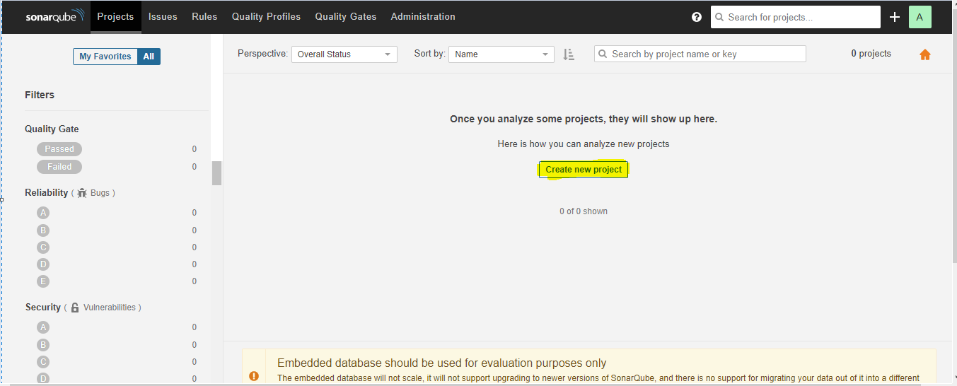

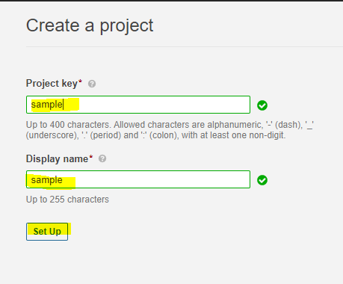

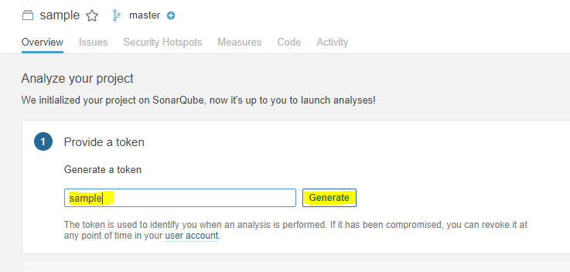

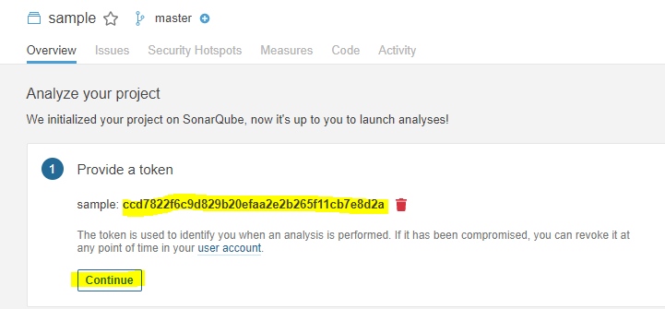

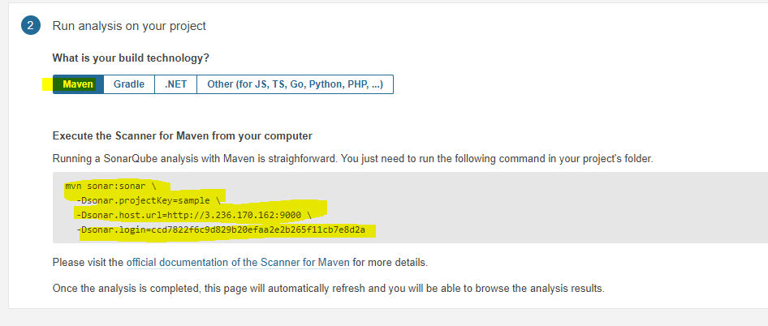

**mvn sonar:sonar \**

**-Dsonar.projectKey=sample \**

**-Dsonar.host.url=http://3.236.170.162:9000 \**

**-Dsonar.login=ccd7822f6c9d829b20efaa2e2b265f11cb7e8d2a**

