# Codtech IT Solutions — SQL Internship Task-1

Task: Joins Practice (INNER, LEFT, RIGHT, FULL JOIN)

Intern Name: Madhugna Kadem

Intern ID: CT04DN607

## 1. Objective

To practice and demonstrate understanding of SQL joins by performing INNER JOIN, LEFT JOIN, RIGHT JOIN, and FULL JOIN on sample tables.

## 2. Tables Used

* Employees

|  |  |  |
| --- | --- | --- |
| emp_id | emp_name | dept_id |
| 1 | Alice | 101 |
| 2 | Bob | 102 |
| 3 | Charlie | 103 |
| 4 | David | NULL |

* Departments

|  |  |
| --- | --- |
| dept_id | dept_name |
| 101 | HR |
| 102 | Engineering |
| 104 | Marketing |

## 3. Join Queries and Explanations

### INNER JOIN

**SELECT e.emp_name, d.dept_name  
FROM employees e  
INNER JOIN departments d ON e.dept_id = d.dept_id;**

Explanation: Retrieves only the employees that have a matching department.

Output Screenshot:

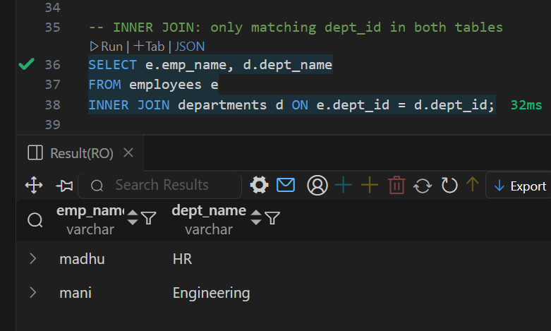

### LEFT JOIN

**SELECT e.emp_name, d.dept_name  
FROM employees e  
LEFT JOIN departments d ON e.dept_id = d.dept_id;**

Explanation: Returns all employees, and matches department data if available. If no match, department is NULL.

Output Screenshot:

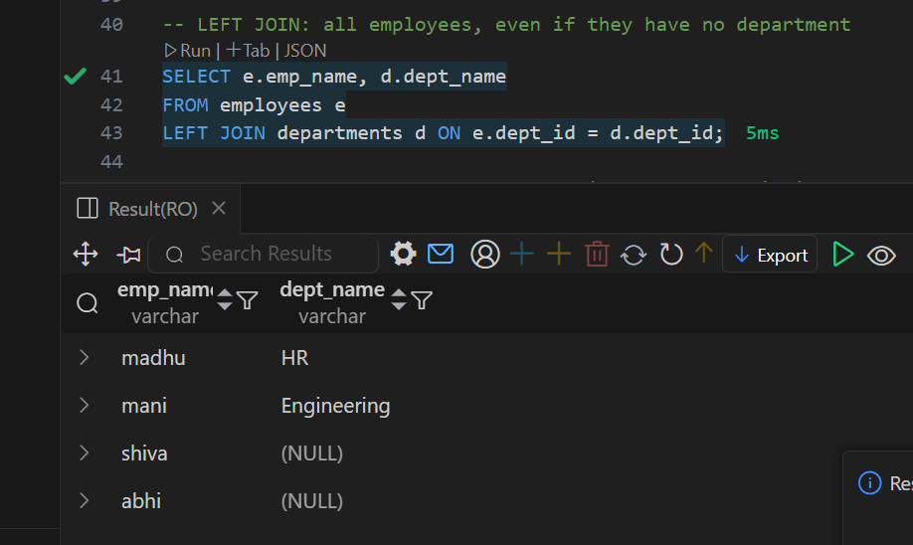

### RIGHT JOIN

**SELECT e.emp_name, d.dept_name  
FROM employees e  
RIGHT JOIN departments d ON e.dept_id = d.dept_id;**

Explanation: Returns all departments and their employees, if any. If no employee in a department, employee is NULL.

Output Screenshot:

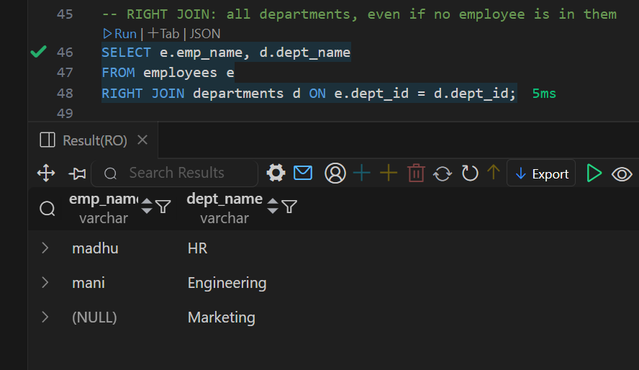

### FULL OUTER JOIN (Simulated with UNION)

**SELECT e.emp_name, d.dept_name  
FROM employees e  
LEFT JOIN departments d ON e.dept_id = d.dept_id  
  
UNION  
  
SELECT e.emp_name, d.dept_name  
FROM employees e  
RIGHT JOIN departments d ON e.dept_id = d.dept_id;**

Explanation: Combines results of LEFT and RIGHT joins to include all records from both tables.

Output Screenshot:

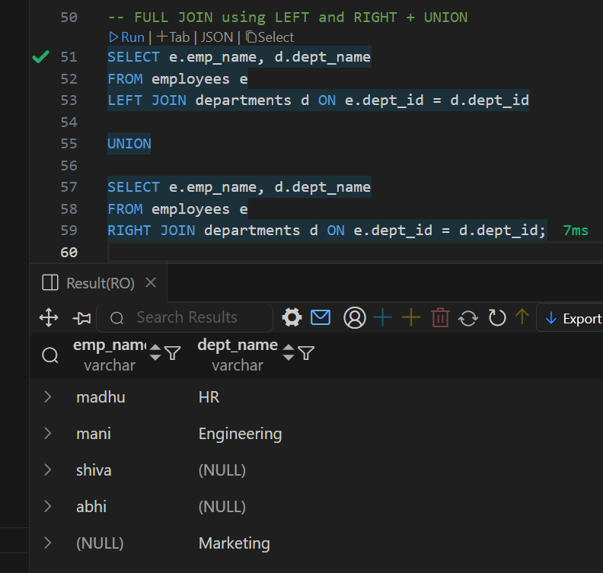

## 4. Summary

This practice helped understand how different joins work in SQL:  
- INNER JOIN: Common data only  
- LEFT JOIN: All from left + matches  
- RIGHT JOIN: All from right + matches  
- FULL JOIN: All from both sides