**WhatNext Vision Motors: Shaping the Future of Mobility with Innovation and Excellence**

**ABSTRACT**

The rapid evolution of the automotive industry has created a growing need for **customer-centric digital solutions** that improve operational efficiency and ensure higher customer satisfaction. Traditional processes often face challenges such as delayed order fulfillment, inaccurate stock management, lack of dealer coordination, and limited transparency in communication with customers.

The **WhatsNext Vision Motors Salesforce Project** addresses these challenges by developing a customized Salesforce CRM solution. This solution streamlines the **vehicle ordering process**, enforces **stock validation**, automates **dealer assignment**, and provides **real-time order status updates**. By incorporating **Apex triggers, batch jobs, flows, and custom objects**, the project ensures that customers receive a seamless experience while the company benefits from improved operational agility.

**OBJECTIVE**

The project has been designed with the following objectives:

* **Customer-Centric Ordering Experience**: To build a seamless ordering system that automatically suggests the nearest dealer and validates stock before order placement.
* **Accurate Stock Management**: To implement mechanisms that prevent customers from ordering vehicles that are out of stock.
* **Automation of Business Processes**: To automate repetitive tasks such as order assignment, email reminders, and order status updates, thereby reducing manual intervention.
* **Operational Efficiency**: To minimize administrative workload through automation, allowing staff to focus on strategic initiatives.
* **Transparency & Trust**: To ensure customers always have visibility into the status of their orders (Pending, Confirmed, In Process).
* **Scalability**: To design a system that can be extended to include payment integrations, customer portals, and AI-driven analytics in the future.

**TECHNOLOGY DESCRIPTION**

**1. Salesforce CRM**

The backbone of the project, Salesforce CRM serves as the platform for developing the custom application. It provides tools for creating **custom objects, flows, Apex triggers, batch jobs**, and **automation processes**.

**2. Custom Objects**

* **Vehicle** – Stores details such as Vehicle Name, Model, Variant, Price, Color, and Stock Quantity.
* **Vehicle Order** – Represents customer purchase requests. Includes Order Number, Vehicle, Customer, Dealer Assigned, Order Status (Pending/Confirmed).
* **Vehicle Customer** – Stores customer details such as Name, Contact Information, Address, and Customer Preferences.
* **Vehicle Test Drive** – Tracks test drive requests, including Vehicle Selected, Preferred Date/Time, Assigned Dealer, and Customer Feedback.

**3. Tabs**

Tabs are created for each custom object (Vehicle, Vehicle Orders, Customers, Test Drives) to enable quick access from the Salesforce navigation bar.

**4. Custom Application**

A dedicated **WhatsNext Vision Motors App** was built in Salesforce Lightning to group all relevant tabs, workflows, and dashboards into a single application for operational use.

**5. Flows**

* **Auto Design Dealer**: Automates assignment of the nearest dealer to an order based on the customer’s address.
* **Test Drive Reminder**: Sends automated email reminders to customers for scheduled test drives.

**6. Apex**

* **Triggers**: Implemented to enforce business rules such as preventing order creation when stock = 0 and auto-assigning dealers.
* **Trigger Handlers**: Used to modularize logic and maintain clean, reusable code.

**7. Batch Class**

Batch Apex and Scheduled Jobs are used to process large volumes of data

**DETAILED EXECUTION OF PROJECT PHASES**

**Phase 1: Salesforce CRM Setup**

* Create a **Developer Org** and define the scope of the project.
* Design the **application layout** in Salesforce Lightning App Builder.

**Phase 2: Custom Object Creation**

* **Vehicle Object**: Fields – Vehicle Name, Model, Price, Stock. Relationships – Lookup to Dealer.
* **Vehicle Order Object**: Fields – Customer Name, Vehicle, Order Date, Status. Relationships – Lookup with Vehicle.
* **Vehicle Customer Object**: Fields – Name, Email, Phone, Address.
* **Vehicle Test Drive Object**: Fields – Customer Name, Vehicle, Dealer, Scheduled Date, Test Drive Status.

**Phase 3: Tabs & Custom Application**

* Tabs created for each object for visibility.
* A **custom Lightning app** “WhatsNext Vision Motors CRM” integrates Vehicles, Orders, Customers, and Test Drives.
* App home page includes dashboards for **Stock Levels, Pending Orders, and Scheduled Test Drives**.

**Phase 4: Flows**

* **Auto Design Dealer**: Uses a record-triggered flow to detect order creation and auto-assign dealer based on customer’s postal code.
* **Test Drive Reminder Flow**: Uses time-based triggers to send email reminders 24 hours before a scheduled test drive.

**Phase 5: Apex Triggers & Classes**

* **VehicleOrder Trigger**: Prevents order creation if Stock < 1. Error message prompts customer to choose another vehicle.
* **VehicleOrder Trigger Handler Classes**: Ensure reusability of code and maintain trigger best practices.

**Phase 6: Batch Apex & Scheduled Jobs**

* **VehicleOrder Batch Job**: Runs nightly to update Vehicle stock across all dealerships.
* **Scheduled Notifications**: Dealers receive stock replenishment alerts weekly; Customers receive order update emails.

**PROJECT EXPLANATION WITH REAL WORLD EXAMPLE**

Consider a customer, **Sarah Williams**, interested in purchasing an SUV from WhatsNext Vision Motors.

1. Sarah logs into the company’s portal and places an order for the SUV.
2. Salesforce validates stock availability:
   * If the SUV is available, her order is marked as **Confirmed**.
   * If out of stock, the order is marked **Pending**.
3. Based on her location, the system auto-assigns the nearest dealer in her city.
4. Sarah also schedules a test drive. An **automated email reminder** is sent to her 24 hours before the appointment.
5. Each night, the **Batch Apex Job** checks stock levels and updates order statuses. Sarah receives updates whenever her pending order moves to confirmed.

This automation ensures that Sarah has a **transparent, efficient, and frustration-free experience**, while the company reduces manual effort and ensures accuracy in order management.

**SCREENSHOTS**

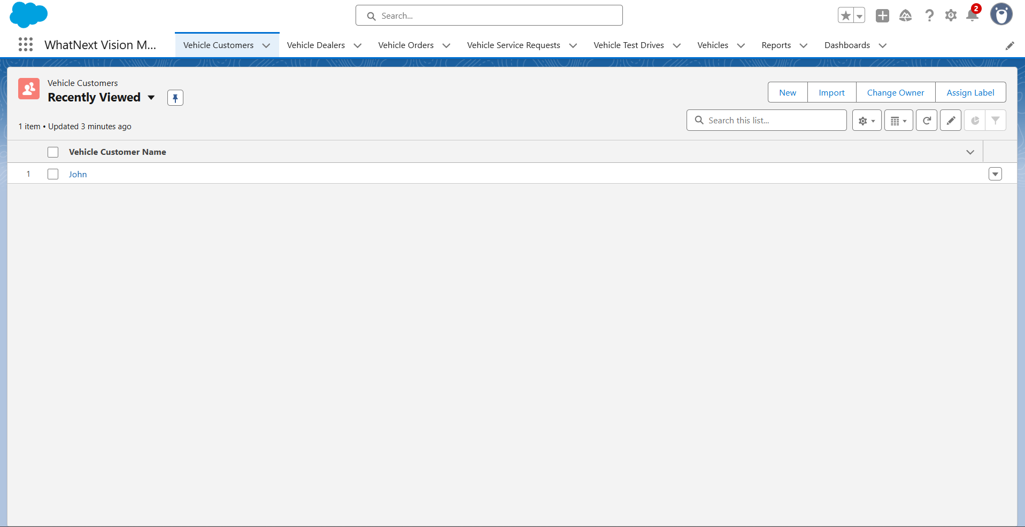

Lightning App Tabs View

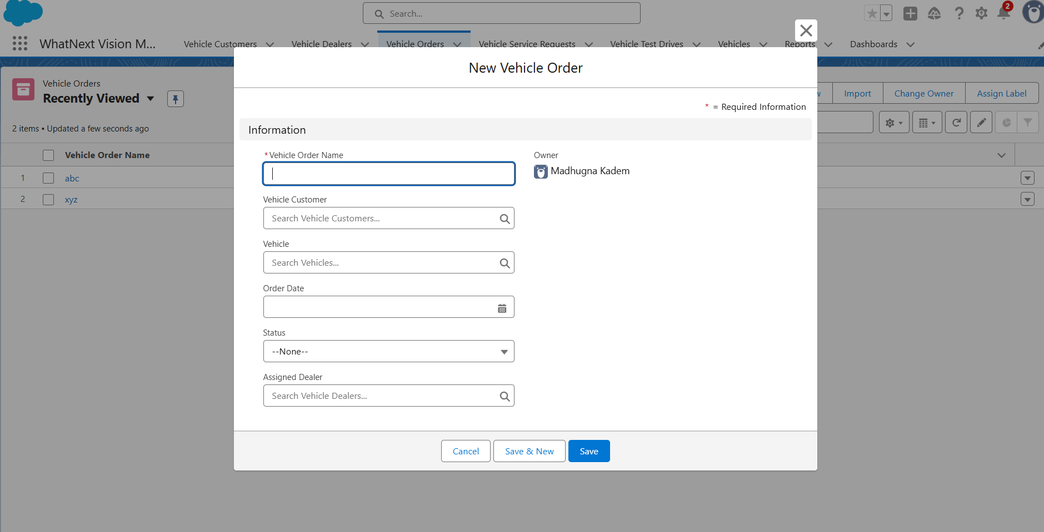

Customer Order Form with Auto Dealer Section

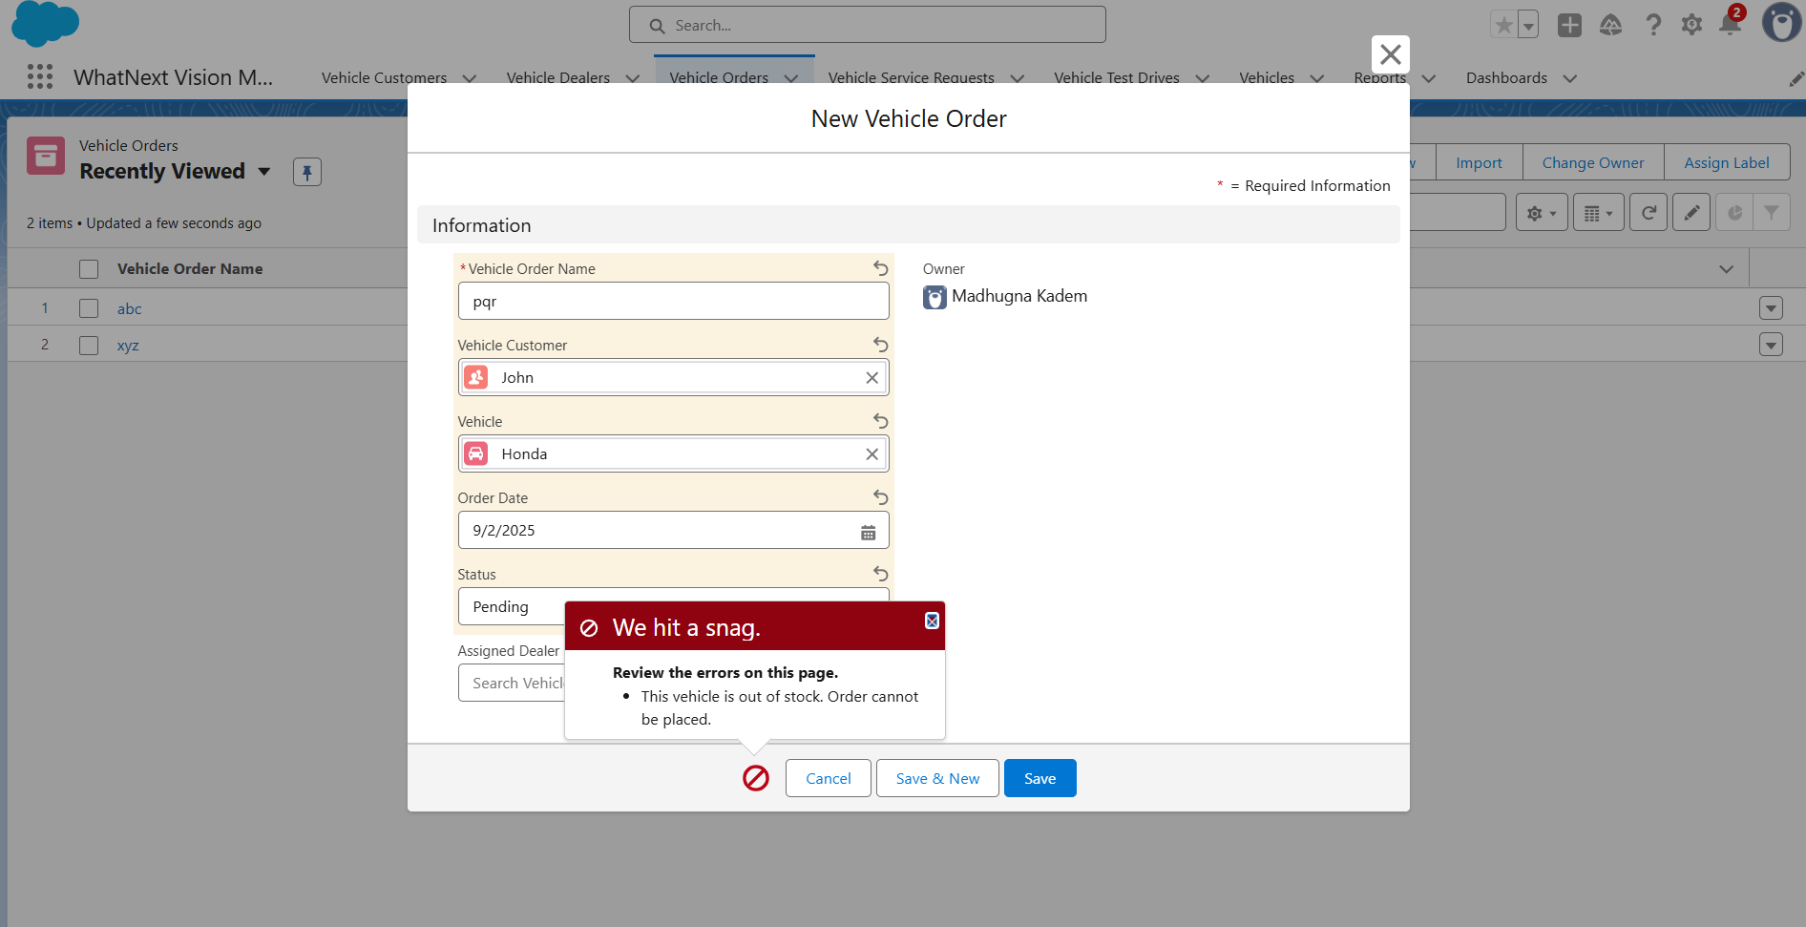

Error Notification for Out-of-stock Vehicle

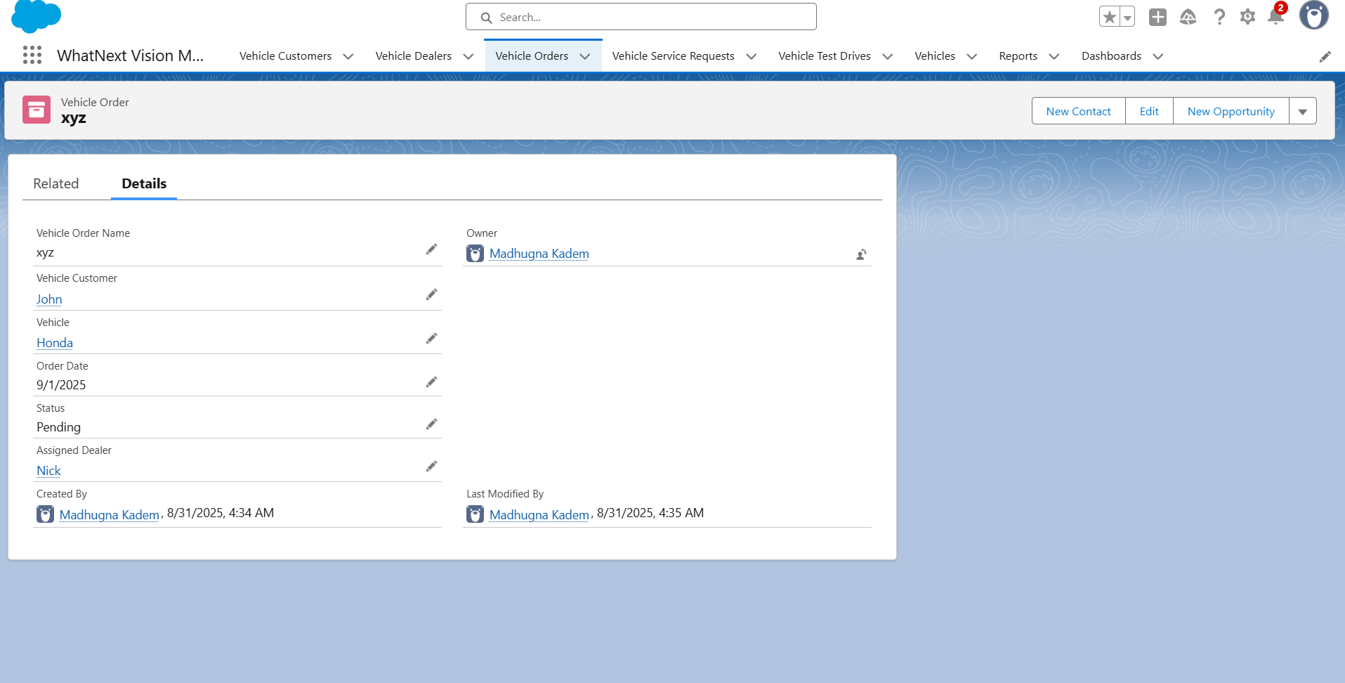

Order Record with Dynamic Status Update

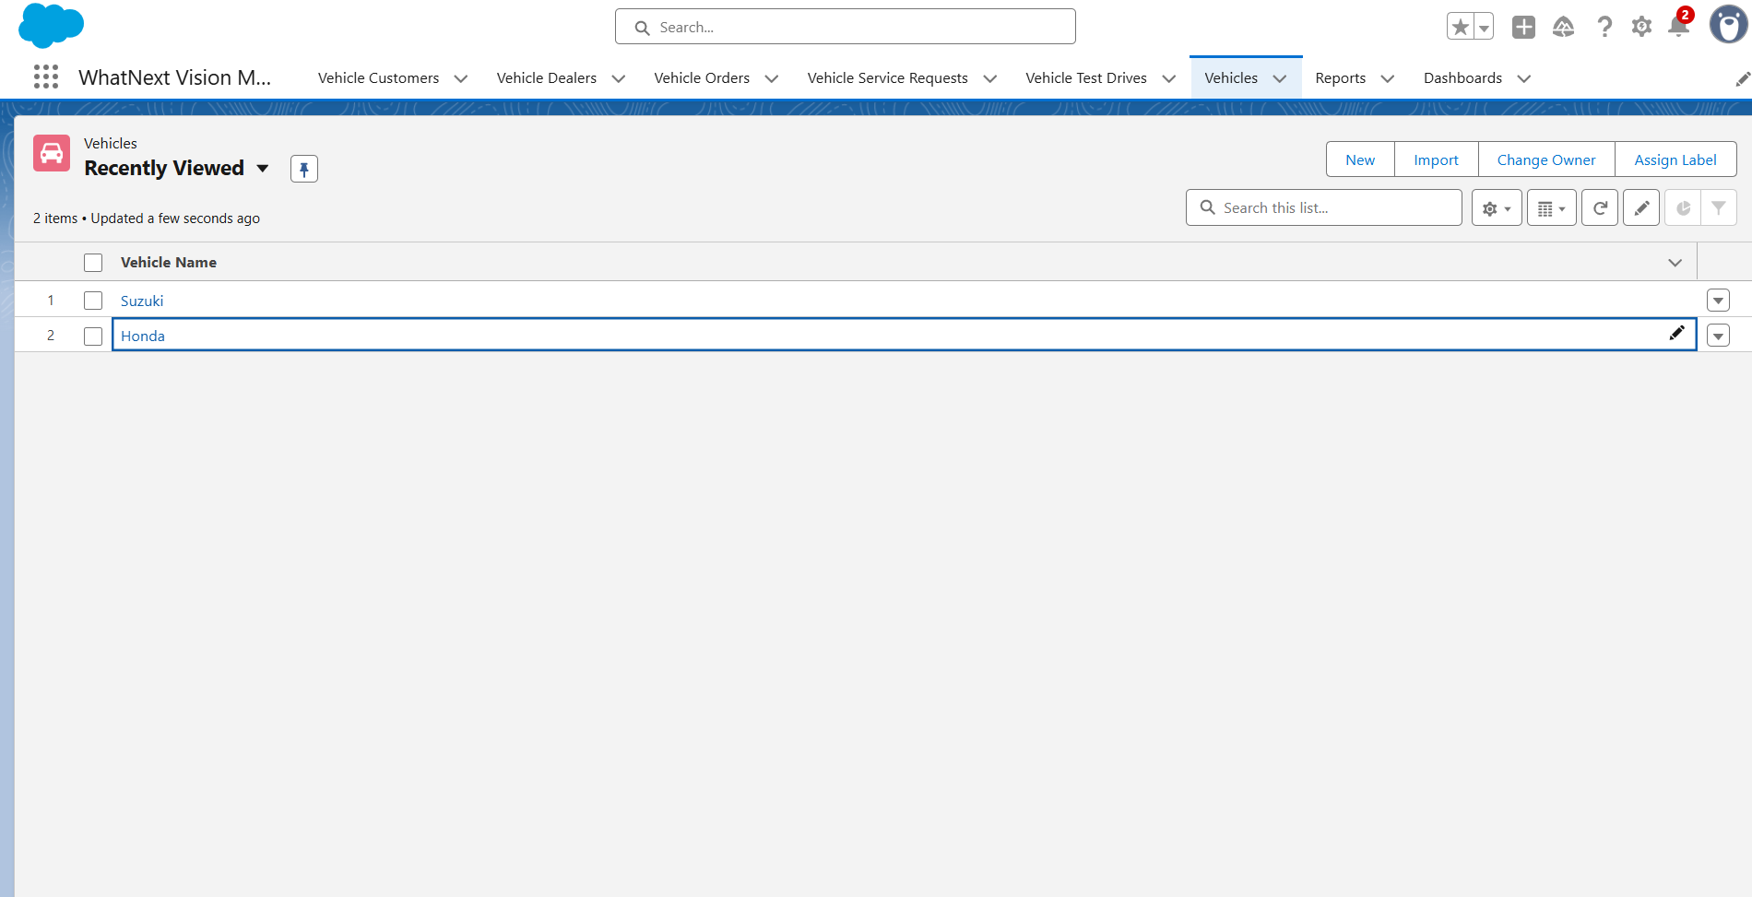

List of Vehicles

**CONCLUSION & FUTURE SCOPE**

**Conclusion**

The WhatsNext Vision Motors Salesforce project demonstrates how CRM systems can transform traditional automotive processes into **digital-first, customer-focused solutions**. By combining **custom objects, flows, Apex triggers, and batch jobs**, the project ensures that:

* Customers always see **accurate stock levels**.
* Orders are automatically routed to the **nearest dealer**.
* Customers and staff receive **real-time updates** on order status and test drives.
* Manual work is reduced, enhancing staff productivity and efficiency.

**Future Scope**

* **Integration with Payment Gateways**: Allow customers to pay online during order creation.
* **Customer Portal Development**: Empower customers to track orders, schedule services, and manage test drives themselves.
* **AI-Powered Demand Forecasting**: Predict vehicle demand and optimize stock across dealerships.
* **Mobile App Integration**: Provide a mobile-friendly platform for dealers and customers.
* **IoT Integration**: Connect with vehicle sensors to schedule predictive maintenance automatically.