

**PLACEMENT EMPOWERMENT PROGRAM**

**Cloud Computing & DevOps Centre**

**Implementing auto-scaling in Azure:** Set up an auto-scaling groups in Azure VMs for handling various workloads.

Name:Madhumitha.H

Dept:ADS

**Step-by-step process:**

**Step 1:** Open the Azure portal and navigate to VM Scale Sets.

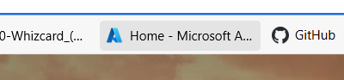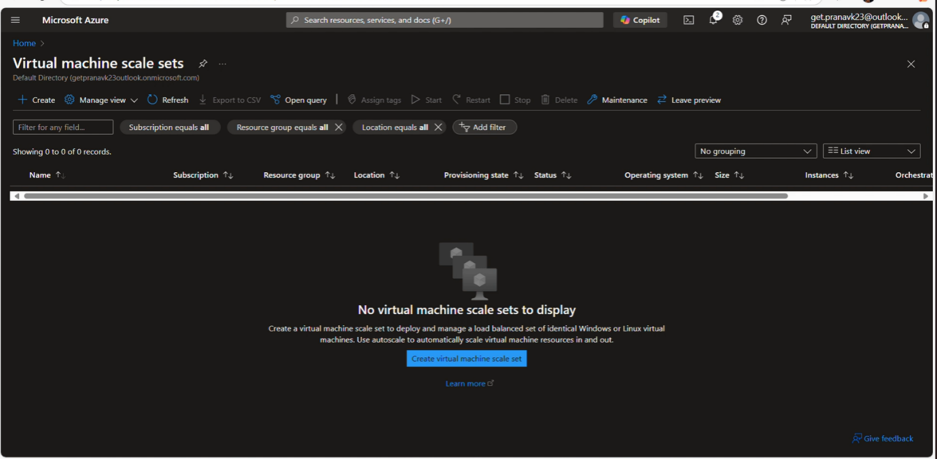

Step 2:create vmss with the required configurations and enable auto scale

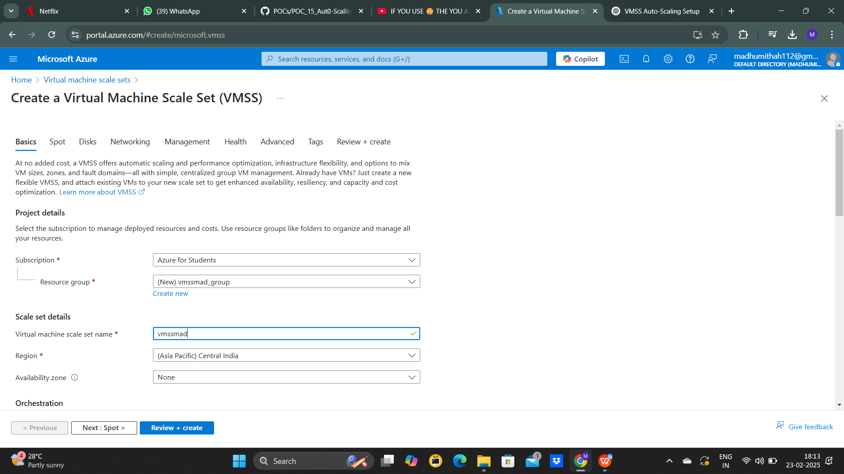

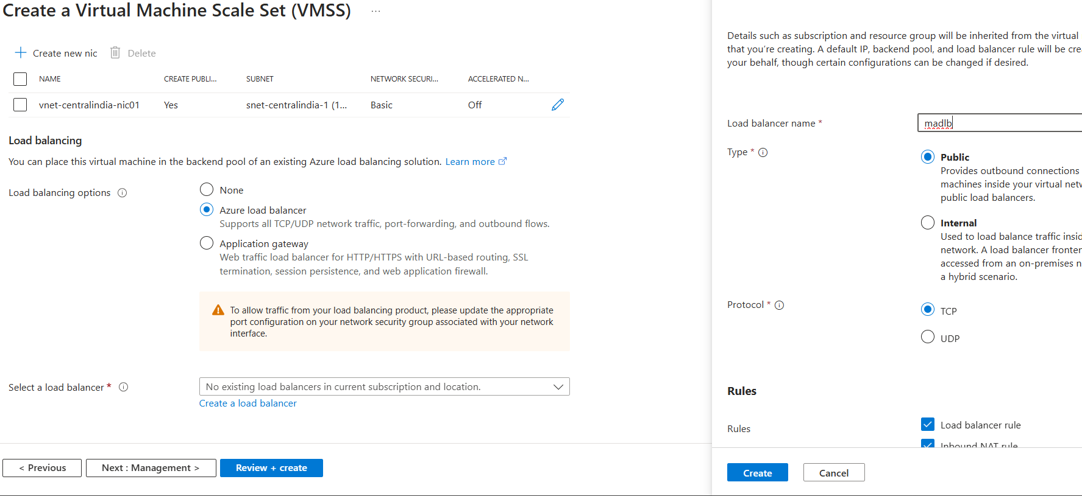

**Step 3:** Go to the Scaling page in your VMSS.

Then add scale-out rule and scale-in rule.

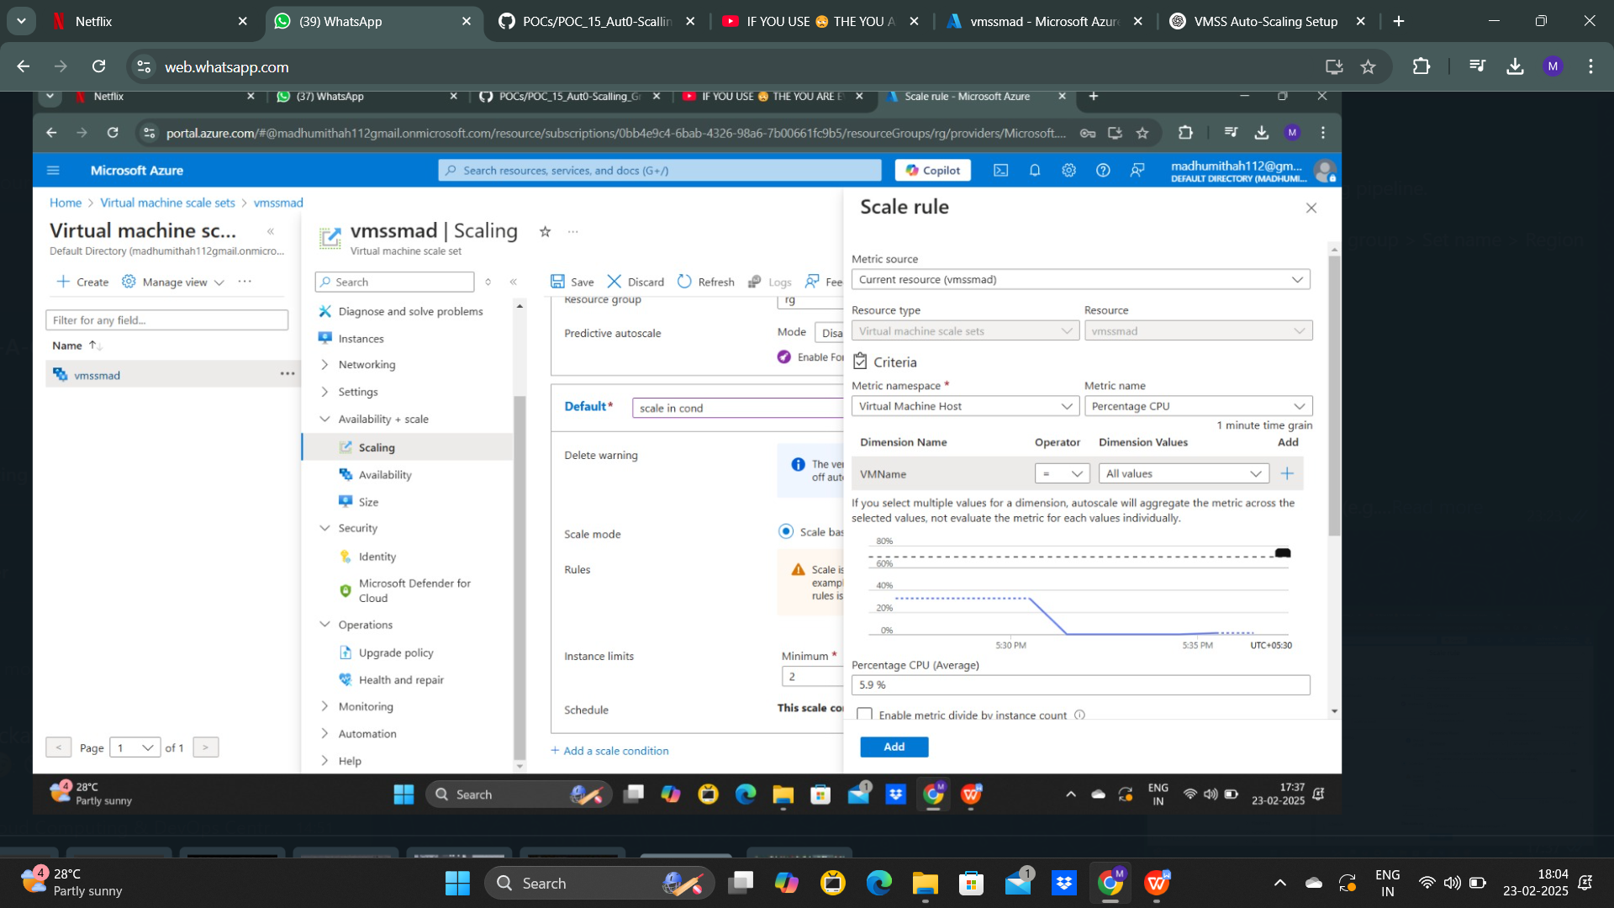

**Step 4:** Testing 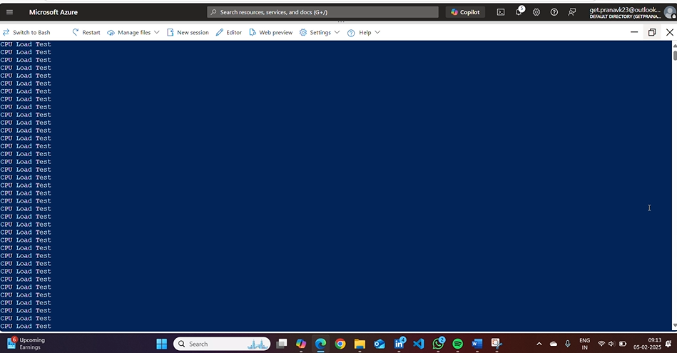

**Step 5:** Go to Azure Monitor for viewing the metrices of your VMSS.

