GENERATING PRIVATE KEY AND CSR

GENERATING PRIVATE KEY AND CSR USING OPENSSL IN LINUX/UNIX

1.) GO TO THE FOLDER WHERE YOU WANT THE PRIVATE KEY AND CSR TO BE CREATED

2.) **TO GENERATE THE PRIVATE KEY:**

openssl genrsa -des3 -out privatekey.key 2048

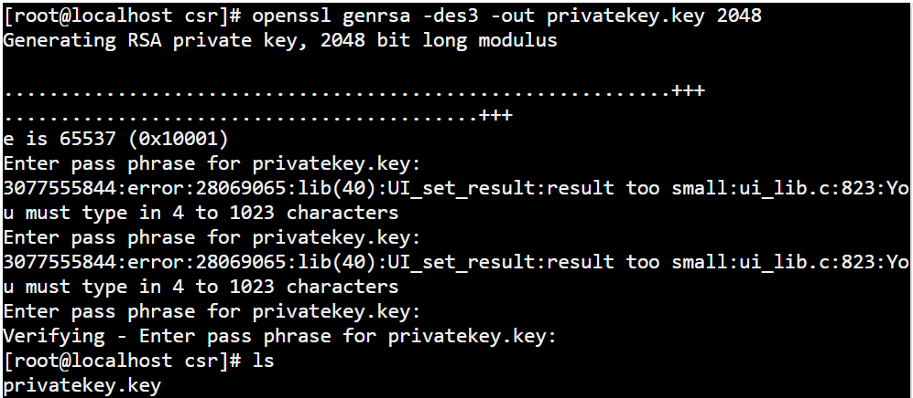

3.) IT ASKS PASS PHRASE FOR THE PRIVATEKEY: USE 4 OR 8 CHARACTERS

4.) VERIFY YOUR PASS PHRASE BY RETYPING

5.) CHECK FOR THE PRIVATEKEY.KEY FILE IN THE FOLDER

6.) **NOW TO GENERATE CSR:**

openssl req -new -key privatekey.key -out request.csr

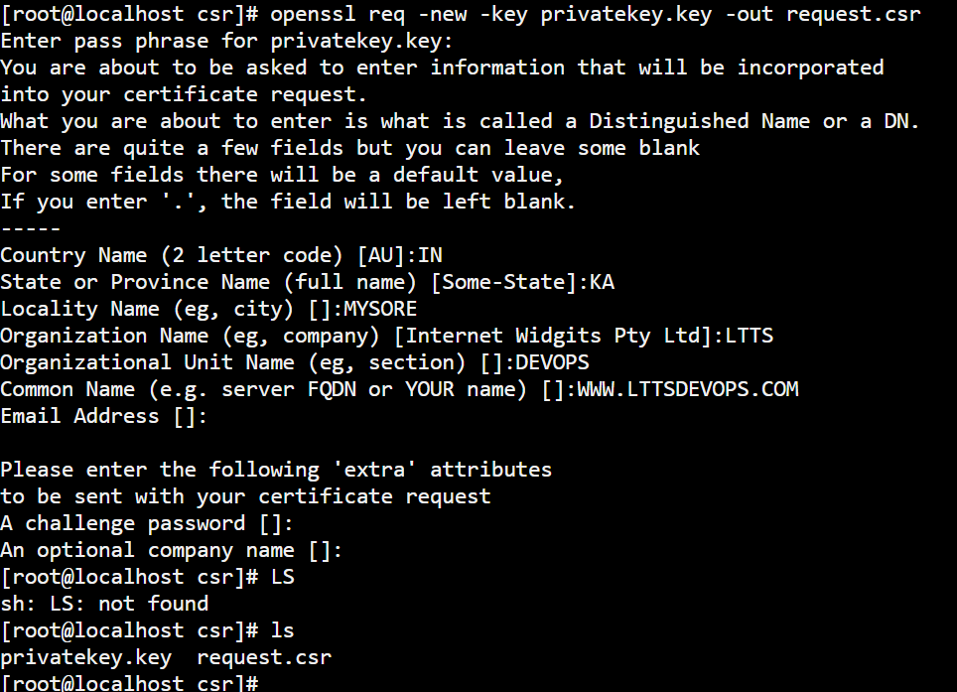

7.) TYPE PASS PHRASE FOR THE PRIVATE KEY

8.) THEN TYPE THE INFORMATION ACCORDINGLY

9.) NOW YOU MUST BE ABLE TO SEE THE CSR FILE IN THE FOLDER

**For generating key pair in windows:**

1.) Open git bash terminal after installing git in windows

2.) go to folder where you want to create key pair (public and private)

3.) to generate the key pair using your email:

$ ssh-keygen -t rsa -C [#############@gmail.com](mailto:#############@gmail.com)

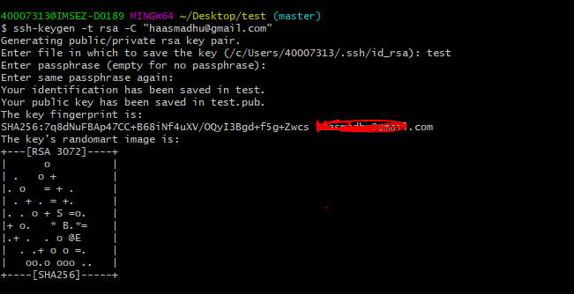

4.) the public key is created in the given folder

THANK YOU