**GCP CICD PIPELINE:**

TOOLS USED TO BUILD THIS PIPELINE:

* GOOGLE CLOUD BUILD
* GOOGLE KUBERNETES ENGINE
* GITHUB
* MAVEN
* DOCKER
* GOOGLE CONTAINERS REPOSITORY
* GOOGLE CLOUD PERMISSION MANAGER (IAM & ADMIN)

**GOOGLE CLOUD BUILD**

It is used to link the source code repository from GitHub/bitbucket/google cloud source repositories and helps to add triggers(webhooks). So, when a code is pushed into source code repository by a developer it automatically starts a build and uses cloud config file in the source code repository.

<https://cloud.google.com/cloud-build>

**GOOGLE KUBERNETEES ENGINE**

It is used to deploy the containers after the application is built using maven and docker. The built application is uploaded to the google cloud container repository from there the google cloud build deploys to the Kubernetes cluster.

[https://cloud.google.com/kubernetes-engine](https://cloud.google.com/kubernetes-engine/)

**GITHUB**

This is the tool used to hold the source code repository and helps to trigger the builds when a code is pushed to the repository by a developer.

[https://github.com](https://github.com/)

**MAVEN**

This is the tool used in the pipeline to build the project using maven life cycle components like compile, test, install, package.

<https://github.com/GoogleCloudPlatform/cloud-builders/tree/master/mvn>

**gcr.io/cloud-builders/mvn** is the tool representation in gcp

**DOCKER**

The docker in gcp helps us to build an image of the application and helps us to push it to the container repository in gcp.

<https://github.com/GoogleCloudPlatform/cloud-builders/tree/master/docker>

gcr.io/cloud-builders/docker is the tool representation in gcp.

**GOOGLE CONAINERS REPOSITORY**

This helps to store the container images of the project that were built by docker and uploaded to this repository.

<https://cloud.google.com/container-registry>

**SETTING PIPELINE IN GCP:**

**STEP1:**

CREATE A NEW PROJECT IN THE GOOGLE CONSOLE ([https://console.cloud.google.com](https://console.cloud.google.com/projectcreate?previousPage=%2Fcloud-)).

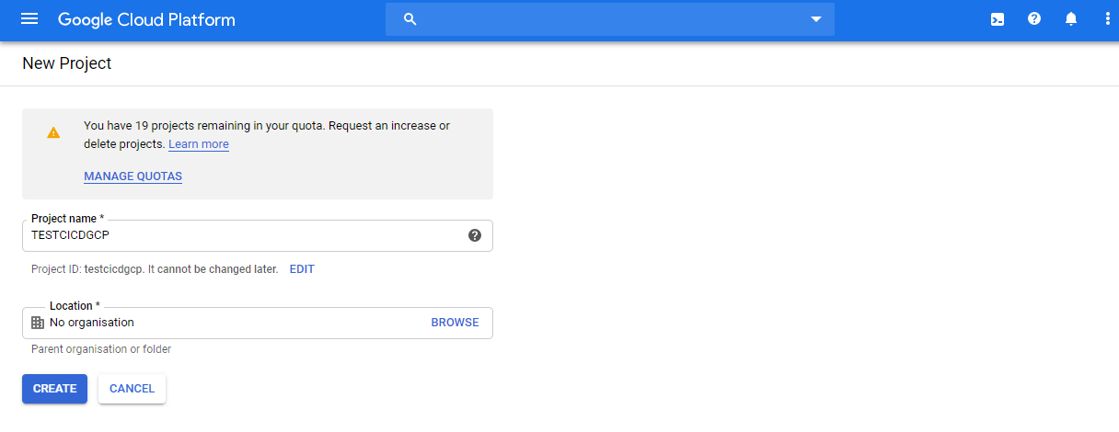

**STEP2:**

NOW GO TO THE APIS & SERVICES DASHBOARD IN THE SAME PROJECT AND CLICK ON ENABLE APIS AND SERVICES

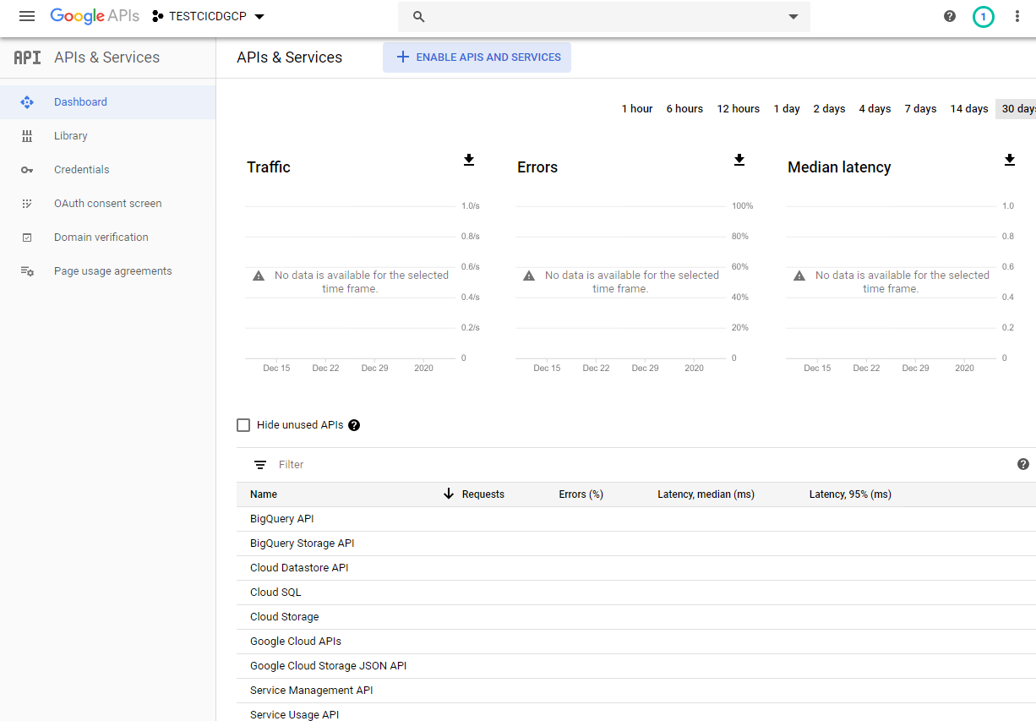

**STEP3:**

SEARCH FOR CLOUD BUILD API AND CLICK ON ENABLE

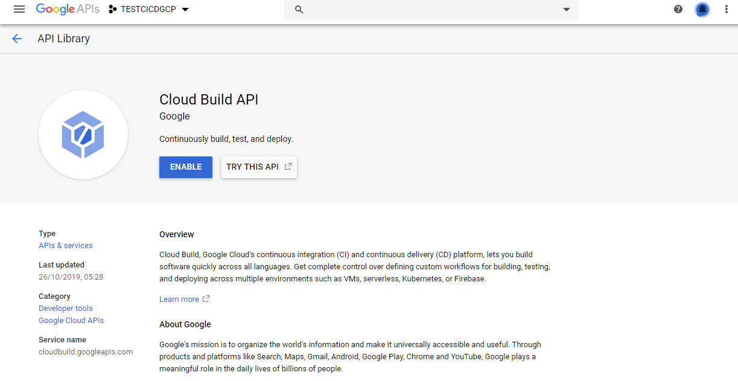

**STEP4:**

YOU CAN SEE THAT THE API IS ENABLED AND BILLING STARTED FOR THE USAGE.

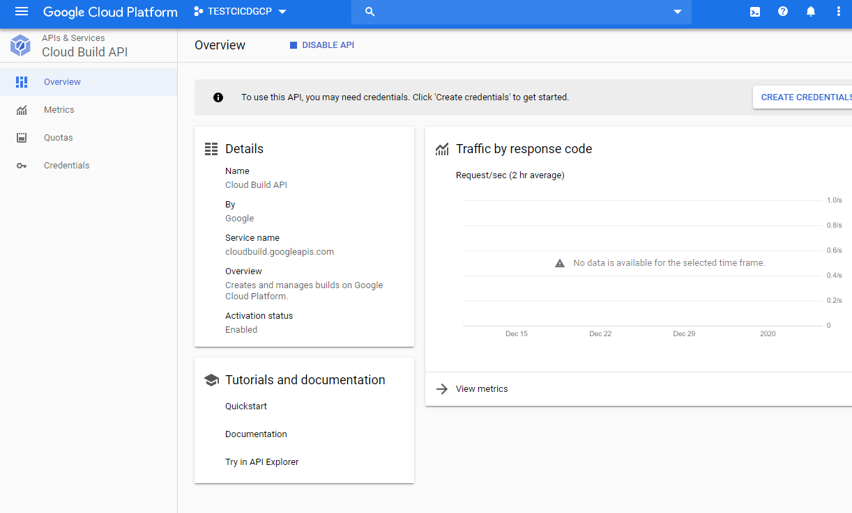

**STEP5:**

GO TO TRIGGERS IN CLOUD BUILD AND SELECT CONNECT REPOSITORY

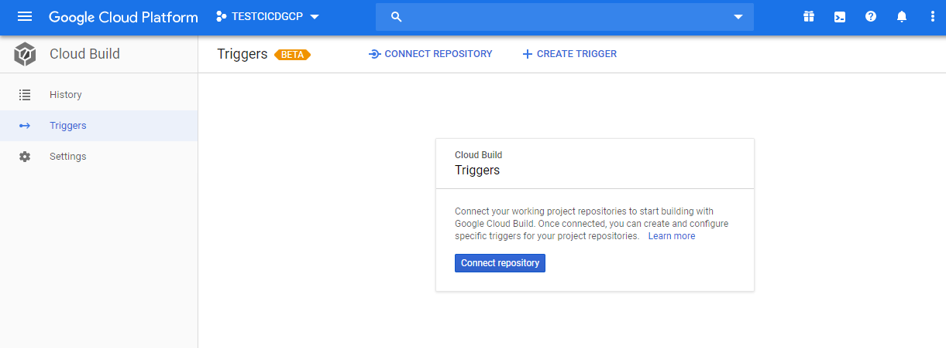

**STEP6:**

AND IN HERE SELECT AS A SOURCE AS GITHUB

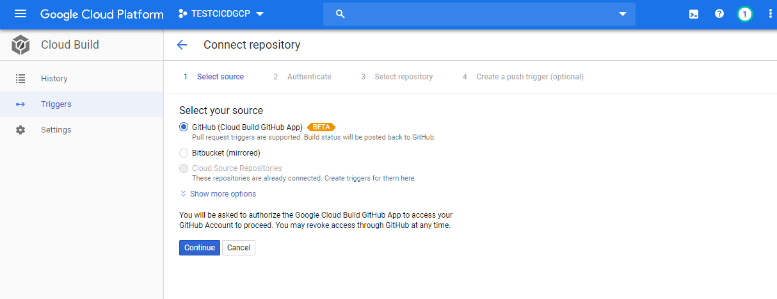

**STEP7:**

AS MY GITHUB IS ALREADY ATHUNTICATED IT DIRECTLY SHOWS THE REPOSITORIES IN MY ACCOUNT NOW WE HAVE TO SELECT THE REPOSITORY FOR SOURCE CODE

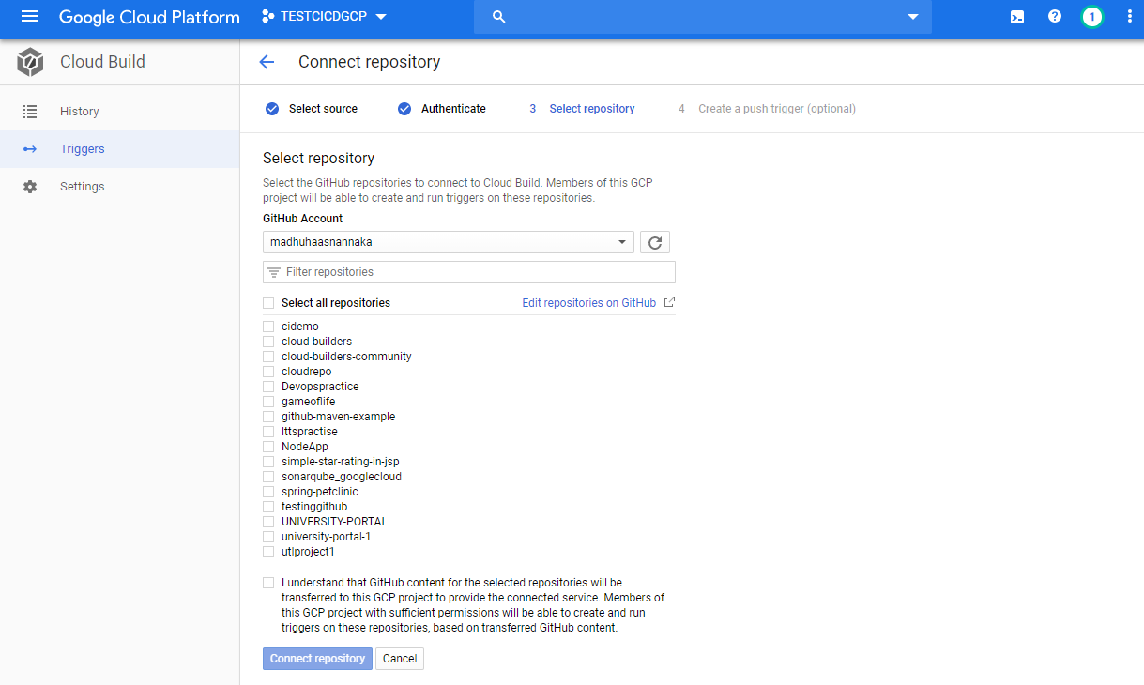

**STEP8:**

NOW CREATE A PUSH TRIGGER SO THAT WHENEVER A COMMIT OCCURRED IN SOURCE CODE THE BUILD STARTS AUTOMATICALLY

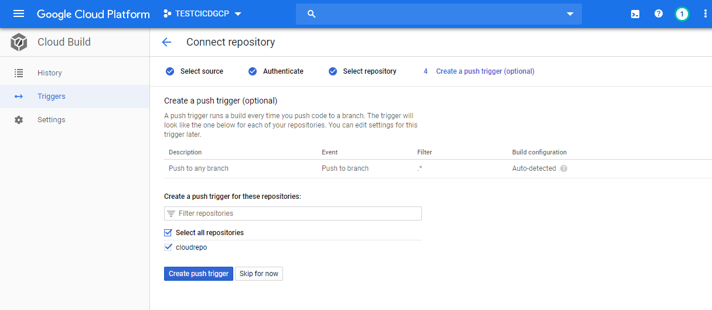

**STEP9:**

WE CAN SEE THAT THE TRIGGER IS ALSO ASSIGNED TO THE

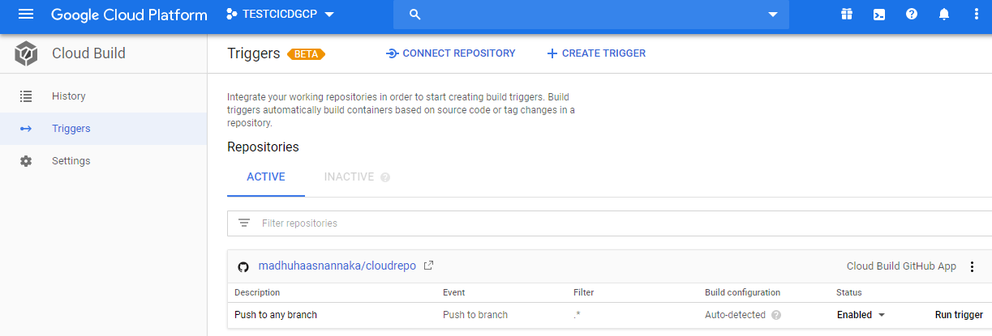

**STEP10:**

BUT IF YOU HAVE NOT SELECTD THE ENABLE TRIGGER IN THE CONNECT REPOSITORY FLOW, TO ENABLE THE TRIGGER CLICK ON CREATE TRIGGER

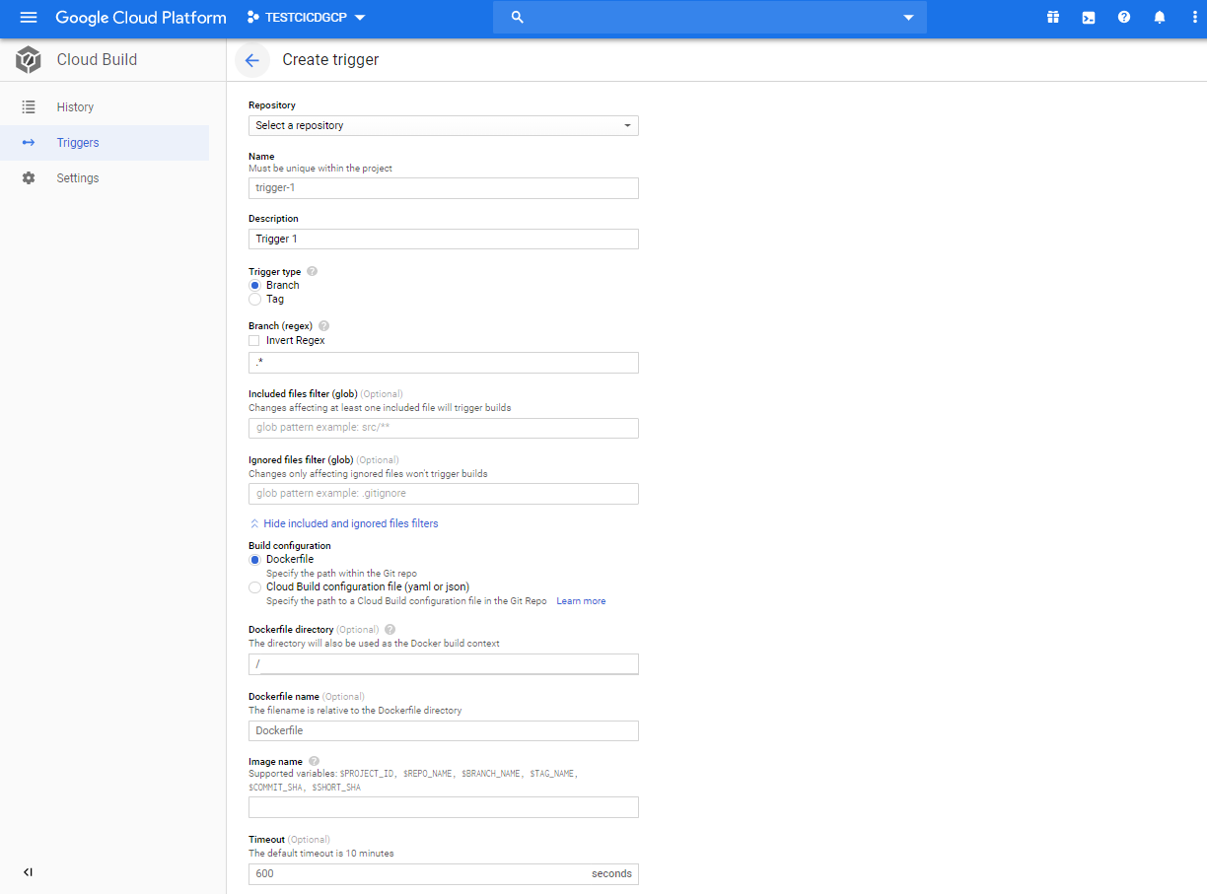

**STEP11:**

AND HERE SELECT THE REPOSITORY AND IN BUILD CONFIGURATION FILE SELECT THE BUILD CONFIGURATION FILE WHICH IS (.YAML) FILE AND CLICK ON CREATE TRIGGER

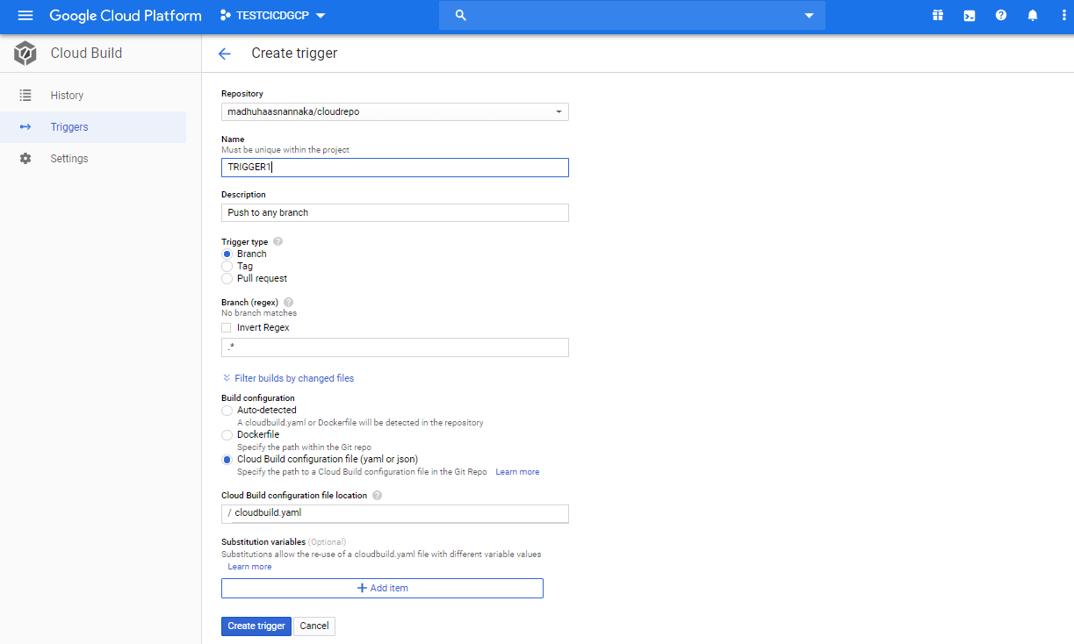

**STEP12:**

WE CAN SEE THE SAME AS BEFORE BUT TRIGGER IS GENERATED

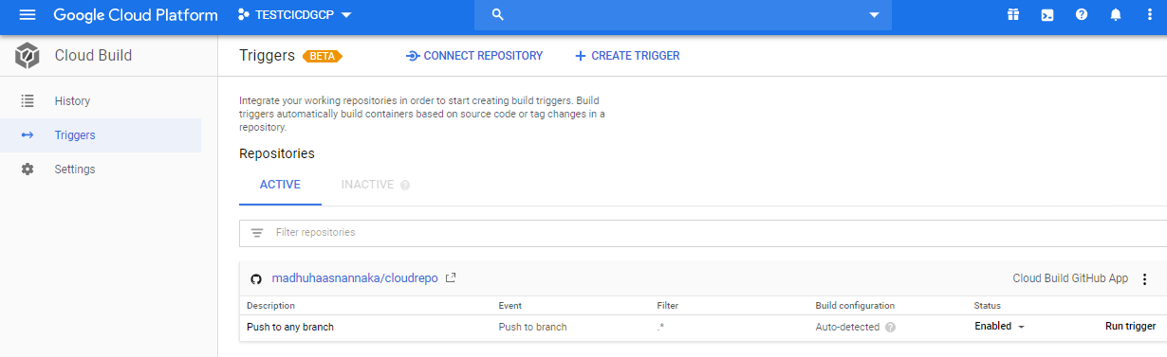

**STEP13:**

WRITE A BUILD CONFIGURATION FILE (cloudbuild. yaml) AND KEEP IT IN THE SOURCE CODE REPOSITORY

LET’S HAVE A LOOK AT THE FILE

<https://github.com/madhuhaasnannaka/cloudrepo/blob/master/cloudbuild.yaml>

STEPS IN THE FILE INCLUDE:

I)USING MAVEN TO PACKAGE TEST AND INSTALL



II)USING DOCKER TO BUILD AN IMAGE



III)NOW PUSHING BUILT IMAGE TO THE CLOUD IMAGE CONTAINER REPOSITORY

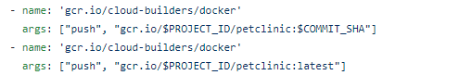

IV)DEPLOYING IMAGE TO THE KUBERNETES

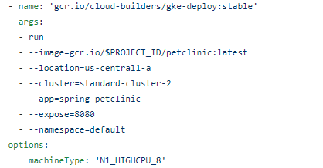

**STEP14:**

NOW OPEN GOOGLE CLOUD KUBERNETES ENGINE AND AS SOON AS IT IS OPENED THE API STARTS ENABLING

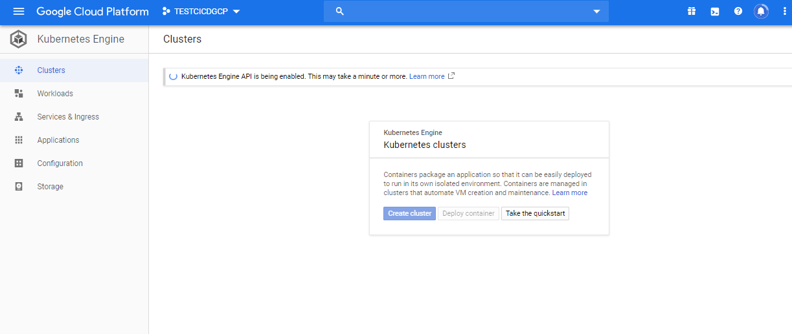

**STEP15:**

HERE CLICK ON THE CREATE CLUSTER

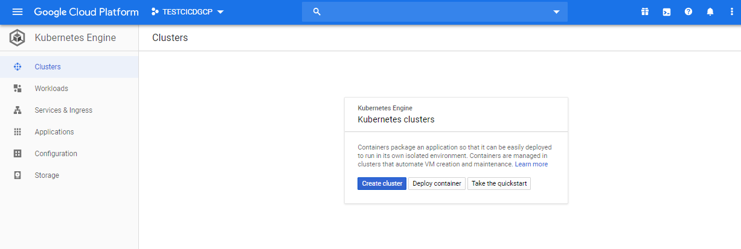

**STEP16:**

THEN CHECK FOR THE NAMES OF THE CLUSTERS AND LOCATION MATHCES AS IN THE CLOUD BUILD CONFIGURATION FILE AND THEN CLICK ON CREATE

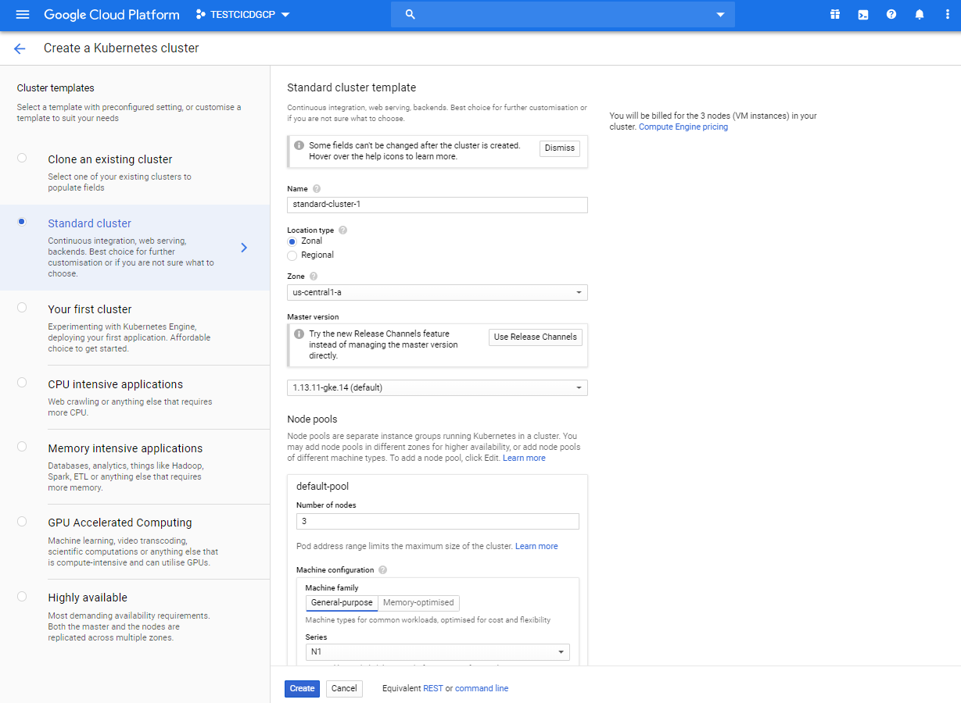



**STEP17:**

THE KUBERNETES CLUSTER IS CREATED

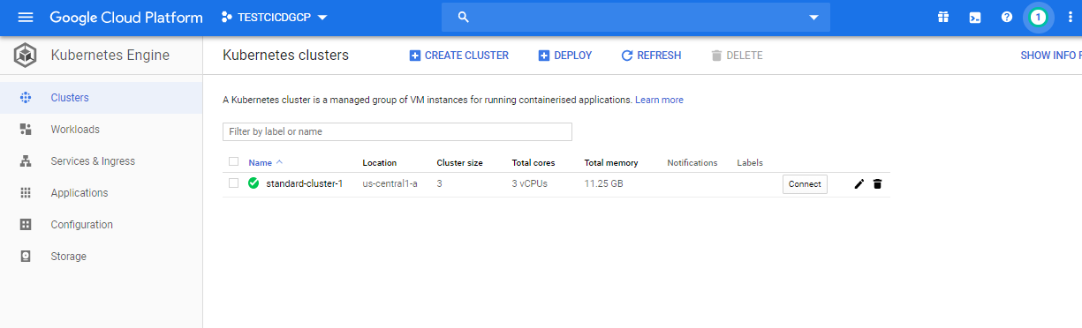

**STEP18:**

NOW GO TO IAM & ADMIN

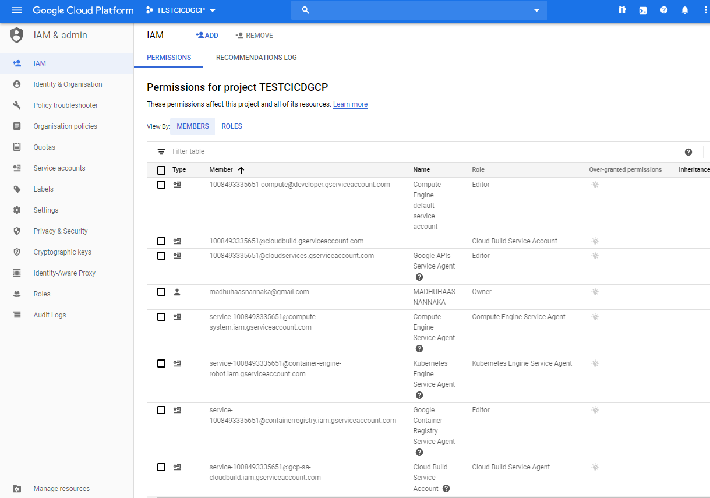

**STEP19:**

CHECK FOR THE cloudbuild.gserviceaccount.com AND CLICK ON EDIT OPTION AND SELECT ADD ANOTHER ROLE

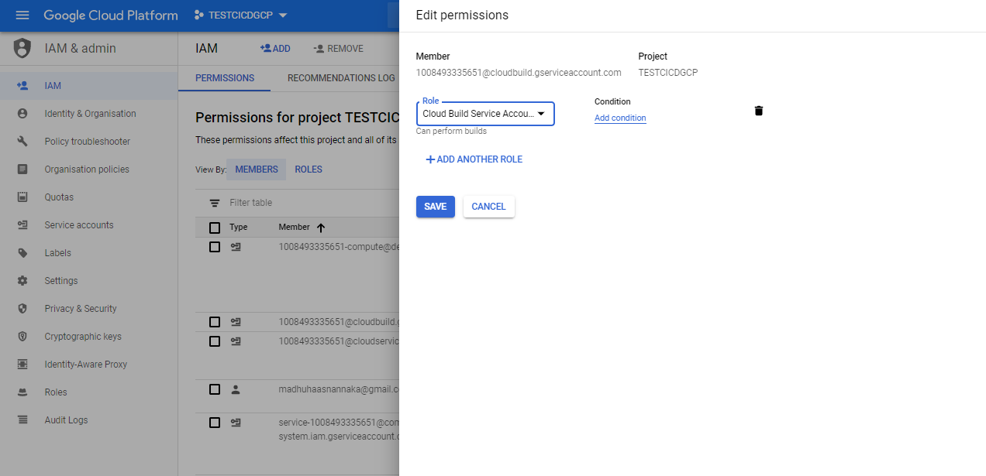

**STEP20:**

SEARCH FOR KUBERNETES ENGINE ADMIN AND CLICK ON SAVE

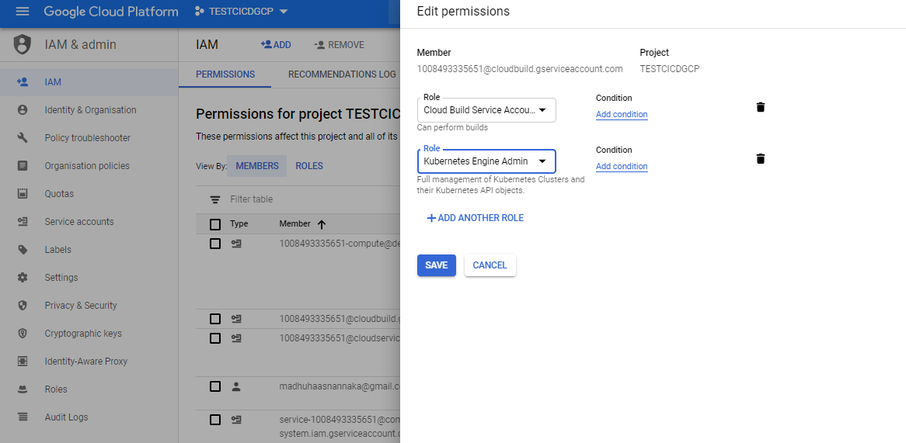

**STEP21:**

NOW THE KUBERNETES ENGINE PERMISSION IS ASSIGNED TO THE CLOUD BUILD SO THAT IT CAN DEPLOY THE APPLICATION IN THE CLUSTER

CHECK THE HIGHLIGHTED PART IN IMAGE

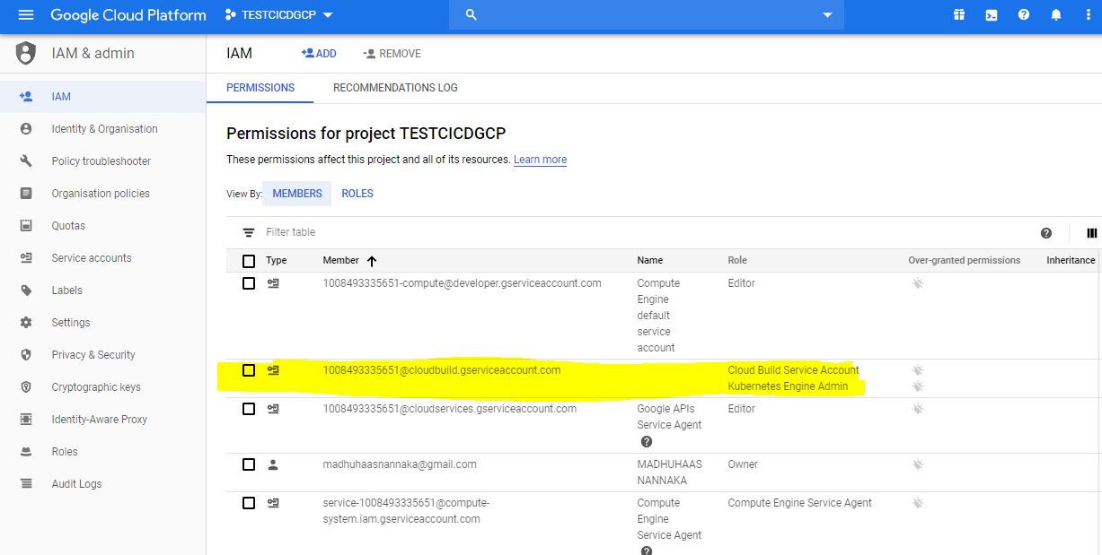

**STEP22:**

NOW CLICK ON RUN TRIGGER OPTION OR PUSH ANY CHANGES TO THE GITHUB SOURCE CODE REPOSITORY TO START THE BUILD

TO START THE BUILD, I PUSHED SOME CODE AND WE CAN SEE THE BUILD STARTED

WE CAN SEE THAT IN GITHUB THE COMMIT ID 533BFCD MATCHES WITH CLOUD BUILD GIT COMMIT ID IN HISTORY

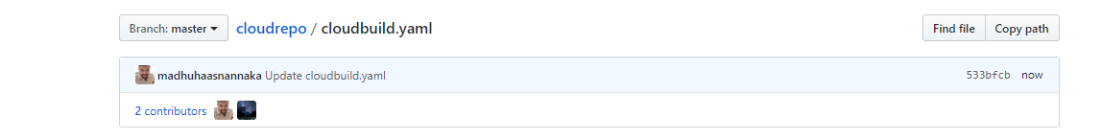

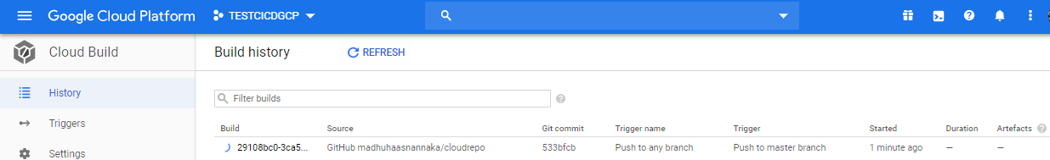

**STEP23:**

WE CAN SEE THE BUILD IN PROGRESS AFTER CLICKING ON IT

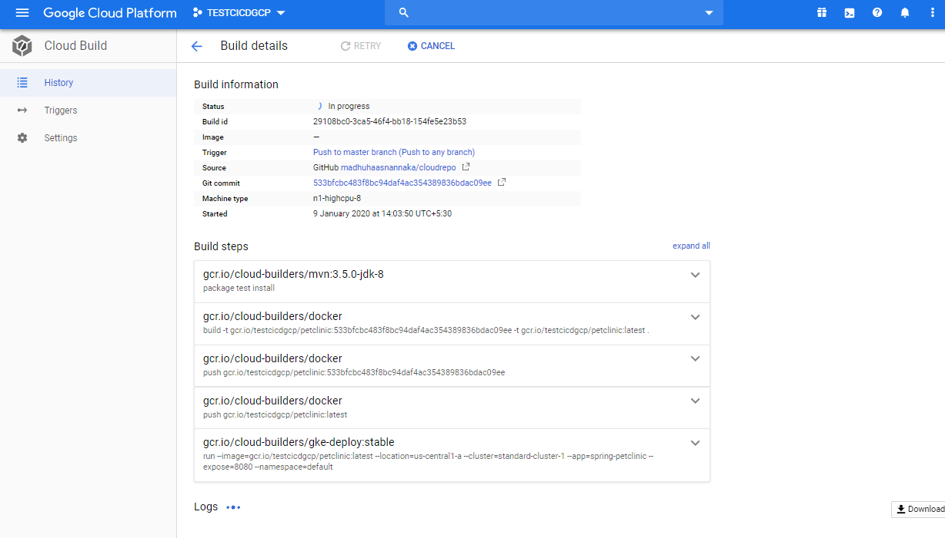

**STEP24:**

WE CAN NOW SEE THAT THE BUILD IS SUCCESSFUL

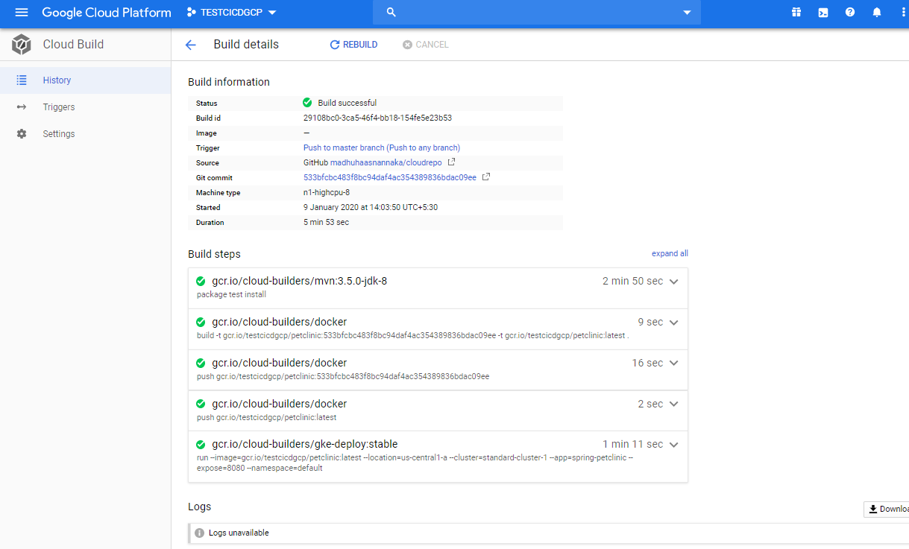

**STEP25:**

GO TO THE KUBERNETES ENGINE AND CLICK ON WORKLOADS NOW WE CAN SEE THAT THE APPLICATION IS DEPLOYED AND ALSO CHECK FOR THE SERVICE FOR THIS APPLICATION IN SERVICES & INGRESS

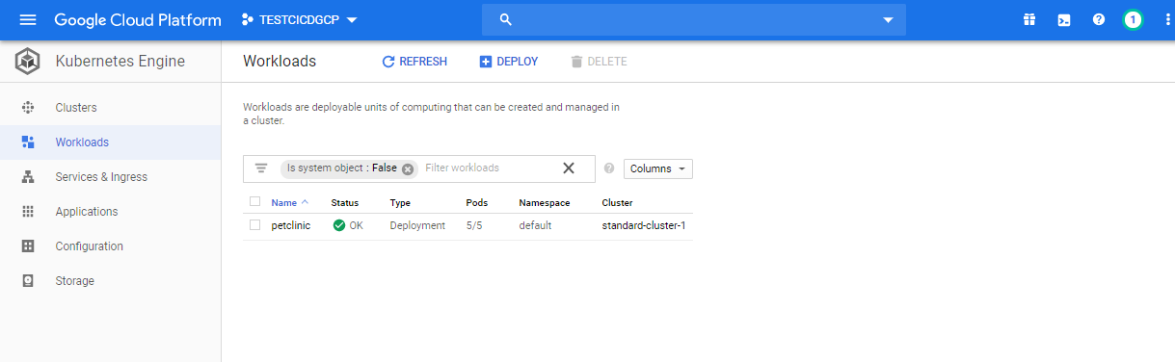

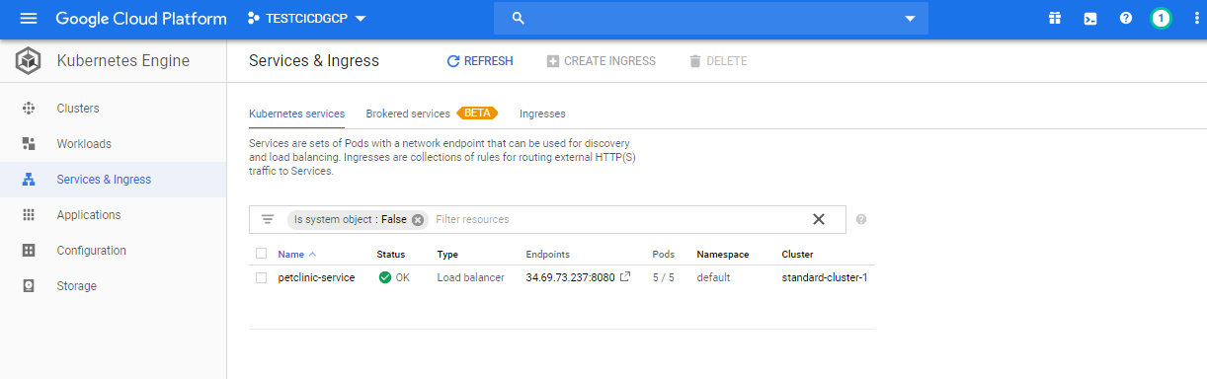

**STEP26:**

**SONARCLOUD INTEGRATION WITH CLOUD BUILD AND INCLUDING IT IN THE CI/CD PIPELINE**

**THE FOLLOWING CODE MUST BE ADDED IN THE CLOUD BUILD CONFIGURATION FILE TO ANALYZE THE SOURCE CODE IN SONAR CLOUD** <https://sonarcloud.io/projects>

<https://github.com/madhuhaasnannaka/cloudrepo/blob/master/cloudbuild.yaml>

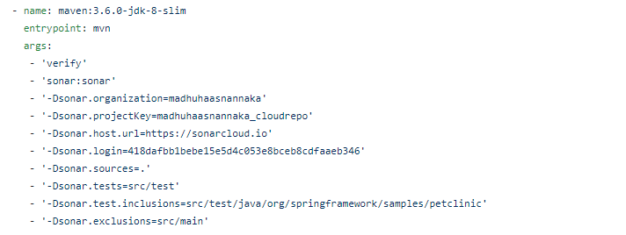

**STEP27:**

**NOW LOGIN TO THE SONARCLOUD** <https://sonarcloud.io/projects> **WITH GITHUB ACCOUNT**

**AND GENERATE A TOKEN IN THE SECURITY AND USE IT IN THE CLOUD BUILD CONFIGURATION FILE (CLOUDBUILD.YAML)**

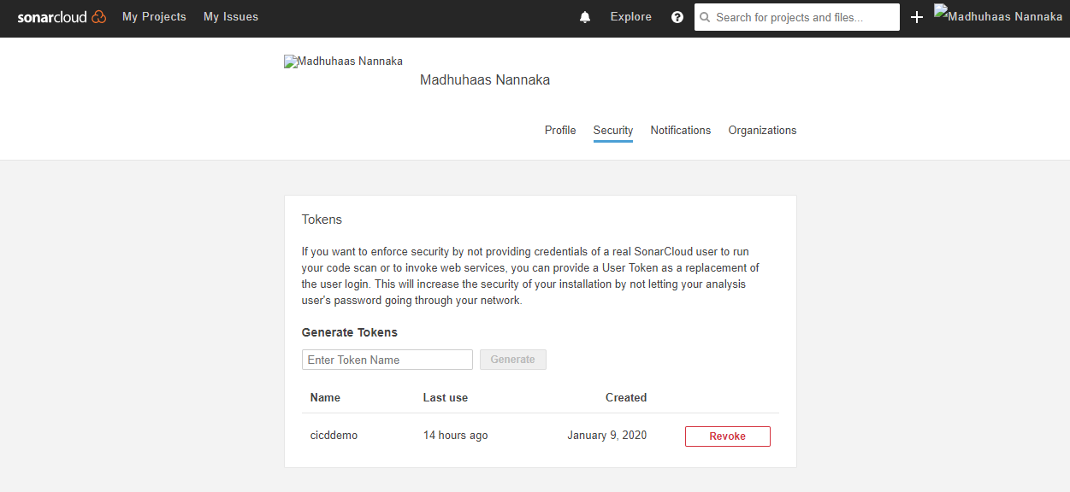

**STEP28:**

**NOW RUN THE TRIGGER OR PUSH SOME CHANGES IN TO THE SOURCE CODE REPOSITORY. THEN THE BUILD STARTS AND ANALYSIS OF CODE WILL BE UPLOADED TO SONAR CLOUD.**

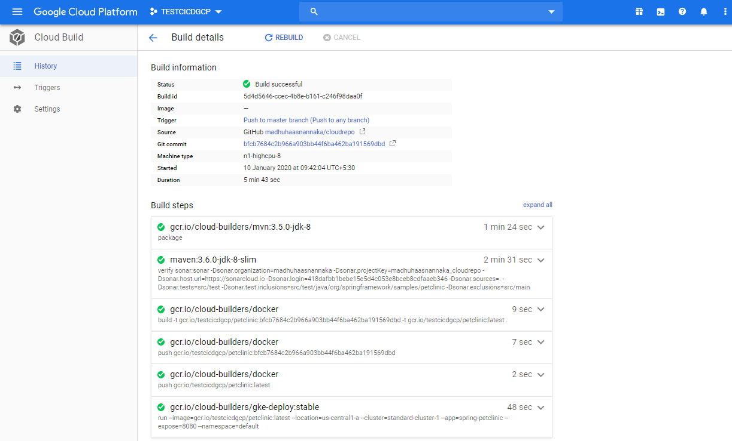

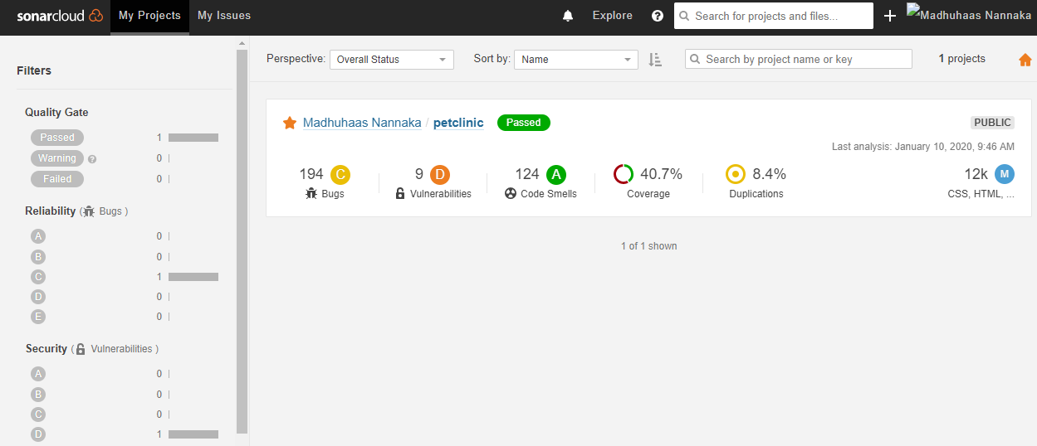

**THANK YOU**