**GITHUB INTEGRATION WITH JENKINS**

Integrating Jenkins with GitHub takes not much concerns if Jenkins is available to the internet. But if Jenkins is in local system and to make it accessible to the internet, we should forward our local address through a tool called ngrok.

The plugins to be installed for integrating GitHub with Jenkins are:

Please check for every plugin to be installed

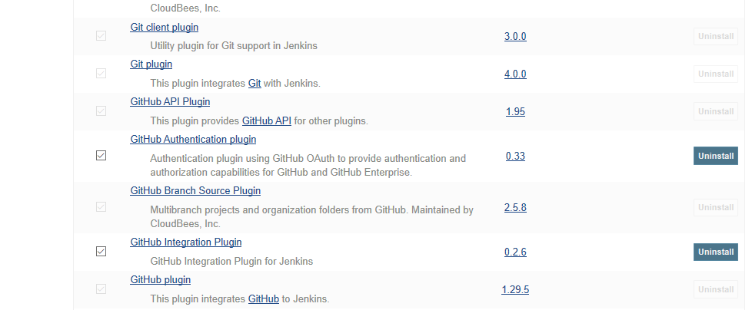

Now to get pull requests from GitHub we should include our repository link in configure Jenkins settings in manage Jenkins, find for GitHub pull requests and paste your repo URL, then click save.

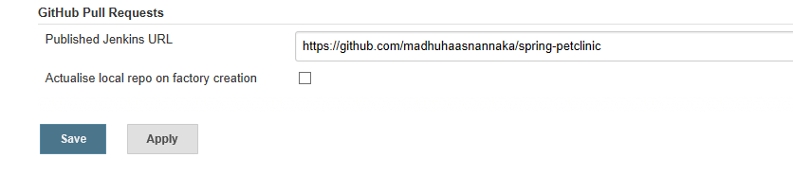

Now create a job in Jenkins selecting free style project and I have given name as testinggithub as my job name

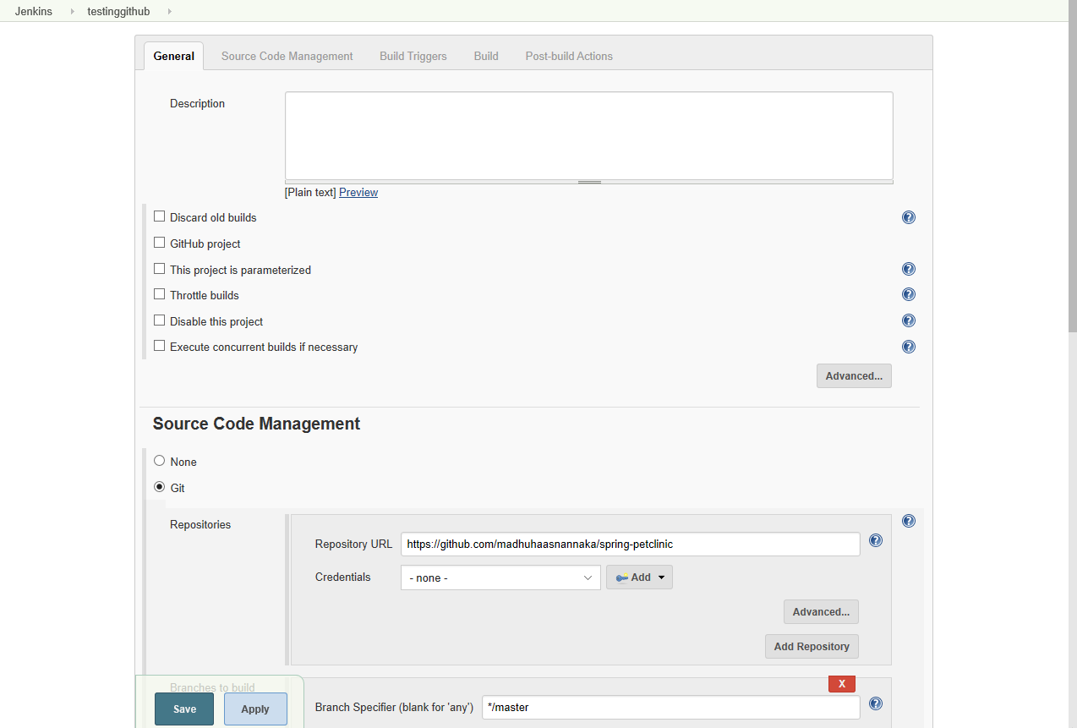

Select git option in source code management and give your repository link in GitHub without any credentials because it was public repository, if so, it was your private repository please add the credentials accordingly.

Now in the build triggers menu select “GitHub hook trigger for GITScm polling “option and in build option select invoke top-level maven targets and give your goals (I have given compile as a goal)

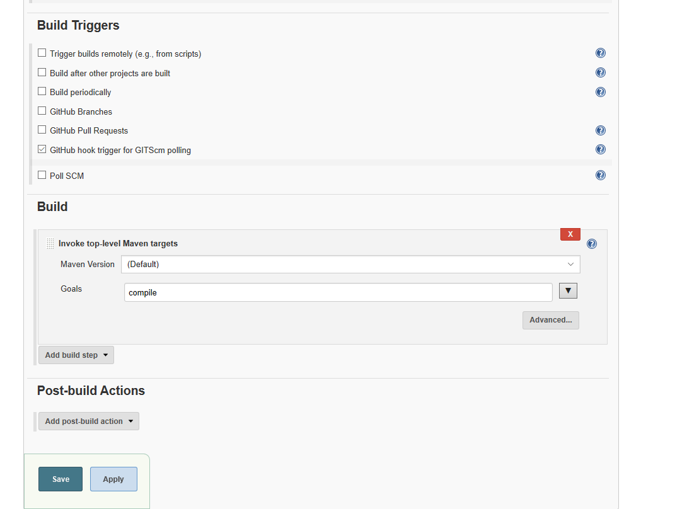

Save the job.

Now you need to have publicly accessible Jenkins server (i.e. available on internet) but as my Jenkins is local server I have to make to internet available for that I am using ngrok (please check <https://ngrok.com/download> for ngrok) and in here I am forwarding my localhost:8080 port by typing “ngrok http http://localhost:8080” command and here you can see my address as http://0ed840c6.ngrok.io which is accessible by internet.

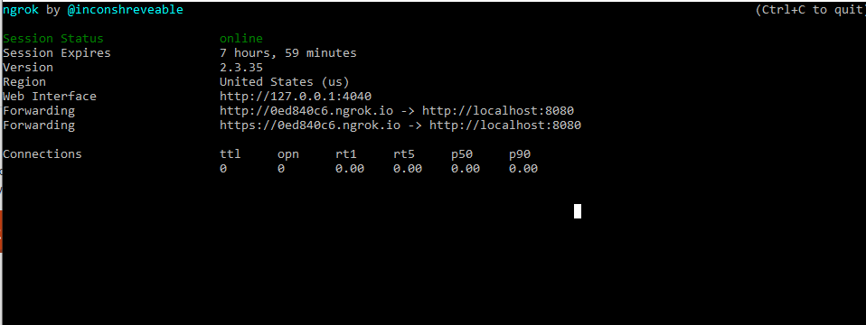

Now copy the ip address and go to GitHub repository which you are about to integrate with Jenkins and go to settings and select webhooks and select add webhook

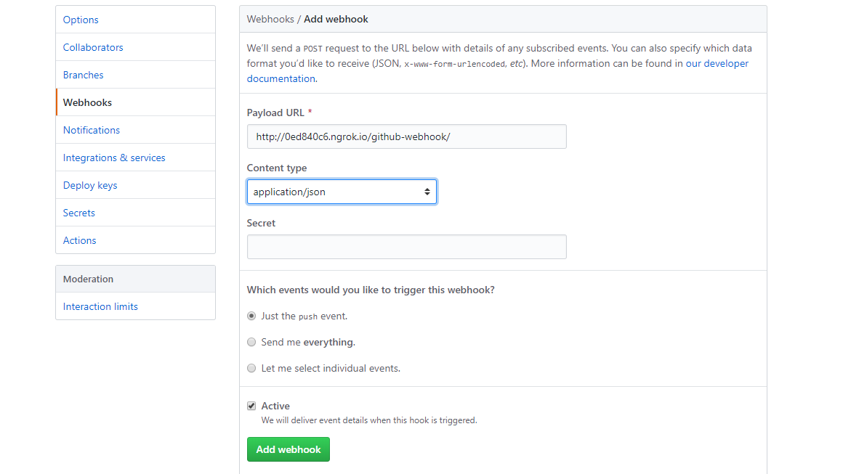

And in here paste the ip address you copied and add /GitHub-webhook/ to the ip address and it becomes as http://0ed840c6.ngrok.io/github-webhook/ now select content type as application/json and select just the push event. And select add webhook.

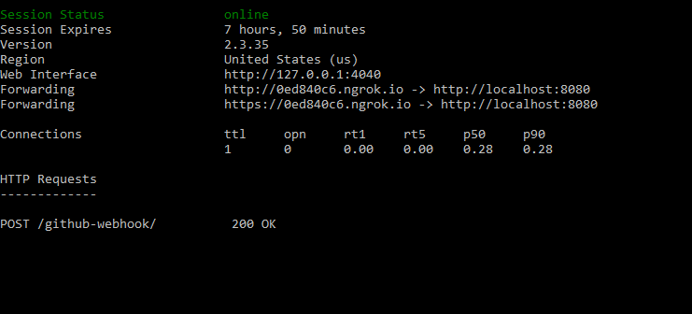

As soon as you add webhook the terminal says 200 ok saying that it received post request.

Now let’s push something into the GitHub and see how the building starts automatically in Jenkins.

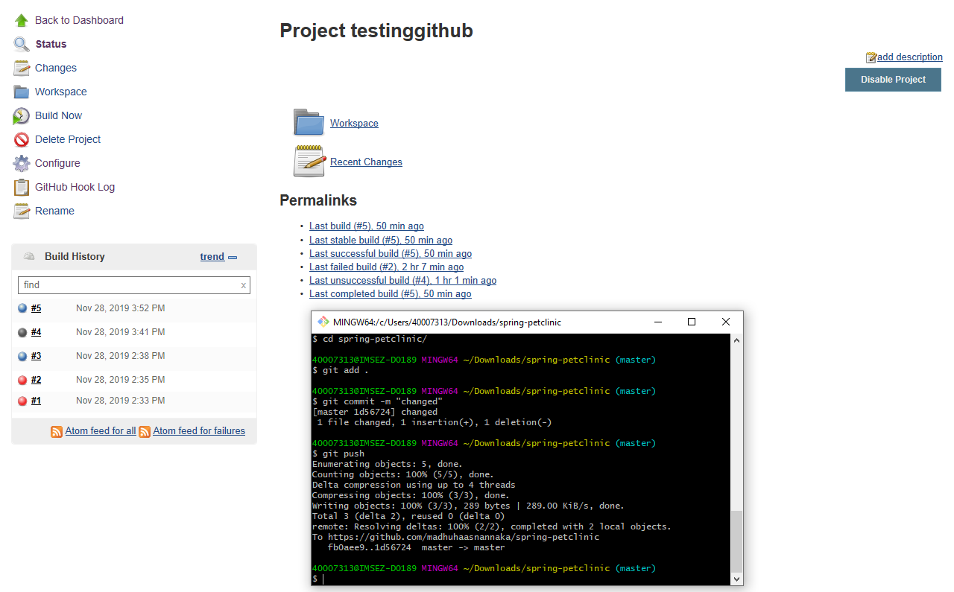

It started new build #6 as soon as I pushed the code into the repository.

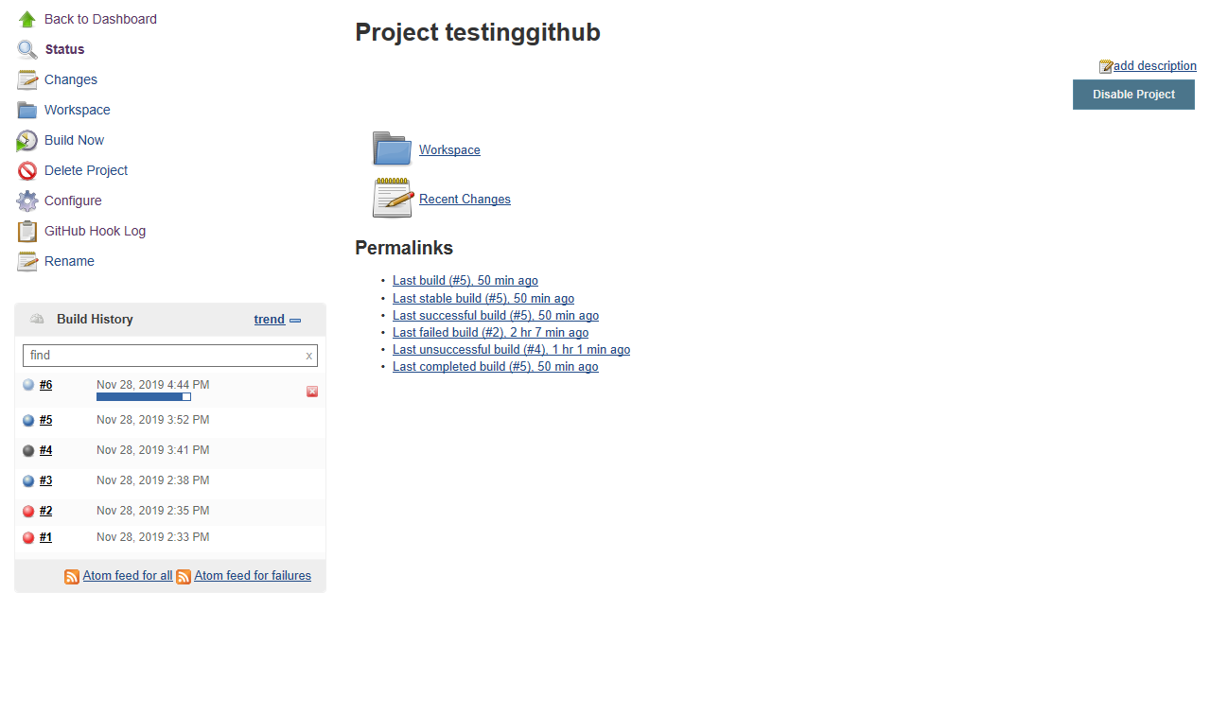

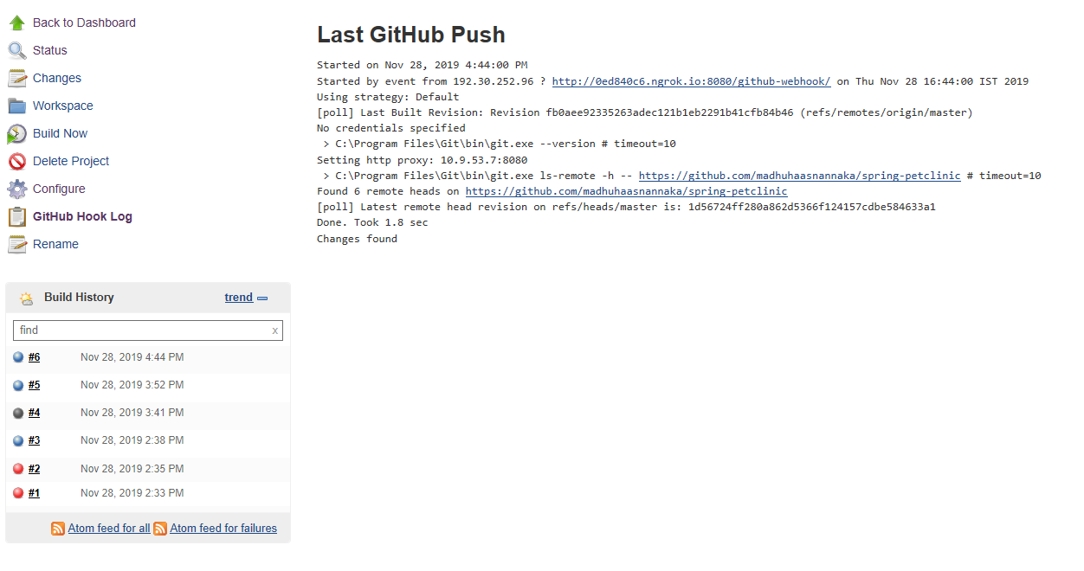

The above three images show how the build is triggered in Jenkins after I push code into the GitHub.

But for all this to happen ssl has to be disabled in the git as there are many errors because of ssl.

So, add: In your gitconfig file of git.

[http]

sslVerify=False

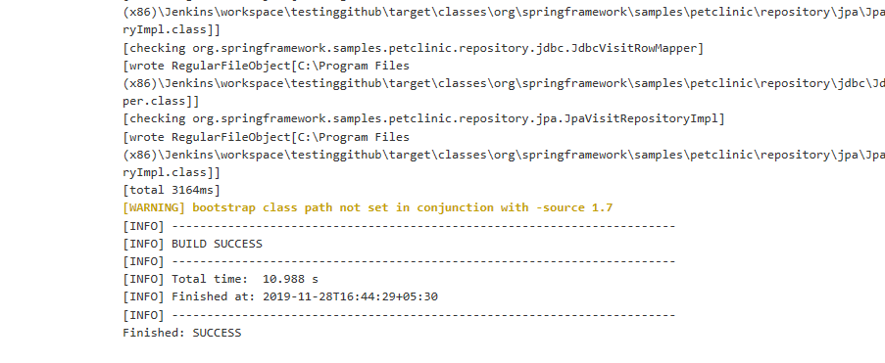

The console tells that the build is success.

Thank you