**MAVEN**

**MAVEN:**

It is an automation and management tool developed by apache. It is written in java and used to build and manage projects. It also allows developer to create project using POM and plugins. It helps to build projects, dependency and documentation.

**USING MAVEN IN DEVELOPMENT PROCESS:**

Using maven java project can be developed easily. New feature created or added in maven can be easily added to the project easily in maven configuration. It increases the performance and building of the project easily.

Main feature of maven is that it can automatically download the project required libraries.

Some IDE’s supporting development with maven are:

* Eclipse
* NetBeans
* JBuilder

**PROCESSES MANAGED USING MAVEN ARE:**

* Builds
* Documentation
* SCM’s
* Releases
* Distribution
* Mailing list
* Reporting
* Dependencies

**MAVEN ARCHITECTURE:**

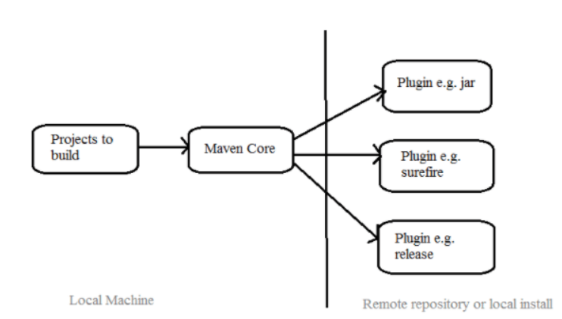

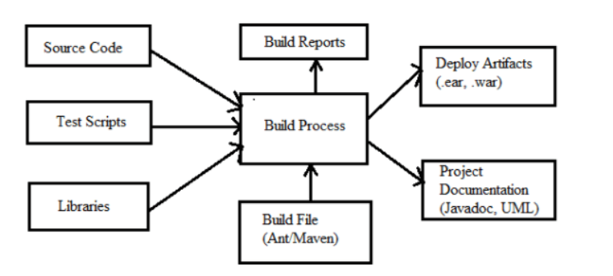

**HOW TO USE MAVEN:**

* So, to configure maven we should use project object model file (POM.XML), this xml file helps in setting up the project in maven.
* POM includes all the configuration settings related to maven. Plugins can be configured and edited in the <plugin> tag of the pom.xml file. Developer can use plugin without much details about it.
* So, when user start working in the maven it has a default setting, we don’t need to add every configuration in pom.xml.

**STEPS INVOLVED IN BUILDING THE PROJECT IN MAVEN:**

* Write code for application creation and process that into the source code repository.
* Edit configuration, plugin details in pom.xml
* Build the application, save the build process output as war or ear file
* Get the war or ear file and deploy it in the production site
* Create and generate the report as per the requirement or application