**INTEGRATING JENKINS WITH MAVEN:**

**To run maven in Jenkins:**

* First maven integration plugin has to be installed in Jenkins
* In plugin manager you can see that maven integration plugin is installed.
* Go to Jenkins home page, there go to manage Jenkins and go to manage plugins select available to see the plugins available to install.

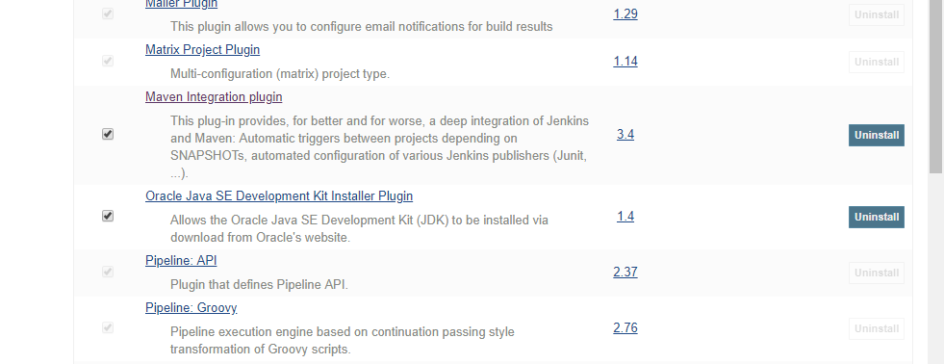

**Now add paths for locally available Jdk and maven installation folders in program files:**

Go to manage Jenkins, there go to global tool configuration, since all the tools are available in my system, I will be adding paths to the tools. So, I added java and maven paths from the local system.

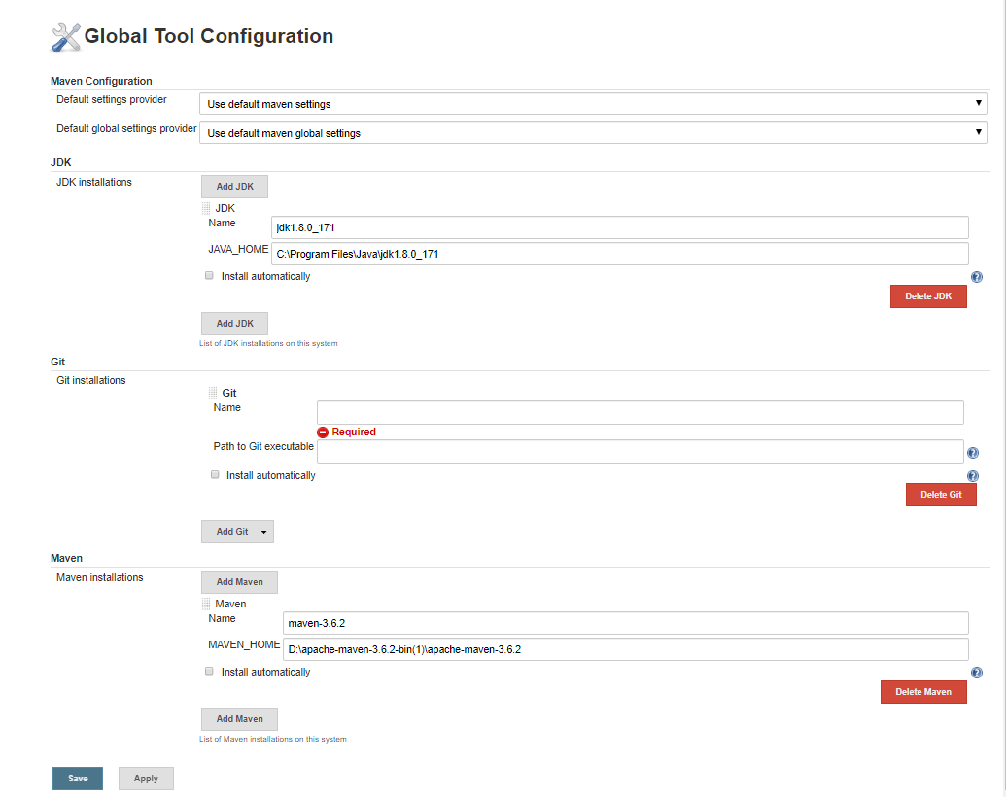

Now go to home page of Jenkins and select new item and there you can see that maven project is available.

Select maven project and give name for the project, I have given as mavenproject. Select ok.

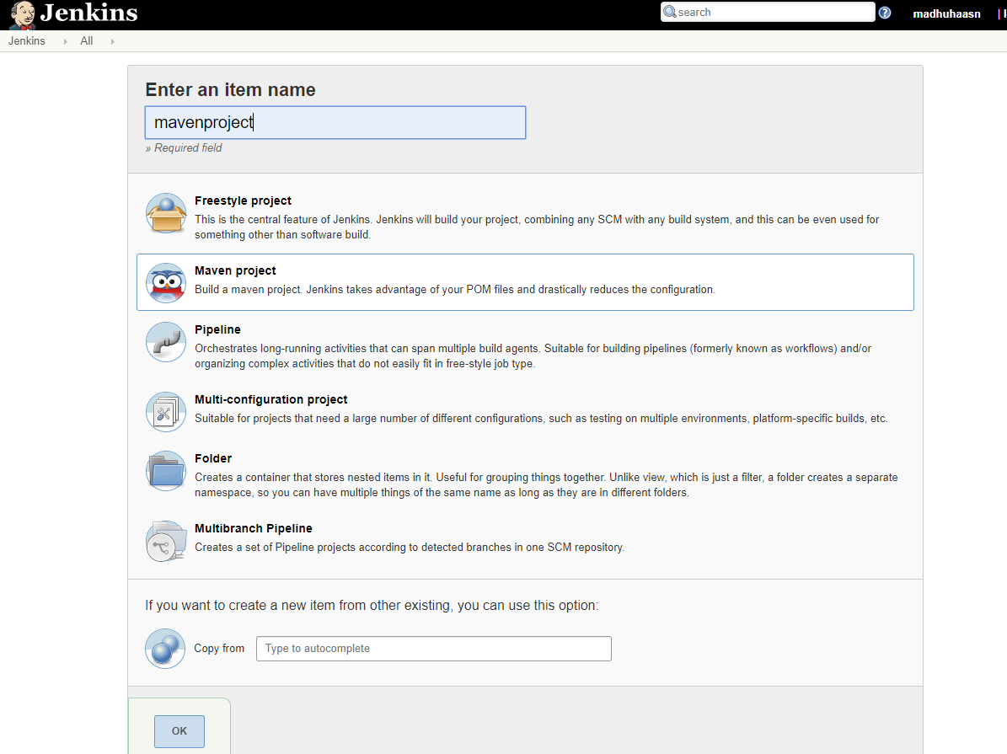

After selecting ok, we will be directed to project configuration page in Jenkins.

Here select discard builds. And set days to keep builds as 1 and max no of builds to keep as 5.

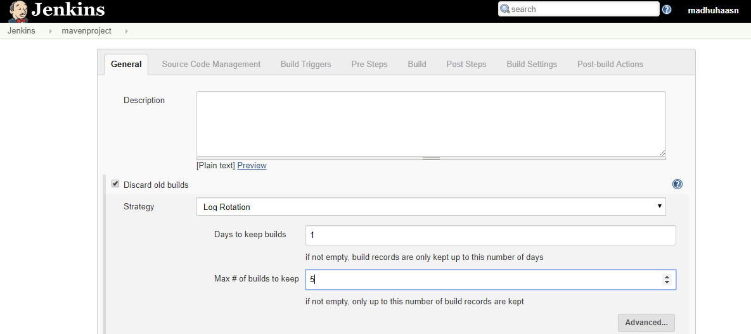

Now go to build and select advanced and in there select the following:

* Resolve Dependencies during Pom parsing
* Use custom workspace (add path to a new folder where the project has to be executed)
* Enable triggering of downstream projects

Now fill the root pom with the path to the pom.xml file in the project folder locally.

For me it is (C:\Users\40007313\Desktop\spring-petclinic\pom.xml).

And in goals and options: (write the maven commands to executed)

In my case I gave clean compile test

Now apply and save

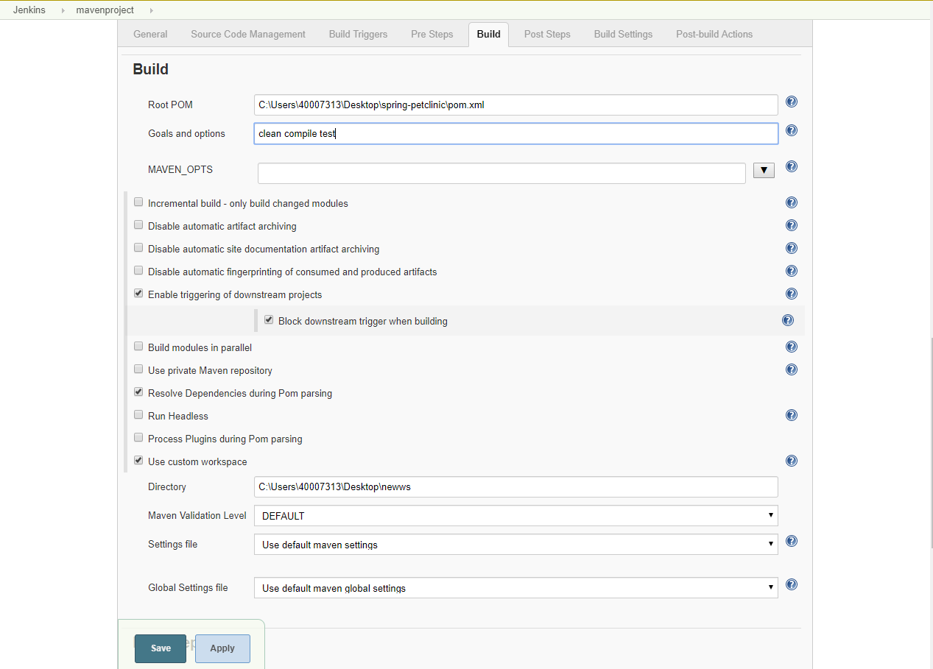

Now go to the project dashboard and select build now:

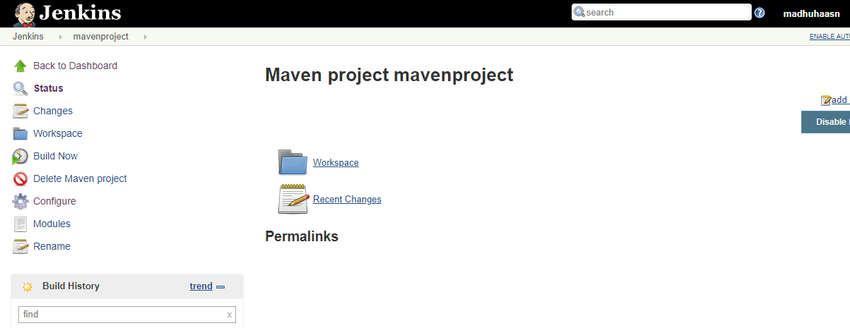

After selecting build now, you can see #2 build going on.

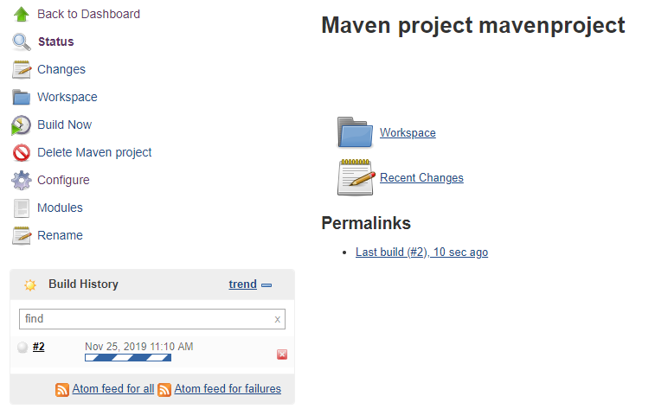

Let’s check the console to see whether the project is getting executed:

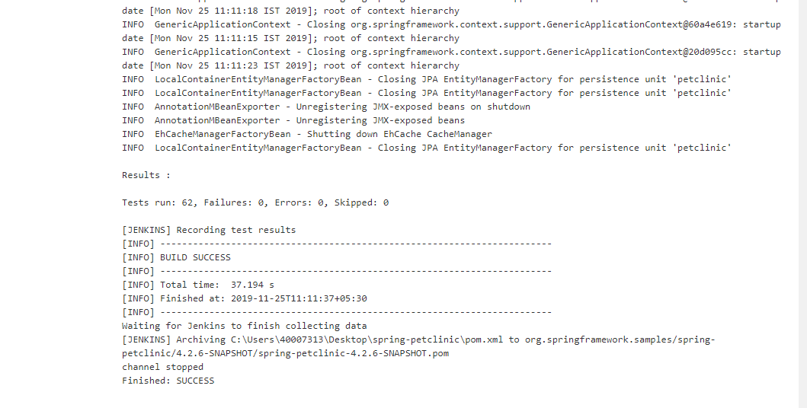

Let’s compare it with the local maven execution in cmd prompt:

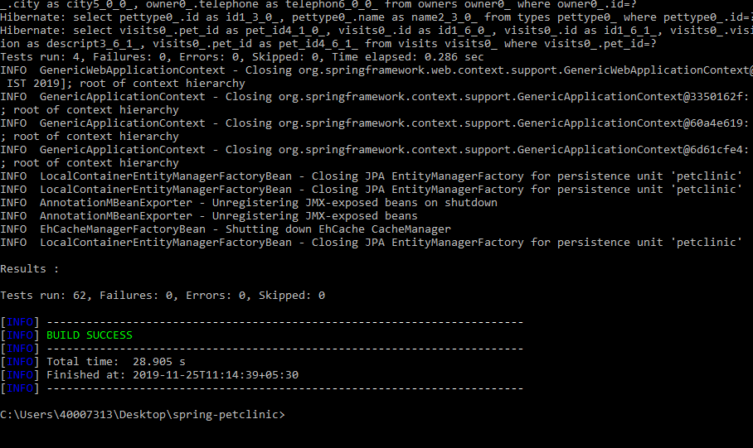

If we observe both the builds and testing in console it was successfully completed.