Scripting test :

Question1:

**Write a program that accepts a sentence and calculate the number of upper-case letters and lower-case letters.**

**Suppose the following input is supplied to the program:**

**Hello world!**

**Solution:**

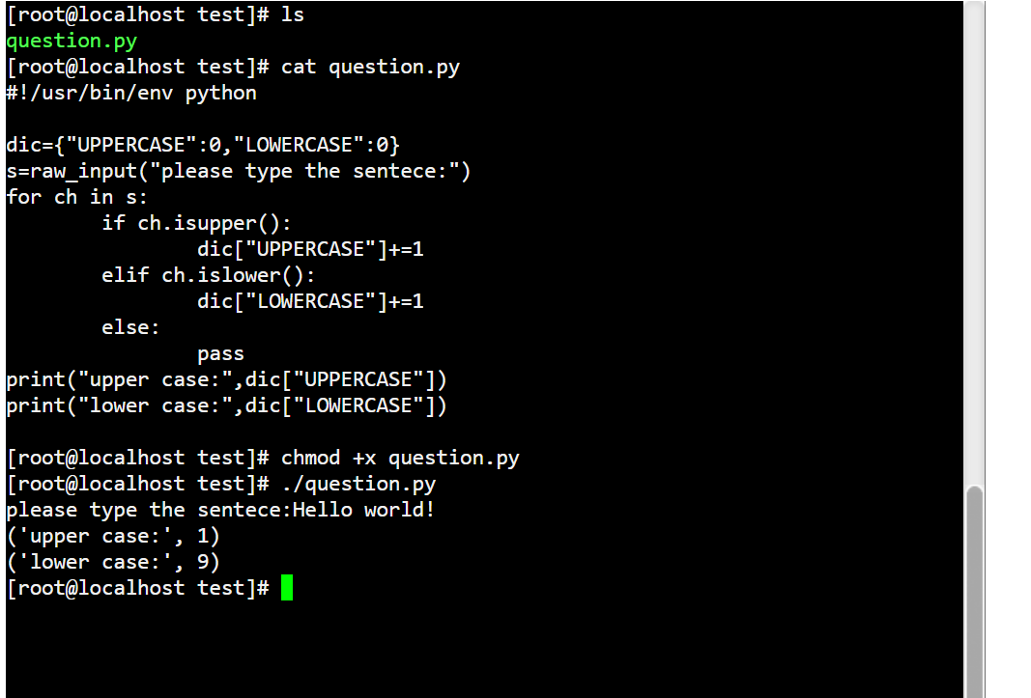

Question2:

**Program to check Armstrong numbers in certain interval.**

**Solution:**

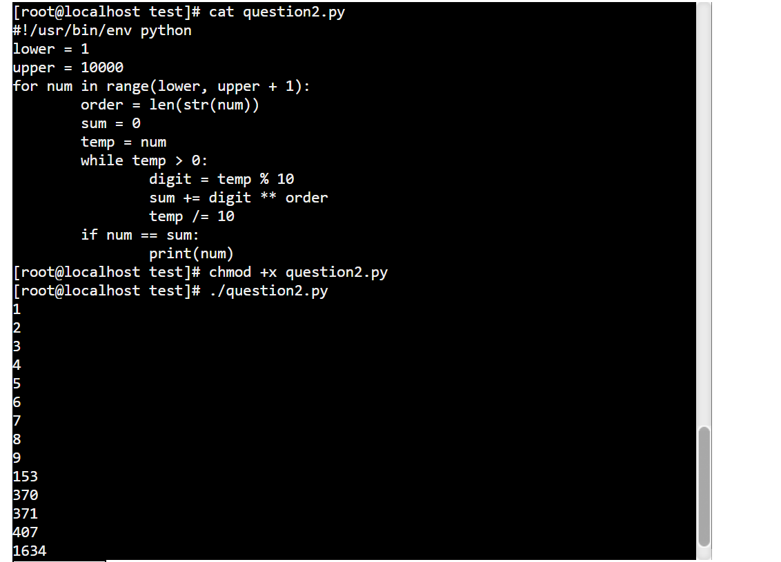

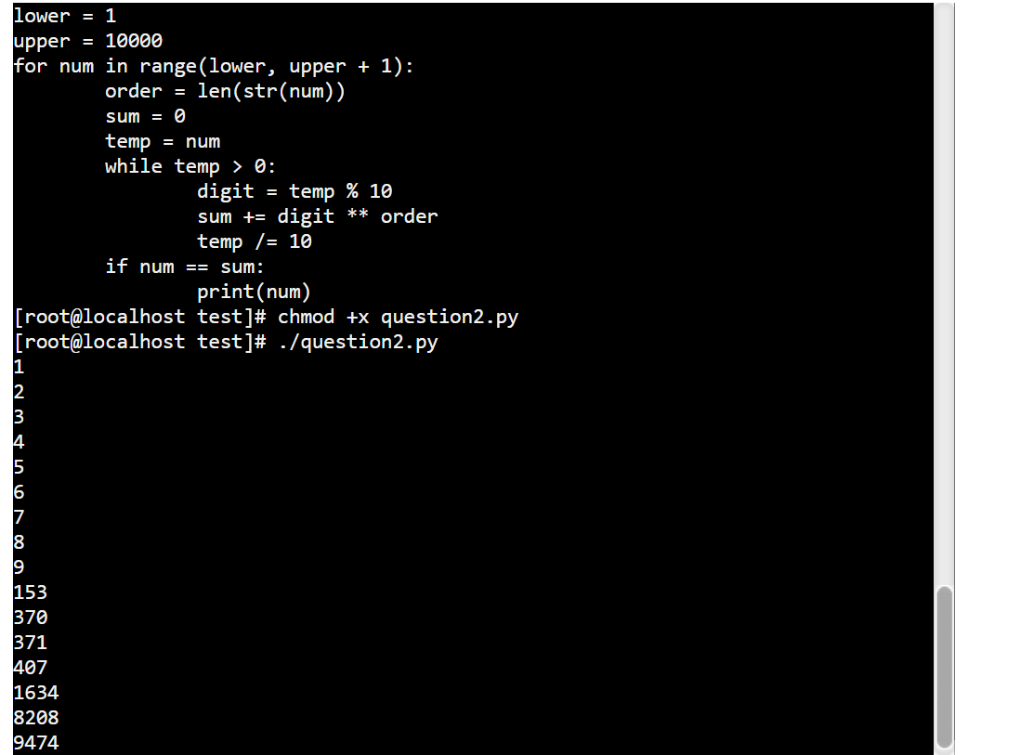

Question3:

1. **Print the pattern as bellow:**

**\*\*\*\*\*\*\*\*\*\***

**\*\*\*\*\*\*\*\*\***

**\*\*\*\*\*\*\*\***

**\*\*\*\*\*\*\***

**\*\*\*\*\*\***

**\*\*\*\*\***

**\*\*\*\***

**\*\*\***

**\*\***

**\***

Solution:

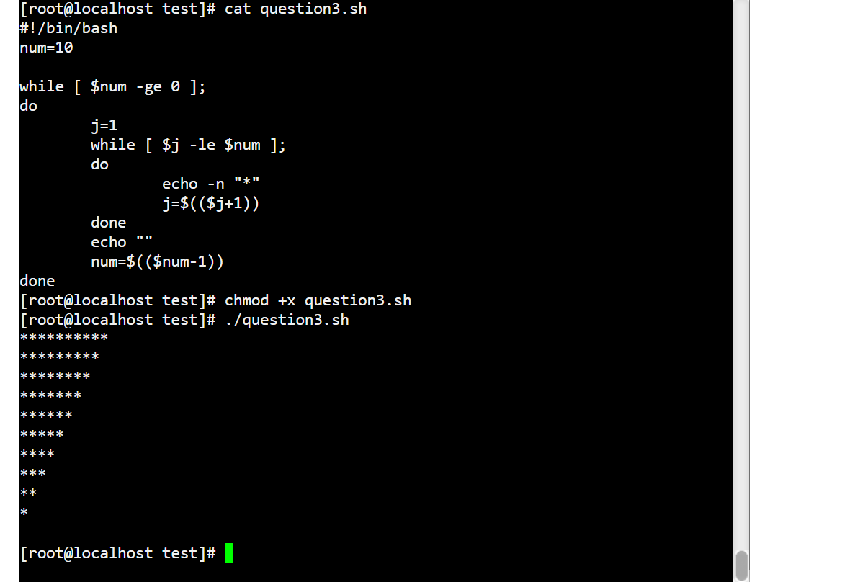

Question4:

**Write a shell script to read two numbers and perform Addition, Subtraction, Multiplication, Division and modulo division according to user input.**

Hint : use Case statement

Solution:

