**CREATING VM USING VAGRANT:**

I am creating an ubuntu VM using vagrant

For that the prerequisites are:

* 1. Vagrant should be installed in the system
  2. Virtual box must be available in the system
  3. Please turn off your Hyper-V
  4. Copy the command line below and run it.

“Disable-WindowsOptionalFeature -Online -FeatureName Microsoft-Hyper-V-All”

Then create a folder named vagrant-test so that the vagrant images and boxes will be in a single folder where we could operate them from.

Now I have started command prompt from the same folder which we created

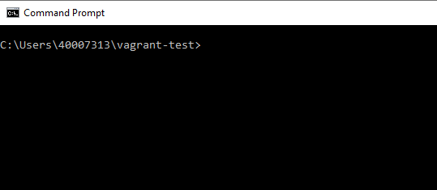

Now using “vagrant init ubuntu/system64 ” command I will create a vagrant file in the folder.

Now as the file is created, we will now add a box for the vm by using:

“vagrant box add ubuntu/system64 ”

Now as the box is added let’s bring up the vm by using the command

“vagrant up “

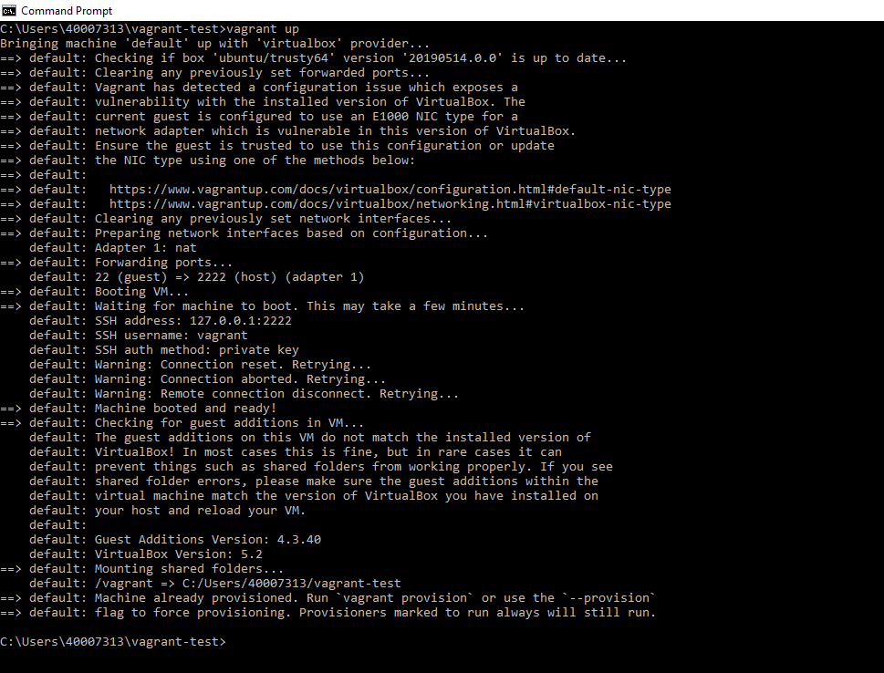

Now let’s see in virtual box manager:

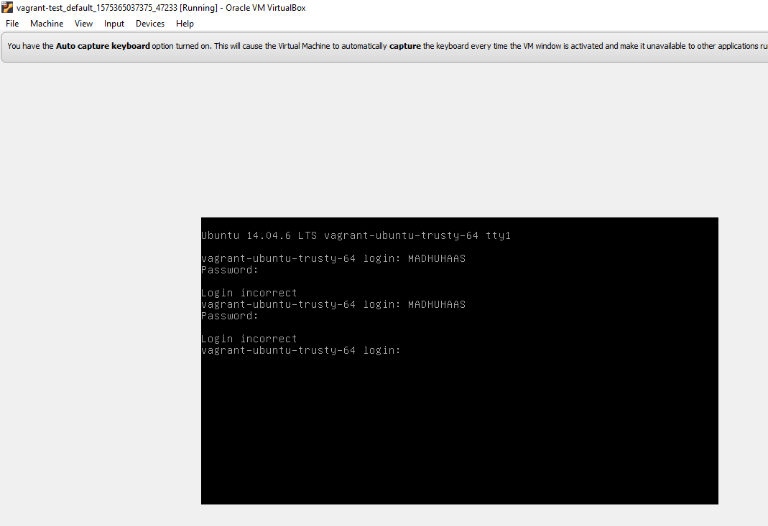

I am trying to login but it’s not possible to do so because I don’t have the login credentials instead of this, we will be using some ssh connection to connect with this vm from the local terminal to connect to the vm’s terminal by using the command:

“vagrant ssh “

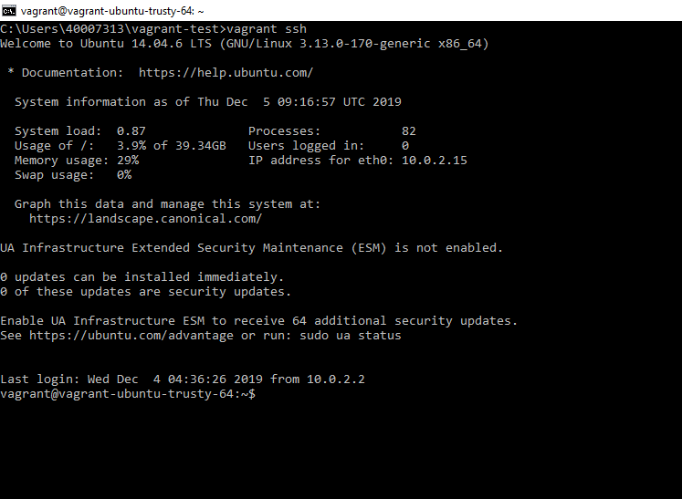

In the above image you can see the terminal of the ubuntu is shown where we can operate that vm from.

THANK YOU