EduTutor AI –

Personalized Learning with Generative AI Documentation

1. Introduction

* Project Title: EduTutor AI – Personalized Learning with Generative AI and LMS Integration
* Team Members:  
   Team Members - J.Madhumitha  
   Team Members - B.Harini  
   Team Members - B.Janani

2. Project Overview

* Purpose:  
  EduTutor AI is a personalized education platform designed to revolutionize learning and assessment. It leverages IBM Watsonx Granite models, FastAPI, Pinecone, and Streamlit to provide dynamic quiz generation, adaptive learning, real-time feedback, and seamless Google Classroom integration. The system empowers both students and educators by offering individualized learning experiences and data-driven performance insights.
* Features:
* **Personalized Learning Experience**  
  Key Point: Adaptive student learning  
  Functionality: Generates customized quizzes aligned to course topics and difficult levels, providing instant AI-powered feedback.
* **Educator Dashboard & Insights**  
  Key Point: Real-time monitoring  
  Functionality: Displays student performance history, scores, attempted topics, and insights from Pinecone DB.
* **Diagnostic Testing & Adaptive Quizzing**  
  Key Point: Intelligent assessment  
  Functionality: Conducts diagnostic testing upon registration and adapts quiz difficulty accordingly.
* **Google Classroom Integration**  
  Key Point: LMS synchronization  
  Functionality: Syncs courses, subjects, and class data to ensure academic alignment.
* **Feedback & Analytics**  
  Key Point: Continuous improvement  
  Functionality: Provides educators with quiz analytics and improvement insights.
* Use Case Scenarios:

- **Personalized Learning:** Students sync courses and receive AI-generated quizzes with feedback.

- **Educator Dashboard:** Teachers monitor quiz performance, history, and trends.

- **Diagnostic & Adaptive Testing:** Students take diagnostic quizzes to personalize learning.

- **Classroom Sync:** Seamless integration with Google Classroom for curriculum consistency.

3. Architecture

* **Frontend (Streamlit):** Student and educator dashboards with quiz history, performance analytics, and real-time interaction.
* **Backend (FastAPI):** APIs for quiz generation, evaluation, authentication, and classroom sync.
* **AI Integration (IBM Watsonx Granite + LangChain):** Quiz generation, adaptive learning, and feedback via Watsonx models.
* **Vector Database (Pinecone):** Stores quiz data, scores, and student embeddings for insights.
* **LMS Integration (Google Classroom):** Syncs class data for quiz alignment.

4. Setup Instructions

**Prerequisites:**  
- Python 3.10+  
- FastAPI, Uvicorn  
- LangChain  
- Pinecone  
- Streamlit  
- Google Auth & API Client  
- python-dotenv

**Installation Process:**  
- Install dependencies: pip install -r requirements.txt  
- Configure .env file with Watsonx, Pinecone, and Google API credentials  
- Start FastAPI backend: uvicorn app.main:app --reload  
- Run Streamlit frontend: streamlit run frontend/Home.py

5. Folder Structure

* **app/** – FastAPI backend services
* routes/ – Endpoints for quiz, auth, feedback, classroom sync
* services/ – AI integration, evaluation, and analytics logic
* **frontend/** – Streamlit UI for students and educators
* Home.py – Entry dashboard
* pages/ – Student and Educator panels
* **quiz_generator.py** – AI-powered quiz creation
* **answer_evaluator.py** – Quiz evaluation logic
* **classroom_sync.py** – Google Classroom integration
* **pinecone_handler.py** – Pinecone database interactions

6. Running the Application

➢ Start FastAPI backend with Uvicorn  
➢ Run Streamlit dashboard  
➢ Student: Login → Take Quiz → View History → Receive Feedback  
➢ Educator: Login → Access Dashboard → Monitor Analytics  
➢ Sync with Google Classroom for curriculum-based quizzes

7. API Documentation

* **POST /generate-quiz** – Creates quizzes based on selected topic & difficulty
* **POST /evaluate-quiz** – Evaluates student answers and returns scores
* **GET /quiz-history** – Retrieves quiz records from Pinecone
* **POST /classroom-sync** – Syncs courses and subjects from Google Classroom
* **POST /feedback** – Stores educator/student feedback
* **GET /docs** – Swagger API documentation

8. Authentication

* Google OAuth2 login for students and educators
* Token-based authentication for backend API access
* Role-based access (student, educator, admin)

9. User Interface

* **Student Panel:** Login, Take Quiz, View History
* **Educator Panel:** Real-time analytics, performance dashboard
* **Adaptive Testing Interface:** Personalized quiz difficulty
* **Feedback Section:** Educators and students provide feedback
* **Classroom Sync:** Import courses directly from Google Classroom

10. Testing

* **Unit Testing:** Backend quiz generation and evaluation
* **API Testing:** Swagger UI, Postman
* **Manual Testing:** Student quiz attempts, educator analytics
* **Edge Cases:** Large classrooms, malformed quiz requests, invalid credentials

11. Screenshots

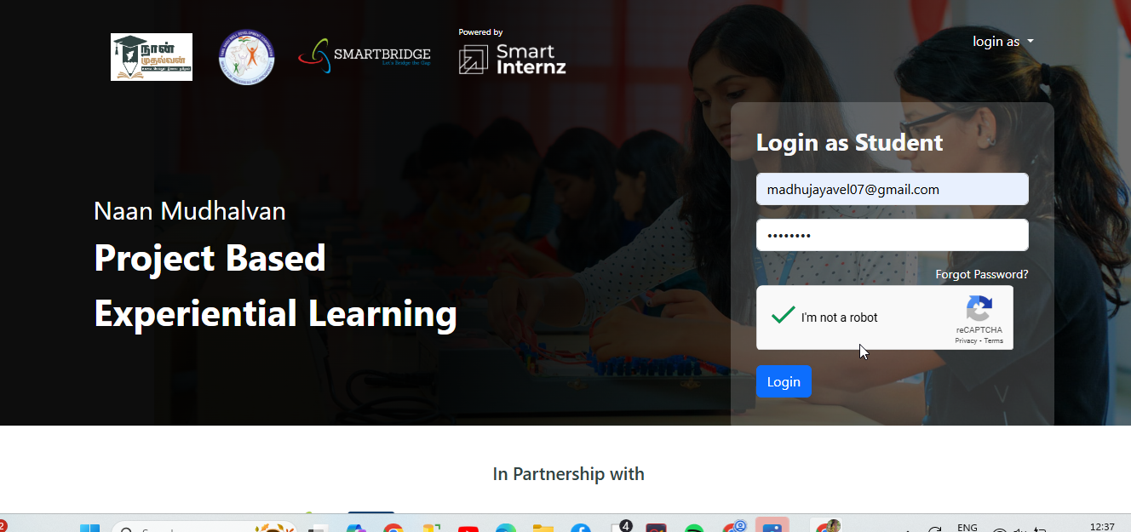

Smartintenz Login Page

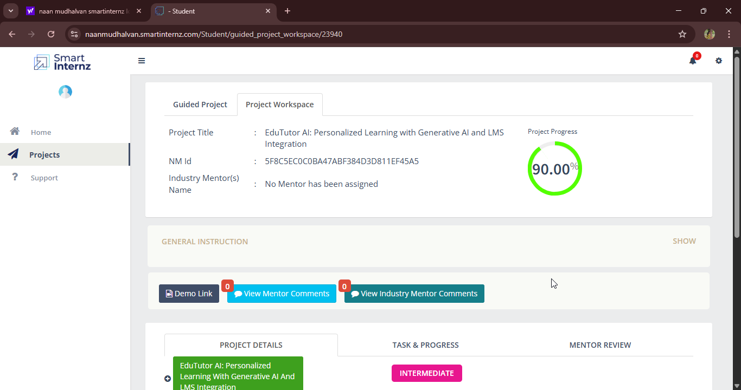

Smartinternz dashboard

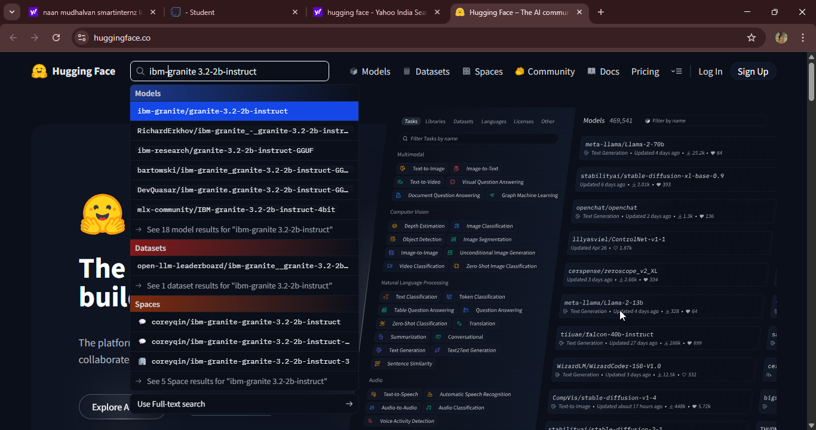

granite-3.2-2b-instruct in hugging face

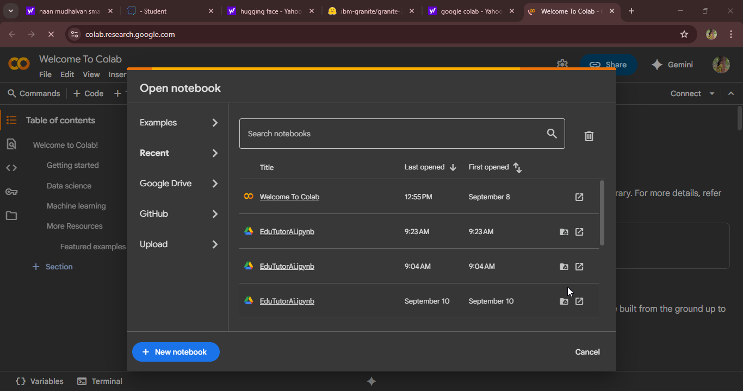

New Notebook notebook page in Google colab

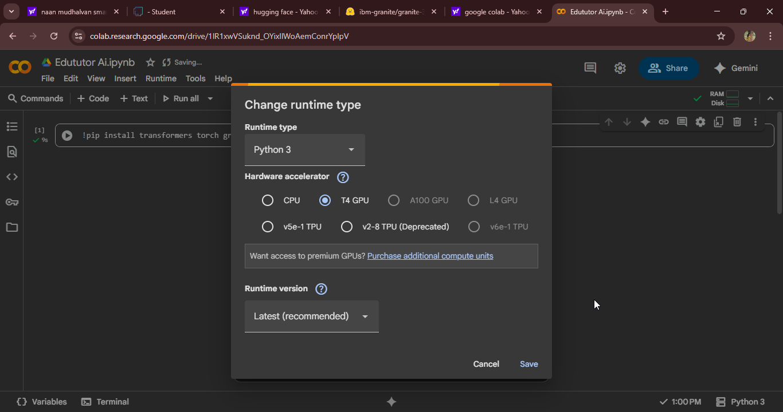

Choose “T4 GPU” and click on “Save”

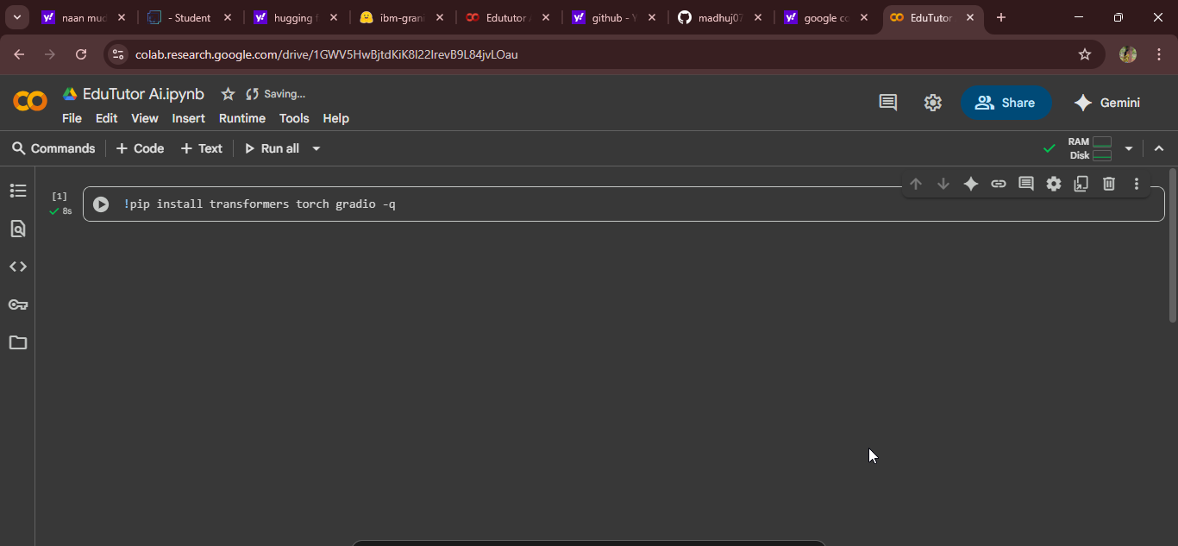

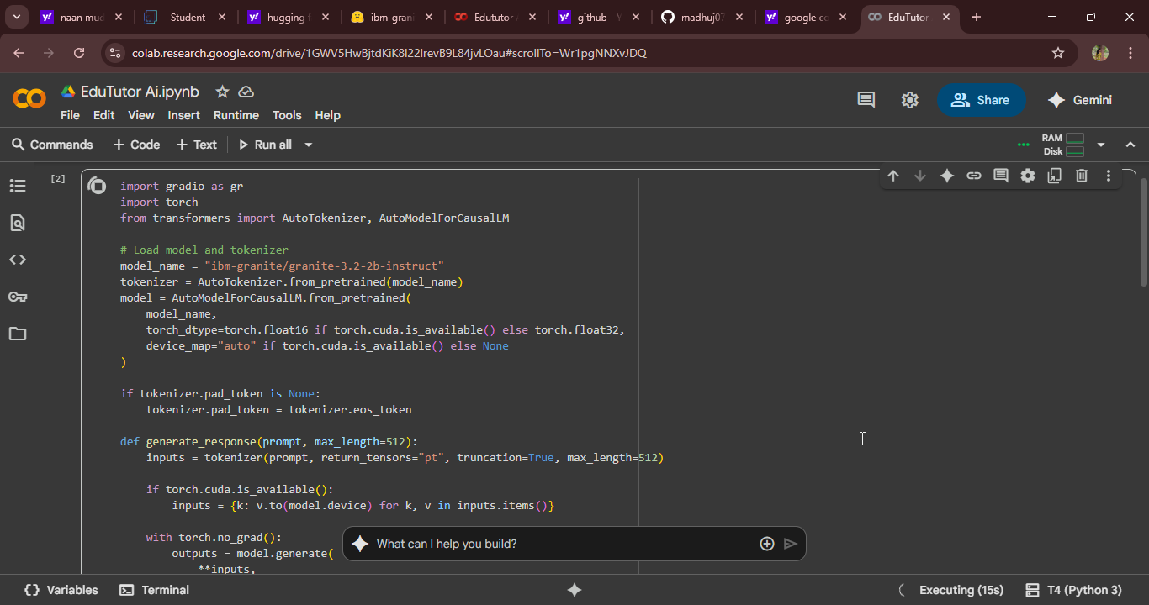

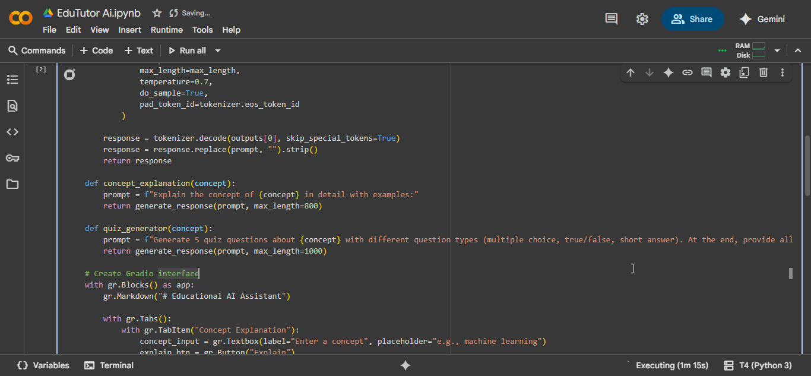

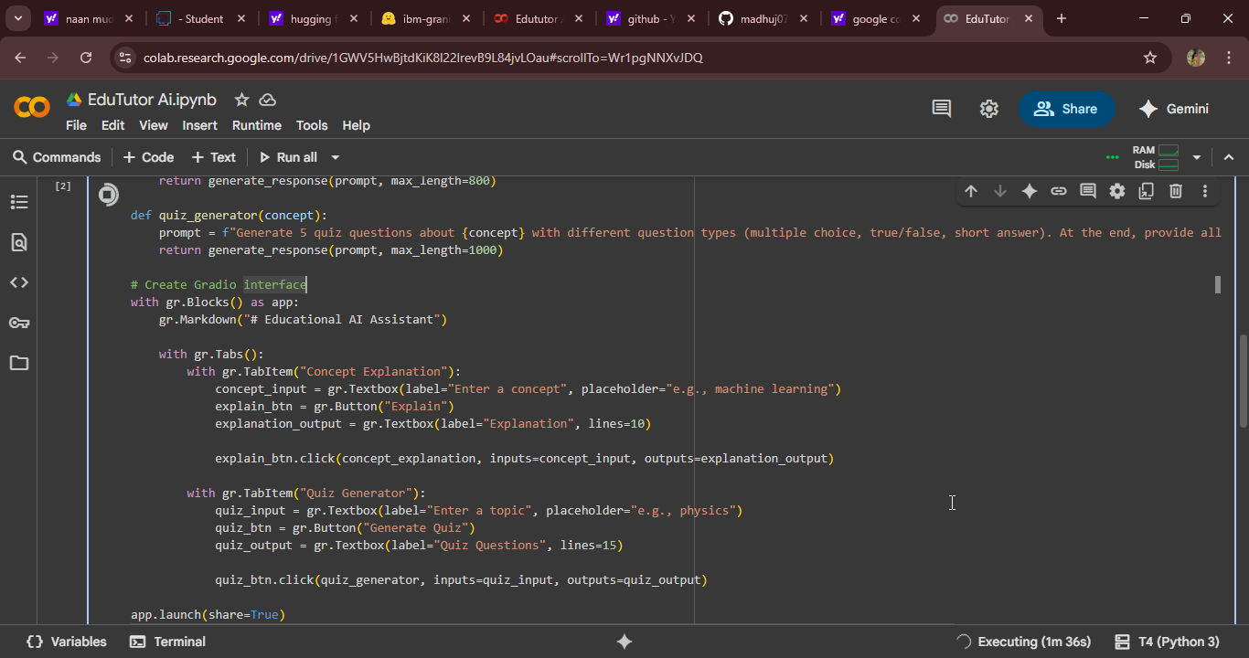

EduTutorAI Coding page

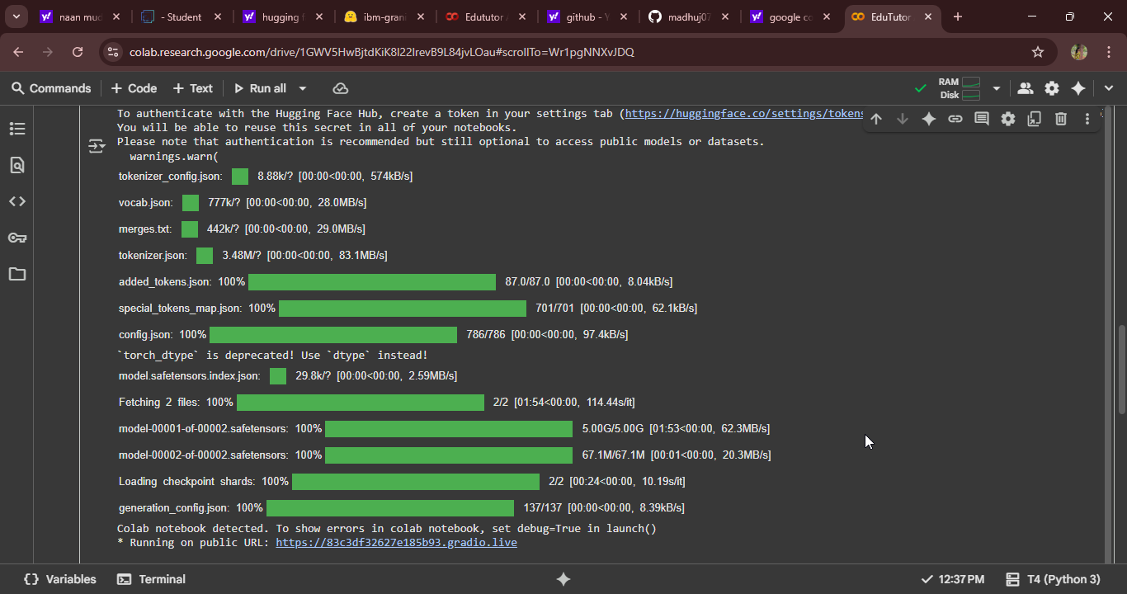

● Click on the URl to open the Gradio Application click on the link.

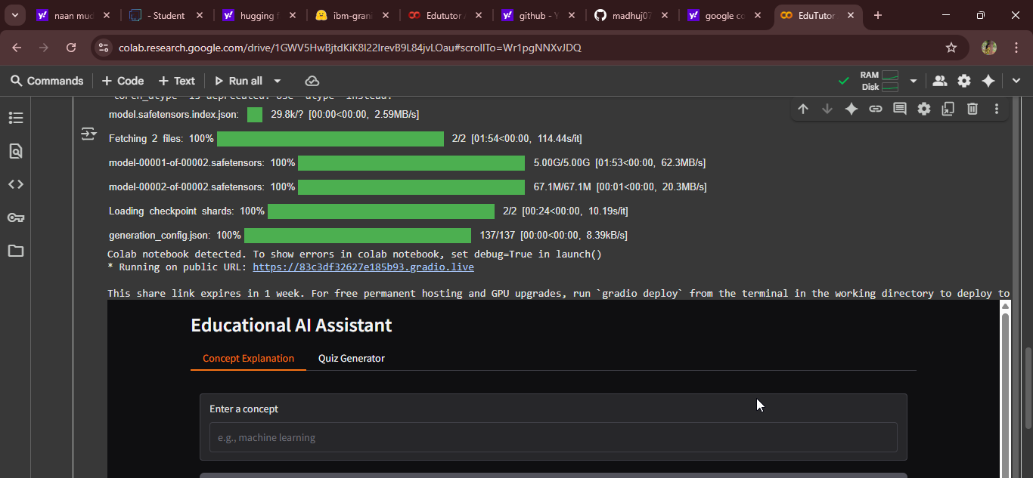

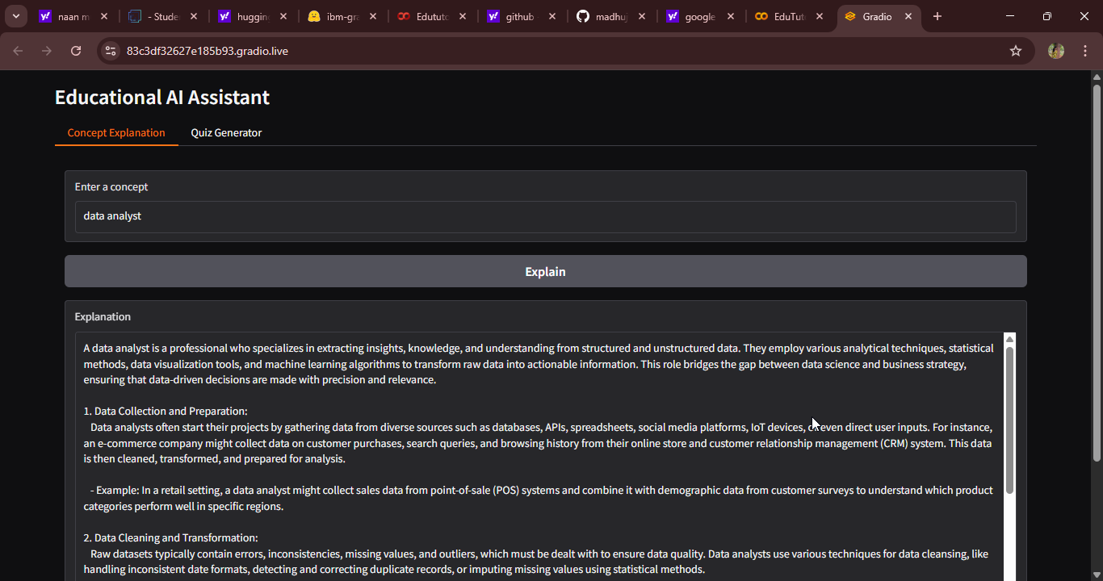

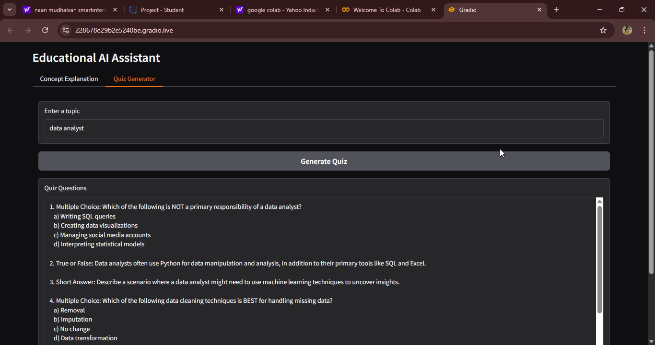

Edututor AI Home Page

12. Known Issues

* Frontend quiz UI incomplete in current version
* Dependency on Watsonx and Pinecone API quota
* Requires stable internet connectivity
* Limited offline support

13. Future Enhancements

* Full-featured student quiz frontend
* Mobile-friendly dashboard
* Multi-language quiz support
* Deeper Google Classroom integration
* AI-driven personalized study plans
* Advanced analytics with predictive performance insights