Core Java

* Data types
  + primitive DT
  + derived DT
* Variables (data)
* methods (behaviour)
* constructor
* static Blocks
* Instance Blocks
* Classes
* Interfaces in Java
* Access specifiers
  + private
  + default
  + protected
  + public
* Access modifiers
  + static
  + abstract
  + synchronized
  + final
* Strings in Java
  + functions
  + StringBuffer
  + StringBuilder
* Threads
* Exception Handling
  + try
  + catch
  + throw
  + throws
  + finally
  + User Defined Exception
* Files
  + properties , text file, excel file
  + Read a file
  + Write to a file
* Loops
  + for
  + foreach
  + while
  + do,while
* conditional Statements
  + if
  + if else
  + if elseif else
  + switch
* Abstract Classes
* Wrapper Classes
* Arrays
* Collections
  + List
  + Set
  + Map
* Generics

Automation Testing :

* What is Software Testing
* What are the drawbacks of Manual testing
* What is regression Testing
* What are the different tools available for automation testing
* Why Selenium is popular ???
* **Selenium 4.0**
* Selenium IDE
  + Record and Playback
* ~~Selenium RC~~
* Selenium WebDriver
  + Object identification
    - id
    - name
    - classname
    - tagname
    - linktext
    - partiallinktext
    - css
    - xpath
      * Basic xpath
      * xpath using Logical Operator
      * xpath using function
      * traversing from parent to child
      * traversing from child to parent
      * xpath using axes functions
        + Traversing to previous siblings
        + Traversing to next siblings
        + Traversing to parent
        + Traversing to child
        + Traversing to ancestor
  + How to play with textbox, radio, checkbox, hyperlinks, images
  + How to play with web table, dynamic elements
  + How to perform validation
  + Select Class
  + Actions Class – KB and Mouse operation
  + End to End Automation
  + Data driven Testing
  + Popups
    - alert
    - confirmation
    - hidden division
    - file download
    - file upload
* AutoIT
* Selenium Grid
* Frameworks
  + ~~Function Driven Automation framework~~
  + ~~Keyword Driven Automation framework~~
  + ~~Hybrid Driven Automation framework~~
  + Page Object Model
  + TestNG
    - annotations

Build Automation Tools :

* Maven
* gradle

Jenkins :

GIT :

Interview Questions : - On the topics covered

2 Sample Applications :

Installations :

1. Java - JDK 1.8
   1. <https://www.oracle.com/in/java/technologies/javase/javase8-archive-downloads.html>
      1. JDK – Java development kit
      2. JRE- Java Runtiime Environment
   2. Open command prompt
   3. java –version ( ON any error set the Environment variables )
2. Editor : Visual Studio Code, **Eclipse**, IntelliJ, ...
   1. https://www.eclipse.org/downloads/packages/release/2021-09/r/eclipse-ide-java-developers
3. GIT
   1. <https://git-scm.com/downloads>
   2. Configuration
      1. signup to gitbub and create your own account
      2. update user name and email in the git commandline tool
         1. git config --global user.name "<<USERNAME>>"
         2. git config --global user.email <<EMAIL>>
   3. Create a Repository in your machine
      1. git init
      2. create some files
      3. add the file to version control -> git add file1, file2......filen OR git add .
      4. git commit –m “Message ” 🡪 this will generate commit id
      5. git push origin master OR
      6. git push --set-upstream origin master

NOTE : link your local repository with the global repository by executing

git remote add origin <<Remote Repository URL>>

JAVA :

­

OOPS Concept :

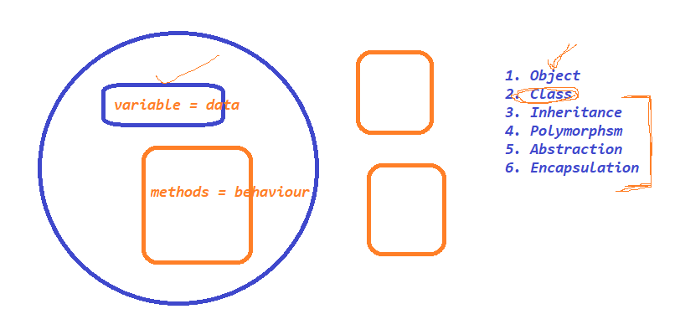

­­­

Features of JAVA :

1. Simple

2. Object oriented Programming language

3. Platform Independent

4. Secure

5. Robust

6.Architecture-neutral

7. Portable

8. Multi-Threading

HelloWorld JAVA Program

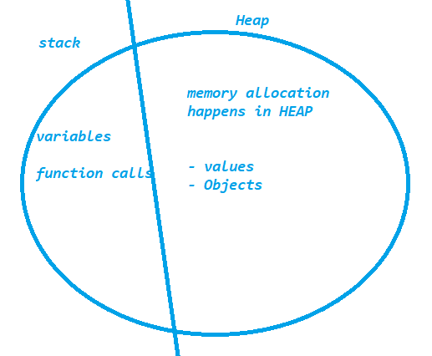

Stack Trace :

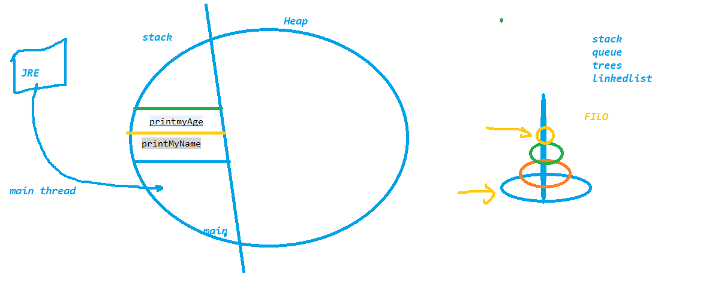

Packages in java :

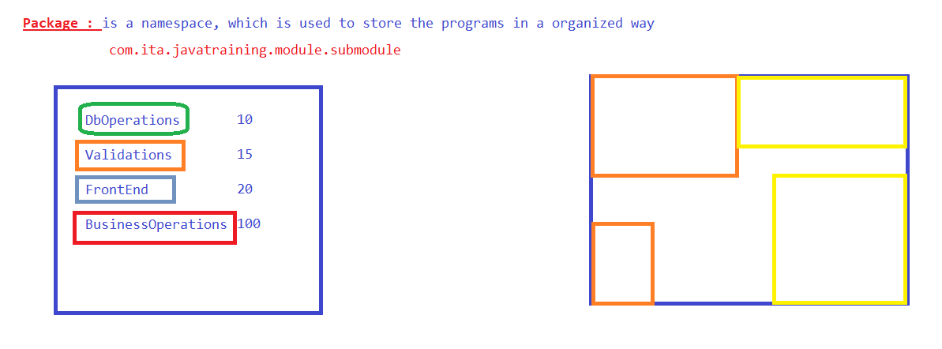

Data Types in JAVA :

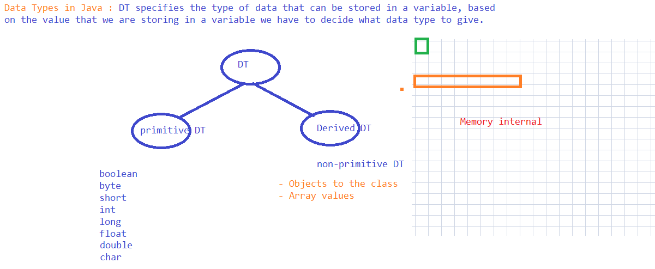

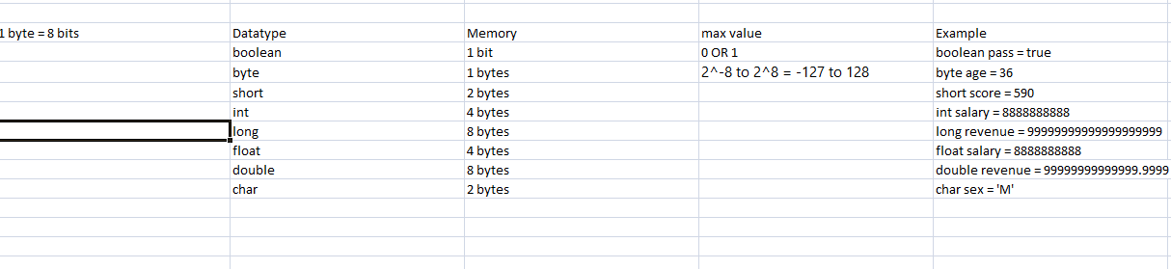

Variables :

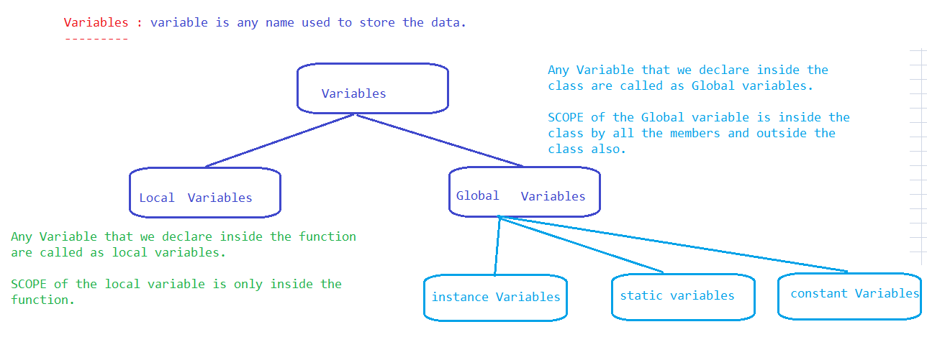

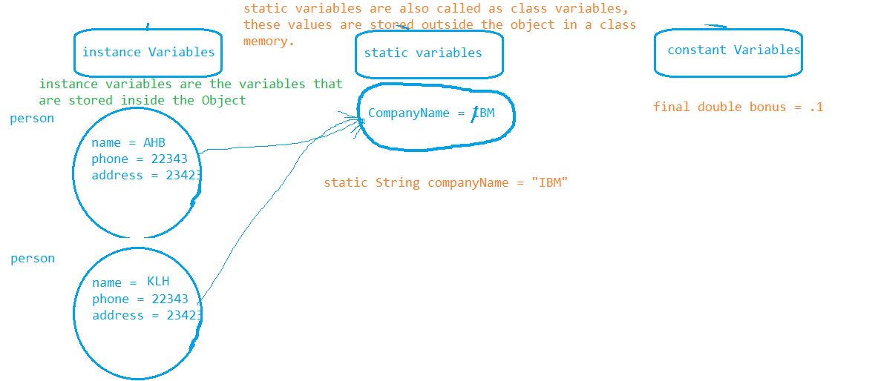

static variables demo :

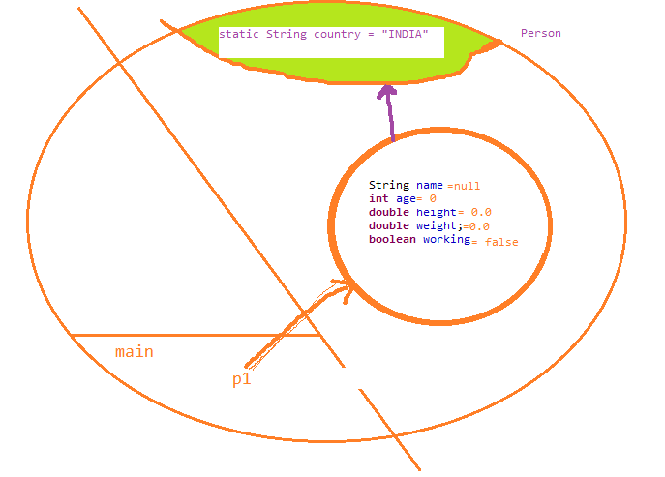

**Functions OR methods**

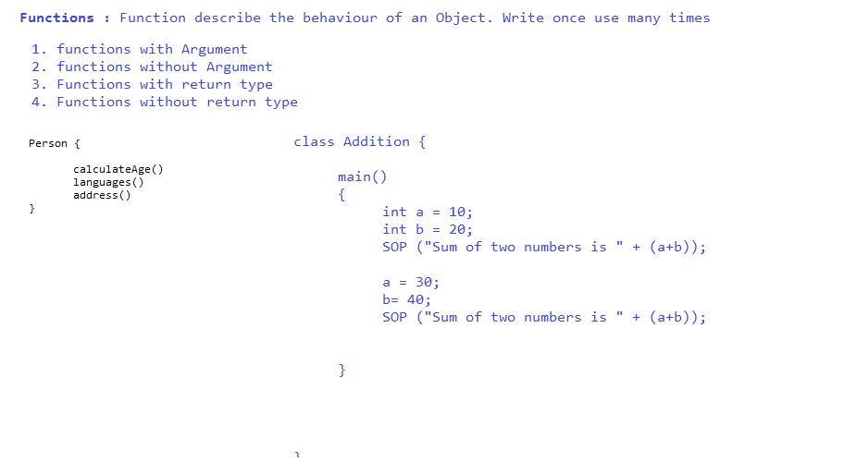

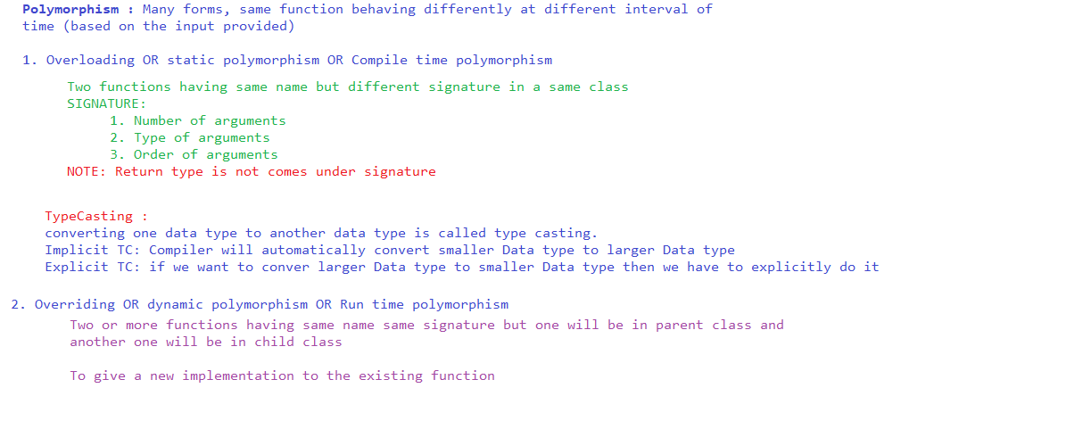

Constructors :

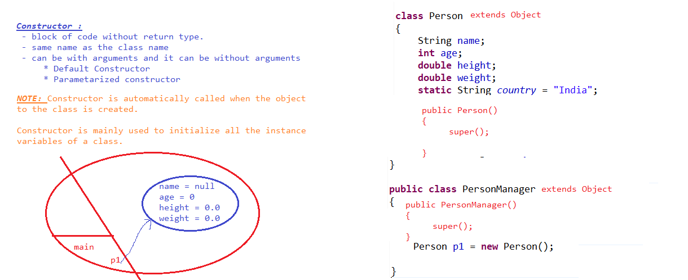

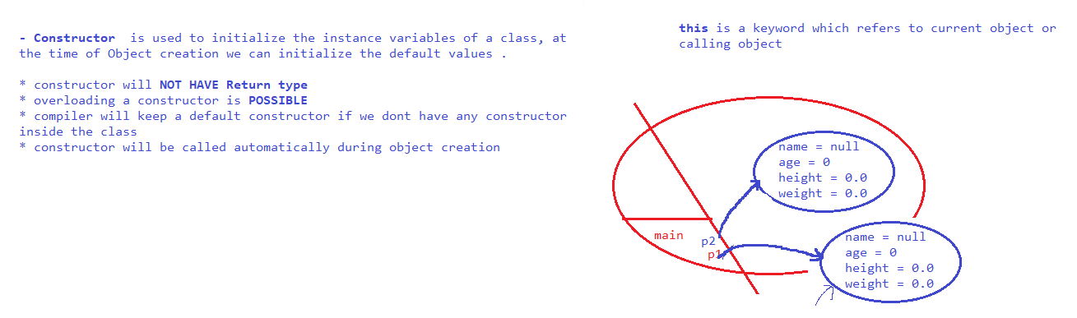

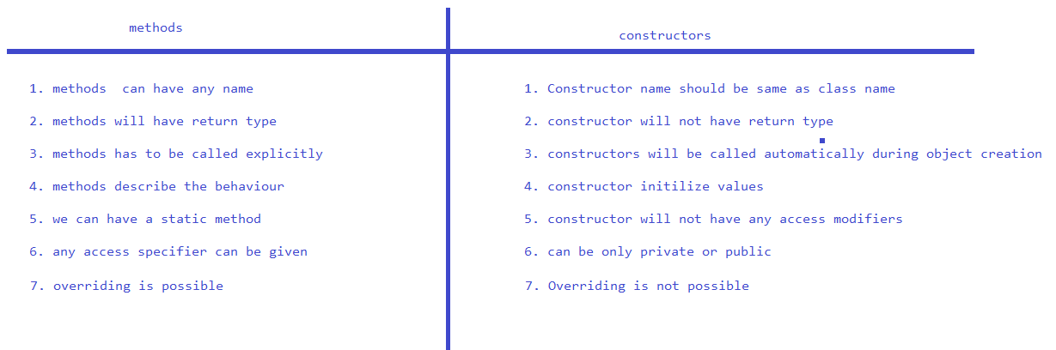

Overriding :

with toString method.

Static initialization Block

static

{

}

Instance initialization Block

{

}

Access Specifiers

* private - private members are accessible only inside the class by all other members
* default – default members are accessible by all the classes within the same package
* protected – protected members are accessible by all the classes within the same package, outside the package it is accessible only if there is a inherited class (child class )
* public - wider access, it can be accessible by all the classes with in the project

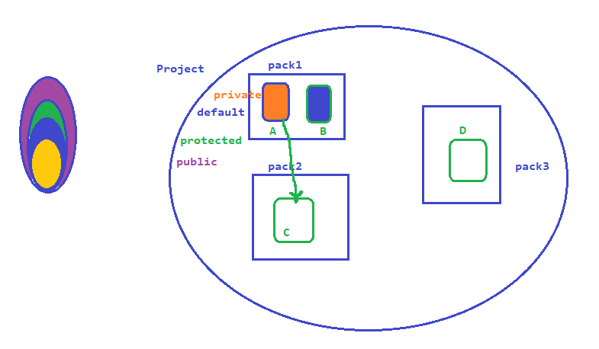

Access modifiers

* static – class member, without creating a object we can access these members
* final –
  + variables : it acts as a constant value, no one can change / alter the value
  + methods : we cannot override
  + class : we cannot make it as a parent class
* abstract

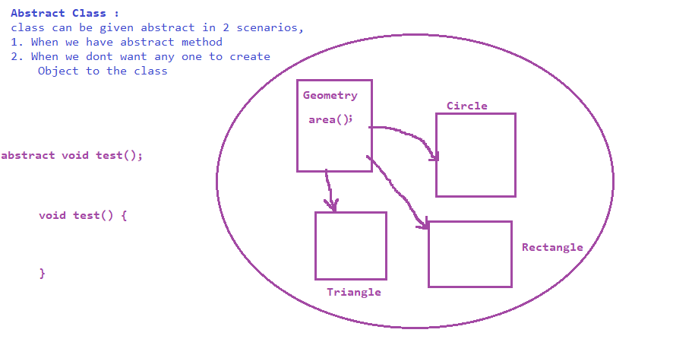

* + methods: when there is no method definition we declare method as abstract
  + class :
    - when we have any abstract method
    - when we want to restrict creating objects to the class
* synchronized –synchronized can be given to method so that we can restrict multiple threads entering to the method

Looping and Conditional Statements :

* for
* while
* do,while
* foreach / Extended for loop

Conditional statements

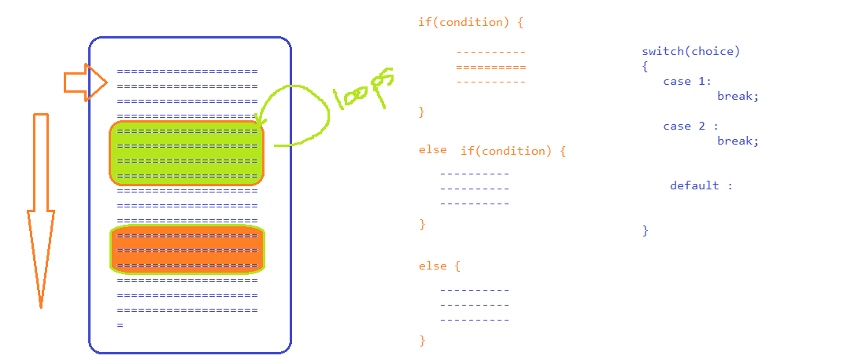

Strings :

- String functions

- String Buffer

- String Builder

Inheritance :

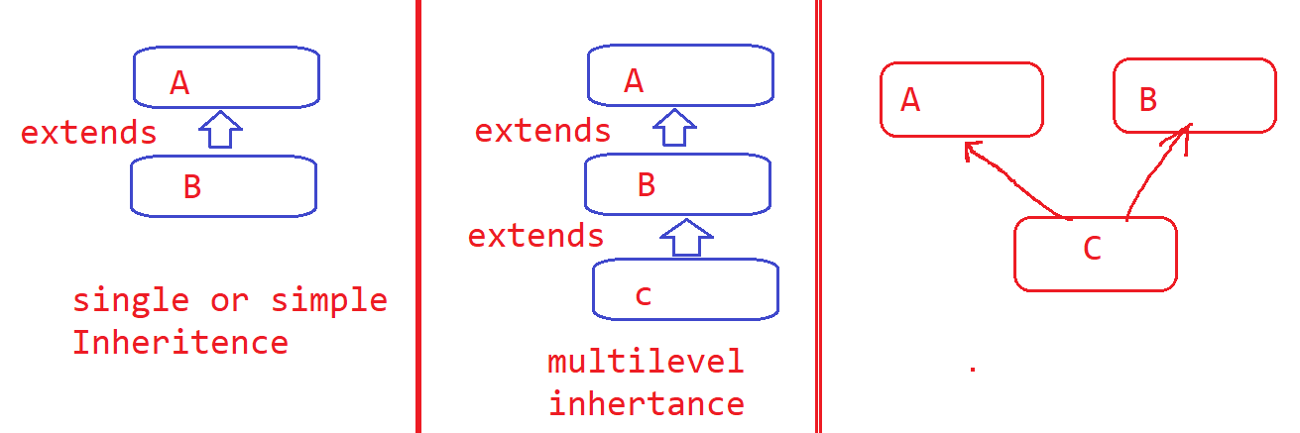

To achieve multiple inheritance we use interfaces.

NOTE : Interfaces are similar to classes, but interfaces are 100% pure abstract class.

Interfaces:

whatever method we declare inside interface is abstract by default and whatever the variable we declare inside the public static final by default

Exception Handling

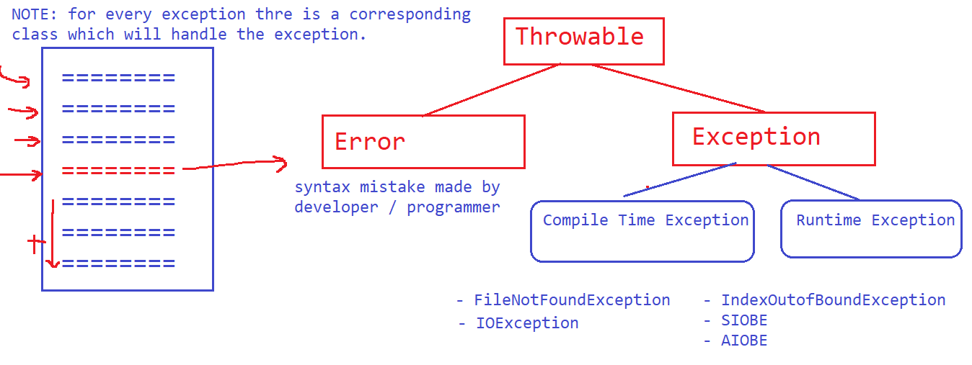

Exception Handling is a mechanism using which we can ask compiler to continue the execution till the last line even though there is a abnormal statement.

To handle exception we have to use try block and catch block

* try : abnormal statements can be kept inside try block
* catch : corresponding class which can handle the exception .
  + for one try we can keep multiple catch blocks
  + there should not be any valid java code between try and catch
* throws : whenever we don’t want to handle the exception from the place where it has occurred then we use thows. using throws, exception will go to the called place (Function call)
* throw : when we want to raise exception explicitly
* finally : to execute all the time ( exception raised or not raised )

File Handling in JAVA :

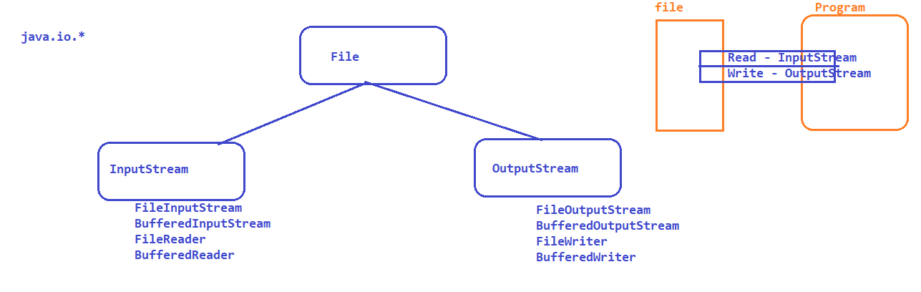

Threads :

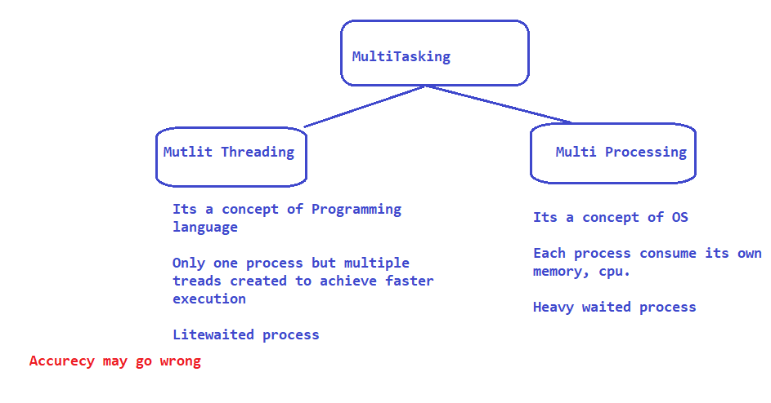

Ways to create thread :

1. using Runnable interface

2. Using Thread class

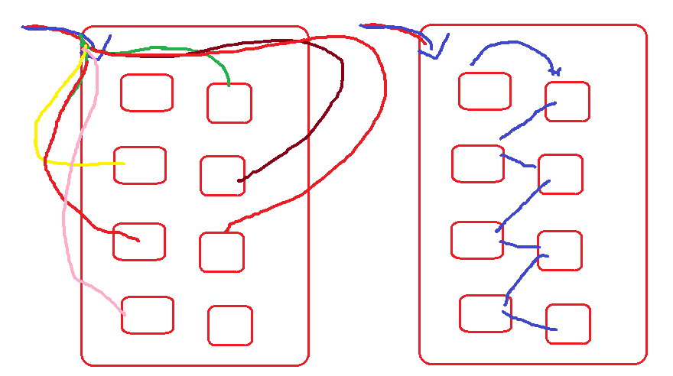

Implementing Threads in a program :

1. Write a class by making Thread class as a super class
2. Override run method and keep the thread task inside **run** method
3. From the main class create an object to Thread class (created by you ) and call **start** method

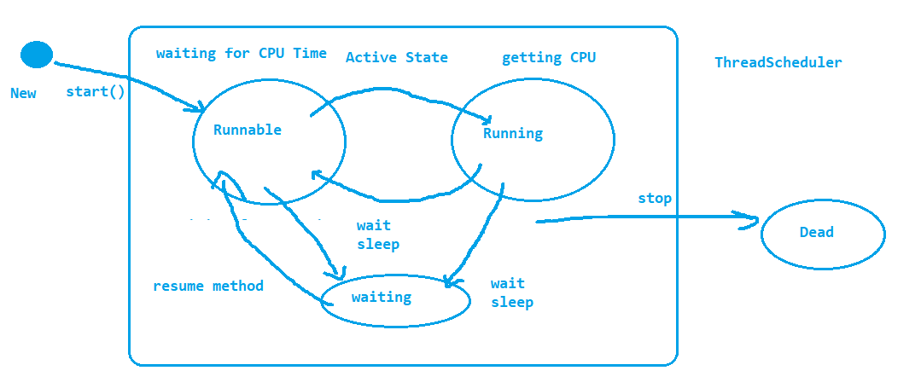

Collections :

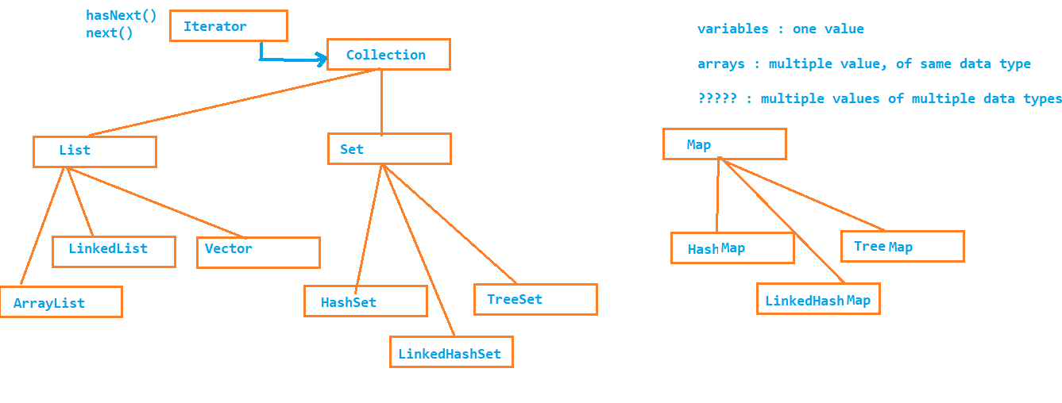

ArrayList :

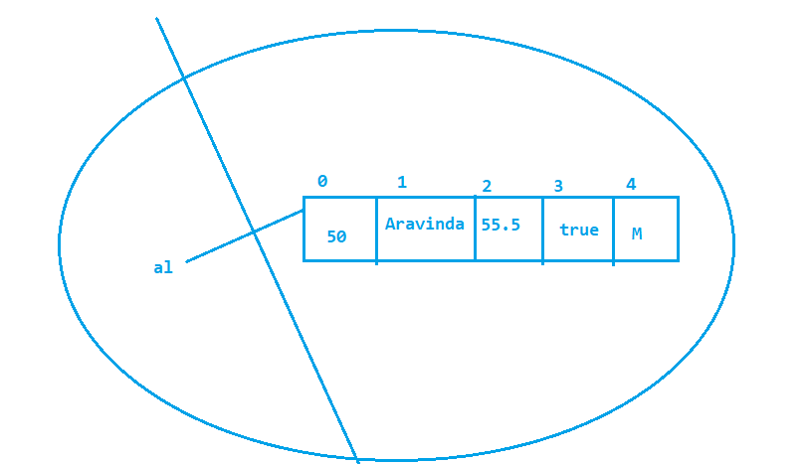

LinkedList :

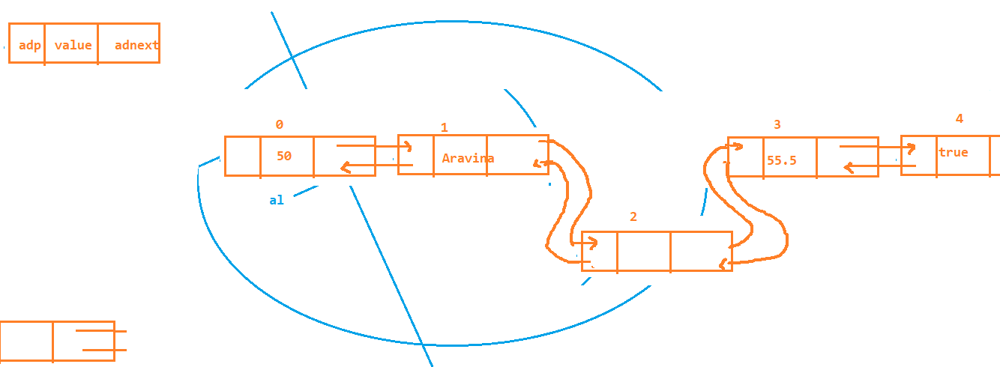

Set :

Hash Set :

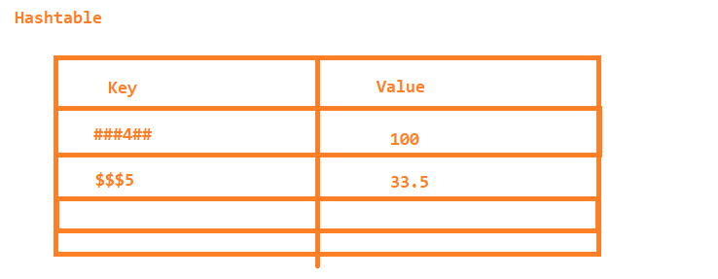

Linked HashSet

TreeSet

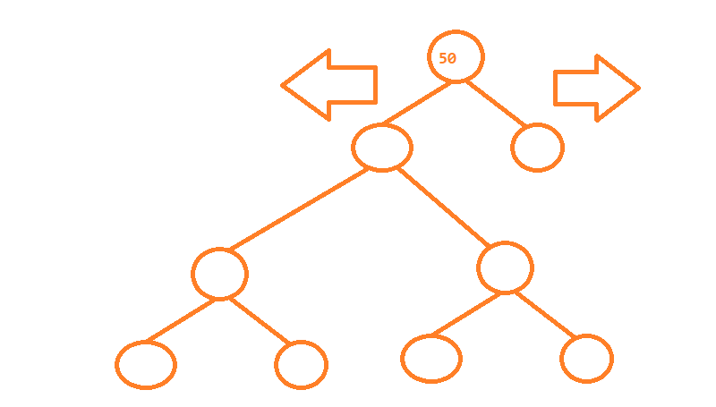

Wrapper class

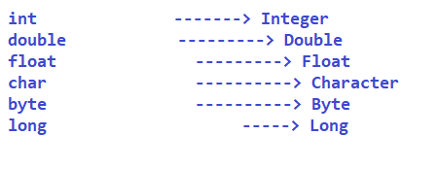

Testing ...????

SDLC :

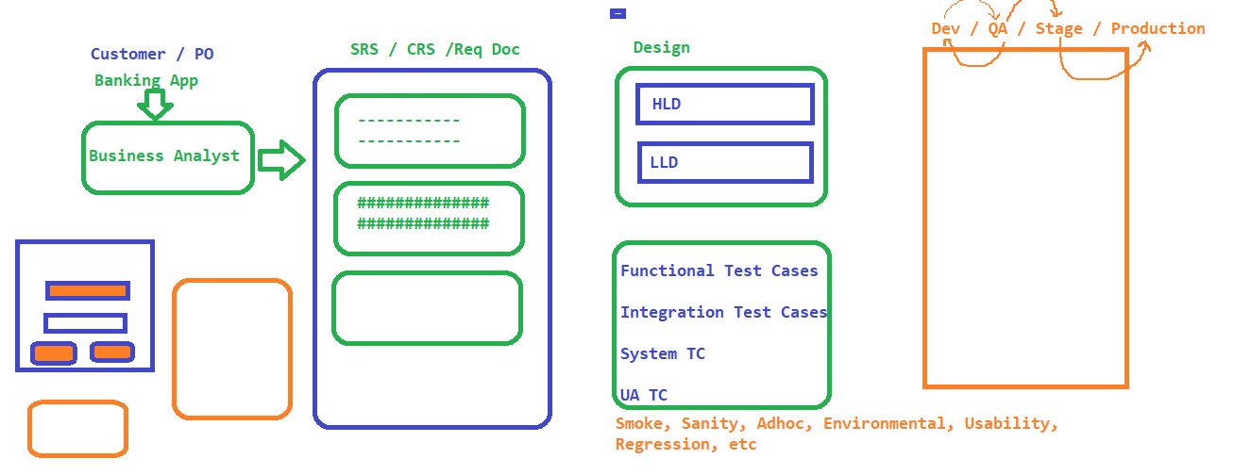

Manual Testing Process / Regression Testing

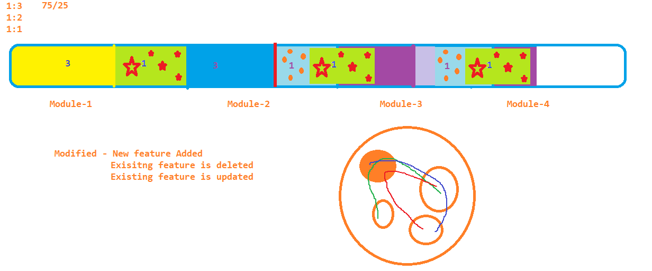

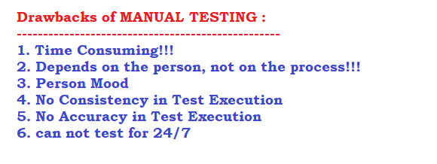

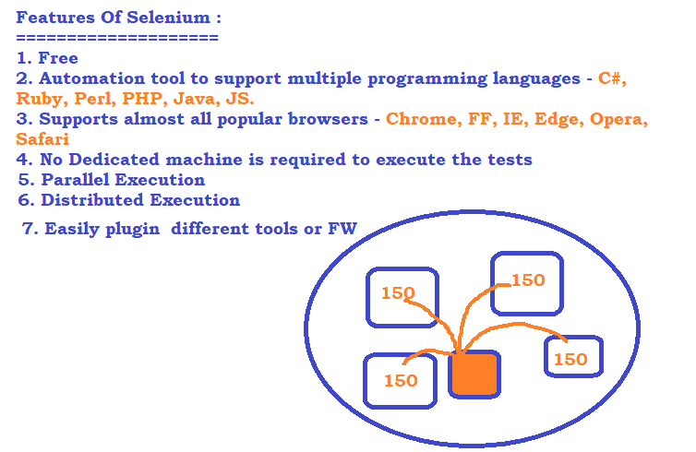

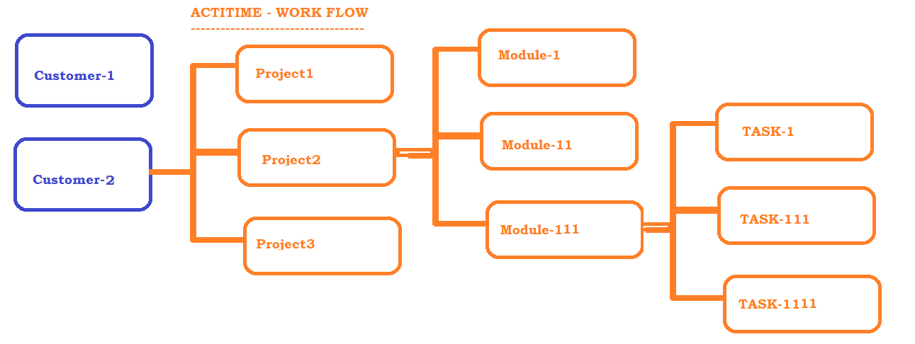

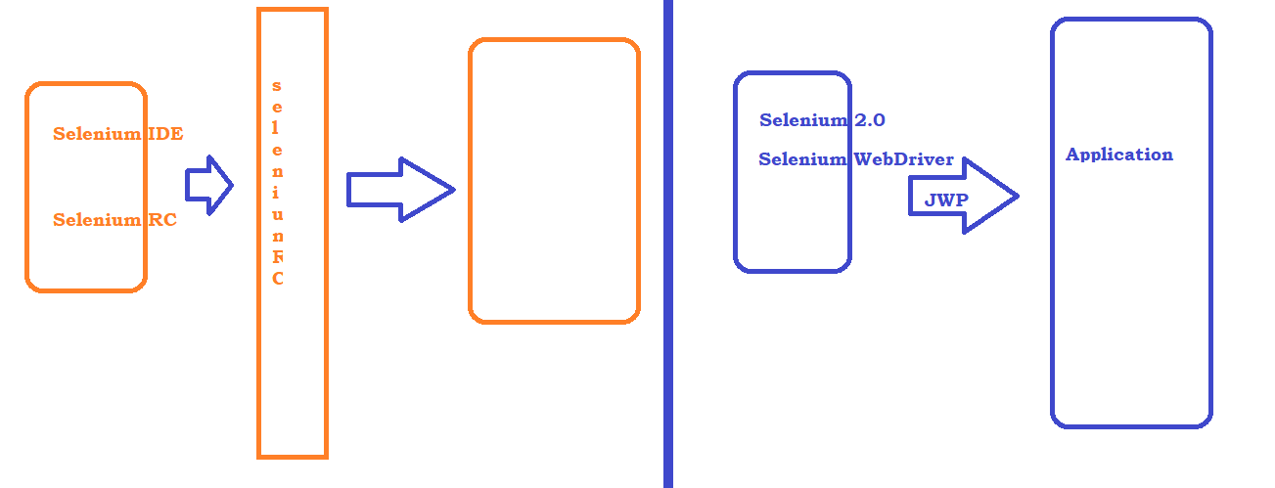

Identification Mechanism in Selenium :

1. OPS Concept : id
2. namename
3. classname
4. tagname
5. linktext
6. partiallinktext
7. css
8. xpath

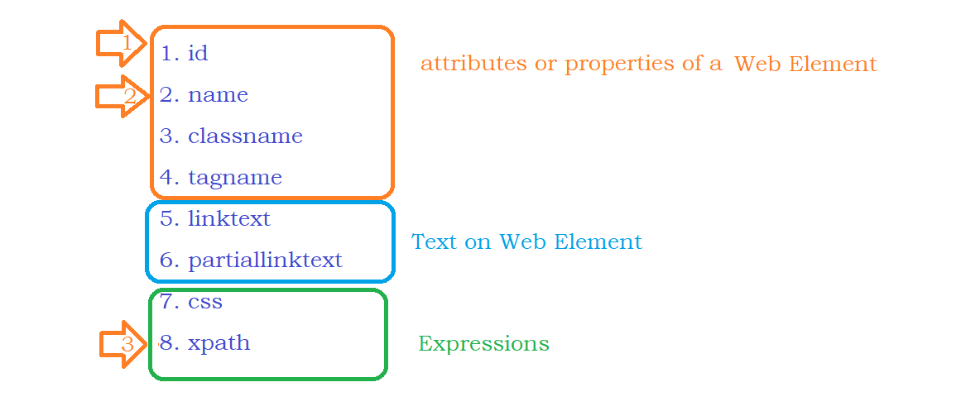

Build Automation Tool :

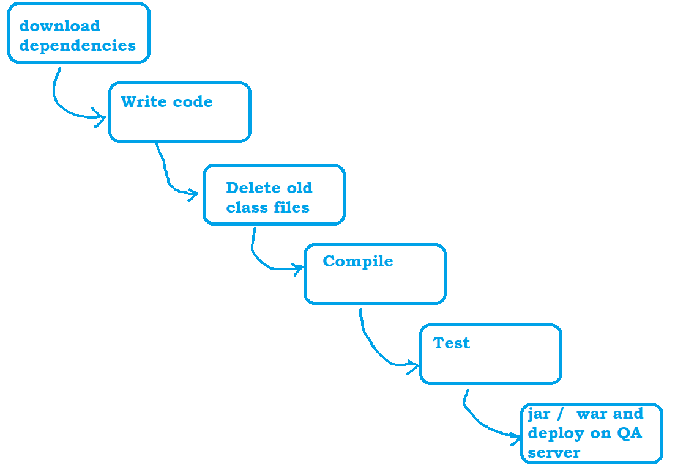

Create Maven Project :

1. 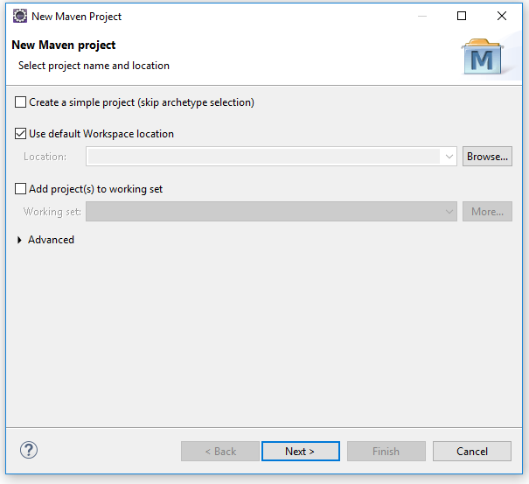

2. 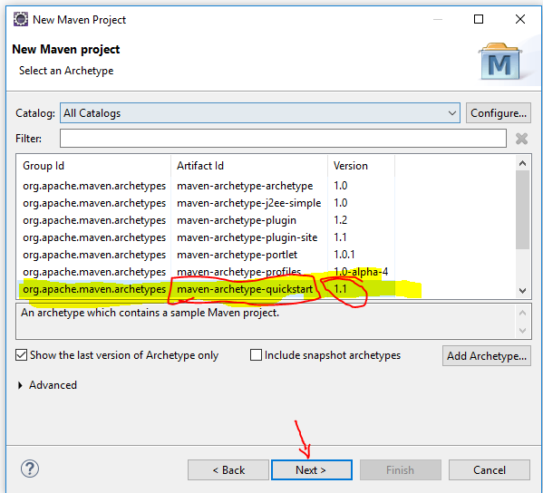

3. 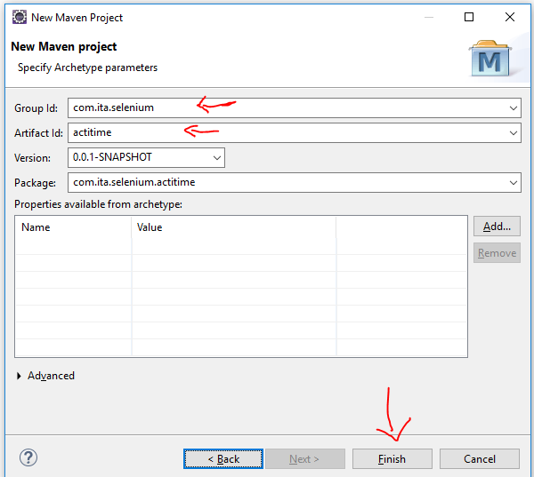

4. Update Compiler and Runtime (JRE) Environment : Right click on project and go to properties

5. 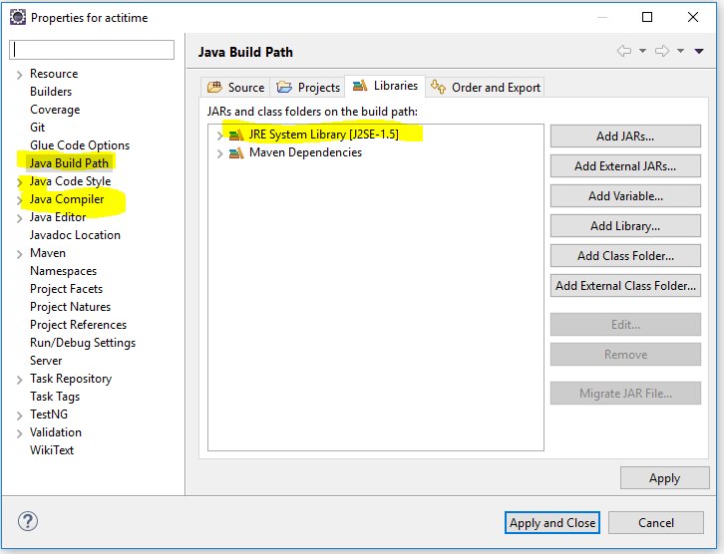

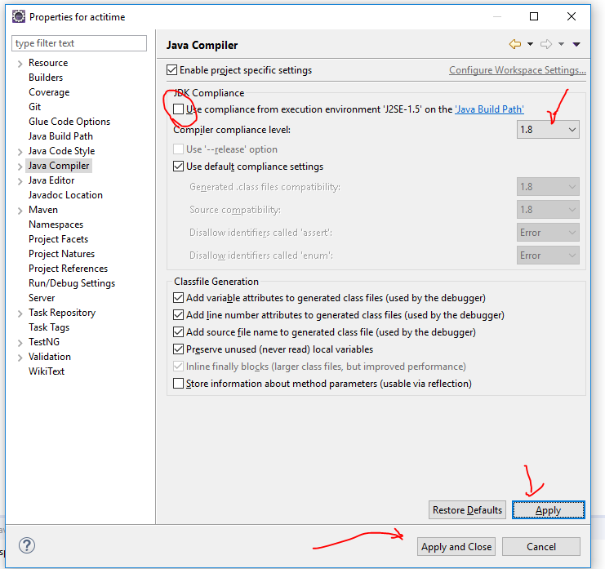

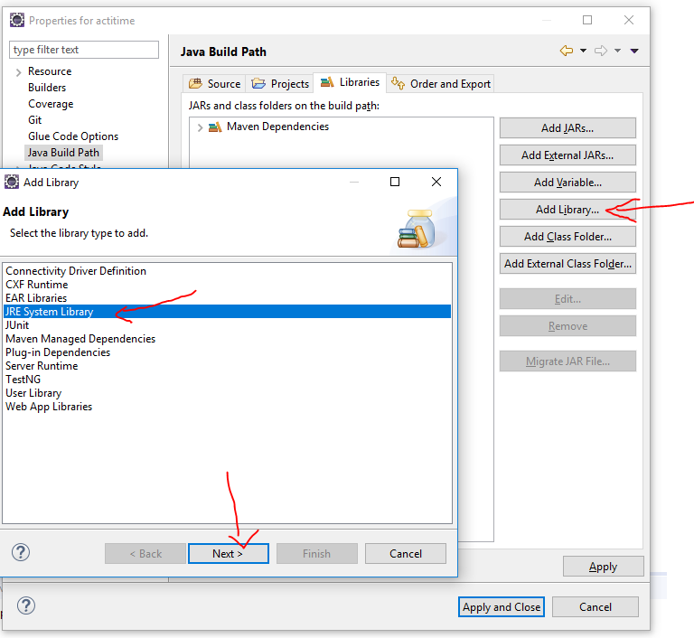

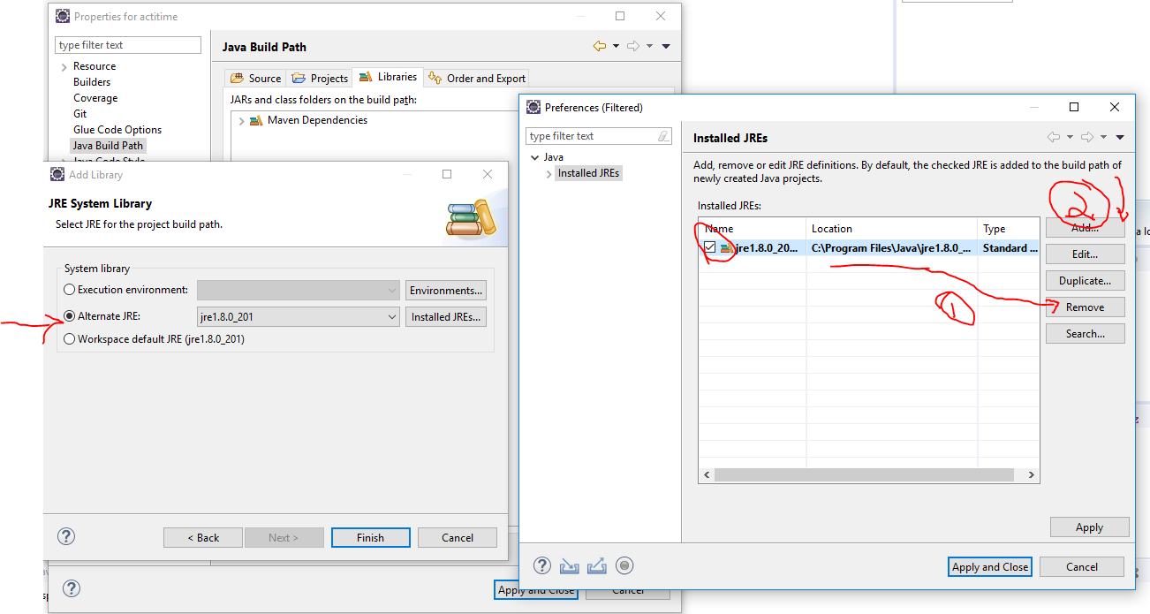

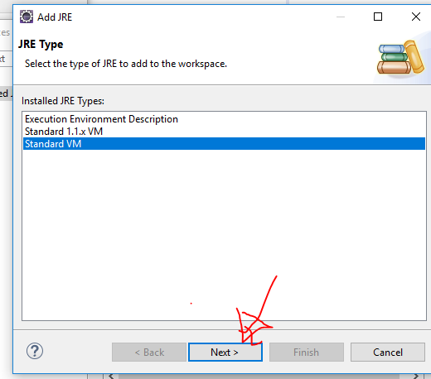

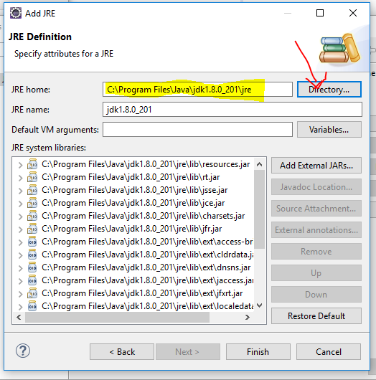

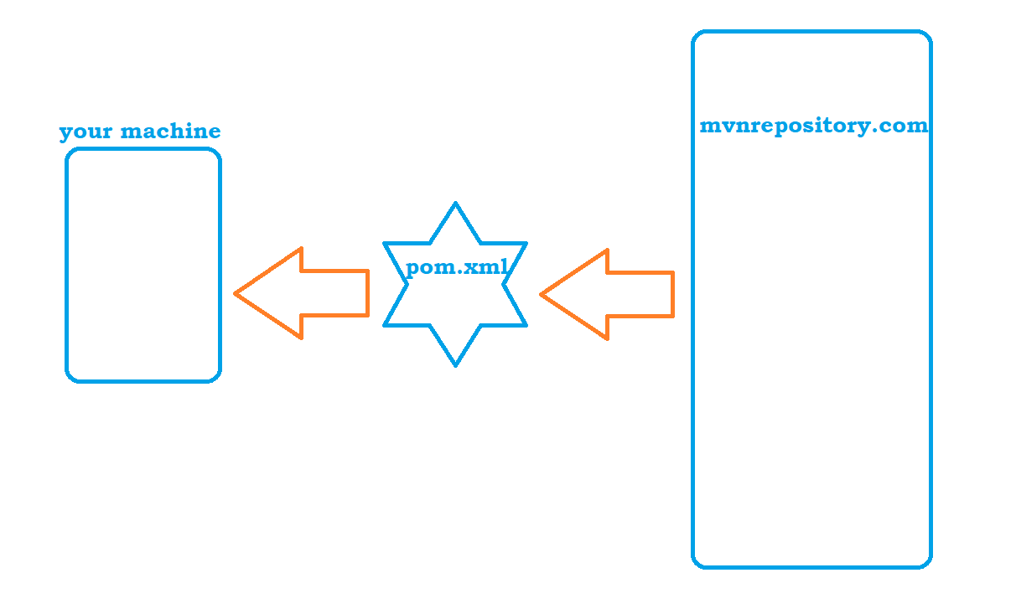

High level Architecture of Selenium

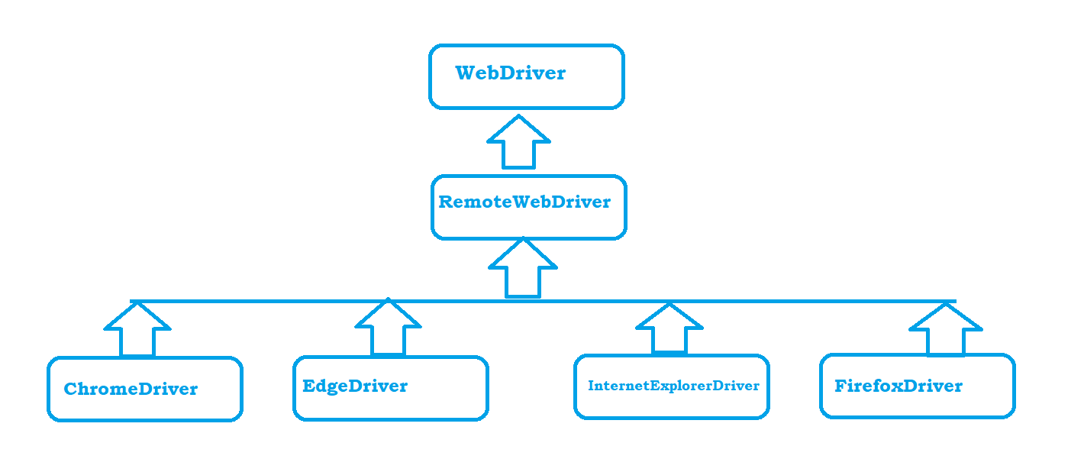

Work flow Architecture:

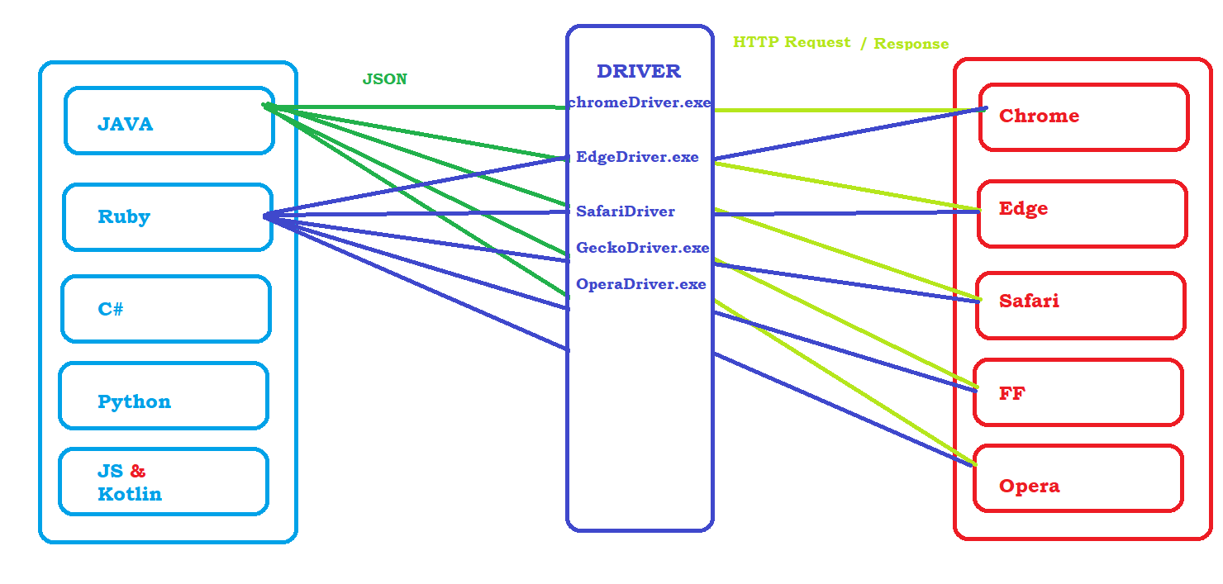

Expressions :

1. CSS

|  |  |  |
| --- | --- | --- |
| 1 | htmltag[attribute or property=’value’] | input[placeholder='Username'] |
|  |  | input[type='checkbox'] |
| 2 | Htmltag#idValue | input#keepLoggedInCheckBox |
| 3 | #idValue | #keepLoggedInCheckBox |
| 4 | HtmlTag.className | input.textField |
| 5 | .className | .textField |
| 6 | Expression > childtag name | a#loginButton > div |

1. Xpath
   1. Finding Element with Attributes
      1. //htmltag[@attribure='Value'] -> //input[@placeholder='Username']
   2. Logical Operators in Xpath
      1. AND
         1. //htmltag[@attribute1=’value1’ and @attribute2 = ‘value2’]
         2. //input[@type='text' and @placeholder='Username']
      2. OR
         1. //htmltag[@attribute1=’value1’ or @attribute2 = ‘value2’]
         2. //input[@type='text' or @placeholder='Username']
      3. NOT
         1. //htmltag[not( @attribute1=’value1’)]
         2. //input[not(@type='text')]

//td[(@class='wd day' or @class='current day' or @class='we day') and text()='3']

//td[not(@class='past day') and text()='4']

* 1. Xpath Using Functions
     1. text()
        1. //htmltag[text()=’ExactValue’] ---- > //td[text()='4']
        2. //label[text()='Keep me logged in']
     2. contains(arg1, arg2)
        1. arg1 can be attribute or text function
        2. arg2 can be partial text which is present on the element
        3. //htmltag[contains(arg1, arg2)]
           1. //label[contains(text(),'Keep')]
           2. //img[contains(@src,'timer')]
     3. starts-with(arg1, arg2)
        1. arg1 can be attribute or text function
        2. arg2 can be text which starts with
           1. //span[starts-with(text(),'Watch')]
           2. //span[starts-with(text(),'iPhone 13')]
  2. Traversing from parent to Child
     1. //a[@id='loginButton']/div
     2. //td[@id='loginButtonContainer']//div[text()='Login ']
  3. Traversing from Child to Parent***NOTE****: Whenever we are playing with dependent and independent elements we have to traverse from child to parent*
     1. Step1 : write a xpath to child element
     2. Step2 : put the complete child xpath in a square bracket and specify parent html tag
     3. //tr[th[text()='Directed by']]//a
     4. //tbody[tr[th[text()='Body']]]//td[@class='nfo']

MMT - //div[div[h4[text()='Udaipur & Mount Abu - Free Cancel...']]]//p[contains(@class,'price-current')]

Using AXES Function : //h4[text()='Udaipur & Mount Abu - Free Cancel...']/ancestor::div[@class='itemCard packageCard']//p[contains(@class,'price-c')]

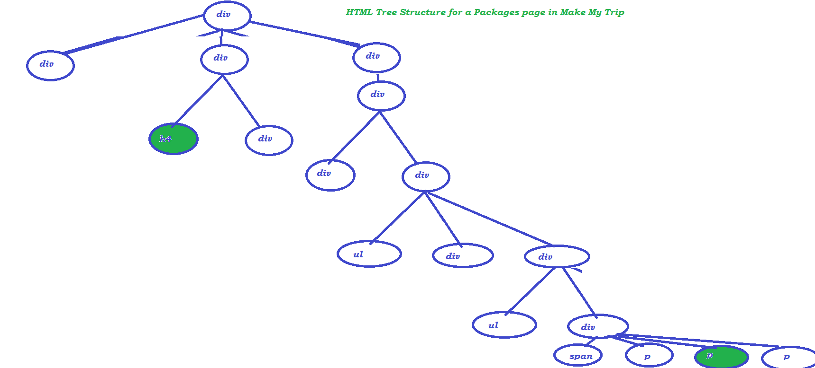

* 1. Axes Functions
     1. Following Sibling
        1. xpathOfaElement/following-sibling::siblingTag
        2. //th[text()='Directed by']/following-sibling::td
     2. Preceding sibling
        1. //td[a[text()='Technology']]/preceding-sibling::th
     3. Following
        1. //table[tbody[tr[th[text()='Display']]]]/following::table
     4. Preceding
        1. //table[tbody[tr[th[text()='Display']]]]/preceding::table
     5. Parent
        1. //th[text()='Display']/parent::tr/parent::tbody/parent::table/following::table
     6. Child
        1. //th[text()='Display']/parent::tr/parent::tbody/parent::table/child::tbody/child::tr/child::th/following-sibling::td
     7. Ancestor
        1. //th[text()='Display']/ancestor::table
     8. //th[text()='Display']/parent::tr/parent::tbody/table

1. Auto Suggestions
2. Sync issue or synchronization issue

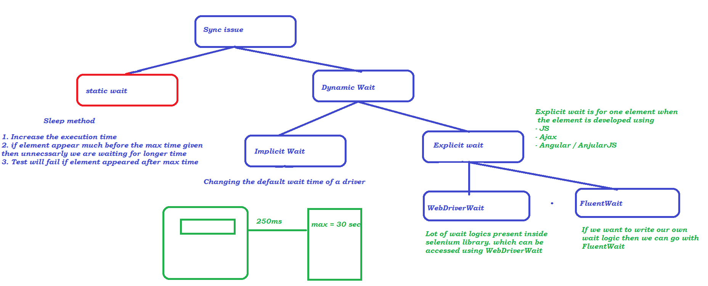

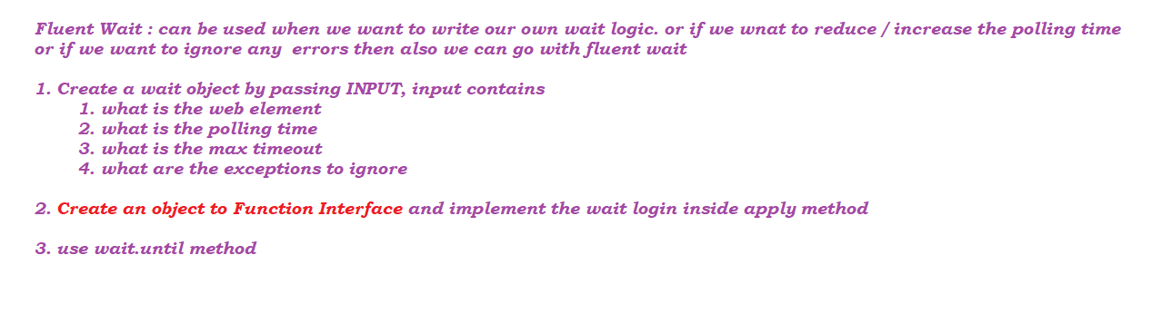3. Tool tip information

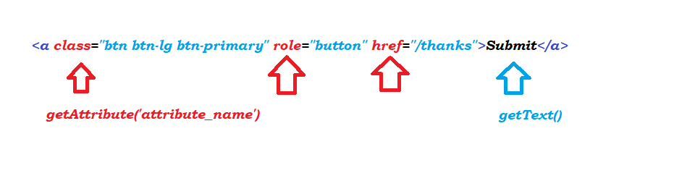

4. Drop Downs

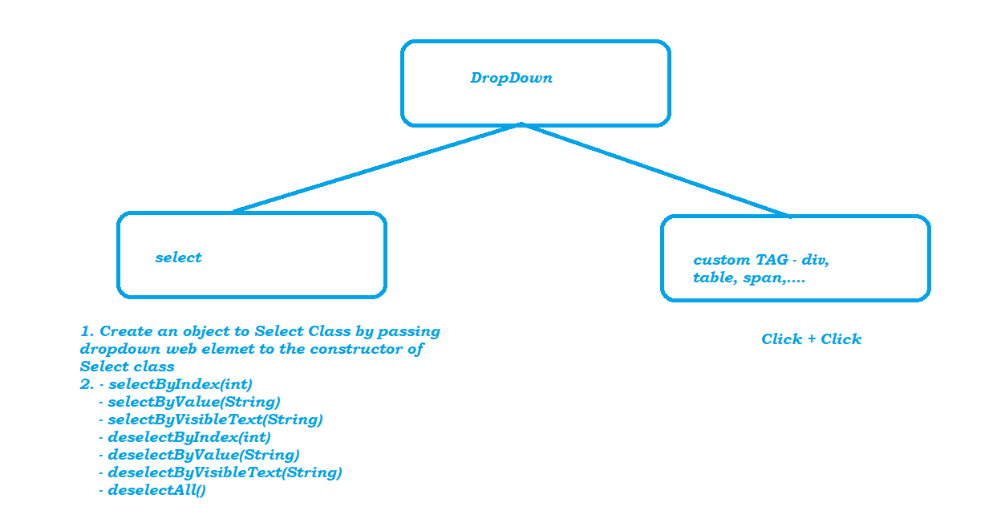

5. Browser Operations

* maximizing the browser
* clicking on back
* forward
* refresh
* navigate.to()

6. Automate End-End Test

* Execute the test case Manually couple of times
* Understand the data required to automate
* Identify the reusable functions
* Identify the places to keep validation statements
* Start with writing reusable functions
* Write a Test by calling the function written

7. Executing Test on a different Browser

* We downloaded the driver executable
* Before creating a Browser Object we set the executable path using System.setProperty(key, value)

OR

we can automate the above process by WebDriverManager

8. Actions

* Actions are used to perform exact keyboard and mouse movement operations

9. End To End Test – using driver reusable functions

10. Validations in Selenium

* isDisplayed()
* isEnabled()
* isSelected()
* getText()
* getTitle()
* getAttribute()

10. PopUps

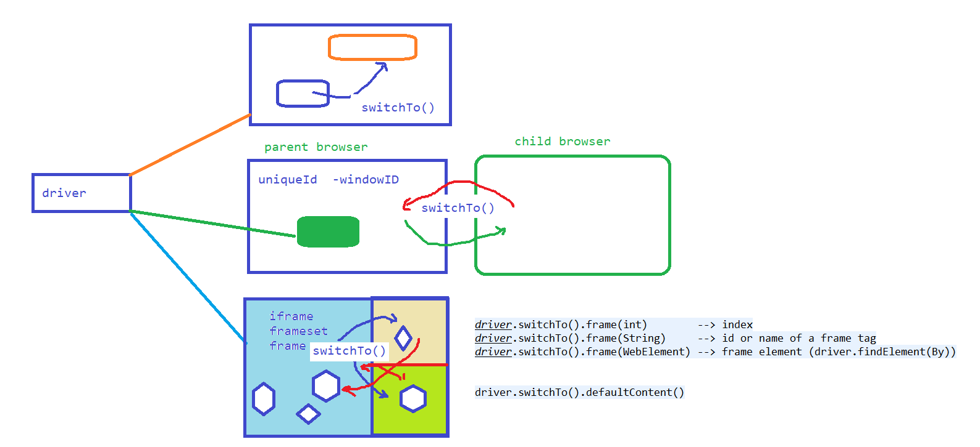

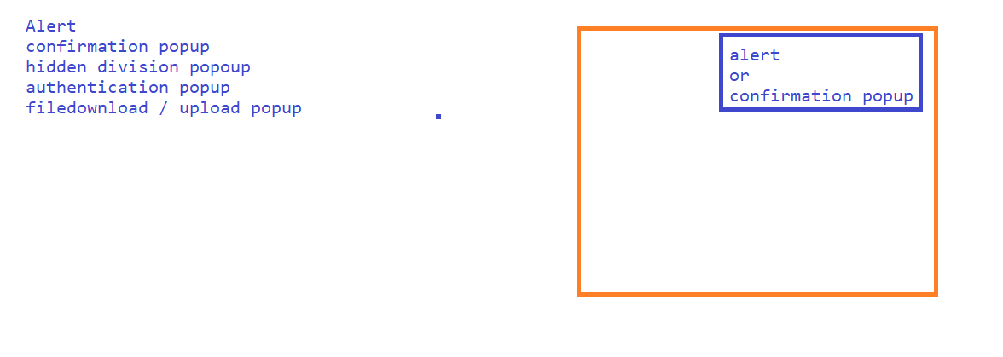

11. Data driven testing

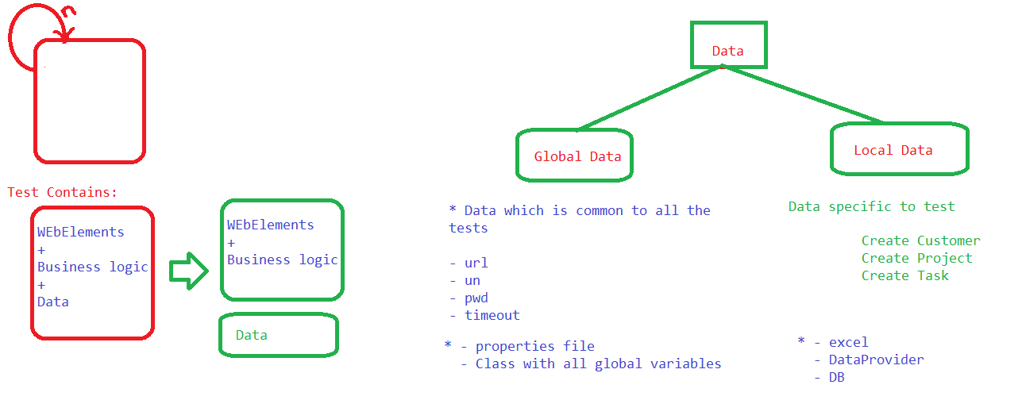

12. TestNG

Framework :

set of rules or guidelines which describes

*1. what is the test format*

*2. what are the logs that gets generated*

*3. what are the format of reports we support*

*4. How execution should happen*

*5. Post execution actions*

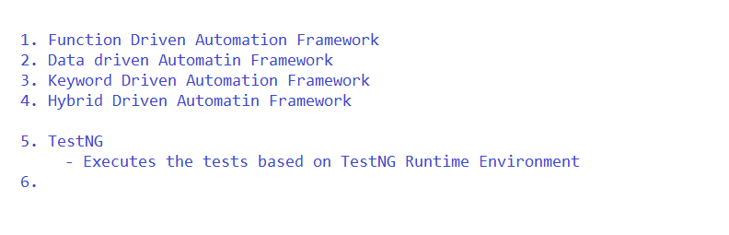

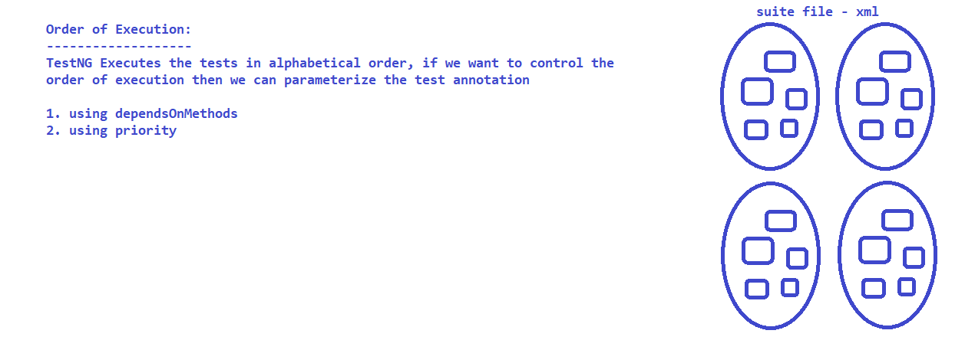

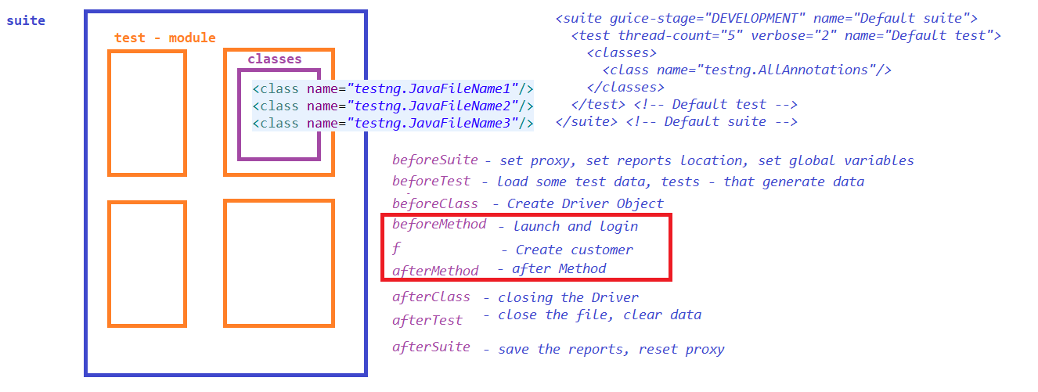

***Assert Statements in TestNG.***

***Soft Asserts in TestNG.***

***DataProvider***

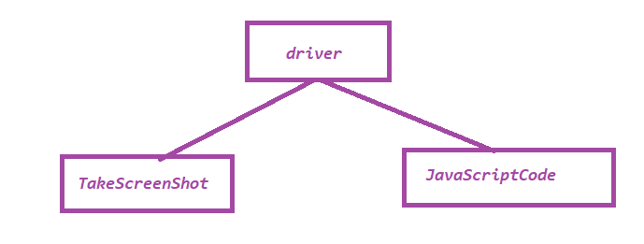

13. POM

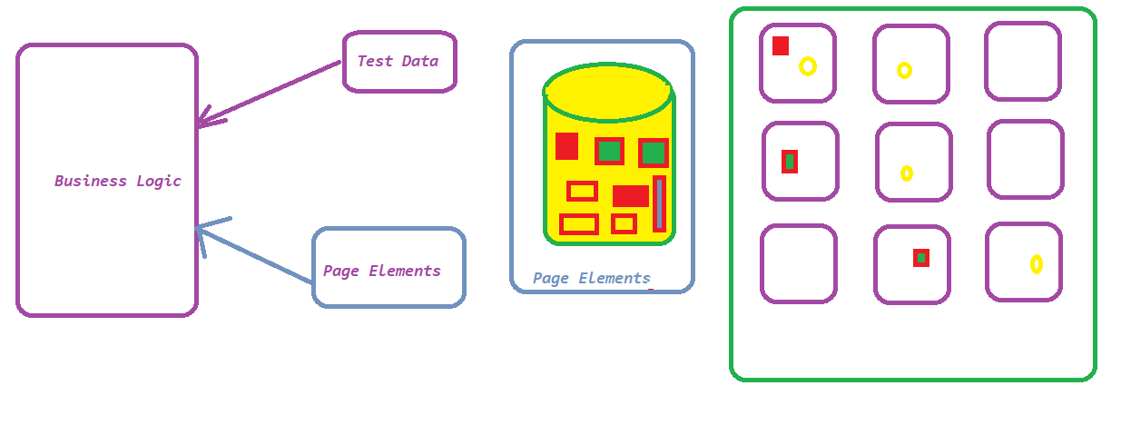

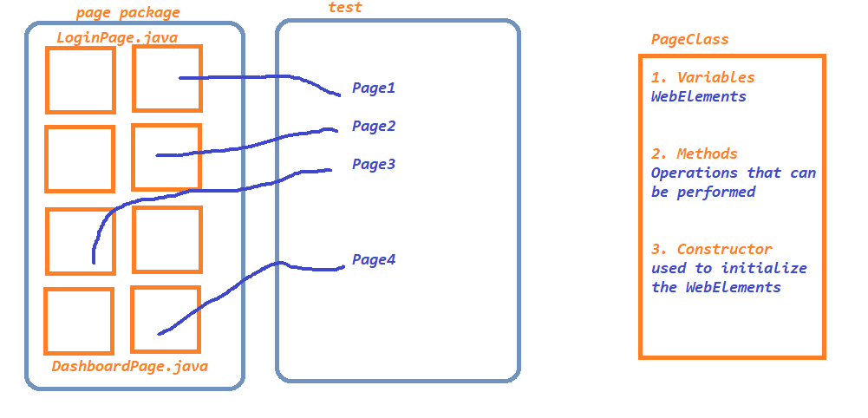

14. Selenium Grid

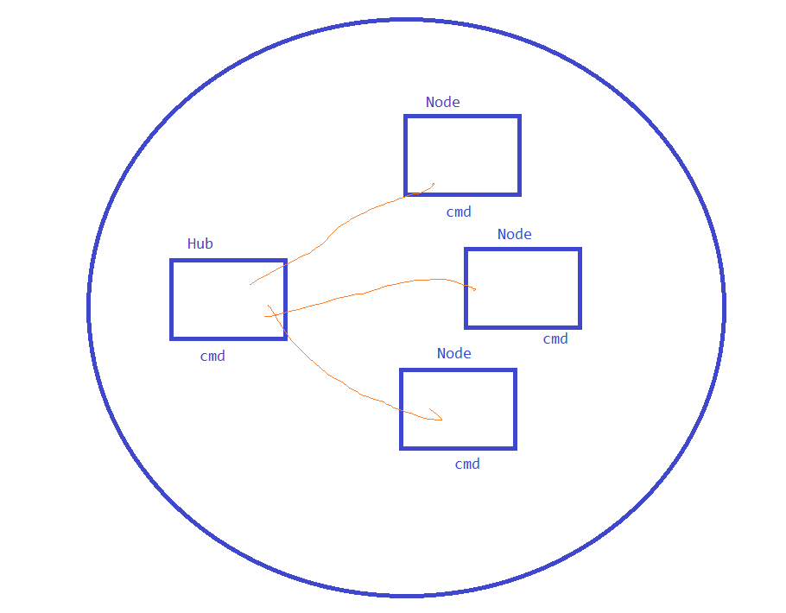

* Standalone
* Hub and Node
* Distributed

15. BDD-Cucumber

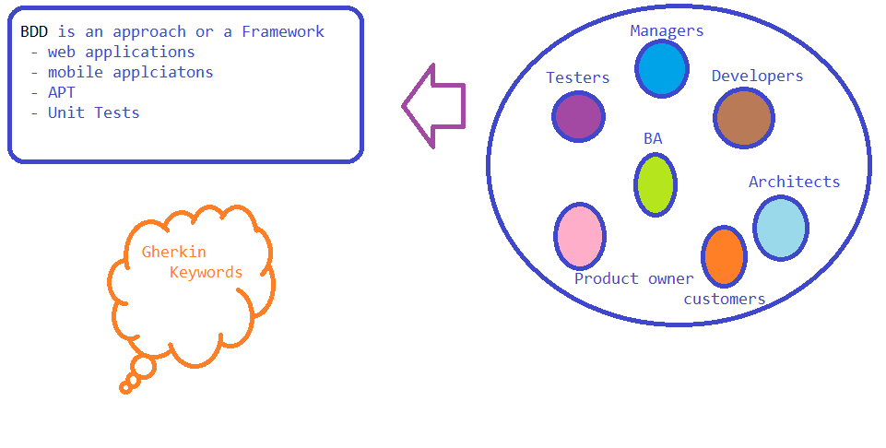

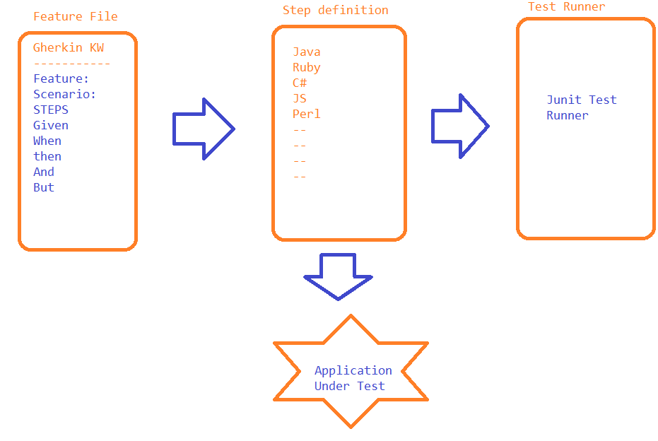

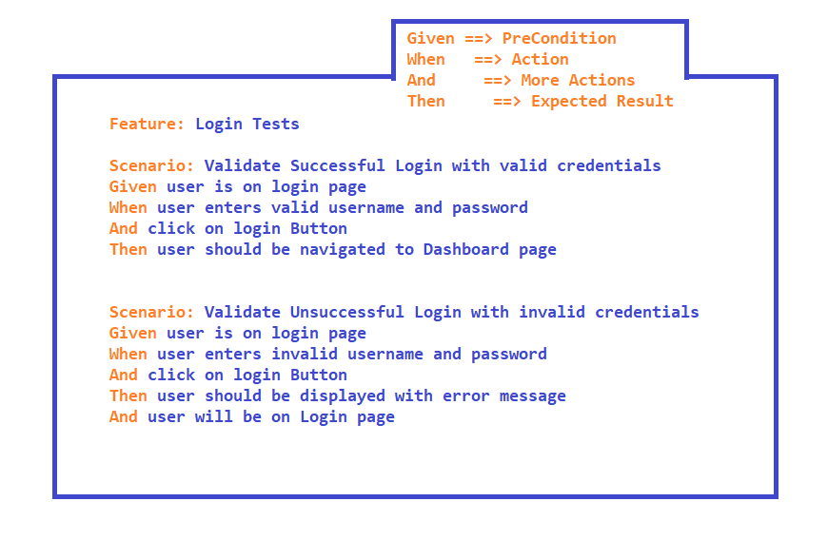

Cucumber project Setup

1. update pom.xml

<https://mvnrepository.com/artifact/io.cucumber/cucumber-java/7.2.3>

<https://mvnrepository.com/artifact/io.cucumber/cucumber-junit/7.2.3>

<https://mvnrepository.com/artifact/junit/junit/4.13.2>

2. Install cucumber plugin

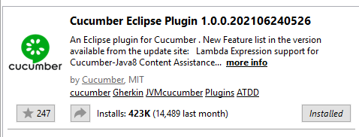

TAGS:

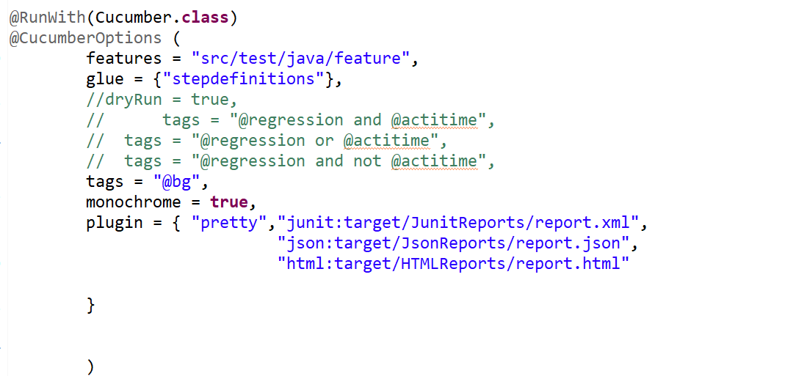

16. GIT – Jenkins

17. Selenium 4.0 Features

* Selenium libs uses W3C Standard
* Windows management
* Element Screenshot
* Open the application in new Tab or new Browser
* Relative locators
* Page loading strategy