Cavalry
User guide
A phased, gated, test-first program for auditing and fixing a Vercel-hosted project: from the first read-only audit to a signed-off production rollout.
Plugin version 0.2.0 · 26 September 2026
Skills: cavalry:recon · fortify · charge · regroup · breach · status

How to use this guide
This guide assumes Cavalry is already registered in Claude Code. It explains how to run a program on a real project, and what to do when something doesn't go to plan.
If you want to… | Read
Understand what Cavalry is and whether it fits | 1 What Cavalry is · 3 Core concepts
Start a program on a new project | 2 Requirements · 4 Getting ready · 5 Quick start
Know exactly what a phase will do and ask you | 6 Phase reference
Read or fix the tracker | 7 The tracker
Run a script by hand | 8 Script reference
Handle a specific situation (resume, overnight run, LIVE finding…) | 10 Recipes
Know the limits, or diagnose an error | 11 Edge cases and limits · 12 Troubleshooting

Contents
1 What Cavalry is
2 Requirements
3 Core concepts
4 Getting ready (before you run any phase)
5 Quick start
6 Phase reference: Pre-flight · Recon · Fortify · Charge · Regroup · Breach · Status
7 The tracker
8 Script reference
9 Working practices
10 Recipes
11 Edge cases and limits
12 Troubleshooting and FAQ
13 Glossary
Appendices: A tracker template · B Rally Point template · C Recon subagent brief · D PR Rollout example · E Version history

Conventions in this guide
- monospace is something you type, a file, or a value Cavalry writes.
- Dark blocks are terminal sessions. Every command and output in them was run for real against the 0.2.0 scripts; [exit N] shows the exit code.
- Figures marked animated play in Word on the desktop. Elsewhere (PDF, LibreOffice, Google Docs, Word on the web) you see their first frame, which is the complete diagram.
- "You" is the human running the program; "Claude" is the Claude Code session running the skill.

1 What Cavalry is
Cavalry is a family of Claude Code skills that runs a structured remediation program on a Vercel-hosted project: audit it, protect the risky parts with tests, fix what the audit found one item at a time, optionally restructure, and roll the result out to production, with you making every decision that matters.
It works with any frontend framework and any backend or database. The only constant is Vercel hosting; everything else (Next.js or Vite, Firebase or Postgres, Vitest or Jest) is detected, never assumed.

When to use it
- A codebase you inherited or haven't looked at closely, that needs an honest audit before you trust it.
- A list of security, data-integrity or money-handling problems that must be fixed without breaking what works.
- Work that will span many sessions or days, possibly on different machines, where you need to resume exactly where you left off.

When not to use it
- A single bug fix or a small feature: use Claude Code normally.
- A general code review: Cavalry skills only run when you invoke them by name.
- A project not hosted on Vercel: the phases assume Vercel deployment and preview behaviour.

The phases
Phase | Does | Produces
Pre-flight | Checks the environment once: access, identity, branches, protection, CI, live state | Tracker header; questions for anything risky
1 Recon | Read-only audit, module by module | Findings docs, decisions, the queue
2 Fortify | Pins current behaviour of risky code with tests; makes CI required | Characterization tests, shared mock, CI
3 Charge | Fixes queue items one at a time, test-first, each on its own branch | One PR per item
4 Regroup (optional) | Restructures files as a proven pure move | One PR per group of moves
5 Breach | Rolls out to production, one signed-off, verified step at a time | Runbook; production matches merged work
Status (any time) | Reports where the program stands | A read-only report
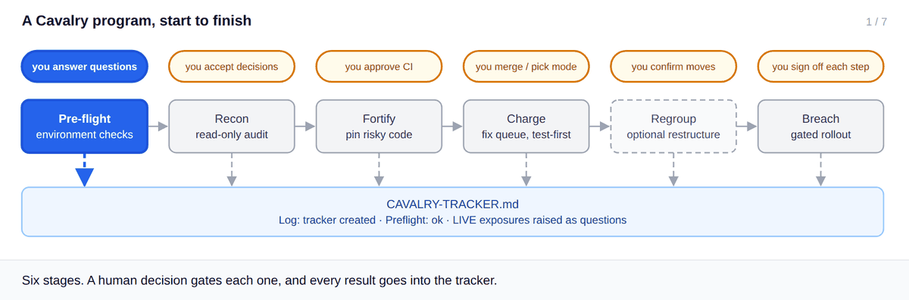
Figure 1 (animated in Word desktop). A program from pre-flight to Breach. Each phase has a human gate (amber), and every result is written to the tracker.

Three guarantees
- Nothing goes live without your go. No phase deploys, changes production configuration, or merges to your production branch on its own. In Breach, every single production step waits for its own explicit approval.
- Test first, always. Risky code is pinned by a characterization test before it changes, and every fix starts with a failing test.
- Resumable from the tracker alone. Everything needed to resume lives in a tracker file inside your project. A brand-new session on a different machine can pick up exactly where the last one stopped.

2 Requirements
Before starting a program, the machine and the project need the following. Chapter 4 turns these into a detailed checklist.
Requirement | Why
Claude Code with Cavalry registered | The cavalry:* skills must be available in your session.
A Vercel-hosted target project | The one constant Cavalry assumes.
git, with a GitHub remote | Every change is a branch and a PR; PR state is read from GitHub.
GitHub CLI gh, authenticated | Used for rulesets, required checks, PR state and Mode C. Without it status still works, minus PR state.
Node.js 20.10 or newer | The cavalry-* scripts are dependency-free Node programs.
A working local test setup (or willingness to add one) | Fortify and Charge run your real test gate.

3 Core concepts
Term | Meaning
Program | One end-to-end Cavalry run on one project, from Recon to Breach. It can span many sessions.
Tracker | A markdown file in your project (default CAVALRY-TRACKER.md) holding everything needed to resume. See chapter 7.
Finding | Something Recon verified in the code, written to a findings doc with an ID (e.g. FB-15).
Decision | A choice you made about a finding (fix now, defer, accept). Recorded under Resolved decisions.
Queue item | A unit of fix work with an ID (e.g. Q9), a one-line title, the files it touches, a Deploy value and dependencies.
Open question | Something only you can answer. Tagged with the phase and whether it blocks progress.
Backlog | Work found but deliberately not queued, recorded so it isn't lost.
Integration branch | Where fixes land first (usually staging). Mode C may merge here.
Production branch | What deploys to production (usually main). Only you promote to it.
Rally Point | A halt report written when a Charge run stops: what merged, what's pending, and what you must do next.
LIVE tag | Marks a critical finding that is exposed in production right now. It triggers an immediate stopgap question.
Verified: marker | How a finding was confirmed: read (code read), ran (executed), or unverified (inferred).

Deploy values
Every queue item declares what production needs beyond merging code, and in what order. The value travels with the item: into its PR's Rollout section, into Rally Points, and into Breach's runbook.
Value | Meaning | Example
code-only | Merging the code is the whole change | Fix a null check
rules-after-code | Backend rules must deploy after the code reaches production | New rules that expect a field the new code writes
rules-before-code | Backend rules must deploy before the code | Code that relies on a permission the rules add
console-config | A manual setting in a hosting or backend console | Turning off open sign-up
none | No production effect (docs, tests, tooling) | Add a CI workflow

Note Order matters for rules-after-code and rules-before-code: deploying rules at the wrong moment can break a live feature (for example, rejecting public form writes).

4 Getting ready (before you run any phase)
Cavalry's pre-flight checks the environment for you, but it can only report problems. It won't change repository settings on its own. Preparing these items first means pre-flight passes on the first run and the program never stalls on plumbing.
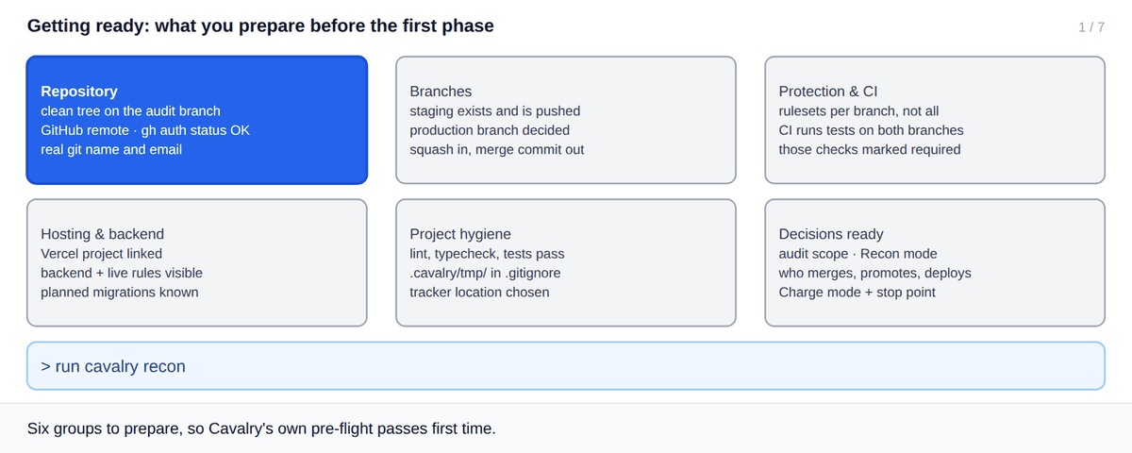
Figure 2 (animated in Word desktop). The six groups to prepare, ticked one by one, ending with the first prompt.

Repository
✓ | Item | How to check | Ready when
☐ | Clean working tree on the branch to audit | git status --short | Prints nothing
☐ | GitHub remote | git remote -v | origin points at github.com
☐ | GitHub CLI signed in | gh auth status | "Logged in to github.com"
☐ | Real git identity | git config user.name and git config user.email | Your real name and email (not "Your Name")

Branches
✓ | Item | How to check | Ready when
☐ | Integration branch exists and is pushed | git ls-remote --heads origin staging | One line is printed
☐ | Production branch decided | (decision) | Usually main
☐ | Merge methods allowed | gh api repos/{owner}/{repo} --jq "{squash: .allow_squash_merge, merge: .allow_merge_commit}" | Both true: squash into staging, merge commit into main

Protection and CI
✓ | Item | How to check | Ready when
☐ | Rulesets scoped per branch | gh api repos/{owner}/{repo}/rulesets | No ruleset targets all branches
☐ | CI runs the test gate on PRs to both branches | Open .github/workflows/* | pull_request covers staging and main
☐ | Those checks are required | gh api repos/{owner}/{repo}/branches/staging/protection (or the ruleset) | Your test job is listed as required

Watch out Mode C waits on required checks. If none are required, there is nothing for it to wait on, so fix this before choosing Mode C.

Hosting and backend
✓ | Item | How to check | Ready when
☐ | Vercel project linked | .vercel/project.json exists, or the Vercel dashboard | You know the project and its domains
☐ | Backend known, live rules visible | Your backend's console or CLI, read-only | You can see the rules/policies actually deployed
☐ | Planned changes known | (decision) | You know about any migration or environment split coming soon

Project hygiene
✓ | Item | How to check | Ready when
☐ | Gates run and pass locally | The lint, typecheck and test scripts in package.json | All pass on the audit branch
☐ | Scratch folder ignored | grep -n .cavalry/tmp .gitignore | One match
☐ | Tracker location chosen | (decision) | Default CAVALRY-TRACKER.md at the repo root, unless you prefer another path

Decisions to have ready
✓ | Item | How to check | Ready when
☐ | Audit scope | (decision) | Whole repo, or named modules or concerns
☐ | Recon mode | (decision) | Parallel (faster, more tokens) or sequential (cheaper)
☐ | Who may do what | (decision) | Who merges to staging, promotes to main, deploys
☐ | How Charge runs | (decision) | Mode A, B or C, and any stop point ("pause after Q5")

Ready to start open Claude Code in the project and type /cavalry:recon (or "run cavalry recon on this repo"). Recon begins with pre-flight.

5 Quick start
One program, condensed. The prompts are examples; any clear phrasing that names the phase works.
# | You type | What happens
1 | /cavalry:recon  "Audit the whole repo, parallel mode." | Pre-flight runs and reports in one block. Recon asks about anything with more than one reasonable answer, audits read-only, and asks your decisions in batches of four. It builds the queue with Deploy values.
2 | /cavalry:fortify | Confirms tests pass, adds characterization tests for risky paths and a shared backend mock, and makes CI required (a PR if CI is missing).
3 | /cavalry:charge  "Use Mode C: merge to staging yourself, pause after Q5." | Works through the queue: test-first, one branch and PR per item, merging to staging on green checks. It posts one line per merged item and stops at Q5 with a Rally Point.
4 | /cavalry:status | At any time: phase, queue progress with live PR state, blocking questions, and anything that needs you.
5 | /cavalry:charge again | In a new session it starts in Mode A. Say "Mode C" again if you want it.
6 | /cavalry:regroup (optional) | Proposes a move manifest, shows a dry run, applies it group by group, and proves each group is a pure move.
7 | /cavalry:breach | Reads what is live, builds the runbook (including the promotion to main) from the Deploy values, then waits for your go on every step.

Tip Run /cavalry:status whenever you come back to a program. It's read-only, costs very little, and tells you exactly what to do next.

6 Phase reference
Each phase follows the same layout: purpose, how to invoke it, what it needs, what it never does, the steps, and its edge cases.

6.1 Pre-flight
Purpose | Catch environment problems once, before any audit work, instead of mid-program.
Invoked by | Recon, automatically, at the start of a program. Charge re-runs it if the tracker header says Preflight: stale or not run.
Writes | Tracker header: Environment, Branch policy, Preflight: ok. Questions for anything risky.

# | Check | Why it matters
1 | Target & isolation: write and delete a probe file | A session locked to another worktree can't write, and neither can its subagents
2 | Git identity is real | Hosting can block deploys from placeholder authors
3 | Branch model (asks you) | Squash into integration, merge commit into production
4 | Rulesets and branch protection (read-only) | Rules on all branches and wrong merge methods cause plumbing PRs
5 | CI runs the full gate and is required | If not, Fortify's last PR adds it
6 | Gates really gate | A typecheck missing type packages "passes" while checking nothing
7 | Live state (asks or reads) | Critical findings live today get LIVE and a stopgap question
8 | Environments (asks) | Projects, IDs, domains; planned migrations
9 | Operating constraints | Sandbox limits, bots to ignore, who may merge, promote and deploy
10 | .cavalry/tmp/ in .gitignore | Helper scripts survive a session resume

Note Pre-flight recommends changes to repository settings but never applies them. Each recommendation becomes an open question for you.

Edge cases
Situation | What Cavalry does | What you do
Hosting or backend is migrated mid-program | Nothing automatic: the header is now wrong | Set Preflight to stale (cavalry-tracker set-header Preflight stale); Charge re-runs pre-flight
The session is isolated to a different worktree | The probe write fails | Switch the session into the target worktree before continuing
No required checks exist | Flagged under check 5 | Mark the test job required before using Mode C

6.2 Recon (Phase 1)
Purpose | A read-only audit that produces verified findings, your decisions, and the fix queue.
Invoke | /cavalry:recon, or "run cavalry recon", "start the Cavalry audit"
Needs | Nothing: it creates the tracker if none exists (and migrates a v1 tracker first).
Never | Changes code, deploys, or marks any phase but its own.

What it asks you
Only items with more than one reasonable answer, in one batch: which branch, what to do about uncommitted work, the scope, the backend, where findings docs live, and parallel or sequential mode.

What it does
- Runs pre-flight and records the results.
- Makes a quick pass to identify modules, then audits each one, either sequentially or by fanning out subagents.
- In parallel mode: one agent per module plus one agent that owns the authorization matrix, all sharing ids-registry.md, so the same bug isn't reported three times. Each agent writes its full doc to disk and returns at most 20 lines.
- Removes duplicates by root cause, and spot-verifies every critical finding by opening the cited lines itself.
- Checks that your quality gates actually cover the code in scope.
- Asks decisions in batches of up to four, each with a recommendation, and records them as they land.
- Turns accepted fixes into queue items, each with a Deploy value.

Outputs
- Findings docs, one per module, every finding marked Verified: read | ran | unverified.
- Resolved decisions, the queue, and open questions in the tracker.
- LIVE findings raised immediately as blocking questions.

Done when
Every module in scope is covered and you confirm there's nothing to add. Then set-phase 1 done.

Edge cases
Situation | What Cavalry does | What you do
A critical finding is live in production | Tags it LIVE and asks a stopgap question at once | Decide the stopgap now; don't wait for Breach
Something looks urgent enough to fix now | Says so and asks; never fixes it | Decide: fix in Charge first, or stopgap in the console
A claim can't be run, only read | Marks it Verified: read or unverified | Weigh unverified findings accordingly; Fortify may correct them
Existing findings from an earlier audit | Extends them instead of starting over | Point Recon at them if they aren't in docs/
Uncommitted work in the tree | Asks whether to stash, commit or proceed with it visible | Choose; it must not be mistaken for findings

6.3 Fortify (Phase 2)
Purpose | Pin down what risky code does now, so every later fix provably changes only what it meant to.
Invoke | /cavalry:fortify, or "run cavalry fortify"
Needs | Recon done, with decisions and a queue. If not, it warns and asks.
Never | Fixes bugs. It writes tests, test infrastructure and CI only.

What it does
- Detects the stack and test runner. If there is none, it picks one that fits and explains why.
- Confirms the existing tests pass before writing anything new.
- Creates one shared backend fake (e.g. tests/helpers/<backend>Mock.ts) that re-exports the real SDK's sentinel helpers, so a new helper later changes one file, not every mock.
- Identifies risky paths: money, auth, flagged bugs, irreversible writes, real user data.
- Writes characterization tests that pin current behaviour, including current bugs, named BUG <id> … flips in <Qn>.
- Corrects Recon findings that don't reproduce, on the record.
- Makes the gate automated: CI runs the full gate on PRs to both branches, and those checks are required. If CI is missing, its last PR adds it.

Edge cases
Situation | What Cavalry does | What you do
Recon isn't done | Warns plainly and asks whether to proceed | Proceed only if you mean to fortify an area Recon hasn't covered
The existing suite already fails | Stops before writing new tests | Fix or quarantine the failures first; tests on a broken suite prove nothing
A bug looks worth fixing right now | Says so and asks; doesn't fix it | Let Charge fix it test-first
A Recon finding doesn't reproduce | Updates the finding (Verified: ran) and the queue title | Review the correction
It can't mark checks as required | Raises an open question | Set required checks in GitHub yourself

6.4 Charge (Phase 3)
Purpose | Implement the queue one item at a time, test-first, each on its own branch and PR.
Invoke | /cavalry:charge, or "run cavalry charge", "resume charge"
Needs | Fortify done (otherwise it warns and asks); pre-flight not stale.
Never | Deploys, changes production config, writes to live data, or merges to production.

Before the first item: the coupling pass
For every queued item, Charge lists the files and APIs it will touch, then orders the queue so that producers come before consumers and items that share files sit next to each other. That way a later item never deletes code an earlier one just targeted. The order goes in the header as Queue order.

The per-item loop
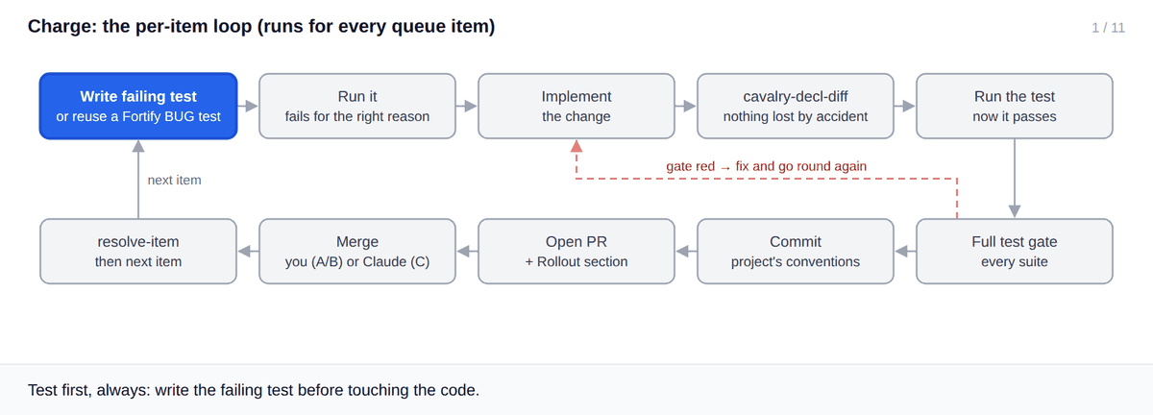
Figure 3 (animated in Word desktop). The per-item loop, including the red-gate path back to "Implement".

Choosing a mode
Mode | Say | Behaviour
A: strict-sequential (default) | Nothing: every run starts here | Opens a PR and waits for you to merge it before branching the next item
B: stacked | "continue without waiting", "keep going", "work through the rest" | Branches each item from the previous unmerged one; you merge in order
C: auto-merge to staging | Explicit permission to merge: "merge to staging yourself" or "use Mode C" | Waits once for required checks, merges to staging on green, fixes on red (2 attempts max), stops before main

Note Mode C only starts on explicit permission to merge. "Keep going" on its own doesn't say whether Charge may merge, so it asks whether you mean Mode B or Mode C. Ambiguity never resolves toward merging.
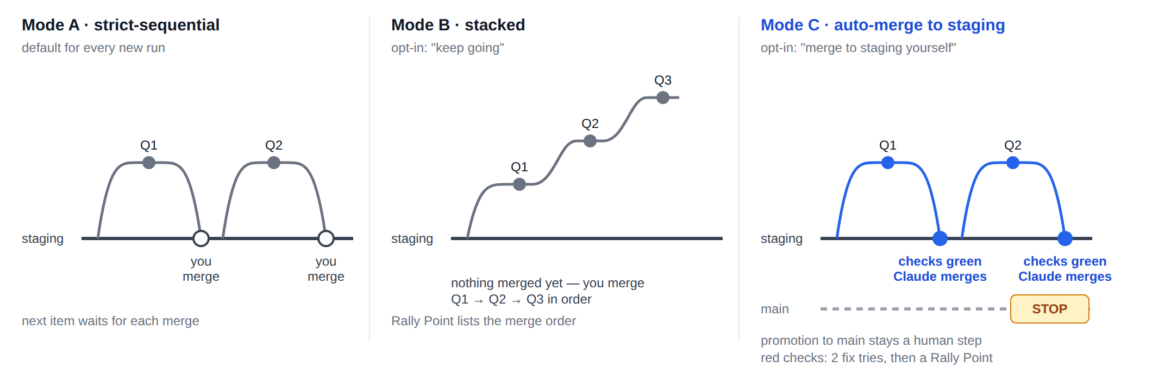
Figure 4. The three modes as branch graphs. Only Mode C merges by itself, and only into staging.
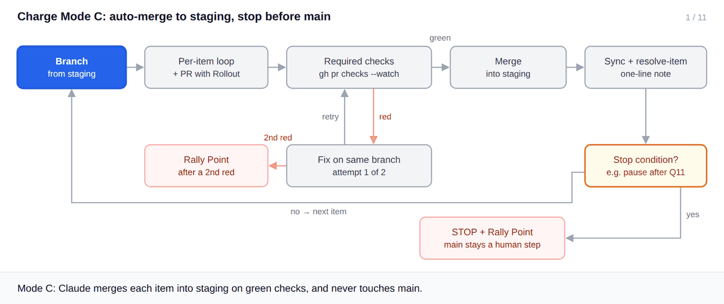
Figure 5 (animated in Word desktop). Mode C, including a red check, the fix, a green merge, the next item, and the stop condition.

Stop conditions and Rally Points
In Mode C you can set a stop condition: "pause after Q11", a time, or a count. You can also ask it to stop at any item whose Deploy isn't code-only/none, so you can review those. Whenever a Mode B or C run halts, Charge writes a Rally Point: what merged, what's pending, promotion readiness, and a ⚠️ block listing everything you must do, with production steps in Deploy order.

Edge cases
Situation | What Cavalry does | What you do
A new session starts | Always starts in Mode A, even if the log shows Mode C last time | Say "use Mode C" again
Required checks fail twice on one item | Stops and writes a Rally Point | Look at the failure; resume when it's fixed
No required checks exist | --watch --required has nothing to wait on | Mark checks required first (pre-flight flags this)
An item needs a production action | Does the code; records the action in Deploy for Breach | Nothing: Breach sequences it
You merged a PR by hand | cavalry-status shows drift and the exact fix command | Run the suggested cavalry-tracker resolve-item
Stop condition reached mid-queue | Finishes the current item, then halts with a Rally Point | Review, then resume
A scripted edit removes a function | cavalry-decl-diff exits 1 and names it | Restore it before running tests

6.5 Regroup (Phase 4, optional)
Purpose | Reorganize files and folders with zero behaviour change, proven per group.
Invoke | /cavalry:regroup, only when you want a restructure
Needs | A clean, up-to-date base; ideally mid-Charge or after.
Never | Changes logic. Anything that isn't a path or an import belongs in Charge.

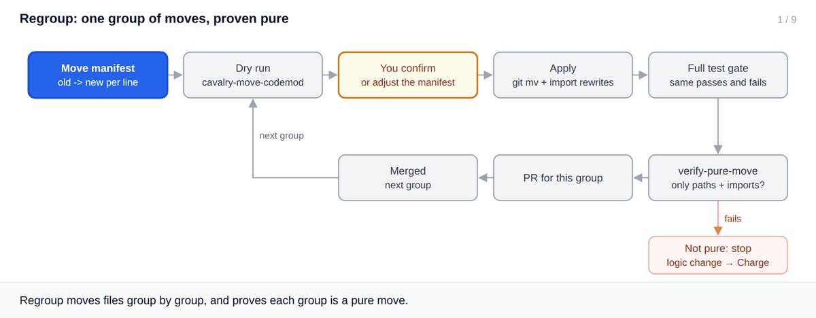
Figure 6 (animated in Word desktop). One group of moves: dry run, your confirmation, apply, test gate, pure-move proof, PR.
- Writes a manifest (old -> new per line; a directory line moves everything under it), placing every file the remaining queue will touch so no second regroup is needed.
- Dry run: cavalry-move-codemod <manifest> lists every move and import rewrite. Nothing changes.
- You confirm, or adjust the manifest.
- Apply: --apply moves the files with git mv and rewrites imports automatically.
- Runs the full test gate: the same tests must pass and fail as before.
- Runs cavalry-verify-pure-move, which fails if anything but paths and imports changed.
- Opens one PR per group, and waits for it to merge before starting the next group.

Edge cases
Situation | What Cavalry does | What you do
A group isn't a pure move | Stops and flags it | Move the logic change to Charge
Docs or config mention old paths | Not rewritten (only code imports are) | Update them in the same PR by hand
Destination already exists | Refuses (destination … already exists) | Pick another path or merge the files in Charge
You don't want a restructure | Nothing: Regroup never runs unless asked | Mark it skipped: cavalry-tracker set-phase 4 skipped

6.6 Breach (Phase 5)
Purpose | Take merged, tested work to production, one signed-off, verified step at a time.
Invoke | /cavalry:breach, once Charge (and Regroup, if used) is merged to staging
Needs | All queue work merged; you available to approve each step.
Never | Takes any production step without its own explicit go, even if earlier steps were approved.

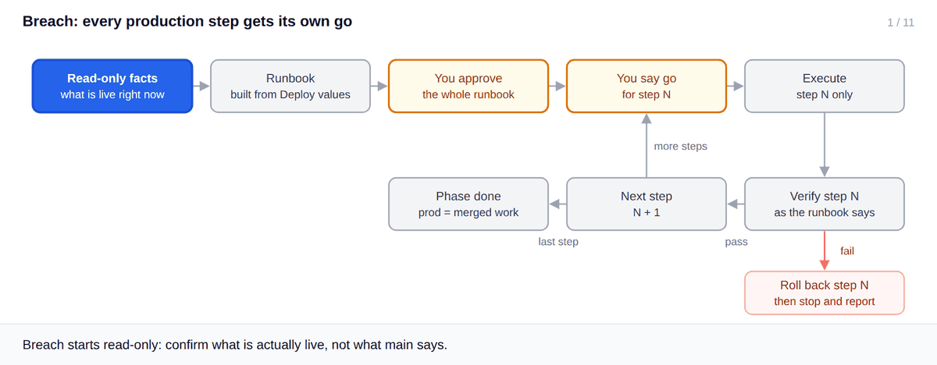
Figure 7 (animated in Word desktop). The runbook loop: a go per step, verify, next step; a failed verification rolls back only that step.
- Reads, read-only, what is actually live, and compares it with what the merged work introduces. It never assumes main equals production.
- Builds the runbook from the queue: every non-code-only item in the order its Deploy value demands, interleaved with the promotion (staging → main, merge commit).
- For each step: what it does, the check before it, how to verify it, and a rollback specific to that step.
- You approve the runbook, then say go before each production step.
- Executes one step, verifies it, and moves on. For rules-type backends, it runs an emulator test and then confirms the live ruleset is byte-identical to the repo.

Edge cases
Situation | What Cavalry does | What you do
A verification fails | Uses that step's rollback, then stops | Investigate; decide how to continue
Rollout paused partway | Records the real partial state; the phase stays in progress | Resume with /cavalry:breach
Production doesn't match main | Reports the difference before proposing anything | Decide whether to reconcile first
Tangential work found mid-rollout | Doesn't auto-add it to the backlog | Decide explicitly whether to record it

6.7 Status (any time)
Purpose | Tell you, or a fresh session, exactly where the program stands.
Invoke | /cavalry:status, or "cavalry status", "where are we in Cavalry"
Never | Writes anything, not even fixes for drift it finds.

It runs cavalry-status and then adds judgement: which attention item matters most, and the natural next step.
Real output (sample program; GitHub PR data stubbed)
$ cavalry-status
Cavalry status — Example Store (tracker: CAVALRY-TRACKER.md)

Current phase: 3 charge (in progress)

| Phase | Skill | Status | Started | Completed | Notes |
|---|---|---|---|---|---|
| 1 | recon | done | 2026-09-26 | 2026-09-26 | 6 modules, 2 LIVE criticals stop-gapped |
| 2 | fortify | done | 2026-09-26 | 2026-09-26 | auth, billing, forms pinned; CI required |
| 3 | charge | in progress | 2026-09-26 | — | Mode C, pause after Q11 |
| 4 | regroup | not started | — | — | |
| 5 | breach | not started | — | — | |

Resolved decisions: 1
Open questions: 1 (1 blocking)
Queue: 1/4 done (order: Q9 Q10 Q11 Q12)
Q10 Remove dead CSV exporter in progress code-only cavalry/q10-csv #28 MERGED → staging
Q11 Fix mailto link builder queued code-only —
Q12 Split | pipe in title queued none —
Backlog: 1 open

Needs attention:
- blocking question 1. [charge, blocking] Confirm the rules deploy window for Q9
- Q10: PR #28 is merged but tracker says "in progress" — run cavalry-tracker resolve-item Q10 28
[exit 0]

Edge cases
Situation | What Cavalry does | What you do
No tracker | Says no program has started (exit 0) | Start with Recon
gh missing or no remote | Prints "PR state unavailable (…)"; everything else works | Install or authenticate gh, or add the remote
v1 tracker | Fails with a migration hint | Run any phase skill; it migrates the tracker first

7 The tracker
The tracker is the program's memory. If a fact matters for resuming, it goes in the tracker, never only in chat.
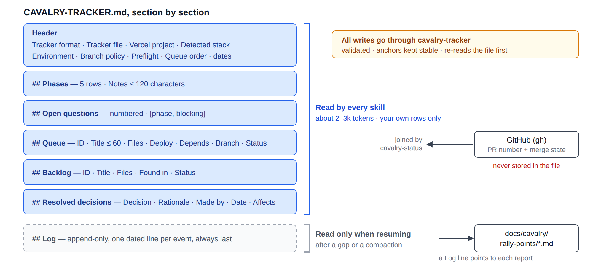
Figure 8. What each part of the tracker holds, which parts are read routinely, and what lives elsewhere.

Location
Always its own file, default CAVALRY-TRACKER.md at the repo root. Scripts look for it in this order: the --file <path> option, then the CAVALRY_TRACKER environment variable, then CAVALRY-TRACKER.md at the git root. If your project already has a planning doc, add a link to the tracker there rather than embedding it.

A real example
CAVALRY-TRACKER.md after part of a program (generated by the scripts)
# Cavalry Tracker — Example Store

- **Tracker format:** v2
- **Tracker file:** `CAVALRY-TRACKER.md`
- **Vercel project:** not yet confirmed
- **Detected stack:** frontend Next.js 14, backend Firebase (Firestore + Auth)
- **Environment:** prod = vercel:example-store / firebase:example-prod; staging = vercel:example-store (preview) / firebase:example-staging
- **Branch policy:** feature→staging squash; staging→main merge commit; required: test, typecheck
- **Preflight:** ok
- **Queue order:** Q9 Q10 Q11
- **Created:** 2026-09-26 by cavalry-tracker
- **Last updated:** 2026-09-26 by cavalry-tracker

## Phases

| Phase | Skill | Status | Started | Completed | Notes |
|---|---|---|---|---|---|
| 1 | recon | done | 2026-09-26 | 2026-09-26 | 6 modules, 2 LIVE criticals stop-gapped |
| 2 | fortify | done | 2026-09-26 | 2026-09-26 | auth, billing, forms pinned; CI required |
| 3 | charge | in progress | 2026-09-26 | — | Mode C, pause after Q11 |
| 4 | regroup | not started | — | — | |
| 5 | breach | not started | — | — | |

## Open questions

1. **[charge, blocking]** Confirm the rules deploy window for Q9

## Queue

| ID | Title | Files | Deploy | Depends | Branch | Status |
|---|---|---|---|---|---|---|
| Q9 | Lock public form writes to rules | firestore.rules,src/forms/submit.ts | rules-after-code | — | cavalry/q9-form-rules | done |
| Q10 | Remove dead CSV exporter | src/admin/export.ts | code-only | Q9 | cavalry/q10-csv | in progress |
| Q11 | Fix mailto link builder | src/email/BulkEmailModal.tsx | code-only | — | | queued |

## Backlog

| ID | Title | Files | Found in | Status |
|---|---|---|---|---|
| B4 | Audit-log gap on role changes | src/admin/roles.ts | charge | open |

## Resolved decisions

| Decision | Rationale | Made by | Date | Affects |
|---|---|---|---|---|
| Keep legacy /api/v1 during migration | Mobile app pinned to v1 until Q1 | human, via recon | 2026-09-26 | api/v1/** |

## Log

- 2026-09-26 tracker created
- 2026-09-26 phase 1 recon → done (6 modules, 2 LIVE criticals stop-gapped)
- 2026-09-26 phase 2 fortify → done (auth, billing, forms pinned; CI required)
- 2026-09-26 phase 3 charge → in progress (Mode C, pause after Q11)
- 2026-09-26 added Q9 (rules-after-code)
- 2026-09-26 added Q10 (code-only)
- 2026-09-26 added Q11 (code-only)
- 2026-09-26 Q9 → in progress
- 2026-09-26 Q9 merged #27
- 2026-09-26 Q10 → in progress
- 2026-09-26 answered question: **[fortify, non-blocking]** Is Vitest acceptable as the runner?
- 2026-09-26 Q10 CI green on attempt 2
- 2026-09-26 rally point → docs/cavalry/rally-points/2026-09-26-1.md

Field rules
Field | Rule
Phase status | not started, in progress, done, skipped (Regroup only)
Phase notes | At most 120 characters; anything longer goes to the Log
Item title | At most 60 characters; detail lives in the findings doc
Item status | queued, in progress, done, deferred, dropped. Rows are never deleted
Deploy | code-only, rules-after-code, rules-before-code, console-config, none
PR / merge state | Never stored. cavalry-status derives it from GitHub
Log | Always last, append-only, one dated line per event

The reading rule
A skill reads the header, Phases, Open questions and its own queue or backlog rows, never the whole file just for a status line. The Log is read only when resuming after a gap.

Inserting work mid-program
- Give it an ID and cavalry-tracker add-item it with a Deploy value.
- Record who asked and why with add-decision.
- Update Queue order with its position (set-header "Queue order" …) and log it.
- Charge treats it like any other item.

Migrating a v1 tracker
A tracker without Tracker format: v2 is v1 (from plugin 0.1.0). The first phase skill that meets one migrates it before doing anything else: it archives the old file to docs/cavalry/tracker-v1-archive.md, rebuilds the file in v2 format, logs the migration, and confirms with you in one line.

8 Script reference
Five scripts live in the plugin's bin/ folder (two levels above any skill's base directory). Skills call them for you; you can also run them by hand from the target repo. They need Node.js 20.10 or newer and have no dependencies. All of them print errors to stderr and exit non-zero on failure.

cavalry-tracker
Synopsis
cavalry-tracker [--file <path>] [--by <skill>] <command> ...

Command | Effect
init <project> | Create a v2 tracker (refuses if one exists)
set-header <field> <value> | Set or add a header field
set-phase <n> <status> [note] | Update a phase; sets Started/Completed dates; logs it
add-item <id> <title> --deploy <d> [--files] [--depends] [--branch] | Add a queue item; appends to Queue order
set-item <id> <column>=<value> … | Update queue columns; logs status changes
resolve-item <id> <pr> | Mark done and log "merged #pr"
add-backlog <id> <title> [--files] [--found-in] | Record deferred work
add-decision <decision> <rationale> <made by> <affects> | Record a decision (dated today)
add-question <phase> <blocking|non-blocking> <text> | Add a numbered open question
answer-question <n> | Remove it, renumber the rest, and log the answer
log <text> | Append a dated Log line
rally-point <file> | Copy a report to docs/cavalry/rally-points/<date>-<n>.md and log a pointer

--by sets the "Last updated … by" field (default cavalry-tracker). Successful commands print nothing; check the file, or run cavalry-status.
$ cavalry-tracker add-item Q9 "Lock public form writes to rules" --files firestore.rules,src/forms/submit.ts --deploy rules-after-code --by cavalry:recon
[exit 0]

$ cavalry-tracker rally-point rally.md
[exit 0]

A rejected value: nothing is written
$ cavalry-tracker set-phase 3 "in progress" "Working through the queue in Mode C after the human asked to merge to staging and pause after Q11 while they are away tonight"
cavalry-tracker: note is 125 chars; the cap is 120 — put the rest in the log
[exit 2]

Exit code | Meaning
0 | Written
2 | Rejected or not found; nothing changed (message on stderr)

cavalry-status
Synopsis
cavalry-status [--file <path>]

Read-only. The report always comes in the same order: current phase, phase table, decision and question counts, unfinished queue items with live PR state, open backlog count, Needs attention. It exits 0 even when there is no tracker.
Without gh: everything but PR state
$ cavalry-status # gh not installed
Cavalry status — Example Store (tracker: CAVALRY-TRACKER.md)

Current phase: 3 charge (in progress)

| Phase | Skill | Status | Started | Completed | Notes |
|---|---|---|---|---|---|
| 1 | recon | done | 2026-09-26 | 2026-09-26 | 6 modules, 2 LIVE criticals stop-gapped |
| 2 | fortify | done | 2026-09-26 | 2026-09-26 | auth, billing, forms pinned; CI required |
| 3 | charge | in progress | 2026-09-26 | — | Mode C, pause after Q11 |
| 4 | regroup | not started | — | — | |
| 5 | breach | not started | — | — | |

Resolved decisions: 1
Open questions: 1 (1 blocking)
Queue: 1/4 done (order: Q9 Q10 Q11 Q12)
Q10 Remove dead CSV exporter in progress code-only cavalry/q10-csv
Q11 Fix mailto link builder queued code-only —
Q12 Split | pipe in title queued none —
PR state unavailable (gh not installed)
Backlog: 1 open

Needs attention:
- blocking question 1. [charge, blocking] Confirm the rules deploy window for Q9
[exit 0]

cavalry-decl-diff
Synopsis
cavalry-decl-diff <file> [ref=HEAD]

Compares a file's top-level JavaScript/TypeScript declarations at a git ref with the working tree. Run it after any scripted or multi-line edit, before tests.
$ cavalry-decl-diff src/BulkEmailModal.tsx
removed: handleReset
removed: mailtoUrl
added: sendBatch
4 declarations, 2 removed — check this was intended before running tests
[exit 1]

Exit code | Meaning
0 | Nothing removed
1 | One or more declarations removed
2 | Unsupported file type or missing file

cavalry-move-codemod
Synopsis
cavalry-move-codemod <manifest> [--apply]

The manifest has one old -> new per line; # comments and blank lines are ignored, and a directory line moves every tracked file under it. It's a dry run unless you pass --apply, which moves the files with git mv, rewrites the imports, and stages everything. It rewrites relative imports, tsconfig/jsconfig wildcard path aliases, dynamic import(), require() and vi/jest.mock() specifiers, including the moved file's own relative imports.
$ cavalry-move-codemod moves-1.txt
move src/applications.ts -> src/features/applications/api.ts
rewrite
src/Page.test.ts: '@/applications' -> '@/features/applications/api'
src/Page.test.ts: '@/applications' -> '@/features/applications/api'
src/Page.tsx: './applications' -> './features/applications/api'
src/Page.tsx: './applications' -> './features/applications/api'
src/applications.ts: './applications.css' -> '../../applications.css'
1 moves, 5 import rewrites in 3 files (dry run — nothing changed; pass --apply to perform)
[exit 0]

After --apply
$ cat src/features/applications/api.ts src/Page.tsx src/Page.test.ts
--- src/features/applications/api.ts
import { db } from '@/lib/firebase';
import '../../applications.css';
export const list = () => db;
--- src/Page.tsx
import { list } from './features/applications/api';
const lazy = () => import('./features/applications/api');
export const Page = list;
--- src/Page.test.ts
import { list } from '@/features/applications/api';
vi.mock('@/features/applications/api');
export const t = list;
[exit 0]

cavalry-verify-pure-move
Synopsis
cavalry-verify-pure-move [base-ref=HEAD]

Passes only if every change against the base is a rename or an import-line edit. Small moved files are paired by content (ignoring import lines), so they don't depend on git's rename-similarity threshold.
$ cavalry-verify-pure-move
pure move against HEAD: 1 renamed, 2 modified (import lines only)
[exit 0]

$ cavalry-verify-pure-move
NOT a pure move against HEAD — 3 problem(s):
src/extra.ts: added
src/checkout.ts: -export const go = submit;
src/checkout.ts: +export const go = submit * 2;
Anything beyond paths and imports belongs in Charge, not Regroup.
[exit 1]

9 Working practices
Every skill follows these practices. The reasons come from a real 1,560-turn program, where cost scaled with turns × context.
Practice | Why
One simple command per shell call; put multi-step logic in a script under .cavalry/tmp/ | Sandboxes reject complex compound commands, and every rejection costs a retry turn
Keep helper scripts in .cavalry/tmp/, never in the session scratchpad | The scratchpad can be wiped on resume
Use targeted edits, not sed -i or whole-file rewrites, on files over ~300 lines | A rewritten file is re-read in full, costing 10–20k tokens each time
Run cavalry-decl-diff after scripted edits | Block replacements have silently deleted neighbouring functions
Act only on required-check results and human reviews; ignore bot deployment comments | Bot comments caused most no-op wake-ups
Wait once with gh pr checks --watch --required | One blocking wait replaces many polls
Read only your own tracker sections; write through cavalry-tracker | Keeps standing context small and anchors stable
Subagents write full output to disk and return ≤20 lines | Stops raw reports from flooding the main session
On long unattended runs, post one line per merged item | You come back to a short summary, not silence or a transcript

10 Recipes

Resume in a new session or on another machine
- Open Claude Code in the project and run /cavalry:status.
- Clear any drift it reports (it prints the exact resolve-item command).
- Invoke the phase it points to. Charge restarts in Mode A, so name the mode again if you want B or C.

Unattended overnight run
- Check that required checks exist (chapter 4).
- Say: "use Mode C, merge to staging yourself, pause after Q11, and stop at anything that isn't code-only."
- Next morning, read the Rally Point (docs/cavalry/rally-points/) and run /cavalry:status.

A LIVE finding appears
- Recon raises it as a blocking question with a proposed stopgap.
- Apply the stopgap yourself (usually a console setting or a rules change), or ask for a dedicated first queue item.
- Record the decision; the finding stays in the queue for a proper fix.

Add scope mid-program
- Tell Charge what to add and where in the order.
- It adds the item with a Deploy value, records who asked, updates Queue order, and logs it.

Restructure mid-Charge
- Pause Charge at a clean point, with everything merged.
- Run /cavalry:regroup. It reads the remaining queue and places those files in the new layout.
- Resume Charge. Queue Files columns are updated to the new paths.

Promote and roll out
- Make sure everything you want is merged to staging.
- Run /cavalry:breach. The runbook includes the promotion PR (merge commit) and every production step in order.
- Approve the runbook, then give a go for each step.

Skip Regroup
Do nothing. Regroup never runs unless you ask, and skipping it is a complete, normal way to finish. Mark it with cavalry-tracker set-phase 4 skipped if you want the tracker to say so.

11 Edge cases and limits
What Cavalry does in unusual situations, and the honest limits of its scripts. Where a script is involved, the output shown is real.

Program flow
Situation | What Cavalry does | What you do
A phase is invoked before the previous one is done | Warns plainly and asks whether to proceed | Proceed only with a reason; the tracker records it
Pre-flight goes stale (migration, new CI, new branch policy) | Charge re-runs pre-flight when the header says stale | cavalry-tracker set-header Preflight stale
A new session | Charge always starts in Mode A | Name the mode again
A queue item needs a production action | The action goes into Deploy; Breach does it | Nothing
A bug worth fixing right now (Recon or Fortify) | Says so and asks; never fixes it | Route it through Charge
A critical exposure is live | Tagged LIVE, immediate stopgap question | Answer now

Charge and Mode C
Situation | What Cavalry does | What you do
Checks red twice on one item | Halts with a Rally Point | Investigate the failure
No required checks configured | Nothing to wait on; pre-flight flags it | Make the test job required
"Keep going" on its own | Asks whether you mean Mode B or Mode C before starting | Say "use Mode C" if you want it to merge
A stop condition is reached | Finishes the item, then halts with a Rally Point | Review and resume
An item isn't code-only and you asked to review those | Stops before starting it | Review, then resume
A PR was merged outside Cavalry | Status flags drift | Run the printed resolve-item

Drift detected (last line of Needs attention)
$ cavalry-status
Cavalry status — Example Store (tracker: CAVALRY-TRACKER.md)

Current phase: 3 charge (in progress)

| Phase | Skill | Status | Started | Completed | Notes |
|---|---|---|---|---|---|
| 1 | recon | done | 2026-09-26 | 2026-09-26 | 6 modules, 2 LIVE criticals stop-gapped |
| 2 | fortify | done | 2026-09-26 | 2026-09-26 | auth, billing, forms pinned; CI required |
| 3 | charge | in progress | 2026-09-26 | — | Mode C, pause after Q11 |
| 4 | regroup | not started | — | — | |
| 5 | breach | not started | — | — | |

Resolved decisions: 1
Open questions: 1 (1 blocking)
Queue: 1/4 done (order: Q9 Q10 Q11 Q12)
Q10 Remove dead CSV exporter in progress code-only cavalry/q10-csv #28 MERGED → staging
Q11 Fix mailto link builder queued code-only —
Q12 Split | pipe in title queued none —
Backlog: 1 open

Needs attention:
- blocking question 1. [charge, blocking] Confirm the rules deploy window for Q9
- Q10: PR #28 is merged but tracker says "in progress" — run cavalry-tracker resolve-item Q10 28
[exit 0]

Tracker
Situation | What Cavalry does | What you do
No tracker | Scripts refuse to write; status says no program started | Start with Recon, or cavalry-tracker init
v1 tracker | Scripts refuse with a migration hint | Run a phase skill; it migrates the tracker first
Tracker at a non-default path | Found via --file or CAVALRY_TRACKER | Record the path in the header (automatic with init --file)
A hand-edit breaks a section heading | Scripts refuse ("has no ## … section") | Restore the exact heading
Two sessions write at once | Each command re-reads right before writing; the last write wins per command | Avoid parallel writers; git shows any clash
A title contains | | Escaped as \| so the table stays intact | Nothing
Dates | Use the machine's local timezone | Nothing

$ cavalry-tracker log hello
cavalry-tracker: No tracker at /path/to/repo/CAVALRY-TRACKER.md. Run `cavalry-tracker init <project>` or pass --file.
[exit 2]

$ cavalry-tracker add-item Q1 Anything --deploy none
cavalry-tracker: tracker has no "## Queue" section — is it a v2 tracker? (see TRACKER-CONVENTION.md § Migrating)
[exit 2]

$ cavalry-tracker add-item Q9 Again --deploy none
cavalry-tracker: queue item Q9 already exists
[exit 2]

$ cavalry-tracker add-item Q12 "Rewrite the entire notification pipeline to use the new queue service" --deploy code-only
cavalry-tracker: title is 69 chars; the cap is 60 — put detail in the findings doc
[exit 2]

$ cavalry-tracker add-item Q12 "Short title" --deploy later
cavalry-tracker: --deploy must be one of: code-only, rules-after-code, rules-before-code, console-config, none
[exit 2]

$ cavalry-tracker set-item Q10 owner=alex
cavalry-tracker: unknown column "owner" (columns: Title, Files, Deploy, Depends, Branch, Status)
[exit 2]

A title containing | is stored escaped
| Q12 | Split \| pipe in title | — | none | — | | queued |

GitHub state
Situation | What Cavalry does | What you do
gh not installed | Prints "PR state unavailable (gh not installed)" | Install gh for PR state and drift
Repo has no remote | Prints "PR state unavailable (no git remotes found)" | Add the GitHub remote
Several PRs on one branch | Uses the highest-numbered PR | Close stale PRs to avoid confusion
PR closed without merging | Shows CLOSED; not treated as done | Reopen, or set the item deferred/dropped
Branch renamed after the PR opened | No PR match for the tracker's branch | set-item <id> branch=<new name>

$ cavalry-status # branch has #30 (closed) and #31 (open)
Q10 Remove dead CSV exporter in progress code-only cavalry/q10-csv #31 OPEN → staging
[exit 0]

$ cavalry-status # PR closed without merging
Q10 Remove dead CSV exporter in progress code-only cavalry/q10-csv #32 CLOSED → staging
[exit 0]

Script limits

cavalry-decl-diff
- JavaScript and TypeScript only (.js .jsx .ts .tsx .mjs .cjs .mts .cts); anything else exits 2.
- Top-level declarations only. Removed class methods and removed names in an export { a, b } list are not detected.
- In const a = 1, b = 2 only the first name is tracked.
- A file that doesn't exist at the ref is treated as entirely added.
A class method and an export-list entry were removed: not detected
$ cavalry-decl-diff src/BulkEmailModal.tsx
5 declarations, none removed
[exit 0]

$ cavalry-decl-diff src/app.css
cavalry-decl-diff: unsupported extension .css; supported: .js .jsx .ts .tsx .mjs .cjs .mts .cts
[exit 2]

cavalry-move-codemod
- Rewrites imports in JS/TS (and .vue, .svelte, .astro) files, including imports of tracked non-code files such as CSS.
- Does not rewrite references in files it doesn't parse: docs, config files, CSS @import or url(). Fix those by hand in the same PR.
- Only wildcard paths aliases ("@/*") are understood; exact-match aliases are ignored.
- Refuses if a destination exists, a source isn't tracked by git, or a manifest line isn't old -> new.
$ grep -n applications README.md # non-code references are left alone
1:See src/applications.ts for the list API.
[exit 0]

$ cavalry-move-codemod moves-3.txt --apply
cavalry-move-codemod: destination src/lib/firebase.ts already exists
[exit 2]

$ cavalry-move-codemod moves-4.txt
cavalry-move-codemod: src/ghost.ts is not a tracked file or directory
[exit 2]

$ cavalry-move-codemod moves-5.txt
cavalry-move-codemod: bad manifest line "src/checkout.ts => src/lib/checkout.ts" — expected "old -> new"
[exit 2]

cavalry-verify-pure-move
- A heuristic: a changed line passes if it looks like an import. An import line that also gains logic (e.g. .then(…) on a dynamic import) passes. The full test gate and your review still matter.
- Added or deleted files fail, unless they pair up by content as a move.
A dynamic import that gained .then(…) still passes
$ cavalry-verify-pure-move
pure move against HEAD: 2 renamed, 2 modified (import lines only)
[exit 0]

Breach
Situation | What Cavalry does | What you do
A step's verification fails | Rolls back that step only, then stops | Decide before continuing
Paused partway | Phase stays in progress with the real state recorded | Resume later
Production differs from main | Reports it before proposing a runbook | Reconcile first if needed

Environment
Situation | What Cavalry does | What you do
The sandbox rejects a compound command | Skills keep to one simple command per call | If it happens, logic moves into a .cavalry/tmp/ script
The session scratchpad is wiped on resume | Helpers live in .cavalry/tmp/; state lives in the tracker | Nothing
Skill changes don't take effect | Claude Code caches skill content | Re-register the plugin with /plugin

12 Troubleshooting and FAQ
You see | Cause | Fix
No tracker at … | No tracker in the git root, or it's elsewhere | Run Recon, init, or pass --file / set CAVALRY_TRACKER
tracker has no "## Queue" section | A v1 tracker, or a broken heading | Run a phase skill to migrate, or restore the heading
PR state unavailable (…) | gh missing, not signed in, or no remote | gh auth status; add the remote
removed: <name> from decl-diff (exit 1) | An edit deleted a declaration | Restore it unless intended
decl-diff exit 2 | Unsupported file type | Only JS/TS files are checked
destination … already exists | Manifest target is taken | Change the target path
… is not a tracked file or directory | Typo, or the file isn't committed | Fix the path, or commit the file first
NOT a pure move | Logic or added/deleted files in a Regroup group | Move that change to Charge
note is N chars; the cap is 120 | Phase note too long | Shorten it; put detail in log
title is N chars; the cap is 60 | Item title too long | Shorten it; detail goes in the findings doc
Charge waits for you even though you said Mode C last time | Every new run starts in Mode A | Say "use Mode C" again
Mode C merges without waiting for tests | No required checks configured | Make the test job required
Skill behaviour didn't change after editing the plugin | Cached skill content | Re-register with /plugin

FAQ
- Can Cavalry deploy for me? Only in Breach, and only one step at a time after your explicit go for that step.
- Can I edit the tracker by hand? Yes. Keep the exact section headings and the one-line rows. Scripts re-read the file before every write.
- Can two people run phases at once? Technically yes, but avoid concurrent writers. Each write re-reads the file, but simultaneous edits can still clash, and git will show it.
- Does it work without GitHub? Only partly. Status works without PR state; Mode C, rulesets and required checks need GitHub and gh.
- Where do findings docs go? Wherever your project keeps docs. Recon proposes a location (e.g. docs/cavalry/findings/) if you have none.

13 Glossary
Term | Definition
Characterization test | A test that pins what code does now (including bugs), so a later fix provably changes only what it meant to
Coupling pass | Charge's ordering of the queue so producers precede consumers and shared-file items sit together
Deploy value | Per-item declaration of the production steps needed beyond merging code
Drift | The tracker says an item is unfinished but its PR is already merged
Gate | The project's full set of checks: lint, typecheck, every test suite
Integration branch | The branch fixes merge into first (usually staging)
LIVE | A critical finding exposed in production today
Mode A / B / C | Charge's branch modes: wait for you / stacked / auto-merge to staging
Pre-flight | The one-time environment check Recon runs first
Production branch | The branch that deploys to production (usually main)
Promotion | Merging the integration branch into the production branch (a merge commit)
Pure move | A change consisting only of file renames and import-path edits
Queue | The ordered list of fix work, one line per item
Rally Point | A halt report: what merged, what's pending, what you must do next
Rollout section | The part of a PR body that states the item's Deploy value and production order
Runbook | Breach's ordered production steps, each with a check, a verification and a rollback
Tracker | The program's memory file inside your project

Appendix A: Tracker template
What cavalry-tracker init "Example Store" creates:
# Cavalry Tracker — Example Store

- **Tracker format:** v2
- **Tracker file:** `CAVALRY-TRACKER.md`
- **Vercel project:** not yet confirmed
- **Detected stack:** not yet detected
- **Environment:** not yet recorded (pre-flight)
- **Branch policy:** not yet recorded (pre-flight)
- **Preflight:** not run
- **Queue order:** —
- **Created:** 2026-09-26 by cavalry-tracker
- **Last updated:** 2026-09-26 by cavalry-tracker

## Phases

| Phase | Skill | Status | Started | Completed | Notes |
|---|---|---|---|---|---|
| 1 | recon | not started | — | — | |
| 2 | fortify | not started | — | — | |
| 3 | charge | not started | — | — | |
| 4 | regroup | not started | — | — | |
| 5 | breach | not started | — | — | |

## Open questions

## Queue

| ID | Title | Files | Deploy | Depends | Branch | Status |
|---|---|---|---|---|---|---|

## Backlog

| ID | Title | Files | Found in | Status |
|---|---|---|---|---|

## Resolved decisions

| Decision | Rationale | Made by | Date | Affects |
|---|---|---|---|---|

## Log

- 2026-09-26 tracker created

Appendix B: Rally Point template
## Rally Point — <date/time>

**This run:** <one or two sentences>

**Items:** Q9 merged (#27), Q10 merged (#28), Q11 open (#29) — from cavalry-status

**Promotion:** staging is 3 items ahead of main; promotion PR not yet opened.

⚠️ **Before moving on:**
- Promote staging → main with a merge commit (not squash).
- Then, in order: deploy Q9 rules (rules-after-code).

A clean run replaces the ⚠️ block with "nothing pending — clear to proceed". Store it with cavalry-tracker rally-point <file>.

Appendix C: Recon subagent brief
You audit <module> at <path> for a Cavalry Recon. Read code; never assume.
- Cross-cutting owner: the authorization matrix is owned by agent AUTH. If you find
an authz issue, reference it ("see AUTH: <rule/collection>") instead of writing a
full finding.
- IDs: use prefix <PFX>-n. Before writing a finding, check ids-registry.md for an
existing one with the same root cause; link it instead. Append your new IDs there.
- Each finding: file:line, what happens, impact, Verified: read|ran|unverified,
suggested decision (if any).
- Write your full doc to <docs path>. Return ONLY ≤20 lines: counts by severity,
the IDs of criticals with one line each, and any open questions.

Appendix D: PR Rollout section example
## Rollout
Deploy: rules-after-code
1. Promote staging → main (merge commit)
2. Then deploy the rules — deploying them first rejects public form writes

Appendix E: Version history
Version | Highlights
0.2.0 | Pre-flight; tracker v2 (capped rows, append-only Log, PR state from GitHub); five cavalry-* scripts with tests; Charge Mode C, coupling pass and Deploy ordering; Recon authorization owner, shared IDs and Verified: markers; Fortify shared mock and required CI; Regroup queue-aware layout; Breach runbook from Deploy values
0.1.0 | Initial release: recon, fortify, charge (Modes A/B), regroup, breach, status, and the tracker convention

