MIT Help document
QA Url: https://mitqa.uniprofoodservice.com/
Login with the valid email address and password
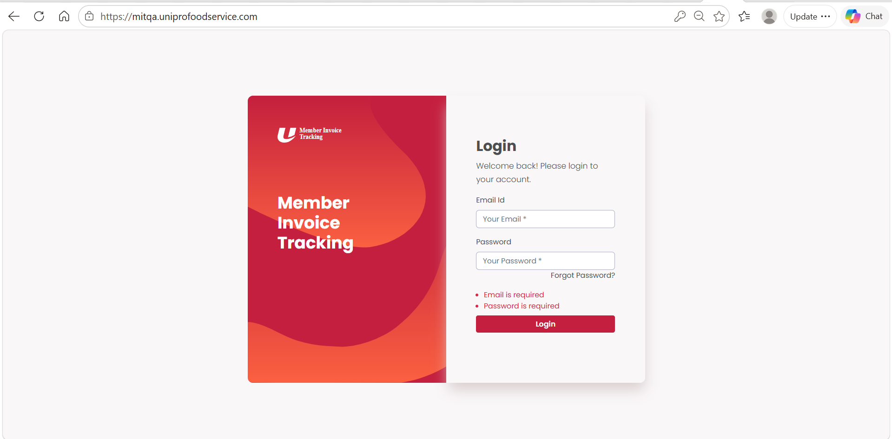
If not a user, ask the admin to create an account for you
To create a user account, admin has to login to the application and create an account for you. Go to Administration->MIT Users
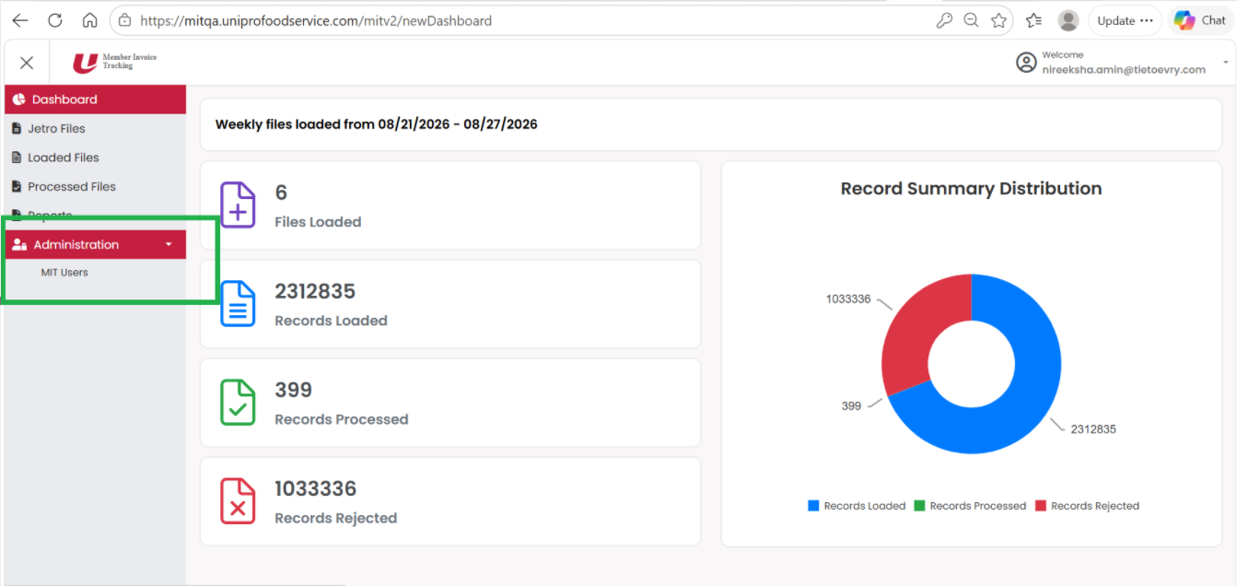
Click on add new user
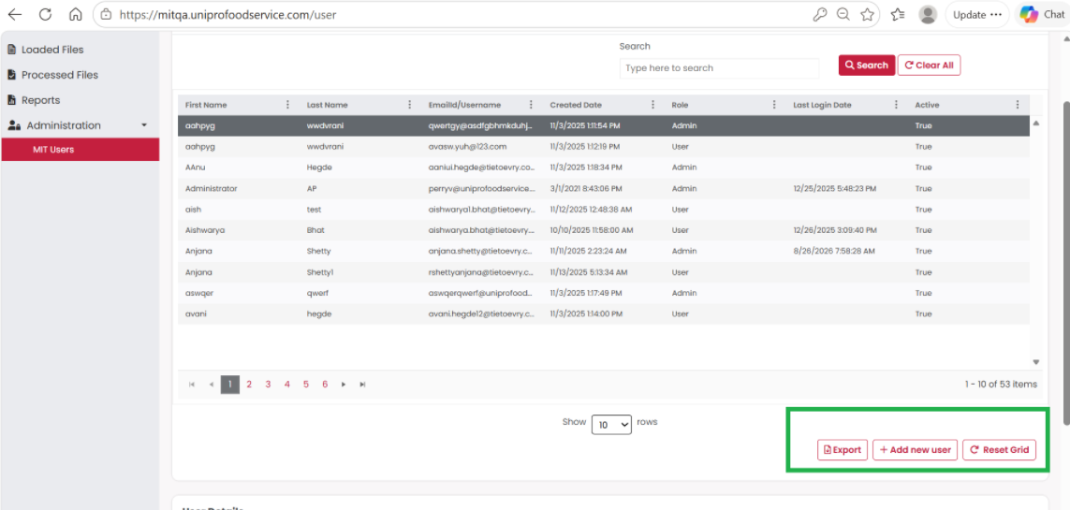
Add new user
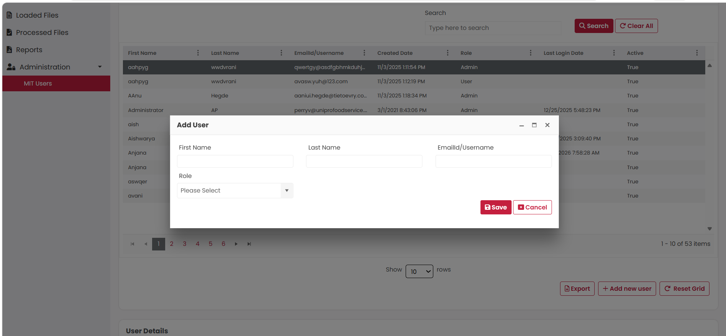
The new user will get the login credentials in the email.And later the user can try to login with those credentials. The user can also give forgot password in the login screen to generate a new password
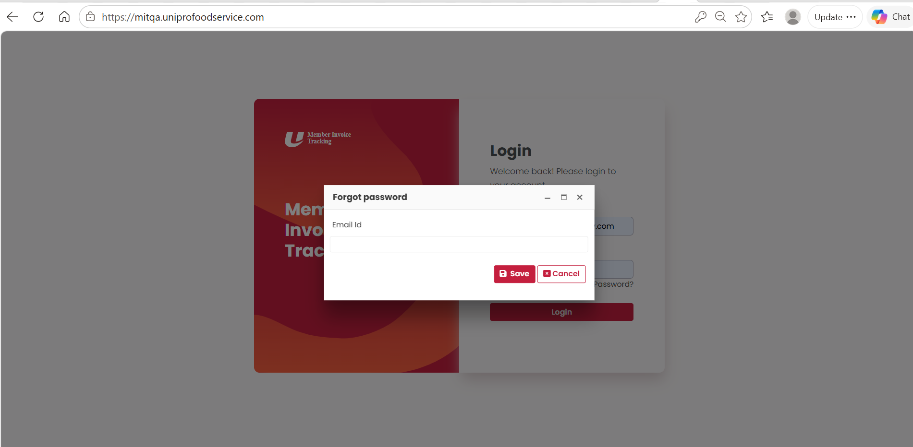
A password will be sent to the user's email and then the user can try to login with the same email id and password.
Once the user logs in, the user can update the password in the user profile. Click your name at the top right and go to my account and change the password by clicking change password
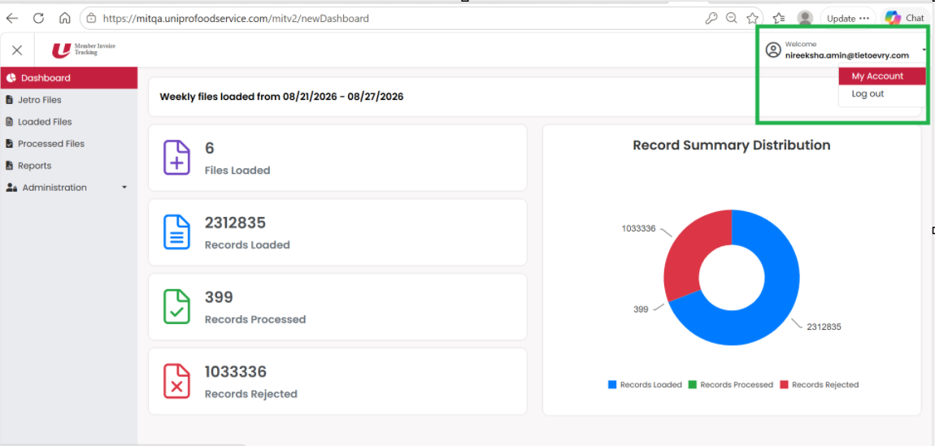
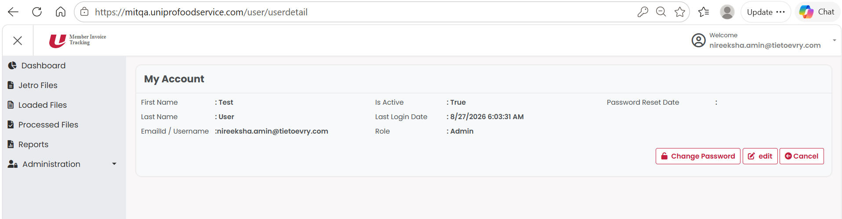
Dashboard
The dashboard displays the tiles which has the count of :
Files Loaded: The total count of files imported.
Records Loaded: The total count of loaded records
Records Processed: The total count of processed records.
Records Rejected: The total count of records rejected due to validation failures
We also have a pie chart showing the count of Records Loaded, Processed, Rejected.
Note: This only shows one week's data.
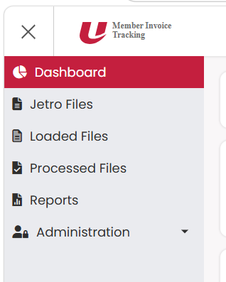
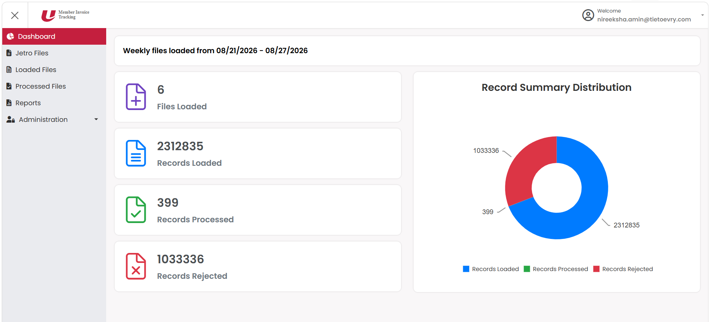
Also, the navigation menu has:
- Dashboard – Navigates to dashboard
- Jetro Files - Navigates to Jetro files
- Loaded Files – navigates to loaded files
- Processed Files – navigates to processed files
- Reports – Navigates to All Reports
- Administrator - Navigates to Administrator module

Jetro files
To import a jetro file
Open AWS S3 go to this location : https://us-east-1.console.aws.amazon.com/s3/buckets/testing-app2-mit-drop?region=us-east-1&prefix=QA/jetroinbound/&showversions=false
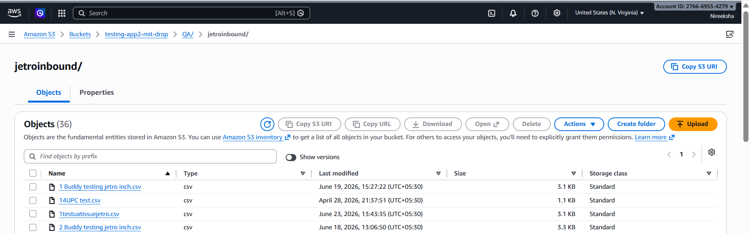
Upload the jetro files here
The files will be automatically uploaded to the application. The uploaded files will show in the Jetro files screen
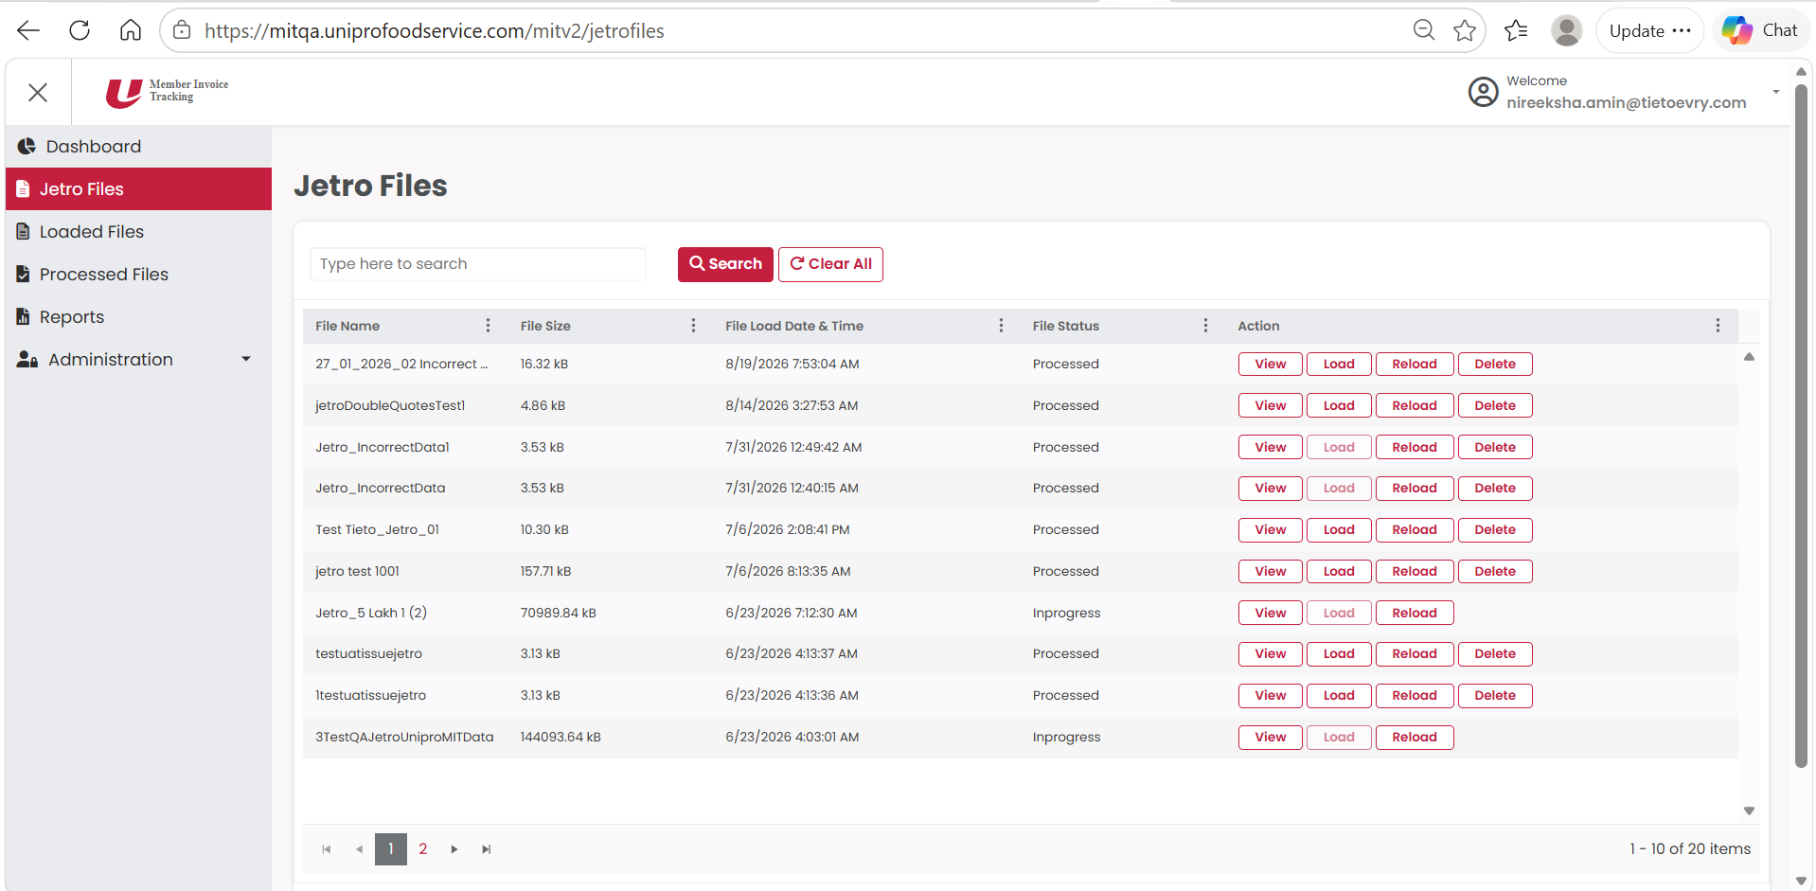
The user can see the details of the filename, filesize, file load date and time and file status.
When the file is just uploaded and undergoing the initial validation it will be in inbound file status.
Once the file has completed its initial validation the file status will change to processed.
When the user clicks load, the file status will change to InProgress file status.
The user can reload the file if the user feels to change the file data. The user has to upload the file with same name in the same location. Only with the same filename the file file can be reloaded otherwise it will be treated as a new file.
Once the file is uploaded the user can click on reload from the jetro files grid and the file will get reloaded.
Note: The jetro files uploaded to the above location will remain there unless the user loads it from the application.
The user has the option to view the file data where the user can check the records in detail and apply filter, sorting, searching etc.
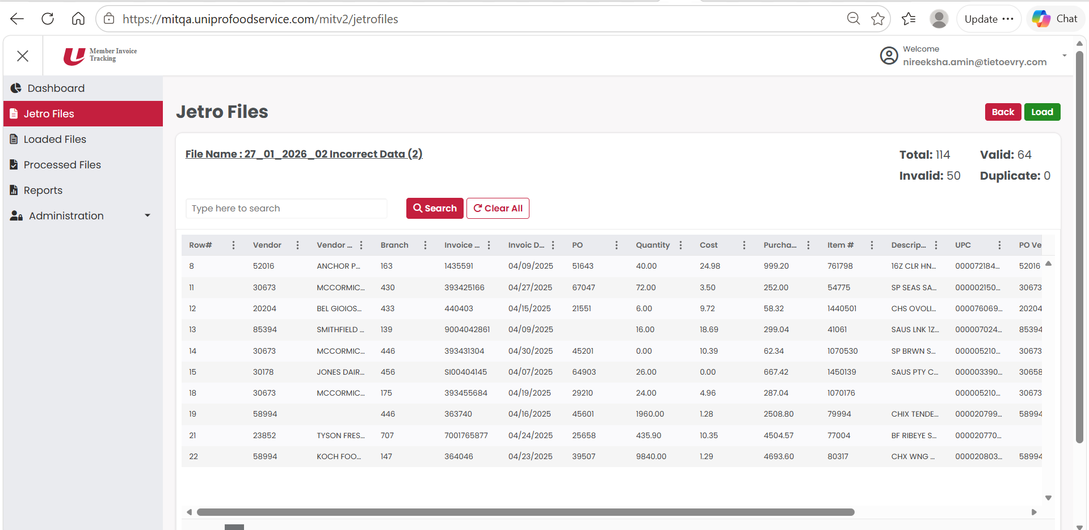
The user can click on the load in this screen or also in the previous files grid screen.
Upon loading the jetro data will be converted into standard format and will be removed from the jetro files section and moved into the Loaded files screen.
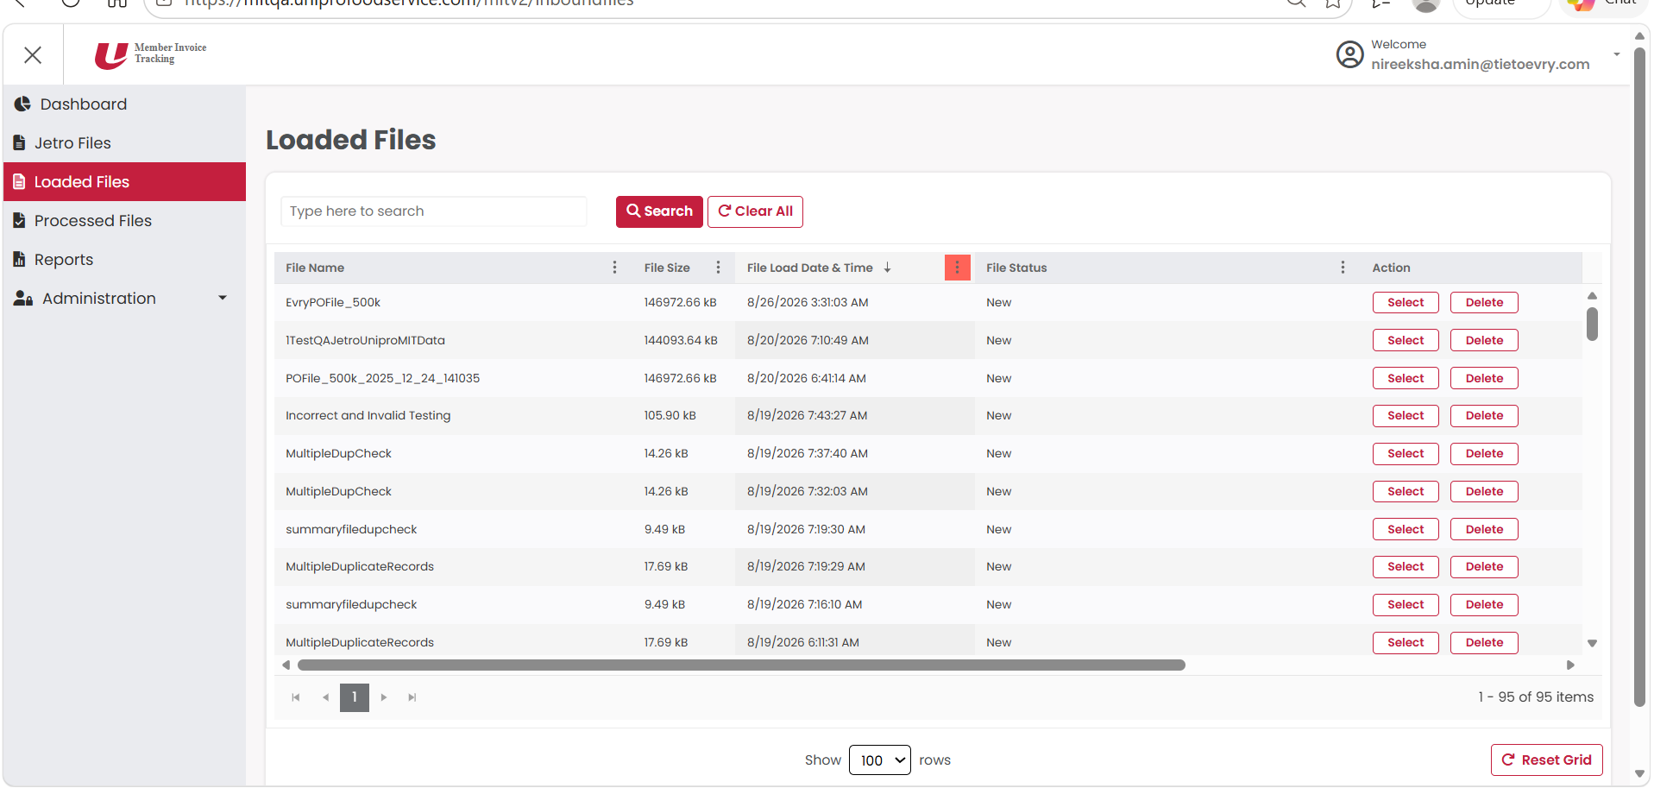
The loaded files screen has the converted jetro data. This screen will also show the item/summary loaded files.
To import item/summary files the user need to open AWS S3 and upload files in the below location: https://us-east-1.console.aws.amazon.com/s3/buckets/testing-app2-mit-drop?region=us-east-1&prefix=QA/inbound/&showversions=false
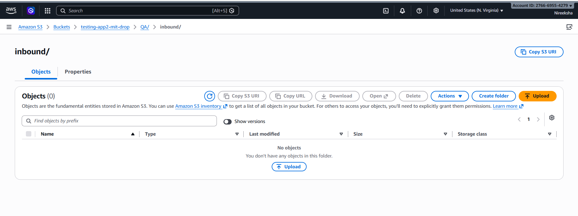
All the item/summary files uploaded here will be automatically imported to the application upon completion of the pre process validations.
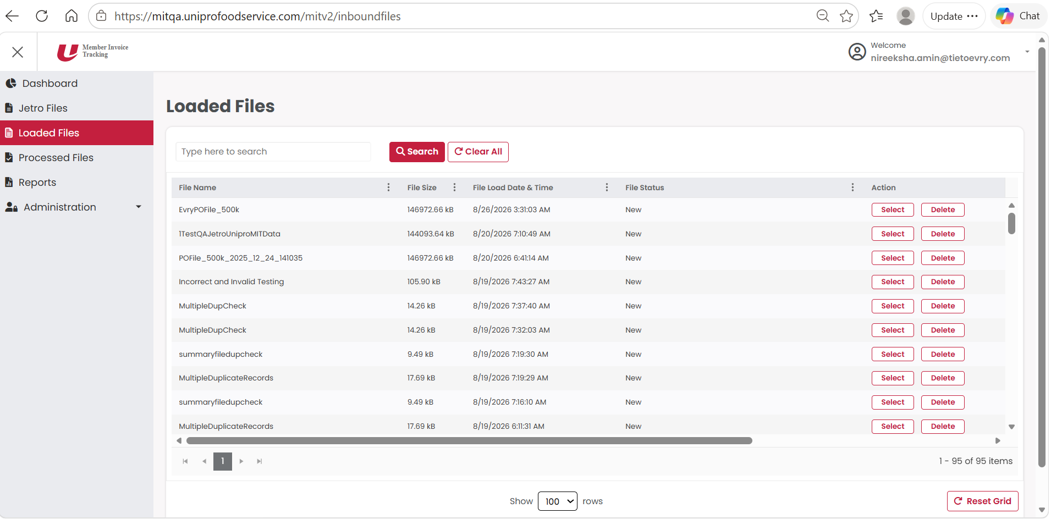

The uploaded file will initially be in inbound state. Once it completes the preprocess validation it will be changed to new state.
The user can filter, sort or search the file in this screen.
Upon clicking on select the user can see the file data in detail.
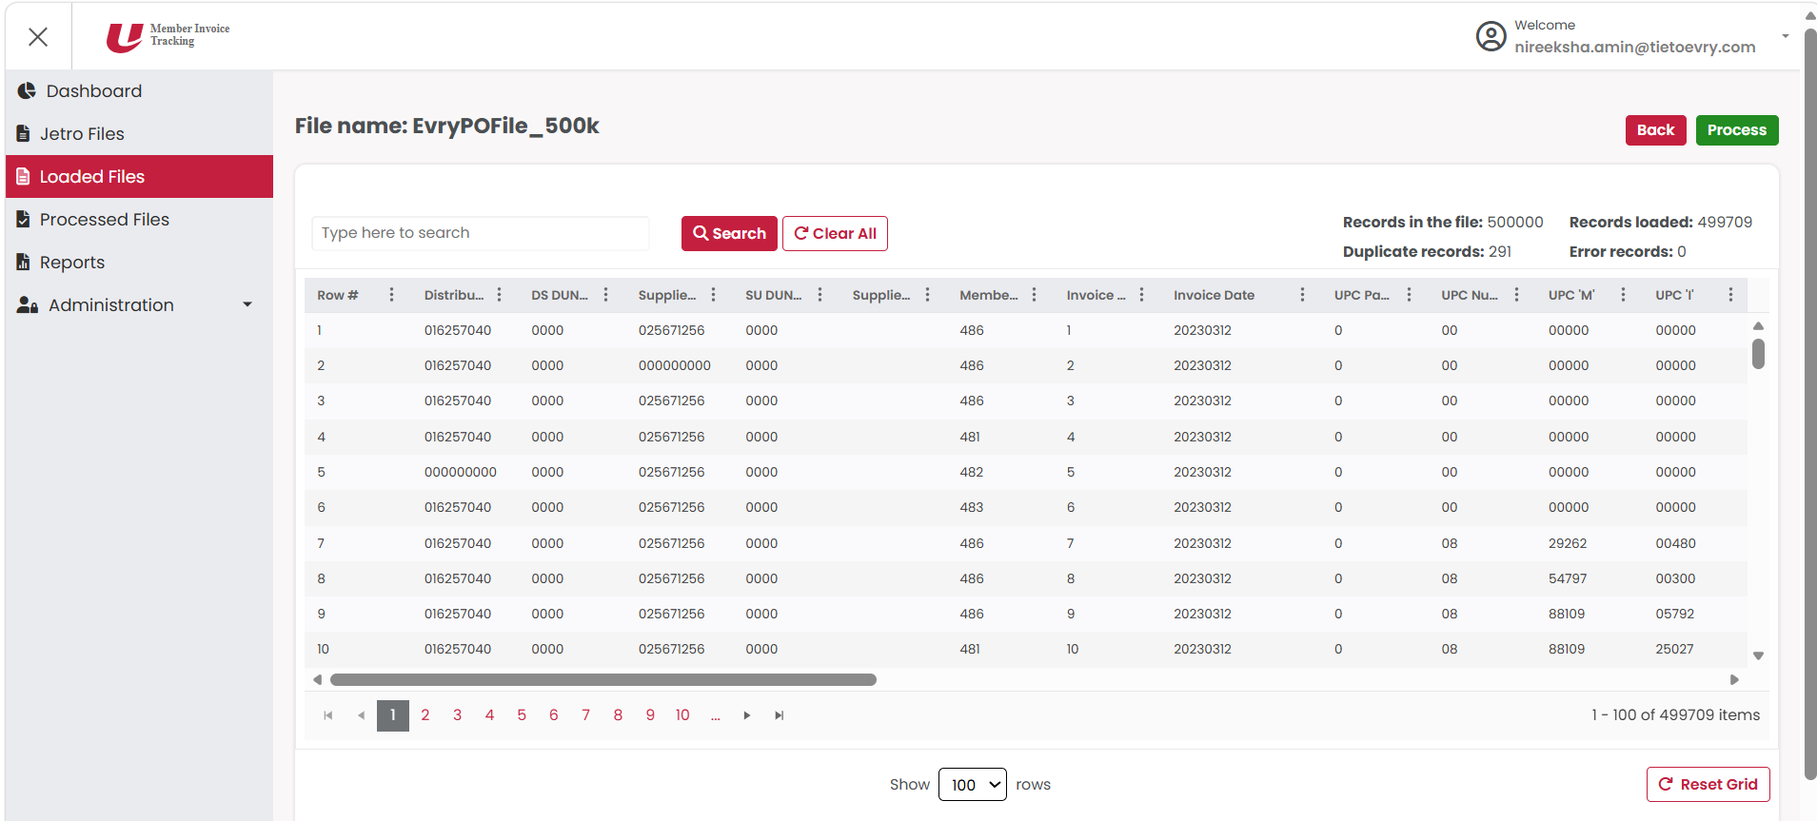
To process the file user needs to click on the process button. Upon clicking this, the application performs all the process validations and the processed file will be available in the processed files section.
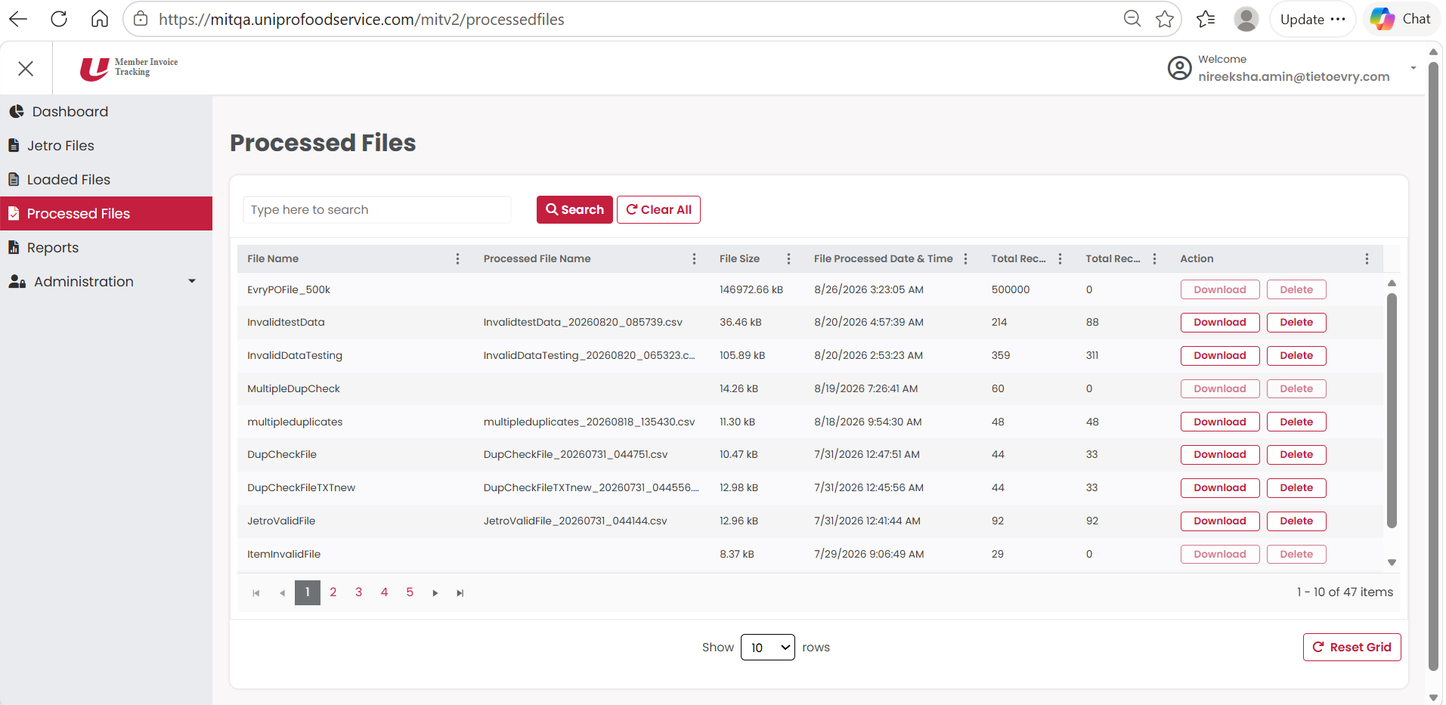
Here the user can see the actual filename, processed filename, file size, file processed date and time, total records in the file and total records processed. The user can also download this file and check the processed data.
Upon processing, one copy of processed file will also be sent to outbound s3 bucket.

Reports
In all this process from importing a file, pre-process, process there could be many errors in the data or some validations could fail or there could be some alert records. In such cases all the invalid records would be rejected. These rejected records will be moved to Reports
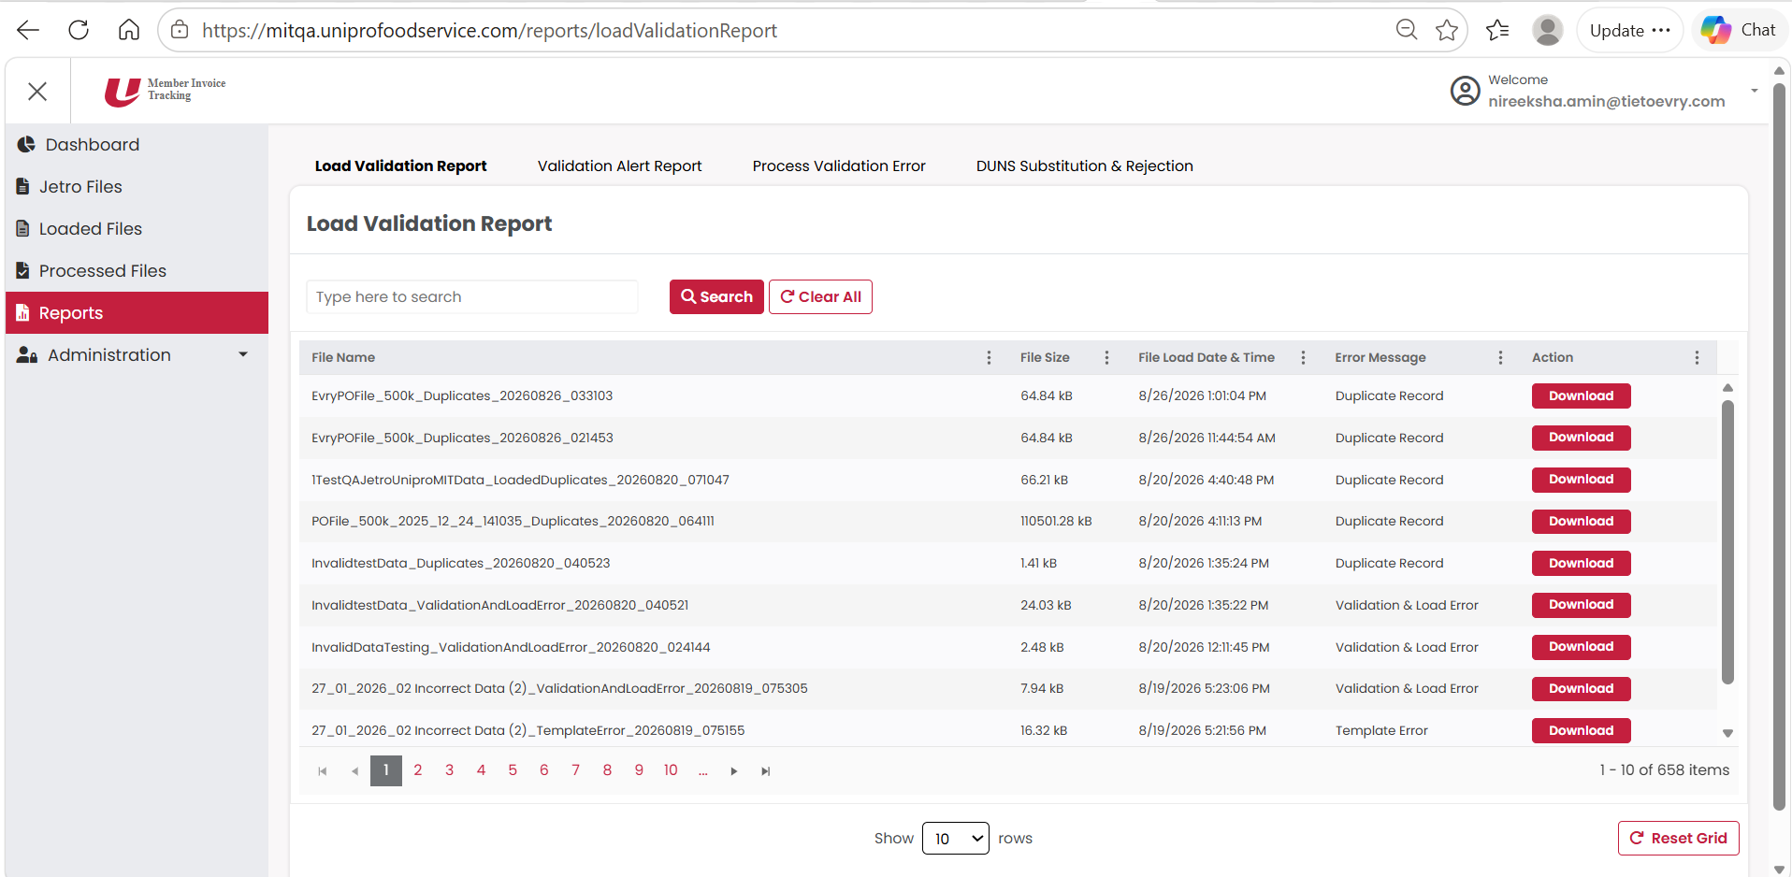
There are four kinds of reports:
- Load Validation Report – Shows all the records rejected at the pre-process stage.
- Validation Alert Report – Shows all the alert records.
- Process Validation Error – Shows all the records rejected at post-process stage
- DUNS Substitution & Rejection - Shows the records rejected due to duns rejection error and also the duns substitution records
Delete: If the user wants to delete any file at any stage then he can delete the file in the jetro files, loaded files and processed files.
Upon clicking the user will be asked for a re-confirmation prompt.
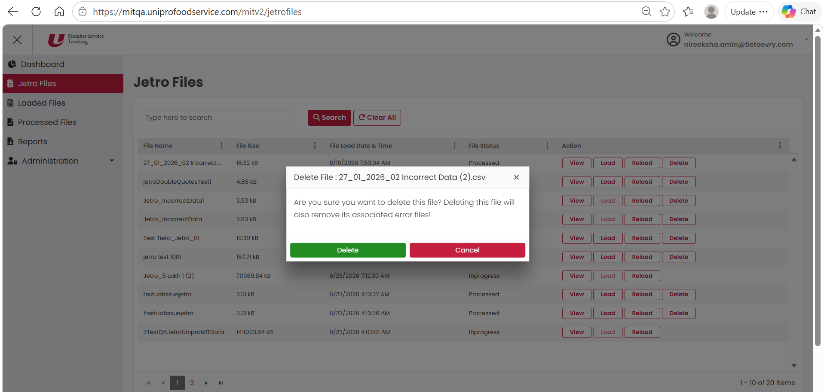
Note: Deleting the files would also delete all its associated reports.

Administrator: This module shows all the user related details. The admin can add new users and also edit the users.
