450T AI – Technical Documentation

1. Document Overview

1.1 Purpose
The Product Matching API is a FastAPI-based service that matches incoming product records against a precomputed product catalog.
The matching engine combines:
- Deterministic identifier matching using GTIN, UPC, MPC, and GLN
- Semantic similarity matching using product description, brand, and pack-size embeddings
- Fuzzy matching using manufacturer-gln
- FAISS-based vector search for efficient semantic candidate retrieval
- Weighted scoring and penalties to rank candidate products
- Top-K result selection to return the best catalog matches
The API is designed to support both individual and high-volume product matching requests.

1.2 Application Components
Component | Purpose
main.py | FastAPI application, initialization, matching logic, scoring, and API endpoints
Dockerfile | Container image definition
buildspec.yml | AWS CodeBuild CI/CD configuration
.env | Local configuration reference
requirements.txt | Python dependencies
catalog pickle | Product catalog, embeddings, and precomputed lookup structures

1.3 Technology Stack
Technology | Purpose
Python 3.11 | Application runtime
FastAPI | REST API Framework
Uvicorn | ASGI application server
Sentence Transformers | Text Embedding Generation
All-miniLM-L6-v2 | Embedding Model
FAISS | Vector Similarity Search
Numpy | Numerical Operations
AWS S3 | Catalog Artifact Storage
Docker | Application Containerization
AWS Codebuild | Container Build Pipeline
Amazon ECR | Container Image Registry

2. System Architecture

2.1 High-Level Runtime Architecture
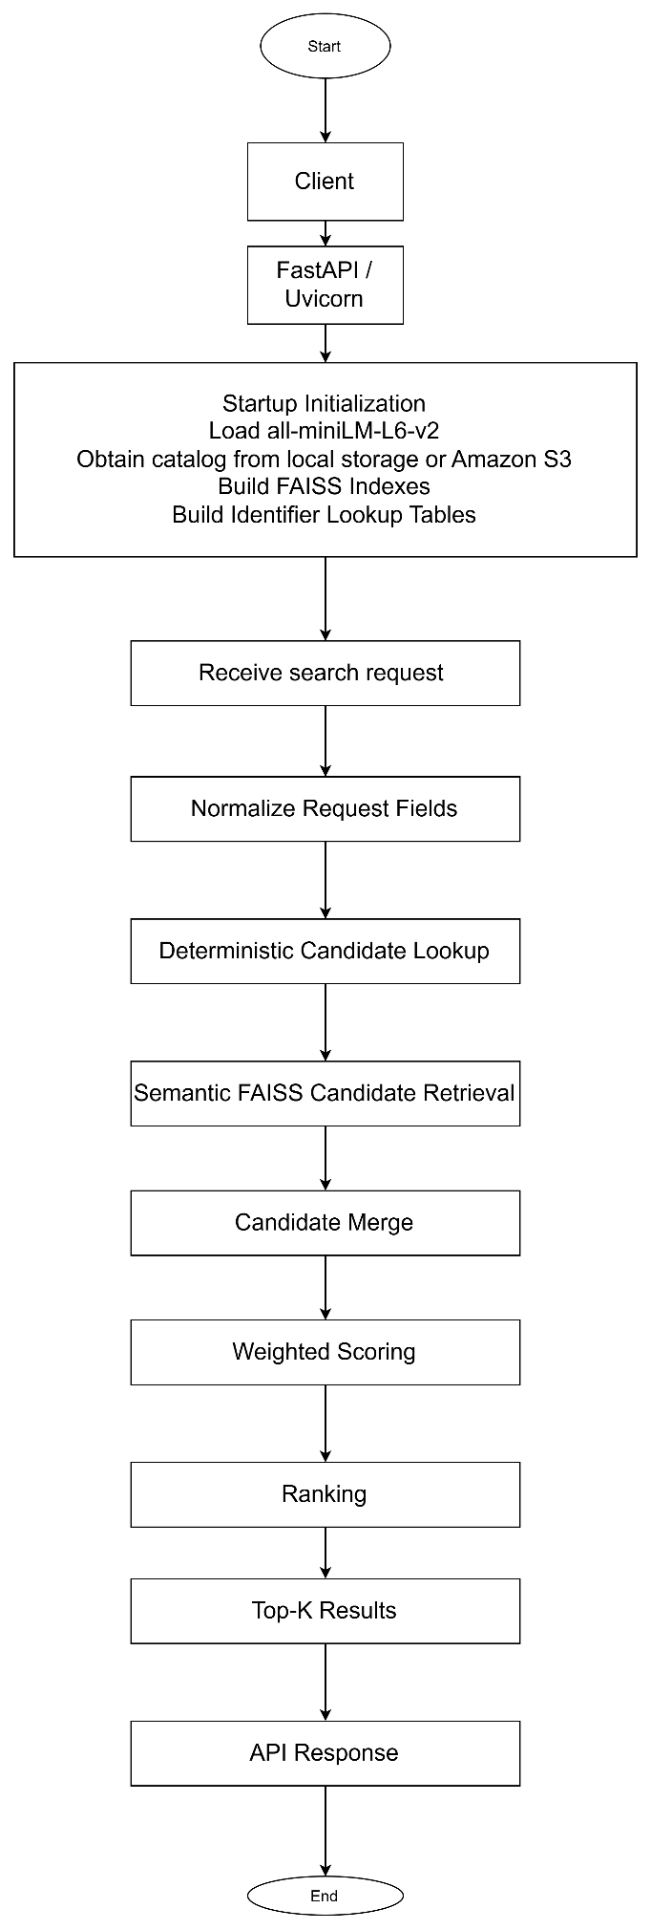

2.2 Application Initialization
main.py uses module-level singletons for the following resources:
- Embedding model
- Product catalog
- Description FAISS index
- Brand FAISS index
- Pack-size FAISS index
- Identifier lookup tables
Initialization is protected by an asyncio.Lock.
This prevents multiple concurrent requests from independently loading the same catalog and building duplicate indexes.
Initialization Flow
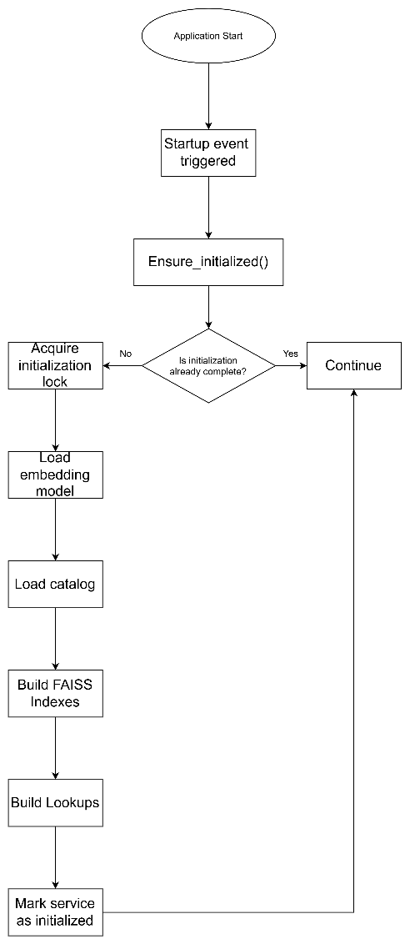

The FastAPI startup event begins initialization in the background.
API endpoints also call ensure_initialized() before processing requests. Therefore, if a request arrives before initialization has completed, the request waits until the required resources are available.

3. API Reference

3.1 Endpoint Summary
Method | Path | Purpose
GET | / | Returns service metadata, version, initialization status, and endpoint information
POST | /search | Searches one product or an array of products (supports smaller batches up to 50)
POST | /bulk-search | High-throughput batch product matching (supports batches up to 10k)
GET | /health | Liveness probe
GET | /ready | Readiness probe
GET | /ready | Returns catalog and FAISS statistics

3.2 GET /
Returns basic service information.
The response includes:
- Service metadata
- Application version
- Initialization status
- Available endpoints

3.3 POST /search
Searches the product catalog for one product request or an array of product requests.
Request Limits
- Single product request: supported
- Array request: maximum 10,000 records
For high-volume workloads, /bulk-search is recommended.

3.4 POST /bulk-search
Provides the high-throughput product matching pipeline.
Request Limit
Maximum 10,000 records per request.
The bulk pipeline provides additional optimization through:
- Batched embedding generation
- In-memory embedding caching
- Batch candidate processing
- Configurable parallel scoring
- Configurable scoring chunk size
Parallel scoring is enabled for sufficiently large batches based on BULK_SCORE_MIN_PARALLEL_RECORDS.

3.5 GET /health
Returns:
{
"status": "ok"
}
This endpoint indicates that the application process is alive.
It does not guarantee that the model and catalog have finished loading.

3.6 GET /ready
The readiness endpoint is intended for traffic gating.
It returns HTTP 503 until the following resources have completed initialization:
- Embedding model
- Product catalog
- FAISS indexes
- Identifier lookup tables
Once initialization is complete, the endpoint reports the service as ready.

3.7 GET /stats
Returns runtime catalog information, including:
- Product count
- Catalog field names
- FAISS index sizes
This endpoint can be used for operational verification after deployment.

4. Search Request Model

4.1 Standard Fields
The following fields are supported by the request model.
All fields are optional.
{
"item_description": "Tomato ketchup 20 oz",
"mpc": "12345",
"supplier_no": "100",
"manufacturer_gln": "1234567890123",
"upc": "012345678905",
"gtin_450": "00012345678905",
"unique_id": "source-record-1",
"brand_name": "Example Brand",
"pack_size": "20 oz"
}

4.2 Additional Fields
Additional request fields are permitted.
These fields are preserved in the response under:
additional_fields
This allows source-system-specific attributes to pass through the matching service without requiring every field to be explicitly defined in the API request model.

4.3 Manufacturer GLN
manufacturer_gln supports:
- A single string
- A list of strings
This allows requests containing multiple manufacturer GLNs to be processed by the matching engine.

5. Matching Engine

5.1 Matching Strategy
The matching engine uses a hybrid approach:
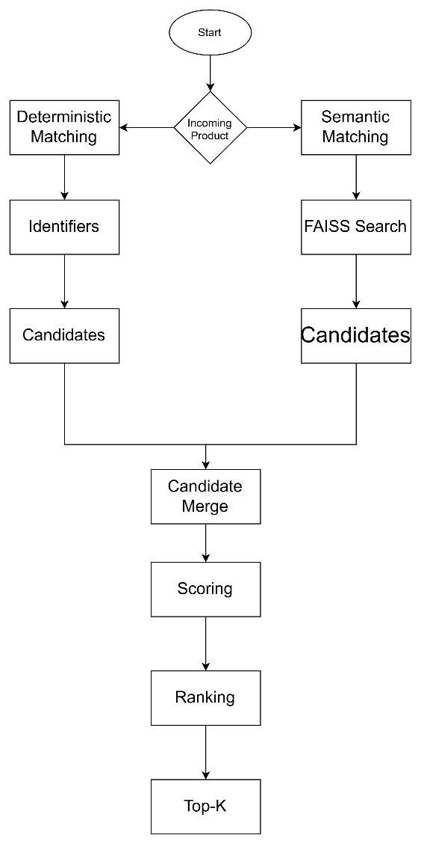

The deterministic and semantic approaches complement each other:
- Deterministic matching provides strong evidence when product identifiers agree.
- Semantic matching handles cases where identifiers are missing, inconsistent, or unavailable.

6. Matching Pipeline

6.1 Step 1 – Request Normalization
Incoming request values are normalized before matching.
The normalization process includes:
- Treating empty strings as absent values.
- Treating the literal value string as absent.
- Normalizing MPC values to uppercase alphanumeric form.
- Normalizing identifier values before lookup.
This ensures that formatting differences do not unnecessarily prevent matching.

6.2 Step 2 – Deterministic Candidate Retrieval
The service retrieves candidate products using identifier lookup structures.
The primary identifiers include:
- GTIN
- UPC
- MPC
- GLN
The catalog contains precomputed lookup structures such as:
gtin_to_indices
mpc_gln_to_indices
Additional in-memory structures are built during startup for:
- GLN lookup
- Positional GTIN lookup
Positional GTIN Matching
The master catalog may contain GTIN values with a standard length while incoming UPC/GTIN values can have different representations.
Positional GTIN indexes allow valid identifiers of different lengths to be matched without scanning the complete catalog.

7. Semantic Search

7.1 Embedding Model
The service uses:
all-MiniLM-L6-v2
from Sentence Transformers.
The model generates vector representations for:
- Item description
- Brand name
- Pack size
Only non-empty fields are encoded.

7.2 FAISS Indexes
The service maintains three FAISS IVF Flat indexes:
Description Index Description embeddings
Brand Index Brand embeddings
Pack Size Index Pack-size embeddings
Semantic search retrieves candidate products from these indexes.
The maximum number of candidates retrieved per semantic search is controlled by:
MAX_FAISS_CANDIDATES

8. Candidate Processing
After deterministic and semantic retrieval:
- Deterministic candidates are collected.
- Semantic candidates are collected.
- Duplicate candidates are merged.
- The combined candidate set is bounded by CANDIDATE_POOL_LIMIT.
- Additional candidates may be retrieved using backfill expansion when required.
- The final candidate pool is passed to the scoring stage.
Candidate Limits
Configuration | Purpose
MAX_FAISS_CANDIDATES | Maximum semantic candidates retrieved from FAISS
MAX_GLN_CANDIDATES | Maximum GLN candidates considered
CANDIDATE_POOL_LIMIT | Maximum merged candidate pool
BACKFILL_EXPANSION_FACTOR | Expansion factor used when additional candidates are required

9. Scoring and Ranking

9.1 Semantic Scoring Components
The scoring engine uses configurable weights for:
Component | Default Weight
Description | 0.60
Manufacturer GLN | 0.20
Brand name | 0.15
Pack size | 0.05

The weights are controlled through environment variables.
WEIGHT_DESC
WEIGHT_BRAND
WEIGHT_GLN
WEIGHT_PACK

9.2 Identifier Penalties
Additional penalties are applied depending on the level of identifier agreement.
Configuration | Default
PENALTY_NO_MATCH | 0.18
PENALTY_GTIN_UPC_MPC_OR_MATCH | 0.15
PENALTY_MPC_AND_GTIN_OR_UPC_MATCH | 0.10
PENALTY_GTIN_UPC_MPC_AND_MATCH | 0.05

The scoring stage combines semantic similarity and identifier agreement before ranking the candidates.

9.3 Ranking
After scoring:
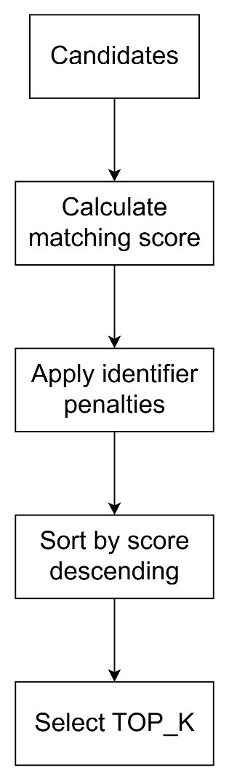
The default value of TOP_K is:
3
Therefore, the API returns up to three best catalog matches for each input record.

10. Catalog Artifact

10.1 Catalog Requirements
The catalog pickle must contain:
- Product data
- Precomputed description embeddings
- Precomputed brand embeddings
- Precomputed pack-size embeddings
- gtin_to_indices
- mpc_gln_to_indices

10.2 Startup Catalog Processing
At application initialization:
Catalog Artifact
- Product Data
- Precomputed Embeddings
- Identifier Lookup Tables
In-Memory Application State
- FAISS Description Index
- FAISS Brand Index
- FAISS Pack Index
- GLN Lookup
- Positional GTIN Lookup
The catalog is loaded either:
- From the configured local catalog path, or
- From the configured Amazon S3 object.

11. Environment Configuration

11.1 Configuration Source
main.py reads configuration using:
os.getenv()
Therefore, process environment variables are authoritative.
The .env file is a configuration reference for local tooling. The application does not load .env files itself.
Configuration must therefore be supplied through:
- Shell environment variables
- Hosting-platform environment configuration
- Process managers that explicitly load .env

11.2 Configuration Reference
Variable | Default | Purpose
ENV | dev | Environment prefix used by the default S3 object key
S3_BUCKET_NAME | product-matching-model-bucket | S3 bucket containing the catalog
S3_REGION | us-east-1 | AWS region
S3_KEY_CATALOG_EMBEDDINGS | ${ENV}/product_catalog_hdsa_v12_development.pkl | S3 catalog object key
LOCAL_CATALOG_EMBEDDINGS | product_catalog_hdsa_v12_development.pkl | Local catalog cache path
WEIGHT_DESC | 0.6 | Description similarity weight
WEIGHT_BRAND | 0.15 | Brand similarity weight
WEIGHT_GLN | 0.2 | Manufacturer GLN weight
WEIGHT_PACK | 0.05 | Pack-size similarity weight
PENALTY_NO_MATCH | 0.18 | Penalty for no structured identifier match
PENALTY_GTIN_UPC_MPC_OR_MATCH | 0.15 | Penalty for partial OR-style identifier agreement
PENALTY_MPC_AND_GTIN_OR_UPC_MATCH | 0.10 | Penalty for MPC plus GTIN/UPC agreement
PENALTY_GTIN_UPC_MPC_AND_MATCH | 0.05 | Penalty when all identifier fields agree
MAX_FAISS_CANDIDATES | 1000 | Maximum semantic candidates per FAISS search
MAX_GLN_CANDIDATES | 50 | Maximum GLN candidates
CANDIDATE_POOL_LIMIT | 200 | Maximum merged candidate pool
BACKFILL_EXPANSION_FACTOR | 5 | Candidate retrieval expansion factor
TOP_K | 3 | Number of results returned
BULK_SCORE_WORKERS | Up to 4 CPU cores | Worker count for bulk scoring
BULK_SCORE_CHUNK_SIZE | 32 | Records per scoring chunk
BULK_SCORE_MIN_PARALLEL_RECORDS | 256 | Minimum records required to enable parallel scoring

11.3 Environment and Catalog Alignment
The checked-in .env currently specifies:
ENV=development
Therefore, the corresponding catalog key resolves to:
development/product_catalog_hdsa_v12_development.pkl
The following three values must remain aligned with the catalog artifact being served:
S3 object key
Local catalog filename
Deployment environment

12. Containerization
12.1 Base Image
The Docker image uses:
public.ecr.aws/docker/library/python:3.11-slim

12.2 Image Build Steps
The Dockerfile:
- Installs required system libraries:
  - libgl1
  - libglib2.0-0
  - libstdc++6
  - curl
- Upgrades Python packaging tools.
- Installs sentencepiece.
- Installs dependencies from requirements.txt.
- Copies main.py.
- Creates:
/app/data
- Pre-caches the all-MiniLM-L6-v2 model to reduce model download time during runtime.
- Sets default S3 and local catalog configuration.
- Exposes port:
8000
- Starts Uvicorn using:
main:app
on:
0.0.0.0:8000

12.3 Environment Handling in Docker
The Dockerfile does not copy .env into the image.
Instead, deployment-specific configuration should be supplied as runtime environment variables.
Important Configuration Difference
The Dockerfile default S3 key uses:
development/...
whereas main.py derives:
dev/...
when neither ENV nor S3_KEY_CATALOG_EMBEDDINGS is explicitly provided.
Therefore, deployment configuration should explicitly set the intended environment and catalog key.

13. Local Container Execution
13.1 Build Image
docker build -t product-matching-api:local .
13.2 Run Container
docker run --rm -p 8000:8000 `
-e S3_BUCKET_NAME=product-matching-model-bucket `
-e S3_REGION=us-east-1 `
-e S3_KEY_CATALOG_EMBEDDINGS=development/product_catalog_hdsa_v12_development.pkl `
-e LOCAL_CATALOG_EMBEDDINGS=/app/data/product_catalog_hdsa_v12_development.pkl `
product-matching-api:local
The container requires AWS credentials with permission to read the configured S3 catalog object unless the catalog is already available at LOCAL_CATALOG_EMBEDDINGS.

14. CI/CD Pipeline
14.1 Build Specification
buildspec_dev.yml defines the AWS CodeBuild pipeline.
The current configuration uses:
Setting | Value
AWS Region | us-east-1
ECR Repository | ecr-apprunner-development
Image Tag | v1.1

14.2 Pipeline Flow
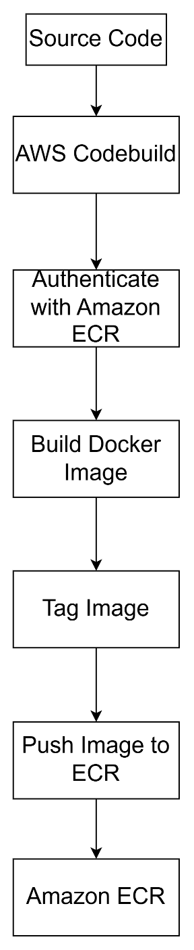
The pipeline:
- Authenticates against private Amazon ECR using aws ecr get-login-password.
- Builds the Docker image from the project root.
- Pushes:
$REPOSITORY_URI:$IMAGE_TAG
No build artifacts are generated by the CodeBuild configuration.

14.3 IAM Requirements
The CodeBuild role requires permissions for:
- ECR authentication
- ECR image push
The runtime role requires separate permission to:
- Read the configured catalog object from S3
Build-time and runtime permissions should therefore be treated independently.

15. Operations and Monitoring
15.1 Basic Service Checks
After starting the service:
curl http://localhost:8000/health
curl http://localhost:8000/ready
curl http://localhost:8000/stats

15.2 Health vs Readiness
/health
Purpose:
Process liveness
It confirms that the application process is running.
/ready
Purpose:
Traffic readiness
It confirms that initialization has completed.
The readiness check is therefore more appropriate for deciding whether the service can safely receive matching traffic.

15.3 Logging
Structured logs include:
- Request ID
- Per-stage timing
- Catalog loading time
- Embedding generation time
- Candidate retrieval time
- Scoring time
- Bulk processing throughput
These timings can be used to identify performance bottlenecks.

16. Security Considerations
16.1 AWS Credentials
Never store AWS credentials in:
- .env
- Docker images
- Source control
- Application source code
Use:
- IAM roles
- Workload identity
- External secret-management systems
where supported by the deployment environment.

16.2 Pickle Security
The product catalog is stored as a Python pickle artifact.
Python pickle data must be treated as a trusted artifact.
Loading an untrusted pickle can execute arbitrary code.
Only load catalog files produced and controlled by the trusted catalog-generation pipeline.

16.3 Container Image Tags
Avoid continually overwriting shared image tags such as:
v1.1
Prefer immutable or release-specific image tags so that deployed versions can be identified and rolled back reliably.
Example:
v1.1.0
v1.1.1
v1.2.0

17. Deployment Health-Check Configuration
Where supported by the deployment platform:
Liveness / Health Check
Configure:
/health
Readiness / Traffic Admission
Configure:
/ready
This separation ensures that a running application process is not automatically treated as ready to process requests before the catalog and FAISS indexes have finished initialization.

18. Quick Reference
Application
Entry point: main.py
Framework: FastAPI
Server: Uvicorn
Python: 3.11
AI / Search
Embedding model: all-MiniLM-L6-v2
Vector index: FAISS
Semantic fields:
- Description
- Brand
- Pack Size
Deterministic Matching
GTIN
UPC
MPC
GLN
Default Ranking Configuration
Description: 0.60
Brand: 0.15
GLN: 0.20
Pack Size: 0.05
TOP_K: 3
Main Endpoints
GET /
POST /search
POST /bulk-search
GET /health
GET /ready
GET /stats
Deployment
Docker
|
AWS CodeBuild
|
Amazon ECR
|
Deployment Platform
|
Amazon S3 Catalog

20. Troubleshooting Reference
Symptom | Areas to Check
Service starts but /ready returns 503 | Model loading, catalog availability, FAISS initialization, lookup-table construction
Catalog cannot be loaded | S3 bucket, S3 key, AWS permissions, local catalog path
Model download occurs during startup | Docker model pre-cache and network availability
No deterministic matches | Identifier normalization and lookup-table contents
Poor semantic matches | Embedding generation, FAISS indexes, candidate limits, scoring weights
Too few candidates | MAX_FAISS_CANDIDATES, MAX_GLN_CANDIDATES, CANDIDATE_POOL_LIMIT, backfill configuration
Bulk requests are slow | Batch size, embedding cache, BULK_SCORE_WORKERS, BULK_SCORE_CHUNK_SIZE
Container cannot access catalog | Runtime AWS credentials/role and S3 permissions
Wrong catalog environment is loaded | ENV and S3_KEY_CATALOG_EMBEDDINGS alignment
Deployment health check fails | Verify /health and /ready configuration
Unexpected catalog loading behaviour | Verify local-vs-S3 catalog configuration and environment variables

21. Configuration and Deployment Checklist
Before deploying a new version, verify:
- Correct Python/runtime version is used.
- requirements.txt contains all required dependencies.
- all-MiniLM-L6-v2 is successfully cached in the image.
- S3 bucket is correct.
- S3 region is correct.
- S3 catalog key points to the intended artifact.
- Local catalog path is correct where applicable.
- ENV matches the deployment environment.
- Scoring weights are intentionally configured.
- Candidate limits are appropriate for the catalog size.
- TOP_K is correctly configured.
- Runtime IAM role has S3 read permission.
- CodeBuild role has ECR push permission.
- Docker image is tagged with the intended release version.
- /health is configured as the liveness check.
- /ready is configured as the readiness check.
- No AWS credentials are stored in source code or the image.
- The catalog pickle originates from a trusted source.

22. Key Design Principles
The Product Matching API follows these core design principles:
- Deterministic matching first – trusted product identifiers are used whenever available.
- Semantic matching as a complementary mechanism – embeddings provide candidate discovery when deterministic identifiers are insufficient.
- Precomputation for performance – catalog embeddings and lookup structures are prepared before request processing.
- FAISS for scalable vector retrieval – semantic candidate retrieval avoids scanning every catalog record for each request.
- In-memory reuse – the model, catalog, indexes, and lookup tables are initialized once and reused across requests.
- Batch-oriented processing – high-volume requests use batching and configurable parallel scoring.
- Configuration-driven behaviour – scoring weights, candidate limits, penalties, and batch parameters can be changed without modifying the matching logic.
- Separate liveness and readiness – a running process is not considered ready until its matching resources are initialized.
- Environment-specific deployment – catalog paths and runtime configuration are explicitly controlled through environment variables.
- Trusted artifact handling – catalog pickle files must originate from a trusted source.

23. Future Maintenance Guidance
When modifying the matching engine, changes should be evaluated across the following areas:
Request Model Normalization Deterministic matching Semantic retrieval Candidate management Scoring Ranking API response
Any change to one stage should be checked for its effect on downstream stages, particularly:
- Candidate recall
- Matching score
- Ranking order
- Response structure
- Bulk performance
- Memory consumption
- Initialization time
Changes to environment variables should also be reflected in the configuration reference and deployment configuration.

24. Reference Files
File | Role
main.py | Core application and matching engine
Dockerfile | Container build definition
buildspec_dev.yml | AWS CodeBuild CI/CD definition
.env | Local configuration reference
requirements.txt | Python dependency definition
This document should be maintained whenever the API contract, matching algorithm, scoring logic, catalog format, configuration variables, container behaviour, or deployment process changes.

Catalog Vector Database Update Pipeline

1. Overview
This repository contains the incremental catalog ingestion pipeline responsible for maintaining the product catalog vector database used by the AI-powered product matching system.
The pipeline reads the latest catalog delta file, validates and normalizes the data, identifies records that have already been processed, generates embeddings only for genuinely new records, and incrementally updates the persisted vector database.
The implementation is primarily contained in the CatalogUpdater class in main.py. The pipeline is designed to run as a scheduled ingestion job and supports both AWS S3-based and local file-system execution.
The key design objectives are:
- Incrementally process catalog updates.
- Prevent duplicate records from being added to the vector database.
- Avoid generating embeddings for records that already exist.
- Maintain lookup indexes required by the product matching engine.
- Track successfully processed source files.
- Provide backup and archival capabilities.
- Support reliable retry behavior when processing fails.

2. Business Purpose
The purpose of the pipeline is to continuously maintain an up-to-date, vectorized product catalog for semantic product matching.
Catalog records may contain attributes such as:
- Product description/name
- Brand
- Pack size
- GTIN
- Manufacturer Product Code (MPC)
- Supplier number
- Manufacturer GLN
The pipeline converts relevant textual attributes into vector embeddings using the configured SentenceTransformers model.
Only newly identified records are embedded and added to the database. This is important because catalog feeds may contain overlapping or repeated records, and regenerating embeddings for existing records would unnecessarily increase:
- Processing time
- CPU and memory utilization
- Storage requirements
- Pipeline execution cost

3. Repository Structure
The main repository components are:
File | Purpose
main.py | Core catalog ingestion, validation, deduplication, embedding generation, and vector database update logic
Dockerfile.catalog | Docker image definition for the catalog update job
buildspecCatalog.yml | AWS CodeBuild configuration used to build and push the Docker image
requirements.txt | Python dependencies required by the pipeline
.env | Local environment configuration values
Most of the business and processing logic resides in main.py.

4. High-Level Architecture
The pipeline follows an incremental ETL-style ingestion process.
Processing flow
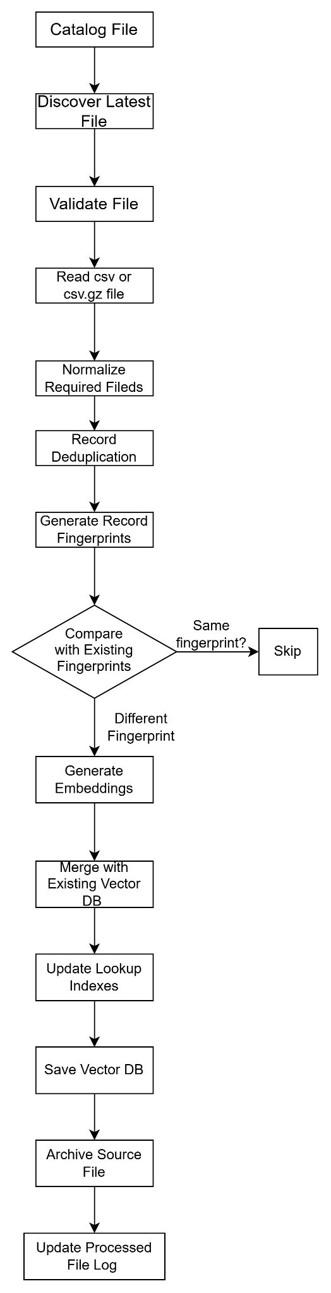
The most important optimization in this flow is that deduplication happens before embedding generation.
5. Vector Database Structure
The current vector database is persisted as a Python pickle object.
The database schema is defined by VECTOR_DB_SCHEMA.
The primary fields include:
Field | Description
descriptions | Product description values
short_names | Short product names; currently reserved for future use
long_names | Long product names; currently reserved for future use
brand_names | Product brand values
pack_sizes | Product pack-size values
gtins | GTIN values
supplier_numbers | Supplier identifiers
manufacturer_glns | Manufacturer GLN values
mpcs | Manufacturer Product Codes
normalized_gtins | Normalized GTIN values containing digits only
normalized_manufacturer_glns | Normalized manufacturer GLN values
sources | Source information associated with records
desc_embeddings | Description embeddings
short_name_embeddings | Short-name embeddings
long_name_embeddings | Long-name embeddings
brand_embeddings | Brand embeddings
pack_embeddings | Pack-size embeddings
gtin_to_indices | GTIN-to-record-index lookup
mpc_gln_to_indices | (MPC, GLN) to record-index lookup
record_fingerprints | SHA-1 fingerprints used for duplicate detection
Important maintenance consideration
record_fingerprints is the primary mechanism used to determine whether a catalog record has already been added to the vector database.
Maintaining consistency between the fingerprint set and the actual database records is therefore critical.

6. Data Normalization
The pipeline normalizes important identifiers before performing comparisons.
normalize_gtin(gtin)
Removes non-numeric characters from the GTIN.
For example:
"123-456-789" → "123456789"
This prevents formatting differences from causing the same GTIN to be treated as different values.
normalize_db_glns(gln)
Handles GLN values that contain multiple entries separated by:
- |
- ,
The values are split and whitespace is removed before being stored.
normalize_mpc(mpc)
Normalizes MPC values by:
- Removing non-alphanumeric characters.
- Converting the value to uppercase.
- Removing leading zeros.
These normalization steps ensure that format-only differences do not result in separate logical records.

7. Record Fingerprinting
7.1 Purpose
The pipeline uses a SHA-1 record fingerprint to identify whether a catalog record already exists in the vector database.
The fingerprint is generated using the following business fields:
- GTIN
- MPC
- Description
- Brand
- Pack size
- Supplier number
- Manufacturer GLN
Before generating the fingerprint, text values are normalized to provide consistent comparisons.
The general process is:
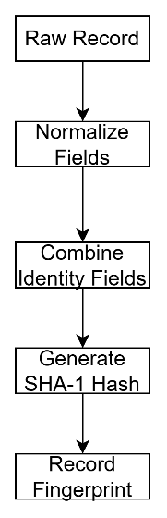

7.2 Vectorized Fingerprint Generation
make_fingerprints_vectorized(...) generates fingerprints across the DataFrame efficiently.
The fingerprint is then added to the DataFrame and compared against the existing record_fingerprints set.
This allows the pipeline to efficiently identify new and previously processed records without performing expensive embedding operations.

8. Runtime Configuration
Configuration is loaded through _load_config() from environment variables and, where applicable, JSON configuration.
Required configuration
The following configuration values must be available:
- catalog_data_dir
- vector_db_path
- processed_log_path
If required configuration is missing, initialization fails rather than allowing the job to continue with an invalid configuration.
Environment variables
The project supports configuration values such as:
VECTOR_DB_PATH
CATALOG_DATA_DIR
PROCESSED_LOG_PATH
BACKUP_DIR
ARCHIVE_DIR
BATCH_SIZE
MODEL_NAME
BACKUP_ENABLED
MAX_FILE_SIZE_MB
MEMORY_CLEANUP_THRESHOLD
These values control file locations, embedding behaviour, backup handling, and memory management.

9. Source Column Mapping
The pipeline expects a defined source-column structure.
The required_columns configuration maps internal field names to the corresponding CSV columns.
For example:
Internal Field | CSV Column
NAME | NAME
MANUFACTURER_PRODUCT_NUMBER | MANUFACTURER_PRODUCT_NUMBER
SUPPLIER_NUMBER | SUPPLIER_NUMBER
MANUFACTURER_GLN | MANUFACTURER_GLN
BRAND_NAME | BRAND_NAME
PACK_SIZE | PACK_SIZE
GTIN | GTIN
Any changes to the source catalog format should therefore be reviewed against this mapping before modifying the ingestion logic.

10. CatalogUpdater Initialization
The CatalogUpdater.__init__() method is responsible for initializing the ingestion process.
It performs the following operations:
- Loads the application configuration.
- Validates mandatory configuration values.
- Initializes runtime statistics.
- Initializes the model reference.
The statistics object tracks information such as:
- Processing start time
- Processing end time
- Number of rows processed
- Number of records added
- Number of duplicate records skipped
- Errors encountered

11. Embedding Model Loading
The _load_model() method loads the configured SentenceTransformers model.
The default model is:
all-MiniLM-L6-v2
The model is loaded lazily, meaning it is initialized only when embeddings are required.
This avoids loading the model unnecessarily when:
- No new file is available.
- The latest file has already been processed.
- The input file contains only duplicate records.
This reduces startup overhead and unnecessary memory consumption.

12. Latest Catalog File Discovery
find_latest_csv_file(s3_folder) identifies the next catalog file to process.
The method:
- Reads the last successfully processed file.
- Scans the configured source location.
- Identifies CSV and CSV.GZ files.
- Sorts the files according to the pipeline's filename ordering logic.
- Selects the latest file.
- Checks whether the file has already been processed.
If the latest file is already recorded in the processed-file log, the pipeline skips it.
Important behaviour
The pipeline is designed as a latest-file incremental updater rather than a full historical replay process.
Future changes to file naming conventions should therefore be reviewed carefully because file ordering affects which file is selected for processing.

13. Vector Database Loading and Saving
The vector database can be loaded from either:
- An S3 path using s3fs.
- A local file-system path using standard Python file I/O.
If the database does not exist, the pipeline initializes an empty database using VECTOR_DB_SCHEMA.
The updated database is persisted using save_vector_database().
First-run behaviour
A new environment can therefore initialize the vector database automatically when no existing database file is available.

14. Duplicate Detection and Filtering
Duplicate handling is a core component of the ingestion process. Catalog feeds may contain duplicate records. Without deduplication, these records would result in unnecessary database growth and repeated embedding generation.
Processing sequence
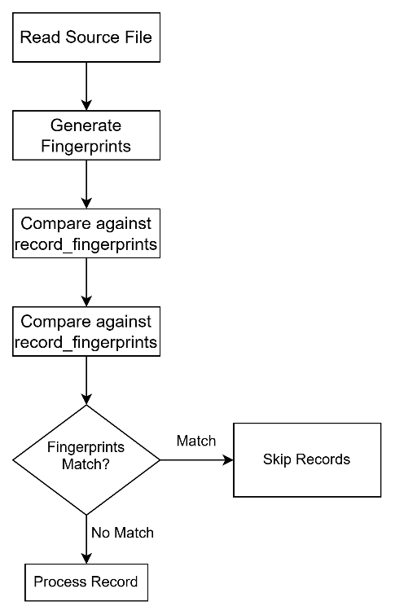
The key optimization is that duplicate filtering takes place before embedding generation.

15. CSV Processing
process_csv_data(csv_file_path, existing_fingerprints) is the primary transformation method in the pipeline.
It is responsible for converting the source CSV into a database-ready payload.
The method performs the following:
- Validates that the input file exists.
- Validates that the file is not empty.
- Reads CSV or CSV.GZ data.
- Validates required columns.
- Generates record fingerprints.
- Compares fingerprints against existing records.
- Removes previously processed records(dupliactes).
- Builds the processed-data structure.
- Generates embeddings for the remaining records.
- Returns the new records and associated embeddings.
This method should be one of the first places to investigate when troubleshooting ingestion or data-quality issues.

16. Embedding Generation
create_single_embedding_set(texts, text_type) generates embeddings for a collection of text values.
The method performs batch-based encoding:
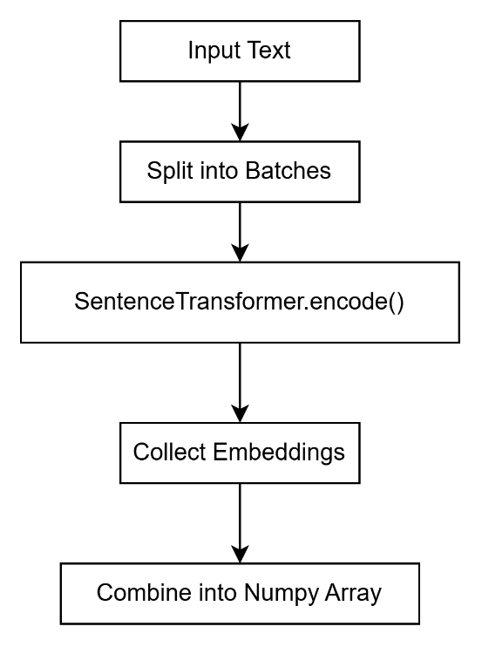
The configurable batch_size controls how many records are processed in each model invocation.
Embeddings can be generated for:
- Descriptions
- Brand names
- Pack sizes
- Short names
- Long names
Currently, short_names and long_names are placeholders and are not populated with active source data.
Memory management
The implementation can perform garbage collection using gc.collect() based on the configured memory_cleanup_threshold.
This is particularly important when processing large catalog files.

17. Vector Database Update
update_vector_database(csv_file_path) coordinates the complete database update operation.
The main steps are:
- Load the existing vector database.
- Ensure required lookup structures exist.
- Determine the starting index for new records.
- Process the catalog file.
- Exit without modification if no new records are found.
- Append new list-based fields.
- Append new embedding arrays.
- Update GTIN indexes.
- Update (MPC, GLN) indexes.
- Merge new fingerprints into record_fingerprints.
- Persist the updated database.
The method must maintain alignment between:
- Record attributes
- Embeddings
- Record indexes
- Lookup dictionaries
- Fingerprints
Any modification to the database schema should therefore be reviewed against this method.

18. Lookup Index Maintenance
The vector database maintains lookup structures used for efficient deterministic retrieval.
GTIN lookup
gtin_to_indices maps a GTIN to the corresponding database record indexes.
Conceptually:
GTIN → [record_index_1, record_index_2, ...]
MPC + GLN lookup
mpc_gln_to_indices uses the combination of:
(MPC, GLN)
as a lookup key.
This allows the system to efficiently retrieve candidate records using deterministic identifiers before semantic matching is performed.
Whenever records are appended, these indexes must be updated using the correct starting offset.

19. Processed File Tracking
The pipeline uses a processed-file log to prevent the same source file from being processed repeatedly.
Two methods manage this state:
- get_last_processed_file()
- set_last_processed_file()
The log contains the filename of the most recently successfully processed source file.
Important failure behaviour
The file is not marked as processed if the update fails.
This allows the same file to be retried during the next execution rather than permanently skipping a failed ingestion.

20. Source File Archival
After successful processing, archive_processed_file(source_s3_path) archives the source file.
The archive operation provides a historical copy of processed source data and helps maintain traceability.
The current implementation copies the processed file into the archive location associated with the vector database environment.
This behaviour should be preserved or explicitly reviewed before changing bucket or prefix configuration.

21. Vector Database Backup
backup_vectorDatabase_file() creates a timestamped backup of the existing vector database before modification.
The purpose is to provide a recovery mechanism in case:
- A database update fails.
- Data becomes corrupted.
- An unexpected application issue modifies the stored database incorrectly.
The backup functionality is controlled through the relevant configuration settings.

22. Main Execution Flow
The application entry point is main().
Conceptually, the runtime behaves as follows:
updater = CatalogUpdater()
stats = updater.run()
if stats["errors"]:
exit(1)
else:
exit(0)
The run() method performs the complete scheduled ingestion workflow:
- Start execution timer.
- Identify the latest catalog file.
- Exit if no new file is available.
- Update the vector database.
- Archive the successfully processed file.
- Update the processed-file log.
- Record final processing statistics.
- Return the execution status.
This allows the container or orchestration platform to determine whether the job completed successfully.

23. AWS and S3 Integration
The pipeline supports AWS-based execution through:
- boto3
- s3fs
The implementation can interact with S3 for:
- Reading catalog files.
- Loading the vector database.
- Saving the vector database.
- Creating backups.
- Archiving processed files.
The application also attempts to retrieve AWS STS caller identity during configuration loading. This provides useful diagnostic information when troubleshooting credentials or IAM permissions.
The pipeline can therefore be executed in environments such as:
- AWS CodeBuild
- ECS
- EC2
- Other AWS-enabled container environments

24. Logging and Monitoring
The application uses Python's logging framework.
Logging is configured for both:
- File output
- Console/stdout output
Console logging is particularly important for containerized execution because logs can be collected by the surrounding AWS infrastructure.
When troubleshooting an ingestion issue, one should review logs for:
- File discovery
- File validation
- Duplicate counts
- Number of new records
- Embedding generation
- Database update
- Backup operations
- Archive operations
- Errors and exceptions

25. Memory Management
Catalog files can contain a large number of records, and embedding generation is memory intensive.
The implementation therefore includes memory-management mechanisms such as:
- Batch-based embedding generation.
- Configurable BATCH_SIZE.
- Garbage collection using gc.collect().
- Configurable MEMORY_CLEANUP_THRESHOLD.
The embedding batch size should be tuned according to the available CPU and memory resources.
Increasing the batch size may improve throughput but can also increase memory consumption.

26. Failure and Retry Behaviour
The pipeline is designed so that a failed ingestion does not result in the source file being permanently marked as processed.
The intended behaviour is:
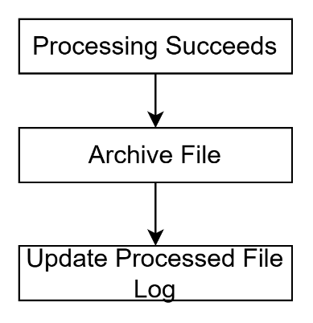
Whereas:
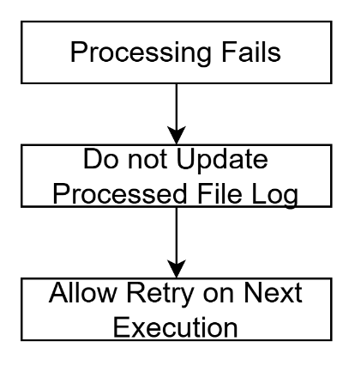
This prevents a temporary failure from causing permanent data loss.

27. Dependencies
The primary runtime dependencies are defined in requirements.txt.
Key libraries include:
- pandas – CSV and tabular data processing
- numpy – numerical and embedding array operations
- sentence-transformers – text embedding generation
- huggingface-hub – model management
- scikit-learn – supporting machine-learning utilities
- torch – model execution
- transformers – NLP model infrastructure
- boto3 – AWS SDK
- s3fs – S3 file-system integration
- python-dotenv – environment configuration
The Docker environment currently uses Python 3.11.

28. Docker Packaging
The catalog update job is containerized using Dockerfile.catalog.
The Docker image:
- Uses a Python 3.11 base image.
- Installs dependencies from requirements.txt.
- Copies the application source code.
- Executes main.py.
Containerization ensures that the same runtime environment can be used across local development and AWS execution environments.

29. CI/CD and CodeBuild
buildspecCatalog.yml defines the AWS CodeBuild process used to package the application.
The pipeline performs operations such as:
- Authenticate with Amazon ECR.
- Build the Docker image using Dockerfile.catalog.
- Tag the image.
- Push the image to the configured ECR repository.
The resulting container image can then be deployed to the target AWS execution environment.

30. Known Implementation Considerations
30.1 Supported input formats
The pipeline currently expects:
- .csv
- .csv.gz
Any new source format requires changes to the ingestion logic.
30.2 Required source columns
The source file must contain the expected required columns.
Changes to the upstream catalog schema must be reflected in the column mapping configuration.
30.3 Fingerprint dependency
record_fingerprints is critical for duplicate prevention.
If this field is missing, corrupted, or generated using different fields from the current implementation, duplicate detection may no longer behave correctly.
30.4 Pickle compatibility
The vector database is currently stored as a Python pickle.
Changes to the schema or object structure should therefore be handled carefully to prevent compatibility issues with previously generated databases.
30.5 Fingerprint changes
Changing the fields used to generate fingerprints changes the definition of record identity.
Any such change should be treated as a data migration concern, not simply a code change.

31. Troubleshooting Checklist
When investigating ingestion problems, follow this sequence:
File discovery
- Confirm that the configured catalog directory contains the expected file.
- Verify that the filename follows the expected naming convention.
- Check whether the file has already been recorded in processed_log_path.
Data validation
- Confirm that the source file is not empty.
- Verify that all required columns are present.
- Check for malformed or unexpected values.
Deduplication
- Review the number of fingerprints generated.
- Check how many records were identified as duplicates.
- Confirm that genuinely new records remain after filtering.
Embedding generation
- Confirm that the SentenceTransformer model loads successfully.
- Verify the configured model name.
- Check whether the embedding batch size is appropriate for the available memory.
Database
- Confirm that the vector database can be read.
- Verify that the destination S3/local path is correct.
- Confirm that lookup indexes are updated correctly.
- Check whether the backup was created before modification.
AWS
- Verify AWS credentials.
- Verify S3 access permissions.
- Check the configured bucket and prefix.
- Review CodeBuild/ECS logs for infrastructure-level failures.

32. Key Components for Future Enhancements
The following components contain the majority of the pipeline's business-critical logic:
Component | Responsibility
VECTOR_DB_SCHEMA | Defines the vector database structure
normalize_gtin() | Normalizes GTIN values
normalize_db_glns() | Normalizes GLN values
normalize_mpc() | Normalizes MPC values
make_fingerprints_vectorized() | Generates record fingerprints
find_latest_csv_file() | Identifies the latest unprocessed source file
_load_model() | Loads the embedding model
create_single_embedding_set() | Generates embeddings
process_csv_data() | Validates, deduplicates, and prepares new records
update_vector_database() | Merges new records into the vector database
save_vector_database() | Persists the database
archive_processed_file() | Archives successfully processed source files
backup_vectorDatabase_file() | Creates a database backup
run() | Orchestrates the complete ingestion workflow
For most ingestion-related issues, the recommended starting points are:
- process_csv_data()
- make_fingerprints_vectorized()
- update_vector_database()
- find_latest_csv_file()
- run()

34. Summary
The catalog update pipeline is an incremental data ingestion and embedding pipeline that maintains the vector database used by the AI product matching system.
Its core design principles are:
- Incremental processing – process only the latest catalog update.
- Duplicate prevention – identify previously processed records using stable fingerprints.
- Efficient embedding generation – generate embeddings only for new records.
- Incremental database updates – append new records without rebuilding the entire database.
- Deterministic lookup maintenance – maintain GTIN and MPC/GLN indexes alongside the vector data.
- Failure-safe processing – failed files remain eligible for retry.
- Operational traceability – maintain backups, archives, logs, and processed-file tracking.
- AWS compatibility – support S3-backed storage and containerized execution.
Understanding the relationship between fingerprints, record indexes, embeddings, and lookup dictionaries is particularly important. These structures must remain synchronized whenever the vector database update logic is modified.
The current implementation provides a solid foundation for incremental AI-powered product catalog processing.

