AZURE

What is Azure?
“Azure is Microsoft’s cloud computing platform, a growing collection of integrated services -analytics, computing, database, mobile, networking, storage, and web -for moving faster, achieving more, and saving money
Azure can be described as the managed data centers that are used to build, deploy, manage the applications and provide services through a global network. The services provided by Microsoft Azure are PaaS and IaaS. Many programming languages and frameworks are supported by it.
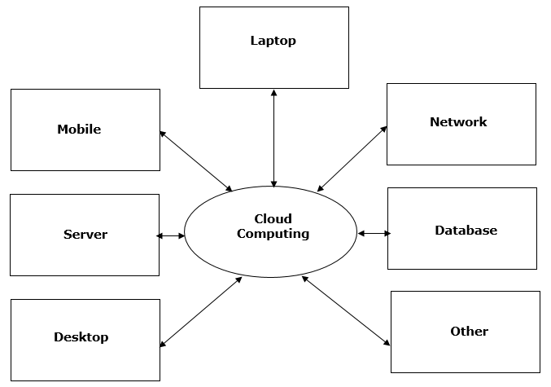
The architecture of cloud computing comprises of the following
component

Front-end device
Back-end platform
Cloud-based delivery
Network
Front-end Devices− These are basically the devices that are used by clients to access the data or program using the browser or special applications.
Back-end Platform− There are various computers, servers, virtual machines, etc. that combine to become a back-end platform.

Types of Cloud:
The storage options on cloud is in 3 forms:
Public
Private
Hybrid

Public Cloud: A service provider makes the clouds available to the general public which is
termed as a public cloud. These clouds are accessed through internet by users. These are
open to public and their infrastructure is owned and operated by service providers as in case
of Google and Microsoft.

Private Cloud: These clouds are dedicated to a particular organization. That particular
organization can use the cloud for storing the company's data, hosting business application,
etc. The data stored on public cloud can't be shared with other organizations. The cloud is
managed either by the organization itself or by the third party.

Hybrid Cloud: When two or more clouds are bound together to offer the advantage of both
public and private clouds, they are termed as Hybrid Cloud. Organizations can use private
clouds for sensitive application, while public clouds for non-sensitive applications. The hybrid
clouds provide flexible, scalable and cost-effective solutions to the organizations.

Benefits of Cloud:
There are many benefits of clouds. Some of them are listed below.
Cloud service offers scalability. Allocation and de-allocation of resources is dynamically
as per demand.
It saves on cost by reducing capital infrastructure.
It allows the user to access the application independent of their location and hardware
configuration.
It simplifies the network and lets the client access the application without buying
license for individual machine.
Storing data on clouds is more reliable as it is not lost easily

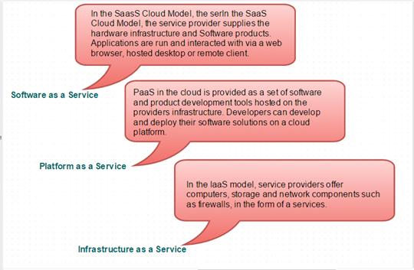

SaaS(Software as a Service)
It allows companies to use software without purchasing them, which reduces the expenditure of the company drastically, since they are already installed on the cloud servers they can be quickly deployed and therefore saves time.
PaaS (Platform as a Service)
It allows developers to build applications, collaborate on projects without having to purchase or maintain infrastructure.
IaaS (Infrastructure as a Service)
It allows companies to rent servers, storage space, etc. from a cloud provider.

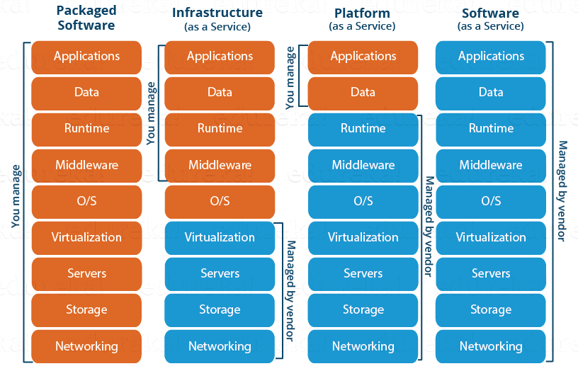
Azure services Azure offers many services in its cloud computing platform. These services include the following.

Compute services :
Services for hosting and running application workload:
Azure Virtual Machines—both Linux and Windows
App Services (Web Apps, Mobile Apps, Logic Apps, API Apps, and Function Apps)
Azure Batch (for large-scale parallel and batch compute jobs)
Azure RemoteApp
Azure Service Fabric
Azure Container Service

Data services :
Services for storing and managing data:
Azure Storage (comprises the Azure Blob, Queue, Table, and File services)
Azure SQL Database
Azure DocumentDB
Microsoft Azure StorSimple
Azure Redis Cache

Application services :
Services for building and operating applications:
Azure Active Directory (Azure AD)
Azure Service Bus for connecting distributed systems
Azure HDInsight for processing big data
Azure Scheduler
Azure Media Services

Network services :
Services for networking both within Azure and between Azure and on-premises datacenters: •
Azure Virtual Network •
Azure ExpressRoute •
Azure-provided DNS •
Azure Traffic Manager •
Azure Content Delivery Network.

AWS VS AZURE:

SERVICES AWS AZURE
Computing Services | EC2 | Virtual Machines
Storage Service | S3 | Storage Block Blob
Networking | VPC(Virtual Private Cloud) | Virtual Network
Load Balancing | Network Load balancer  Application Load balancer | Azure Load Balancers  Application Gateway
Scaling | Auto-Scaling | Virtual Machine Scale Sets.
Container Service. | Ec2 Container Service | Azure Container instances.
Kubernetes | Elastic Container Service for Kubernetes (EKS) | Azure Kubernetes Service(AKS)
Database | RDS | SQL Database,Azure Database for MYSQL
Cache Service | Elastic Cache | Azure redis Cache
Monitoring | Cloud Watch | Azure Monitor
CI/CD | Code Deploy,Code Commit, Code Pipeline | Azure Devops.
Messaging | Simple Queue Service(SQS) | Azure Queue Storage
DNS Service | Route 53 | Azure DNS.
Authentication And Authorization | IAM(identity Access Management)  Multi-Factor Authentication | Azure Active Directory  Multi-Factor Authentication
Virtual Server Disks | Elastic Block Store(EBS) | Azure Managed Disks.
Shared File system | EFS(Elastic File System) | Azure Files
Archiving And Backup | S3 IA(Infrequent Access)  S3 Glacier | Azure Storage Cool-Tier  Azure Storage Archive access tier
Web Apps | Cloud Front | Azure Content Delivery Network
Automation | Cloud Formation | Azure Resource Manager, VM Extensions, Azure Automation.
Encryption | CloudHSM | Key Vault

Azure Compute Domain and Services:

Virtual Machine
- Virtual machine allows you to deploy any workload, language, or operating system.

Virtual Machine Scale Sets
- Virtual machine scale sets are used to create thousands of identical virtual machines within minutes.
- They rely on integrated load balancing and auto
Azure Container Service
- Azure Container Service is used to create a container hosting solution optimized for Azure.
- In addition to that, it is also used to scale and manage applications using DC/OS, Docker Swarm, or Kube.
Azure Container Registry
- Azure Container Registry stores and manages container images across all types of Azure deployments.
Functions
- It lets you write codes regardless of infrastructure and provisioning of servers, especially when your functions call rate scales up.
Batch
- Batch is used to scale tens, hundreds, or thousands of virtual machines at a time.
- It stages data and executes the compute pipeline.
Service Fabric
- It simplifies small service-based application deployment and lifecycle management.
- It also delivers low-latency performance and efficiency at a massive scale.
Cloud Services
- Cloud services focus on apps and not on the hardware.
- They support Java, Node.js, PHP, Python, .NET, and Ruby.

Azure Networking Domain and Services:

Virtual Network
- Performs Network isolation and segmentation
- Filters and routes network traffic

Load Balancer
- Delivers high availability and network performance to your application
- Balances the load of incoming traffic to virtual machines
- Pushes the external traffic to a specific virtual machine
Application Gateway
- A dedicated virtual appliance providing Application Delivery Controller as a service
- Comprises multiple worker instances for scalability and high availability
Traffic Manager
- Allows you to control the distribution of user traffic for service endpoints such as Azure, web apps, and cloud services in different data centers
ExpressRoute
- Lets you extend your current networks into Microsoft cloud over a customized private connection assisted by a connectivity provider
- Establishes connections to Microsoft cloud services, such as Microsoft Azure, Office 365, and CRM online
Azure DNS
- Is responsible for translating a website to its IP address
Content Delivery Network (CDN)
- Caches the static web content at crucially placed locations to provide maximum throughput for delivering content to users
VPN Gateway
- A type of virtual network gateway that sends encrypted traffic across a public connection

Azure Storage Domain and Storage Services:
Blob Storage
- Blob storage is a service which stores unstructured data in the cloud as objects/blobs.
- It can store any type of text or binary data, such as an application installer, document, or a media file.

Queue Storage
- This type of storage provides cloud messaging between the components of an
- Queue storage delivers asynchronous messaging for communication between the components of the application.
File storage
- File Storage offers file shares in the cloud using the standard Server Message Block Protocol.
- With Azure File Storage, one can migrate legacy applications that rely on file shares to Azure quickly and without costly rewrites.
Table storage
- It is one of Azure Storage services which stores semi-structured NoSQL data in the cloud.

Azure Database Domain and Services:
SQL Database
- SQL Database is a relational database service which is based on the Microsoft SQL server engine.
DocumentDB
- It is a fully managed NoSQL database service, which is built for a fast and expected performance.
Redis Cache
- Managed by Microsoft, Redis cache is an advanced key–value store, where keys can contain data structures such as strings, hashes, lists, sets, and sorted sets.

