**COMPUTER COMMUNICATION NETWORKS – PROJECT 2**

**Team Mates: Madhukar Ganesh Chatra & Vasudevan Niketh**

1. The sample output when the constructor of each node is called to initialize the distance table:

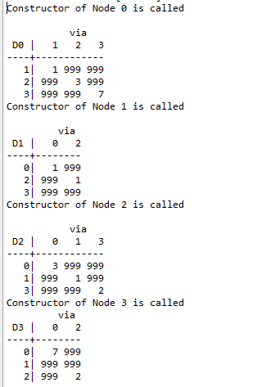

1. The sample output when the each node is updated showing the sender and receiver information along with the event and time information:

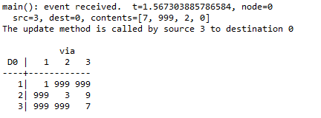

1. The Sample output when the message is displayed to show that the distance table of particular table is updated along with the updated distance table:

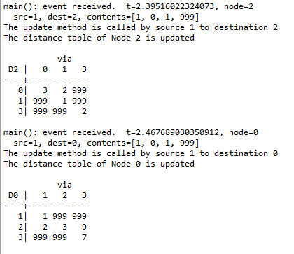

1. The final distance table at each node:

Node 0 Distance table:

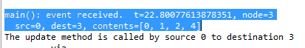

Node 1 Distance table:



Node 2 Distance table:



Node 3 Distance table:



1. The sample output to show that Network simulator is running:

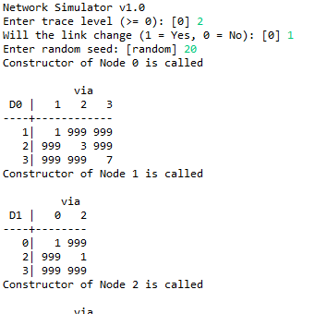

1. After Network simulator termination:

