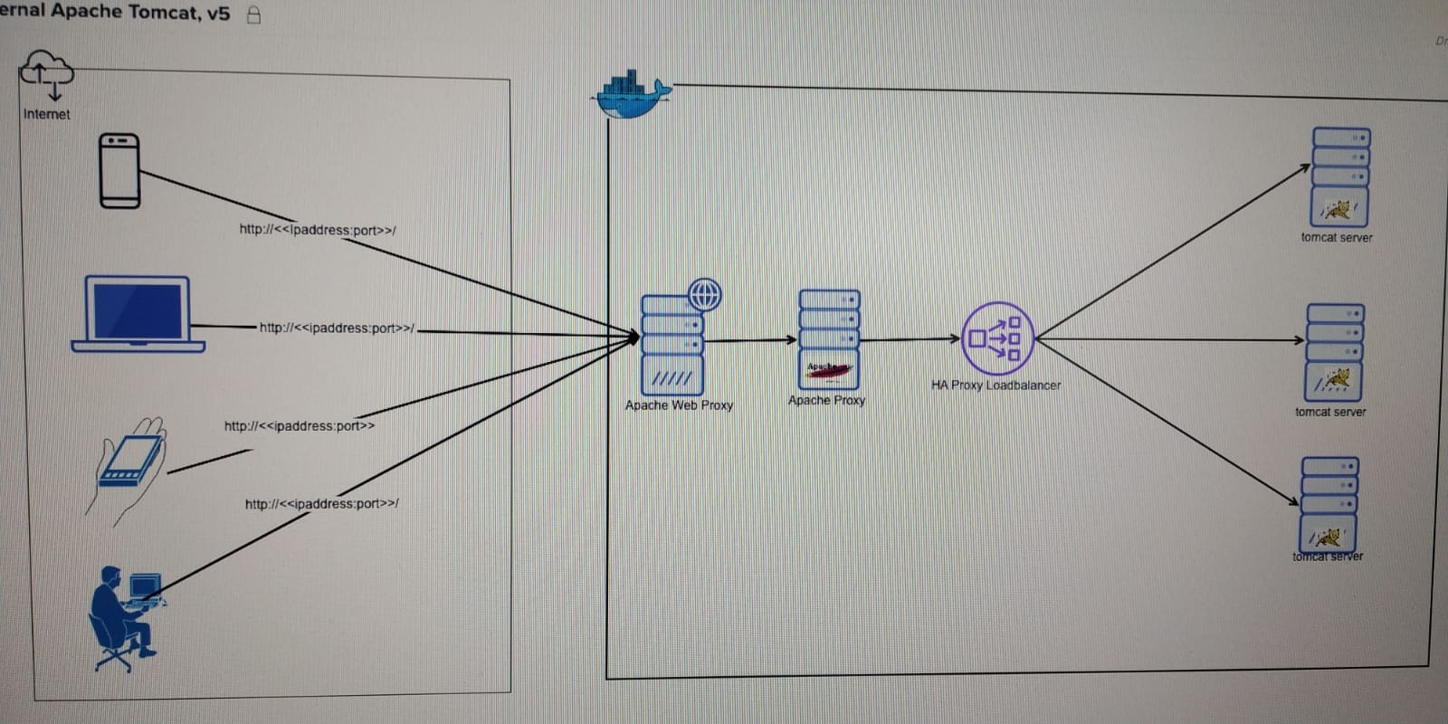

|  |
| --- |
| **Step1: Create the tomcat server containers**  docker network create wechat-server-network  docker container run -itd --name tom-wechat1 madhukargunda/wechat-social-connector-tomcat:2.0.0  docker container run -itd --name tom-wechat2 madhukargunda/wechat-social-connector-tomcat:2.0.0  docker container run -itd --name tom-wechat3 madhukargunda/wechat-social-connector-tomcat:2.0.0  docker network connect wechat-server-network tom-wechat1  docker network connect wechat-server-network tom-wechat2  docker network connect wechat-server-network tom-wechat3 |
| **Step2 : Create the haproxy container**  docker build --tag haproxy:1.0 .  docker network create ha-proxy-network  docker container create -it -p 9261:80 --network ha-proxy-network --name haproxy haproxy:1.0  docker network connect wechat-server-network haproxy  docker container start haproxy |
| **Step3: Create the reverse proxy containers**  docker build --tag my-httpd:1.0 .  docker network create reverse-proxy-network  docker container create -it -p 444:80 --network reverse-proxy-network --name my-httpd my-httpd:1.0  docker network connect ha-proxy-network my-httpd  docker container start my-httpd |
| **Step4: Create the web proxy containers**  docker build --tag myweb-httpd:1.0 .  docker network create myweb-httpd-network  docker container create --network myweb-httpd-network -p 443:80 --name myweb-httpd myweb-httpd:1.0  docker network connect reverse-proxy-network 4f28b1c80  docker inspect 4f28b1c80  docker container start 4f28b1c80  docker logs 4f28b1c80 |
| **URL to access the Tomcat**  [**http://venkateshkurva2c.mylabserver.com:9261/v1/madhukar/socialconnections/wechat**](http://venkateshkurva2c.mylabserver.com:9261/v1/madhukar/socialconnections/wechat) |