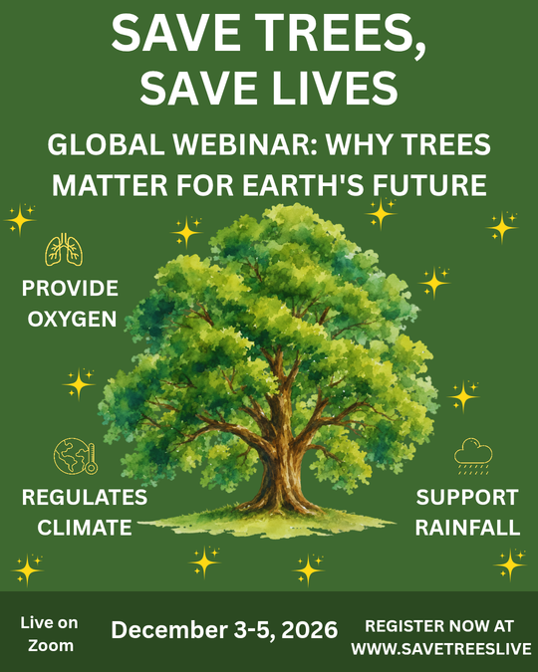

DESIGN EXPLANATION
Concept: Promotional poster for an environmental webinar to raise ecological awareness.
Colors: Forest green background with off-white typography for high contrast, legibility, and a natural feel.
Layout: Central tree illustration as the hero visual, supported by ecological benefit icons and an organized footer bar.

