Storyboard: Introduction to Iron Ore

Ref# | Slide Content | Graphics | Audio Voiceover Script | Technical Info
 | Introduction to Iron Ore | Graphic Legend  Graphic yet to be created by Graphic Artist  Graphic yet to be selected  Statistics needed to complete graph  Graphic to be created within Captivate  Unsure | Note: Voiceover should should be warm, friendly, and conversational, second person (our/we, your/you) informal. | Course Unit Learning Objective:  Demonstrate an awareness of the Iron Ore customer sector group sufficient to participate in group workshop discussions.  Intro audio = 35sec
 | - Overview  - About Iron Ore  - Our Products  - Our Business Structure  - Our Business Strategy  - Current & Future Challenges  - Summary  - Final Assessment | 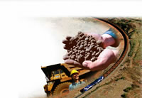  0.0.0_introduction_mockup.jpg | [sound: woosh3.mp3] | Navigation menu for entire course unit.
0.0 | Overview  Duration: 1 minute  [update elapsed time figure as needed] |  | [sound: plop.wav]  [no voiceover] | Title slide for this overview or summary lesson that prepares the learner for what this entire unit is all about.
0.1 | About this Course Unit  [Fade in each bullet point as mentioned]  - About Iron Ore  - Our Products  - Our Business Structure  - Our Business Strategy  - Current & Future Challenges  - Summary  - Final Assessment |  | In this course unit we learn About the Iron Ore Customer Sector Group in BHP Billiton.  We look at Iron Ore’s Products, with some background information about the steel industry.  We’ll learn about Iron Ore’s Business Structure…  …and Business Strategy.  Finally we discuss the Challenges it faces now and those it may face in Future.  A short Summary at the end recaps all the main points. | Provides a quick overview of the learning objectives covered in each lesson in this unit.  Bullet points all appear first and then each one is described as its bullet point is highlighted and others in the list are faded out.  Thumbnail versions of graphics from the relevant lessons can accompany the point.
0.2 | About Assessments  [large callout]  Final Assessment results may be recorded! | Show screen capture or Captivate movie of a typical assessment slide question. | Each lesson finishes with a few questions to check your learning.  When you complete all lessons, do the Final online Assessment.  Your score may be recorded for reporting purposes. | Explains the purpose of the assessments.
0.3 | Lesson End  [option buttons allow the learner to go back to the main menu or move to the next lesson in the unit.] |  | [no audio necessary] | Returns learner to the Menu slide showing all lessons within this course units.
 | About Iron Ore  Duration: ## minutes [update elapsed time figure as needed] |  | [sound: plop.wav]  [no voiceover] | Overall Lesson Learning Objective:  Define this CSG’s unique position.  Lesson audio = 3min 10sec
 | Lesson Overview  [Fade in each bullet point as mentioned]  - Our Place in BHP Billiton  - Brief History  - Our Competitive Position  - Financial Data |  | In this lesson we examine the role of Iron Ore in BHP Billiton and take a brief look at our history.  We talk about our current position in the world market..  ..and finish off with some financial statistics. | Lists the learning objectives covered in this lesson to give learners a mental picture.  Highlight each bullet point as voiceover discusses it.
 | Our Place in BHP Billiton  [fade in callout text in sync with voiceover]  Supplier of SEABORNE iron ore to carbon steel market.  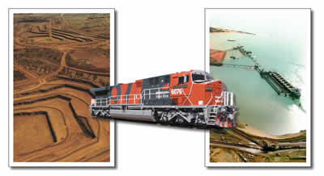  [large callout]  We Don’t Make Steel! | Fade in separate pics (as each is mentioned) in a montage left to right: iron ore mine, railway & ore cars, bulk ship handlers  [Helps to emphasize seaborne iron ore]  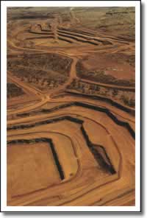  1.2.1_yandi_csm_1.swf  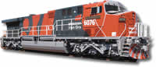  1.2.2_train.swf  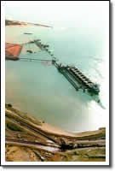  1.2.3_pthedland.swf | The Iron Ore Customer Sector Group specialises in supplying seaborne raw materials to the world’s iron and steel producers.  The key point to remember here is that we only mine and ship iron ore as raw material.  We do not produce iron or steel itself. | Learning Objective: Identify where this CSG fits within the BHP Billiton organisational structure
 | Brief History - 1899-1949  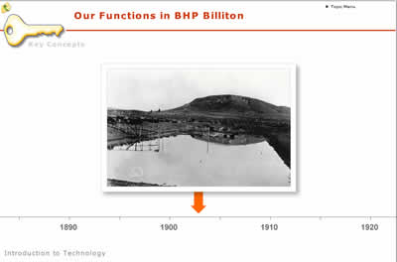 | Flash animation timeline  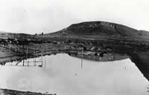  1.3.1_Iron Monarch&Iron Knob_1903.jpg  [1903] | The Broken Hill Proprietary company, or BHP as it was later known, first became interested in iron ore as far back as 1899, more than 100 years before its merger with Billiton in 2001.  Around 1900, Iron ore mines were established at Iron Knob and Iron Baron in outback South Australia.
 | Brief History - 1950-1964  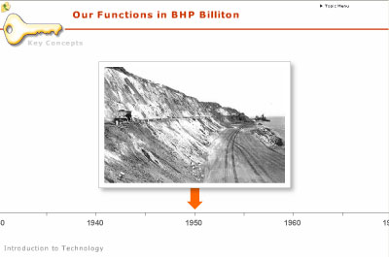 | 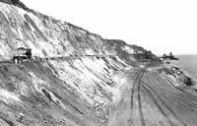  1.3.2_Kookin Island - Oct 1973.jpg  [1950] | From 1950 onwards, mines were established in Yampi Sound at Koolan and Cockatoo Islands in remote North Western Australia.
 | Brief History - 1965-2000  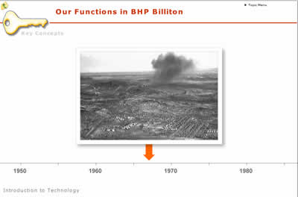  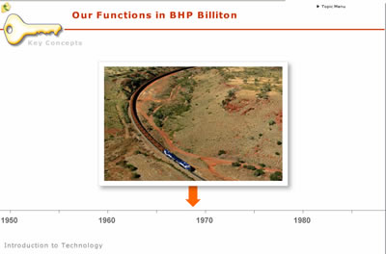  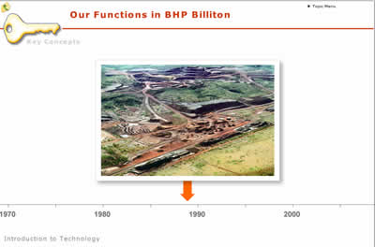 | 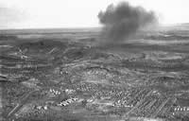1.3.4_Newman Township, with dust cloud from blast - Apr 1971.jpg  [1960’s]  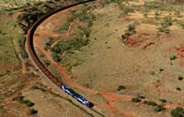  1.3.5_pthedland_csm_21.jpg  [Late ‘60s]  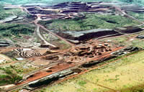  1.4.8_jimblebarA.jpg  [Late ‘80s] | In the late 1960’s, BHP partnered with other companies to mine a rich deposit at Mt Whaleback near Newman in the Pilbara region of Western Australia.  A world-class heavy-haulage rail system around 430 kilometers long was constructed to transport ore to shipping facilities at Port Hedland on the coast.  The opening of several other mines in this general area required continual expansion of rail transport and port facilities.
 | Brief History - 2001-Now  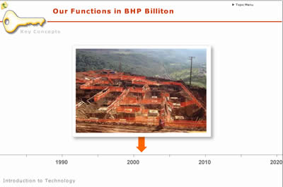 | 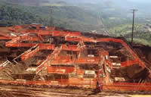  1.4.11_slide0897_image008.swf  [2001]  [blank frame pointing to 2006 with text:  Iron Ore becomes CSG | Since the BHP Billiton merger in 2001, our mining assets have continued to expand,..  .. including joint venture operations in Brazil.  Originally classed as an asset group within the Carbon Steel Materials CSG, Iron Ore was formally named as a separate CSG in its own right at the end of 2006.
 | Our Competitive Position  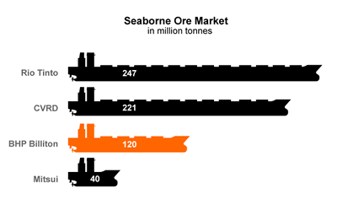 |   1.6.1_shipborne_ore.gif | BHP Billiton Iron Ore is currently the third largest producer of seaborne iron ore in the world…with about 18% of the world’s market. | Learning Objective: Compare this CSG relative to its major competitors in the world resources market
 | Financial Information  2006 EBIT 2.5 Billion USD  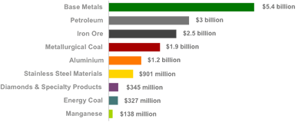 | 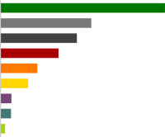  1.7.1_csg_ebit.gif  [Fade out other CGS figures, leaving just Iron Ore’s bar] | In the 2006 financial year, Iron Ore’s Earnings Before Interest and Tax, or EBIT, came in at US$2.5 Billion..  ..a 72% increase over the previous year..  ..making us one of the top three customer sector groups in BHP Billiton.  Our EBIT growth looks set to continue as the developing world, especially China and India, continue to industrialise and expand. | Learning Objective: Generalise current high-level financial data about CSG  (avoid quoting data subject to enormous changes from year to year)  Avoid quoting figures in the voiceover that might be highly subject to change, so as to reduce maintenance.  Some high level information about this CSG that is not subject to wild fluctuations from year to year (so that we don’t need to spend a lot of time maintaining and updating the content).
 | Lesson Summary  [Fade in each bullet point as mentioned]  - Seaborne Iron Ore  - Not in Steel Production  - Mining iron ore since 1899 (105 years)  - Became CSG in 2006  - 3rd Largest in Seaborne Iron Ore  - EBIT 2006 = USD$ 2.5 Billion | 1.2.3_pthedland.swf | So in summary:  The Iron Ore Customer Sector Group supplies seaborne iron ore to iron and steel producers around the world..  ..but we don’t actually make steel itself.  BHP mined iron ore as far back as 1899, over 100 years before the merger with Billiton in 2001.  Iron Ore became a separate CSG at the end of 2006 and is now the world’s third largest supplier of seaborne iron ore with about 18% of the global market.  In the 2006 Financial Year our EBIT was more than US$ 2.5 Billion, an increase of 72% over the previous year’s result. | Restates the learning objectives from the Learning Overview. Should use similar wording but may also state key info related to each objective.  Will need to quote some figures here because the question slides refer to them.
 | Lesson Assessment Questions  Instructions  [as per template] |  | Answer the following questions to see if you remember key points from this lesson.  Don’t forget to click Submit before moving onto the next question.  Click the button when you’re ready to begin. | This quiz section applies only to learning objectives covered in the current lesson.  Provide any instructions about prerequisites (e.g. must be online) about how to complete the quiz.
 | True or False  BHP Billiton Iron Ore specialises in supplying seaborne iron ore to the world’s iron and steel producers.  [Mark the statement True or False, then click Submit.]  - True  - False |  | [no voiceover] | Iron Ore is the Customer Sector Group within BHP Billiton that supplies seaborne iron ore to iron and steel producers around the world.
 | Multiple Choice  What was Iron Ore’s annual EBIT contribution in 2006?  [Select the most correct answer, then click Submit.]  - US$ 2.0 Billion  - US$ 2.1 Billion  - US$ 2.2 Billion  - US$ 2.3 Billion  - US$ 2.4 Billion  - US$ 2.5 Billion |  | [no voiceover] | In the 2006 Financial Year our EBIT was more than US$ 2.5 Billion, an increase of 72% over the previous year’s result.
 | Multiple Choice  When did BHP begin mining iron ore?  [Select the most correct answer, then click Submit.]  - 1879  - 1899  - 1909  - 1919 |  | [no voiceover] | The BHP company mined iron ore as early as 1899, over 100 years before the merger with Billiton in 2001.
 | Multiple Choice  Where does Iron Ore rank among world producers of seaborne iron ore?  [Select the most correct answer, then click Submit.]  - first  - second  - third  - fourth  - fifth |  | [no voiceover] | Iron Ore became a separate CSG in its own right at the end of 2006 and is now the world’s third largest supplier of seaborne iron ore with about 18% of the global market.
 | True or False  BHP Billiton Iron Ore is involved in steel production.  [Mark the statement True or False, then click Submit.]  - True  - False |  | [no voiceover] | Iron Ore is the Customer Sector Group within BHP Billiton that supplies seaborne iron ore to iron and steel producers around the world but we don’t actually make steel itself.
 | Assessment Results  [standard automated slide] |  |  | This slide automatically displays the learner’s assessment results. After reading their results, learners can opt to review their answers and see where they went wrong.
 | Lesson End  [option buttons allow the learner to go back to the main menu or move to the next lesson in the unit.] |  | [no audio necessary] | Returns learner to the Menu slide showing all lessons within this course units.
 | Our Products  Duration: ## minutes [update elapsed time figure as needed] |  | [sound: plop.wav]  [no voiceover] | Lesson Learning Objective:  Explain the product/s from which this CSG creates revenue.  Audio voiceover time = 4min 0 sec
 | Lesson Overview  [fade in each point as mentioned]  - About Iron Ore  - Iron Ore Products  - About Steel  - How Steel is Made  - Steel Products |  | In this section we look at our core product - iron ore.  We discuss the different forms of the mineral..  ..and how we ship it to customers.  Since Iron ore is used to make steel, we’ll also briefly discuss steel production. | Previews the learning objectives for this lesson
 | About Iron Ore  [fade in transparent callout of percentage in a dark corner of the earth photo. White text on the black]  5% | Flash animation:  zoom out FE (iron) on table of elements  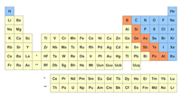  2.2.2_periodic_table_of_elements.fla    2.2.1_j0182763.swf | Iron is one of the most abundant elements on our planet,..  ..making up about 5% of the Earth's crust. | Learning Objective: List four different mineral variants of iron ore.
 | Types of Iron Ore  [fade in callouts over top of each ore pic as mentioned]  Magnetite  Hematite  Goethite  Limonite  [ticks appear to right of ores that BHPB mines – i.e hematite, goethite, limonite] | 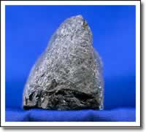  2.2.3_magnetite.swf  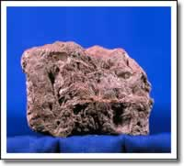  2.2.4_hematite.swf  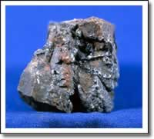  2.2.5_goethite.swf  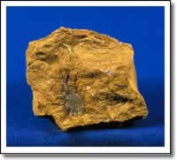  2.2.6_limonite.swf | The most common mineral forms of iron ore are..  ..magnetite..  ..hematite..  ..goethite..  ..limonite and..  ..itabirite.  Most of BHP Billiton’s iron ore operations mine hematite, goethite and limonite.
 | Iron Ore Products  [fade in callouts over top of pic as mentioned]  Lump  Fines  Concentrate & Pellets | 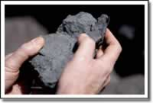  2.3.1_newman_csm_82.swf  [Lump]  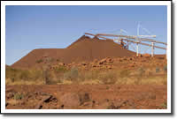  2.3.2_Yandi_CSM_2b_fines.swf  [Fines]  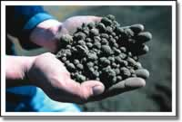  2.3.3_metalloys_csm_9.swf  [Pellets] | We sell and ship iron ore to clients as either:  Lump,  Fines,  Concentrate..(which is ore enriched by removing waste material)..  ..or Pellets – which are marble-sized iron ore balls made from Concentrate.
 | About Steel  [fade in bullets]  - Carbon Steel  - Alloy Steel | [fade in pics of steel products]  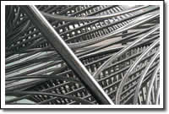  2.4.1_800px-Stainless_steel.swf    2.4.3_toaster.jpg | Iron ore makes up about 90% of the ingredients required to produce steel..  ..and steel is without doubt the most useful metal known to man.  There are two main types of steel:  Carbon Steel..  ..and Alloy steel. | Learning Objective: Explain the difference between carbon steel and alloy steel.  Conceptual topic to differentiate carbon steel from alloy steel.
 | About Carbon Steel  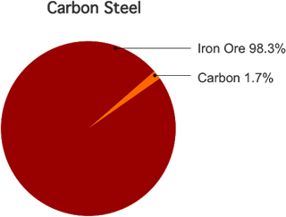 | 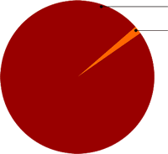  2.4.1_carbon_pie_blank.gif | Carbon Steel …, contrary to what its name might suggest, is not high in carbon!  During steel-making, carbon is removed until only 1.7% or less remains. This is because too much carbon makes steel brittle and easily shattered. | Learning Objective: Explain the importance of carbon content in steel.
 | About Alloy Steel  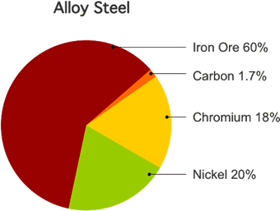 | 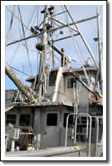  2.4.2_ist2_2251971  _fishing_boat.swf  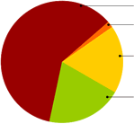  2.4.3_alloy_pie_blank.gif | Alloy Steel…is just carbon steel with other metals added to give the steel special properties.  For example stainless steel has Chromium and also usually Nickel added to make it corrosion resistant. | Learning objective: Explain the function of alloys in alloy steel.
 | How Steel is Made  [diagram and animation of a blast furnace operation]  [animation should follow the steel process] | Flash Animation of blast furnace and steel mill  [use these graphics as needed to create the animation]  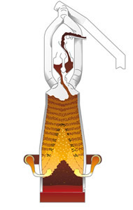  2.5.1_blast_furnace_cutaway.jpg  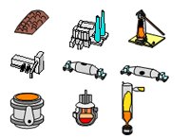  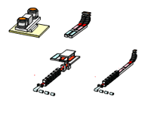  2.5_plant_and_product_graphics.ppt | The most common method of steel production is a two-stage process using blast furnaces.  In the first part of the process:  Layers of iron ore and coking coal are added at the top of the furnace.  Hot air is forced or “blasted” into the furnace until temperatures reach over 2,000 degrees Celsius.  Gases such as carbon monoxide are formed which strip oxygen from the iron ore, which then melts to form liquid pig iron with about 4% carbon.  The liquid iron is taken out of the furnace and transported in rail cars to another furnace called a Basic Oxygen Furnace.  In the second phase of the process excess carbon and other impurities are removed…to finally create carbon steel.  If steel with special properties is required, other metals are added in precise quantities to create alloy steel.  Finally the steel is poured or ‘cast’ into moulds. | Learning objective: Explain the steelmaking process.  Basic awareness of steelmaking concepts.
 | About Steel Products  [fade in each bullet and graphic set as mentioned]  - Blooms  - Billets  - Slabs | [use these graphics as needed to create the animation]  2.5_plant_and_product_graphics.ppt  (For graphics of rolling mills and treatment)    2.5_plant_and_product_graphics.ppt  (For graphics of blooms, billets and slabs.) | Cast steel comes in one of three forms:  Blooms are long lengths of steel with a large square cross-section.  Billets are smaller versions of blooms, usually square or rounded cross-section.  And..Slabs ..thick, flat pieces that can be rolled to make sheet or plate steel. | Learning objective: List different shapes of steel products emerging from the steel production process.
 | About Long and Flat Products  [fade in callouts over top of relevant graphics]  Long Products  Flat Products | [use these graphics as needed to create the animation]  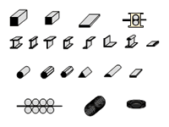  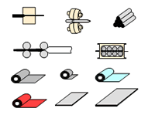  2.5_plant_and_product_graphics.ppt | After casting, steel is further processed into:  Long Products—such as wire, rods, girders or bars; and  Flat Products—such as rolls of sheet metal or steel plate.
 | Where Steel is Used  [fade in various overlapping photos one at a time showing steel end uses] |   2.5.2_Chrysler_Building  _detail.swf  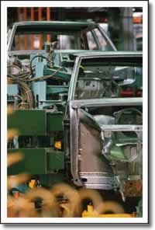  5.6.2_j0400416.swf  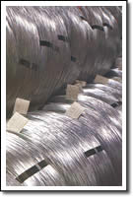  2.5.7_slide0073_image098  _edit.swf | Steel's desirable properties, and its relatively low cost, make it the main structural metal in engineering and building projects, accounting for about 90% of all metal used each year.  But it’s important to remember that iron ore is the key ingredient in steel, no matter what type or shape of steel you have and no matter what you make with it.
 | Lesson Summary  - Hematite, Goethite, Limonite  - Lumps, Fines, Concentrate, Pellets  - Carbon Steel—does NOT have high carbon!  - Carbon Steel + Alloys = Alloy Steel  - Steel Production Process  - Blooms, Billets, Slabs  - Long & Flat Product | 2.5.1_blast_furnace_cutaway.jpg | So in summary:  Our core product is Iron Ore, usually mined as hematite, goethite or limonite.  We ship product as lump, fines, concentrate, or pellets.  Iron Ore is the main ingredient in both carbon steel..  ..which actually has less than 2% carbon,..  ..and alloy steel, which is just carbon steel with extra alloys added to give special properties.  To make steel, iron ore and coke are added to a blast furnace to produce pig iron, from which surplus carbon is removed to create carbon steel. Extra ingredients are then added to create alloy steel.  Steel is cast as blooms, billets or slabs and sold as either long or flat products. | Recap to reinforce the learning
 | Lesson Assessment Questions  Instructions  [as per template] |  | Answer the following questions to see if you remember key points from this lesson.  Don’t forget to click Submit before moving onto the next question.  Click the button when you’re ready to begin. | This quiz section applies only to learning objectives covered in the current lesson.  Provide any instructions about prerequisites (e.g. must be online) about how to complete the quiz.
 | True or False  Alloy Steel begins as carbon steel to which extra metals are added to give special properties.  [Mark the statement True or False, then click Submit.]  - True  - False |  | [no voiceover] | Alloy steel is just carbon steel with extra alloys added to give special properties.
 | Multiple Answer  Which of the following statements about steel are correct?  [Select all correct statements, then click Submit.]  - Carbon Steel is so-named because it contains high levels of carbon.  - Carbon steel has low levels of carbon content.  - Carbon makes steel harder.  - Too much carbon makes steel brittle.  - Carbon is required to prevent steel from becoming brittle. |  | [no voiceover] | Despite what its name might suggest, carbon steel has less than 2% carbon content.
 | Multiple Answer  Which of the following items are iron ore?  [Select all correct answers, then click Submit.]  - Hematite  - Pyrite  - Goethite  - Cellulite  - Limonite  - Itabirite  - Laterite  - Magnetite |  | [no voiceover] | Our core product is Iron Ore, mined usually as hematite, goethite or limonite.
 | Drag and Drop  Match the stages in the steelmaking process with their correct order.  [Drag steps from the right over to their correct order on the left side, then click Submit]  - Layers of iron ore and coke are added to the blast furnace.(1)  - Carbon monoxide is strips oxygen is from the iron ore(2)  - Pig Iron is produced.(3)  - Alloy steel is produced.(7)  - Carbon Steel is produced.(5)  - Excess carbon is removed.(4)  - Extra metals are added in precise quantities to give special properties.(6) |  | [no voiceover] | Iron ore and coke are added to a blast furnace to produce pig iron, from which surplus carbon is removed in a Basic Oxygen Furnace to create carbon steel. Then extra ingredients are added to create alloy steel.  Note to Developer: Numbers in parentheses show the correct order of steps.
 | Multiple Answer  Steel products come in which of the following shapes?  [Select all correct answers, then click Submit.]  - Billets  - Pellets  - Blooms  - Lump  - Slabs  - Fines |  | [no voiceover] | Steel is cast as blooms, billets or slabs and sold as long or flat products.
 | Assessment Results  [standard automated slide] |  |  | This slide automatically displays the learner’s assessment results. After reading their results, learners can opt to review their answers and see where they went wrong.
 | Lesson End  [option buttons allow the learner to go back to the main menu or move to the next lesson in the unit.] |  | [no audio necessary] | Returns learner to the Menu slide showing all lessons within this course units.
 | Our Business Structure  Duration: ## minutes [update elapsed time figure as needed] |  | [sound: plop.wav]  [no voiceover] | Lesson Learning Objective:  Summarise the current business structure of this CS  Audio Voiceover = 4 min 0 sec
 | Lesson Overview  [fade in each point as mentioned]  - About Our Business Structure  - Our Site Locations  - Our Human Resources |  | In this lesson we explain how BHP Billiton Iron Ore is structured organisationally,..  ..we take a quick tour of Iron Ore’s site locations,..  ..and finish off with some figures about our workforce. | Overview topic to state the learning objectives.
 | About Our Business Structure  [fade in callouts over boxes when mentioned]  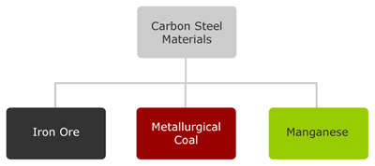 | 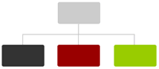  3.2.1_csm_org1_blank.gif  [fade in world map over top of org chart]  _global_map.jpg  [fade in symbols over locations of Perth and Singapore as mentioned]    3.2.2_headoffice.swf    3.2.3_sales.swf | Iron ore is one of three Customer Sector Groups in the Carbon Steel Materials group. The others are Metallurgical Coal and Manganese.  All three became customer sector groups in their own right in late 2006.  Our world headquarters is located in Perth, the capital of Western Australia, where most of our mining assets are located.  For product sales, we rely on the services of the Marketing functional group, based in Singapore. | Learning Objective: Outline the organisational hierarchy of this CSG
 | About Joint Ventures  [fade in as mentioned]  CVRD Samarco is a 50:50 JV  Tang Shan Steel |   3.3.1_handshake.swf  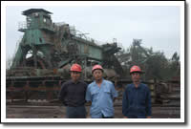  3.3.3_DSC_004.swf | Virtually all of BHP Billiton’s iron ore operations are joint ventures with other partners from around the world.  For example, BHP Billiton currently partners 50:50 with CVRD as Samarco to mine and ship iron ore deposits at our operations in Brazil.  We also often enter into specific partnering arrangements with major clients.  This offers a win:win relationship for both parties because we gain a guaranteed customer, and they gain a guaranteed supplier.
 | Our Site Locations | [Fade in map and then fade in West Oz and Brazil when mentioned]  _global_map.jpg    _global_map_  western_australia.swf    _global_map_brazil.swf | Iron Ore’s main mining operations are located in two continents..  ..Western Australia,..  ..and Brazil in South America. | Learning Objective: Identify main site locations for this CSG around the world
 | Western Australia  [fade in highlight boxes over each mine as it is mentioned in the voiceover]  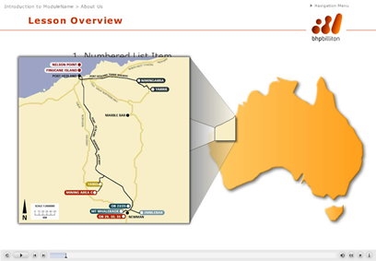 | [fade in map of Australia]    3.5.1_Australia.swf  [fade in map of pilbara region]  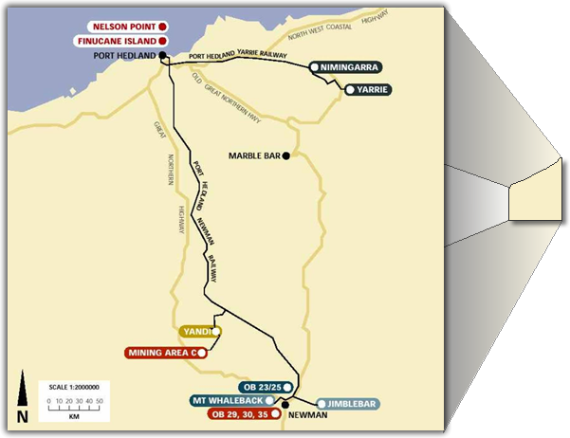  3.5.2_PilbaraMap.swf  [fade in train pic over map of Australia]  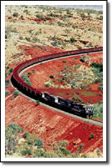  3.6.1_pthedland_csm_21.swf | Australia has some 31.5 billion tonnes in iron ore reserves,  …and about 80% of this is located in the Pilbara region of central Western Australia.  Most of BHP Billiton’s iron ore assets are located here..  ..at Mt Whaleback near the Newman township..  ..Nimingarra  ..Yarrie  ..Yandi,  ..Jimblebar  ..and Area C,  ..as well as several other satellite orebody locations near Newman.  To transport iron ore from mines to port facilities, a privately owned heavy haulage rail link was built over 400 kilometers to Port Hedland on the Pilbara coast.  Spur lines were built to bring ore from each mine.  Our rail lines don’t just transport ore to port. They also play a key role in the production process itself.
 | Port Hedland | 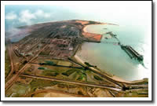  3.6.2_H309-08A.swf  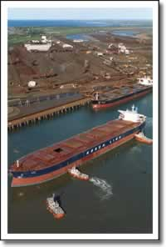  4.6.1_pthedland_csm_18.swf | Port Hedland on the Pilbara Coast has been expanded over the past 40 years to now permit loading of bulk carriers,  ..some in excess of 250,000 tonnes dead weight.  This world-class infrastructure allows us to ship record tonnages of iron ore each year.
 | South America – Brazil  [fade in as mentioned]  Samarco 50% joint venture. | (fade in complete map of world again and overlay map of Brazil  _global_map.jpg  _global_map.png  _global_map_brazil.swf  2.3.3_metalloys_csm_9.swf  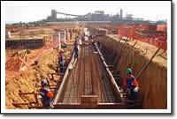  3.7.1_slide0897_image013.swf  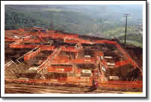  3.7.2_slide0897_image008.swf | In South America, BHP Billiton has a 50% joint venture with CVRD in Samarco Iron Ore in Brazil.  This operation produces more than 15 million tonnes of low-cost pelletised iron ore annually.  Ore is transported via a 400 kilometre slurry pipeline from inland mines to coastal port facilities producing pellets. These are then shipped to the world’s seaborne iron ore markets.  A new pelletising plant is set to increase production by 7.6 million tonnes to a total of 21.6 million tonnes per annum.
 | Our Human Resources  [display callout on top]  Approx 9,000 Employees and Contractors | [fade in overlapping pics of employees]  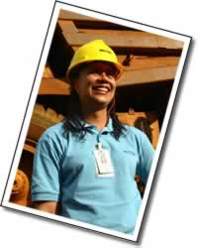  3.8.1_samarco_csm_46.swf  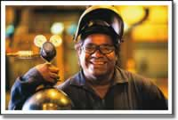  3.8.2_newman_csm_4.swf  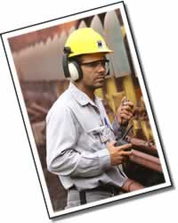  3.8.3_samarco_csm_74.swf | On the human resources side,..  Iron Ore has a workforce of about 9,000 employees and contractors, not including Samarco in Brazil where BHP Billiton is not the operating company. | Learning Objective: State the approximate number of human resource working within this CSG  Shows size relative to other CSGs
 | Lesson Summary  [fade in each point as mentioned]  - BHP Billiton Iron Ore is a CSG  - Focus on operations - not sales  - Pilbara, Western Australia  - Samarco, Brazil.  - Around 9,000 employees and contractors |  | So in summary:  Iron Ore is one of a group of CSGs in the Carbon Steel Materials group.  Our head office is in Perth, Western Australia and product marketing is handled by the Marketing Functional Group from Singapore.  The bulk of our site operations are in the Pilbara region of Western Australia, including Mt Whaleback near Newman, as well as Yandi, Nimingarra, Yarrie, and Area C.  We have a world class heavy haulage rail line stretching over 400 kilometers from Newman to Port Hedland’s bulk shipping facility.  We have a joint venture operations at Samarco in Brazil with inland mines connected via a slurry pipeline to a pelletising plant and port facilities on the coast.  Our workforce is approximately 9,000 employees and contractors, not including Samarco in Brazil. | Lesson Learning Objective:  - Summarise the current business structure of this CSG  Topic-level learning objectives:  - Outline the organisational hierarchy of this CSG  - Compare breakdown numbers of human resource groupings within this CSG  - Identify main site locations for this CSG around the world
 | Lesson Assessment Questions  Instructions  [as per template] |  | Answer the following questions to see if you remember key points from this lesson.  Don’t forget to click Submit before moving onto the next question.  Click the button when you’re ready to begin. | This quiz section applies only to learning objectives covered in the current lesson.  Provide any instructions about prerequisites (e.g. must be online) about how to complete the quiz.
 | True or False  BHP Billiton Iron Ore is a Functional Group belonging to Carbon Steel Materials and markets its own products from headquarters in Perth Western Australia.  [Mark the statement True or False, then click Submit?]  - True  - False |  | [no voiceover] | Iron Ore is one of a group of CSGs in the Carbon Steel Materials group.  Our head office is in Perth, Western Australia and product marketing is handled by the Marketing Functional Group from Singapore.  This is false because Iron Ore is a CSG, not a Functional Group, and does not do marketing.
 | Multiple Answer  In which continents does BHP Billiton have established iron ore operations?  [Select all correct answers, then click Submit.]  - Europe  - Africa  - Asia  - Australia  - North America  - South America  - Antarctica |  | [no voiceover] | The bulk of our site operations are in the Pilbara region of Western Australia, including Mt Whaleback near Newman, as well as Yandi, Nimingarra, Yarrie, and Area C.  We have a world classs heavy haulage rail line stretching over 400 kilometers from Newman to Port Hedland’s bulk shipping facility.  We have a joint venture operations at Samarco in Brazil with inland mines connected via a slurry pipeline to a pelletising plant and port facilities on the coast.
 | Multiple Choice  In which region of Western Australia are most of BHP Billiton Iron Ore’s assets located?  [Select the most correct answer, then click Submit.]  - The Kimberley  - The Pilbara  - The Murchison  - The Monaro  - The Outback |  | [no voiceover] | The bulk of our site operations are in the Pilbara region of Western Australia, including Mt Whaleback near Newman, as well as Yandi, Nimingarra, Yarrie, and Area C.
 | Multiple Answer  Which of the following items are BHP Billiton mines located in West Australia?  [Select all correct answers, then click Submit.]  - Iron Knob  - Iron Baron  - Mt Whaleback  - Port Hedland  - Samarco  - Yandi  - Yarrie |  | [no voiceover] | South Australian mine names are not correct because they are not in Western Australia. Port Hedland is not a minesite.
 | Multiple Choice  What is the name of BHP Billiton’s iron ore joint venture mine and pelletising project in Brazil?  [Select the most correct answer, then click Submit.]  - Samarco  - Semancor  - Semantica  - Sonora |  | [no voiceover] | We have a joint venture operations at Samarco in Brazil with inland mines connected via a slurry pipeline to a pelletising plant and port facilities on the coast.
 | Multiple Choice  Approximately how many people work at Iron Ore’s locations around the world?  [Select the most correct answer, then click Submit.]  - Less than 2000  - 2,001 to 3,000  - 3,001 to 5,000  - 5,001 to 10,000  - Greater than 10,000 |  | [no voiceover] | Our workforce is approximately 9,000 employees and contractors, not including Samarco in Brazil.
 | Assessment Results  [standard automated slide] |  |  | This slide automatically displays the learner’s assessment results. After reading their results, learners can opt to review their answers and see where they went wrong.
 | Lesson End  [option buttons allow the learner to go back to the main menu or move to the next lesson in the unit.] |  | [no audio necessary] | Returns learner to the Menu slide showing all lessons within this course units.
 | Our Business Strategy  Duration: ## minutes [update elapsed time figure as needed] |  | [sound: plop.wav]  [no voiceover] | Lesson Learning Objective:  Describe core elements of the CSG business strategy
 | Lesson Overview  [fade each bullet with highlights]  - About Our Business Strategy  - Our Competitive Advantages  - Our Enabling Technologies  - Proof of Strategy Succcess |  | In this lesson we discuss Iron Ore’s business strategy,..  ..and look at the technologies that are vital to the success of our operations.  Finally we outline evidence that proves our strategy is a success.
 | About Our Strategy  [fade in strategy callout when mentioned]  Be the World’s Premier Iron Ore Producer  [fade in callouts one above each other as shown below to spell out BRIC]  Brazil  Russia  India  China  [Fade out all overlay maps except China] |   _global_map.png  _global_map.jpg  [fade in country overlays as each is mentioned in the voiceover]  _global_map_brazil.swf    _global_map_russia.swf    _global_map_india.swf    _global_map_china.swf | Iron Ore’s business strategy is to be the world’s Premier producer of iron ore helping to build the modern world.  As a high performing organisation we deliver superior value to our shareholders by expanding our production capacity on a timely basis to meet our customer demands.  The world’s demand for iron ore is directly tied to demand for steel. At present the demand is high..  ..driven by a group of emerging nations known as the BRICs economies made up of:  ..Brazil  ..Russia  ..India, and  ..China..the undisputed leader at this point.  Maintaining our current clients while we expand our operations to meet the huge demand for iron ore by China’s developing economy is a key to our success. | Learning Objective: Explain Iron Ore’s business strategy
 | Our Competitive Advantages  [fade in each bullet as it is mentioned in the voiceover]  - Quality asset portfolio  - Economies of scale  - Innovative products  - History as reliable supplier  - Superior customer service |  | We have a number of competitive advantages in our favour:  Firstly, we have a strong portfolio of long life, high-quality mining assets located close to emerging markets;  The sheer scale of our operations and advanced infrastructure makes us cost effective.  Our intimate knowledge of the steel industry and related technologies enables us to develop innovative products that meet customer requirements;  We’ve demonstrated a proven history as a reliable supplier; and finally...  We’re dedicated to superior customer service. | Learning Objective: List factors to prove the success of the CSG’s chosen strategy
 | Our Enabling Technologies  [fade in each point as mentioned]  - Heavy Earthmovers  - Heavy Rail Transport  - Bulk Shipping | [fade in small pics for each bullet]  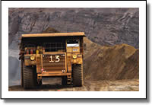  4.4.1_samarco_csm_31a.swf  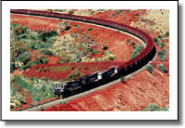  4.4.2_pthedland_csm_21.swf  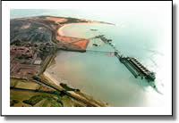  4.4.3_H309-08A.swf | Our success relies on a number of enabling technologies.  Iron ore, is a bulk commodity.  As a result, we are very reliant on technologies that permit large-scale bulk ore handling,  ..including heavy earthmovers,  ..bulk rail transport,  ..and bulk shipping. | Learning Objective: Describe key technologies essential for this CSG to achieve production
 | Heavy Earthmoving and Mining Equipment | 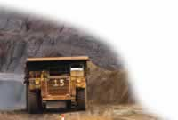  4.5.1_samarco_csm_31a.jpp  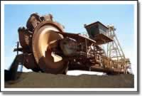  4.5.2_reclaimer.swf | The mining industry is constantly moving to larger earthmoving equipment, ore trains, and ships to achieve economies of scale.  Our operations utilise the latest and largest in earthmoving technologies. | Learning Objective: Describe key technologies essential for this CSG to achieve production
 | Bulk Rail Transport | 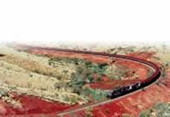  4.6.1_pthedland_csm_21.jpg  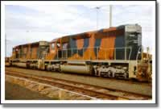  4.6.2_pthedland_csm_93.swf    4.6.3_NQ8K7418.swf | Since our mines in the Pilbara are far from our port facilities on the coast, rail transport is at least as important as our mining technology and is a key element in producing on-grade iron ore.  Our Pilbara operations have one of the best heavy haulage rail systems in the world., with over 400 kilometers of track designed and built to carry enormous loads..  .  .and now with state of the art automated equipment to track every shovel of ore at any point on its journey from mine to market. | Learning Objective: Describe key technologies essential for this CSG to achieve production  This is a reference to the E2E project.
 | Bulk-handling Port and Shipping  [pics or video of Port Hedland, ore stackers, ship loaders etc] | 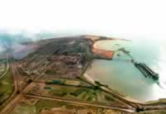  4.7.1_pt_hedland1.jpg  4.7.2_pthedland_csm_18.swf  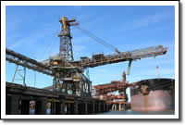  4.7.4_shiploader.swf | At Port Hedland, bulk carrier vessels over 250,000 tonnes dead weight can now be docked,..  ..loaded..  ..and dispatched in a less than 36 hours.  As you can see, our infrastructure, together with our proximity to the Asian market, gives us a significant competitive advantage. | Learning Objective: Describe key technologies essential for this CSG to achieve production
 | Proof of Success  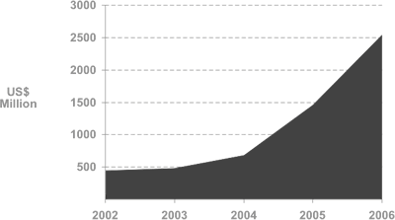 | 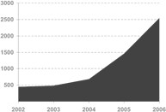  4.8.1_iron_ore_5yearebit.gif  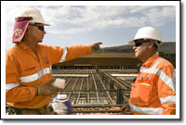  4.8.1_RGP4 (1).swf  [Fade in over blank part of graph] | Proof that our chosen business strategies are working can be seen in the following facts:  We are currently one of the top three suppliers of seaborne iron ore in the world,..  ..and to cope with forecast demand, we have major growth projects in the pipeline to boost production to over 150 million tonnes by 2012. | Learning Objective: List factors to prove the success of the CSG’s chosen strategy
 | Lesson Summary  [fade in each point as mentioned]  - Be the World’s Premier Iron Ore Producer  - Technologies:  - Heavy Earthmoving,  - Heavy Rail Transport  - Bulk Ship Handling  - Success proven by current expansion projects  - Competitive Advantages:  - Portfolio  - Cost Efficiency  - Reliability  - Service Reputation |  | So to review:  Our business strategy is to:  Become the world’s premier iron ore producer while maintaining our existing clients,  .. boosting production to increase our market share in the developing world ..  ..especially to the BRICs economies of Brazil, Russia, India and China.  Our key enabling technologies revolve around bulk handling of ore, specifically..Heavy earthmoving equipment..Heavy rail transport, and..Bulk ship loading facilities.  We’re now the world’s third largest producer of seaborne iron ore with several expansion projects under way – proof that our business strategy is working.  We’ve achieved this position because we have a portfolio of long life mining assets,..  ..economies of scale..  ..we’re a reliable supplier of innovative products,..  ..with a reputation for great customer service. | Restate the key points to reinforce learning before the assessment.
 | Lesson Assessment Questions  Instructions  [as per template] |  | Answer the following questions to see if you remember key points from this lesson.  Don’t forget to click Submit before moving onto the next question.  Click the button when you’re ready to begin. | This quiz section applies only to learning objectives covered in the current lesson.  Provide any instructions about prerequisites (e.g. must be online) about how to complete the quiz.
 | True or False  Iron Ore’s business strategy is to become the world’s premier iron ore producer servicing the demands of emerging economies such as China.  [Mark the statement True or False, then click Submit.]  - True  - False |  | [no voiceover] | Our business strategy is to:  Become the world’s premier iron ore producer while maintaining our existing clients,  .. boosting production to increase our market share in the developing world ..  ..especially to the BRICs economies of Brazil, Russia, India and China.
 | Multiple Answer  The key enabling technologies for successful iron ore business are:  [Select all correct answers, then click Submit.]  - Heavy earthmoving equipment  - Heavy rail transport  - Sulphide ore leaching  - Bulk handling port and shipping facilities  - Basic Oxygen Blast Furnace Technologies |  | [no voiceover] | Our key enabling technologies all revolve around bulk handling of ore, specifically..Heavy earthmoving equipment..Heavy rail transport, and..Bulk handling port facilities
 | Multiple Choice  Which of the following statements is true?  [Select the most correct statement, then click Submit.]  - We are now the world’s largest producer of seaborne iron ore.  - We contribute more EBIT to BHP Billiton than any other CSG.  - We sell more iron ore to India than to China.  - We now have multiple expansion projects now underway to cope with increased demand. |  | [no voiceover] | Our business strategy is working because we are now the world’s third largest producer of seaborne iron ore with several expansion projects under way.  The idea here is to require the learner to show that they understand a number of truths already covered in previous lessons as well as this one.  - Iron ore is only the third largest supplier of seaborne iron ore.  - We are not the largest EBIT contributor to BHP Billiton. Base Metals is currently that leader.  - Lots of people sell iron ore to China, not just us.  - Our expansion is just one of the proofs that our strategy is working. But it’s the only proof listed here so it’s the correct answer.
 | Multiple Answer  What are some of Iron Ore’s competitive advantages?  [Select all correct answers, then click Submit.]  - We have an excellent portfolio of long life mining assets.  - We have a reputation as a reliable supplier.  - We know the steel industry well.  - We give excellent customer service.  - Our size creates economies of scale. |  | [no voiceover] | We gained this position because we have an excellent portfolio of long life mining assets,..we enjoy economies of scale due to sheer size..we’re a reliable supplier of innovative, high quality product,..with a reputation for great customer service.
 | Assessment Results  [standard automated slide] |  |  | This slide automatically displays the learner’s assessment results. After reading their results, learners can opt to review their answers and see where they went wrong.
 | Lesson End  [option buttons allow the learner to go back to the main menu or move to the next lesson in the unit.] |  | [no audio necessary] | Returns learner to the Menu slide showing all lessons within this course units.
 | Current & Future Challenges  Duration: ## minutes [update elapsed time figure as needed] |  | [sound: plop.wav]  [no voiceover] | Lesson Learning Objective:  Outline the challenges faced by this CSG  Title slide for this lesson. Should also show the duration in minutes. Update this by referring to the Captivate Storyboard tab info at each publish.  Voiceover time = 4min 0 sec.
 | Lesson Overview  [fade in each as mentioned]  - Our Greatest Challenge  - Other Challenges  - About the Ages of Steel  - Our Future |  | In this final lesson we examine the greatest challenges currently facing Iron Ore..  ..and future challenges that we expect.  We also look at the cyclical nature of the steel commodities market..  ..to see what the future of iron ore may be. | Briefly state the learning objectives to prepare the learner for what is to come.
 | Our Greatest Current and Future Challenge  [fade in large callout over top of pictures of workers]  Not enough people! | 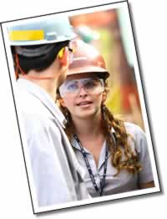  5.2.1_samarco_csm_112.jpg    5.2.2_samarco_csm_76.jpg  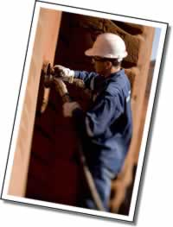  5.2.3_newman_csm_102.jpg | One of Iron Ore’s main challenges at present, and for the foreseeable future, is dealing with a lack of adequate human resources.  Simply put, we just can’t find enough skilled people to fill available positions at our operations. As a result, expansion at several locations is being held up.  To satisfy expected demand over the next 5-10 years we need to employ thousands of extra workers.  However,..during this same period, about one quarter of our current workforce is due to retire.  So this shortfall in skilled labour will continue to be one of our main challenges for the foreseeable future, and has the potential to impact our ability to exploit available opportunities. | Learning objective: List the key challenges that are currently limiting factors in achieving our goals.
 | Another Challenge—Increasing Costs | 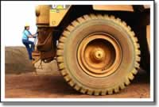  5.3.1_samarco_cs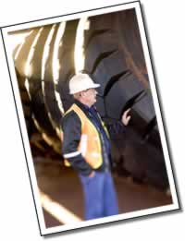  5.3.2_newman_csm_50.jpg m_49.jpg  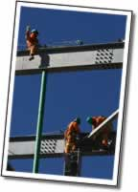  5.3.3_Spence_BM_16.swf | Another serious challenge we face is increasing costs.  We’ve already mentioned labour costs,..but we’re also seeing increases in other areas..  For example..  Earthmoving tyres are currently in critical supply around the world because the rubber and tyre industry simply cannot keep up with current demand..  ..and shortages are likely to continue for at least two more years.  Ironically,..steel,..the very product our own iron ore creates, is also in strong demand and therefore costly.  Yet we need large amounts of steel to expand our mining operations, rail links, and port facilities. Steel is also used in a number of components essential to our operations. | Learning objective: List the key challenges that are currently limiting factors in achieving our goals.
 | About The Ages of Steel  Steel demand follows building and industrialisation  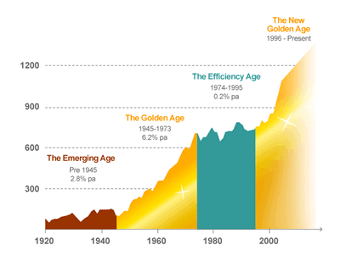 | 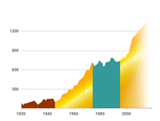  5.4.1_steel_age.gif | The future of Iron Ore is tied to the rise and fall in demand for steel.  Analysts refer to the cyclical nature of the steel market as the Ages of Steel.  The governing principle is that large periods of growth in steel production, are driven by rapid expansion of cities, and industrialisation of nations.  Looking at the past century, a distinct pattern emerges: | Learning objective: Explain the reasons for conditions that are negatively impacting CSG profitability.
 | 1920-1945 | [highlight box over  emerging age on graph] | Up to the end of World War II steel production increased less than 3% per year. | Learning objective: Explain the cyclical nature of the steel industry
 | 1946-1973 First Golden Age of Steel | [highlight box over  first golden age on graph] | However, post-war rebuilding and industrialisation in Europe, Japan, and America drove up steel production by over 6% per year..  ..This became known as the Golden Age of Steel. | Learning objective: Explain the cyclical nature of the steel industry
 | 1974-1995 | [highlight box over  efficiency age on graph] | Between 1974-1995 a number of issues kept growth to a minimum. | Learning objective: Explain the cyclical nature of the steel industry
 | 1996-On | [highlight box over  current golden age] | However, the rapid industrialisation of China and other countries in the developing world is giving us another Golden Age for steel. | Learning objective: Explain the reason for the current rising demand in iron ore.
 | Our Near Future…linked to China  [Fade in each point and graphic as mentioned]  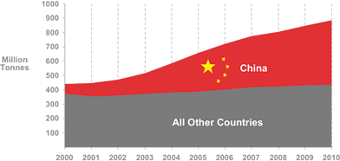 | 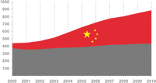  5.5.1_iron_ore_demand.png | China is the key player in world demand for iron ore and steel.  It produces less than half the iron ore it currently needs to feed its steel industry. As a result China is relocating its steel industry to coastal areas for better access to seaborne iron ore,..  By 2007, China will consume around half of all seaborne iron ore in the world market..  ..and 90% of the world’s seaborne iron ore comes from Australia and Brazil,..where BHP Billiton Iron Ore has all of its assets. | Learning Objective: Explain trends or factors that could affect short-term future profitability over the next 10 years.
 | Our Overall Future | 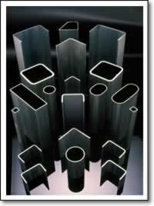  5.6.1_slide0100_image011.jpg  5.6.2_j0400416.jpg  [Use images from 2.4 if necessary]  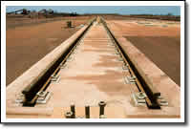  5.6.4_train_line.swf | Demand for steel commodities has always been driven by basic human needs for new roads,..  ..bridges,  ..buildings,  ..homes,  ..appliances  ..cars.  Despite the development of new products, technologies, techniques, and materials, steel continues to be an important requirement in our daily lives..  ..which means that iron ore will be there too. | Learning Objective: Summarise the overall future outlook for this CSG.
 | Summary  [fade in each point]  - Greatest challenge – Skills Shortages  - Other challenges:  - Supply of consumables  - Supply of steel  - Iron ore demand tied to Ages of Steel  - China drives steel demand |  | To summarise:  Our greatest current and future challenge is likely to be a critical shortage of skilled human resources.  Other challenges include scarcity of products and supplies required to enable our growth, including earthmoving consumables such as tyres, and steel for construction of expansion projects.  The iron ore market is tied to the cyclical ‘Ages’ in the steel market, which peaks when large nations rapidly industrialise and build infrastructure.  China is the current driver with other nations in the BRICs economies to follow giving the world another Golden Age of Steel.  Steel is set to be a part of all our lives for the foreseeable future, so iron ore is here to stay. | Summarise the lesson contents to reinforce learning
 | Lesson Assessment Questions  Instructions  [as per template] |  | Answer the following questions to see if you remember key points from this lesson.  Don’t forget to click Submit before moving onto the next question.  Click the button when you’re ready to begin. | This quiz section applies only to learning objectives covered in the current lesson.  Provide any instructions about prerequisites (e.g. must be online) about how to complete the quiz.
 | True or False  Steel demand rises when nations undergo rapid industrialisation, as happened after World War II.  [Mark the statement True or False, then click Submit.]  - True  - False |  | [no voiceover] | The iron ore market is tied to the cyclical ‘Ages’ in the steel market, which peaks when large nations rapidly industrialise and build infrastructure.
 | Mutliple Choice  Which of the following periods was the last Golden Age of Steel?  [Select the most correct answer, then click Submit.]  - 1919-1939  - 1940-1945  - 1946-1973  - 1974-1995  - 1996-2005 |  | [no voiceover] | The iron ore market is tied to the cyclical ‘Ages’ in the steel market, which peaks when large nations rapidly industrialise and build infrastructure.
 | Multiple Answer  Which of the following are factors currently limiting Iron Ore’s ability to exploit business opportunities?  [Select all correct answers, then click Submit.]  - Inadequate software technologies  - Lack of Human Resouces  - Lack of raw materials for expansion  - High cost of fuel  - Industrial relations issues |  | [no voiceover] | Our greatest current and future challenge is likely to be the critical shortage of skilled human resources.  Other problems include scarcity of products and supplies required to enable our growth, including earthmoving consumables such as tyres, and steel for construction of expansion projects.
 | Multiple Choice  Over the next 10 years, which of the following is regarded as the greatest driver for iron ore demand?  [Select the most correct answer, then click Submit.]  - Africa’s industrialisation  - Brazil’s industrialisation  - China’s industrialisation  - India’s industrialisation  - Russia’s industrialisation |  | [no voiceover] | China is the current driver with other nations in the BRICs economies to follow giving the world another Golden Age of Steel.
 | True or False  The overall future outlook for Iron Ore is excellent with demand for our products set to continue as long as people create products with steel.  [Mark the statement True or False, then click Submit.]  - True  - False |  | [no voiceover] | Overall though, steel is set to be a part of all our lives for the foreseeable future, so iron ore is here to stay.
 | Assessment Results  [standard automated slide] |  |  | This slide automatically displays the learner’s assessment results. After reading their results, learners can opt to review their answers and see where they went wrong.
 | Lesson End  [option buttons allow the learner to go back to the main menu or move to the next lesson in the unit.] |  | [no audio necessary] | Returns learner to the Menu slide showing all lessons within this course units.
 | Summary  Duration: ## minutes [update elapsed time figure as needed] |  | [sound: plop.wav]  [no voiceover] | Lesson Learning Objective: Identify  Title slide for this lesson. Should also show the duration in minutes. Update this by referring to the Captivate Storyboard tab info at each publish.  Voiceover time = 4min 0 sec
 | Lesson Overview  [fade in each point as mentioned]  - About Iron Ore  - Our Products  - Our Business Structure  - Our Business Strategy  - Current & Future Challenges |  | In this lesson we do a quick review of all the key points from this Introduction to Iron Ore as a customer sector group.  These are the points you’ll need to remember to pass the Final Assessment.  So pay close attention! | Briefly state the learning objectives for this course unit.
 | About Iron Ore  [Fade in each bullet point as mentioned]  - Seaborne Iron Ore  - Not Involved in Steel Production  - Mining iron ore since 1899 (105 years)  - Became CSG in 2006  - 3rd Largest in Seaborne Iron Ore  - EBIT 2006 = USD$ 2.5 Billion | 1.2.3_pthedland.swf | The Iron Ore Customer Sector Group supplies seaborne iron ore to iron and steel producers around the world..  ..but we don’t actually make steel itself.  BHP mined iron ore as far back as 1899, over 100 years before the merger with Billiton in 2001.  Iron Ore became a separate CSG at the end of 2006 and is now the world’s third largest supplier of seaborne iron ore with about 18% of the global market.  In the 2006 Financial Year our EBIT was more than US$ 2.5 Billion, an increase of 72% over the previous year’s result. | Identify where this CSG fits within the BHP Billiton organisational structure.  Outline the history of iron ore mining in BHP Billiton.  Rank this CSG among its competitors in the world resources market.  Generalise the current financial position of this CSG.
 | Our Products  - Hematite, Goethite, Limonite  - Lumps, Fines, Concentrate, Pellets  - Carbon Steel—NOT high in carbon!  - Carbon Steel + Alloys = Alloy Steel  - Steel Production Process  - Blooms, Billets, Slabs  - Long & Flat Product | 2.5.1_blast_furnace_cutaway.jpg | So in summary:  Our core product is Iron Ore, usually mined as hematite, goethite or limonite.  We ship product as lump, fines, concentrate, or pellets.  Iron Ore is the main ingredient in both carbon steel..  ..which actually has less than 2% carbon,..  ..and alloy steel, which is just carbon steel with extra alloys added to give special properties.  To make steel, iron ore and coke are added to a blast furnace to produce pig iron, from which surplus carbon is removed to create carbon steel. Extra ingredients are then added to create alloy steel.  Steel is cast as blooms, billets or slabs and sold as either long or flat products. | Identify products this CSG uses to create revenue.  Recall basic information about this product mined or produced by this CSG.  Recall basic information about this product mined or produced by this CSG.  Explain key concepts essential to understanding this CSG's product lines.
 | Our Business Structure  [fade in each point as mentioned]  - BHP Billiton Iron Ore is a CSG  - Focus on operations - not sales  - Pilbara, Western Australia  - Samarco, Brazil.  - Around 9,000 employees and contractors | 3.2.1_csm_org1_blank.gif | So in summary:  Iron Ore is one of a group of CSGs in the Carbon Steel Materials group.  Our head office is in Perth, Western Australia and product marketing is handled by the Marketing Functional Group from Singapore.  The bulk of our site operations are in the Pilbara region of Western Australia, including Mt Whaleback near Newman, as well as Yandi, Nimingarra, Yarrie, and Area C.  We have a world class heavy haulage rail line stretching over 400 kilometers from Newman to Port Hedland’s bulk shipping facility.  We have a joint venture operations at Samarco in Brazil with inland mines connected via a slurry pipeline to a pelletising plant and port facilities on the coast.  Our workforce is approximately 9,000 employees and contractors, not including Samarco in Brazil. | Summarise the current structure of this CSG  Identify main site locations for this CSG around the world Compare numbers of human resources for this CSG with other CSGs.  Identify the approximate number of employees in this CSG.
 | Our Business Strategy  [fade in each point as mentioned]  - Be the World’s Premier Iron Ore Producer  - Enabling Technologies:  - Heavy Earthmoving,  - Heavy Rail Transport  - Bulk Ship Handling  - Success proven by current expansion projects  - Competitive Advantages:  - Portfolio  - Cost Efficiency  - Reliability  - Service Reputation |  | Our business strategy is to:  Become the world’s premier iron ore producer while maintaining our existing clients,  .. boosting production to increase our market share in the developing world ..  ..especially to the BRICs economies of Brazil, Russia, India and China.  Our key enabling technologies revolve around bulk handling of ore, specifically..Heavy earthmoving equipment..Heavy rail transport, and..Bulk ship loading facilities.  We’re now the world’s third largest producer of seaborne iron ore with several expansion projects under way – proof that our business strategy is working.  We’ve achieved this position because we have a portfolio of long life mining assets,..  ..economies of scale..  ..we’re a reliable supplier of innovative products,..  ..with a reputation for great customer service. | Describe core elements of the CSG business strategy  Describe key technologies essential for this CSG to achieve production  Identify core policies that underpin the CSG business strategy  List some successes that offer proof of good strategy
 | Current and Future Challenges  [fade in each point]  - Greatest challenge – Skills Shortages  - Other challenges:  - Supply of consumables  - Supply of steel  - Iron ore demand tied to Ages of Steel  - China drives steel demand |  | Our greatest current and future challenge is likely to be a critical shortage of skilled human resources.  Other challenges include scarcity of products and supplies required to enable our growth, including earthmoving consumables such as tyres, and steel for construction of expansion projects.  The iron ore market is tied to the cyclical ‘Ages’ in the steel market, which peaks when large nations rapidly industrialise and build infrastructure.  China is the current driver with other nations in the BRICs economies to follow giving the world another Golden Age of Steel.  Steel is set to be a part of all our lives for the foreseeable future, so iron ore is here to stay. | Explain issues or challenges currently facing this CSG  Explain the impact of each challenge to this CSG.  Outline future prospects for this CSG.  Explain trends or developments that could affect competition in this industry.  Name any expected developments that could impact this CSG in future.  Describe the future outlook for this CSG (according to current trend data)
 | End of Summary  [Large callout]  Do the Final Assessment? |  | And that’s the end of the Summary!  If you think you’ve successfully absorbed all the knowledge, you’re ready to do the Final Assessment.  Thanks for listening! | Briefly summarise the objectives to reinforce the learning  Tell them where to go next.
 | Lesson End  [option buttons allow the learner to go back to the main menu or move to the next lesson in the unit.] |  | [no audio necessary] | Returns learner to the Menu slide showing all lessons within this course units.
 | Final Assessment  Duration: ## minutes [update elapsed time figure as needed] |  | [sound: plop.wav]  [no voiceover] | Objective: Cover all learning objectives from unit level down.  Quiz for the entire course unit.
 | Assessment Instructions:  This assessment is recorded for reporting purposes!  [Show list with checkboxes and tick each off as it is mentioned]  - Have you completed all lessons in this unit?  - Have you done all lesson assessments?  - Did you score over 75% for each assessment?  - Complete all questions in one sitting.  - Passing score is 75%  - Go for it! |  | [no voiceover] | Passing score can be varied if necessary without changing the voiceover.
 | About Iron Ore |  | Note to developer: Bold indicates correct answer/s. | Learning Objective: Identify this CSG’s unique context or position.
 | True or False  BHP Billiton Iron Ore specialises in supplying seaborne iron ore to the world’s iron and steel producers but does not produce any steel itself.  [Mark the statement True or False, then click Submit.]  - True  - False |  | [no voiceover] | Iron Ore is the Customer Sector Group within BHP Billiton that supplies seaborne iron ore to iron and steel producers around the world.
 | Multiple Choice  What was Iron Ores annual EBIT in 2006?  [Select the most correct answer, then click Submit.]  - US$ 1.5 Billion  - US$ 1.75 Billion  - US$ 2.0 Billion  - US$ 2.25 Billion  - US$ 2.5 Billion |  | [no voiceover] | In the 2006 Financial Year our EBIT was more than US$ 2.5 Billion, an increase of 72% over the previous year’s result.
 | Multiple Choice  Iron ore has been a part of our organisation’s portfolio for over:  [Select the most correct answer, then click Submit.]  - 105 years  - 100 years  - 95 years  - 90 years |  | [no voiceover] | The BHP company mined iron ore as early as 1899, over 100 years before the merger with Billiton in 2001.
 | Multiple Choice  Where does Iron Ore rank among world producers of seaborne iron ore?  [Select the most correct answer, then click Submit.]  - first,  - second,  - third,  - fourth,  - fifth |  | [no voiceover] | Iron Ore became a separate CSG in its own right at the end of 2006 and is now the world’s third largest supplier of seaborne iron ore with about 18% of the global market.
 | Our Products | 2.3.3_metalloys_csm_9.swf  [Pellets]
 | True or False  Alloy Steel begins as carbon steel to which extra metals are added to give special properties.  [Mark the statement True or False, then click Submit.]  - True  - False |  | [no voiceover] | Alloy steel is just carbon steel with extra alloys added to give special properties.
 | Multiple Answer  Which of the following statements are true?  [Select all correct answers, then click Submit.]  - Carbon Steel is so-named because it contains high levels of carbon.  - Carbon steel has less than 2% carbon content.  - Carbon makes steel harder but too much carbon makes it brittle.  - Iron ore is the second largest ingredient in steel. |  | [no voiceover] | Despite what its name might suggest, carbon steel has less than 2% carbon content.  Iron Ore is the main ingredient in both carbon steel and alloy steel.
 | Multiple Answer  Which of the following items are required in production of carbon steel?  [Select all correct answers, then click Submit.]  - Iron Ore  - Metallurgical (Coking) Coal  - Nickel  - Molybdenum  - Manganese  - Chromium |  | [no voiceover] | Iron ore and coke are added to a blast furnace to produce pig iron, from which surplus carbon is removed in a Basic Oxygen Furnace to create carbon steel. Then extra ingredients are added to create alloy steel.
 | Multiple Answer  Which of the following are types of iron ore?  [Select all correct answers, then click Submit.]  - Hematite  - Pyrite  - Goethite  - Cellulite  - Limonite  - Itabirite  - Flourite  - Fryitrite |  | [no voiceover] | Our core product is Iron Ore, mined usually as hematite, goethite or limonite.
 | Drag and Drop  Match the stages in the steelmaking process with their correct order:  [Drag items from the right to their correct place in the sequence at left, then click Submit.]  - Alternate layers of iron and coke are added to the top of a blast furnace.(1)  - Gases in the furnace are heated to 2300 degrees, carbon monoxide is produced and strips oxygen is from the iron ore.(2)  - Pig Iron is produced.(3)  - Alloy steel is produced.(7)  - Carbon Steel is produced.(5)  - The product is placed in a basic oxygen furnace and excess carbon is removed.(4)  - Extra metals are added in precise quantities to give special properties.(6) |  | [no voiceover] | Iron ore and coke are added to a blast furnace to produce pig iron, from which surplus carbon is removed in a Basic Oxygen Furnace to create carbon steel. Then extra ingredients are added to create alloy steel.
 | Drag and Drop  Match the items that belong together.  [Drag items from the right to the appropriate category on the left, then click Submit.]  Categories:  Iron ore products (pellets, lumps, fines)  Steel cast forms (blooms billets slabs)  Steel product types (long, flat) |  | [no voiceover] | We ship product as lumps, fines, concentrate, or pellets.  Steel is cast as blooms, billets or slabs and sold as long or flat products.
 | Our Business Structure | 3.2.1_csm_org1_blank.gif
 | True or False  BHP Billiton Iron Ore is a Functional Group that markets products to the steel industry from headquarters in Perth Western Australia.  [Mark the statement True or False, then click Submit.]  - True  - False |  | [no voiceover] | Iron Ore is one of a group of CSGs in the Carbon Steel Materials group.  Our head office is in Perth, Western Australia and product marketing is handled by the Marketing Functional Group from Singapore.
 | Multiple Choice  Approximately how many people work at Iron Ore’s locations around the world?  [Select the most correct answer, then click Submit.]  - Less than 2000  - 2,001 to 3,000  - 3,001 to 5,000  - Greater than 5,000 |  | [no voiceover] | We have a total workforce of approximately 7,000 employees and contractors, not counting our interests in Brazil where we are not the operating partner.
 | Multiple Answer  In which continents does BHP Billiton have established iron ore operations?  [Select all correct answers, then click Submit.]  - Europe  - Africa  - Asia  - Australia  - North America  - South America  - Antarctica |  | [no voiceover] | The bulk of our site operations are in the Pilbara region of Western Australia, including Mt Whaleback near Newman, as well as Yandi, Nimingarra, Yarrie, and Area C.
 | Multiple Choice  The region of Western Australia with the largest known deposits of iron ore is called…  [Select the most correct answer, then click Submit.]  - The Kimberley  - The Pilbara  - The Murchison  - The Monaro  - The Outback |  | [no voiceover] | The bulk of our site operations are in the Pilbara region of Western Australia, including Mt Whaleback near Newman, as well as Yandi, Nimingarra, Yarrie, and Area C.  We have a world classs heavy haulage rail line stretching over 400 kilometers from Newman to Port Hedland’s bulk shipping facility.
 | Multiple Answer  Which of the following are BHP Billiton mines located in Western Australia?  [Select all correct answers, then click Submit.]  - Mt Whaleback  - Iron Knob  - Iron Baron  - Yandi  - Yarrie  - Port Hedland |  | [no voiceover] | The bulk of our site operations are in the Pilbara region of Western Australia, including Mt Whaleback near Newman, as well as Yandi, Nimingarra, Yarrie, and Area C.  South Australian mine names are not correct because they are not in Western Australia. Port Hedland is not a minesite.
 | Multiple Choice  What is the name of BHP Billiton’s iron ore joint venture in Brazil?  [Select the most correct answer, then click Submit.]  - Samarco  - Semancor  - Semantica  - Senorita |  | [no voiceover] | We have a joint venture operations at Samarco in Brazil with inland mines connected via a slurry pipeline to a pelletising plant and port facilities on the coast.
 | Our Business Strategy | 4.5.2_reclaimer.swf
 | True or False  Iron Ore’s business strategy is to become the world’s premier iron ore producer, delivering iron ore to build the developing world.  [Mark the statement True or False, then click Submit.]  - True  - False |  | [no voiceover] | Become the world’s premier iron ore producer while maintaining our existing clients,  .. boosting production to increase our market share in the developing world ..  ..especially to the BRICs economies of Brazil, Russia, India and China.
 | Multiple Choice  Which are the countries represented by the so-called the BRIC economies?  [Select the most correct answer, then click Submit.]  - Britain, Russia, India, China  - Brazil, Romania, Ireland, Canada  - Bosnia, Russia, Israel, Chile  - Brazil, Russia, India, China |  | [no voiceover] | ..especially the BRICs economies - Brazil, Russia, India and China.
 | Multiple Answer  Which of the following are key enabling technologies for Iron Ore’s business?  [Select all correct answers, then click Submit.]  - Heavy earthmoving equipment  - Heavy rail transport  - Sulphide ore leaching  - Bulk handling port and shipping facilities  - Basic Oxygen Blast Furnace Technologies |  | [no voiceover] | Our key enabling technologies all revolve around bulk handling of ore, specifically..Heavy earthmoving equipment..Heavy rail transport, and..Bulk handling port facilities
 | Multiple Choice  What demonstrates that Iron Ore’s business strategy is working?  [Select the most correct answer, then click Submit.]  - We are now the world’s largest producer of seaborne iron ore.  - We contribute more EBIT to BHP Billiton than any other CSG.  - We sell lots of iron ore to China.  - We have multiple expansion projects now underway to cope with increased demand. |  | [no voiceover] | Our business strategy is working because we are now the world’s third largest producer of seaborne iron ore with several expansion projects under way.  The idea here is to require the learner to show that they understand a number of truths already covered in previous lessons as well as this one.  - Iron ore is NOT the world’s largest producer, only the third larges.  - We are not the largest EBIT contributor to BHP Billiton. Base Metals is currently that leader.  - Lots of people sell iron ore to China, not just us.  - Our expansion is just one of the proofs that our strategy is working. But it’s the only proof listed here so it’s the correct answer.
 | Multiple Answer  What are some of Iron Ore’s competetive advantages?  [Select all correct answers, then click Submit.]  - We have an excellent portfolio of long life mining assets.  - We have a reputation as a reliable supplier.  - We know the steel industry well.  - We give excellent customer service.  - Our size creates economies of scale. |  | [no voiceover] | We gained this position because we have an excellent portfolio of long life mining assets,..we enjoy economies of scale due to sheer size..we’re a reliable supplier of innovative, high quality product,..with a reputation for great customer service.  All answers in this one are correct in this case.
 | Current & Future Challenges | 5.3.1_samarco_csm_49.jpg
 | True or False  Steel demand rises when nations undergo rapid industrialisation and build or rebuild infrastructure.  [Mark the statement True or False, then click Submit.]  - True  - False |  | [no voiceover] | The iron ore market is tied to the steel market which peaks when large nations rapidly industrialise and build or rebuild infrastructure.
 | Multiple Choice  Which of the following problems is Iron Ore’s greatest current and future challenge?  [Select all correct answers, then click Submit.]  - Inadequate technologies  - Lack of Human Resouces  - Lack of raw materials for expansion  - High cost of fuel  - Shortage of earthmover tyres |  | [no voiceover] | Our greatest current challenge is a critical shortage of skilled human resources.  This is also likely to be our main challenge for the foreseeable future as well.  Other problems include scarcity of products and supplies required to enable our growth, including earthmoving consumables such as tyres, and steel for construction of expansion projects.
 | Multiple Choice  Demand for iron ore over the next 10 years is expected to come mainly from:  [Select the most correct answer, then click Submit.]  - The developed world  - Brazil’s industrialisation  - Russia’s industrialisation  - India’s industrialisation  - China’s industrialisation |  | [no voiceover] | China is the current driver with other nations in the BRICs economies to follow giving the world another Golden Age of Steel.
 | True or False  The long-term future outlook for Iron Ore and steel is poor because people now create fewer products using steel.  [Mark the statement True or False, then click Submit.]  - True  - False |  | [no voiceover] | Overall though, steel is set to be a part of all our lives for the foreseeable future, so iron ore is here to stay.
 | Assessment Results  [default automated slide] |  |  | This slide automatically displays the learner’s assessment results. After reading their results, learners can opt to review their answers and see where they went wrong.
 | Lesson End  [option buttons allow the learner to go back to the main menu or move to the next lesson in the unit.] |  | [no audio necessary] | Returns learner to the Menu slide showing all lessons within this course units.

