Apply sealing tape
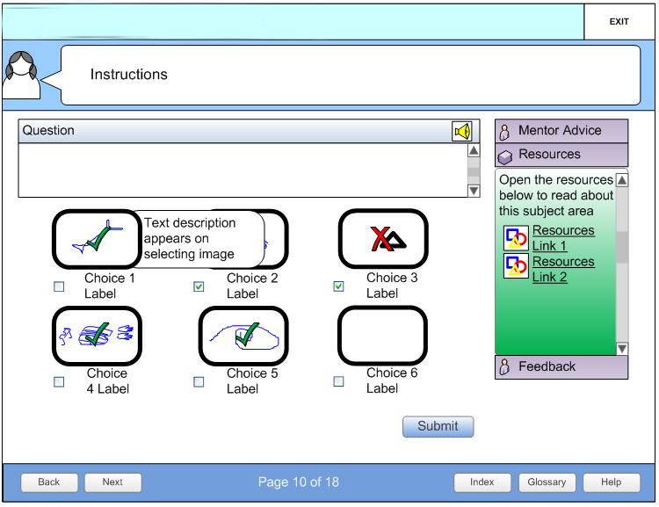

Description (Screen type: Multiple choice pic)
This page type tests a learners judgement in selecting the correct options from a range. Six items have been allowed for in the table below, however you may add or delete up to a maximum of 8 items as required. Also, please indicate with a highlight, the correct answers from the options below and ensure incorrect answers are plausible, but wrong.

Field ID | Field | Content
 | Screen ID | QWNW7
 | Screen Title | Apply sealing tape
 | Instructions | First, check out your Mentor Advice and Resources. Then click each picture for its explanation select all the correct answers and click Submit.  When you’re done, click Next to continue.
 | Question | Which of the following are good techniques for applying sealing tape?
 | Item 1 image | Image of a guy putting grease on the fitting
 | Item 1 rollover text | Greasing the fitting before applying the sealing tape makes it easier to join them.
 | Item 2 image | Image of a guy putting two layers around the fitting
 | Item 2 rollover text | Often one layer is not enough, for a good seal, wrap the thread with two layers of tape.
 | Item 3 image
 | Item 3 rollover text
 | Item 4 image
 | Item 4 rollover text
 | Item 5 image
 | Item 5 rollover text
 | Item 6 image
 | Item 6 rollover text
 | Correct feedback | Well done, you show a good understanding of sealing tape technique. Move on to the next activity.
 | 1st incorrect feedback | Good try. Check out your Resources and watch the video before trying this activity again.
 | 2nd incorrect feedback | That is not correct. The correct answers are now displayed on screen. Look at the answers you got incorrect and see if you can work out why.
 | Mentor advice text | A good seal prevents leaks. Leaks cost time and money. Check out the video on sealing tape technique before doing this activity.
 | Resources | Video of the step

